《机器学习》实验报告

年级、专业、班级 |  |  |  |  | 姓名
实验题目 | 对数几率回归算法实践
实验时间 | 2026年4月26日 |  | 实验地点 | DS1408
实验成绩 |  |  | 实验性质 | □验证性 ☑设计性 □综合性
教师评价：
□算法/实验过程正确； □源程序/实验内容提交 □程序结构/实验步骤合理；
□实验结果正确； □语法、语义正确； □报告规范；
其他：
评价教师签名：
一、实验目的
掌握线性模型、对率回归算法原理。
二、实验项目内容
1.理解对率回归算法原理。
2.编程实现对数几率回归算法。
3.将算法应用于西瓜数据集、鸢尾花数据集或其它数据集分类问题。

三、实验过程或算法（源程序）
"""
使用只含数据属性的样本（3.0a.csv）西瓜分类学习器
"""
from pathlib import Path
import numpy as np
import pandas as pd
DATA_ROOT = Path("/Users/previous_rium/Desktop/PY/ml_exp1/dataset/watermelon")
TRAIN_CSV = DATA_ROOT / "train" / "3.0a.csv"
VAL_CSV = DATA_ROOT / "val" / "table_4.2.csv"
TEST_CSV = DATA_ROOT / "test" / "4.0.csv"
def standardize_fit_transform(x):
mean = x.mean(axis=0)
std = x.std(axis=0)
std[std == 0] = 1.0
return (x - mean) / std, mean, std
def standardize_transform(x, mean, std):
std_safe = std.copy()
std_safe[std_safe == 0] = 1.0
return (x - mean) / std_safe
def sigmoid(z):
z = np.clip(z, -500, 500)
return 1.0 / (1.0 + np.exp(-z))
def binary_metrics(y_true, y_pred):
y_true = y_true.astype(int)
y_pred = y_pred.astype(int)
tp = int(np.sum((y_true == 1) & (y_pred == 1)))
tn = int(np.sum((y_true == 0) & (y_pred == 0)))
fp = int(np.sum((y_true == 0) & (y_pred == 1)))
fn = int(np.sum((y_true == 1) & (y_pred == 0)))
acc = (tp + tn) / len(y_true)
precision = tp / (tp + fp) if (tp + fp) else 0.0
recall = tp / (tp + fn) if (tp + fn) else 0.0
f1 = 2 * precision * recall / (precision + recall) if (precision + recall) else 0.0
return acc, precision, recall, f1
class LogisticRegressionScratch:
def __init__(self, n_features, lr=0.5, epochs=200):
self.w = np.zeros(n_features, dtype=float)
self.b = 0.0
self.lr = lr
self.epochs = epochs
self.losses = []
def fit(self, x, y):
y = y.astype(float)
best_loss = float("inf")
best_epoch = -1
best_w = self.w.copy()
best_b = self.b
for epoch in range(self.epochs):
logits = x @ self.w + self.b
probs = sigmoid(logits)
eps = 1e-12
loss = -np.mean(y * np.log(probs + eps) + (1 - y) * np.log(1 - probs + eps))
self.losses.append(loss)
grad_w = (x.T @ (probs - y)) / len(y)
grad_b = np.mean(probs - y)
self.w -= self.lr * grad_w
self.b -= self.lr * grad_b
if loss < best_loss:
best_loss = loss
best_epoch = epoch + 1
best_w = self.w.copy()
best_b = self.b
if (epoch + 1) % 20 == 0 or epoch == 0:
print(f"epoch: {epoch + 1}, loss: {loss:.6f}")
self.w = best_w
self.b = best_b
return best_loss, best_epoch
def predict_proba(self, x):
return sigmoid(x @ self.w + self.b)
def predict(self, x, threshold=0.5):
return (self.predict_proba(x) >= threshold).astype(int)
def main():
df_train = pd.read_csv(TRAIN_CSV, encoding="utf-8")
df_val = pd.read_csv(VAL_CSV, encoding="utf-8")
feature_cols = ["密度", "含糖率"]
x_train = df_train[feature_cols].values.astype(float)
y_train = df_train["好瓜"].values.astype(int)
x_val = df_val[feature_cols].values.astype(float)
y_val = df_val["好坏"].map({"好瓜": 1, "坏瓜": 0}).values.astype(int)
df_test = pd.read_csv(TEST_CSV, header=None, names=feature_cols, encoding="utf-8")
x_test = df_test[feature_cols].values.astype(float)
x_train, mean, std = standardize_fit_transform(x_train)
x_val = standardize_transform(x_val, mean, std)
x_test = standardize_transform(x_test, mean, std)
model = LogisticRegressionScratch(n_features=x_train.shape[1], lr=0.5, epochs=200)
best_loss, best_epoch = model.fit(x_train, y_train)
save_path = Path("checkpoints") / "watermelon1.npz"
save_path.parent.mkdir(parents=True, exist_ok=True)
np.savez(save_path, w=model.w, b=model.b, mean=mean, std=std)
print(f"最小训练损失: {best_loss:.6f} (epoch {best_epoch})")
print(f"最佳权重已保存到: {save_path}")
y_val_pred = model.predict(x_val)
acc, precision, recall, f1 = binary_metrics(y_val, y_val_pred)
print(f"验证集准确率: {acc:.4f}")
print(f"验证集 Precision: {precision:.4f}")
print(f"验证集 Recall: {recall:.4f}")
print(f"验证集 F1: {f1:.4f}")
probs = model.predict_proba(x_test)
y_pred = (probs >= 0.5).astype(int)
print("测试集样本数:", len(y_pred), "（4.0.csv 无标签，仅输出预测）")
print("预测类别 (0=坏瓜, 1=好瓜):", y_pred)
print("预测概率 P(好瓜):", probs)
print("系数 (标准化后特征):", dict(zip(feature_cols, model.w)))
print("截距:", model.b)
if __name__ == "__main__":
main()

"""
使用含全部数据属性的样本（3.0.csv）西瓜分类学习器
离散 one-hot 部分用 0 填充后再预测
"""
from pathlib import Path
import numpy as np
import pandas as pd
DATA_ROOT = Path("/Users/previous_rium/Desktop/PY/ml_exp1/dataset/watermelon")
TRAIN_CSV = DATA_ROOT / "train" / "3.0.csv"
VAL_CSV = DATA_ROOT / "val" / "table_4.2.csv"
TEST_CSV = DATA_ROOT / "test" / "4.0.csv"
def sigmoid(z):
z = np.clip(z, -500, 500)
return 1.0 / (1.0 + np.exp(-z))
def standardize_fit_transform(x):
mean = x.mean(axis=0)
std = x.std(axis=0)
std[std == 0] = 1.0
return (x - mean) / std, mean, std
def standardize_transform(x, mean, std):
std_safe = std.copy()
std_safe[std_safe == 0] = 1.0
return (x - mean) / std_safe
def binary_metrics(y_true, y_pred):
y_true = y_true.astype(int)
y_pred = y_pred.astype(int)
tp = int(np.sum((y_true == 1) & (y_pred == 1)))
tn = int(np.sum((y_true == 0) & (y_pred == 0)))
fp = int(np.sum((y_true == 0) & (y_pred == 1)))
fn = int(np.sum((y_true == 1) & (y_pred == 0)))
acc = (tp + tn) / len(y_true)
precision = tp / (tp + fp) if (tp + fp) else 0.0
recall = tp / (tp + fn) if (tp + fn) else 0.0
f1 = 2 * precision * recall / (precision + recall) if (precision + recall) else 0.0
return acc, precision, recall, f1
class LogisticRegressionScratch:
def __init__(self, n_features, lr=0.05, epochs=200):
self.w = np.zeros(n_features, dtype=float)
self.b = 0.0
self.lr = lr
self.epochs = epochs
self.losses = []
def fit(self, x, y):
y = y.astype(float)
best_loss = float("inf")
best_epoch = -1
best_w = self.w.copy()
best_b = self.b
for epoch in range(self.epochs):
logits = x @ self.w + self.b
probs = sigmoid(logits)
eps = 1e-12
loss = -np.mean(y * np.log(probs + eps) + (1 - y) * np.log(1 - probs + eps))
self.losses.append(loss)
grad_w = (x.T @ (probs - y)) / len(y)
grad_b = np.mean(probs - y)
self.w -= self.lr * grad_w
self.b -= self.lr * grad_b
if loss < best_loss:
best_loss = loss
best_epoch = epoch + 1
best_w = self.w.copy()
best_b = self.b
if (epoch + 1) % 50 == 0 or epoch == 0:
print(f"epoch: {epoch + 1}, loss: {loss:.6f}")
self.w = best_w
self.b = best_b
return best_loss, best_epoch
def predict_proba(self, x):
return sigmoid(x @ self.w + self.b)
def predict(self, x, threshold=0.5):
return (self.predict_proba(x) >= threshold).astype(int)
def main():
df_train = pd.read_csv(TRAIN_CSV, encoding="utf-8")
df_val = pd.read_csv(VAL_CSV, encoding="utf-8")
cat_cols = ["色泽", "根蒂", "敲声", "纹理", "脐部", "触感"]
num_cols = ["密度", "含糖率"]
df_test = pd.read_csv(TEST_CSV, header=None, names=num_cols, encoding="utf-8")
y_train = df_train["好瓜"].map({"是": 1, "否": 0}).values.astype(int)
y_val = df_val["好坏"].map({"好瓜": 1, "坏瓜": 0}).values.astype(int)
# 独热编码
X_train_cat = pd.get_dummies(df_train[cat_cols], dtype=float)
X_val_cat = pd.get_dummies(df_val[cat_cols], dtype=float)
X_train_cat, X_val_cat = X_train_cat.align(
X_val_cat, join="left", axis=1, fill_value=0.0
)
x_train_num, mean, std = standardize_fit_transform(df_train[num_cols].values.astype(float))
x_val_num = standardize_transform(df_val[num_cols].values.astype(float), mean, std)
x_test_num = standardize_transform(df_test[num_cols].values.astype(float), mean, std)
X_train_df = pd.concat(
[X_train_cat.reset_index(drop=True), pd.DataFrame(x_train_num)], axis=1
)
X_val_df = pd.concat(
[X_val_cat.reset_index(drop=True), pd.DataFrame(x_val_num)], axis=1
)
# 4.0.csv 仅有数值特征，没有离散特征；离散 one-hot 部分用 0 填充保持维度一致
X_test_cat = pd.DataFrame(0.0, index=df_test.index, columns=X_train_cat.columns)
X_test_df = pd.concat(
[X_test_cat.reset_index(drop=True), pd.DataFrame(x_test_num)], axis=1
)
X_train = X_train_df.values
X_val = X_val_df.values
X_test = X_test_df.values
model = LogisticRegressionScratch(n_features=X_train.shape[1], lr=0.05, epochs=200)
best_loss, best_epoch = model.fit(X_train, y_train)
save_path = Path("checkpoints") / "watermelon2.npz"
save_path.parent.mkdir(parents=True, exist_ok=True)
np.savez(save_path, w=model.w, b=model.b, mean=mean, std=std, columns=X_train_df.columns.values)
print(f"最小训练损失: {best_loss:.6f} (epoch {best_epoch})")
print(f"最佳权重已保存到: {save_path}")
y_val_pred = model.predict(X_val)
acc, precision, recall, f1 = binary_metrics(y_val, y_val_pred)
print(f"验证集准确率: {acc:.4f}")
print(f"验证集 Precision: {precision:.4f}")
print(f"验证集 Recall: {recall:.4f}")
print(f"验证集 F1: {f1:.4f}")
test_probs = model.predict_proba(X_test)
y_test_pred = (test_probs >= 0.5).astype(int)
print("测试集样本数:", len(y_test_pred))
print("测试集预测类别 (0=坏瓜, 1=好瓜):", y_test_pred)
print("测试集预测概率 P(好瓜):", test_probs)
print("参数维度:", len(model.w))
print("截距:", model.b)
if __name__ == "__main__":
main()

===============================================================
"""
鸢尾花三分类学习器
十折交叉验证，无测试
"""
from pathlib import Path
import numpy as np
import matplotlib.pyplot as plt
import pandas as pd
DATA_ROOT = Path("/Users/previous_rium/Desktop/PY/ml_exp1/dataset/iris")
TRAIN_CSV = DATA_ROOT / "train" / "iris.csv"
def standardize_fit_transform(x):
mean = x.mean(axis=0)
std = x.std(axis=0)
std[std == 0] = 1.0
return (x - mean) / std, mean, std
def standardize_transform(x, mean, std):
std_safe = std.copy()
std_safe[std_safe == 0] = 1.0
return (x - mean) / std_safe
def softmax(z):
z_shift = z - np.max(z, axis=1, keepdims=True)
exp_z = np.exp(z_shift)
return exp_z / np.sum(exp_z, axis=1, keepdims=True)
def one_hot(y, n_classes):
out = np.zeros((len(y), n_classes), dtype=float)
out[np.arange(len(y)), y] = 1.0
return out
def stratified_kfold_indices(y, n_splits=10, random_state=42):
rng = np.random.RandomState(random_state)
y = np.asarray(y)
classes = np.unique(y)
per_class_chunks = {}
for c in classes:
idx = np.where(y == c)[0]
rng.shuffle(idx)
per_class_chunks[c] = np.array_split(idx, n_splits)
for fold in range(n_splits):
val_idx = np.concatenate([per_class_chunks[c][fold] for c in classes])
train_idx = np.setdiff1d(np.arange(len(y)), val_idx, assume_unique=False)
yield train_idx, val_idx
def multiclass_metrics(y_true, y_pred, n_classes):
cm = np.zeros((n_classes, n_classes), dtype=int)
for t, p in zip(y_true, y_pred):
cm[t, p] += 1
acc = np.trace(cm) / np.sum(cm)
precisions = []
recalls = []
f1s = []
for i in range(n_classes):
tp = cm[i, i]
fp = np.sum(cm[:, i]) - tp
fn = np.sum(cm[i, :]) - tp
precision = tp / (tp + fp) if (tp + fp) else 0.0
recall = tp / (tp + fn) if (tp + fn) else 0.0
f1 = 2 * precision * recall / (precision + recall) if (precision + recall) else 0.0
precisions.append(precision)
recalls.append(recall)
f1s.append(f1)
return acc, float(np.mean(precisions)), float(np.mean(recalls)), float(np.mean(f1s))
class SoftmaxRegressionScratch:
def __init__(self, n_features, n_classes, lr=0.05, epochs=200):
self.w = np.zeros((n_features, n_classes), dtype=float)
self.b = np.zeros((1, n_classes), dtype=float)
self.lr = lr
self.epochs = epochs
self.losses = []
def fit(self, x, y):
y_oh = one_hot(y, self.b.shape[1])
best_loss = float("inf")
best_epoch = -1
best_w = self.w.copy()
best_b = self.b.copy()
for epoch in range(self.epochs):
logits = x @ self.w + self.b
probs = softmax(logits)
eps = 1e-12
loss = -np.mean(np.sum(y_oh * np.log(probs + eps), axis=1))
self.losses.append(loss)
grad_logits = (probs - y_oh) / len(y)
grad_w = x.T @ grad_logits
grad_b = np.sum(grad_logits, axis=0, keepdims=True)
self.w -= self.lr * grad_w
self.b -= self.lr * grad_b
if loss < best_loss:
best_loss = loss
best_epoch = epoch + 1
best_w = self.w.copy()
best_b = self.b.copy()
self.w = best_w
self.b = best_b
return best_loss, best_epoch
def predict(self, x):
logits = x @ self.w + self.b
return np.argmax(logits, axis=1)
def train_one_fold(x_train, y_train, x_val, y_val, epochs=200, lr=0.05):
model = SoftmaxRegressionScratch(
n_features=x_train.shape[1], n_classes=3, lr=lr, epochs=epochs
)
best_loss, best_epoch = model.fit(x_train, y_train)
save_path = Path("checkpoints") / "Iris.npz"
save_path.parent.mkdir(parents=True, exist_ok=True)
np.savez(save_path, w=model.w, b=model.b)
y_pred = model.predict(x_val)
acc, precision, recall, f1 = multiclass_metrics(y_val, y_pred, n_classes=3)
return acc, precision, recall, f1, model.losses, best_loss, best_epoch
def main():
df = pd.read_csv(TRAIN_CSV, encoding="utf-8")
cols = df[["Sepal.Length","Sepal.Width","Petal.Length","Petal.Width"]].values.astype(float)
labels = df["Species"].map({"setosa": 0, "versicolor": 1, "virginica": 2}).values.astype(int)
fold_accs = []
fold_precisions = []
fold_recalls = []
fold_f1s = []
fold_losses = []
for fold, (train_idx, val_idx) in enumerate(
stratified_kfold_indices(labels, n_splits=10, random_state=42), start=1
):
X_train, X_val = cols[train_idx], cols[val_idx]
y_train, y_val = labels[train_idx], labels[val_idx]
X_train, mean, std = standardize_fit_transform(X_train)
X_val = standardize_transform(X_val, mean, std)
acc, precision, recall, f1, train_losses, best_loss, best_epoch = train_one_fold(
X_train, y_train, X_val, y_val, epochs=200, lr=0.05
)
fold_accs.append(acc)
fold_precisions.append(precision)
fold_recalls.append(recall)
fold_f1s.append(f1)
fold_losses.append(train_losses)
print(
f"Fold {fold:02d} | Acc: {acc:.4f} | "
f"P(macro): {precision:.4f} | R(macro): {recall:.4f} | "
f"F1(macro): {f1:.4f} | best_loss: {best_loss:.6f} (epoch {best_epoch})"
)
print("-" * 40)
print("10-fold accuracies:", [round(a, 4) for a in fold_accs])
print("10-fold precisions(macro):", [round(a, 4) for a in fold_precisions])
print("10-fold recalls(macro):", [round(a, 4) for a in fold_recalls])
print("10-fold F1s(macro):", [round(a, 4) for a in fold_f1s])
print(f"Mean accuracy: {np.mean(fold_accs):.4f}")
print(f"Std accuracy : {np.std(fold_accs):.4f}")
print(f"Mean precision(macro): {np.mean(fold_precisions):.4f}")
print(f"Mean recall(macro) : {np.mean(fold_recalls):.4f}")
print(f"Mean F1(macro) : {np.mean(fold_f1s):.4f}")
# 绘制 10 折平均训练损失曲线
mean_loss_curve = np.mean(np.array(fold_losses), axis=0)
epochs = np.arange(1, len(mean_loss_curve) + 1)
plt.figure(figsize=(8, 5))
plt.plot(epochs, mean_loss_curve, color="#1f77b4", linewidth=2)
plt.title("Iris 10-Fold Mean Training Loss Curve")
plt.xlabel("Epoch")
plt.ylabel("Cross-Entropy Loss")
plt.grid(alpha=0.3)
plt.tight_layout()
out_path = Path("/Users/previous_rium/Desktop/PY/ml_exp1/iris_mean_loss_curve.png")
plt.savefig(out_path, dpi=160)
print(f"Mean loss curve saved to: {out_path}")
plt.show()
if __name__ == "__main__":
main()

四、实验结果及分析
1.使用3.0a.csv数据集训练西瓜分类学习器
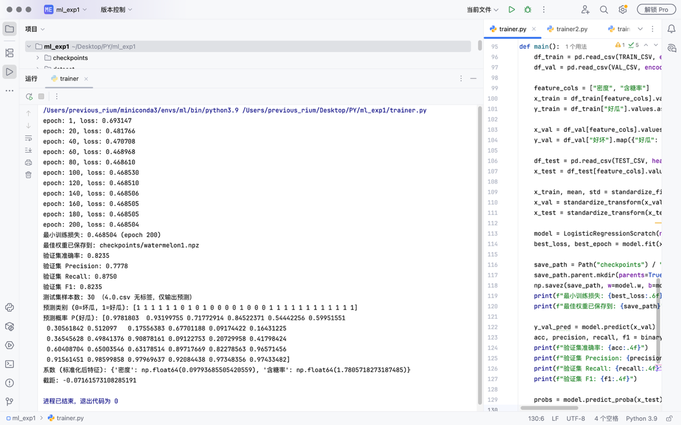
模型在120epoch后趋于稳定。

2.使用3.0.csv数据集训练西瓜分类学习器
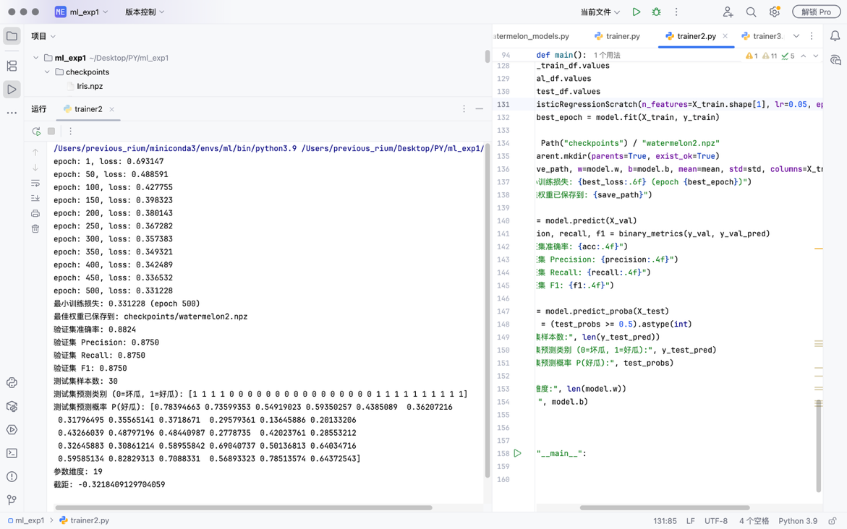
模型在500epoch后，损失还能继续下降。
3.两个学习器横向对比
（1）验证集（训练时不可见）性能表现（两个模型均训练200epochs）

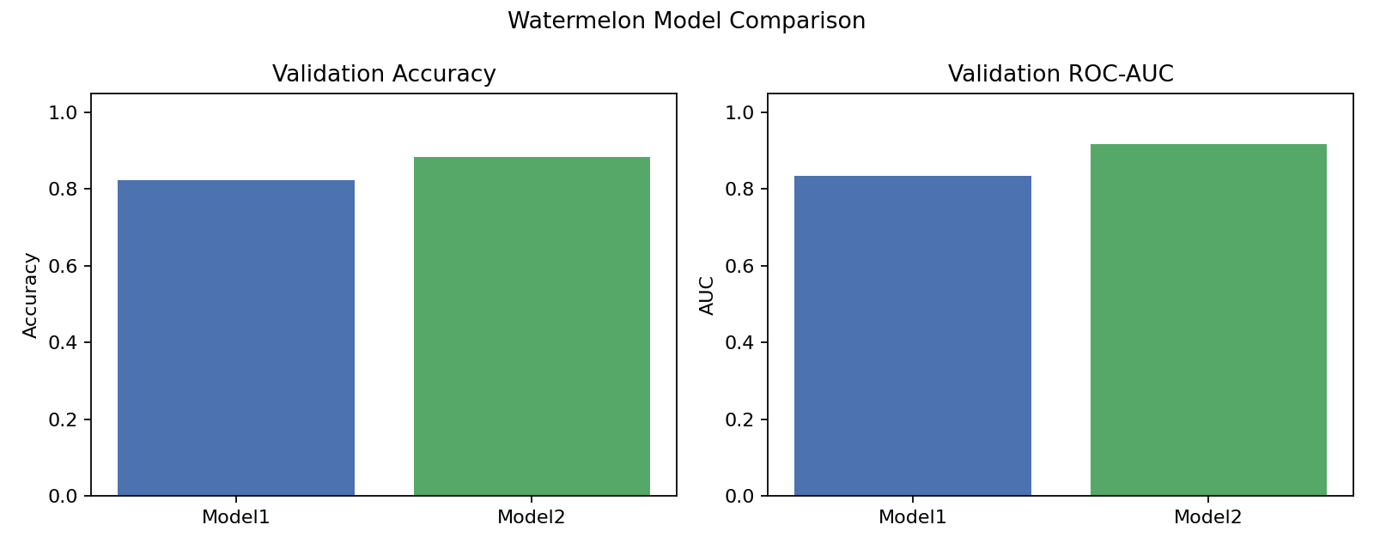
*该表数据来源于验证集（table_4.2.csv）的评估指标
可见以多维特征为输入学习的模型表现更好，精度更高。

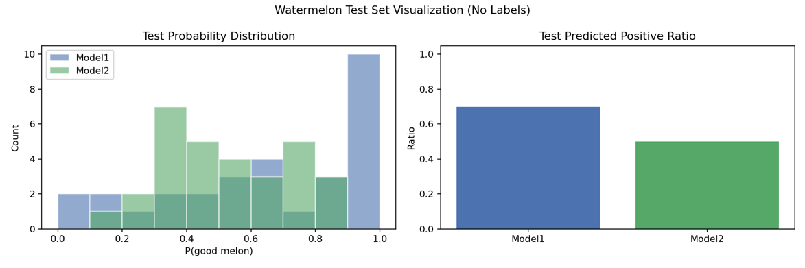
*该表数据来源于测试集（4.0.csv，无标签）的测试结果，只做分类结果分布对比。（模型2在处理离散标签时自动补0）
多维特征学习的模型，在分类时logit更集中，且判断好瓜的条件更加严格，因此精度更高。

（2）多维度横向对比
指标  (200epochs) | Accuracy | AUC | PR-AUC | Precision | Recall
Model1  (thres=0.5) | 0.8235 | 0.8333 | 0.8073 | 0.7778 | 0.8750
Model2  (thres=0.5) | 0.8824 | 0.9167 | 0.8957 | 0.8750 | 0.8750
*该表数据来源于验证集（table_4.2.csv）的评估指标。

3.Iris数据集三分类学习器（十折交叉验证）
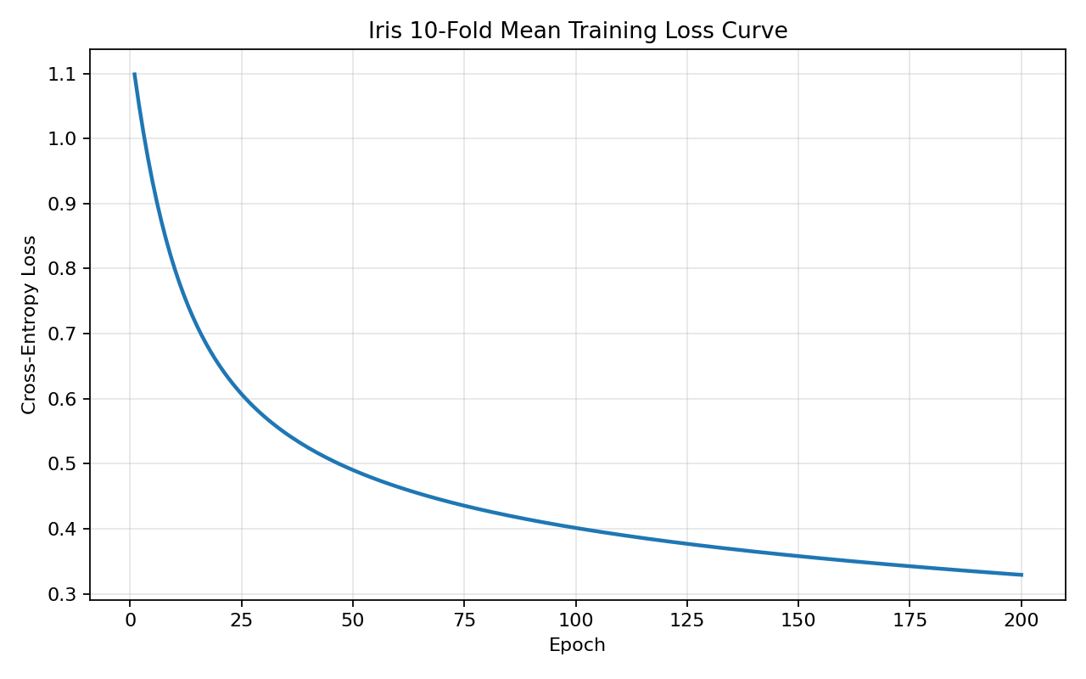
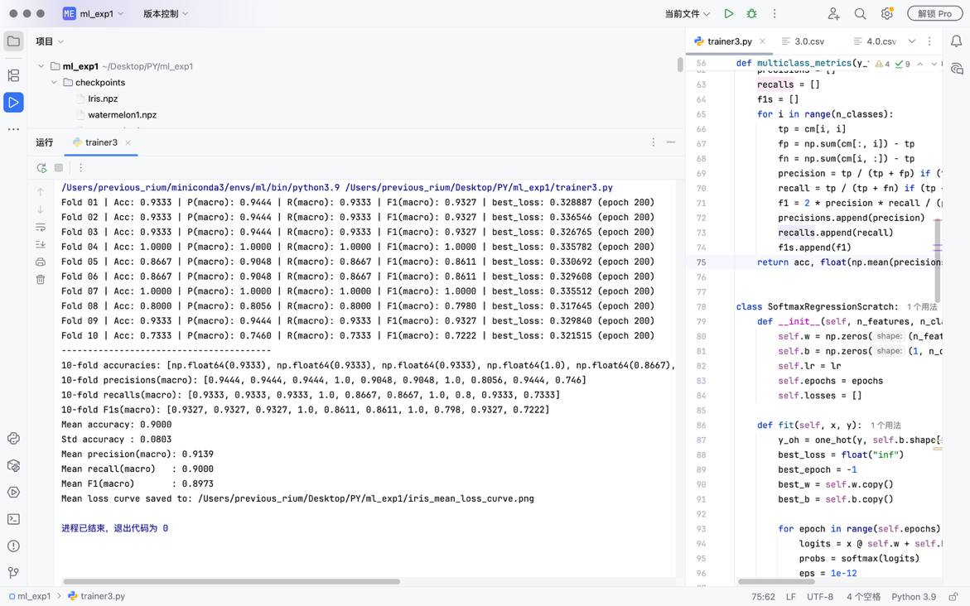
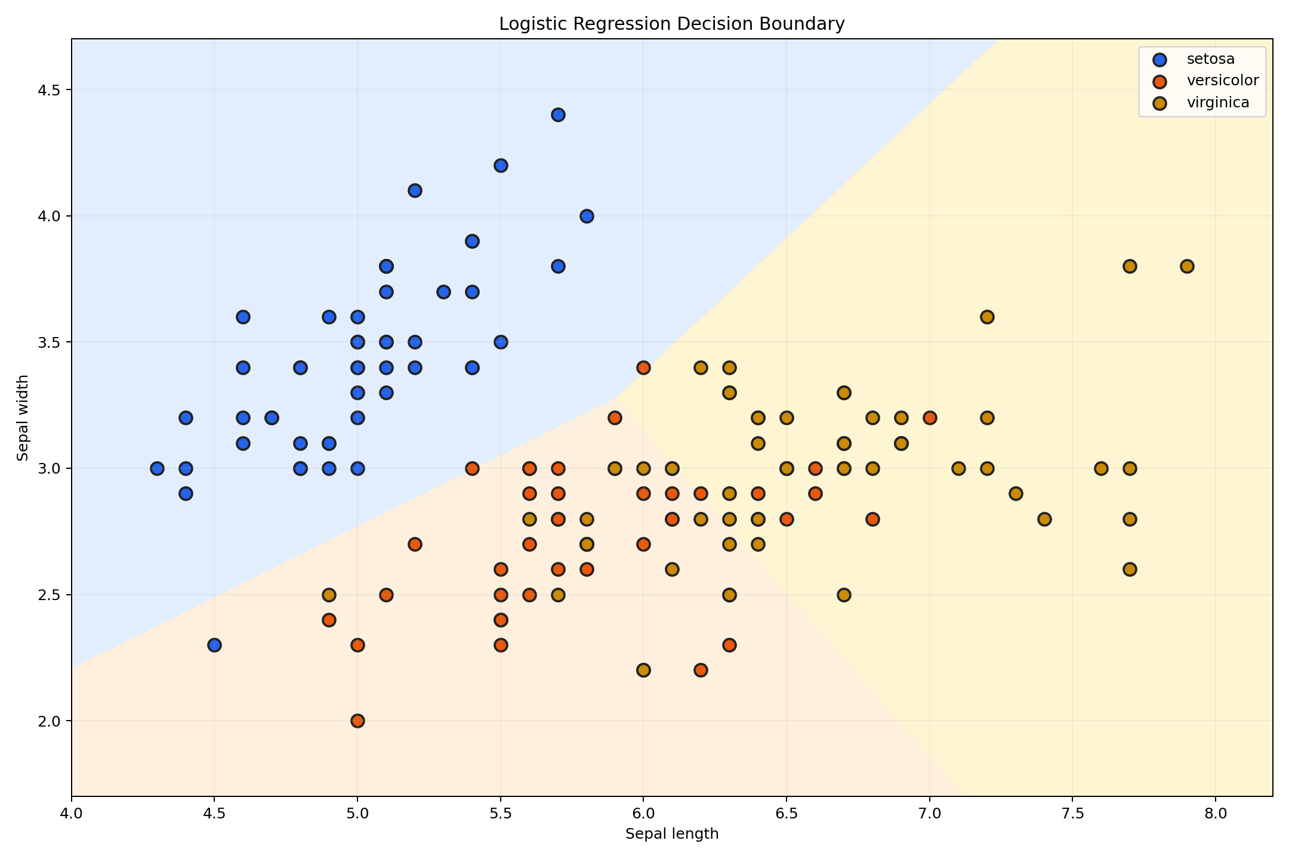
Setosa分类效果最好，几乎覆盖了所有正样本。Versicolor和Virginica边界模糊，难以进行线性划分。
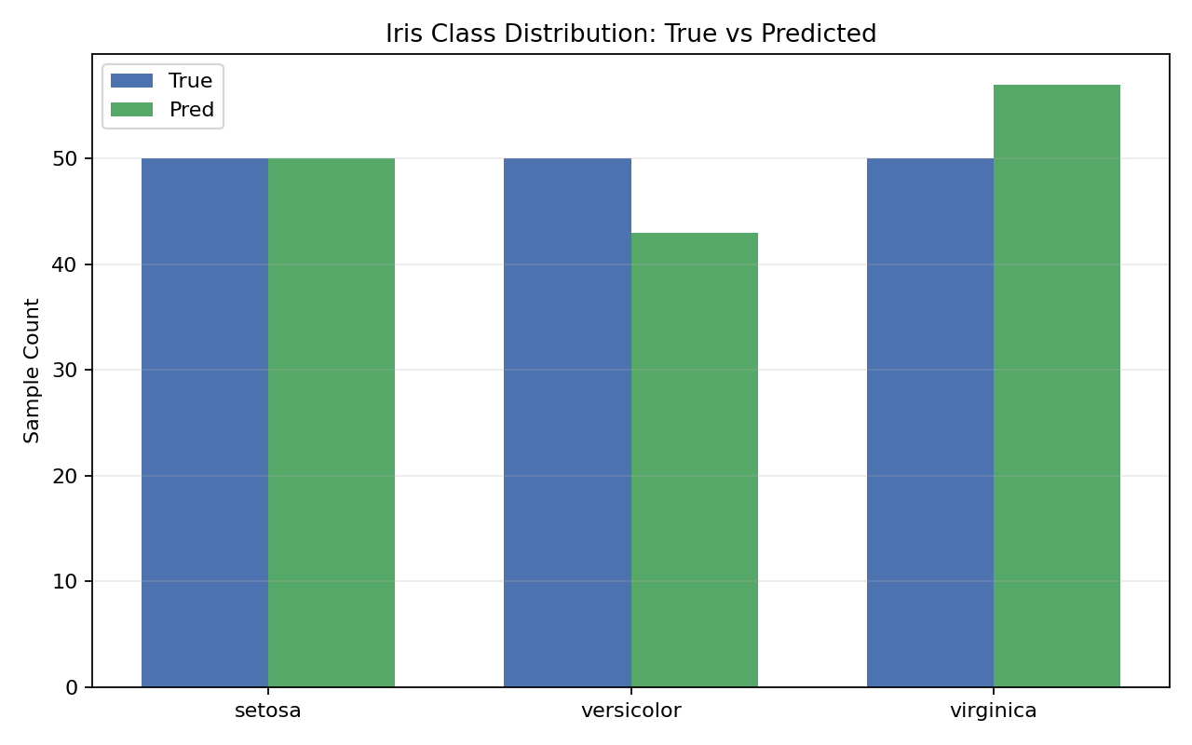
总体性能较好：10 折平均 Acc=0.9000，Macro-F1=0.8973，说明 softmax 对率回归能较好完成 Iris 三分类。

