|  |
| --- |
|  |



**THE UNIVERSITY OF NAIROBI  
SCHOOL OF COMPUTING AND INFORMATICS**

**APPLICATION OF BLOCKCHAIN IN  
COUNTERFEIT BOOK RECOGNITION SYSTEM­­­**

**MWAILONGO EVINGTONE NGOA  
P15/55580/2012**

**SUPERVISOR  
DR. ANDREW MWAURA KAHONGE**

**JANUARY 2020**

**A project proposal submitted in partial fulfillment of the requirements for the degree of Bachelor of Science in Computer Science, School of Computing and Informatics, University of Nairobi.**

# **DECLARATION**

I declare that this proposal, submitted to the school of Physical and Biological sciences, Faculty of Computing & Informatics, University of Nairobi, barely for the award of ***Bachelor of Science degree in Computer Science***, is my original work and has best of my knowledge, not been submitted to any other institution of higher learning.

Signed: __________________________ Date: _________________________

Evingtone Ngoa Mwailongo - P15/55580/2012

This project has been submitted in partial fulfillment of the requirements of the Bachelor of Science in Computer Science of the University of Nairobi with my approval as the university supervisor.

Signed: __________________________ Date: _________________________

Dr. Andrew Mwaura Kahonge

# **ACKNOWLEDGEMENT**

I thank the Lord God Almighty for giving me the strength and good health to be able to start working on the fourth year project.

In addition, I want to thank Ms. Pauline Wagunyu and Dr. Samuel Ruhiu for helping me narrow down project selection ideas.

My sincere gratitude to my supervisor, Dr. Andrew Mwaura Kahonge, for his support, technical guidance and encouragement during the course of the project. Thank you Dr. Kahonge.

Table of Contents

**DECLARATION** 1

**ACKNOWLEDGEMENT** 2

**LIST OF ABBREVIATIONS** 7

**CHAPTER ONE: INTRODUCTION** 8

**1.0 Background** 8

**1.1** **Problem Definition** 9

**1.2** **Objectives** 10

**1.2.1 Research Objectives** 10

**1.2.2 System Objectives** 10

**1.3** **Scope** 11

**1.4 Project Justification** 12

**1.5 Assumptions** 12

**CHAPTER TWO: LITERATURE REVIEW** 13

**2.1 Legal Outlook in Publishing Industry** 13

**2.2 Level of counterfeiting in urban Kenya** 14

**2.3 Distributed Ledger Technologies** 15

**2.3.1 Hyper ledger** 15

**2.4 Review of current systems** 16

**2.4.1 CHKTAG System** 16

**2.4.2 Techrock** 17

**2.4.3 ZealSeal** 18

**2.4.3 Tambua** 20

**2.5 Proposed System** 20

**CHAPTER THREE: METHODOLOGY** 22

**3.1** **System Development Methodology** 22

**3.1.1 How the methodology works** 23

**3.2** **System Requirements** 25

**3.2.1 Hardware Requirements** 25

**3.2.2 Software Requirements** 26

**3.3 Research Methodology** 26

**3.3.1 Document Analysis** 26

**3.4 Project Schedule** 27

**3.5 Resources** 27

**CHAPTER FOUR: SYSTEM ANALYSIS** 28

**4.1** **Introduction** 28

**4.2** **Modelling Tools and Techniques** 28

**4.2.1 UML Diagrams** 28

**4.2.2 Data Flow Diagrams** 30

**4.3 Feasibility Study** 32

**4.3.1 Operational Feasibility** 32

**4.3.2 Technical Feasibility** 32

**4.3.3 Schedule Feasibility** 33

**4.3.4 Economic Feasibility** 33

**4.4 Requirements Elicitation** 33

**4.4.1 Methods** 33

**4.4.2 Research Findings** 33

**4.5 System Requirements** 34

**4.5.1 Functional Requirements** 34

**4.5.2 Non-functional Requirements** 35

**4.5.3 Constraints** 35

**CHAPTER FIVE: SYSTEM DESIGN** 36

**5.1 Introduction** 36

**5.2 System Architecture** 36

**5.3 User Interface Design** 37

**5.3.1 Web Interface** 37

**5.3.2 Mobile Interface** 39

**CHAPTER SIX: SYSTEM IMPLEMENTATION AND TESTING** 41

**6.1 Implementation** 41

**6.1.1 Programming tools, techniques and technologies** 41

**6.1.2 System Frontend** 42

**6.1.3 System Backend** 42

**6.2 Testing** 42

**6.2.1 Unit Testing** 43

**6.2.2 Integration Testing** 43

**6.2.3 System Testing** 43

**CHAPTER SEVEN: DISCUSSION AND CONCLUSION** 44

**7.1 Discussion** 44

**7.2 Conclusion** 44

**7.2.1 Recommendations for further work** 44

**References** 45

**Appendix A : User Manual** 46

**List of Figures**

Figure 1 Techrock Website 18

Figure 2 ZealSeal Website 19

Figure 3 Scrum Methodology 22

Figure 4:Gantt Chart 27

Figure 5: Supply Chain Use Case Diagram 29

Figure 6: Conceptual Design Diagram 30

Figure 7: Context Diagram 31

Figure 8: Level 0 Supply Chain 31

Figure 9: Update Shipment 32

Figure 10: System Architecture Overview 36

Figure 11: Customer Dashboard 37

Figure 12: Place Order 37

Figure 13: Create Shipment 38

Figure 14: Mobile App Interface 39

Figure 15: Response Supply Chain 40

# **LIST OF ABBREVIATIONS**

API - Application Programming Interface

CHK – **Champasak**

KTN – Kenya Television Network

NFC – Near Field Communication

# **CHAPTER ONE: INTRODUCTION**

## **1.0 Background**

“In Kenya, every passing counterfeiting goods are flocking the market and so are the heightened concerns given that such goods, may endanger the health and safety of consumers. Illicit trade is a global phenomenon undermining the vital concept of a free and open marketplace. In so doing it also collapses with it the fundamental goal of competitiveness, increased investment and job creation and improving the economic status of a country and its people.” (Obuya, KTN 2019).

The trade undermines minds legitimate businesses and leaves consumers exposed to unsafe products. “The amount of counterfeiting globally has reached to 1.2 trillion Dollars in 2017 and is bound to reach 1.82 trillion Dollars by year 2020.” (R Strategic Global 2018). The International Monetary Fund and World Bank together estimate that this parallel economy represents 15 to 20 percent of the global GDP. In Kenya, the illicit trade undermines the dream to attain in Kenya's vision 2030 and Uhuru Kenyatta has perceived big four agenda. The trade has brought down our economy for years. Unfortunately, the trade survives courtesy of rogue civil servants at the Kenyan ports, law enforcement agencies and politicians. In the publishing industry their affairs are getting blurry every day.

“An unprecedented increase has taken place after the emergence of new states as a result of de colonization and rapid growth of higher education in the newly independent states. Since all the modern sciences developed in western countries their intellectual leadership is universally accepted. Textbooks and research journals are used as instruction materials for higher education throughout the world. These factors have contributed to the increasing trend of book piracy particularly for academic purposes, and necessitated international conventions against book piracy.” (Chaudhry, 2001). In this paper, we will be concentrating on publishing of pirated textbooks and literature set books currently in use in Kenyan secondary and primary schools.

## **Problem Definition**

The human resource in a country is very important for its development especially in Kenya with vision 2030 just closing in about 10 years 1 month to come. In order to have proper human resource, the quality of education provided by learning institutions should be of quality. However, this is threatened by the rise of pirated books that are imported and printed locally into the Kenyan market by criminals. In addition, piracy also threaten the big four agenda under manufacturing. The errors present in pirated books are rampant which include mislabelling of diagrams, grammatical errors etc. which degrades the quality of education especially in primary and secondary schools.

The Kenya Publishers Association (KPA) in partnership with the Ministry of Education and Kenya Institute of Curriculum Development (KICD) have developed a tool, CHKTAG system that helps in combating piracy. The CHKTAG system managed to reduce piracy from 39% to 17%. (Obuya, KTN 2019). Even with the reduction rate, the criminals have managed to take advantage of the loopholes in the system. The loophole present is the tag number provided in each book can be duplicated which when verified can return a false positive.

The high rate of corruption in Kenya has enabled the criminals bribe the police to serve them as watchers to warn them of any incoming arrests and also early released while on their way to the police station. Obuya reports that some judges are also offered bribes in order to provide penalties as oppose to imprisonment or both.

The low penalty amount provided in the Kenya Copyright Act 2001 contributes to the piracy as the criminals in the 7 billion shillings illicit industry can comfortably afford to pay penalty up to a maximum to Ksh. 800,000 (Copyright Act 2001). In addition, the alleged suspects that are taken to court plead guilty intentionally in order to pay the fines and go back to their illicit activities. This is a problem as their business environment is not disrupted even after arrest or pleading guilty.

## **Objectives**

The objective of this counterfeit book recognition system project is to combat the piracy in the publishing industry;

### **1.2.1 Research Objectives**

This paper is based on building a counterfeit system for publishers in the publishing industry therefore the general research objective is;

1. Research into the application of counterfeit system in the publishing industry.

The specific research objectives include;

1. To identify existence of a system that curbs book piracy in Kenya.
2. To identify weaknesses of the current book counterfeit system.
3. To identify major stakeholders and roles they play in the publishing industry.

### **1.2.2 System Objectives**

The system development objectives include;

1. To provide a mobile friendly web application from which various stakeholders in the publishing industry can manage their books.
2. To provide verification mechanism of identifying original/pirated books.
3. To create and implement designs for the counterfeit system.
4. To create the required system documentation.

## **Scope**

The project will consist of creating a counterfeit system based upon a verification module on the application. The modules of the project include:

1. Registration module of the stakeholders.
2. Update of book ownership on every stage of distribution module.
3. Random number generation module for book identification.
4. Book verification module.
5. Invalidate the book serial on sale and purchase code sent to customer.

The project will be completed by April 2020 and will have the following deliverables:

1. Consultation with supervisor sign sheet.
2. Project Report.
3. PowerPoint file used in the presentation.
4. A complete working project based on the scope.

The project will be determined successful if the system fully curbs the duplication of tag on pirated books.

A Gantt chart represents activities to be done in chronological order to achieve the objectives of this project which is to come up with a system that will curb piracy in the publishing industry in Kenya. The Gantt chart is labelled in Figure 5.

## **1.4 Project Justification**

Using the verification mentioned above, the CHKTAG will not be necessary as only printed serial numbers can be used for verification therefore reducing production cost of the publishers. Pirated books can easily be identified using the proposed system if the unique serial number sent once is purchased and no purchase code is sent to the buyer, then the book verified was fake. The proposed system is flexible as it can be used in other products like car battery. In addition, it will reduce the production cost of publishers. The publisher can blacklist enlisted book resellers if certain threshold of fake books have been reported sold from the establishment thereby frustrating the illegal business environment of piracy. The consumer can verify the book store thus providing confidence of the consumer to the store.

## **1.5 Assumptions**

Assumptions made in this project are;

1. Majority of Kenyans have internet enabled smart phones.
2. Most of the publishers will appreciate the technology used for the good of their authors and consumers.
3. Customers will have preference to purchase original books because of quality of content and the book itself, long lasting.
4. Customers will need to verify the books before purchase.
5. A bookstore having both original and fake book will opt to sell the original since once the purchase is done the QR Code shall be invalidated thus can’t sell the original or fake depending on the sold book which leads to losses.

# **CHAPTER TWO: LITERATURE REVIEW**

The publishing industry presents itself as a linear production process where inputs are converted to outputs. Its output and outcomes generate products, services, information and other resources in order to work with the environment. Loop holes emerge when the publishers try to maintain a balance between demand and supply. The production process for the books depend on the technologies available in the general environment leading to mass production due to increased demand for books leading to book piracy.

## **2.1 Legal Outlook in Publishing Industry**

The absence of strong supporting legislative system is the main criticism of the view that criminal justice is a system. “For any particular criminal justice system, an attempt to resolve book piracy problems may be hindered by low risk of detection, weak legal and regulatory framework, weak enforcement systems and weak penalties” (Kraska, 2004). This can be proven by the Kenya’s Copyright Act (No 12 of 2001) rendering copyright piracy and copyright infringements as a punishable offense, copyright piracy has continued. “A fine to offenders not exceeding Ksh 400,000 or imprisonment not exceeding 10 years or both if found culpable of making, distributing or importing infringing copies. Further, selling or possessing infringing copies aimed for commercial purposes attracts a larger fine not exceeding Ksh 800,000 or imprisonment not exceeding two years or both if found pay three times found but not exceed 800,000/=.” (Copyright Act 2001).

The amount of money fined in the act is just a slap to the wrist of the criminals as they reap big in the piracy business with income amounting to Ksh. 7 Billion nationally. (Onyango, 2017). Suspected criminals would plead guilty to the piracy charges voluntarily so that they could pay the Ksh 800,000/= fine and continue with their illegal business without any dire consequences. (Obuya, KTN 2019)

## **2.2 Level of counterfeiting in urban Kenya**

The Anti-counterfeit Act, 2008 defines counterfeiting to include; the manufacturing, production, packaging, re-packaging, labelling or making of protected goods whereby those protected goods are copied. Counterfeit industry is a billion shillings industry which exists throughout the world but also in low income economies like Kenya. Counterfeit products are a major problem to manufacturers, consumers, innovators and traders in Kenya and the global market.

A study was done by the Anti-Counterfeit Agency in 2016. The objective was to obtain data on the counterfeiting trends in urban Kenya. The data will help formulate policies on anti-counterfeiting practices and form a benchmark upon which impact can be assessed.

“ Findings on counterfeiting activity targeting manufacturer goods showed that for both local and imported goods, 56% of manufacturers were aware of counterfeiting activity targeting their products, 33% were not aware and 11% did not know of any activities. From the manufacturers who were able to estimate the trend of counterfeiting in the country, 82% said it was increasing, 8% thought the trend is constant, 8% said it was decreasing and 2% didn’t know anything about the trend of counterfeiting. 46% of manufacturers said that counterfeit goods are locally manufactured, 35% said they are imported while 19% said they are both imported and locally made. 37% of manufacturers work with the government bodies in fighting counterfeit trade, while 63% don’t. 60% of the manufacturers maintain a supply chain management with their retailers and resellers while 40% do not. From the manufacturers and suppliers who were able to estimate the market value of their products being counterfeited, the level of counterfeiting in urban Kenya stood at 23.86% as at December 2015” (ACA, 2016).

The study also uncovered the consequences of counterfeit trade. They include; increasing corruption, discouraging investors, closure of businesses, evasion of tax, poor quality of products, health risks, environmental hazards, loss to the economy, unemployment and low production.

## **2.3 Distributed Ledger Technologies**

A distributed ledger is a database that is consensually shared and synchronized across multiple sites, institutions or geographies. It allows transactions to have public "witnesses," thereby making a cyber-attack more difficult. The participant at each node of the network can access the recordings shared across that network and can own an identical copy of it. (Majaski, 2019).

Once the information is stored, it becomes an immutable database, which the rules of the network govern. While centralized ledgers are prone to cyber-attack, distributed ledgers are inherently harder to attack because all the distributed copies need to be attacked simultaneously for an attack to be successful. Further, these records are resistant to malicious changes by a single party.

### **2.3.1 Hyper ledger**

It is the umbrella open source project that the Linux foundation created and hosted since 2015.Hyperledger aims to advance cross-industry block chain technologies that ensures trust among business partner and accountability. Hyper ledger has various frame works that are used to build enterprise block chains for a consortium of organisations (Paul, 2018). Other example of private block chain include:

1. Iroha: Hyper ledger Iroha is designed to be simple and easy to incorporate into infrastructure projects requiring distributed ledger technology. Hyper ledger Iroha emphasizes mobile application development with client libraries for Android and IOS, making it distinct from other hyper ledger frameworks.
2. Saw tooth: Hyper ledger Saw tooth, contributed by Intel, is a block chain framework that utilizes a modular platform for building, deploying and running distributed ledgers. Distributed ledger solution built with hyper ledger Saw tooth can utilize various consensus algorithms based on the size of the network. By default, it uses the Proof of Elapsed Time, PoET, consensus algorithm, which provides the scalability of the Bit coin block chain without the high energy consumption.
3. Indy: Hyper ledger Indy is a distributed ledger purpose build for decentralized identity. Hyper ledger Indy’s goal is to achieve this by developing a set of decentralized identity specs artefacts that are independent of any particular ledger and will enable interoperability across any DLT that supports them.
4. Burrow: Currently under incubation, hyper ledger Burrow is a permission able smart contract machine that provides a modular block chain client with a permissioned smart contract interpreter built-in part to the specifications of the Etherium Virtual Machine[EVM].It is the only available Apache-licensed EVM implementation.

Fabric: hyper ledger is the most widely used private block chain network in enterprise setting to make to make transactions between multiple businesses more efficient. It records a history of transactions in a chronological order. In Fabric assets are transferred between participants, it allows businesses to set asset types. Assets type are represented as a collection of key value pairs, with state change recorded as transaction on the ledger. Fabric allows businesses /participants to modify assets using chain code also known as business logic. Members of each permissioned network can interact with ledger using chain code. To allow this permissioned network hyper ledger fabric provides a membership identity service that manages IDs authenticates participants on the network. Access control list are used to provide additional layers of permission. Fabric assigns network roles through node type

## **2.4 Review of current systems**

### **2.4.1 CHKTAG System**

The Kenyan government, through the Ministry of Education, Kenya Institute of Curriculum Development and Kenya Publishers Association purchased an electronic system that could discourage piracy. The tool was first embedded on literature and ‘fasihi*’* set books. The books have been affixed with unique hidden numbers at the front, inside and back where buyers could use to verify whether they are buying authentic books. Using mobile technology, the initiative makes it possible for parents, teachers and students to distinguish between pirated and genuine books by tracking each and every uniquely serialised book. They are supposed to scratch the panel on the CHKTAG affixed to the book to reveal the PIN, enter the PIN into the KPA SMS short code 22776, send and seconds later a reply will confirm the book and other vital information to verify. The SMS is free and can be sent using Safaricom or Airtel lines. According to The Lead, the tool managed to reduce the distribution of pirated books from 39% to 17% and even some of the publishing company’s revenue went higher by 15% without using any new marketing strategies.

**Disadvantage**

1. The system does have some weaknesses that the criminals use. For instance, once one serial number has been identified by the criminals, the 16 digit identifier numbers are duplicated on the pirated books thereby validating them as genuine through SMS. Another exploit strategy that is used is the duplicate of the covers of the original books making the cover of the copied books not scratch able proving that the book was clearly pirated. Lastly, the other strategy is that they generate fake pin numbers on the tags that even sometimes don’t reach 16 digit number. Some of the books have the ‘original’ text tag on the page in order to confuse the consumers. The proposed counterfeit verification system once done has the functionality to prevent double verification of the purchased book making it very difficult for criminals to make copy of the PINs and reuse once sold.
2. The production cost of the books to the publisher rises due to the addition of the CHKTAG thereby increasing the buying prices of books.
3. Diversity Limitation – The CHK TAG system cannot be easily used in other products like flour, car battery etc. and is only limited to books.

### **2.4.2 Techrock**

Previously known as Walimai. “The way it works for the consumer is that they come to the shop, they take their mobile phone, they touch the label with their mobile phone. It takes about 2 seconds for the confirmation and re-writing of the codes. And then the first piece of information that they get is that it's actually authentic.” (Busarov, 2017). It has an embedded RFID chip with a re-writable memory, changing with every scan. This makes it virtually impossible to counterfeit. Each label is single use, and is destroyed when the product is opened. There's an antenna within the label which gets torn and it's very difficult to put it back together. Techrock's smart label will soon be used on bottles of alcohol - another sector battling Chinese counterfeiters.

Website: <https://rock.tech/>

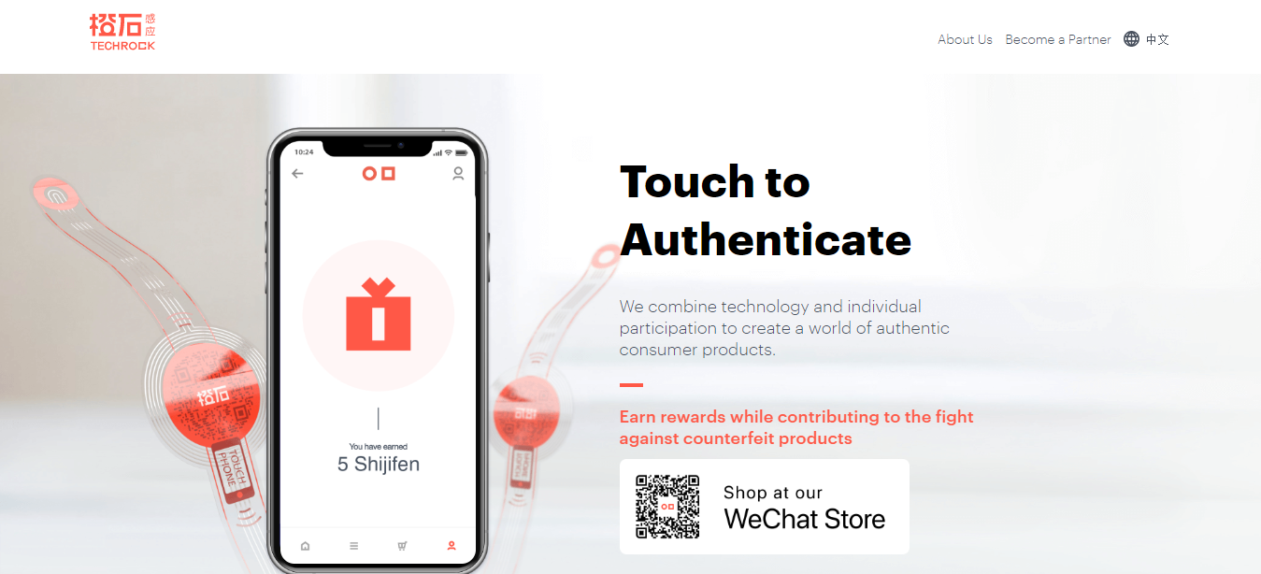

Figure 1 Techrock Website

**Advantage**

It is nearly impossible for piracy to take place using the system as they have to redesign the RFID which has its unique identifier.

**Disadvantage**

1. The use of RFIDs to track genuine products increases the cost of supply thereby increasing the price of the product.
2. While they stand up well to the elements, RFID tags can be interfered with by metals and liquids when you are trying to read them. In some cases, they have to be placed in a certain location on different types of product, which can be a little time consuming.

### **2.4.3 ZealSeal**

Products are verified by issuing smart ZealSeal™ labels to verified manufacturers. Manufacturers then apply these labels to their products. Consumers identify ZealSeal™ certified products and scan them using the ZealSeal™ App, with their NFC-enabled smartphones. The ZealSeal™ App verifies the smart label against our secure servers. If the label found to be authentic, the App displays the product information to the user. Otherwise, the App recommends against the purchase.

To prevent duplicate tags, each time anyone scans a ZealSeal™ smart label using the ZealSeal™ App, a new identification code is generated and applied to that label. Even if anyone managed to clone that label and make it appear genuine, that label would be invalidated as soon as the original label is scanned by someone else using the ZealSeal™ App.

**Disadvantage**

1. The use of RFIDs to track genuine products increases the cost of supply thereby increasing the price of the product.
2. Require NFC enabled smartphones.

Website: <https://www.zealseal.com/> 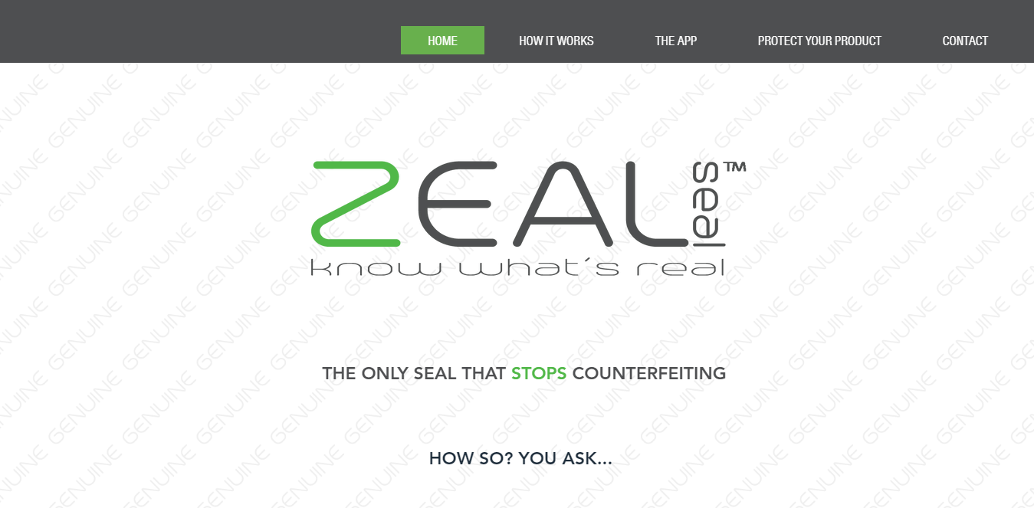

Figure 2 ZealSeal Website

**Advantage**

Duplication of the tags is almost impossible due to continuous update of the serial code after every verification attempt.

### **2.4.3 Tambua**

A mobile phone application for identifying approved medicines and drugstores is helping Kenya to fight counterfeit and substandard medicines. The application helps consumers avoid counterfeit medicine by verifying government- approved pharmaceutical premises and individual drug brands. The app uses a barcode and location tracking technology to identify medicines throughout the supply chain, adding that the app could work with limited access to the internet, which makes it different from similar solutions on the market.

In addition, Tambua has developed a cross platform mobile application for diagnosing tuberculosis (TB) and pneumonia, using sound waves, deep analytics, and an expert system to record a cough and profile whether a person has symptoms of these respiratory diseases.

**Disadvantage**

Suitable for products that are used once especially in medications.

## **2.5 Proposed System**

The project will achieve the objectives through;

1. Creation of web application that will enable various stakeholders like publishers, book resellers and distributors be able to register, add books into the system and verify legitimacy of the books.
2. The system can also have order and shipment management that have details stored in the block chain.
3. The system shall invalidate the book serial once purchase either through delivery to institution or personal purchase in book store.
4. A mobile app shall be developed for verification of books
5. All the information shall be stored in the block chain. Every transaction recorded, securely stored against tampering and read and write access only granted based on the users role in the system.

**Advantage**

1. Using the verification mentioned above, the CHKTAG will not be necessary as only printed serial numbers can be used for verification therefore reducing production cost of the publishers.
2. Fake books can easily identified using the proposed system by if the unique serial number sent once is purchased and no purchase code sent to the buyer, then the book verified was fake.
3. The proposed system is flexible as it can be used in other products like car battery.
4. The proposed system will reduce the production cost of publishers.
5. The publisher can blacklist enlisted book resellers if certain threshold of fake books have been reported sold from the establishment thereby frustrating the illegal business environment of piracy.
6. The consumer can verify the book store thus providing confidence of the consumer to the store.

# **CHAPTER THREE: METHODOLOGY**

## **System Development Methodology**

The software development methodology that will be used is agile methodology. This type of methodology is based on iterative and incremental development where the requirements and solutions evolve through collaboration between the developers and the client. In addition, the specific type of agile development methodology that shall be used is scrum. The scrum framework is based on continuous learning and adjustment to fluctuating factors such as requirements. The objective of employing this approach is to provide the potential for rapid development of incremental versions of the software. The sum of all the Product Backlog items completed during a Sprint and the value of the increments of all previous Sprints. At the end of a Sprint, the new Increment must be “Done,” which means it must be in useable condition and meet the Scrum Team’s definition of “Done.” The increment is a step toward a vision or goal.

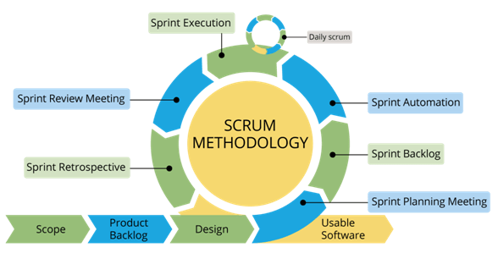

Figure 3 Scrum Methodology

*Fig 1.0 Agile Scrum Methodology*

The reason for the selection of the above is because it enables concurrent development and delivery within an overall planned context. Furthermore, the functionality can be developed rapidly and demonstrated.

### **3.1.1 How the methodology works**

Scrum processes address specific activities and flow of a scrum project. In total, there are nineteen processes which are grouped into the following five phases.

#### **3.1.1.1 Initiation Phase**

This phase include activities related to the initiation of a project. The following activities take place duting this phase;

**Create Project provision**

In this activity, the project business case is reviewed to create a project vision statement that will serve as the inspiration for the project. In addition, the identification of the Product owner is also selected during this activities. In the context of this project, the panel will represent the product owners.

**Identify Scrum Master and stakeholders**

Identification of Scrum Master and Stakeholders are carried out during this stage. In this stage, the supervisor will be the scrum master.

**Develop Epic(s)**

Epic in agile scrum refers to a big chunk of work that has one common objective which can be a feature, customer request or business requirement. The Project Vision Statement serves as the basis for developing epics.

**Conduct Release Planning**

In this activity. The development team review the user stories in the prioritized product backlog to develop a release planning schedule, which is essentially a phased deployment schedule can be shared with the project shareholders. The duration of sprint is determined in this activity.

#### **3.1.1.2 Plan and Estimate Phase**

This phase consists of processes related to planning and estimating tasks which include create user stories, Approve, Estimate, and Commit User Stories, Create Tasks, Estimate Tasks, and Create Sprint Backlog.

**Create User Stories**

User stories and their related user story acceptance criteria are created by the product owner in this activity.

**Approve, Estimate, and Commit User Stories**

The product owner approves the user stories for a sprint. The scrum team then estimate the effort required to develop the functionality described in each story.

**Create Tasks**

In this activity, the Approved, Estimated, and Committed User Stories are broken down into specific tasks and compiled into a Task List.

**Create Sprint Backlog**

This activity involves the Scrum Core Team holds Sprint Planning Meetings where the group creates a Sprint Backlog containing all tasks to be completed in the Sprint.

#### **3.1.1.3 Implementation Phase**

This phase is related to the execution of the tasks and activities to create a project's product. These activities include creating the various deliverables, conducting Daily Standup Meetings, and grooming (i.e., reviewing, fine-tuning, and regularly updating) the Product Backlog at regular intervals.

#### **3.1.1.4 Review and Retrospective Phase**

This activity is concerned with reviewing the deliverables and the work that has been done and determining ways to improve the practices and methods used to do project work.

**Demonstrate and Validate Sprint**

The scrum team demonstrate the sprint deliverables to the product owner and relevant stakeholders in a sprint review meeting for approval and acceptance from the product owner for the deliverables created in the sprint.

**Retrospective Sprint**

The scrum master and team discuss the lessons learnt throughout the sprint. Thereafter, there may be agreed actionable improvements that will be implemented on the project.

#### **3.1.1.5 Release Phase**

This phase emphasizes on delivering the Accepted Deliverables to the customer and identifying, documenting, and internalizing the lessons learned during the project.

**Ship Deliverables**

The accepted deliverables are delivered to the relevant stakeholders.

**Retrospect Project**

The stakeholders and Scrum core team members meet to retrospect the project by identifying, document and internalize the lessons learnt. Normally, the lessons lead to the documentation of agreed actionable advances to be implemented in future projects.

## **System Requirements**

### **3.2.1 Hardware Requirements**

For the system to be implemented, there must be;

1. A personal computer or laptop running on Windows operating System with at least 4GB RAM, 2 GHZ, 100 GB Hard disk.
2. Local host server running on Apache that will be used during project implementation.
3. Remote host server running on Apache for remote application hosting.
4. Android Mobile phone: internet enabled feature phone.
5. External storage disk for secondary backup preferably Hard disk 500GB.

### **3.2.2 Software Requirements**

The following software resources will be required in the development of the system;

1. Visual studio code editor that will be used during coding of the application.
2. Node Package Manager v3.10
3. GitHub for backing up the project.
4. Trello, a project management tool.
5. Microsoft Office 2013, includes word and PowerPoint used for documentation and presentation respectively.
6. JavaScript, PHP 7, CSS 3, HTML 5.
7. Windows 10 Operating System.
8. Photoshop - Online Platform Design for Data Flow Diagrams.
9. Mailtrap that will be used in simulating all email features.
10. Docker Engine Version 17.03 or higher
11. Docker-Compose Version 1.8 or higher
12. Windows Sub Linux system (WSL)
13. Android studio

The following Frameworks shall be used for development;

1. Bootstrap 3 – Used in designing frontend.
2. Laravel Framework version 5.7 – PHP framework for backend development.

## **3.3 Research Methodology**

The methodology used to carry out the research is qualitative method. The main sources of data used associated with qualitative method include;

### **3.3.1 Document Analysis**

Some of the sources of information used are publications and the legal documents. All the materials were read and recorded into this proposal. Figures like reduction of piracy from 39% to 17% using the CHKTAG system.

## **3.4 Project Schedule**

The project planning and implementation shall start from November 2019 to April 2020.

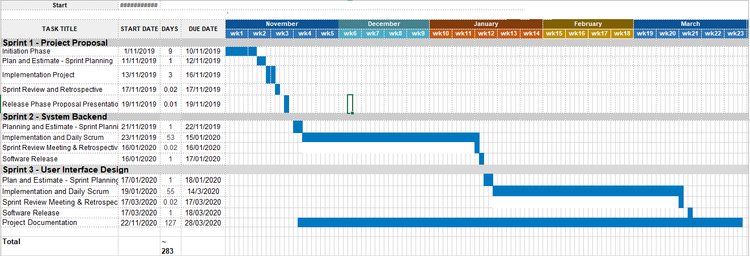

Figure 4:Gantt Chart

## **3.5 Resources**

|  |  |
| --- | --- |
| **Item** | **Cost (Ksh)** |
| Zuku Internet (6 months) | 14,994/= |
| Remote Host Server | 3,100/= |
| Hard Disk | 6,000/= |
| **Total** | **24,094/=** |

# **CHAPTER FOUR: SYSTEM ANALYSIS**

## **Introduction**

The objective of system analysis is to understand the proposed project by ensuring that it supports business requirements and build solid foundation for system development. Models and other documentation tools are used to visualize and describe the proposed project.

## **Modelling Tools and Techniques**

Modeling involves graphical methods and non-technical language that represent the system at different stages of development. Various tools are used to describe business processes, requirement and user interaction with the system. Different models like data flow diagrams and Unified modeling Language diagrams can be used for modeling.

### **4.2.1 UML Diagrams**

It is a diagram based on the Unified Modeling Language with the intention of visualizing and documenting software systems. UML provide various graphical tools such as use case diagrams and sequence diagrams.

**Use Case Diagrams**

Use case diagrams are used to visually represent the interaction between users and the system.

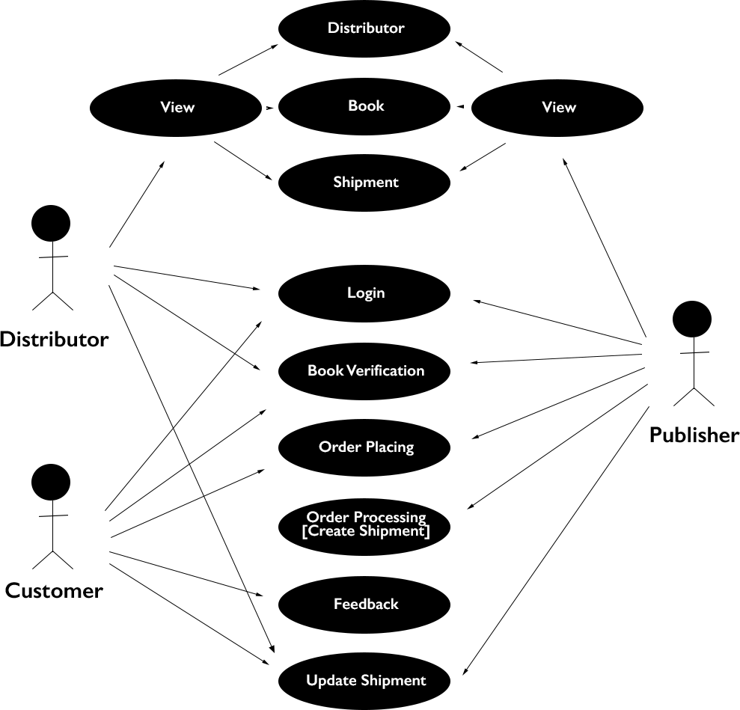

Figure 5: Supply Chain Use Case Diagram

1. **Distributor**

The distributor is involved in viewing other distributors, books assigned to them, and current and past shipments. In addition, they can login, verify book to check originality and update the shipment status once they have received from the publisher.

1. **Customer**

The customer can login into the system, verify book once received from the distributor, place an order for other books from the publisher and also provide feedback on the received shipment.

1. **Publisher**

The publisher have the rights to view distributors, their own registered books, current and past shipments and orders. Furthermore, they can verify books, process orders by creating shipment and assigning to a distributor.

### **4.2.2 Data Flow Diagrams**

DFDs are used to show how the system stores, processes and transforms data.

#### **4.2.2.1 Conceptual Design Diagram**

Figure 6: Conceptual Design Diagram

#### **4.2.2.2 Context Diagram**

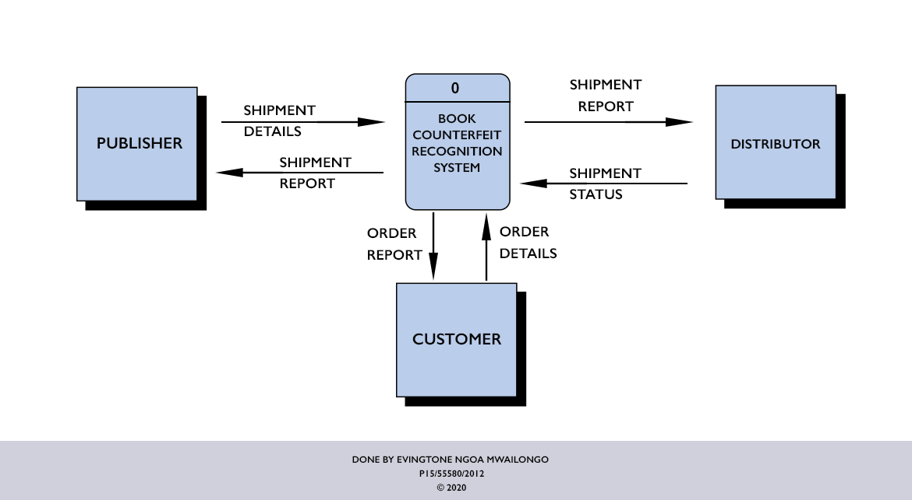

Figure 7: Context Diagram

#### **4.2.2.3 Level 0 Supply Chain Data Flow Diagram**

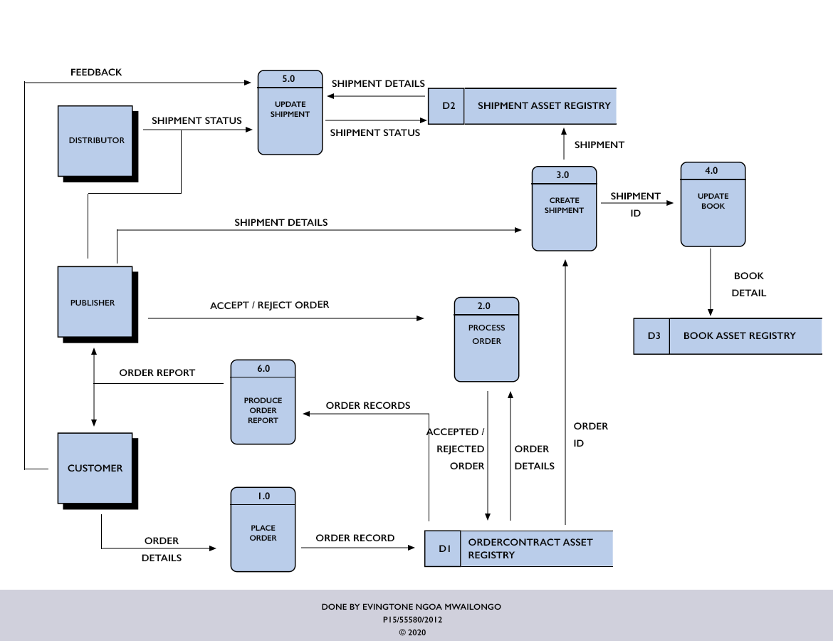

Figure 8: Level 0 Supply Chain

#### **4.2.2.4 Level 1 Update Shipment Data Flow Diagram**

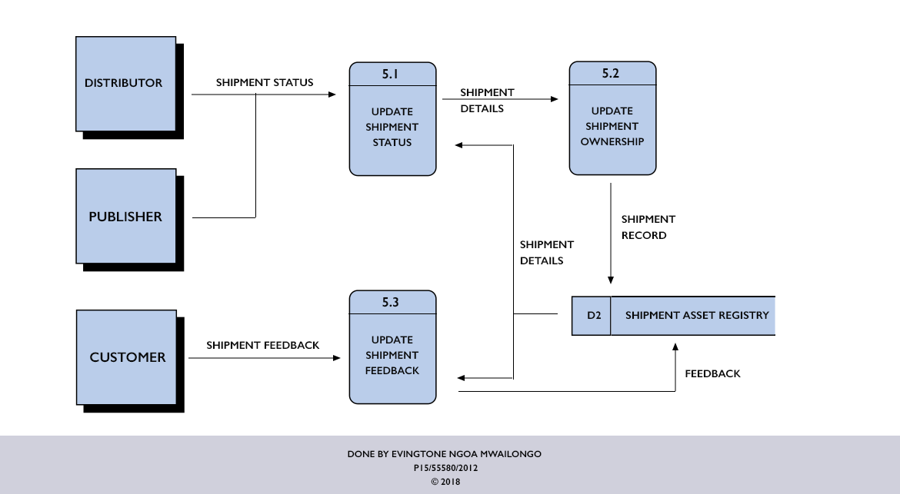

Figure 9: Update Shipment

## **4.3 Feasibility Study**

Feasibility study measures the practicality of the proposed system into adoption. It assesses whether the book counterfeit recognition system is a viable project that can be used by the publishing industry. The following are the factors that determine the project feasibility;

### **4.3.1 Operational Feasibility**

It describes how well the system will work when implemented and rolled out to the public. The proposed systems aims on validating original book and also identify fake books based on the retail owner of the verified book. A book is deemed fake if there is absence of QR Code and also the final owner of the return verified information does not match the store name. The CHKTAG system that still has major loopholes managed to reduce piracy from 39% to 17%. This is evident that adoption of this system will further reduce piracy and improve book sales.

### **4.3.2 Technical Feasibility**

Technical feasibility provides an assessment of the hardware and software and how it meets the need of the proposed system. The hardware requirement need to make the system are available and the software resources are open source. For instance, the Hyperledger fabric is a product of IBM and The Linux Foundation that is open source and sufficient documentation is readily available. The technology is relatively new but is stable at the moment with sufficient support.

### **4.3.3 Schedule Feasibility**

This investigates the duration it will take to finish the project implementation. The provided period of development is sufficient as the use of framework like Laravel, hyper ledger composer and composer-rest-api help in speeding up the development period and also provide software security out of the box.

### **4.3.4 Economic Feasibility**

It analyses the cost benefit of a system of whether the benefits outweigh the cost. The cost of developing the system is minimal as most tools used are open source and the benefits may readily increase the sales of the books by publishers as fake book publishing might decrease due to a robust framework that can identify fake books.

## **4.4 Requirements Elicitation**

Requirements are functional needs that a particular design, product or process aims to satisfy.

### **4.4.1 Methods**

Various methods were used gather requirements which include; investigative documentaries, study of literature such as web articles and documents on counterfeits in publishing industry. Informal interviews were also carried out through colleagues who buy school books for their children.

### **4.4.2 Research Findings**

The findings derived from various documents, interviews and investigative documentaries include;

1. **Publishers –** The publishers are the stakeholders that are mandated to printing their books therefore are mandated to print the QR Codes to the books.
2. **Authors –** They are the original owners of the book. There must be a contract between the author and the publisher. In the contract with the publisher the author licenses the rights of reproduction and distribution over a work, thus providing the publisher with the legal means necessary for publication. In Kenya, section 33(3) of the Copyright Act requires that any exclusive license between an author and a publisher must be in writing.
3. **Distributors –** They sign a contract agreement with the publisher to distribute books to the consumer who might be an institution like school or bookshops.
4. **Book Prices –** The price of both counterfeit and original books are the same. This is because the price disparity would expose the book as a counterfeit.
5. **Legal –** According to the Kenya’s Copyright Act (No 12 of 2001), copyright piracy and copyright infringements is a punishable offense. A fine to offenders not exceeding Ksh 400,000 or imprisonment not exceeding 10 years or both if found culpable of making, distributing or importing infringing copies. Further, selling or possessing infringing copies aimed for commercial purposes attracts a larger fine not exceeding Ksh 800,000 or imprisonment not exceeding two years or both if found pay three times found but not exceed 800,000/=.

## **4.5 System Requirements**

### **4.5.1 Functional Requirements**

They define what the system should accomplish. They include;

1. The publisher should be able to manage their books by creating, reading, updating and deleting their information.
2. The system should generate QR Code image for each book created by the publisher.
3. The publisher and distributor should be able to update the shipment status of the ordered books.
4. The system should be able to handle different book status upon delivery. For instance, when damaged, what amount should be deducted?
5. The customer should be able to place an order to the publisher requesting delivery of books.
6. The system should be able to invalidate the QR Code once a purchase is made.

### **4.5.2 Non-functional Requirements**

It describes the characteristics, features and attributes of a system together with the constraints.

1. **Security –** The system running on block chain should be hack proof. For a record to be changed without authorization, they need to be changed on all nodes running the fabric which is the most difficult task to accomplish.
2. **Reliability –** The system should be up and running at all times. Since the system is based on the fabric, the network should be up and running at all times as it is the source of truth,
3. **Interoperability –** The system should provide equal user experience while used on different operating systems or browsers.
4. **Non-repudiation –** The system should provide an assurance that the task performed was done by the individual without denying it.

### **4.5.3 Constraints**

They are the rules that the system enforces. They include;

1. Only the publisher can register books.
2. Only the publisher and Customer can place an order.
3. Only the publisher can edit or delete the books.
4. Only the publisher can process the order.
5. Only the customer can create a feedback.

# **CHAPTER FIVE: SYSTEM DESIGN**

## **5.1 Introduction**

This chapter describes the physical designs that will meet the specifications described in the system requirements. The tasks will include user interface design, data design and system architecture.

## **5.2 System Architecture**

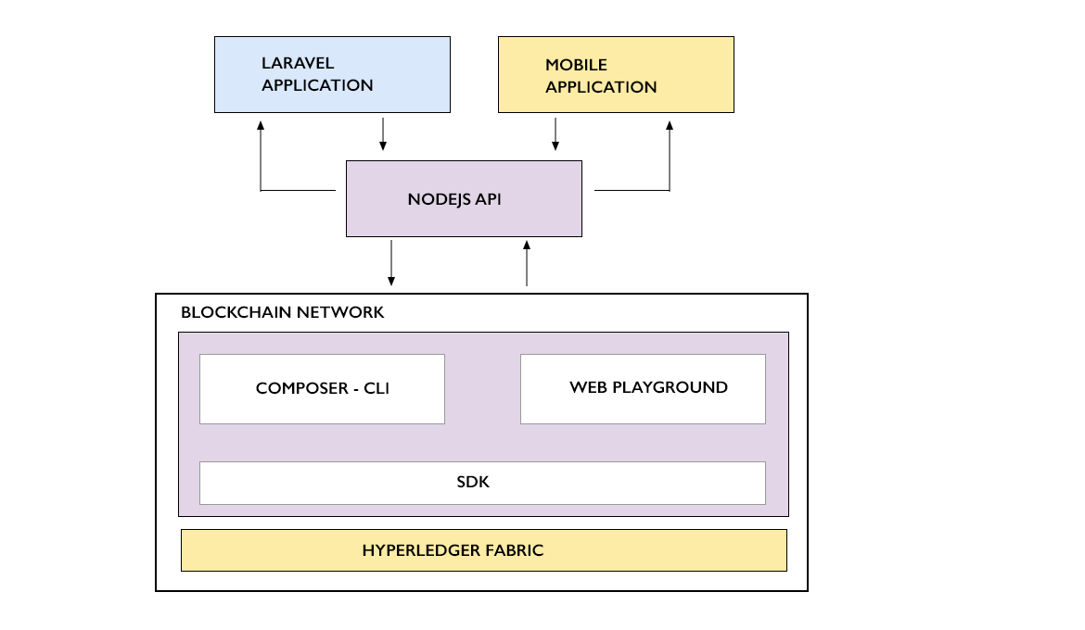

Figure 10: System Architecture Overview

The figure above shows the general system architecture of the counterfeit book recognition system. The Laravel application shall be the web client that will receive and send resources to and from the block chain network respectively, through the nodejs API that will be a medium of communication. The mobile application shall be sending the scanned value from the QR Code scanner to the network and query the network to respond with the ideal record according to the sent book identifier from the QR Code.

## **5.3 User Interface Design**

### **5.3.1 Web Interface**

**Dashboard**

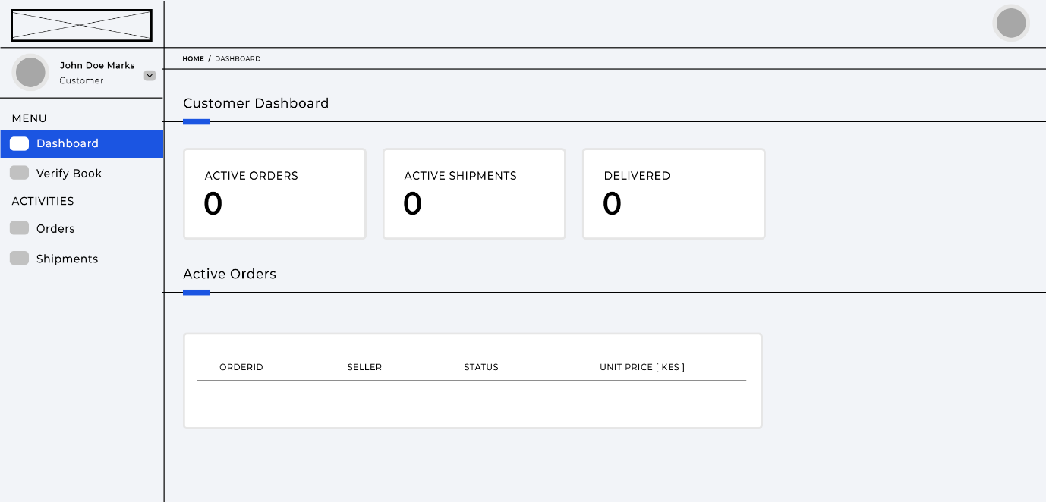

Figure 11: Customer Dashboard

**Place Order Form**

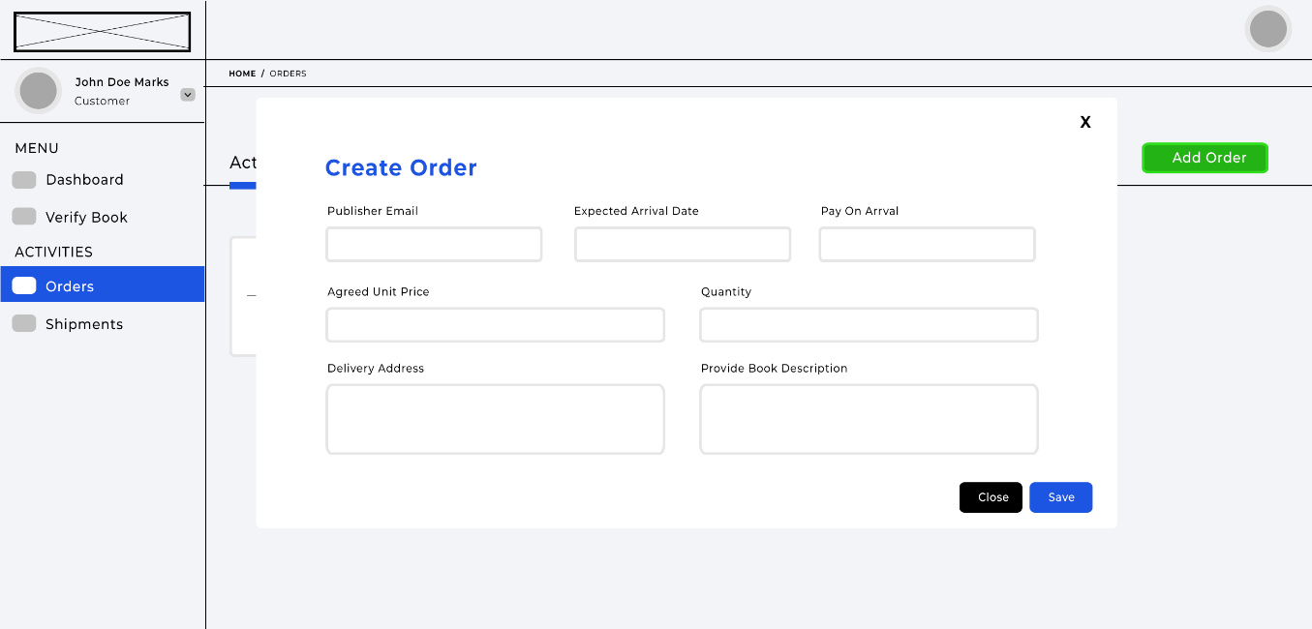

Figure 12: Place Order

**Create ­­Shipment Form**

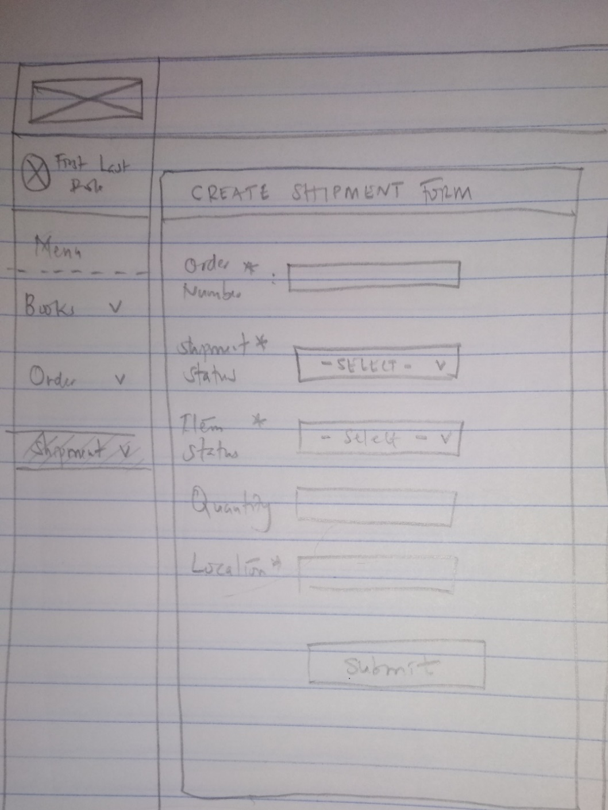

Figure 13: Create Shipment

### **5.3.2 Mobile Interface**

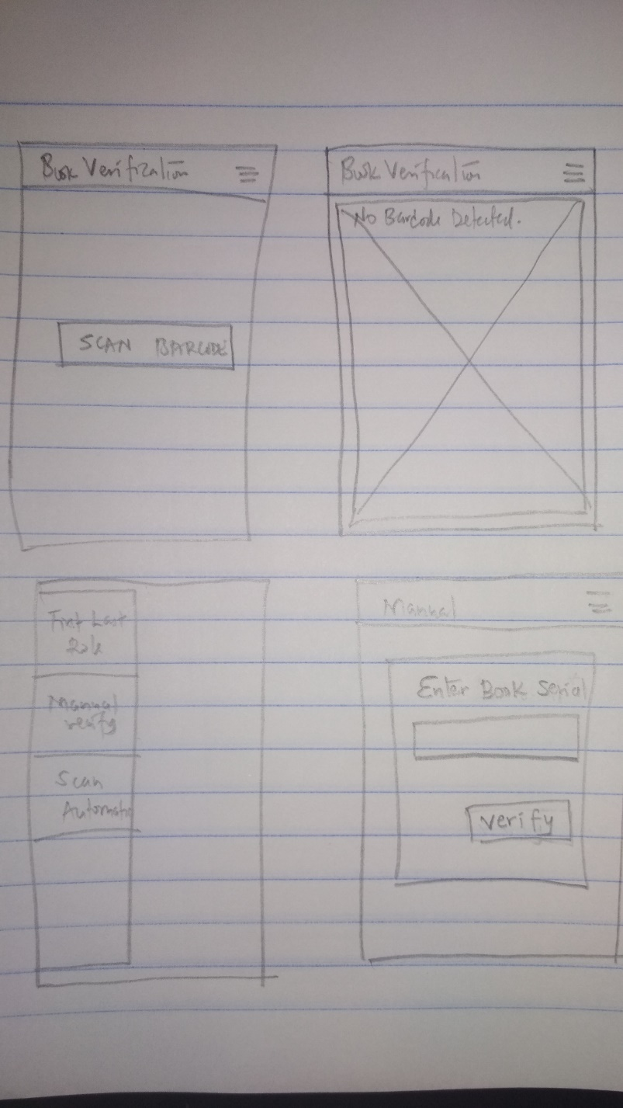

Figure 14: Mobile App Interface

**Response**

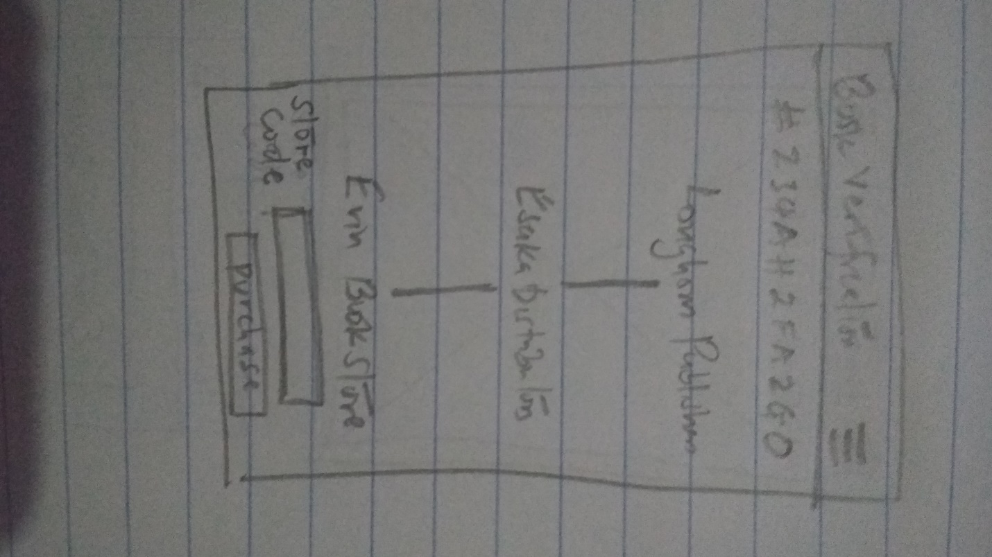

Figure 15: Response Supply Chain

# **CHAPTER SIX: SYSTEM IMPLEMENTATION AND TESTING**

This chapter describes the tools and processes that were used during implementation and testing of the software.

## **6.1 Implementation**

### **6.1.1 Programming tools, techniques and technologies**

The following technologies were used in the development of the system.

1. **NodeJS**

An asynchronous event-driven JavaScript runtime designed to build scalable network applications. The implementation of this technology has been utilized in the hyper ledger composer logic functions.

1. **Hyperledger Composer**

It is a number of tools that enable business owners, operators and developers a way to create blockchain applications on top of Hyperledger Fabric using logical functions called smart contracts. Hyperledger enables the developer to focus on the implementation of the system rather than worry on the technicalities of the underlying low level fabric technology.

1. **Laravel**

It is an open-source PHP framework used in web application development with expressive, elegant syntax through built-in features. These features are part of what makes Laravel so widely used by web developers.

1. **Docker**

A tool that uses containers to make it easier to create, deploy and run applications. It ensures that applications work efficiently in any environment by packaging them with all of the parts it needs such as libraries and other dependencies and deploy it as one package.

1. **Android**

An open-source mobile operating system developed by Google. It is based on the Linux kernel and used by several smartphones and tablets. The operating systems support third party programs. Developers can create programs written in java for android using free android software developer kit (SDK).

1. **Version Control**

The use of Git version control was a necessity in order to track any changes made to the system source code on every update. All changes were committed and pushed to Github for hosting my project repository. This provides an online backup for the system source code in the event that an accident occurs to the local repository.

1. **Trello**

A tool that can be used by either teams or individuals that organizes projects into boards. The projects can be broken down further into tasks depending the features of the system. Trello is mostly used to track progress of project implementation which provide perfect environment to manage the development progress efficiently.

### **6.1.2 System Frontend**

The system web interface was made using Laravel. The Laravel received requests from API generated by the composer REST API which are then displayed to the user on the web platform. In addition customer mobile android application was also utilized to make scanning easier for customers.

### **6.1.3 System Backend**

The backend was built in Hyperledger Composer and Composer REST API. The Hyperledger Composer contained the model file which acts as a database schema of the application. It also contained a JavaScript file that contains the logic of the system which forms the smart contract. Features like book ownership transfer are implemented on the smart contract. The composer REST API generate API endpoints on all the transactions and queries defined in the hyperledger composer. The API are then consumed by the Laravel web application. In order to manage identity on mobile, Laravel web application API was implemented in order to make the web service a node for the fabric.

## **6.2 Testing**

Testing ensures that the system works as expected. It is used to check whether the results of the system correspond to the expected results and also ensure that the system is error free in both logical and syntax.

### **6.2.1 Unit Testing**

It refers to testing of an individual program or module. It identifies and eliminate execution errors that could cause the program to terminate prematurely.

### **6.2.2 Integration Testing**

It involves testing of two or more programs that depend on each other. This ensures that the client and the server, API, are working efficiently with no errors on integration.

### **6.2.3 System Testing**

Following integration testing, the entire information system was tested. The testing include all typical processing situations like placing orders and shipping orders and is meant to assure users and developers that all necessary features have been included. The whole flow from registering a book from publisher to consumer through a distributor and scanning validity of the book.

# **CHAPTER SEVEN: DISCUSSION AND CONCLUSION**

## **7.1 Discussion**

The system developed in this project achieved the objectives set out to be accomplished. One of the objective was to provide verification mechanism of identifying original books using blockchain technology by scanning a book and getting supply chain details to the named bookstore. The consequence of the project led to my familiarity of usage of new tools like Hyperledger Composer, Git, Docker and Android.

Some of the challenges that I encountered are;

* 1. Late responses from publishers, institutions and bookstores on my enquiries.
  2. Hyperledger Composer became deprecated which led to lack of support from the owners as multi user authentication of custom email was not supported which led me to implementation customized authentication system using the cards provided.
  3. Closure of campus which led to inaccessibility of internet for project research due to insufficient funds to purchase Safaricom bundles.
  4. Tension in my area of residence as there were high rates of Covid-19 infections.
  5. Unstable mental state due to loss of a brother and close cousin in a span of one month.
  6. Uncertainty of project presentations.

## **7.2 Conclusion**

The use of the system in the publishing industry in verifying legit book from those counterfeit will really benefit the publishers and authors by increasing their revenues and help combat the multibillion counterfeit industry. The cancellation of the book qrcode upon purchase would prevent duplication of the qrcode thus making it invalid.

### **7.2.1 Recommendations for further work**

There are a number of ways in which the current system can be improved;

1. Using GoLang and NodeJS to develop the application on Hyperledger Fabric as Hyperledger Composer has no support currently.
2. Develop a low level authentication service.

# **References**

Anti-Counterfeit Authority, (2016). *Levels of Counterfeits In Kenya*: <https://www.aca.go.ke/downloads/research-paper-abstracts/145-level-of-counterfeiting-in-urban-kenya-aca> [Viewed on 8th Jan. 2020]

Chaudhry, A.W. (2001). *Copyright laws. Lahore*: Lahore law Times Publications. <https://www.researchgate.net/publication/236173152_Copyright_and_Book_Piracy_in_Pakistan> [Viewed on 28th Oct. 2019]

Kraska, P.B. (2004). *Theorizing criminal justice.* Long Grove, IL: Waveland.

Copyright Act (2001) *Laws of Kenya*.

Obuya, B., KTN (2019). *Faking the read: The rot that is book piracy in Nairobi Part 1| The Lead* <https://www.standardmedia.co.ke/ktnnews/video/2000178486/faking-the-read-the-rot-that-is-book-piracy-in-nairobi-part-1-the-lead> [Accessed on 30th Oct. 2019]

Obuya, B., KTN (2019). *Faking the read: The rot that is book piracy in Nairobi Part 2 | The Lead* <https://www.standardmedia.co.ke/ktnnews/video/2000178487/faking-the-read-the-rot-that-is-book-piracy-in-nairobi-part-2-the-lead> [Accessed on 30th Oct. 2019]

Onyango, P. (2017). *System to end Sh7 billion book piracy in Kenya launched*. [Blog] The Standard Digital. Available at: <https://www.standardmedia.co.ke/article/2001229379/system-to-end-sh7-billion-book-piracy-in-kenya-launched> [Accessed on 25 Oct. 2019]

Paul, S.M. (2017). *Hyperledger - Chapter 1 | Block chain Foundation*. [Blog] The Startup. Available at: <https://medium.com/swlh/hyperledger-chapter-1-foundation-7ad5bd94d452> [Accessed on 8th Jan. 2020]

R Strategic Global, (2018). *Global Brand Counterfeiting Report*. *An in-depth Report on the size modes, routes and issues underlying counterfeiting both through physical as well as online medium.*

# **Appendix A : User Manual**

1. Installing Hyperledger Fabric and Composer:

To run Hyperledger Composer, it is advised to have a laptop or desktop with a minimum of 4Gb of RAM Memory.

Step 1: The following are the pre-requisites for installing the required development tools:

1. Operating Systems: Ubuntu Linux 14.04 / 16.04 LTS (both 64-bit), or Mac OS 10.12.
2. Docker Engine: Version 17.03 or higher
3. Docker-Compose: Version 1.8 or higher
4. Node: 8.9 or higher (note version 9 and higher is not supported)
5. npm: v5.x
6. git: 2.9.x or higher
7. Python: 2.7.x
8. A code editor of your choice, we recommend VSCode.

Step 2: Installing development environment. Note that you should not use su or sudo for the installation npm install commands. Install essential packages using the following npm commands;

1. Essential CLI tools: *npm install -g* [*composer-cli@0.20*](mailto:composer-cli@0.20)
2. Utility for running a REST Server on your machine to expose your business networks as RESTful APIs: *npm install -g* [*composer-rest-server@0.20*](mailto:composer-rest-server@0.20)
3. Useful utility for generating application assets: *npm install -g* [*generator-hyperledger-composer@0.20*](mailto:generator-hyperledger-composer@0.20)
4. Yeoman is a tool for generating applications, which utilises generator-hyperledger-composer: *npm install -g yo*
5. Install Playground on your local machine; *npm install -g* [*composer-playground@0.20*](mailto:composer-playground@0.20)

Step 3: Install Hyperledger Fabric;

1. In any directory in your local machine, run *mkdir ~/fabric-dev-servers && cd ~/fabric-dev-servers.*
2. Download the compressed package containing the tools to install Hyperledger Fabric by running; *curl -O* [*https://raw.githubusercontent.com/hyperledger/composer-tools/master/packages/fabric-dev-servers/fabric-dev-servers.tar.gz*](https://raw.githubusercontent.com/hyperledger/composer-tools/master/packages/fabric-dev-servers/fabric-dev-servers.tar.gz)*.* Unzip the package by running *tar -xvf fabric-dev-servers.tar.gz.*
3. Run the script to download a local Hyperledger Fabric v1.2 runtime:

*> cd ~/fabric-dev-servers*

*> export FABRIC_VERSION=hlfv12*

*> ./downloadFabric.sh*

Step 4: Starting and stopping Hyperledger Composer

*> cd ~/fabric-dev-servers*

*> export FABRIC_VERSION=hlfv12*

*> ./startFabric.sh*

*> ./createPeerAdminCard.sh*

1. Running the application

Step 1: The project should be in the *fabric-dev-servers* directory and navigate to the project *cd book-counterfeit-composer.*

Step 2: Open 2 terminals into the project directory and run *./start.sh -f --start -v 0.4.6*  in one terminal. Once complete, run *composer-playground* on the second terminal.

Step 3: On the Laravel web application directory, run *php artisan serve.* Move to the browser and open *localhost:8000.*

Step 4: Install the book counterfeit mobile for the customer service provision.

1. Once the application is running, you can register as distributor, customer or publisher and begin tasks like registering book, sell to customers and tracking the book.