SAT Outcomes in New York City Public Schools

Introduction

Education in New York City is widely known to be unequal, with the highest performing schools seeing a rise in graduation rates. Those in NYC’s highest quintile increased from 93 to 97% in 2016, whereas those in the lowest quintile suffered a drop from 61% to just 50% (Office of the NYC Comptroller, 2016). In comparison to the rest of the US, the City is also performing badly. Although the city has seen rising graduation rates, only 25% of students who begin high school in the city are ready to apply for college in 4 years, and less than half enroll, placing the value of graduation rates as a measure of school success into question (Santos, 2011).

The SAT is one of two exams, alongside the ACT which high school students take to apply to colleges in the US. A good score on one of these exams is required for admission to most institutions. This paper compares the average SAT results of NYC high schools to the US average, measuring NYC public school’s performance in college preparedness.

Method

This analysis uses open data available from the NYC Open Data portal recording the 2012 SAT results in NYC public schools. The SAT has three sections: critical reading, writing and math. This data averages the student’s three section scores at the school-level. Data for a few schools was cross-checked with information from the school’s websites to ensure accuracy, as well as with the identical data from the previous year (2010).

The raw data was exported as a .csv file and opened in Microsoft Excel. Conditional formatting was used to ensure there were no repeats of ‘school name’. Cleaning the data removed missing results. The column ‘composite’ was generated, generating an average SAT score for each school, and the column ‘school district’ was generated from the first two digits of the school’s DBN. Using a PivotTable, the average of each SAT section was calculated for school districts. This data was copied into a separate excel document “averagedistrictscores” to use later in QGIS.

Chart 1

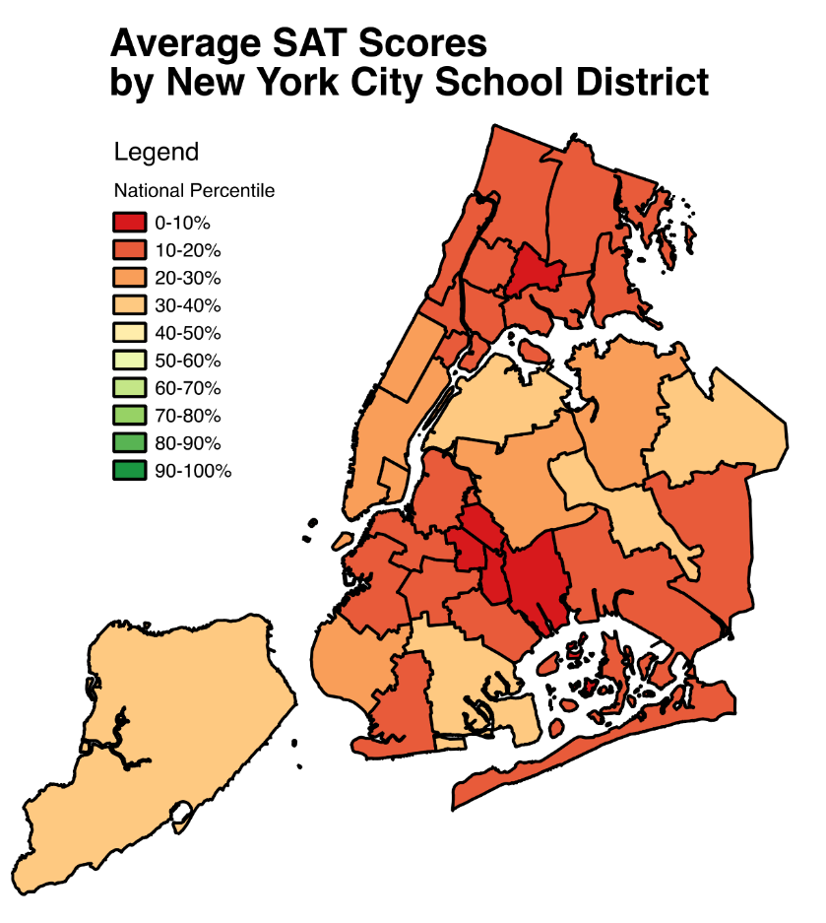To create chart 2, the number of schools with SAT averages within each national quartile was calculated through the “CountIf” function. The national percentile data for 2012 from the College Board, which administers the SAT test, was used. The number of schools in each quartile was calculated for critical reading, writing, math and composite scores.

To create Chart 1, this data was imported into QGIS and joined with the base map ‘School Districts’, available from NYC Open Data portal (data.cityofnewyork.us) by school district code. The chart was formatted with a colour gradient to represent the school districts average overall score in all SAT tests, compared to the national grade percentiles.

Analysis

As can be seen from chart 1, public schools in NYC are generally performing badly in comparison to the rest of the US. Schools in Queens, Staten Island, central and southern Manhattan, and southeast Brooklyn are performing the best, although no school district in the city exceeds the 50th percentile on average, with many falling below the 20th percentile. 5 school districts, located in eastern Brooklyn and in central Bronx can be seen to be performing exceedingly badly, falling below the 10th percentile, or producing the worst 10% of results in the country.

As can be seen from chart 2, results are again universally bad, with a large proportion of schools’ average scores within the lowest 25% nationally. NYC school averages are best on the Math SAT, this subject having the lowest proportion of schools’ averages falling into the fourth quartile, with just over 50% of schools. SAT results are worse in Reading and Writing, with over 80% of schools’ averages falling into the fourth quartile. However, less than 5% of NYC school’s averages in any subject fall into the first quartile, or the best 25% of grades nationally.

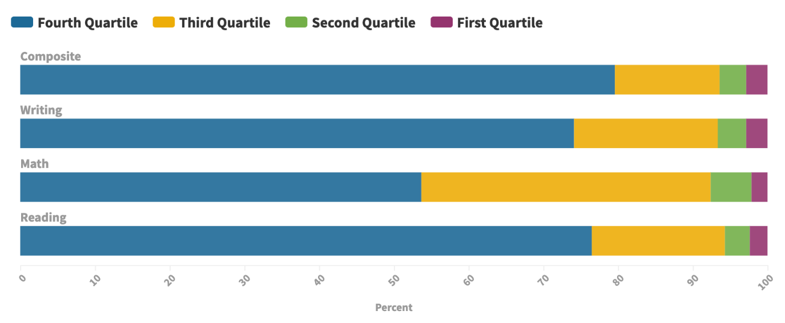

**NYC School’s Average Performance on SATs in Comparison with the Nation**

Chart 2

Conclusion and Recommendations

This analysis unveils the poor performance in SAT grades of students in NYC, when compared to the national average. This provides a compelling ground for action to increase access to higher education for urban students.

Firstly, we recommend that SAT scores be used as a measure of school performance, in providing a measure of students’ readiness for college. A better awareness of students’ ability to enroll in college, rather than just to graduate high school, can inform better policymaking in overcoming educational inequalities.

Secondly, although improvements to education should be made throughout the city, we recommend that schools improvement targets those districts shown to be the most underperforming, in northeastern Brooklyn and central Bronx.

Finally, more effort should be made to improve SAT preparations in literary subjects, as these are where students are performing most badly.

Limitations

The raw data has a low granularity, with information for schools rather than individual students. In the visualisations, we have produced data becomes less granular as it is generalised to school district in chart 1 and subject in chart 2. As a result, the specificity of schools is not represented in the charts; there may be schools which perform very well in on average underperforming districts, and vice versa. Additionally, there may be schools with a high standard deviation of students’ scores, where average score does not provide a complete representation of their student body. This is a limitation in our analysis, and it may be beneficial to make policy decisions through accessing anonymous student-level data.

Similarly, SAT scores cannot be taken to measure school performance in general, as not all student sit SATs. Generally, students who are more prepared for college take the SATs. Therefore, schools’ performances may be overrated on college preparedness and many student performances unrepresented.

Regarding quality of data, information for 56 schools in the city was missing out of a total of 478. Most information is therefore in place, but inaccuracies must be considered.

Data sources

City of New York (2019) “2012 SAT Results”. Available at : <https://data.cityofnewyork.us/Education/2012-SAT-Results/f9bf-2cp4?fbclid=IwAR1cMgaXmGmGNaEv-XAo6mmMZjuCI-ayKXgL6vr1cUN_FyocZMi3IVZLRfw> (Accessed: 22.12.2019).

College Board (2012) “SAT Percentile Ranks”. Available at: <http://secure-media.collegeboard.org/digitalServices/pdf/research/SAT-Percentile-Ranks-2012.pdf?fbclid=IwAR37zTm66-ZMNGaWMZwi_VMJGczFPpqYNR2rYKlt0UXeg3-pB1PQRZ5Gi-A> (Accessed: 22.12.2019).

Base map

City of New York (2019) “School Districts”. Available at : <https://data.cityofnewyork.us/Education/School-Districts/r8nu-ymqj?fbclid=IwAR0YgJsiUo-4j-uU1W1NUNMYKzaz_iq-MLx2o3pv02PJvhsXrl-97nyJmGU> (Accessed: 22.12.2019).

References

Office of the NYC Comptroller (2017) “Diploma Disparities: High school graduation rates in New York City”. Available at: <https://comptroller.nyc.gov/wp-content/uploads/documents/Graduation_Rate_Brief.pdf> (Accessed: 22.12.2019).

Santos, Fernanda (2011) “College Readiness Is Lacking, City Reports Show”. *New York Times*. Available at: <https://www.nytimes.com/2011/10/25/education/25progress.html>. (Accessed: 22.12.2019).