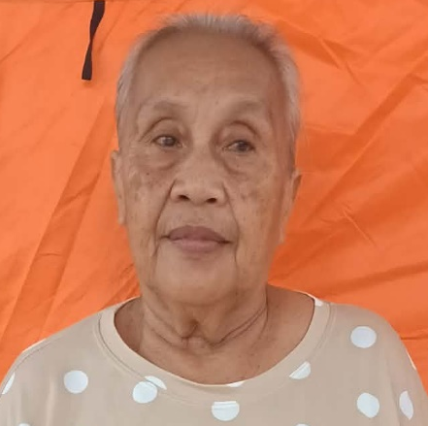
CAMARIN, REMINILITA/ 53

MODEJAR, CONSUELO/ 65
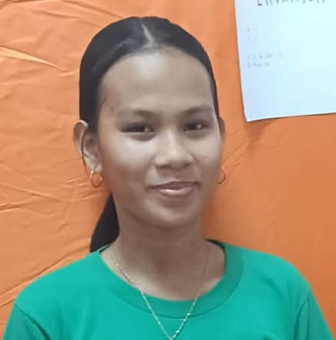
LINDAYEN, ASHANEE/13

BONIFACIO, SHEENA LEN/ 17

AUSA, EJ/22
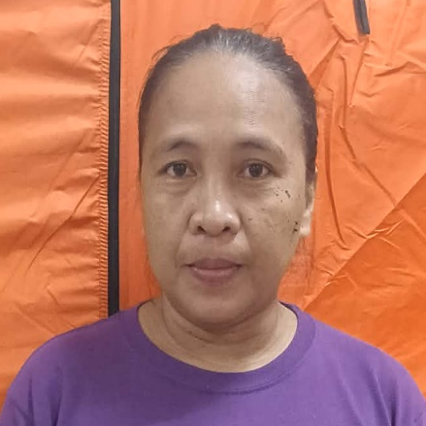
ASIS, RENALYN/47

ASIS, BLEZY FAITH/13
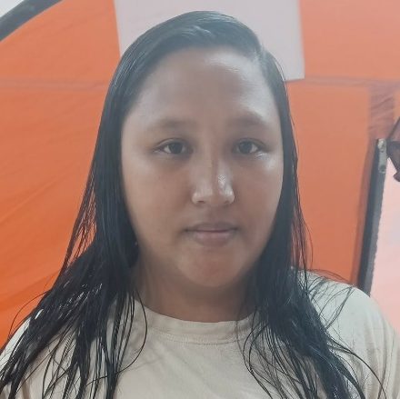
REARIO, MICHAELL KATE /25


REARIO, KATELYN JOY/3

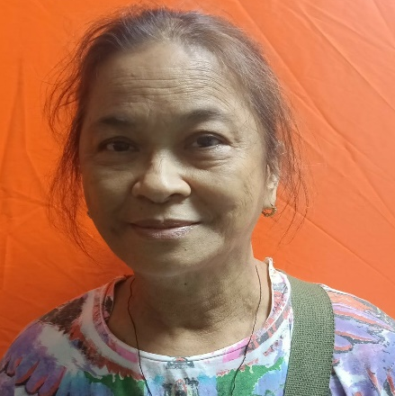
ATIENZA, MARICHU/64

GARCIENES, BRIANA/11

CENTENO, GEMMARIE/33
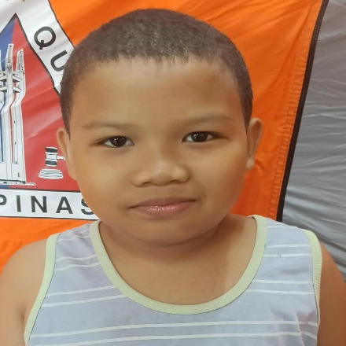
OBAOB, MARK JOHN REY/10


BASA, JUNEREX/3
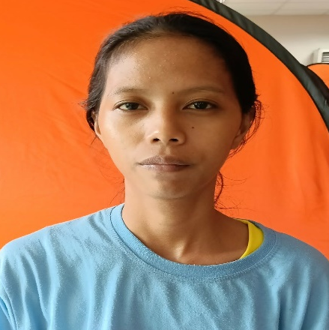
ANTOC, IDILYN MARIE/ 24
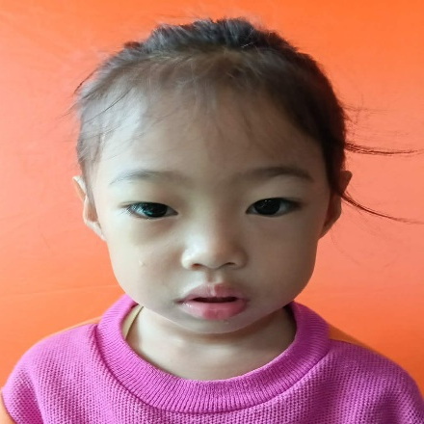
ANTOC, ANGELA NICOLE/3


ANTOC, JAMES ETHAN/4
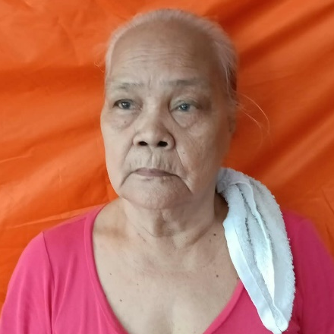
AMIGO, CATALINA/75

AMIGO, RANDY/38
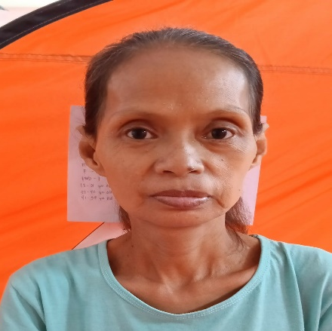
GOMEZ, CATHERINE/49

GOMEZ, IRA MARIE/14
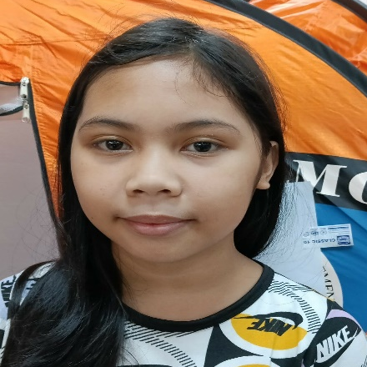
RECONIS JESHYRA/13

RECONES, EMILY/ 44
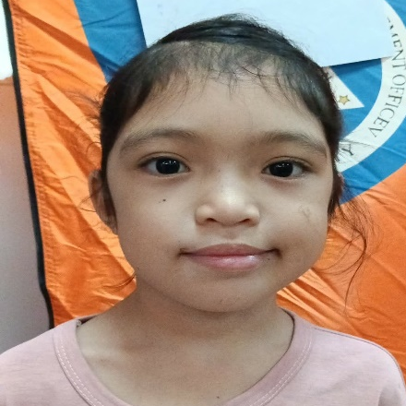
RECONES, JELRIE/8

GOMEZ, JAKE/13
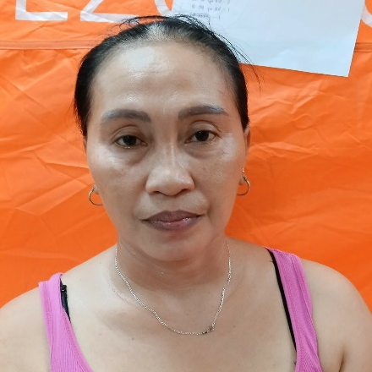
BONIFACIO, LENGIE LEE/45
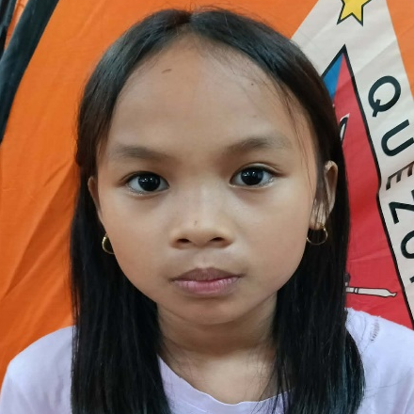
LINDAYEN, ALIJAH MAE/10

