Cho Han Program Flowchart
Caleb Cano | CSD 325 Module 3 Assignment

Betting and dice roll
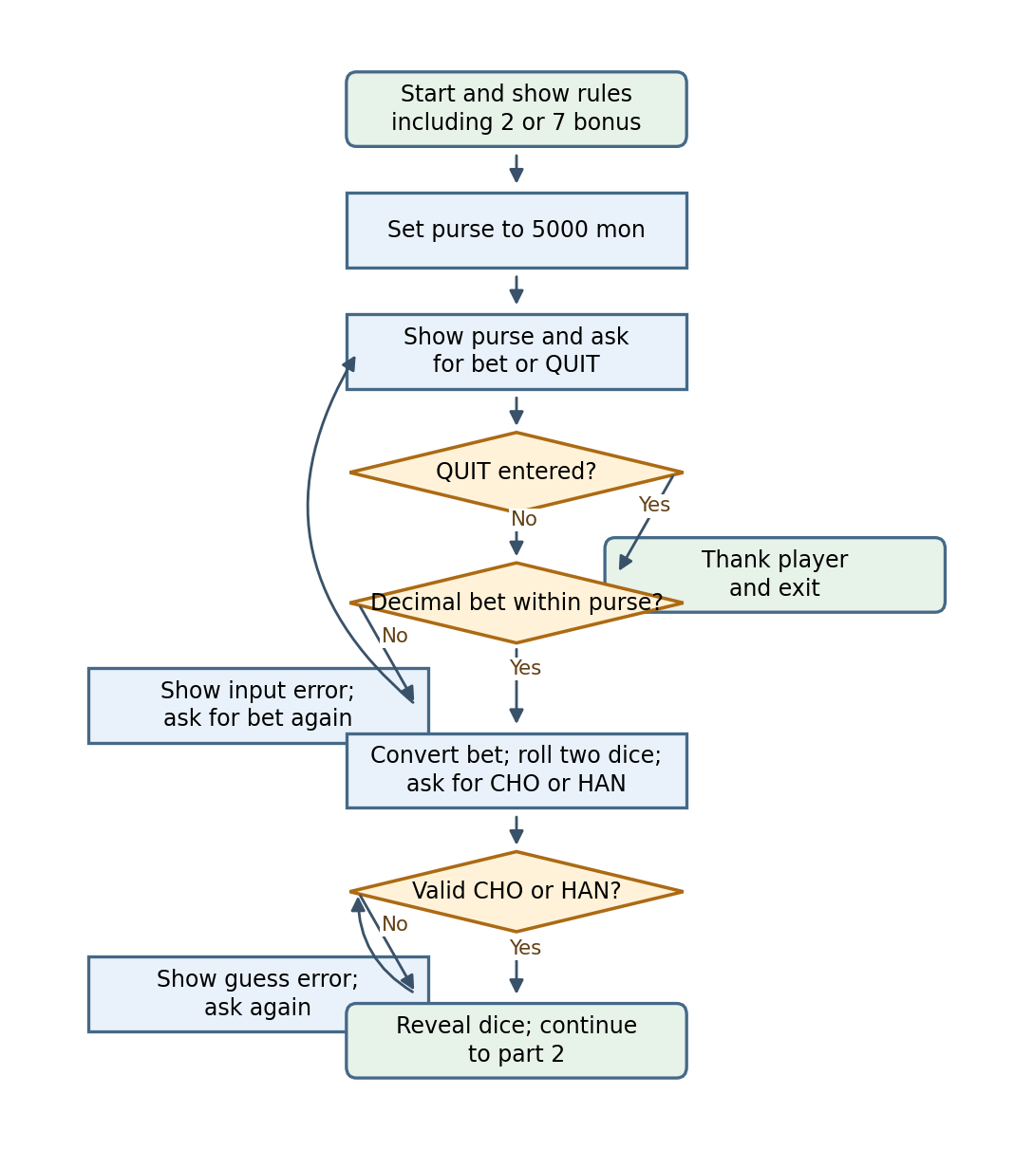

Cho Han Program Flowchart
Caleb Cano | CSD 325 Module 3 Assignment

Result and bonus
