**EVOLENT HEALTH**

**NAME :** NIKHIL PUNDLIKRAO RAGHUTE

**CONTACT :** 9975967445

**Email :** [**niks.1390@gmail.com**](mailto:niks.1390@gmail.com)

**Project Name :** EvolentHealth_Contacts

**Technology Used :** C#,ASP.Net MVC , SQL , Entity Framework

**Tools Used :** Visual Studio 2015 , SQL Server Managment Studio 2014, GitHub

**Project Information :**

The Project is implemented using a web application built in ASP.Net MVC framework using Visual Studio 2015 and Entity Framework.

For Database Management , SQL server management Studio 2014 is used

**Steps to Run the application :**

1. Execute the attached **SQL_DB&TableCreation.sql** script file using SQL Server Management Studio .These will create a ContactsDB Database with Contacts table having Data and Schema.
2. Open the Solution File **EvolentHealth_Contacts.sln** in Visual Studio 2015

build the application by **CTRL + B**

1. On successful build, Run the Application by pressing **CTRL + F5**
2. By Default , a Contacts Controller page will get open displaying the Idex view for List of Contacts along with CREATE/UPDATE/DELETE/DETAILS options

**Below is a screen shot displaying the functionality**

**HOME PAGE :**

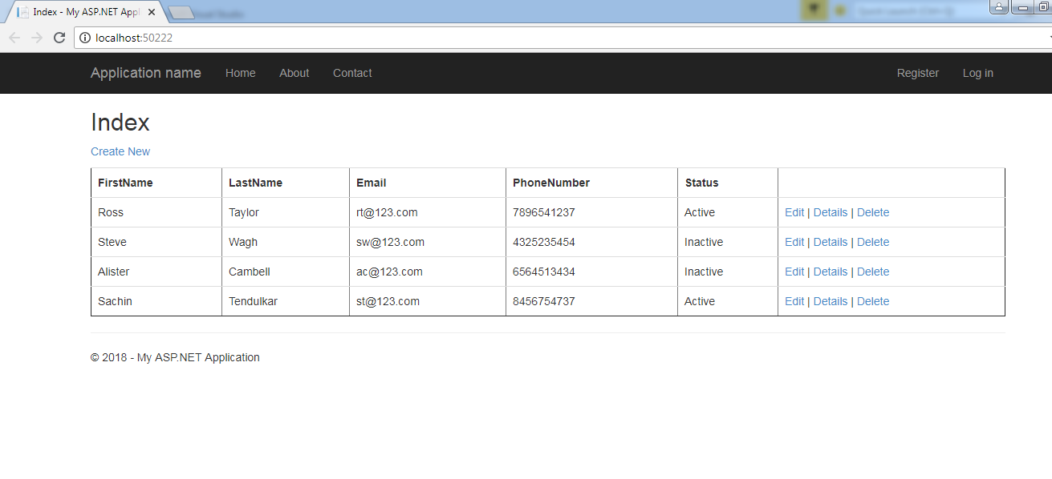

**CREATE VIEW :**

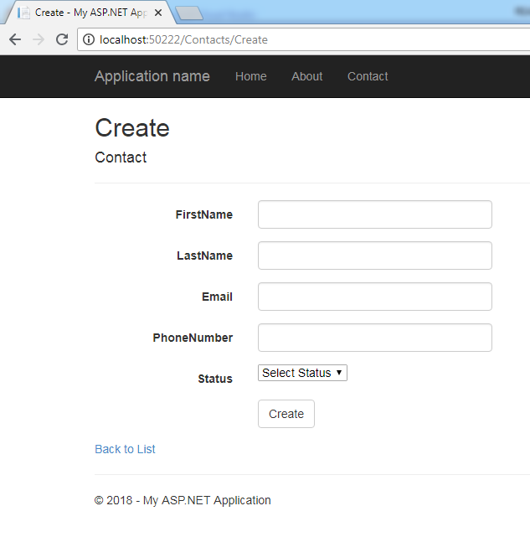

**EDIT VIEW :**

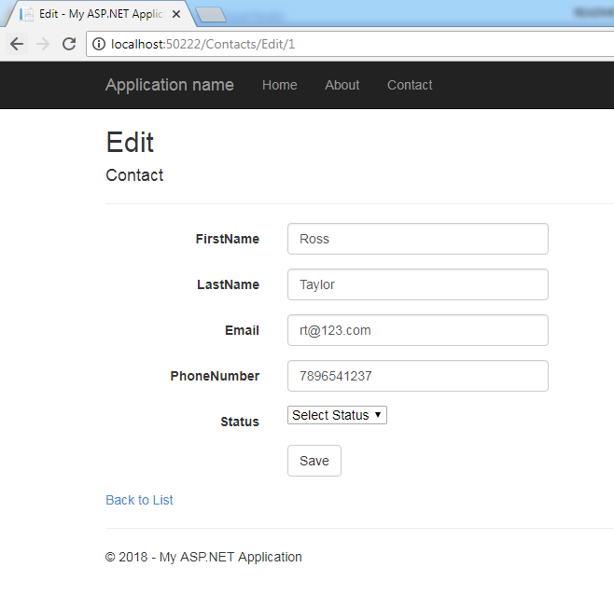

**DETAILS VIEW :**

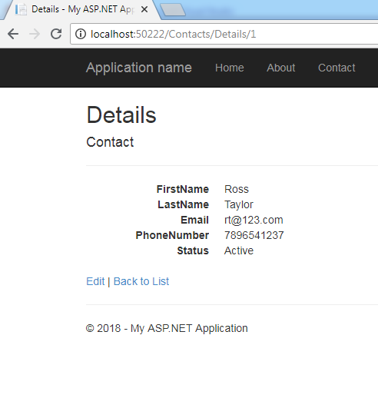

**DELETE VIEW :**

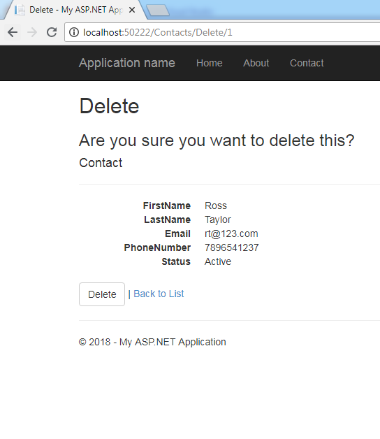

The application is designed using MVC scaffolding templates and Entity models are created from Database using Entity framework.

First a database ContactsDB was created followed by creation of Contacts Table with Required fields like FirstName,LastName, Email,PhoneNumber and Status.

In Visual Studio :

File 🡪 New 🡪Project 🡪ASP.Net Web Application was selected for MVC Template

Once the Project got created, a new Entity Model was generated using the Created Database using **ADO.Net Entity Data model** Template.

This provides the Enitity models and Classes.

Further, a new MVC Controller was created with actions and razor view to create ,read,update,delete and list entities from an entity framework data context.

This would create a MVC Controller for ContactContext Scaffolder.

A seperate Partial Class was created for Implementing Validations over the controls.