ADMIN API DOCUMENTATION

Module | Purpose | Click to Navigate
Login Page | System Access and Authentication | Login Page
User Management | Create, View, and Manage all User Accounts | User
Roles Management | Define Access Permissions and Roles | Roles
Store Management | Update Store Profiles | Stores
Products & Variants | Manage Inventory and Product Configurations | Products
Orders & Refunds | Search Orders and Process Refunds | Orders
Delivery Zones | Define Delivery Zones and Fees per Store | Zones
Top Picks | Manage Featured Products and Rankings | Top Picks
Product Taxonomy | Manage Brands, Categories, and Packages | Taxonomy
Coupon & Voucher | Create and Track Promotional Offers | Coupons
Reports | Generate Store Performance Data | Reports

Login Page

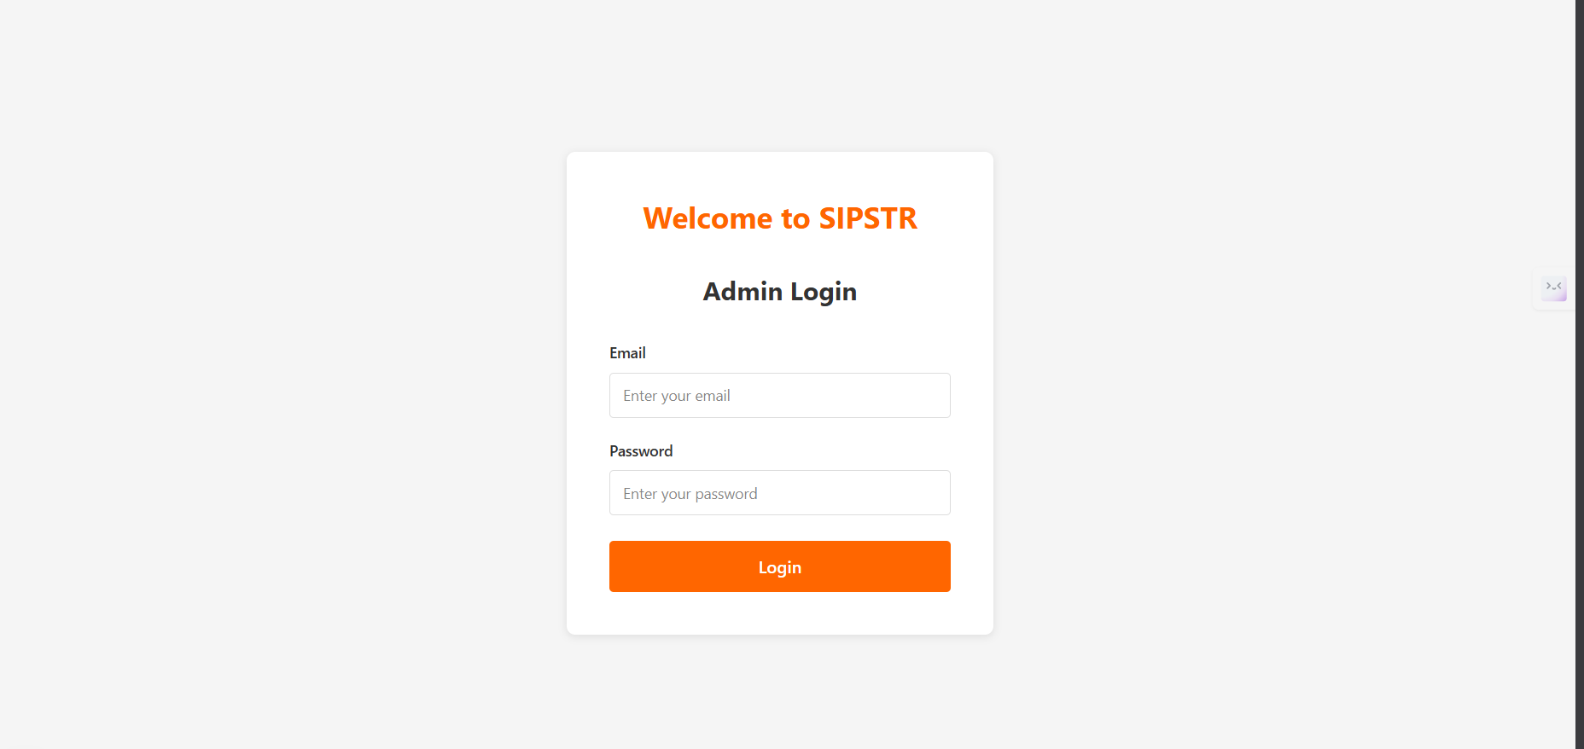

🔒 Admin Login Page: Access Control
The Admin Login page is the required entry point for all administrative users (including Super Admin, Admin, Store Owner, etc.) to access the SIPSTR management system.

1. Login Functionality
Page Elements: The page displays the welcome message "Welcome to SIPSTR" and the title "Admin Login".
Required Credentials:
Email: Field for entering the user's registered email address.
Password: Field for entering the corresponding password.
Access Requirement: An administrator is initially signed up by a Super Admin.
Process: The user must enter correct credentials and click the orange Login button to gain access to the dashboard and modules (like Users, Roles, Stores, etc.).

👩‍💻 User Management Overview
The User Management module provides administrators with a full suite of CRUD (Create, Read, Update, Delete) operations for managing user accounts, ensuring control over system access and user data integrity.
- View and Search (Read)

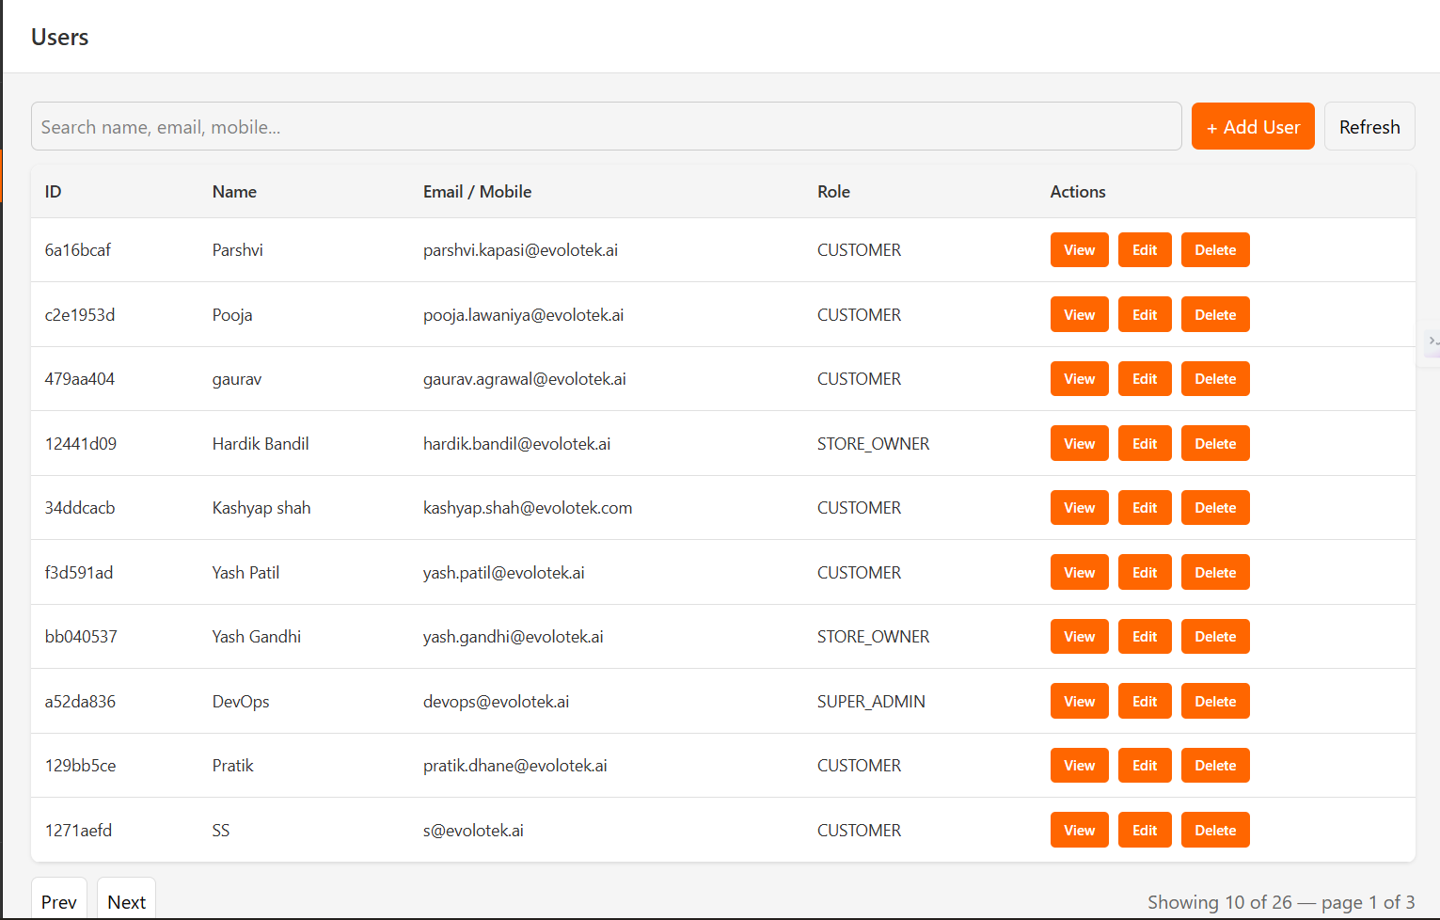
- Functionality: The main Users dashboard displays a paginated list of all system accounts, providing at-a-glance information including the unique ID, Name, Email/Mobile, and assigned Role.
- Search Feature: A centralized search bar enables efficient retrieval of user records. The search dynamically queries across multiple fields (Name, Email, Mobile) as the administrator types.
- Detailed View: The View action initiates a modal display of the User details, providing a read-only summary of the user's core attributes (Name, Email, Mobile, Role). This is essential for quick data verification without risking accidental changes.

2. Add New User (Create)
- Functionality: Triggered by the + Add User button, this function allows for the manual provisioning of new user accounts.
- Data Requirements: The form enforces collection of all mandatory fields necessary for a new account:
  - Full name (String)
  - Email (String and it should be unique)
  - Mobile (Number, and it should be unique)
  - Password (String, subject to complexity requirements)
  - DOB (Date field, format dd-mm-yyyy)
  - Role (Dropdown selection, critical for defining system access and permissions, e.g., CUSTOMER, STORE_OWNER, SUPER_ADMIN).
- Process: Upon completing the form, clicking Create validates the data and registers the new user in the system database.

3. Edit User Profile (Update)
- Functionality: The Edit action initiates the update process, allowing specific profile fields to be modified for an existing user.
- Editable Fields: While user identity fields (like Email/Mobile) may be restricted, common editable fields include:
  - Full name
  - DOB (Date field)
- Process: Changes are saved back to the database only after clicking the Save button.

4. Delete User
- Functionality: The Delete action is used to permanently remove a user record from the system.
- Process: This action triggers a confirmation prompt to prevent accidental deletion, which is a key security measure. Once confirmed, the user and associated credentials are removed, revoking their access(currently the system follows soft delete).

🔐 Roles and Permissions Management: Detailed Functionality

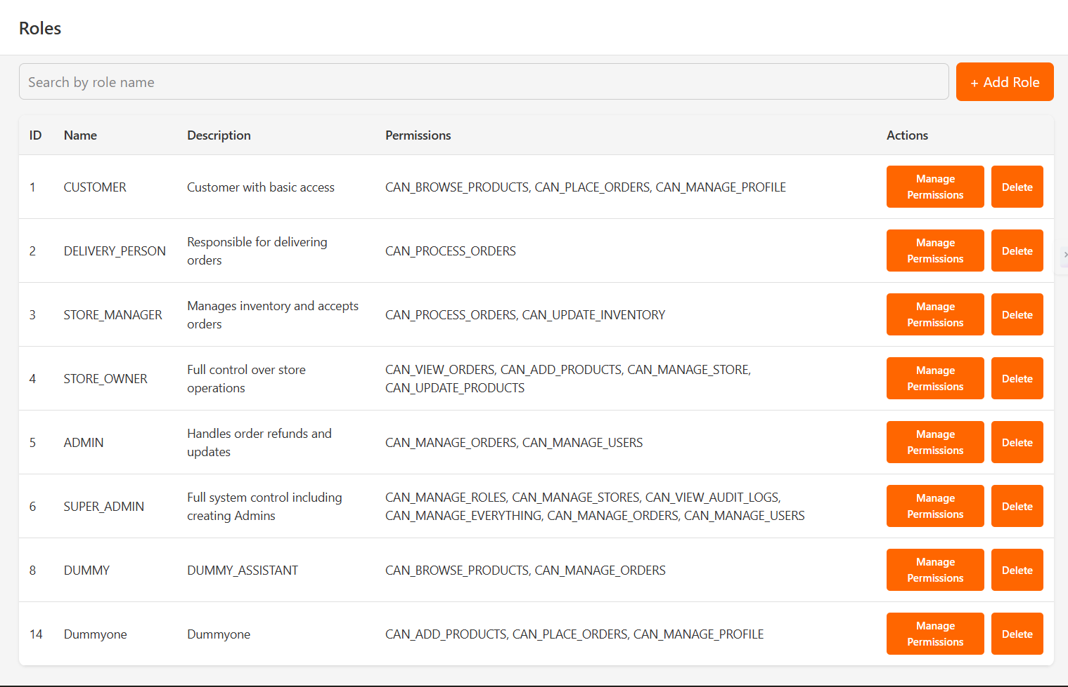
The Roles module is the system's access control center, allowing administrators to define access levels and privileges. This module handles the CRUD operations for user roles and manages the granular permissions associated with each role.

1. Role Overview (Read & Search)
- Functionality: The main Roles page displays a table listing every defined role in the system. Key details include the unique ID, Name, Description, and a list of assigned Permissions.
- Search Feature: A search bar at the top allows the administrator to quickly locate roles by searching against the Role Name.
- Actions: The Actions column provides two critical functions for each role:
  - Manage Permissions: Used to modify the specific rights associated with the role.
  - Delete: Used to permanently remove the role from the system.

2. Adding a New Role (Create)
- Functionality: Initiated by the + Add Role button, this function allows the creation of a new, custom access profile.
- Data Requirements: The administrator must define the following:
  - Role Name: A unique and descriptive name.
  - Description: A brief explanation of the role's purpose and scope.
  - Permissions: A multi-select checklist displays all available system permissions (e.g., CAN_BROWSE_PRODUCTS, CAN_PLACE_ORDERS). The administrator selects the specific permissions required for the new role.
- Process: Clicking the Create button validates the input and saves the new Role and its initial set of permissions.

3. Managing Role Permissions (Update)
- Functionality: Clicking Manage Permissions for an existing role opens a dedicated interface to modify the permissions assigned to that role.
- Interface Structure: The form displays the Role Name and Description (immutable), along with a list of available permissions to be managed.
- Permission Modification:
  - Add: Selecting Add allows the administrator to view and check permissions that the role does not currently have. Checking a box and clicking Save grants that permission to the role.
  - Remove: Selecting Remove allows the administrator to view and check permissions that the role currently has. Checking a box and clicking Save revokes that permission from the role.
- Process: After making the necessary adjustments, clicking Save commits the changes, instantly updating the permissions for the specific role.
- Image Reference:
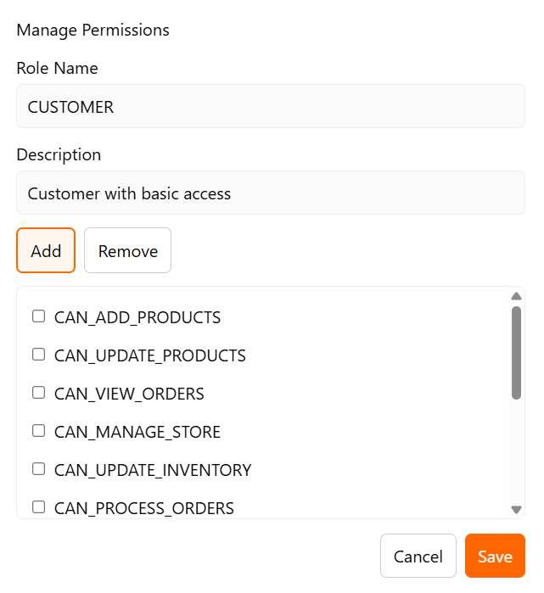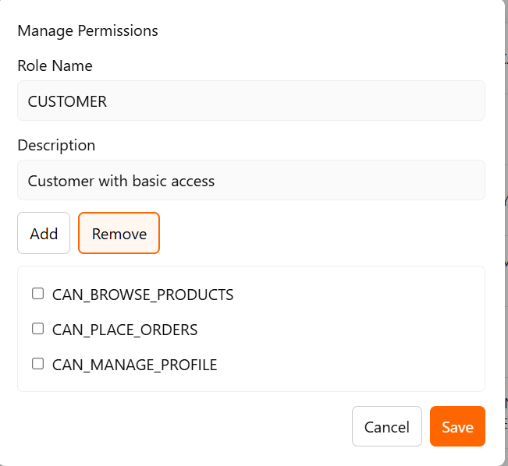

4. Deleting a Role
- Functionality: The Delete action permanently removes a role.
- Process: This action triggers a confirmation prompt “Are you sure you want to delete this role?” to prevent accidental deletion Once confirmed, the role gets permanently deleted.

🏬 Store Management: Detailed Functionality
The Store Management module provides administrative control over all active retail outlets, covering the viewing, and modification of essential store details and operational parameters.

1. Store Overview (Read)
- Functionality: The main Stores page displays a list of all retail entities registered in the system. This list serves as a central registry for store information.
- Key Details Displayed: The table provides immediate information for quick management:
  - Store Name
  - Corporation Name (The legal entity name)
  - Contact Email
  - Contact Phone
  - Is Active (A status flag, typically a 'Yes'/'No' indicator)
- Actions: The Actions column enables management of individual stores:
  - Update: Used to modify any details of the store.
  - Delete: Used to remove the store from the system.

2. Updating Store Details (Update)
- Functionality: Clicking Update for a store opens the Update Store form, allowing the administrator to modify basic and advanced configuration settings for that specific outlet.
- Basic Details: The initial view focuses on essential, legal, and identity information:
  - Store Name
  - Corporation Name
  - EIN (Employer Identification Number, a crucial tax/legal identifier)
  - License Number
- Advanced Options (Operational Parameters):
  - The Advanced Options toggle expands the form to reveal operational and consumer-facing details.
  - Description: A short bio or summary of the store, often used on the customer-facing front-end.
  - Contact Email / Contact Phone: Direct communication channels for the store.
  - Delivery Radius (km): Defines the geographical area the store services.
  - Minimum Order Amount: The minimum cart total required for a customer to place an order.
  - Average Preparation Time (min): A metric used to set customer expectation for fulfilment time.
  - Rating: A read-only field reflecting the store's customer rating.
  - Tax Rate (%): The percentage applied to orders originating from this store.
  - Commission Rate (%): The percentage of sales the platform takes from the store.
  - Latitude / Longitude: Geographic coordinates used for location-based services, delivery calculations, and map plotting.
  - Currently Accepting Orders: A boolean (checkbox) flag to quickly pause or resume order acceptance at the store level.
  - Active: A boolean (checkbox) flag indicating the overall operational status of the store.
- Process: The administrator modifies the necessary fields and clicks Save to commit the changes to the system.

- Image Reference:
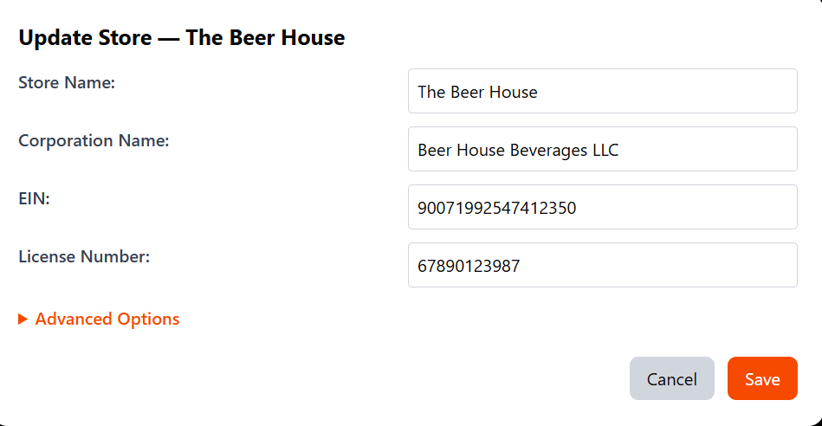
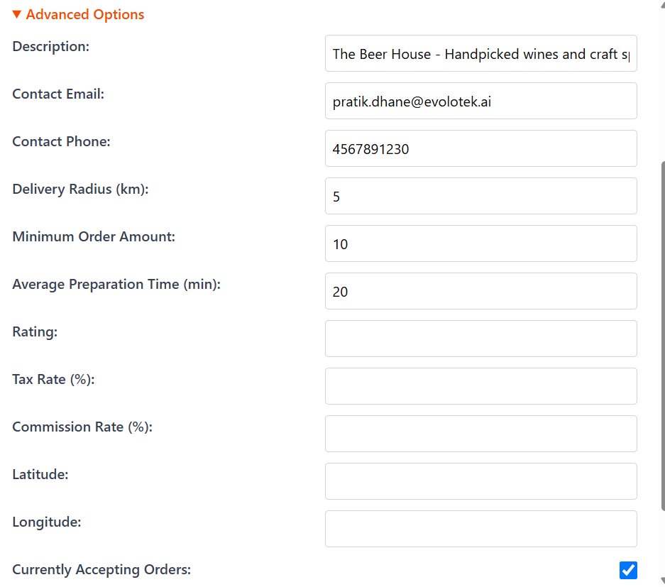

Deleting a Store (Delete)
- Functionality: The Delete action is used to permanently remove a store and its associated data from the system.
- Caution: Deletion is a final action. Ensure all dependent data (like active orders or outstanding payments) are managed before proceeding with a delete operation.

📦 Product Management & Variants: Detailed Functionality
The Products module manages the system's entire inventory catalog. It handles the core definition of a product (name, category, attributes) and separately manages its purchasable variations (Product Variants).

1. Product Overview and Search (Read)
- Functionality: The main view displays a list of all products in the system.
- Key Details Displayed: The table includes the unique Product ID, Name, Category, Brand, and the Active status (a quick togglable flag).
- Search & Filter:
  - The search bar allows administrators to query products by Name, Brand, or Category.
  - A dropdown filter allows refinement of the list by All, Active, or Inactive status.
- Actions: Each product row offers actions for View / Add Variants, Update, and Delete.
- Image Reference:
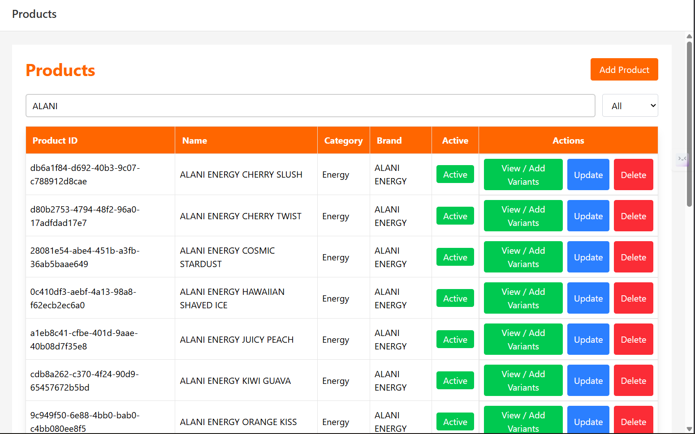

2. Product Creation (Add)
- Functionality: Clicking Add Product opens the creation form for defining a new core item.
- Core Fields:
  - Product Name and Description
  - Dropdowns for linking the product to an existing Brand and Category.
  - A field for Tax Category.
- Boolean Attributes (Checkboxes):
  - Alcoholic, Gluten Free, Kosher, Returnable: Essential attributes for categorization and legal compliance.
  - Perishable, Active: Operational flags; Active dictates whether the product is currently available for sale.
- Process: Clicking Add registers the base product record.

- Image Reference:
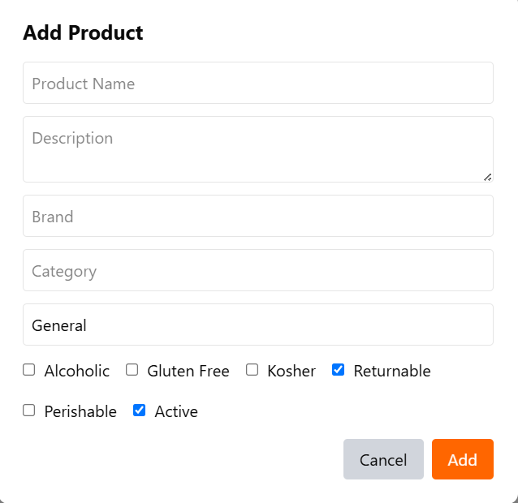

3. Product Update (Edit)
- Functionality: Clicking Update opens a form identical to the creation form, but with existing data populated, to modify the core attributes of a product.
- Process: The administrator modifies the necessary fields (Name, Description, Brand, Category, Flags) and clicks Update to save the changes.

4. Product Deletion (Delete)
- Functionality: The Delete action is used to permanently remove a product and all its associated variants from the system.
- Process: This action triggers a confirmation alert ("Are you sure you want to delete?") to prevent accidental removal of inventory data.

5. Managing Product Variants (View / Add Variants)
- Functionality: Clicking View / Add Variants opens the Manage Product Variants modal, which is the control panel for all purchasable versions of the product.
- Existing Variants: A table lists existing variants, showing the Package Name, UPC (Universal Product Code), Unit Price, and Update/Delete actions.
- Adding a New Variant (Create):
  - The form under "Add New Variant" is used to define a specific version of the product.
  - Key Fields: Package Name (e.g., 8.4OZ CAN 24 LS), Unit Price, UPC, and fields for Thumbnail Image URL and Full Size Image URL.
  - Advanced Details: Clicking Show Advanced Details expands the form to include comprehensive data points essential for logistics, compliance, and detailed customer information:
    - Shelf Life (Days), Alcohol By Volume, Weight (grams), Calories, Carbs, IBU Value, Sugars, Added Sugars, Dimensions (cm), and Storage Instructions.
  - Clicking Add creates the new variant.
- Updating an Existing Variant (Edit):
  - Clicking Update next to an existing variant transfers its data to the creation form (the "Add New Variant" section), and the action button changes to Update (as inferred from the user prompt).
  - The administrator modifies the details, including the advanced nutritional/physical data, and clicks Update to save the changes.
- Deleting a Variant:
  - Clicking Delete next to a variant removes that specific packaging/pricing configuration.
- Image Reference:

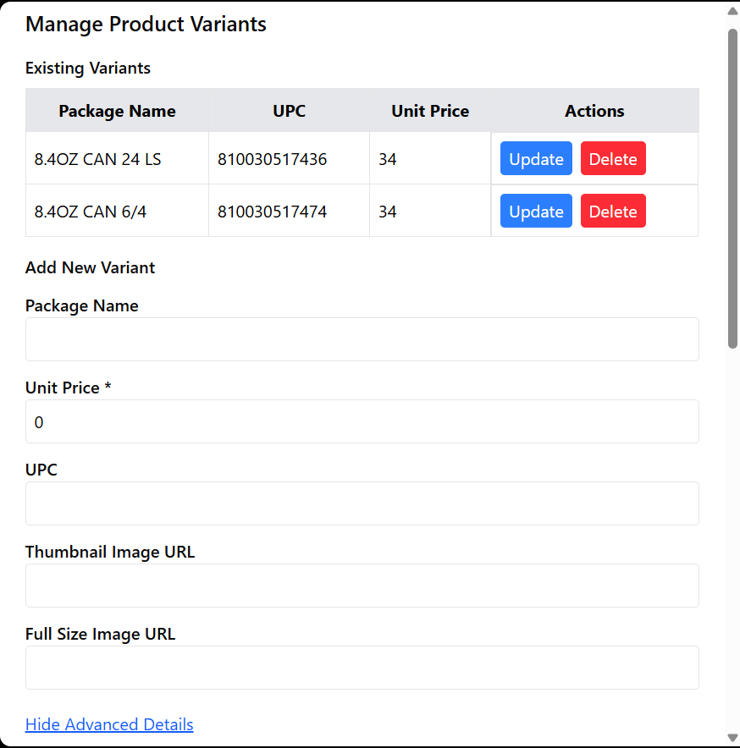
Add Variant
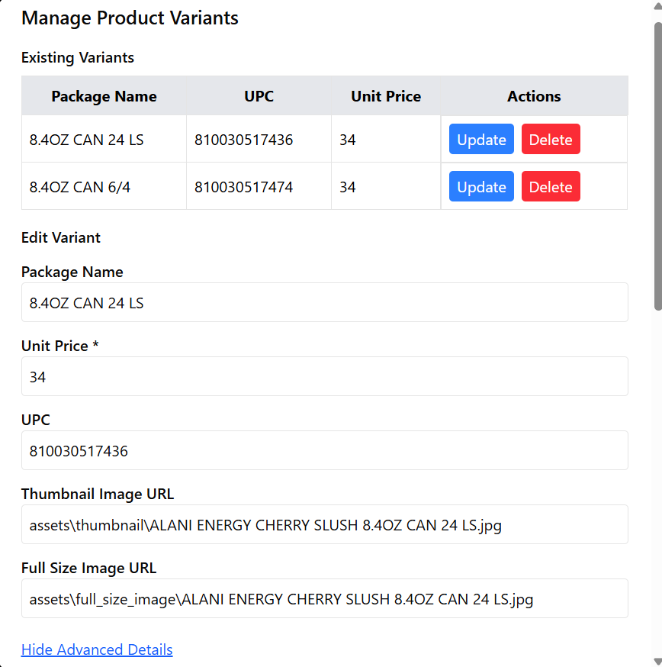
Edit Variant

💰 Order Management & Refunds: Detailed Functionality
The Order Management & Refunds module is the administrator interface for tracking specific orders, reviewing their financial details, and initiating refund processes. This module has been streamlined to use a dedicated list view for refund actions.
1. Refund Management
- Functionality: The landing page now serves as a central hub for initiating refund workflows.
- Process: The administrator selects either Process Full Refund or Process Partial Refund to enter the corresponding order list view.
- Image Reference:

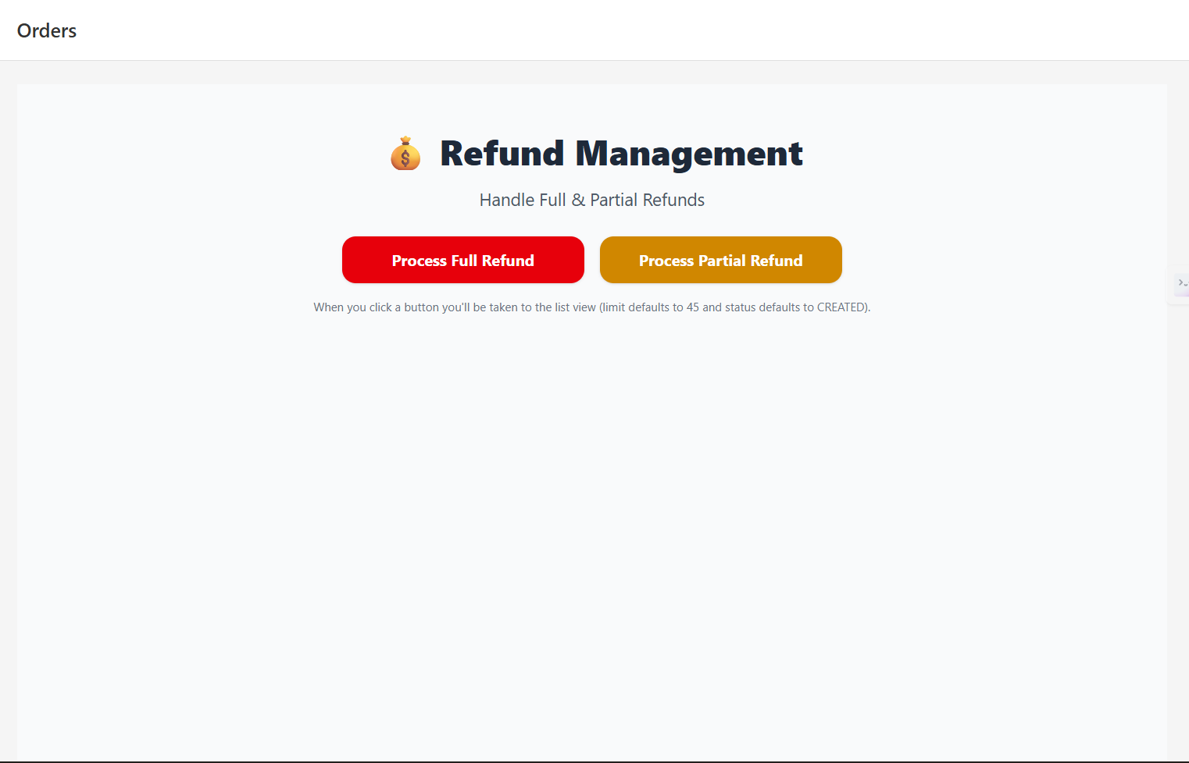

2. Order Search and Retrieval (List View)
- Functionality: Upon selecting a refund type, the administrator is taken to a filterable list of recent orders.
- Default View: The list defaults to showing the Recent Orders (Last 45) with the Status filter set to CREATED.
- Process: The administrator uses the table to identify the target order by ORDER ID, CUSTOMER, or ORDER TOTAL.

- Image Reference
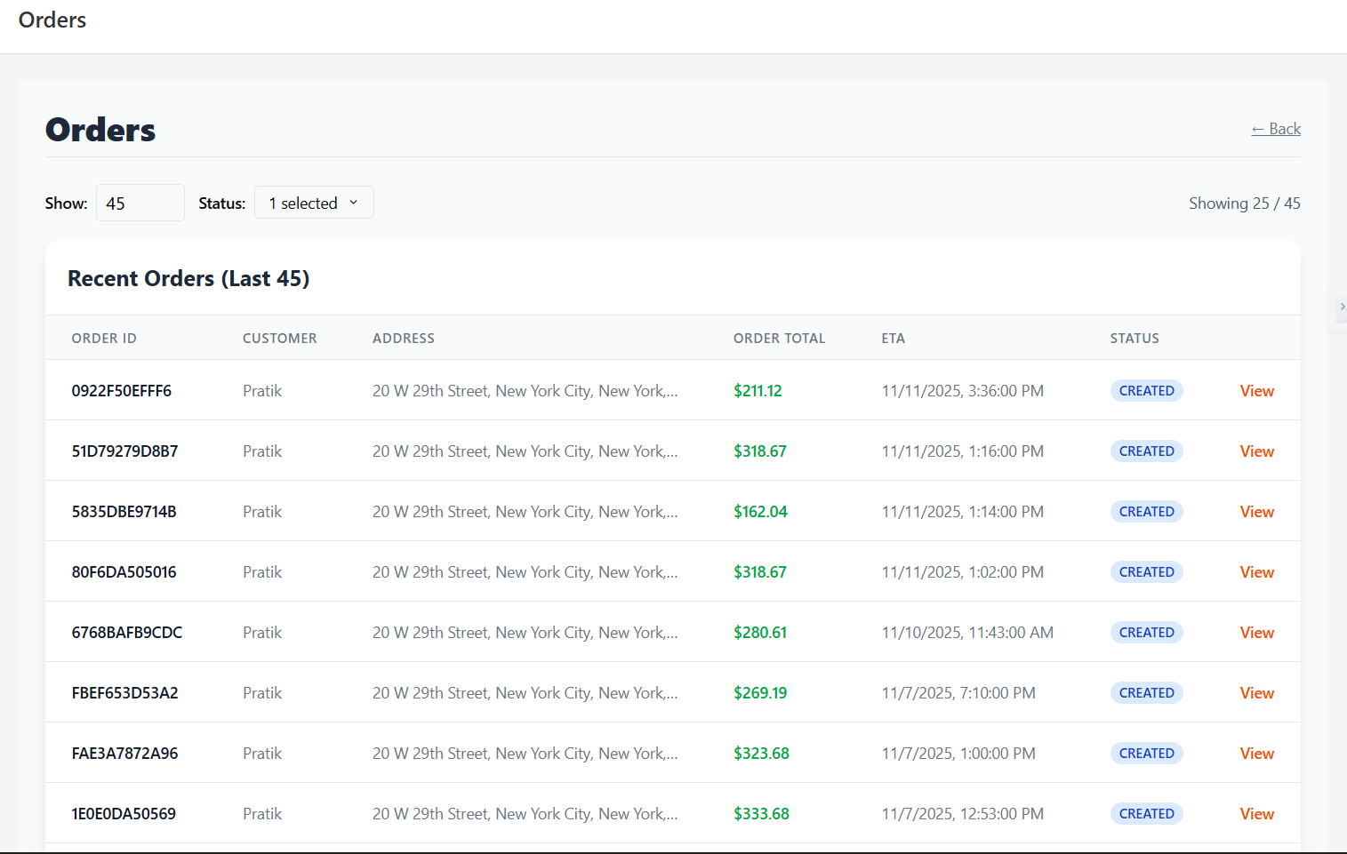

3. Full Refund Process
- Functionality: This action cancels the entire order and initiates a refund for the full Original Total amount.
- Process: In the Orders List, click View next to the desired order.This opens the Full Refund Confirmation page, which displays a comprehensive summary of the order details, all fees, and the calculated total. Review the details, including the Original Total and Difference fields.
Click the Process Full Refund button. A confirmation alert will appear. Upon confirmation, the full refund is processed.
The order's status is updated to REFUNDED.
Image Reference:
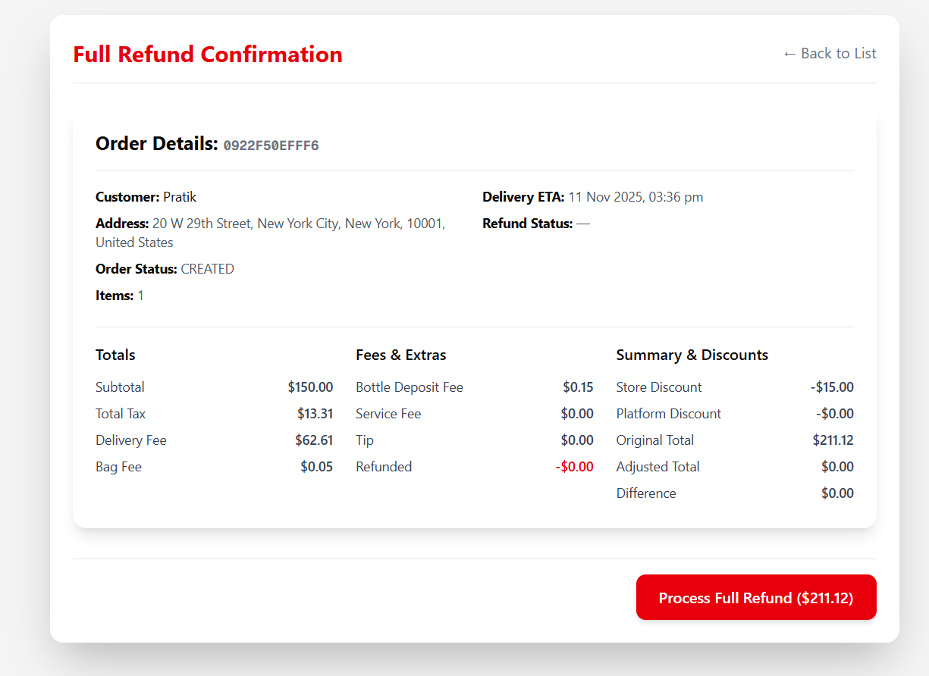

4. Partial Refund Process
- Functionality: This action allows the administrator to refund a customer for specific items, fees, or charges, resulting in a PARTIALLY_REFUNDED status.
- Process: Navigate to the Orders List after selecting Process Partial Refund from the landing page. Click View next to the desired order. This opens the Partial Refund Configuration page, which displays all order details, the refund selection options, and the summary on a single scrollable view.
Select Items: Use the checkboxes next to the listed items (grouped by store) to select items for a refund.
Select Fees: Use the checkboxes under Select Fees to Refund (e.g., Delivery Fee, Tip) if applicable.
Click the Process Partial Refund button at the bottom of the page.
A confirmation alert will appear. Upon confirmation, the partial refund is processed.
The order's status is updated to PARTIALLY_REFUNDED and the refunded amount is tracked.
- Image Reference:

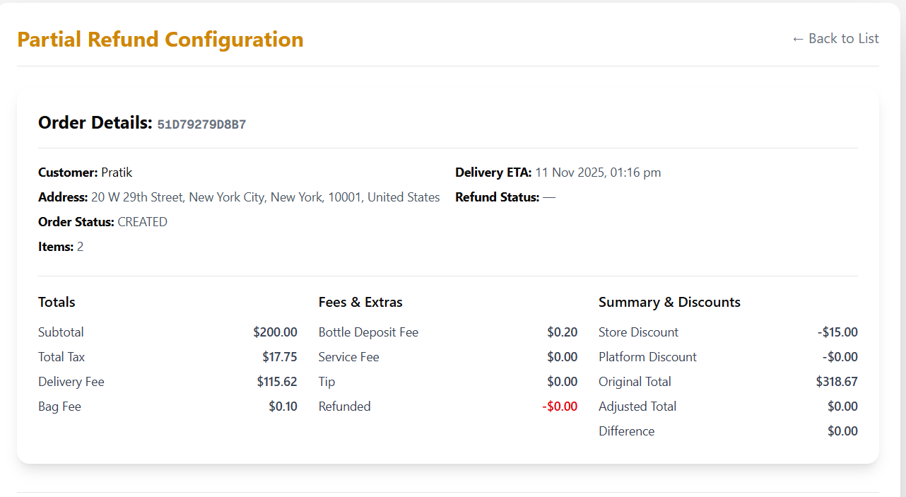
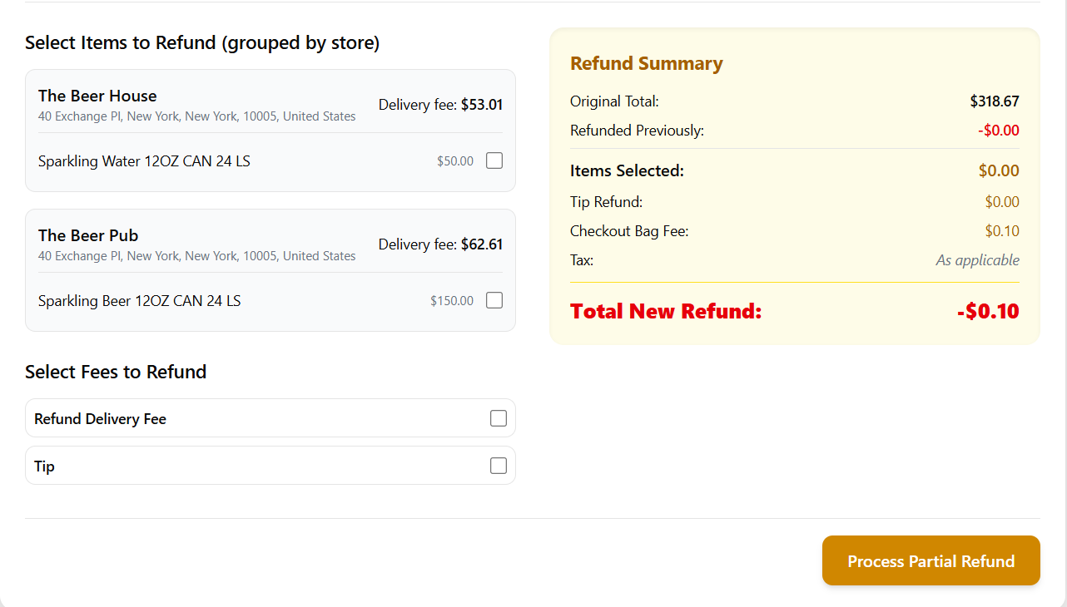

🗺️ Delivery Zones Management: Detailed Functionality
The Zones module allows administrators to define, manage, and configure geographical service areas (Delivery Zones) for each individual store, including associated pricing, order minimums, and time estimates.

1. Store Selection and Zone Overview
- Functionality: The system first requires the administrator to select the target store before managing its zones.
- Store Selection:
  - The administrator enters the Store Name into the search field (e.g., "The Beer Pub").
  - Clicking Resolve Store confirms the store name and fetches its unique Store UUID.
  - Once a store is resolved, the Delivery Zones table appears, listing all existing zones for that store, along with their core pricing and parameters.
- Zone Details Displayed:
  - Zone Name
  - Base Fee (Fixed charge for delivery within the zone)
  - Per Mile Fee (Variable charge based on distance)
  - Min Order (Minimum order amount required for this zone)
  - Restricted (A flag indicating if the zone has special access limitations)
- Actions: The table allows for Edit and Delete actions on existing zones, and the Add Delivery Zone button initiates the manual creation process.
  - The Fetch Zones button is used to retrieve the delivery zone for the currently selected store.
- Image Reference:
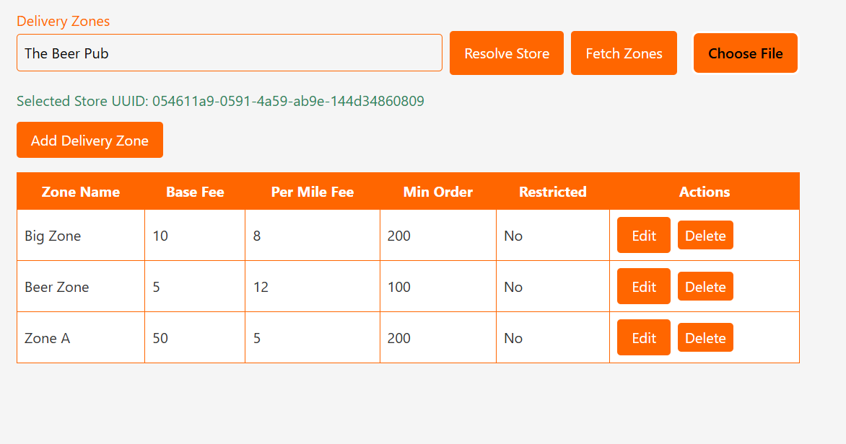

2. Manual Zone Creation/Update
- Functionality: Clicking Add Delivery Zone (or Edit on an existing zone) opens a detailed form for configuration.
- Key Fields:
  - Zone Name
  - Base Fee / Per Mile Fee
  - Min Order
  - Estimated Prep Time (Estimated time to prepare an order for this zone)
  - Restricted: A checkbox flag.
  - Store UUID: Read-only field confirming the target store.
- Defining the Zone Boundary (Coordinates):
  - A delivery zone's boundary is defined by a set of GPS coordinates (Latitude/Longitude pairs).
  - Add Coordinate: Allows the administrator to manually input or paste new Lat/Lng pairs to build or modify the zone shape.
  - Remove: Removes an existing Lat/Lng pair from the zone boundary.
- Process:
  - For new zones, clicking Add commits the zone and its polygon boundary to the store's configuration.
  - For editing, the button changes to Update (as per the Admin prompt), saving the modified parameters and boundary.
- Image Reference:
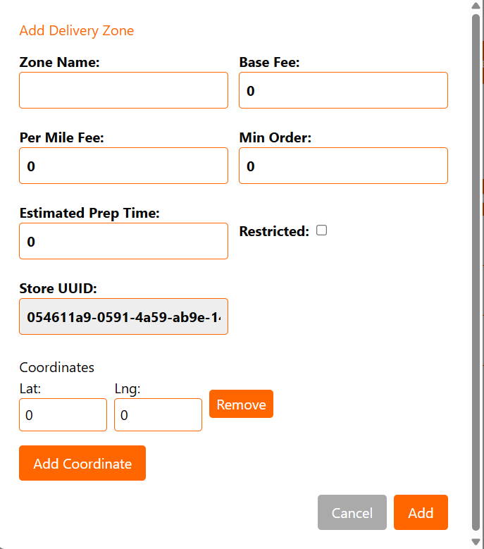

3. Creating Zones via KML File Import
- Functionality: This feature allows for bulk or complex zone creation by uploading a file (KML format, created from google maps my map).
- Process:
  - Click Choose File to select the KML file containing the zone boundary data.
  - The system parses the file and displays the imported zone(s) in an Imported Placemarks section.
  - A summary of the imported zone (e.g., Zone A with its fee structure and number of coordinates) is shown.
  - The administrator has two options:
    - Review & Edit: Opens the manual configuration form for that imported zone, allowing for parameter adjustments before final creation.
    - Create Now: Creates the single zone immediately with the parameters parsed from the file.
  - The administrator can also use Create All to save all imported zones simultaneously or Clear List to discard the imported data.
- Image Reference:
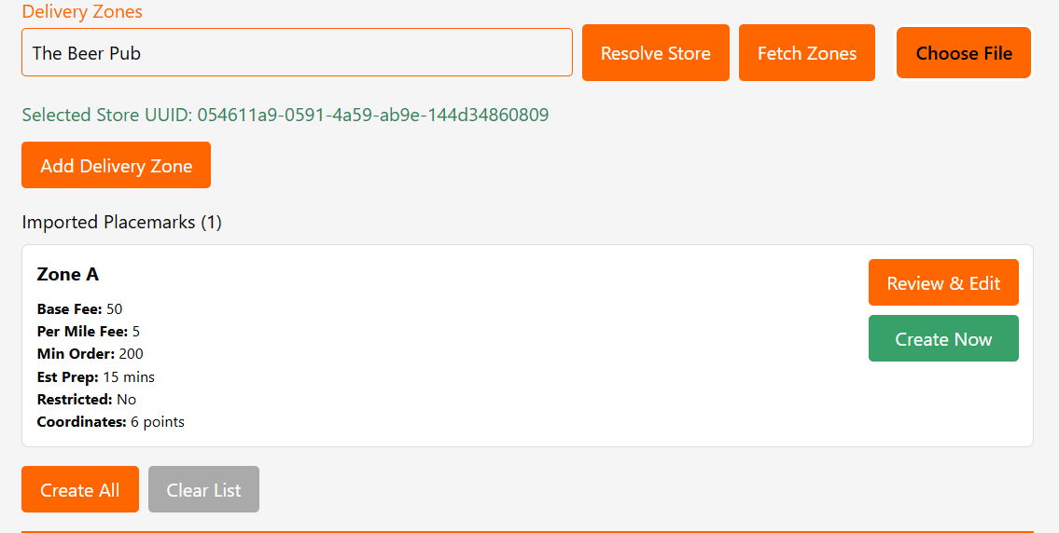

4. Delete Zone

Functionality: The Delete action permanently removes a delivery zone from the selected store's configuration.

⭐ Top Picks Management: Detailed Functionality
The Top Picks module allows administrators to hand-select and prioritize specific products to be prominently featured to customers. This function is essential for promoting seasonal items, high-margin products, or slow-moving inventory.

1. Top Picks Overview (Read & Actions)
- Functionality: The main view lists all products currently designated as a "Top Pick."
- Key Details Displayed:
  - ID: The internal system identifier for the product.
  - Product: The name of the product.
  - Rank: A numerical value that determines the display order (lower numbers typically mean higher priority/placement).
  - Featured: A boolean (checkbox) indicator showing whether the product is currently marked as featured.
- Actions: The table provides direct Update and Delete actions for management, alongside the primary + Add Top Pick button.
- Image Reference:
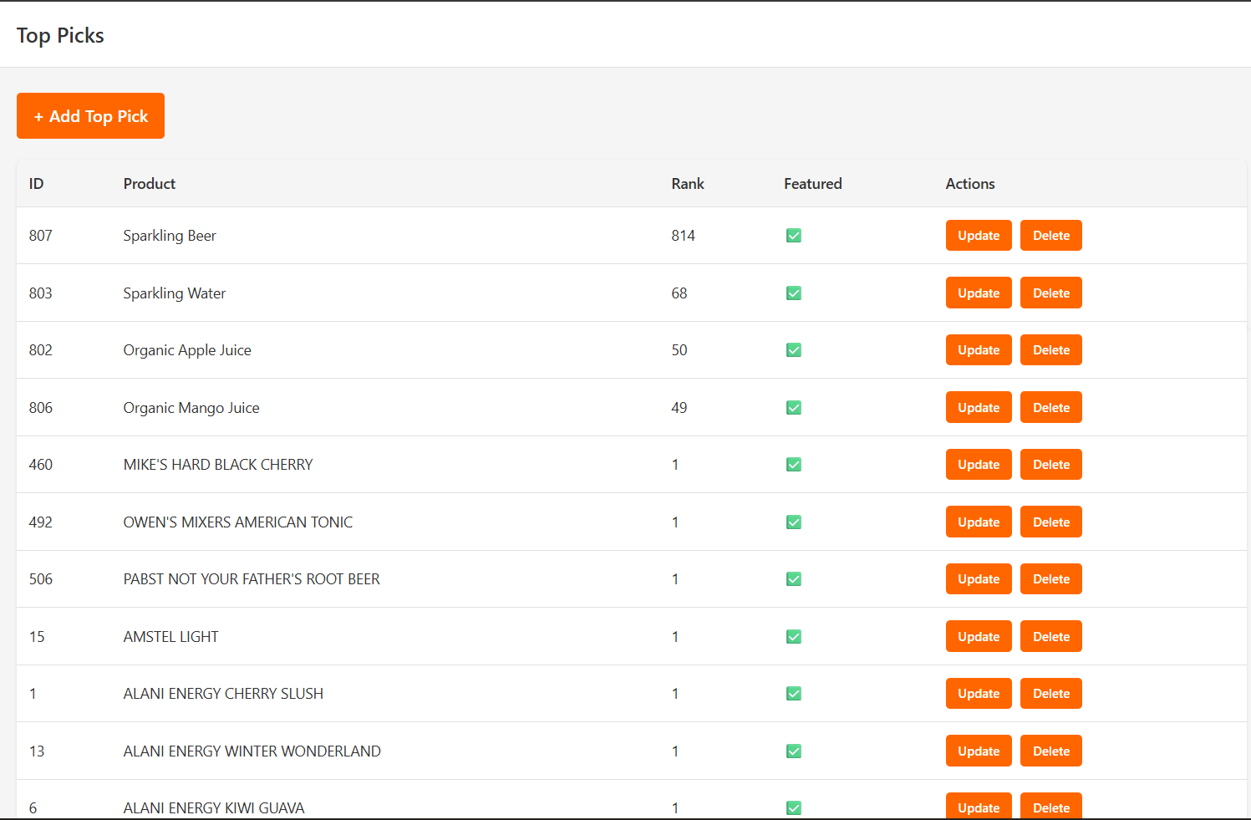

2. Adding a Top Pick (Create)
- Functionality: Clicking + Add Top Pick opens a form to designate a new product for promotion.
- Data Requirements:
  - Product UUID: The unique system identifier for the product that must be entered manually. This links the promotion to the actual product record.
  - Rank: A numerical value assigned to determine the product's position in the Top Picks list.
- Process: After entering the necessary details, clicking Add Top Pick saves the entry and adds the product to the main list.

3. Editing a Top Pick (Update)
- Functionality: Clicking Update on any listed product opens the Edit Top Pick modal to modify its promotional attributes.
- Editable Fields:
  - Product Name: This field is read-only, confirming the product being edited but preventing changes to the product identity itself within this module.
  - Rank: This numerical field can be updated to change the product's priority.
  - Featured: A checkbox that can be toggled. Checking it marks the product as featured; unchecking it effectively removes the product from the Top Picks display (or demotes it), even though the record remains in the management list.
- Process: Clicking Save commits the changes to the system.
- Image Reference:
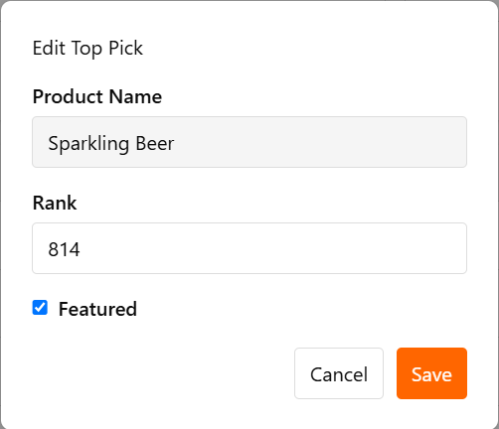

4. Deleting a Top Pick
- Functionality: The Delete action is used to permanently remove the product's entry from the Top Picks management list.
- Note: This action only removes it from top-pick and does not delete the core product record from the system.

🏷️ Brands, Categories, & Packages Management
This module provides the central interface for managing the fundamental organizational elements of the product catalogue: Brands, Categories, and Packages (Units). The view is controlled by a dropdown selector, allowing for focused management of each element.

1. Brands Management
- View & Search (Read):
  - Functionality: Selecting Brands from the dropdown displays a table of all registered brand names.
  - Key Details: The list shows the unique ID and the Name of the brand.
  - Search: The search bar allows the administrator to filter the list by Brand Name.
- Create (Add):
  - A simple form is used to input the new Brand Name.
- Update (Edit):
  - Clicking Edit opens a modal/form that allows the administrator to modify the existing Brand Name.
- Delete:
  - Clicking Delete removes the brand from the list and database.
- Image Reference:
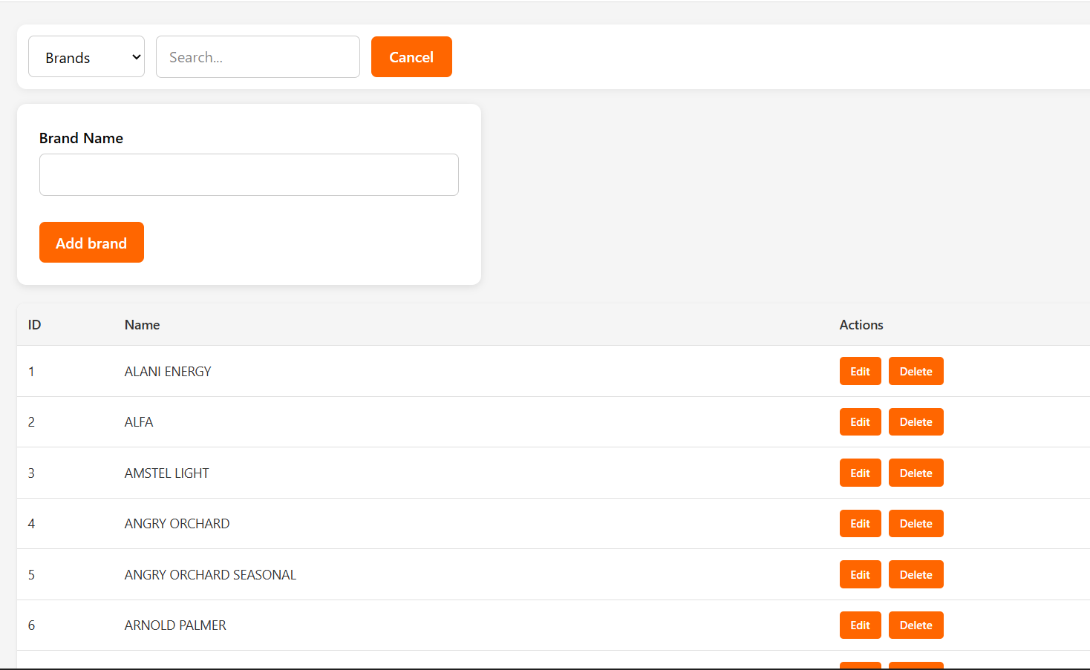

2. Categories Management
- View & Search (Read):
  - Functionality: Selecting Categories from the dropdown displays a table of product categories.
  - Key Details: The list shows the ID, Category Name, and a Description.
- Create (Add):
  - Clicking + Add opens the creation form.
  - Fields: Requires a Category Name and a Description. The action button is Add categories.
- Update (Edit):
  - Clicking Edit opens a modal/form to modify the Category Name and Description. The action button is Update categories.
- Delete:
  - Clicking Delete removes the category.
- Image Reference
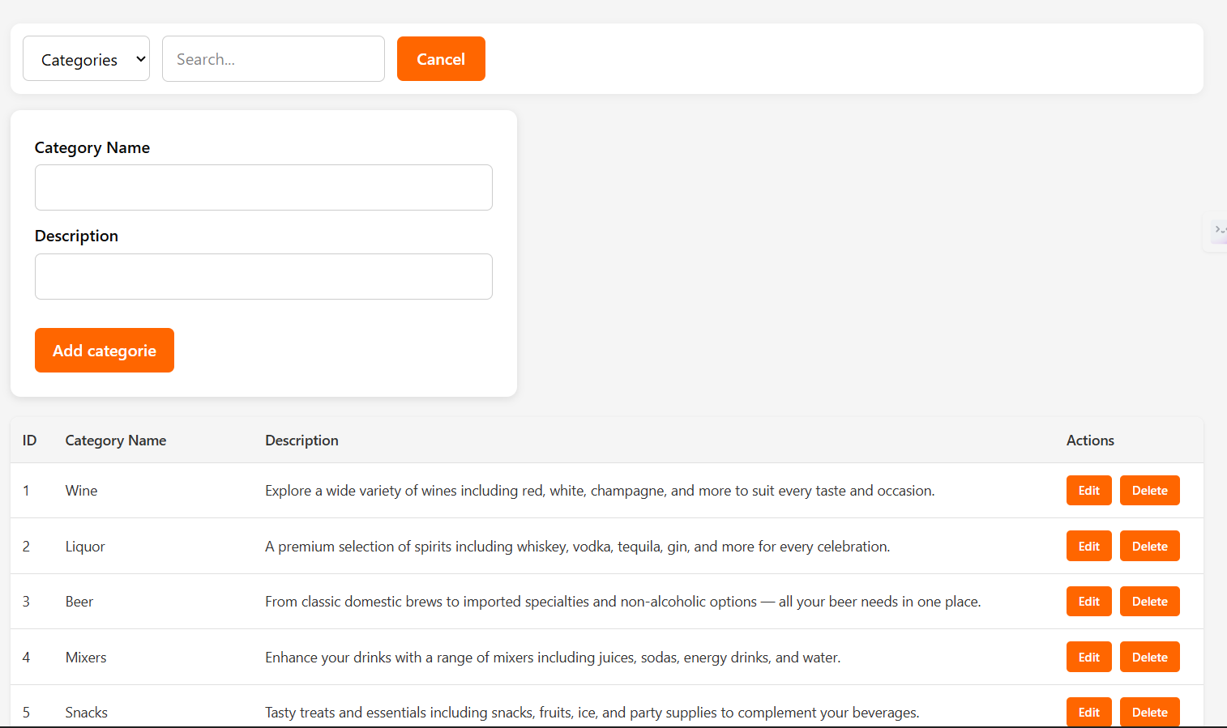

3. Package Units Management
- View & Search (Read):
  - Functionality: Selecting Packages (or a similar term) from the dropdown displays a table of product packaging configurations.
  - Key Details: The list shows the ID, Package Name, Type (e.g., GLASS_BOTTLE, CAN), and Description.
- Create (Add):
  - Clicking + Add opens the creation form.
  - Fields: Requires Package Name, Description, and a selection from the Package Type dropdown (e.g., CAN, GLASS_BOTTLE, KEG).
- Update (Edit):
  - Clicking Edit opens the form to modify the Package Name, Description, and Package Type.
- Delete:
  - Clicking Delete removes the package unit.

- Image Reference
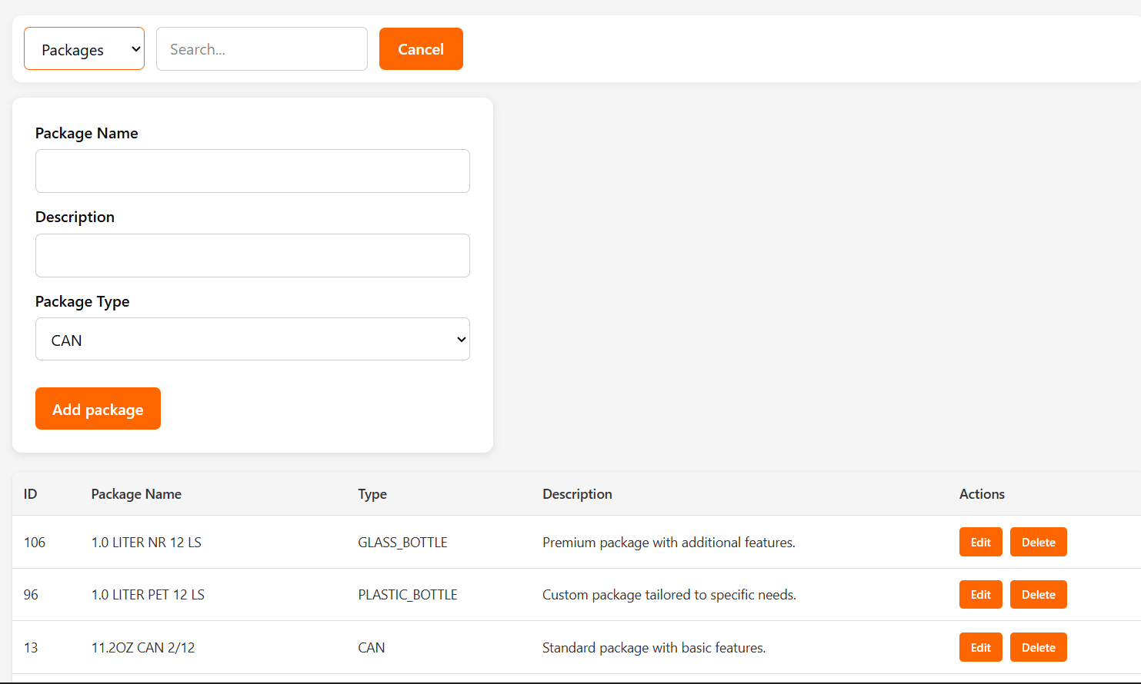

🎁 Coupon & Voucher Management: Detailed Functionality
The Coupon & Voucher module allows administrators to create, manage, and track promotional offers that provide discounts to customers. Offers are managed on a per-store basis.

1. Offer Overview and Search (Read)
- Functionality: The main page displays a central search bar to locate offers tied to a specific retail location.
- Search Requirement: The administrator must Enter storeId (number) and click Search to view the offers associated with that store.
- Key Details Displayed: Once resolved, the table lists offers, showing the ID, Name, Method (e.g., COUPON, VOUCHER), Type (e.g., PERCENTAGE, FLAT), Code, Period (Start and End Date/Time), and Status (e.g., Active).
- Actions: The management actions include Edit, Delete, Toggle, and Consumption.
- Image Reference
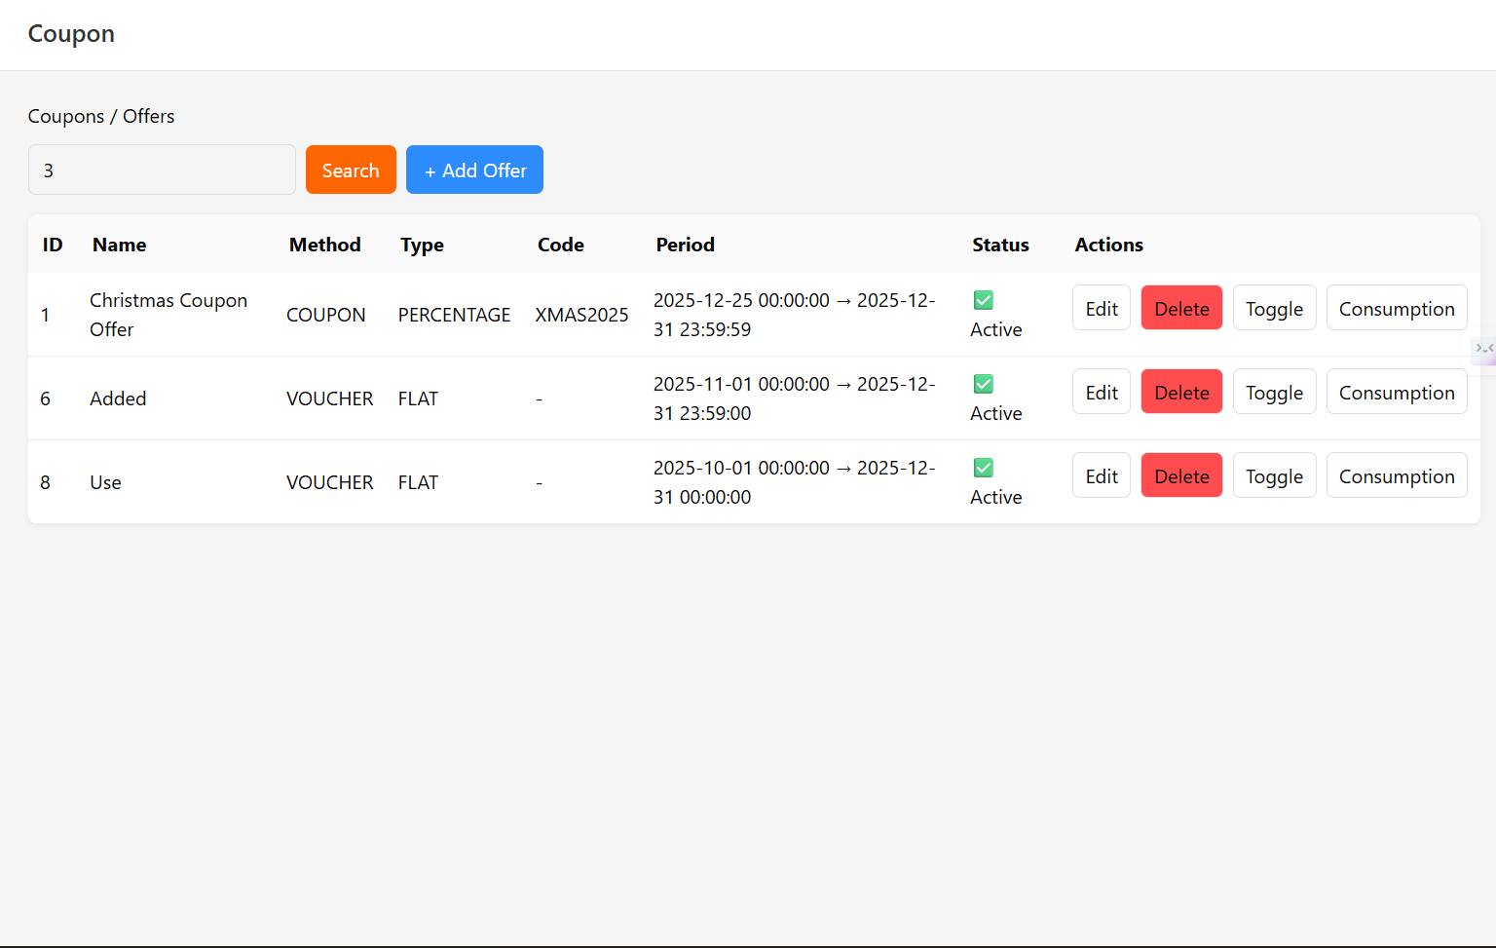

2. Creating a New Offer (+ Add Offer)
- Functionality: Clicking + Add Offer opens the Create Offer form, which defines the parameters of a new discount.
- Core Fields (Universal):
  - Name
  - Store ID (The specific store the offer applies to, e.g., 3).
  - Method (Dropdown for COUPON or VOUCHER).
  - Type (Dropdown for discount calculation, e.g., FLAT or PERCENTAGE).
  - Discount amount/percentage, Allowed Max Discount, Min Spend Amount, and Max Total Usage.
  - Description and Required Voucher Count.
  - Start Date & Time and End Date & Time.
- Method-Specific Fields (Coupon Details): If the Method is set to COUPON, additional fields appear for tracking specific code usage:
  - Coupon Code
  - Website Display Message
  - Max Usage Per User
  - Usability Count (The total number of times the coupon can be used)
  - Usability Option (Dropdown for defining specific usage rules)
- Process: Clicking Create Offer registers the new promotional discount in the system.
- Image Reference
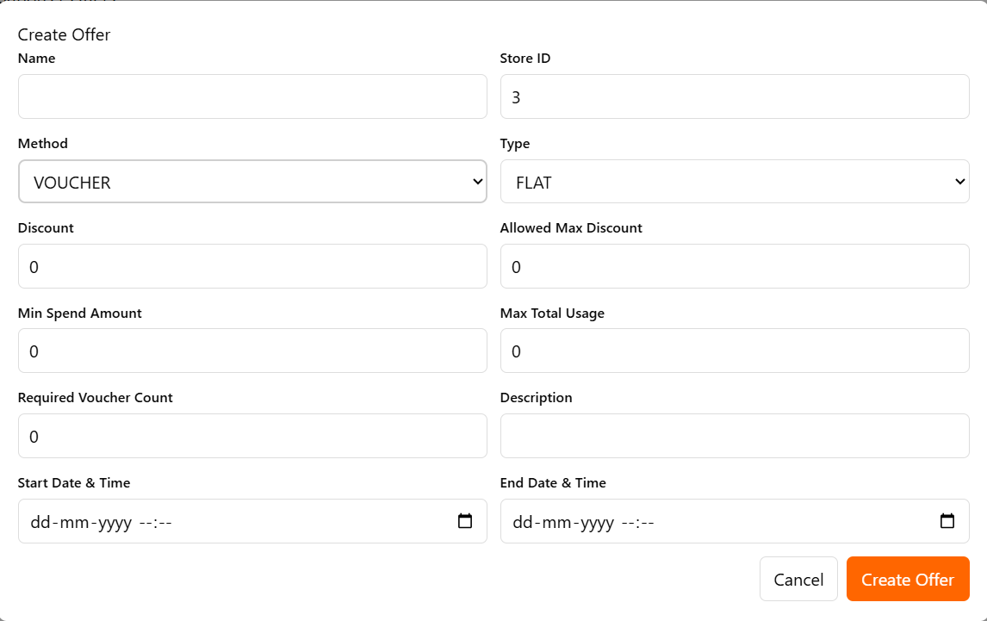

3. Offer Management Actions (Update, Toggle, Consumption)
- Update (Edit):
  - Clicking Edit opens the exact same form used for creation, pre-filled with the offer's existing details.
  - The administrator can modify any field (Name, Dates, Discount values, Code, etc.) and save the changes.
- Toggle Status:
  - The Toggle action instantly changes the offer's Status between Active and Not Active, allowing immediate pausing or resumption of the promotion.
- Consumption History:
  - The Consumption action opens a view detailing the usage history of that specific coupon or voucher.
- Delete:
  - Clicking Delete permanently removes the promotional offer record.

📊 Reports Module: Store Report Functionality
The Reports module is used to generate critical financial and transactional data based on specific criteria, allowing administrators to analyze store performance over a defined period.

1. Generating the Store Report
- Functionality: The primary function on this page is to Generate Store Report, which fetches transaction details for a single store within a specified date range.
- Input Criteria (Filtering): The administrator must provide three mandatory inputs:
  - Store UUID: The unique identifier for the target store
  - Start Date and End Date: The date range for which order data should be aggregated (e.g., 01-10-2025 to 27-10-2025).
- Process: Clicking the Generate Report button initiates the data retrieval process.
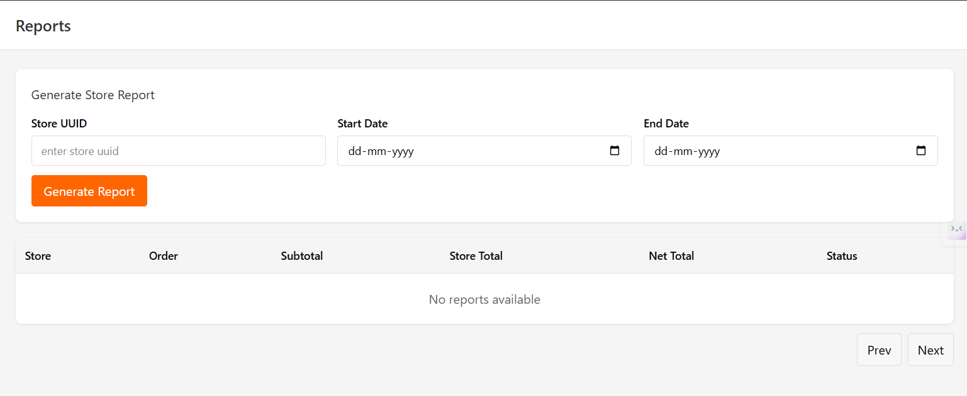

2. Report Data Display (Read)
- Functionality: Once the report is successfully generated, a detailed table lists each relevant order.
- Key Data Columns: The report provides a transactional breakdown for analysis:
  - Store: The name of the store.
  - Order: The unique order ID.
  - Subtotal: The item price before any taxes, fees, or discounts.
  - Store Total: The total revenue associated with the order before platform fees or adjustments.
  - Net Total: The final amount retained by the store after all refunds and commissions (can be negative if a full refund was processed).
  - Status: The final state of the order (e.g., REFUNDED, PARTIALLY_REFUNDED).
- Pagination: The report interface includes Prev and Next buttons for navigating through large result sets.

