**# CREATE FUNCTION**

USE AdventureWorks2017;

SELECT TOP(10)

p.FirstName, p.LastName, e.BirthDate,

dbo.GetEmployeeAge(BirthDate) EmployeeAge

FROM HumanResources.Employee e

INNER JOIN Person.Person p

ON E.BusinessEntityID = p.BusinessEntityID

**# SELECT QUERY RESULTS:**

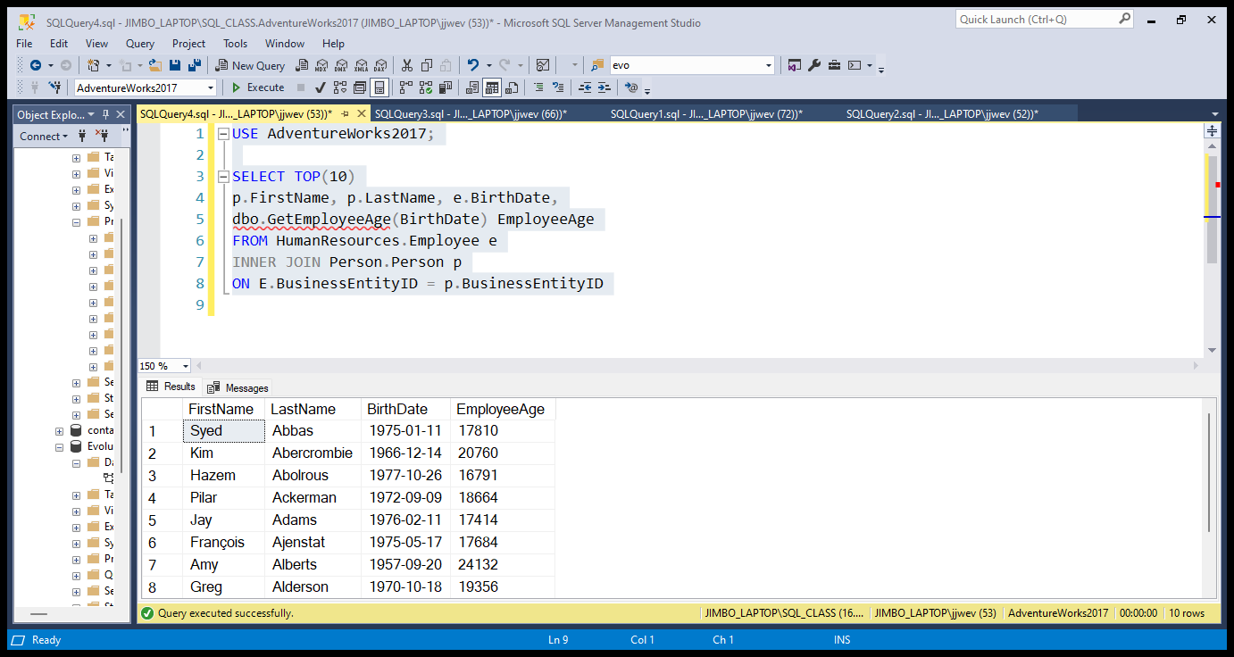

USE AdventureWorks2017

-- ================================================

SET ANSI_NULLS ON

GO

SET QUOTED_IDENTIFIER ON

GO

-- =============================================

-- Author: James W

-- Create date: 10/16/2023

-- Description: Scalar function that will be used to return employee age

-- =============================================

CREATE FUNCTION dbo.GetEmployeeAge

(

@BirthDate datetime

)

RETURNS int

AS

BEGIN

-- Declare the return variable here

DECLARE @Age int

-- Add T-SQL Statements to Compute Value

SELECT @Age = DATEDIFF(Day, @BirthDate, GetDate())

-- Return result of function

RETURN @Age

END

GO

**# ALTER FUNCTION:**

USE AdventureWorks2017

GO

DECLARE @Age int;

EXECUTE @Age = dbo.GetEmployeeAge @BirthDate = '5/26/1972'

SELECT @Age;

USE AdventureWorks2017

SELECT TOP(10)

p.FirstName, p.LastName, e.BirthDate,

dbo.GetEmployeeAge(BirthDate) EmployeeAge

FROM HumanResources.Employee e

INNER JOIN Person.Person p

ON e.BusinessEntityID = p.BusinessEntityID

**# EXECUTE FUNCTION**



