# Evolution Marketplace

# Final DB Project: Requirements & Design: Detailed Database Design

Instruction

This template provides the final detailed technical (infrastructure) specifications and design to address the business needs outlined in the *Project Charter* and the *Business Requirements Analysis*. The *High-Level Database Design Template* that was completed during the Inception phase of the project should be used as a starting point for this more detailed template.

If there are significant changes to requirements or design, this template should be updated accordingly and funding to support the changes should be verified and approved.

1. Project Overview

This project is intended as a way for me to personally implement what I have learned from class into my own life as an e-commerce database for online storewide sales. It is also intended for guest users to access to browse items. We will track sales from an omnichannel marketing e-commerce platform with a database administrator assigned as a user to administer tasks, schedule updates, and more. In this scenario, I would be the owner and data custodian to help us gain competitive advantage over other vendors within our niche category.

1.1 Objective

This database is intended as an inventory tracking system to ensure that my company shipments arrive and are marked as received by the buyer. The database also includes a way to connect as a guest account to anonymously access our recently shipped products.

1.2 Business Case

We are an e-commerce platform that uses omnichannel marking to advertise. We are currently in the process of setting up secure protocols for logging into our RDMS. We want to ensure that we achieve transparency between customer data in our current inventory database tracking system by limiting role access and user privileges.

1.3 Risks

SQL injection is going to be one of our largest concerns with the current schema we have developed, simply because we want to offer guest user’s the ability to login to certain portions of the database to view tracking information. We must ensure that we thoroughly apply techniques such as obfuscation to the table’s displayed to the guest user account to protect the personally identifiable information of other people. We can do this by enforcing access control mechanisms for the guest account to deny them the ability to view sensitive material related to our business and/or customers.

Secondly, there is a lot of competition, so our company is still in the process of delineating customer information within the database to deploy our marketing strategy. With, we will need enough money in order to gain leverage. Thirdly, we are currently selling a diverse number of products. It would be wise for us to zone in on a single niche to maximize our net profit.

1.4 Out of Scope

Anything out of scope pertaining to our project is directly related to the articles contained within the Computer Crime Fraud and Abuse act, fraud, deceit, gambling, and related criminalized online activity in connection with 18 U.S.C. Code - 1030(a).

**3. Detailed Design of the Database**

We will be using a dedicated server to host our internal infrastructure and segmenting this information on a different network that maintains a connection with MySQL. We will be using a stored procedure function that updates the information for the end-user based on the shipping status. For our database administrators, we will be using the other half of our database design to enforce security via segmentation. We will be using a well detailed and outlined differential backup plan to ensure our company’s information is backed up appropriately. In addition, we will use cloud-based services to scale out other resources in encrypted parts of the database that may overwhelm our dedicated server with bandwidth and/or protect us from corporate espionage via trade secrets being taken.

3.1 Database Objects

Table Name: Address

|  |  |  |  |  |
| --- | --- | --- | --- | --- |
| **Field** | **Type** | **Nullable** | **Description** | **Default** |
| Address_ID | Primary Key (int) | N | Unique identifier for customer address. | Y |
| Customer_ID | Foreign_Key (int) | N | Keypair to join back to the address table, | Y |
| State | Demographical | N | State where the customer lives | Y |
| Zip | Personal | N | Zip code used for the address table. | Y |
| Street | Personal | N | Street or P.O. Box | Y |
| City | Demographical | N | City name of the customer. | Y |
| Name | Personal | N | Customer name. | Y |

Table Name: Customers

|  |  |  |  |  |
| --- | --- | --- | --- | --- |
| **Field** | **Type** | **Nullable** | **Description** | **Default** |
| Customer_id | Personal | N | Primary key for the customer table. | Y |
| User_Name | Public | N | The username of the buyer. | Y |
| Customer_rating | Public | Y | Customer can leave a rating on website. | N |

Table Name: Orders

|  |  |  |  |  |
| --- | --- | --- | --- | --- |
| **Field** | **Type** | **Nullable** | **Description** | **Default** |
| Order_ID | Unique | N | Primary key for orders table. | Y |
| Customer_ID | Unique | N | Foreign key #1 for orders table. | Y |
| Product_ID | Unique | N | Foreign key #2 for orders table. | Y |
| Order_Date | Public | N | The day and time the user purchased the order. | Y |
| Order_Total | Public | N | The price (after shipping & fees) of the product. | Y |

**Indexes**

PK_orders_Clustered Index

Trigger/Stored Procedure Code:

|  |
| --- |
| Object Name: Order_Total |
| The amount received after deduction of taxes. |

4. Resource Needs

Identify the staff resources needed to successfully complete this project. Also identify the staff, technical, and other resource dependencies that should be considered. Put database users, roles, and passwords to access the database.

* **Staff Resources:**

1. Role: DBA - We will require a database administrator with a very clean track record who has had experience with order inventory management systems and their correlation to relational databases. They must be able to regularly perform maintenance on the database and be knowledgeable in database security so that personally identifiable information related to buyer information (i.e., metadata) is not exposed.

* We will use a guest account during first phase of the SDLC for our database as a template while we ensure to enforce rigorous security checks, constraints, and utilize data integrity techniques. We will be doing this by reformatting the structure of the currently proposed design to setup a separate databank to use for collecting customer information to cross reference with competitors based on cookie tracking services.
* Staff Dependencies: A database administrator will be required to provide upkeep for the database.
* Technical Dependencies: We currently are dependent on a skeleton design of the precursor to our final maintenance stages, where we will sanitize the data properly. We are also reliant on a network/dedicated server that will help us ensure the security and speed of which data is accessed throughout our catalog of products.
* Other Dependencies

5. Assumptions

Enumerate all additional assumptions that will impact the technical design, documentation, and cost estimate for this project: Funding, lack of security database engineer, delays in data migration for customers and products that may cause the documentation to change rapidly. We will be using an agile approach to design this project, so it is imperative that our team works as fast as possible to ensure the upmost integrity of data and protection of confidentiality/availability of product and/or tracking information.

6. Concerns and Issues

Enumerate all additional concerns and issues that may impact the technical design, documentation, or cost estimate for this project.: Backlog and lag between the inhouse RDMS system and our server architecture which may cause delays on the main website when updating the tracking information. We may have to spend a lot of money upfront in order to brand our website for the database to even become populated with customer information in the first place because of the growth in e-commerce over the years. Finally, security is major concern for us and should be taken seriously. I am concerned that there is a guest account with access to certain information that could potentially lead to privilege escalation via SQL injection or another form of attack that is intended to steal trade secrets and personally identifiable information.

**7. Projected Costs**

**Startup costs:** $50,000

**TCO**: $150,000 (assuming three year lifecycle of project)

**Estimation of ROI**: $214,000 (estimation)

**Document Tracking**

The following chart is used to log of all changes made to this document.

| **Version** | **Date of edit/change** | **Who made the edit/change** | **Description of edit/change** |
| --- | --- | --- | --- |
| 1 | 12/7/2023 | James | Documentation of database design and explanation of its functionality as well as the DDD in the form of an ERD. |

**Database Design Document (DDD):**

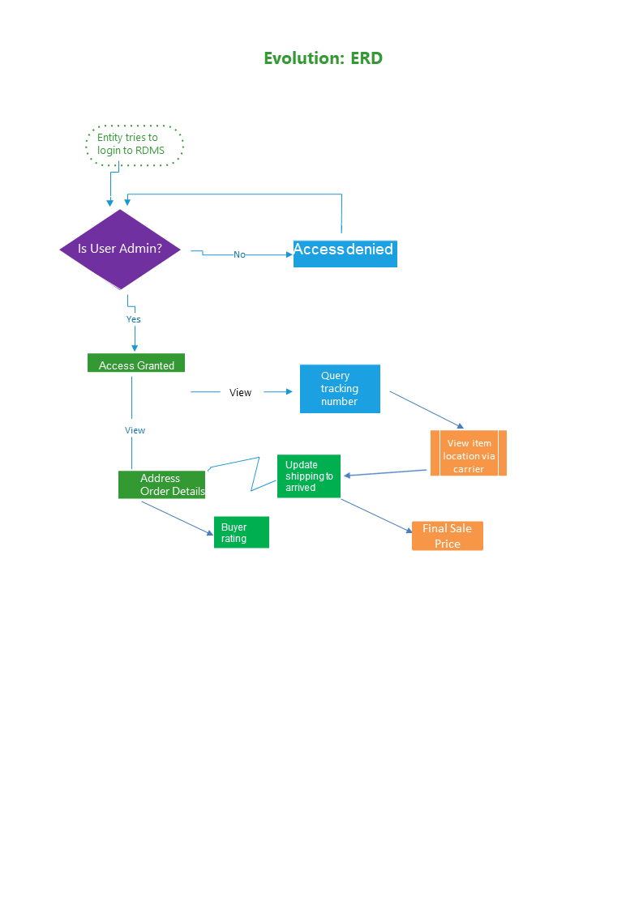

**Maintenance Plan (See attached photo):**

We will be using an automated incremental backup technique for days that we deem to be most profitable to the company while it is offline. In addition to this, we will consistently be updating data input validation checks, rules, and constraints to ensure overall integrity of the information presented to our customers. Once per month, we will have our company’s internal infrastructure (if any) that is outward facing to the public penetration tested to ensure that it is not vulnerable to any type of malicious attack.

This will be used to automate many of our maintenance tasks such as backing up data, updating services, and for data validation purposes. **Maintenance occurs every week on Sunday at 12:00:00 AM E.S.T.** and the Schedule will be used starting on **12/7/2023.**

We can enforce this security measurement by also using ABA to monitor the traffic to our website during our first year of operation to demographically allocate our information services in areas that will expedite the speed at which our database administrators can work, as well as improving the accuracy and reliability of the shipping times by incorporating metadata into our relational fields. We will also have a preconfigured local backup hosted onsite at the Immortality Marketplace facility where information is uploaded to an offline segmented intranet. Most of this information will be sensitive information of which we plan to remove from preexisting fields through striving to achieve the highest level of normalization. Integrity checks will be emphasized upon heavily and done twice a week at the same time as our incremental backup on an alternating day of the week (Saturday).



