Next-Tick Signals Across Eurex Bond Futures
A Cross-Instrument Comparison: Bund, Bobl, Buxl, BTP and OAT
Quantitative Research — Eurex Fixed-Income Futures · June 2026

Executive Summary
The same microstructure next-tick model — ninety order-book, trade-flow and cross-instrument features feeding a transparent linear regression — was fitted and evaluated identically across the five core Eurex bond futures. The signal generalises across the curve, with a clear liquidity gradient: it is strongest for the liquid German core (Bund and Bobl) and weaker, though still clearly skilful, for the longer-dated Buxl and the French/Italian contracts. In every case in-sample and out-of-sample performance are close (no over-fitting), and the order-book imbalance is the dominant predictor. The caveats established for Bund apply throughout: the predictability is concentrated at very short, near-mechanical horizons, so these are high-quality directional signals rather than demonstrated trading strategies.

1. Cross-Instrument Comparison
Instrument | d_max | R² in | R² out | Sign-acc in | Sign-acc out | Top-group share
Euro-Bund | 200 | 0.745 | 0.733 | 92.5% | 92.3% | Order-book imbalance 44%
Euro-Bobl | 300 | 0.739 | 0.731 | 92.2% | 92.3% | Order-book imbalance 41.8%
Euro-Buxl | 200 | 0.617 | 0.644 | 88% | 89.3% | Order-book imbalance 55%
Euro-BTP | 200 | 0.52 | 0.508 | 83.7% | 83.5% | Order-book imbalance 57.5%
Euro-OAT | 200 | 0.496 | 0.508 | 82.6% | 83.5% | Order-book imbalance 54.5%
Table 1. Full-model performance across instruments, in and out of sample. RMSE is omitted as it is in each instrument's own ticks (not comparable). The dominant feature group is the order-book imbalance everywhere.
The ordering tracks liquidity and tick economics: the German core (Bund, Bobl) achieves the highest accuracy and explained variance, the 30-year Buxl sits in the middle, and the French and Italian contracts (OAT, BTP) are the weakest — but all remain well above a coin flip, and all hold up out-of-sample.

2. Per-Instrument Summaries
Each instrument is summarised below with its single-feature correlations (importance) and its book-versus-signal behaviour. Full standalone reports are available per instrument.

2.1 Euro-Bund (FGBL)
Out-of-sample sign accuracy 92.3%, R² 0.733; in-sample 92.5%. The order-book imbalance correlates 0.847 with the next-tick target and the order-book imbalance family contributes the largest share (44%) of explained variance. Target: 99.94% one-tick moves; modelled rows 35,60,772 in / 36,49,184 out; d_max 200.
Metric | Full (90) · in | Full · out | Stepwise (78) · in | Stepwise · out
RMSE (ticks) | 0.506 | 0.518 | 0.506 | 0.518
R² | 0.745 | 0.733 | 0.745 | 0.733
wRMSE | 0.413 | 0.431 | 0.413 | 0.431
P×A | 0.748 | 0.737 | 0.748 | 0.737
wP×A | 0.828 | 0.817 | 0.828 | 0.817
Sign accuracy | 92.5% | 92.3% | 92.5% | 92.2%
Weighted sign accuracy | 95.6% | 95.3% | 95.6% | 95.3%
Accuracy | 92.5% | 92.3% | 92.5% | 92.2%
Precision | 92.4% | 92.3% | 92.4% | 92.3%
Recall | 92.5% | 92.3% | 92.5% | 92.3%
F1 | 0.925 | 0.923 | 0.925 | 0.923
Table 2. Headline metrics for Euro-Bund — full and stepwise models, in- and out-of-sample (metrics as rows). RMSE is in this instrument's own ticks (not comparable across instruments); “P×A” is the mean product of predicted and realised move, “w” the proximity-weighted variant. Accuracy, precision and recall coincide with sign accuracy to ~3 significant figures given the balanced target.
Feature group | Standalone R² | Share of explained variance
Order-book imbalance | 0.718 | 44%
Quote-price momentum | 0.553 | 28%
Depth-price momentum | 0.47 | 23.5%
Intraday drift | 0.1 | 3.4%
Cross-instrument lead-lag | 0.013 | 0.6%
Net trade intensity | 0.002 | 0.4%
Table 3. Feature-group contributions for Euro-Bund (in-sample). Standalone R² uses only that family's features; the share splits the model's explained variance fairly across families and sums to 100%.
Keep |signal| > | 0.25 | 0.5 | 0.75 | 1 | 1.25 | 1.5
Coverage | 91.6% | 81.1% | 64.9% | 30% | 2.3% | 0.3%
Sign accuracy (out) | 95.02% | 96.88% | 98.16% | 98.72% | 94.36% | 77.15%
Table 4. Cumulative accuracy/coverage by confidence threshold for Euro-Bund (out-of-sample): keeping only events whose signal strength exceeds each threshold — confident signals are more reliable on a smaller share of events.
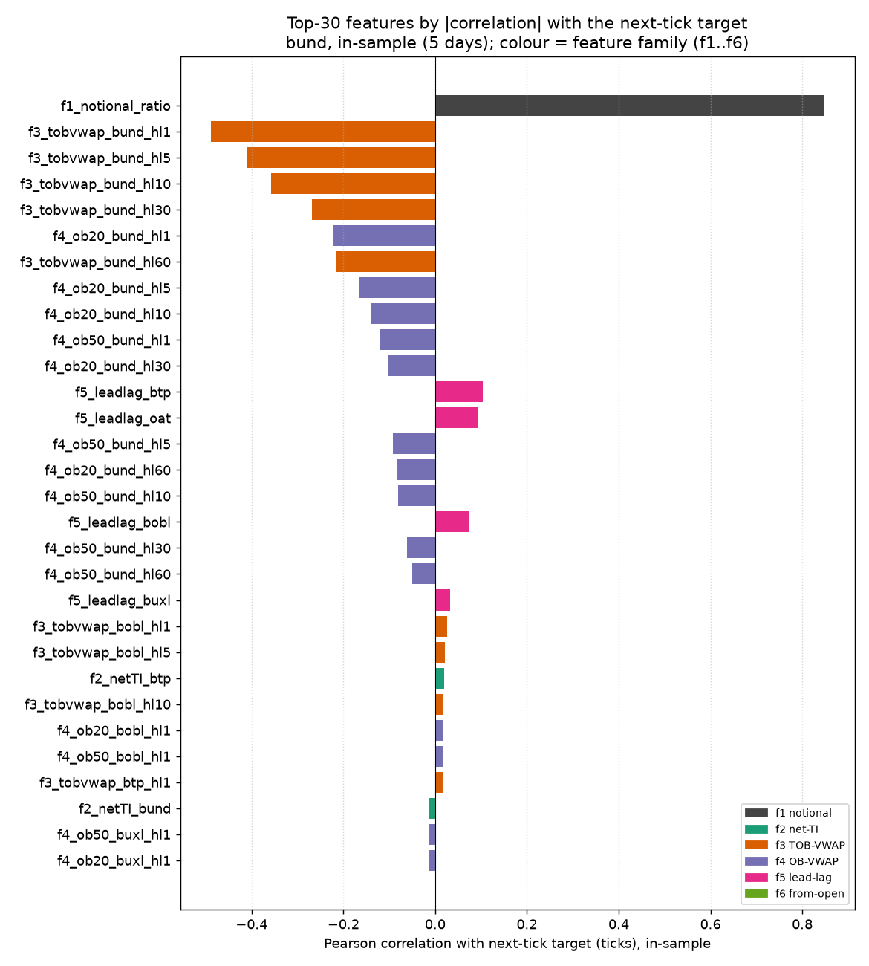
Figure 1. Euro-Bund: top features by absolute correlation with the next-tick target (in-sample).
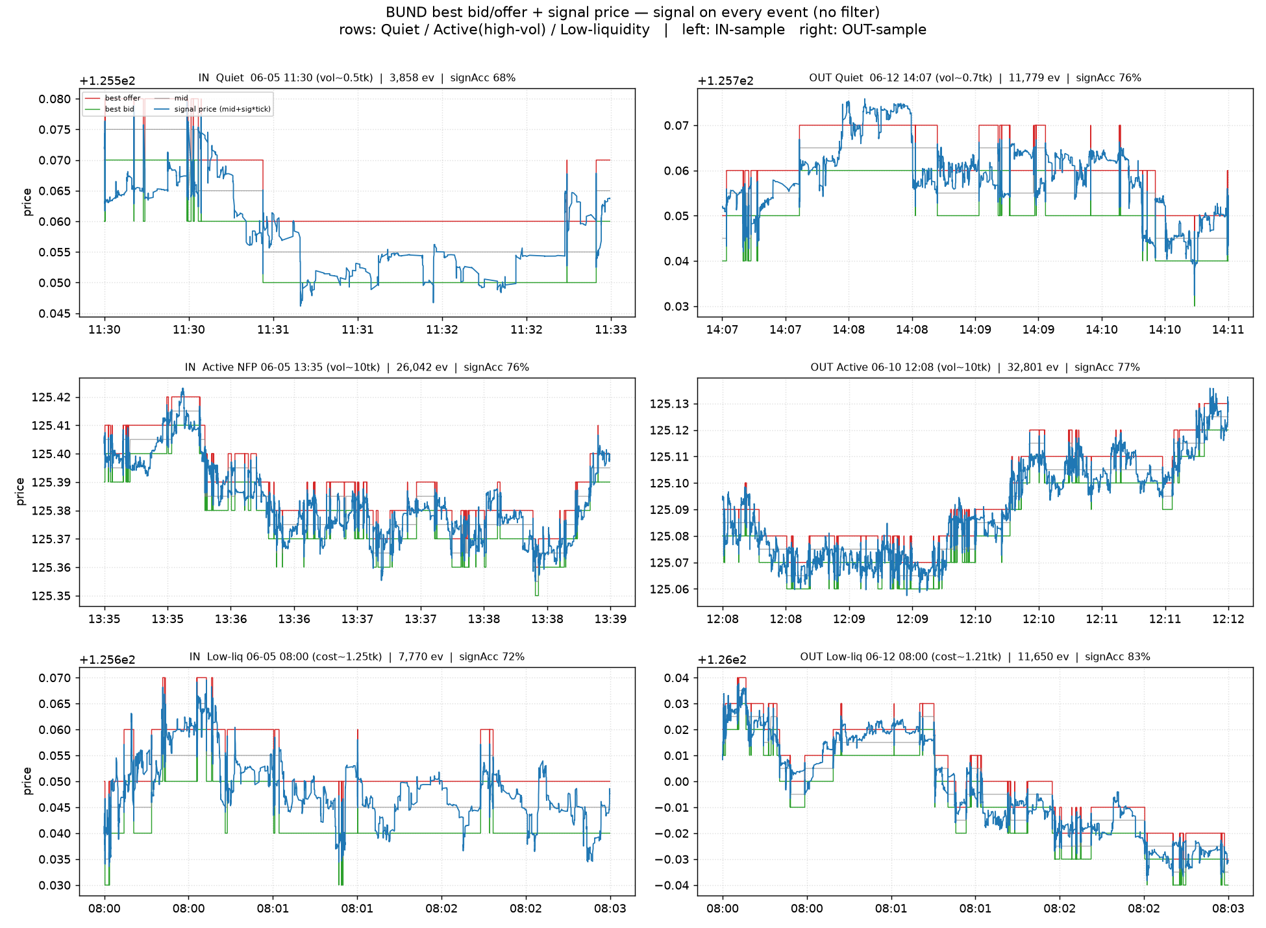
Figure 2. Euro-Bund: best bid/offer and signal price across regimes (rows) and in/out-sample (columns).

2.2 Euro-Bobl (FGBM)
Out-of-sample sign accuracy 92.3%, R² 0.731; in-sample 92.2%. The order-book imbalance correlates 0.843 with the next-tick target and the order-book imbalance family contributes the largest share (41.8%) of explained variance. Target: 99.98% one-tick moves; modelled rows 19,16,752 in / 20,35,112 out; d_max 300.
Metric | Full (90) · in | Full · out | Stepwise (78) · in | Stepwise · out
RMSE (ticks) | 0.511 | 0.518 | 0.511 | 0.519
R² | 0.739 | 0.731 | 0.739 | 0.731
wRMSE | 0.417 | 0.433 | 0.417 | 0.434
P×A | 0.739 | 0.735 | 0.739 | 0.735
wP×A | 0.82 | 0.813 | 0.82 | 0.813
Sign accuracy | 92.2% | 92.3% | 92.2% | 92.3%
Weighted sign accuracy | 95.4% | 95.1% | 95.4% | 95.1%
Accuracy | 92.2% | 92.3% | 92.2% | 92.3%
Precision | 92.3% | 92.8% | 92.3% | 92.8%
Recall | 91.9% | 91.8% | 91.9% | 91.8%
F1 | 0.921 | 0.923 | 0.921 | 0.923
Table 5. Headline metrics for Euro-Bobl — full and stepwise models, in- and out-of-sample (metrics as rows). RMSE is in this instrument's own ticks (not comparable across instruments); “P×A” is the mean product of predicted and realised move, “w” the proximity-weighted variant. Accuracy, precision and recall coincide with sign accuracy to ~3 significant figures given the balanced target.
Feature group | Standalone R² | Share of explained variance
Order-book imbalance | 0.71 | 41.8%
Quote-price momentum | 0.59 | 29.4%
Depth-price momentum | 0.508 | 24.9%
Intraday drift | 0.08 | 2.8%
Cross-instrument lead-lag | 0.019 | 0.8%
Net trade intensity | 0.005 | 0.4%
Table 6. Feature-group contributions for Euro-Bobl (in-sample). Standalone R² uses only that family's features; the share splits the model's explained variance fairly across families and sums to 100%.
Keep |signal| > | 0.25 | 0.5 | 0.75 | 1 | 1.25 | 1.5
Coverage | 91.1% | 80.2% | 65.2% | 30.4% | 2% | 0.3%
Sign accuracy (out) | 95.1% | 96.89% | 98.01% | 98.6% | 95.43% | 85.74%
Table 7. Cumulative accuracy/coverage by confidence threshold for Euro-Bobl (out-of-sample): keeping only events whose signal strength exceeds each threshold — confident signals are more reliable on a smaller share of events.
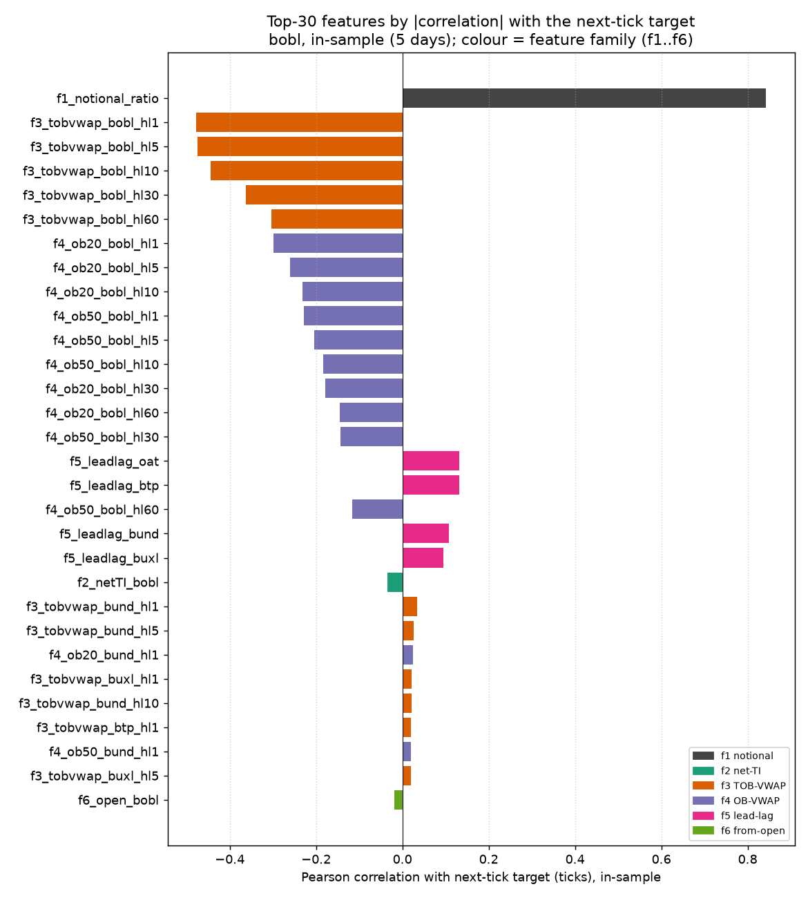
Figure 3. Euro-Bobl: top features by absolute correlation with the next-tick target (in-sample).
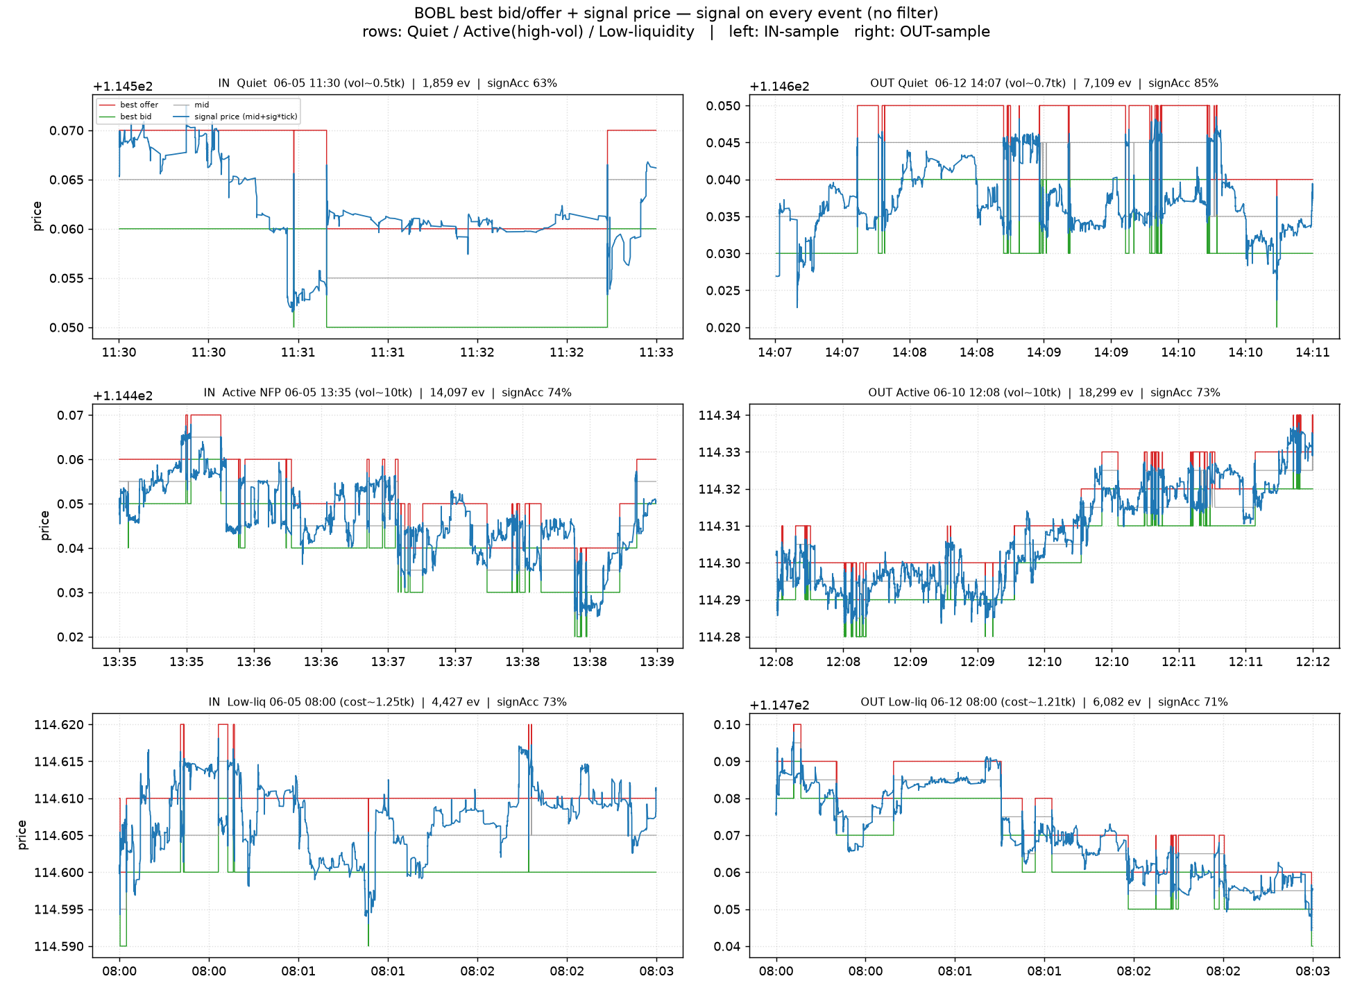
Figure 4. Euro-Bobl: best bid/offer and signal price across regimes (rows) and in/out-sample (columns).

2.3 Euro-Buxl (FGBX)
Out-of-sample sign accuracy 89.3%, R² 0.644; in-sample 88%. The order-book imbalance correlates 0.779 with the next-tick target and the order-book imbalance family contributes the largest share (55%) of explained variance. Target: 99.97% one-tick moves; modelled rows 18,48,426 in / 18,43,247 out; d_max 200.
Metric | Full (90) · in | Full · out | Stepwise (70) · in | Stepwise · out
RMSE (ticks) | 0.619 | 0.597 | 0.619 | 0.597
R² | 0.617 | 0.644 | 0.617 | 0.644
wRMSE | 0.523 | 0.511 | 0.523 | 0.511
P×A | 0.618 | 0.649 | 0.618 | 0.649
wP×A | 0.712 | 0.735 | 0.712 | 0.735
Sign accuracy | 88% | 89.3% | 88% | 89.3%
Weighted sign accuracy | 92.3% | 92.9% | 92.3% | 92.9%
Accuracy | 88% | 89.3% | 88% | 89.3%
Precision | 87.8% | 89.2% | 87.8% | 89.2%
Recall | 88.4% | 89.5% | 88.4% | 89.5%
F1 | 0.881 | 0.893 | 0.881 | 0.893
Table 8. Headline metrics for Euro-Buxl — full and stepwise models, in- and out-of-sample (metrics as rows). RMSE is in this instrument's own ticks (not comparable across instruments); “P×A” is the mean product of predicted and realised move, “w” the proximity-weighted variant. Accuracy, precision and recall coincide with sign accuracy to ~3 significant figures given the balanced target.
Feature group | Standalone R² | Share of explained variance
Order-book imbalance | 0.606 | 55%
Quote-price momentum | 0.429 | 37.9%
Depth-price momentum | 0.012 | 4.4%
Cross-instrument lead-lag | 0.025 | 1.5%
Intraday drift | 0.013 | 0.7%
Net trade intensity | 0 | 0.5%
Table 9. Feature-group contributions for Euro-Buxl (in-sample). Standalone R² uses only that family's features; the share splits the model's explained variance fairly across families and sums to 100%.
Keep |signal| > | 0.25 | 0.5 | 0.75 | 1 | 1.25 | 1.5
Coverage | 87.2% | 72.6% | 54.1% | 26.8% | 2% | 0.2%
Sign accuracy (out) | 93.27% | 95.63% | 97.12% | 97.95% | 94.25% | 69.54%
Table 10. Cumulative accuracy/coverage by confidence threshold for Euro-Buxl (out-of-sample): keeping only events whose signal strength exceeds each threshold — confident signals are more reliable on a smaller share of events.
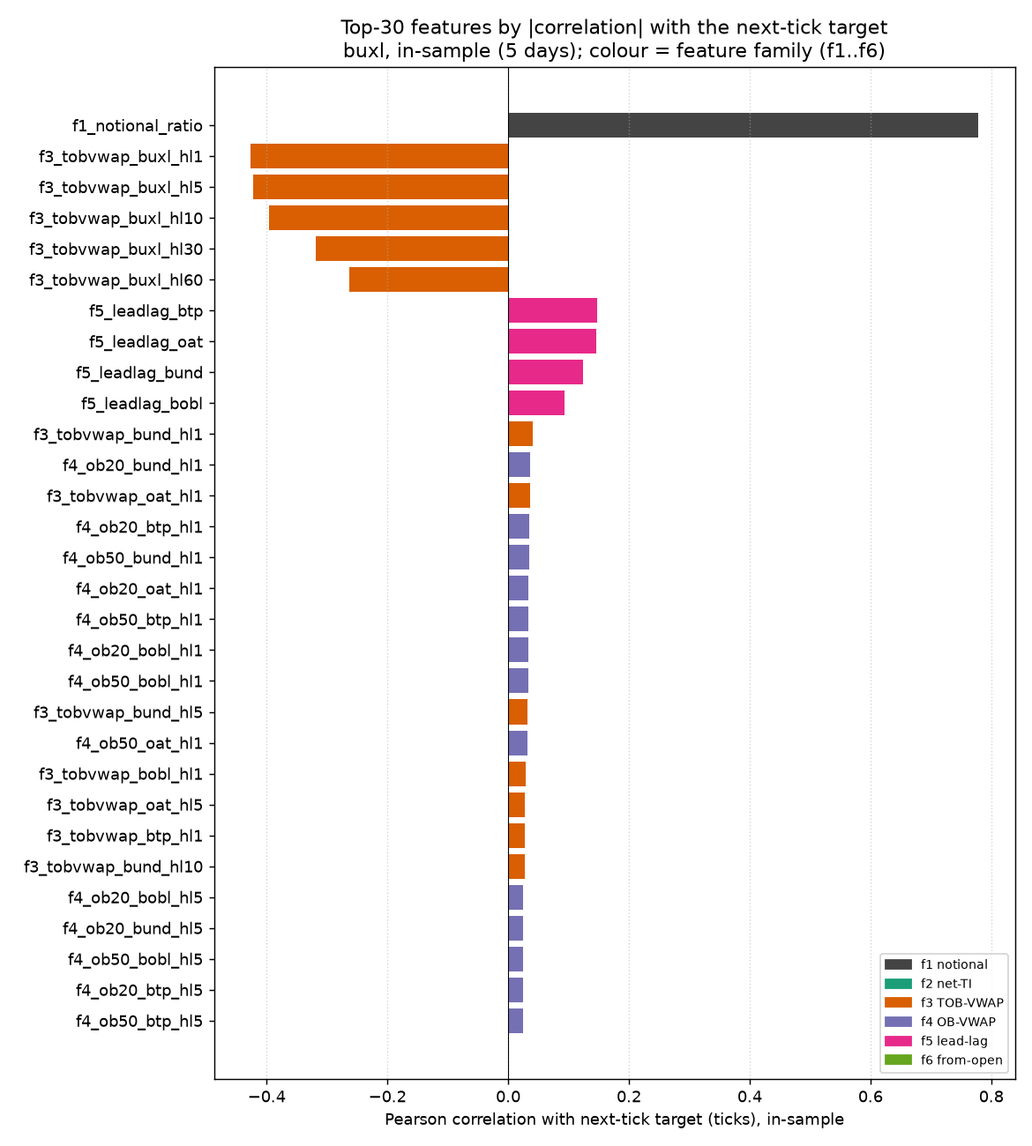
Figure 5. Euro-Buxl: top features by absolute correlation with the next-tick target (in-sample).
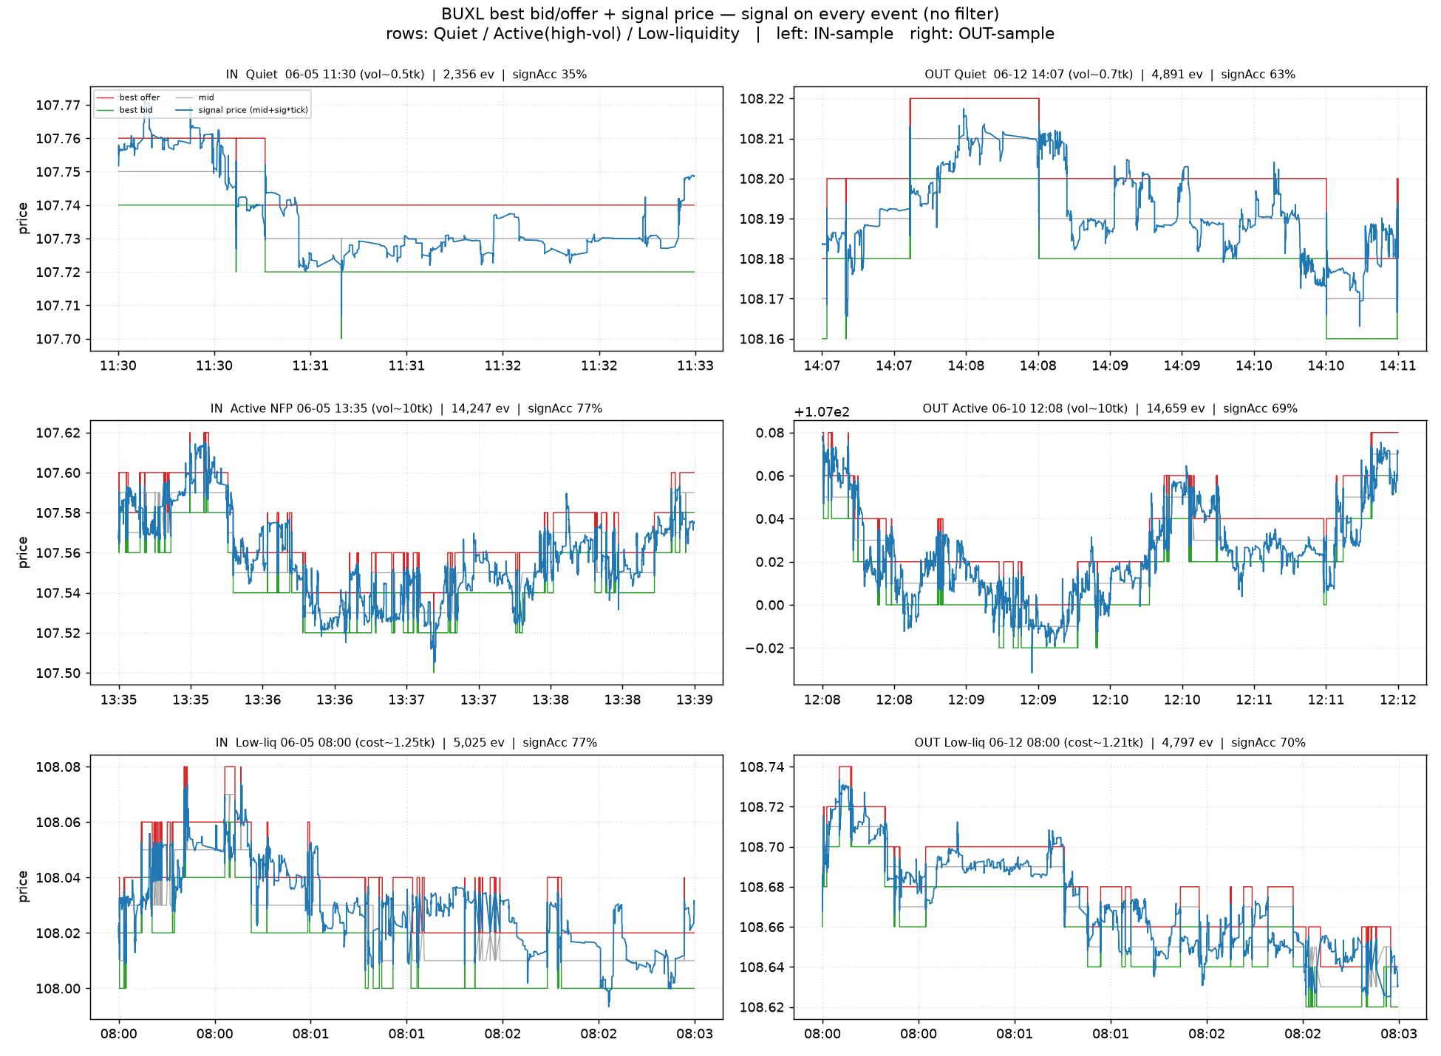
Figure 6. Euro-Buxl: best bid/offer and signal price across regimes (rows) and in/out-sample (columns).

2.4 Euro-BTP (FBTP)
Out-of-sample sign accuracy 83.5%, R² 0.508; in-sample 83.7%. The order-book imbalance correlates 0.714 with the next-tick target and the order-book imbalance family contributes the largest share (57.5%) of explained variance. Target: 99.91% one-tick moves; modelled rows 36,96,734 in / 36,61,662 out; d_max 200.
Metric | Full (90) · in | Full · out | Stepwise (78) · in | Stepwise · out
RMSE (ticks) | 0.694 | 0.703 | 0.694 | 0.703
R² | 0.52 | 0.508 | 0.52 | 0.508
wRMSE | 0.591 | 0.605 | 0.591 | 0.605
P×A | 0.522 | 0.513 | 0.522 | 0.513
wP×A | 0.619 | 0.607 | 0.619 | 0.607
Sign accuracy | 83.7% | 83.5% | 83.7% | 83.5%
Weighted sign accuracy | 88.9% | 88.6% | 88.9% | 88.6%
Accuracy | 83.7% | 83.5% | 83.7% | 83.5%
Precision | 83.5% | 83.3% | 83.5% | 83.3%
Recall | 83.9% | 83.9% | 83.9% | 83.9%
F1 | 0.837 | 0.836 | 0.837 | 0.836
Table 11. Headline metrics for Euro-BTP — full and stepwise models, in- and out-of-sample (metrics as rows). RMSE is in this instrument's own ticks (not comparable across instruments); “P×A” is the mean product of predicted and realised move, “w” the proximity-weighted variant. Accuracy, precision and recall coincide with sign accuracy to ~3 significant figures given the balanced target.
Feature group | Standalone R² | Share of explained variance
Order-book imbalance | 0.51 | 57.5%
Quote-price momentum | 0.308 | 33.2%
Depth-price momentum | 0.039 | 7.6%
Cross-instrument lead-lag | 0.009 | 0.9%
Net trade intensity | 0 | 0.4%
Intraday drift | 0.005 | 0.4%
Table 12. Feature-group contributions for Euro-BTP (in-sample). Standalone R² uses only that family's features; the share splits the model's explained variance fairly across families and sums to 100%.
Keep |signal| > | 0.25 | 0.5 | 0.75 | 1 | 1.25 | 1.5
Coverage | 85.1% | 66.9% | 42.9% | 13.7% | 0.4% | 0%
Sign accuracy (out) | 87.89% | 91.61% | 94.76% | 96.47% | 89.51% | 73.93%
Table 13. Cumulative accuracy/coverage by confidence threshold for Euro-BTP (out-of-sample): keeping only events whose signal strength exceeds each threshold — confident signals are more reliable on a smaller share of events.
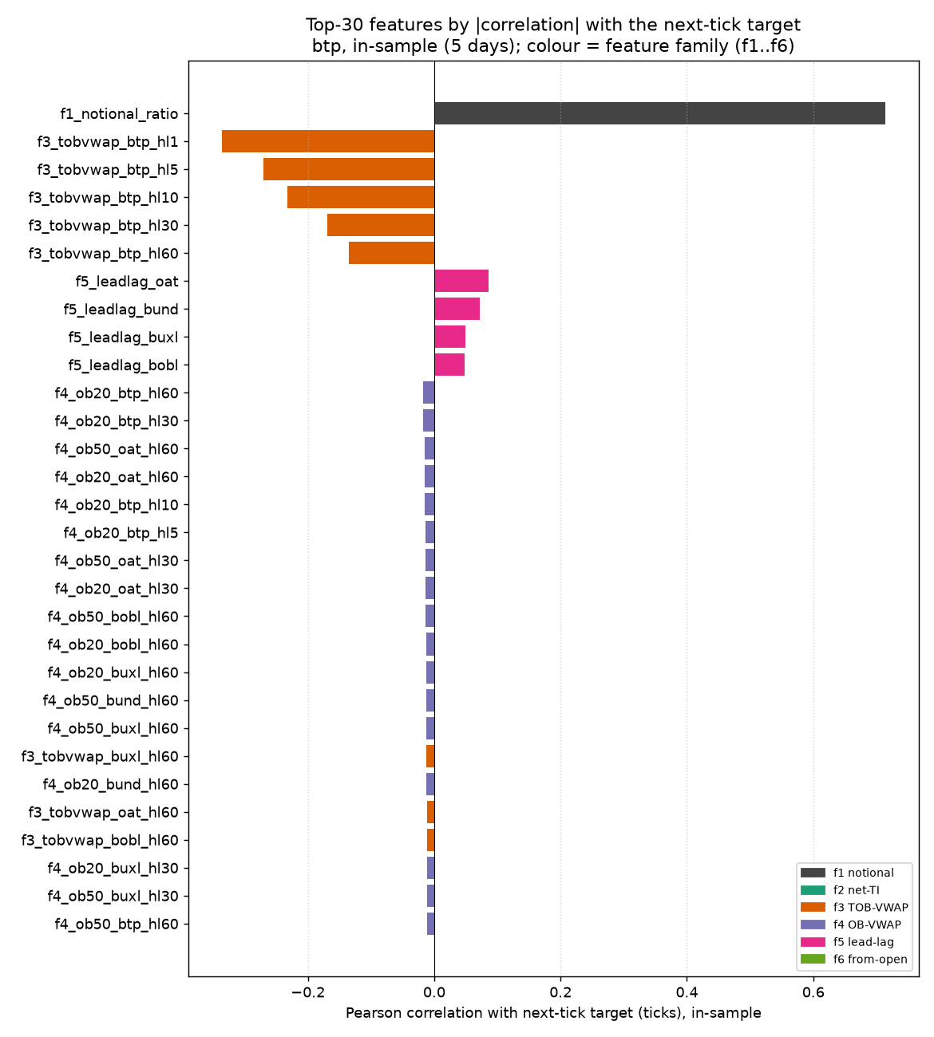
Figure 7. Euro-BTP: top features by absolute correlation with the next-tick target (in-sample).
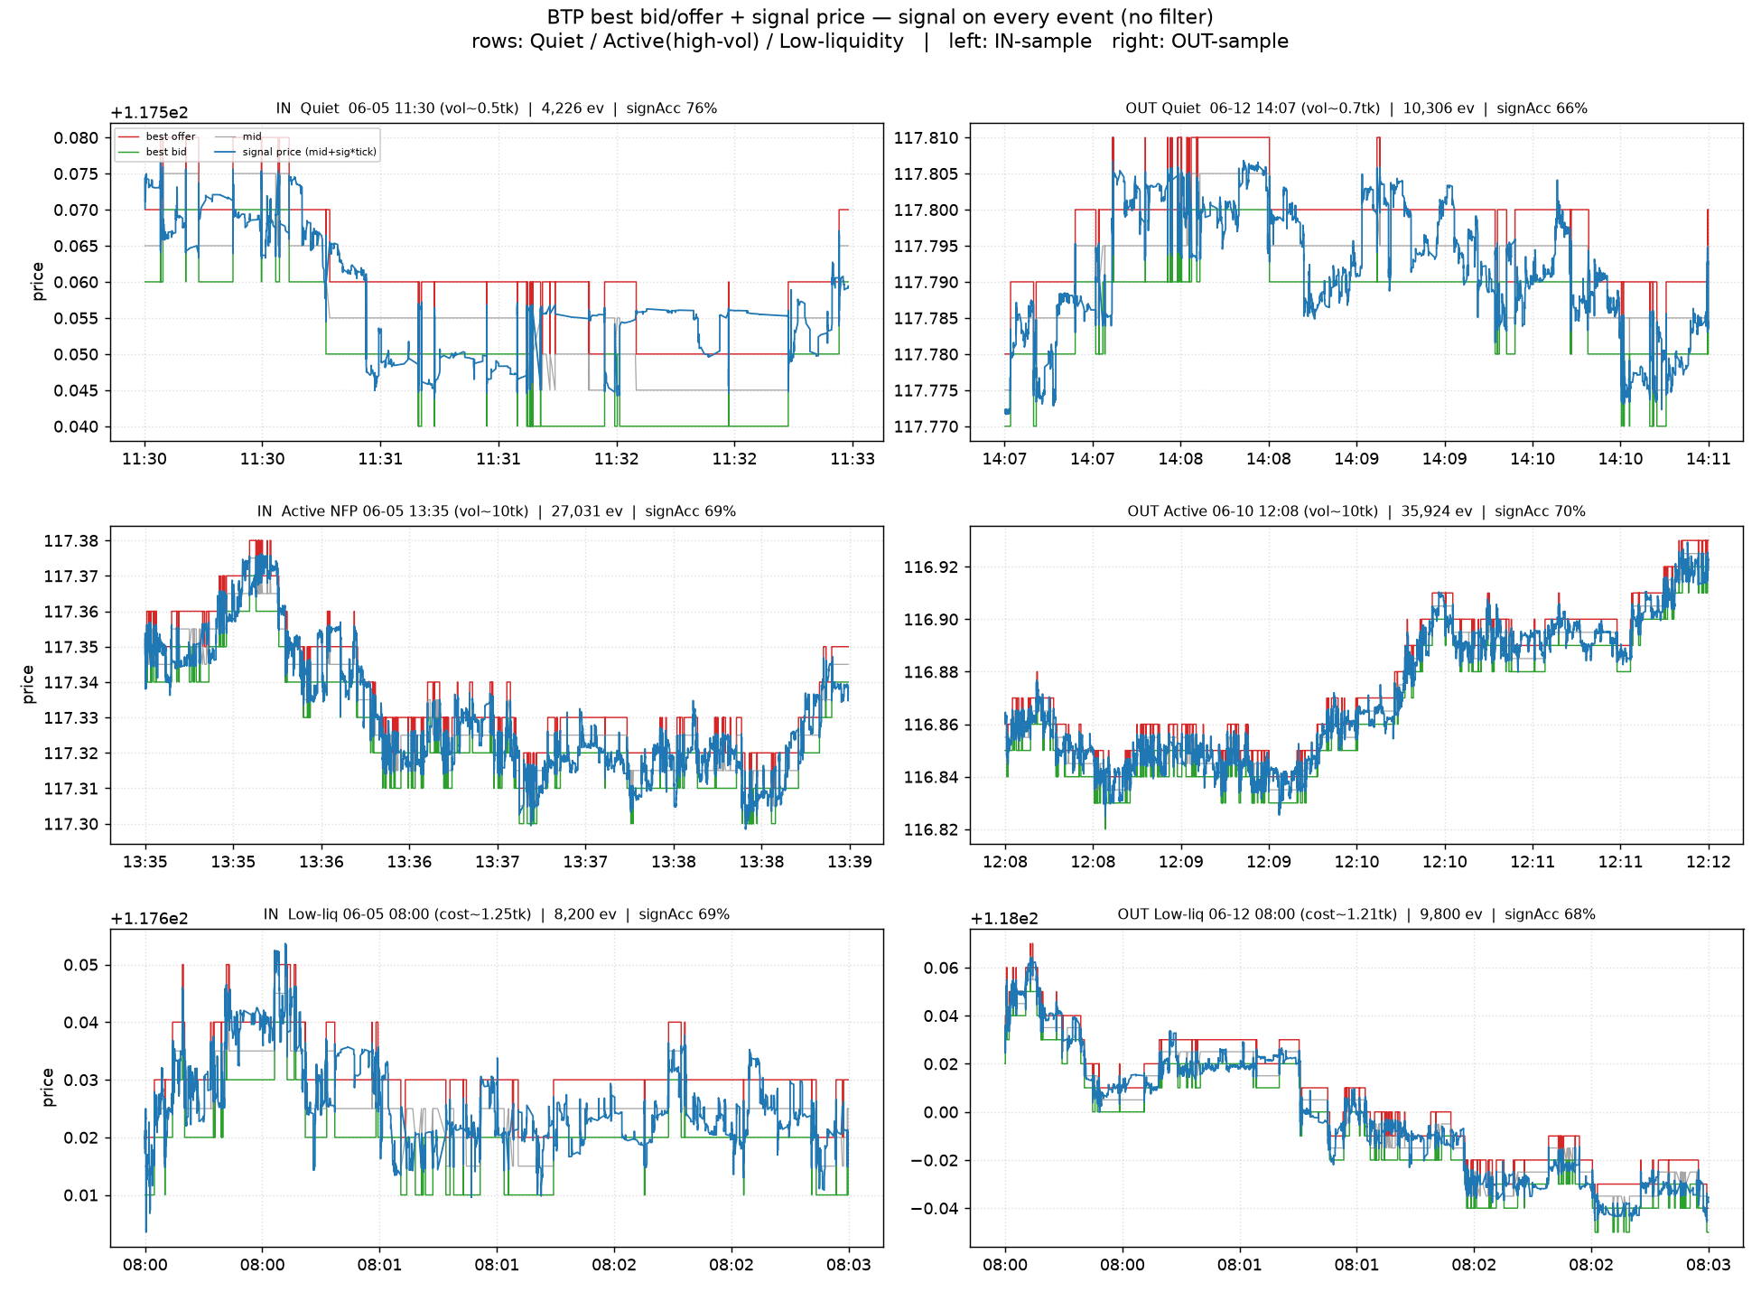
Figure 8. Euro-BTP: best bid/offer and signal price across regimes (rows) and in/out-sample (columns).

2.5 Euro-OAT (FOAT)
Out-of-sample sign accuracy 83.5%, R² 0.508; in-sample 82.6%. The order-book imbalance correlates 0.694 with the next-tick target and the order-book imbalance family contributes the largest share (54.5%) of explained variance. Target: 99.95% one-tick moves; modelled rows 28,75,278 in / 30,10,048 out; d_max 200.
Metric | Full (90) · in | Full · out | Stepwise (78) · in | Stepwise · out
RMSE (ticks) | 0.711 | 0.702 | 0.711 | 0.702
R² | 0.496 | 0.508 | 0.496 | 0.508
wRMSE | 0.605 | 0.603 | 0.605 | 0.603
P×A | 0.497 | 0.506 | 0.497 | 0.506
wP×A | 0.596 | 0.6 | 0.596 | 0.6
Sign accuracy | 82.6% | 83.5% | 82.6% | 83.5%
Weighted sign accuracy | 88.3% | 88.7% | 88.3% | 88.7%
Accuracy | 82.6% | 83.5% | 82.6% | 83.5%
Precision | 82.2% | 83.4% | 82.2% | 83.3%
Recall | 83.1% | 83.8% | 83.1% | 83.8%
F1 | 0.827 | 0.836 | 0.827 | 0.836
Table 14. Headline metrics for Euro-OAT — full and stepwise models, in- and out-of-sample (metrics as rows). RMSE is in this instrument's own ticks (not comparable across instruments); “P×A” is the mean product of predicted and realised move, “w” the proximity-weighted variant. Accuracy, precision and recall coincide with sign accuracy to ~3 significant figures given the balanced target.
Feature group | Standalone R² | Share of explained variance
Order-book imbalance | 0.482 | 54.5%
Quote-price momentum | 0.322 | 33.5%
Depth-price momentum | 0.089 | 10.5%
Cross-instrument lead-lag | 0.009 | 0.9%
Net trade intensity | 0 | 0.4%
Intraday drift | 0.003 | 0.2%
Table 15. Feature-group contributions for Euro-OAT (in-sample). Standalone R² uses only that family's features; the share splits the model's explained variance fairly across families and sums to 100%.
Keep |signal| > | 0.25 | 0.5 | 0.75 | 1 | 1.25 | 1.5
Coverage | 85% | 68% | 43.1% | 10% | 0.4% | 0.1%
Sign accuracy (out) | 87.81% | 91.43% | 94.57% | 95.85% | 82.24% | 72.03%
Table 16. Cumulative accuracy/coverage by confidence threshold for Euro-OAT (out-of-sample): keeping only events whose signal strength exceeds each threshold — confident signals are more reliable on a smaller share of events.
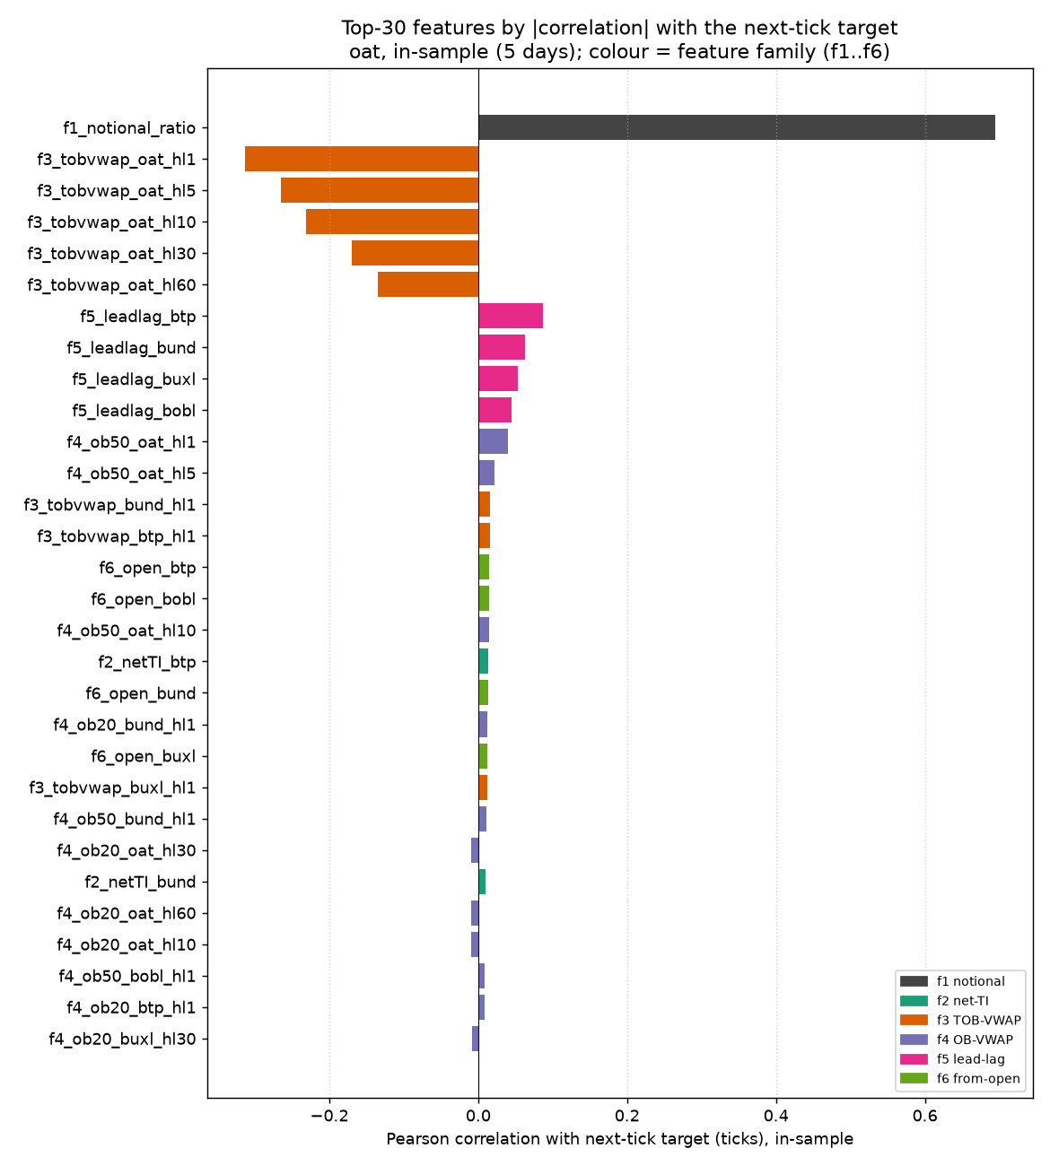
Figure 9. Euro-OAT: top features by absolute correlation with the next-tick target (in-sample).
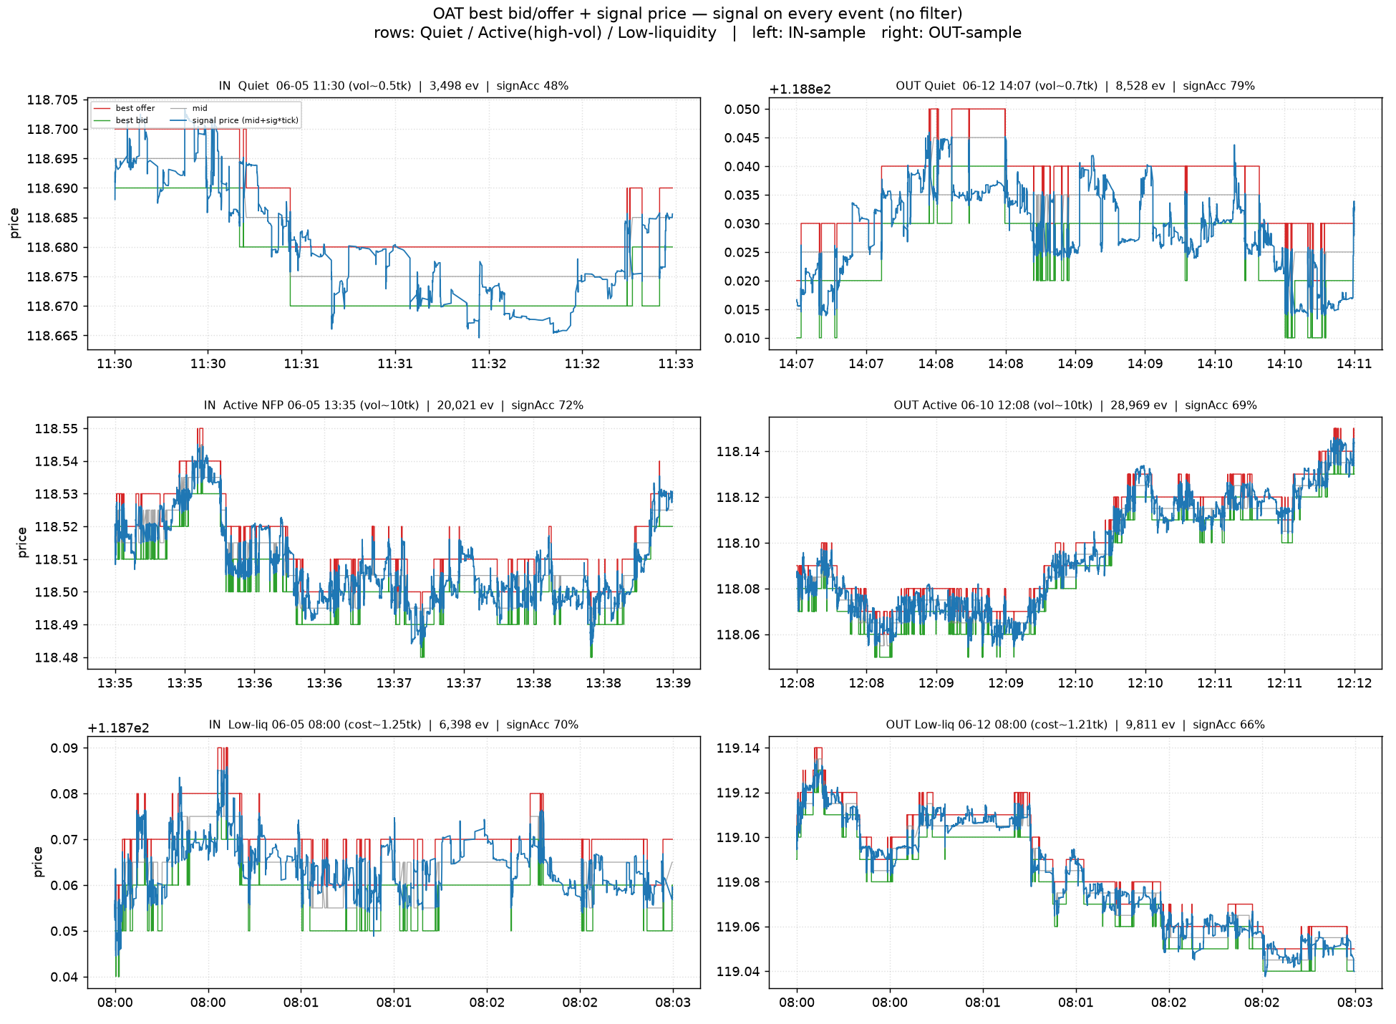
Figure 10. Euro-OAT: best bid/offer and signal price across regimes (rows) and in/out-sample (columns).

3. Methodology and Caveats
All instruments use an identical pipeline: events are top-of-book changes at a one-tick spread; the target is the signed next settled one-tick move; ninety standardised features feed an unweighted OLS regression (with a bidirectional-stepwise cross-check); estimation and evaluation use five in-sample and five strictly held-out days, one per weekday, over 08:00–17:00 London. Per-instrument the only differences are the target's own book (the modelled instrument), the lead-lag reset reference, the tick size, and the horizon cap (Bobl uses a larger cap to match its stickier mid).
Caveat. Across every instrument the high accuracy is concentrated at sub-second, near-mechanical horizons; the genuinely forward-looking skill is lower but still clearly above chance. These are calibrated directional signals, not demonstrated strategies — a tradeability assessment netting the bid-offer spread and queue dynamics is the necessary next step.

Appendix

A. The six feature families
Ninety features span six families, identical across all instruments in this study. Two are specific to the modelled instrument (its own order-book imbalance and the cross-instrument lead-lag reset); the others are computed across all five instruments, including the modelled one.
# | Family | Definition | Count
f1 | Order-book imbalance | Top-of-book notional (bid−ask)/(bid+ask), modelled instrument | 1
f2 | Net trade intensity | Signed trade flow, 5 s decay, all 5 instruments | 5
f3 | Quote-price momentum | Top-of-book VWAP vs its EWMA, 5 horizons × 5 instruments | 25
f4 | Depth-price momentum | Order-book VWAP at €20M/€50M vs EWMA, 5 horizons × 2 × 5 | 50
f5 | Cross-instrument lead-lag | Other 4 instruments’ move since the modelled instrument’s last move | 4
f6 | Intraday drift | Mid move since 07:00, all 5 instruments | 5
Table 17. The six feature families (90 features total). “EWMA” denotes an exponentially weighted moving average; the five momentum horizons are half-lives of 1, 5, 10, 30 and 60 seconds. All prices are normalised to ticks.
A note on the depth-price feature (f4). This measures the volume-weighted price to execute a fixed notional by walking the book. When the visible book cannot fill that size, we do not insert a zero (which would create a catastrophic artificial spike); instead we extrapolate the execution price from the available depth with a 50% spread penalty. This keeps the feature finite and on-scale in every state.

B. Evaluation metric definitions
Every metric is computed both in-sample and out-of-sample. The model is fitted by unweighted least squares on the raw signed target; the proximity weight (1.0 immediately before a move, decaying to 0.1 at the horizon cap) is an evaluation device only, used in the weighted metrics below to emphasise observations near a move.
Metric | Definition / interpretation
RMSE | Root mean squared error of the predicted move (ticks). Lower is better.
R² | Fraction of target variance explained. 0 = no skill, 1 = perfect.
Accuracy / Precision / Recall / F1 | Direction (up vs down) treated as classification.
Weighted RMSE | RMSE weighted toward observations nearest the move.
Mean(pred×actual) | Average product of predicted and realised move. Rewards correctly-signed conviction; does not penalise over-sizing.
Weighted mean(pred×actual) | As above, weighted toward near-the-move observations.
Sign accuracy | Fraction of events whose predicted direction is correct.
Weighted sign accuracy | Sign accuracy weighted toward near-the-move observations.
Table 18. Metric definitions. The mean-product metrics reward a strong, correctly-signed signal on a large move without punishing the model for under-sizing it; the weighted variants use the proximity weight. The model itself is fitted by unweighted least squares on the raw signed target — the proximity weight enters only these evaluation metrics, not the fit.

