STAT413 HW5

Stockreturns <- c(-8.36, 1.63, -2.27, -2.93, -2.70,   
 -2.93, -9.14, -2.64, 6.82, -2.35,   
 -3.58, 6.13, 7.00, -15.25, -8.66,  
 -1.03, -9.16, -1.25, -1.22, -10.27,  
 -5.11, -0.80, -1.44, 1.28, -0.65,  
 4.34, 12.22, -7.21, -0.09, 7.34,   
 5.04, -7.24, -2.14, -1.01, -1.41,   
 12.03, -2.53, 4.33, 1.35)  
Stockreturns

## [1] -8.36 1.63 -2.27 -2.93 -2.70 -2.93 -9.14 -2.64 6.82 -2.35  
## [11] -3.58 6.13 7.00 -15.25 -8.66 -1.03 -9.16 -1.25 -1.22 -10.27  
## [21] -5.11 -0.80 -1.44 1.28 -0.65 4.34 12.22 -7.21 -0.09 7.34  
## [31] 5.04 -7.24 -2.14 -1.01 -1.41 12.03 -2.53 4.33 1.35

##1.   
mean(Stockreturns)

## [1] -1.124615

##2.   
a <- var(Stockreturns)  
sd <- sqrt(a)  
sd

## [1] 5.977673

##3.   
pnorm(q = -1.5, mean = -1.124615, sd = 5.977673)

## [1] 0.4749637

##4.   
qnorm(p = 0.30, mean = -1.124615, sd = 5.977673)

## [1] -4.25931

##5.   
summary(Stockreturns)

## Min. 1st Qu. Median Mean 3rd Qu. Max.   
## -15.250 -3.255 -1.410 -1.125 1.490 12.220

## Q1 is -3.255.

##6.   
boxplot(Stockreturns)

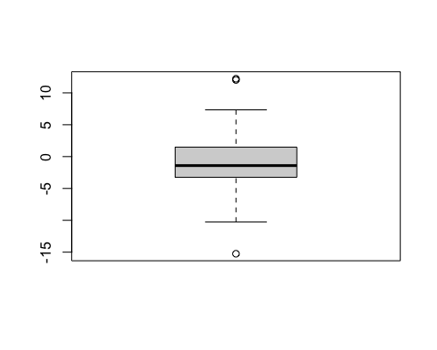

qqnorm(Stockreturns)  
qqline(Stockreturns)

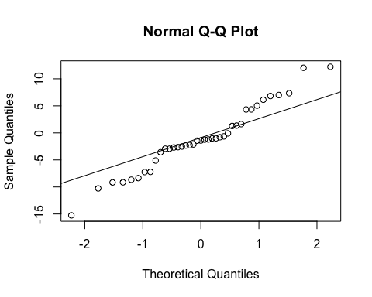

## For the boxplot, we can see that the distribution is aliitle bit right skew but approximately symmatric. And for the norm qq plot, the points at the beginning and at the end is following the other way, but most of the point in the middle is following the line. Thus, the distribution is not perfectly normal, but approxiamtely normally distribution.

##7,   
t.test(Stockreturns,mu=0.0095, alternative = "less", conf.level = .95)

##   
## One Sample t-test  
##   
## data: Stockreturns  
## t = -1.1848, df = 38, p-value = 0.1217  
## alternative hypothesis: true mean is less than 0.0095  
## 95 percent confidence interval:  
## -Inf 0.4891698  
## sample estimates:  
## mean of x   
## -1.124615

## t value is -1.1848.

##8.   
## t value is -1.1848 with the p value 0.1217. The 95% confidence interval is [-inf, 0.489168].

##9.   
## t value is -1.1848 with the p value 0.1217, which is greater than 0.05, we cannot reject the null hypothesis, thus, we cannot conclude that the broker perform is worse than average.