Representative Import Fixture for Apple Pages
This document is intentionally ordinary: it is meant to be opened in Apple Pages and saved as a native .pages file for importer tests.

1. Body text and inline formatting
Purpose. Use this fixture to validate basic text extraction, paragraph ordering, character runs, and style preservation. It includes bold, italic, underlined, and code-like text: let importer = PagesImporter().
Unicode coverage: café, naïve, coöperate, emojis 🚀 ✅, smart quotes “like this”, em dash —, non-breaking spaces, and CJK text: 日本語・中文・한국어.

2. Lists
- Plain paragraph before list should remain separate.
- First unordered item with a longer line that wraps naturally.
- Second unordered item with punctuation: a/b, 10–20%, $1,234.56.
- First ordered item
- Second ordered item
- Third ordered item with nested-looking text: 1.1 not actually nested

3. Table
The table has a header row, mixed alignment, empty cells, currency-like text, and multiline text.
Feature | Expected import | Sample value | Notes
Paragraph | Text + style | Heading 1 | Preserve reading order
Image | Binary asset | PNG 1000×520 | Alt text may or may not survive conversion
Hyperlink | URL target | https://developer.apple.com | External link relationship
Empty cell |  |  | Importer should not crash

4. Link and image
External link: Apple Developer Documentation — useful for checking URL extraction.
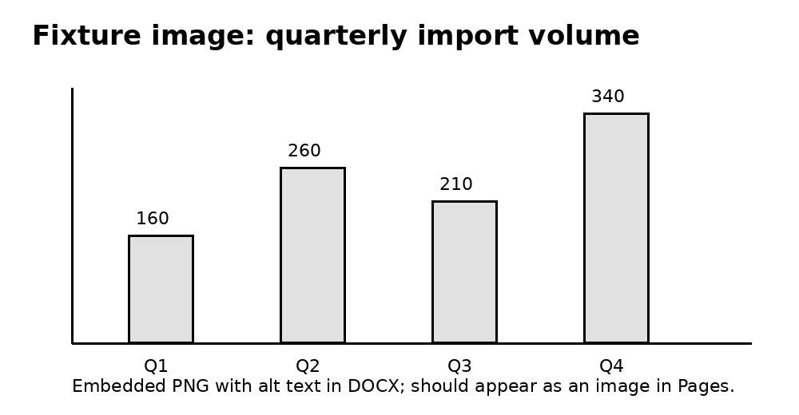
Figure 1. Embedded chart image generated for this fixture.

5. Landscape section and wider table
This page checks section handling, orientation, headers/footers, and wide tables after Pages conversion.
Column A | Column B | Column C | Column D | Column E | Column F
R1C1 | R1C2 | R1C3 | R1C4 | R1C5 | R1C6
R2C1 | R2C2 | R2C3 | R2C4 | R2C5 | R2C6
R3C1 | R3C2 | R3C3 | R3C4 | R3C5 | R3C6

6. Dates and formula
This page checks dates and formula
Column A | Date | Column B | Column C | Column D
Item 1 | 6-18-26 | 12 | 0,35 USD | 4,20 USD
Items 2 | 6-15-26 | 8 | 34,49 USD | 275,92 USD
Total |  | 20 |  | 280,12 USD

7. End marker
END_OF_PAGES_IMPORT_FIXTURE — use this marker to verify full-document extraction.

