DOCUMENT 25
Validation Timing Guide
When to Validate, from the First Script to the Final Push
U.S. Retail Sector Health — Macro Indicators to Item-Level Movement
Audience: the person building the project, working through documents 02 and 15 with document 21 open alongside.
Version 1.0 · September 2026 · Portfolio Project · Companion to documents 02, 15, 21 and 22
Contents
In Word: right-click the table and choose 'Update Field' (or press Ctrl+A then F9) to populate page numbers.

1. Purpose and How to Use
Document 02 §9 defines what to check. Document 22 records the results. This document says when: at which point in the build each check first becomes possible, which checks must pass before the next phase starts, and which events after the build mean checking again. This guide ensures that at every gate: check a thing at the step that produced it and nothing is missed.
Kind | What it is | Defined in | Recorded in
Step check | The verify line of one build step — a SQL script’s VERIFY block, a query’s row count, a folder’s closing check | The step itself: the header of each sql/ script, document 02 | Nothing formal. Anything unexpected goes in the Relevant Notes column of document 21
Gate | A named stopping point. The next phase does not start until the gate passes | This document, §3 | The matching phase rows in document 21, marked done
Suite check | One of the seventeen checks in document 02 §9 | Document 02 §9, expanded on the Check Catalog tab of document 22 | Document 22, Check Results tab, against a Run ID
Table 1.1 — The three kinds of validation in this project.

1.1 Two Passes, One Run
Twelve of the seventeen checks test data and measures, so they can run in the model file before it is published. The other five — checks 7, 8, 15, 16 and 17 — test report pages and how the report files bind to the model, so they cannot run until the reports exist. The suite therefore runs in two passes: the model pass at gate G5, before the model is published, and the report pass at gate G8, before each report is published.
Pass | Checks | Gate | Must pass before
Model pass | 1, 2, 3, 4, 5, 6, 9, 10, 11, 12, 13, 14 | G5 — end of document 02 §8 | Publishing the model (document 02 §10)
Report pass | 7, 8, 15, 16, 17 — with 9 and 11 re-confirmed on their pages | G8 — end of each report in document 15 | Publishing that report (document 15 §10)
Table 1.2 — The two passes.
Both passes are recorded against the same Run ID in document 22. Its Outcome column reads INCOMPLETE — 5 not recorded after the model pass, and PASS only once the report pass is in. That is intended: the run is not finished until the reports are.
The split is the same one document 22 already draws in its Re-run after a fact-table reload column. The twelve model-pass checks are the ones new data can break; the five report-pass checks are the ones only a change to a report can break. That is why §4 re-runs the twelve after every reload and the five only when a report changes.
Test measures without adding visuals to the model file. The model file carries one blank page and no visuals — document 02 §1.1. To evaluate a measure during gates G4 and G5, use DAX query view: select the DAX Query View icon on the left side of Power BI Desktop, paste a query, and run it. A DAX query returns a result grid and creates nothing in the model or the report, so the model file stays exactly as specified. The queries in §3.5 are paste-ready.

2. The Gates at a Glance
Ten gates, G0 to G9, in build order, then the events that call for validation after the build is finished. A number in a circle is one of the seventeen suite checks; teal checks run in the model file, navy checks need a report page.
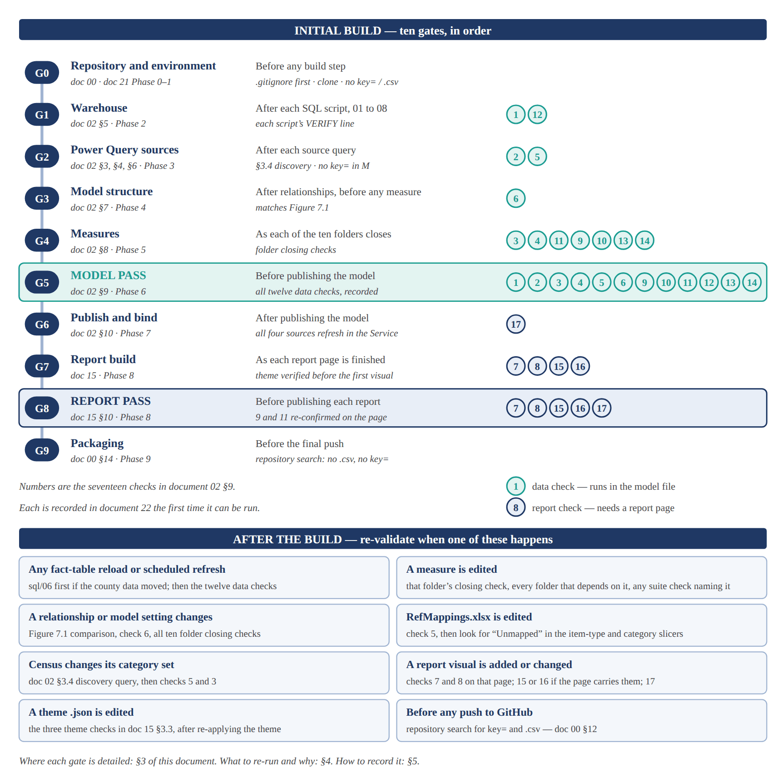
Figure 2.1 — Validation gates across the build, and the re-validation triggers after it. Each suite check is recorded in document 22 the first time it can be run.
The same timeline in plain text, for the README and for anyone reading this on a device that does not render the figure:
INITIAL BUILD SUITE CHECKS
---------------------------------------------------------------------------
G0 Repository and environment before any build step -
G1 Warehouse after each SQL script 1 12
G2 Power Query sources after each source query 2 5
G3 Model structure before any measure 6
G4 Measures as each folder closes 3 4 11 9 10 13 14
G5 MODEL PASS before publishing the model the twelve data checks:
1-6 and 9-14
G6 Publish and bind after publishing the model 17
G7 Report build as each page is finished 7 8 15 16
G8 REPORT PASS before publishing a report 7 8 15 16 17
G9 Packaging before the final push -

AFTER THE BUILD - re-validate when
a fact table reloads ........... sql/06 first if the county data moved,
then the twelve data checks
a measure is edited ............ its folder check, dependent folders,
any suite check naming it
a relationship or setting ...... Figure 7.1, check 6, all ten folder checks
RefMappings.xlsx is edited ..... check 5, then look for "Unmapped"
Census changes its categories .. doc 02 section 3.4 discovery, checks 5, 3
a report visual changes ........ checks 7 and 8 on that page,
15 or 16 if present, then 17
a theme .json is edited ........ doc 15 section 3.3 theme checks
before any push ................ search the repository for key= and .csv

Gate | Doc 21 phase | Run it | Suite checks | Do not continue if
G0 | 0 – 1 | Before any build step | — | .gitignore was not in place before the first upload, or the clone is not at X:\retail-sector-health
G1 | 2 | After each SQL script, 01 to 08 | 1 after script 05; 12 after script 06 | A script’s VERIFY line fails, or staged and loaded rows differ without every dropped row explained
G2 | 3 | After each source query | 2, 5 | The coverage query returns any row, or key= appears in any query’s M
G3 | 4 | After relationships and model configuration, before the first measure | 6 | Model view differs from document 02 Figure 7.1 by a single line
G4 | 5 | As each measure folder closes | 3, 4, 11, 9, 10, 13, 14, in the order their folders close | A folder’s closing check fails — the next folder is built on it
G5 | 6 | Before publishing the model | The twelve data checks | Any Blocking check fails
G6 | 7 | After publishing the model | 17, as each report file is created | Any of the four sources fails to refresh in the Service
G7 | 8 | As each report page is finished | 7, 8, 15, 16 where the page carries them | The theme was not verified before the first visual, or a case measure sits beside a nominal dollar measure
G8 | 8 | Before publishing each report | 7, 8, 15, 16, 17 | Any Blocking check fails for that report’s pages
G9 | 9 | Before the final push | — | The repository search finds .csv, key= or the key’s first six characters
Table 2.1 — The ten gates. §3 details each one.

3. Gate by Gate

3.1 G0 — Repository and Environment
When: before any build step. Document 00; document 21 Phases 0 and 1.
Check | Pass when | Reference
.gitignore committed before the first file | The repository’s first commit already contains .gitignore. A file it blocks was never tracked; one removed later stays in history | Doc 00 §4.3
Clone in place | git status runs from X:\retail-sector-health and reports a clean working tree | Doc 00 §5
Environment matches the verified build | SSMS 22 connects to BRUNO\MSSQLSERVER01; versions match document 02 Table 2.1 | Doc 02 §2.1
Table 3.1 — Gate G0.

3.2 G1 — Warehouse
When: after each of the eight SQL scripts, before running the next. Document 02 §5; document 21 Phase 2. Every script carries its own VERIFY line in its header; this table collects them.
Script | Pass when | Suite | Record
01 | SELECT name FROM sys.schemas WHERE name IN ('stg','dw') returns two rows | — | —
02 | The final SELECT returns approximately 330,080 rows | — | —
03 | The five result sets are read and noted. Nothing is created; the cleansing choices in 04 follow from these results | — | Doc 21 notes
04 | Each dimension has rows and no duplicate business key | — | —
05 | The staged-versus-loaded reconciliation at the end of the script returns no unexplained gap | 1 | Doc 22, Run 1
06 | No lifecycle column is NULL for an item with movement, and MAX(LastSeenDateKey) equals MAX(DateKey) in the fact | 12 | Doc 22, Run 1
07 | sys.indexes shows the columnstore index on dw.FactItemMovement | — | —
08 | SELECT TOP 10 * FROM dw.vw_ItemMovement returns rows with resolved dimension attributes | — | —
Table 3.2 — Gate G1, one row per script.
Check 12, paste-ready for SSMS 22:
SELECT (SELECT MAX(LastSeenDateKey) FROM dw.DimItem) AS LastSeenInDimItem,
(SELECT MAX(DateKey) FROM dw.FactItemMovement) AS LastMonthInFact;
-- Pass: the two values are equal.

3.3 G2 — Power Query Sources
When: after each source query is built, in the order of document 02 §7.1. Document 02 §3, §4 and §6; document 21 Phase 3.
After | Pass when | Suite | Doc 02
The discovery query, run once | The category codes the API returns reconcile with Table 3.1; then its load is disabled | — | §3.4
FactSectorSales | One row per month for 44X72, from pStartPeriod through the latest month Census has published, with no gap | 2 | §3.5
FactMacro | Nine SeriesId values, each with a monthly value series. A blank series means a wrong ID | — | §4.3
DimCategory | The referential coverage query returns zero rows | 5 | §6.5
DimItem merge | No blank BeverageClass; any unmatched item type shows as “Unmapped” | — | §6.3
Every query | No key= literal in any M; pCensusKey and pRefMappingsPath are referenced only as parameters | — | §3.1, §6.1
Table 3.3 — Gate G2.

3.4 G3 — Model Structure
When: after document 02 §7.2 and §7.3, and before the first measure. Document 21 Phase 4.
Check | Pass when | Suite
Auto-detected relationships removed | Only the seven relationships of §7.2 exist — nothing Power BI created on load | —
Model view against Figure 7.1 | Seven lines, every one one-to-many and single-direction, each landing on the columns Figure 7.1 shows | —
Date relationship integrity | No blank row in DimDate | 6
Model configuration | DimDate marked as the date table; three sort-by columns set; keys hidden; numeric columns set to Do Not Summarize | —
Table 3.4 — Gate G3.
Check 6 in DAX query view. VALUES includes the blank row Power BI adds for unmatched keys; DISTINCT does not, so any difference is that blank row:
EVALUATE
ROW (
"Blank DimDate row", COUNTROWS ( VALUES ( DimDate[DateKey] ) )
- COUNTROWS ( DISTINCT ( DimDate[DateKey] ) )
)
-- Pass: 0.

3.5 G4 — Measures
When: as each of the ten display folders is finished, in the order of document 02 Table 8.2. Document 21 Phase 5. A measure whose dependencies are missing returns blank rather than an error, so a folder that fails its closing check is fixed before the next folder starts.
Folder | Close the folder when (doc 02 Table 8.2) | Suite checks first runnable here
01 Macro | CPI Index for a known month matches the FRED series page | —
02 Sector | Sector Sales for code 452 matches FRED MRTSSM452USS within rounding | 3, 4 — the closing check is check 4
03 Micro | Total Cases unfiltered reconciles to the fact-table sum in SQL | 11
04 Cross-Tier | National Liquor Stores Real Sales moves with, not against, RRSFS | —
05 Channel | On-Premise Share 2019 Baseline returns a value under every R1 Page 3 slicer combination | 9, 10 — the closing check is check 9
06 Elasticity | Observation Count is non-zero and plausible before any slope is trusted | —
07 Rotation | Rate Sensitivity Beta lands negative for 441, 442 and 444 | —
08 Assortment | Cumulative Cases % reaches exactly 100% at the lowest-ranked item | 13, 14 — the closing check is check 14
09 Supplier | Supplier HHI falls between 0 and 10,000 | —
10 Seasonality | The twelve Month Seasonal Factor values average to approximately 1.00 | —
Table 3.5 — Gate G4, one row per folder.

Paste-ready queries for DAX query view
One query per closing check that has a clear numeric answer, plus the suite checks first runnable in this gate. Each states its pass condition in its last line.
01 Macro — CPI Index by month, newest first. Compare one month against the CPIAUCSL page on fred.stlouisfed.org.
EVALUATE
SUMMARIZECOLUMNS ( DimDate[DateKey], "CPI Index", [CPI Index] )
ORDER BY DimDate[DateKey] DESC
-- Pass: the value for a chosen month matches FRED CPIAUCSL.
02 Sector — check 4. Census code 452 beside FRED MRTSSM452USS for every month.
EVALUATE
SUMMARIZECOLUMNS (
DimDate[DateKey],
"Census 452", CALCULATE ( [Sector Sales], DimCategory[CategoryCode] = "452" ),
"FRED MRTSSM452USS", CALCULATE ( [Macro Value], DimIndicator[SeriesId] = "MRTSSM452USS" )
)
ORDER BY DimDate[DateKey]
-- Pass: the two columns agree within rounding in every month.
02 Sector — check 3. Every category against the headline for one month. Replace 20240101 with any loaded month (DateKey is YYYYMM01).
EVALUATE
SUMMARIZECOLUMNS (
DimCategory[CategoryCode],
DimCategory[CategoryName],
TREATAS ( { 20240101 }, DimDate[DateKey] ),
"Sector Sales", [Sector Sales],
"Total Retail and Food Services", [Total Retail and Food Services]
)
-- Record the gap and its reason. Categories overlap, so exact equality is not expected.
03 Micro — closing check and check 11. Run the SQL beside it in SSMS 22.
EVALUATE
ROW ( "Total Cases", [Total Cases], "Return Rows", [Return Rows] )
-- Pass: Total Cases equals the SQL result below; Return Rows is non-zero.

-- SSMS 22:
-- SELECT SUM(TotalMovement) AS TotalCases FROM dw.vw_ItemMovement;
05 Channel — check 9. Lists every item-type combination whose 2019 baseline is blank. ADDCOLUMNS is used rather than SUMMARIZECOLUMNS on purpose: SUMMARIZECOLUMNS drops rows whose measures are all blank, which would hide exactly the rows this check is looking for.
EVALUATE
FILTER (
ADDCOLUMNS (
SUMMARIZE ( DimItem, DimItem[BeverageClass], DimItem[ItemType] ),
"2019 baseline", [On-Premise Share 2019 Baseline]
),
ISBLANK ( [2019 baseline] )
)
-- Pass: no rows returned. Any row is a combination that will blank the card.
05 Channel — check 10. The national series beside the local on-premise share, 2019 to 2021.
EVALUATE
SUMMARIZECOLUMNS (
DimDate[DateKey],
FILTER ( VALUES ( DimDate[Year] ), DimDate[Year] IN { 2019, 2020, 2021 } ),
"722 YoY %", CALCULATE ( [Sector Sales YoY %], DimCategory[CategoryCode] = "722" ),
"4453 YoY %", CALCULATE ( [Sector Sales YoY %], DimCategory[CategoryCode] = "4453" ),
"On-Premise Share", [On-Premise Share %]
)
ORDER BY DimDate[DateKey]
-- Record the direction and the months, not a yes or no.
06 Elasticity — closing check.
EVALUATE
ROW ( "Observation Count", [Observation Count] )
-- Pass: non-zero, and close to the number of months with a prior-year value.
07 Rotation — closing check.
EVALUATE
SUMMARIZECOLUMNS ( DimCategory[CategoryCode], "Rate Sensitivity Beta", [Rate Sensitivity Beta] )
-- Pass: negative for 441, 442 and 444.
08 Assortment — check 13. Tests directly the property check 13 protects: that no item is missing a cohort year.
EVALUATE
ROW (
"Items with a cohort year",
CALCULATE ( COUNTROWS ( DimItem ), NOT ISBLANK ( DimItem[CohortYear] ) ),
"All items",
COUNTROWS ( DimItem )
)
-- Pass: the two values are equal.
08 Assortment — closing check and check 14.
EVALUATE
TOPN (
1,
ADDCOLUMNS (
VALUES ( DimItem[ItemDescription] ),
"Rank", [Item Rank by Volume],
"Cumulative", [Cumulative Cases %]
),
[Rank], DESC
)
-- Pass: Cumulative is exactly 1 on the lowest-ranked row, or on every row tied for it.
09 Supplier and 10 Seasonality — closing checks.
EVALUATE
ROW (
"Supplier HHI",
[Supplier HHI],
"Average seasonal factor",
AVERAGEX ( VALUES ( DimDate[MonthNumber] ), [Month Seasonal Factor] )
)
-- Pass: HHI between 0 and 10,000; average factor approximately 1.00.
Folder 04 has no query here. Its closing check is a comparison of direction — National Liquor Stores Real Sales moving with RRSFS — which is read from the two series side by side, not from a single number. Run a SUMMARIZECOLUMNS by DimDate[DateKey] with both and read the turns.

3.6 G5 — Model Pass
When: after the last folder closes and before publishing the model. Document 02 §9; document 21 Phase 6.
- Open document 22. If Run 1 does not exist yet, add it on the Run Summary tab with Trigger set to Initial build.
- Re-run all twelve data checks together on the finished model — 1, 2, 3, 4, 5, 6, 9, 10, 11, 12, 13, 14. Most were first run at G1 to G4. They are run again here because a later step can undo an earlier result: a re-run of script 06, an edited relationship, a measure changed while building a later folder.
- Update each check’s row in Check Results with the final observed value and today’s date. Log any Fail on the Failure Log tab.
- Read the Outcome on the Run Summary tab. The state that permits publishing the model is INCOMPLETE — 5 not recorded, with Blocking failures at zero. The five unrecorded checks are the report checks, which cannot run yet.
Do not publish over a Blocking failure. A Blocking failure in the model pass carries into every report built on the model. Fix it, re-run the check, and close it on the Failure Log before document 02 §10.

3.7 G6 — Publish and Bind
When: after document 02 §10, and again as each report file is created. Document 21 Phase 7.
Check | Pass when | Suite
First refresh in the Service | All four sources refresh: SQL Server and RefMappings.xlsx through the gateway, FRED and Census without it | —
Refresh schedule | Set on the semantic model — twice weekly is sufficient | —
Each report file as it is created | The status bar shows the live connection and the Fields pane is read-only | 17
Table 3.6 — Gate G6.

3.8 G7 — Report Build
When: as each report page is finished, before starting the next page. Document 15; document 21 Phase 8.
Before the first visual in each report, apply that report’s theme and run the three theme checks in document 15 §3.3. A theme changes defaults; it does not overwrite settings already made by hand, so a theme applied late means re-formatting every visual built before it.
Page | Visuals that bring a check into play (document 15 specs) | Checks when the page is finished
R1 P1 | 1.6 dual axis | 7
R1 P2 | Dollar series only | —
R1 P3 | Case measures 3.1, 3.5, 3.7, 3.9; the one permitted pairing 3.5; 2019 baselines 3.2, 3.10; Return Rows 3.8; national series 3.5, 3.12 | 8, 9, 10, 11
R2 P1 | Dual axis 4.5; case measures 4.5, 4.7, 4.6a–d; slope and correlation 4.2, 4.3, with Observation Count 4.4 | 7, 8, 15
R2 P2 | Dual axis 5.7; case measures 5.2, 5.8; 2019 baselines 5.3, 5.4, 5.6, 5.8 | 7, 8, 9
R2 P3 | Slope visuals 6.8, 6.9 | 15
R3 P1 | Dual axis 7.5, 7.7; case measures and Pareto 7.5 | 7, 8, 14
R3 P2 | Survival visuals 8.3, 8.4, 8.6 to 8.8 | 16
R3 P3 | Dual axis 9.6; case measures 9.7, 9.8 | 7, 8
R3 P4 | Case measure 10.5 | 8
Table 3.7 — Gate G7, one row per report page. Derived from the document 15 specification tables.
Checks 9, 10, 11 and 14 were first run in the model at G4. On the page they are re-confirmed as the reader sees them: the baseline card holds a value under each slicer combination, the narrative on R1 Page 3 matches what check 10 found, the Return Rows card carries its explanation, and the Pareto line reaches the right-hand edge.

3.9 G8 — Report Pass
When: after the last page of a report, before publishing that report. Document 15 §10; document 21 Phase 8.
- In document 22, Run 1: record checks 7, 8, 15 and 16 for this report’s pages, and 17 for this report. The Observed value column names the pages and reports covered so far.
- For R1, update checks 9 and 11 with what R1 Page 3 shows.
- Publish the report only when none of its checks has a Blocking failure. Follow document 15 §10.
- After the third report, all seventeen rows carry a result and the Run Summary Outcome reads PASS. Run 1 is closed.
Check 8 is the one to run last and slowly. It is the single error that would discredit the project: a case measure beside a nominal dollar measure. Walk every visual, every tooltip and every text box on every page that carries a case measure — Table 3.7 lists them.

3.10 G9 — Packaging
When: before the final push to GitHub. Document 00 §14; document 21 Phase 9.
- Run the document 00 §14 verification checklist end to end.
- Search the repository for .csv, key= and the first six characters of the Census key. Zero hits is the pass.
- Confirm the three report PBIP folders contain a report definition and no TMDL — the file-level evidence that the reports are thin.

4. After the Build — When to Validate Again
Validation does not end at Run 1. Each event below starts a new run in document 22; the last column is the Trigger value to choose on its Run Summary tab.
Event | Re-run | Why | Doc 22 Trigger
A fact table reloads with new data | Script 06 first if the county data moved. Then the twelve data checks | Document 21 Phase 6 makes this a standing rule. Script 06’s lifecycle columns go stale silently | Post fact-table reload
A measure is edited | That folder’s closing check; every folder whose Depends on column names the measure (document 02 §8); any suite check that names it. Then republish | A measure with a broken dependency returns blank, not an error — downstream folders fail quietly | Post measure change
A relationship or model setting changes | Compare against Figure 7.1; check 6; all ten folder closing checks; then the model pass | A relationship defect produces plausible wrong numbers in every measure that crosses it | Ad hoc — name the change in Notes
RefMappings.xlsx is edited | Check 5; look for “Unmapped” in the item-type and category slicers; check 3 if IsAggregate changed | A missing mapping appears as a blank slicer entry, not an error | Ad hoc
Census changes its category set | The document 02 §3.4 discovery query; update Table 3.1 and RefMappings.xlsx; checks 5 and 3 | A NAICS vintage change can alter what a code means | Ad hoc
A report visual is added or changed | Checks 7 and 8 on that page; any of 9, 11, 14, 15, 16 the page carries (Table 3.7); 17 for the report | Only a report change can break the five report checks | Post report change
A theme .json is edited | Re-apply the theme, then the three theme checks in document 15 §3.3 | A theme edit applies only when re-applied | Not recorded in doc 22
The model is republished | First refresh succeeds in the Service; check 17 on each report | A republish can reset credentials or break a binding | Pre-publication
Before any push to GitHub | Search for key= and .csv | A committed key stays in history even after the file is removed | Not recorded in doc 22
Table 4.1 — Re-validation triggers.
How often to re-run after a scheduled refresh. Every scheduled refresh reloads all three fact tables, and the model refreshes twice a week. Refreshes that bring no new source data cannot change a check’s result, so the practical cadence is once a month: after the first refresh that picks up the new MARTS advance estimate and the new month of county data.

5. Recording What You Ran
Where | What goes in it
Document 22 — Run Summary | One row per run. Run 1 is the initial build and spans gates G1 to G8: it reads INCOMPLETE until the report pass at G8, then PASS. Every later run is one row, with its Trigger from Table 4.1
Document 22 — Check Results | A check’s first result goes in at the gate where it first runs. At G5 and G8 the same row is updated with the final observed value and date
Document 22 — Failure Log | Every Fail, at any gate, stays open until a later run re-verifies it
Document 21 — phase rows | Marked done when the phase’s gate passes. Step-check surprises go in its Relevant Notes column
Table 5.1 — Where each result is recorded.

6. References
Verified against the live pages in September 2026.
Work with DAX query view (§1.1, §3.4, §3.5) — https://learn.microsoft.com/en-us/power-bi/transform-model/dax-query-view
DAX overview — https://learn.microsoft.com/en-us/dax/dax-overview
On-premises data gateway (§3.7) — https://learn.microsoft.com/en-us/power-bi/connect-data/service-gateway-onprem
Within the document set: document 02 §5 to §10 for the build steps and the seventeen checks; document 15 §3.3 and §10 for the theme checks and report publishing; document 21 for the phase rows; document 22 for recording.

7. AI Assistance Disclosure
Portions of this document were drafted with the assistance of a generative AI system. The author defined the project scope and reviewed all content prior to publication.
Every step check, closing check and suite check in this guide was taken from the document sources — the sql/ script headers, document 02 Table 8.2 and §9, document 15 §3.3 and §10, and document 22 — rather than written anew. The page-to-check mapping in Table 3.7 was derived from the document 15 specification tables. The DAX queries use only measures and columns defined in documents 02 and 20; the DAX query view behaviour they rely on was checked against Microsoft Learn.

