DOCUMENT 01
U.S. Retail Sector Health
From Macroeconomic Indicators to Item-Level Movement
Power BI Portfolio Project — Census MARTS · FRED · Montgomery County Item Movement
Audience: BI reviewers and sector analysts | Tooling: Power BI Desktop · Power BI Pro · SQL Server 2025 Developer Edition
Prepared by Evy | September 2026 | Document 01 · Project ID: PBI-MACRO-001
Contents
In Word: right-click the table and choose 'Update Field' (or press Ctrl+A then F9) to populate page numbers.

1. Executive Summary
This project delivers three Power BI reports built on one shared semantic model, tracing U.S. retail performance from national macroeconomic conditions down to item-level physical product movement. It demonstrates three distinct ingestion patterns in a single coherent model — a keyed REST API, an on-premises SQL Server warehouse, and a governed Excel reference file — together with a star-schema design, a documented DAX layer of roughly seventy measures, and the shared-model / thin-report deployment pattern that enterprise BI teams use to avoid divergent copies of the same logic.
Business scenario: a retail sector analyst needs to know whether consumer spending is holding up in real terms, which kinds of business are gaining or losing share, and whether observed physical volume at the shelf confirms what the national dollar series reports. The reports answer: What is the economic backdrop? Which categories are rotating? Does actual volume agree with the dollar headline?
Portfolio positioning: most public-data BI projects stop at one CSV and a dollar total. This build differentiates on three things a reviewer can verify in thirty seconds — every source is live and citable with no fabricated tables; the model reconciles a physical volume series against a nominal dollar series by deflating one of them, which is a modelling decision rather than a chart; and the work ships as one published model with three live-connected reports rather than three copies of the same data.
Why this project is defensible
Every table in the model comes from a live public source. Nothing is simulated, and no measure is computed from a number that was typed in by hand.
The hardest problem in the project is stated openly rather than hidden: Tier 3 measures cases while Tiers 1 and 2 measure dollars. Section 8 explains how the model reconciles them, and why forward-filling or a raw level comparison would have been wrong.

2. Data Sources
Source | Purpose | Reporting — what it tells a business reader | URL / Origin
U.S. Census Bureau — MARTS (PRIMARY) | Monthly retail sales by NAICS kind of business, seasonally adjusted, national. The sector tier and the benchmark every local series is compared against. | Answers whether the retail market itself is growing or shrinking, and which kinds of business are gaining or losing share. That is what lets a reader tell a market-wide movement from something specific to one business — a decline everyone is having is a different problem from a decline only you are having. In R2 it shows which categories keep selling when households come under pressure and which are cut first, which is where a defensive budget decision gets made. Not used in R3. | https://api.census.gov/data/timeseries/eits/marts
Federal Reserve Economic Data (FRED) | Nine monthly macro series: CPI, retail sales headline and real, general merchandise, Fed funds, sentiment, unemployment, saving rate, real disposable income. | Explains WHY demand moved, not just that it did. R1 sets the economic conditions behind the sales line — inflation, rates, jobs, confidence. R2 combines the household-pressure indicators into one stress line, so a fall in sales can be attributed to customers being unable to spend rather than unwilling. Its quietest contribution is the largest: CPI strips inflation out of every dollar figure in the project, which is what separates “we sold more” from “we charged more”. | https://fred.stlouisfed.org/
Montgomery County, MD — Warehouse and Retail Sales | 330,080 rows of item-level monthly product movement, 2017–2026, by supplier and item type. The only public source in this project with genuine item grain. | The only place actual units are counted, so it is the reality check on whether a dollar trend reflects real demand or just higher prices. R1 shows whether physical volume agrees with the national dollar headline. R2 shows customers trading down, or changing where they consume rather than simply spending less. R3 is where the operational decisions sit: which products earn their shelf space, how long new lines survive, how few products carry most of the volume, and how exposed the business is if one large supplier goes away. | https://catalog.data.gov/dataset/warehouse-and-retail-sales
RefMappings.xlsx (analyst-maintained) | Display names and groupings that no upstream system owns. Category codes and names are transcribed from the published MARTS list; item types from the source’s own distinct values. The grouping columns are analyst classifications that change how results are displayed, never what they are. Full provenance: document 02 Table 6.1. | Never appears as a chart, but decides the words on every one of them — the category names, the groupings and the order they appear in. It is the business vocabulary of the reports, and it is a spreadsheet on purpose: someone who knows the business can regroup how results are presented without touching the data or waiting on a developer. Changing a grouping re-cuts every chart in all three reports without altering a single underlying number. | Derived from the three sources above — no independent data
Table 2.1 — Data sources and what each one contributes to the reports. Which pages carry which content is §6.2; the visual-by-visual specification is document 15.
Licensing note: all three external sources are U.S. federal or county open data and carry no redistribution restriction. The Census API requires a free key, which is personal and is never committed to the repository. The county CSV is not redistributed in the repo; the README links to it, and document 00 §4.3 blocks it in .gitignore.
Dataset facts to sanity-check after load: county source 330,080 rows, 2017–2026, nine columns, item types Wine / Liquor / Beer / Kegs / Non-Alcohol; MARTS publishes nineteen kind-of-business codes used here, headline code 44X72; FRED series all monthly, CPIAUCSL and MRTSSM452USS both starting January 1992.
The county measures are cases, not dollars. The publisher defines all three measure columns as counts of cases. Tier 3 is a physical volume series; Tiers 1 and 2 are denominated in dollars. They are never compared directly — Section 8 gives the reconciliation rule and Section 6 marks every visual where it applies.

2.1 Sources Considered and Not Used
Source | Disposition
tradingeconomics.com | Not ingested. The underlying data is Census retail sales, already taken at source. Full history sits behind a paid subscription and table scraping would be both a terms-of-use concern and fragile under refresh. Retained as a narrative reference for consensus-versus-actual commentary.
Yahoo Finance historical CSV | Not used. Bulk historical download is gated, and the export has never contained margin or inventory data. Equity prices are out of scope.

3. Data Pipeline — Source to Semantic Layer
Four sources reach one semantic model by three different ingestion patterns, and the pattern is the point: a keyed REST API, an on-premises relational database, and a governed file. Nothing is hand-copied between stages. Every arrow below is either a Power Query step or a SQL script that can be re-run from scratch, which is what makes the model reproducible rather than merely built.
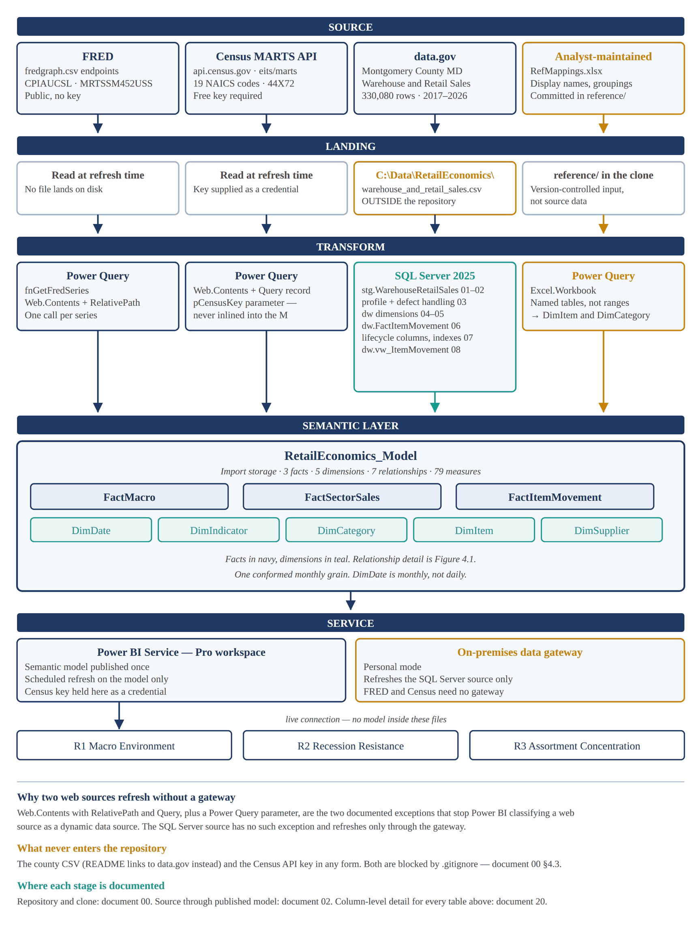
Figure 3.1 — Data pipeline, source to semantic layer. Navy is the default path, teal the SQL Server path, amber everything that is either never committed or analyst-maintained.
The same pipeline in plain text, for the README and for anyone reading this on a device that does not render the figure:
SOURCE LANDING TRANSFORM SEMANTIC LAYER
-----------------------------------------------------------------------
FRED -> read at refresh -> Power Query -\
CSV endpoints (no file) fnGetFredSeries \
\
Census MARTS -> read at refresh -> Power Query \
API (keyed) (key = cred) + pCensusKey param > RetailEconomics
/ _Model
data.gov CSV -> C:\Data\ -> SQL Server 2025 / 3 facts
330,080 rows RetailEconomics\ stg -> dw -> view / 5 dimensions
NEVER COMMITTED scripts 01 .. 08 / 79 measures
/ |
RefMappings -> reference/ -> Power Query -/ |
.xlsx (in the clone) Excel.Workbook |
v
Power BI Service (Pro)
gateway ----> published model
(SQL Server only) |
live connection v
R1 .... R2 .... R3

3.1 What Happens at Each Stage
Stage | Tool | What it produces | The rule that governs it
Source | — | Four publishers, four different access patterns | Nothing is downloaded by hand except the county CSV, which is versioned by the publisher, not by this project
Landing | Filesystem | Two sources land nothing; the county CSV lands outside the repository; RefMappings.xlsx lands inside it | A file that is source data stays out of Git. A file that is analyst judgement goes in. That distinction is the whole rule
Transform | Power Query · T-SQL | Three M queries and eight SQL scripts run in numeric order | Transformation happens as close to the source as possible: row-level work in SQL, shaping in M, nothing in DAX that could have been done earlier
Semantic layer | Power BI Desktop | One model — three facts, five dimensions, seven relationships, 79 measures | The model is the contract. Reports consume it; they never extend it
Service | Power BI Pro | One published model, three live-connected thin reports | One refresh, one measure library, one version of every number
Table 3.1 — Pipeline stages. The click-by-click procedure for every row is document 02; this table is the map, not the instructions.

3.2 Why the Refresh Paths Differ
Two of the three ingestion patterns refresh in the Service unattended. The third cannot, and the reason is worth stating explicitly because it is the most common thing a reviewer asks about a multi-source model.
Source | Refresh in the Service | Gateway | Why
FRED | Yes | Not required | Static URL read by Web.Contents with RelativePath
Census MARTS | Yes | Not required | Web.Contents with a Query record plus a Power Query parameter for the key — the documented pattern that keeps the source from being classified as dynamic
SQL Server 2025 | Yes | Required | The database is on a local machine. There is no exception that removes this requirement
RefMappings.xlsx | Yes | Required if read from a local path | Held in the repository clone, so the gateway that serves SQL Server serves this too
Table 3.2 — Refresh requirements by source.
A dynamic data source will not refresh in the Service at all. Concatenating a key or a parameter directly into a URL string makes the source dynamic, and the Service refuses to refresh it — with an error that names neither the query nor the cause. RelativePath, Query and Power Query parameters are the two documented ways around this, and both are used here. Document 02 §3.6 carries the working M.
Nothing in this pipeline moves data by hand. No copy-paste into Excel, no exported extract, no manual step between any two boxes above. That is what makes the whole thing re-runnable from an empty machine, and it is a fair question for a reviewer to ask of any portfolio project.

4. Data Model — Star Schema
Four sources resolve into three fact tables and five dimensions, conformed on a single monthly date grain. All relationships are single-direction, one-to-many, filtering from dimension to fact. No bidirectional filters are used anywhere in the model. Foreign keys are hidden from Report view; currency, percentage and decimal formats are set at the model level so no visual has to correct them.

4.1 Tables and Relationships
Eight tables: three facts and five dimensions. The full column-level dictionary — data type, derivation, format string, visibility and description for all 47 columns — is document 20, which is the single source of truth and is not repeated here.
Table | Type | Grain | Source
DimDate | Dimension | One row per month | SQL Server, recursive CTE
DimIndicator | Dimension | One row per FRED series | Entered in the model
DimCategory | Dimension | One row per NAICS code | RefMappings.xlsx
DimSupplier | Dimension | One row per supplier | SQL Server
DimItem | Dimension | One row per item | SQL Server + RefMappings.xlsx merge
FactMacro | Fact | Series × month | FRED, via a reusable M function
FactSectorSales | Fact | Category × month | Census MARTS API
FactItemMovement | Fact | Item × supplier × month | SQL Server — 330,080 rows
Table 4.1 — Model tables. Expected row counts are in document 20, Model Tables tab.
Seven relationships, all one-to-many from dimension to fact, all single-direction. The model uses no bidirectional filters and no virtual joins — if a bidirectional filter ever seems necessary here, the grain is wrong rather than the relationship.

4.2 Relationship Diagram
The same eight tables as Table 4.1, drawn as the model view renders them. Every relationship is one-to-many from the dimension side, single-direction, and active — there are no exceptions in this model and no reason for one.
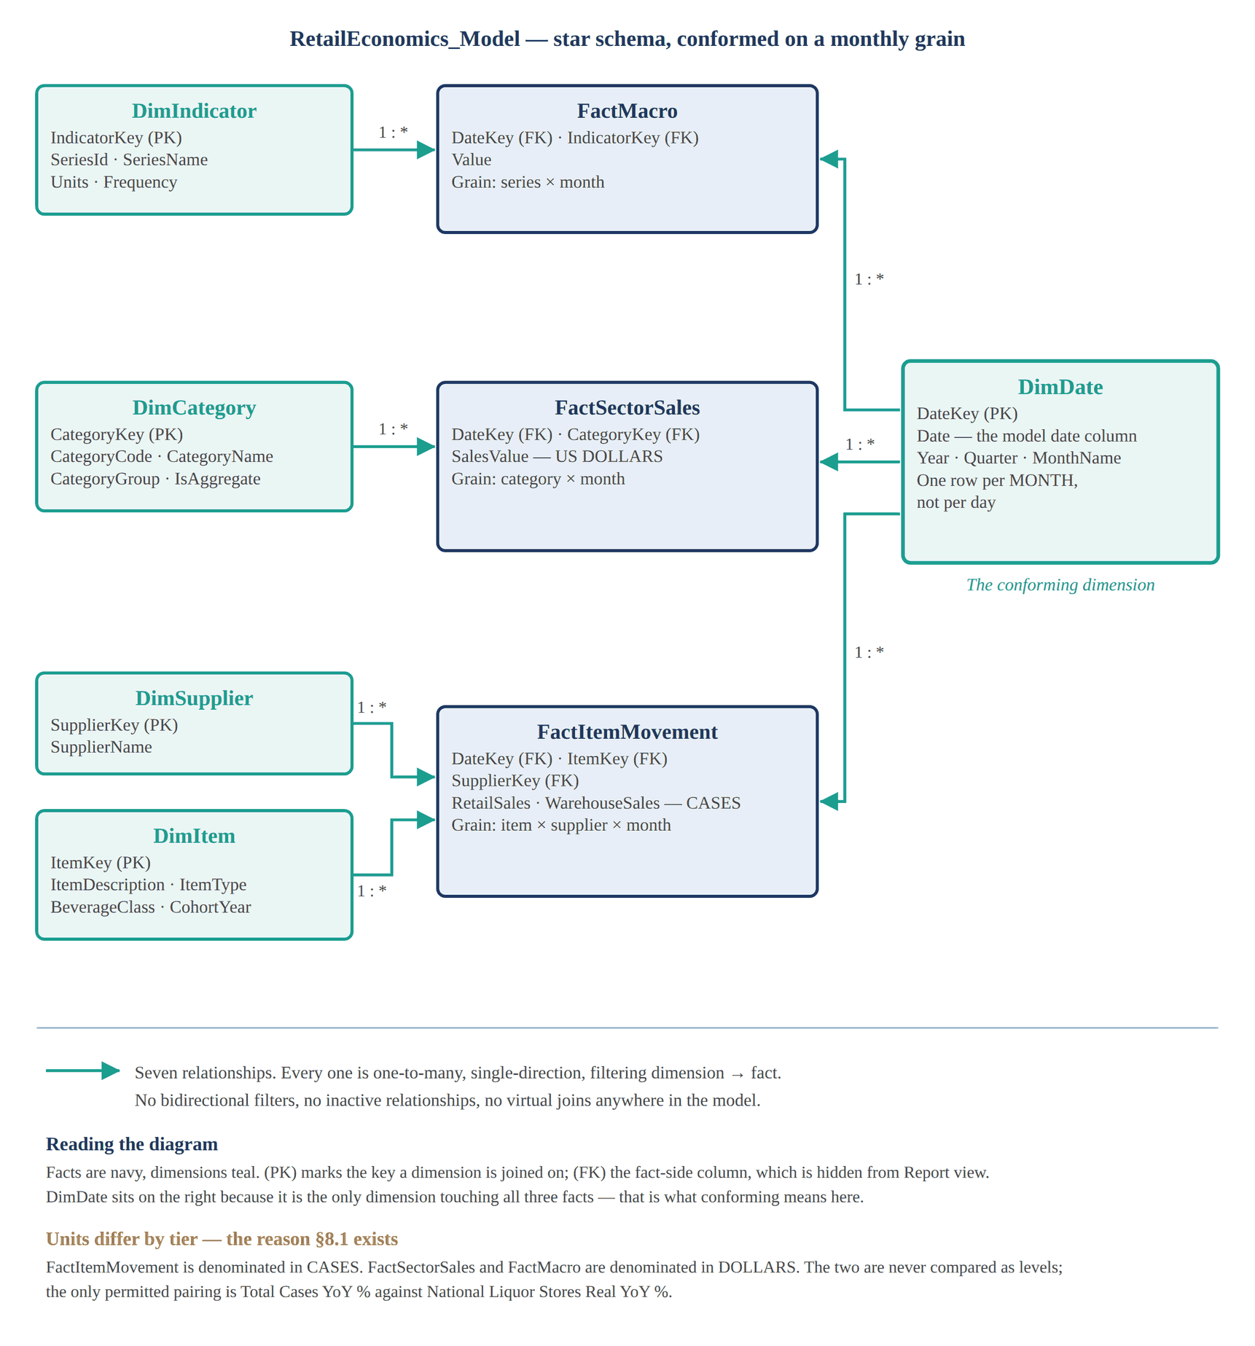
Figure 4.1 — Semantic layer relationships. DimDate is drawn apart from the other dimensions because it is the only one filtering all three facts.
The same schema in plain text:
DimIndicator --1:*--> FactMacro <---------------\
\
DimCategory --1:*--> FactSectorSales <---------------+-- DimDate
/ (1:* to all
DimSupplier -\ / three facts)
>--1:*--> FactItemMovement <------------/
DimItem -/

Seven relationships. Every one is one-to-many, single-direction,
filtering dimension -> fact. No bidirectional filters, no inactive
relationships, no virtual joins. DimDate is the conforming dimension.

Read the direction, not just the line. A relationship line says nothing on its own; the arrow says everything. Filtering runs dimension to fact and nowhere else. If a visual ever needs the reverse — a fact filtering a dimension — the answer is a measure written with the right filter context, never a bidirectional relationship, which is how a model starts returning different totals depending on which visual asked.

4.3 The Conforming Decision
The three tiers arrive at three different natural grains, and reconciling them is the most consequential modelling decision in the project. FRED and Census are already monthly. The county source stores Year and Month as separate integers with no date key at all, so DateKey is constructed during the fact load rather than in Power Query.
All three facts therefore share one conformed monthly key, and DimDate is a monthly dimension rather than a daily one. This is deliberate. A daily date table joined to three monthly facts creates twenty-nine empty days per month in every filter context and produces time intelligence that is quietly wrong.
Do not forward-fill to align grains. Filling monthly values across daily rows to make a join work fabricates observations the source never published, and corrupts every average and every correlation computed downstream. Conform the grain instead.

5. Report Portfolio — One Model, Three Reports
Fourteen analytical questions do not belong in one report. A single artifact carrying all of them runs past twelve pages, serves three different audiences badly, and is abandoned halfway through by every reviewer who opens it. The work is split into three reports built by live connection against one published semantic model.
Report | Pages | Audience | Questions Answered
R1 — Retail Sector Health | 3 (spec 1–3) | Executive; the general reader | Macro backdrop, sector performance, item-level volume, on-premise versus off-premise channel shift
R2 — Consumer Stress and Sector Rotation | 3 (spec 4–6) | Macro and sector analyst | Is alcohol demand recession-resistant, does the mix shift between item types under stress, e-commerce and warehouse-club share transfer, rate sensitivity by category
R3 — Assortment and Supplier Analytics | 4 (spec 7–10) | Merchandising and operations | Assortment concentration and long tail, item survival by cohort, supplier concentration, distribution quality, seasonality
Table 5.1 — Report portfolio. Spec numbers run 1 through 10 across all three reports, so every visual in the project has a unique identifier.
Why one model and three reports, not three models
One refresh serves all three reports. Three independent models would mean three gateway connections, three schedules, and three chances to be looking at different numbers in the same meeting.
One measure library: a correction to Real Sector Sales lands everywhere at once. Anything two reports need lives in SQL or the shared model; a calculated column added inside a live-connected report exists only in that report, which is the divergence this pattern exists to prevent.

5.1 How the Document Set Fits Together
Seven documents, each doing one job. The fastest way to lose a day on this project is to look for something in the wrong one. Document 00 comes first because nothing else starts until the repository exists.
Doc | Answers | Use it when
00 | Where does the work live? | Before anything else. Creating the GitHub repository, cloning it locally, the PBIP workflow, the daily commit loop.
01 | What are we building, and why is it defensible? | This document. Scope, sources, the analytical argument, the page inventory and design rules, limitations.
02 | How do I get the data in and build the model? | Standing up the warehouse, writing the queries, configuring the model, building all 79 measures, publishing it.
12 / 13 / 14 | What should the reports look like? | Building a page — open the matching mockup on a second screen.
15 | What exactly does this visual show, and how do I build it? | The complete specification — type, fields, position, formatting — plus eleven click-by-click patterns. The single source of truth for every visual.
20 | What is this column, and what does this measure do? | Any question about a field, a format, a relationship, or one of the 79 DAX definitions — the filterable copy of what document 02 §8 builds.
Table 5.2 — Document set at a glance. Section 9 carries the full register including reserved numbers.

6. Report Design
Canvas 1280 × 720 (16:9). Every page shares a header band carrying the report title, the synced date slicer, and page-navigation buttons. Colour is set by a report theme rather than visual by visual — navy #1F3864 primary, blue #2E74B5 secondary, teal #1B9E8F for real and deflated series, amber #C8860A for markers and thresholds, red #C0392B and green #1E7B34 for conditional extremes, light-gray canvas #FAFAFA.
Each report carries its own theme file, because Power BI applies exactly one theme JSON per report and themes cannot inherit from one another. All three share an identical palette, page background and text classes; each adds visual defaults for the chart types that report actually uses. The three files live in theme/ and are applied before the first visual is built — a theme changes defaults and does not overwrite a property already set by hand.
File | Applied to | Report-specific defaults it adds
R1_Retail_Sector_Health.json | R1 — Macro Environment | Line and combo stroke weights, markers off, KPI card callout sizing
R2_Consumer_Stress.json | R2 — Recession Resistance | Diverging matrix scale (red · neutral · green), stacked-area transparency
R3_Assortment_Supplier.json | R3 — Assortment Concentration | Scatter bubble sizing and fill, Pareto combo settings, matrix banding
Table 6.1 — Report theme files. Document 15 §3.3 lists which properties the theme sets and which are still set by hand.
This section sets the design rules and lists the pages. Documents 12, 13 and 14 show what the finished pages look like; document 15 carries the complete visual-by-visual specification and the instructions to build it. The spec numbers are identical across all four documents.

6.1 Power BI Buildability Rules
Every visual in this project is buildable with a native Power BI visual and no custom or AppSource import. Three constraints shaped the design and are recorded here because each one rules out an approach that would otherwise look reasonable on a mockup.
Constraint | Consequence for this design
Small multiples are not available on scatter charts | Supported on line, bar, column and area only. Where a per-category scatter is wanted (spec 4.6), the page uses a row of four separate scatter visuals each carrying a visual-level filter, not a small-multiples scatter.
X-axis constant lines require a continuous axis | A line chart with a text X axis such as MonthYear offers no X-axis constant line. Every visual that marks March 2020 (specs 3.9 to 3.12, and 6.7) sets the X axis to DimDate[Date] on Continuous, which makes the Analytics-pane X-Axis Constant Line available.
There is no native histogram visual | Spec 8.5 is built by creating a bin group on DimItem[MonthsActive] (right-click the field, New group, Bin, size 3) and plotting Count of ItemKey against the resulting bin on a clustered column chart.
Table 6.2 — Native-visual constraints that shaped the design. Document 15 §12 carries the Microsoft documentation supporting each.
Beyond these three, the design uses only cards with sparklines, line, clustered bar, clustered and stacked column, stacked area, line-and-clustered-column combination, scatter with Analytics-pane trend and quadrant lines, matrix with conditional formatting, table, numeric range slicer, and small multiples on column and line charts. Reference lines, Top N visual filters, drillthrough, bookmarks, sync slicers and tooltip pages are all native behaviour.

6.2 Page Inventory
Ten pages across three reports. Spec numbers run 1 through 10 so that every visual in the project has a unique identifier, used identically in this document, in the mockups and in document 15.
Page | Report | Title | Question it answers | Visuals | Specs
1 | R1 | Macro Environment | What is the economic backdrop for consumer spending? | 8 | 1.1 – 1.8
2 | R1 | Sector Performance | Which kinds of business are gaining or losing share, and how much of that is price? | 6 | 2.1 – 2.6
3 | R1 | Item-Level Volume and Channel Shift | Does physical volume agree with the dollar headline, and where did consumption happen? | 12 | 3.1 – 3.12
4 | R2 | Is Alcohol Recession-Resistant? | Does volume hold when unemployment rises, sentiment falls and saving climbs? | 12 | 4.1 – 4.9
5 | R2 | Mix Shift Under Stress | Does the composition move between item types while the total holds? | 8 | 5.1 – 5.8
6 | R2 | Sector Rotation and Rate Sensitivity | Where has share moved, and which categories are rate-sensitive? | 9 | 6.1 – 6.9
7 | R3 | Assortment Concentration | How few items carry the volume, and is the tail lengthening? | 8 | 7.1 – 7.8
8 | R3 | Item Survival by Cohort | What share of new items survive, and is that improving? | 8 | 8.1 – 8.8
9 | R3 | Supplier Concentration and Distribution Quality | How concentrated is the supplier base, and where does distribution misfire? | 8 | 9.1 – 9.8
10 | R3 | Seasonality | How strong is seasonality, and is its amplitude changing? | 8 | 10.1 – 10.8
Table 6.3 — Page inventory. Visual counts include the four separate scatter panels that together satisfy spec 4.6.
The full specification lives in document 15. Type, fields, exact canvas position and formatting for all eighty-seven visuals are in document 15 §5 to §7, one row per visual, alongside the click-by-click pattern that builds it. That was previously split across two documents, which meant every visual was described twice and a change had to be made in both. It is now stated once.

7. Build Sequence
Block | Deliverable | Key tasks
0 | Repository | Create the GitHub repository, add the .gitignore, create the folder skeleton, then clone to X:\retail-sector-health. Everything in every block below is saved inside that clone. Document 00 §4 and §5.
1 | Warehouse | Extract the county CSV; staging table; profiling queries; dimensions; fact table and load procedure; item lifecycle columns; columnstore index; presentation views
2 | Shared model | Census and FRED queries with parameters; Excel reference queries; relationships; monthly DimDate marked as date table; hide foreign keys; set formats
3 | Measure library | Measures in display folders: Macro, Sector, Micro, Cross-Tier, Channel, Elasticity, Rotation, Assortment, Supplier, Seasonality. Validate against the sanity-check facts in §2
4 | Publish model | Publish RetailEconomics_Model.pbix; install personal gateway; configure credentials and refresh schedule; confirm all four sources refresh
5 | R1 (specs 1–3) | Theme JSON; live connection; three pages in order; channel panel last
6 | R2 (specs 4–6) | Live connection; three pages; four-scatter row on spec 4.6
7 | R3 (specs 7–10) | Live connection; four pages; bin group for spec 8.5
8 | Polish and packaging | Sync slicers; reset bookmarks; drillthrough; tooltip pages; alt text and tab order; README; screenshots; validation results
Block 0 is not optional and not deferrable. Work produced outside the clone has to be relocated later, and its history collapses into a single bulk commit — which is the opposite of what a reviewer opens a repository to see. Scope guardrails: if Block 1 is at risk, load the county data without the lifecycle columns and drop R3 Page 2 (specs 8.1–8.8) entirely rather than shipping half a cohort analysis. If Block 7 is at risk, drop spec 10.7 first, then 9.7. Never cut the channel panel (3.9–3.12) or the cross-tier comparison (3.5) — they are the differentiators, and without them this is three disconnected reports rather than one argument.

8. Methodology and Limitations

8.1 The Cases-to-Dollars Reconciliation
Tier 3 measures cases. Tiers 1 and 2 measure dollars. The reconciliation rule is stated once here and enforced by a validation check before publication.
- Total Cases YoY % may be compared to National Liquor Stores Real YoY % and to nothing else. The national series is deflated by CPI before it meets the local series, because setting a dollar growth rate against a volume growth rate without removing price attributes inflation to the local market.
- The wedge between national nominal and national real growth is reported alongside as Implied Price Contribution, so the reader can see how much of the dollar headline was price rather than quantity.
- Placing a case count beside a nominal dollar series — on one axis, in one matrix, or in one sentence — is the most consequential error available in this model, and it is invisible once the visual is built.

8.2 Limitations
- Tier 3 is not a national sample. It covers alcoholic beverage distribution in one Maryland county under a county-controlled distribution model. It is used for item-level grain, not for national inference, and every comparison to the national series is labelled illustrative on the page.
- Cases are not comparable across item types. A case of beer, a case of wine and a keg differ in contained volume, in value and in units per case. Totals summed across item types are mix-weighted quantities, not physical totals.
- Regression coefficients are descriptive, not inferential. The slopes and correlations are ordinary least squares fits over short monthly series with no standard errors, no confidence intervals, no lag structure and no control variables. They indicate direction and rough magnitude. Reporting one as a demand elasticity would misstate what was measured.
- Census advance estimates are revised. MARTS advance figures are revised in MRTS, benchmarked annually to ARTS and every five years to the Economic Census. Figures quoted from a given vintage will change.
- Correlation is not causation, and level correlation is not evidence at all. Every cross-series comparison is computed on year-over-year percentage changes for this reason.
- The channel split reflects the county distribution channel, not consumer behaviour directly. Warehouse movement to licensees carries licensee inventory decisions, and a county policy change would appear as though it were a demand change. Spec 3.12 is the check that distinguishes the two.
- Seasonal factors are ratio-to-average, not X-13ARIMA-SEATS. The comparison to the national adjustment is descriptive.
- The 2017 item cohort is left-censored, and the final loaded month distorts discontinuation counts. Both are handled in the measures and labelled on the page.

8.3 Future Enhancements
Listed in the README at zero build cost, and each is an honest next step rather than a wish:
- Lagged and lead-lag cross-correlation for the elasticity question — the correct next step, and one DAX is a poor host for. The honest implementation is Python against the same SQL Server tables.
- Incremental refresh with RangeStart and RangeEnd if the warehouse grows by an order of magnitude.
- Row-level security by item type, and a deployment pipeline across Dev, Test and Production workspaces.
- Fabric Git integration in place of the GitHub Desktop loop, once capacity is available — see document 00 §10.
- Census vintage handling via ALFRED, so revisions to the advance estimate can be shown rather than silently absorbed.

9. Document Set and Numbering
The set is gap-numbered so later documents slot in without renumbering anything a reader or another document already references. Numbers marked reserved are planned and not yet written; the gap is deliberate, not an omission.
Doc | Title | Status | Contents
00 | Development Environment and Source Control Setup Guide | Delivered | Repository design, creating and cloning the repository, local development environment, PBIP workflow, the daily loop, branching, Fabric Git integration, packaging. Numbered 00 because it precedes all other work
01 | Project Plan — U.S. Retail Sector Health | This document | Executive summary, sources, model, report portfolio, full page specifications, build sequence, methodology
02 | Data Setup and Semantic Model Guide | Delivered | Source to ingestion to a published model: Census API and FRED queries, the SQL warehouse build, the Excel reference workbook, model configuration, all 79 measure definitions with build order and per-folder checks, validation, publish and thin-report binding
12 | R1 Report Mockup (HTML) | Delivered | Interactive mockup for specs 1–3
13 | R2 Report Mockup (HTML) | Delivered | Interactive mockup for specs 4–6
14 | R3 Report Mockup (HTML) | Delivered | Interactive mockup for specs 7–10
15 | Report Build Instructions | Delivered | The complete visual specification for all ten pages and eighty-seven visuals, the report themes, and the click-by-click build patterns
20 | Data Dictionary (XLSX) | Delivered | Six tabs: source columns, model tables, column dictionary, all 79 measures with full DAX, relationships. The single source of truth for measure definitions
21 | Development Checklist (XLSX) | Delivered | Every build task across ten phases, each marked needed or not needed for this project with the reason, and a formula-driven progress block that follows edits to the list
22 | Validation and QA Results (XLSX) | Delivered | Four tabs: the seventeen pre-publication checks expanded with severity, where each runs and what it protects; a per-run recording sheet; a run summary whose counts and pass rate are formulas; and a failure log that stays open until a later run re-verifies the fix
24 | Evaluation Dashboard Mockup | Reserved | A mockup of the validation results as a report page, so QA is visible rather than filed
30 | Fabric Migration Path | Reserved | Moving the warehouse to a Fabric Lakehouse and the model to Direct Lake
Table 9.1 — Document set. Numbering follows lifecycle sequence: if a human reads it in lifecycle sequence it is numbered and lives in docs/; if a system consumes it, it keeps a functional name in its purpose folder.

10. Portfolio Packaging Checklist
- Public GitHub repository with README, .gitignore, MIT licence and the folder skeleton — see document 00.
- docs/ holds the numbered set; pbip/ holds the diffable text form of the model and all three reports; pbix/ holds the four binaries at milestone.
- Eleven screenshots in assets/: ten report pages at 1280×720 plus one model-view screenshot showing the star schema. The model view is the credibility shot.
- One screenshot of a PBIP commit diff showing a single measure change line by line — the strongest “works like an engineer” image a Power BI portfolio can carry.
- README states the business scenario, the three-report structure, the cases-versus-dollars reconciliation in two sentences, and the limitations list from §8.2.
- Attribution line: “Retail sales data © U.S. Census Bureau; macroeconomic series via Federal Reserve Bank of St. Louis (FRED); item movement data © Montgomery County, Maryland, published as open data.”
- Census API key confirmed absent from every committed file, including PBIP text and query text. Search the repository for “key=” before the first push.
- Validation results recorded in docs/22_Validation_Results.xlsx with a date, so the numbers in the reports are reproducible.

11. AI Assistance Disclosure
Portions of this document were drafted with the assistance of a generative AI system. The author defined the project scope, selected and vetted the data sources, and reviewed all technical content prior to publication.
All source URLs, API endpoint structures, dataset row counts, column inventories and units of measure, NAICS category codes, FRED series identifiers and units, and Power BI native-visual capabilities cited in this document were verified against the live sources in September 2026. Visual specifications were checked against Power BI’s native visual set; the three constraints that ruled out otherwise-reasonable designs are recorded in §6.1 rather than discovered during the build.

