DOCUMENT 01
Retail Sales Analysis & Forecasting Dashboard
Power BI Portfolio Project — Superstore Dataset
Audience: Regional Sales Team | Timebox: 4 Hours | Tooling: Power BI Desktop
Prepared by Evy | July 2026 | Document 01 · Project ID: PBI-RETAIL-001

Contents
Contents 2
1. Executive Summary 3
2. Data Sources 3
3. Data Model — Star Schema 4
3.1 Tables 4
3.2 Relationships 4
4.1 Structure 5
4.2 Sample Rows 5
6.1 Page 1 — Sales Performance 6
6.2 Page 2 — Forecast & Outlook 7
6.3 Page 3 — Account & Rep Actions 8
8. Forecast Methodology & Limitations 9
9. Portfolio Packaging Checklist 9

1. Executive Summary
This project delivers a three-page Power BI report for a regional sales team at a fictional office-supplies retailer, built on the public Superstore dataset. It demonstrates end-to-end BI engineering discipline inside a deliberate four-hour timebox: a proper star-schema data model, a documented DAX measure layer (~35 measures), native time-series forecasting with confidence intervals, quota-attainment tracking against a self-generated quota table, and account-level action lists (top accounts, at-risk accounts, discount-vs-profit diagnostics).
Business scenario: the VP of Sales needs monthly visibility into regional performance versus quota, a six-month sales outlook to inform territory planning, and a prioritized account list for reps. The report answers: *Are we on pace? Where are we headed? Which accounts need attention this week?*
Portfolio positioning: thousands of Superstore dashboards exist online; almost all are flat-table visual dumps. This build differentiates on data modeling (star schema from a single CSV), a quota framework that does not exist in the source data, and explicit forecast-methodology documentation — the habits of a production BI engineer, not a tutorial follower.

2. Data Sources
Source | Purpose | URL / Origin
Superstore Dataset (Kaggle, vivek468) — PRIMARY | 9,994-row retail orders CSV (2014–2017): sales, profit, quantity, discount, customer, product, geography, ship mode | https://www.kaggle.com/datasets/vivek468/superstore-dataset-final
Superstore Sales / Forecasting variant (Kaggle, rohitsahoo) | Alternative copy framed for time-series forecasting practice (train split) | https://www.kaggle.com/datasets/rohitsahoo/sales-forecasting
Tableau Sample Data page | Original 'Sample – Superstore' Excel workbook (same data, .xls format) if a non-Kaggle source is preferred | https://public.tableau.com/app/learn/sample-data
SalesQuota table (self-generated) | Region × Month quota targets; generated in Power Query as prior-year actuals × 1.10 (§4; M script in document 15 §3.5) | Created in-model — no external source

Licensing note: Superstore is a fictional dataset distributed by Tableau as free sample data and is safe to publish in a public portfolio (GitHub .pbix + screenshots + LinkedIn) with attribution. Verify the license text on the specific Kaggle mirror you download from.
Dataset facts to sanity-check after load: 9,994 rows; 4 regions (Central, East, South, West); 3 categories / 17 sub-categories; ~793 distinct customers; order dates spanning Jan 2014 – Dec 2017; total sales ≈ $2.297M; total profit ≈ $286K.

3. Data Model — Star Schema
The single Superstore CSV is split in Power Query into one fact table and four dimensions, plus the self-generated quota table and a DAX date table. All relationships are single-direction, one-to-many, filtering from dimension to fact. Foreign-key columns are hidden in report view; currency and percentage formats are set at the model level.
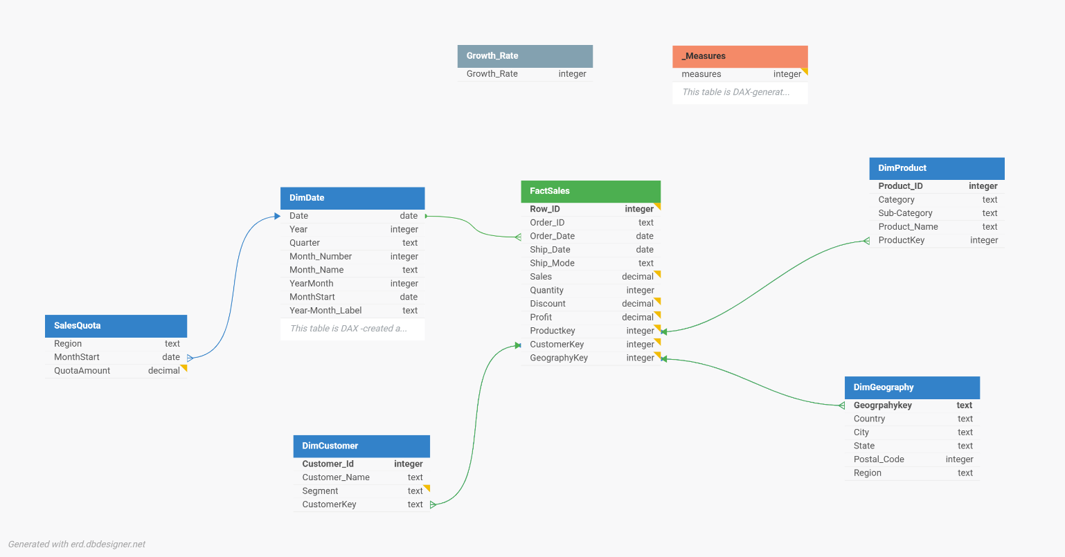

3.1 Tables
Table | Type | Grain / Key | Columns (post-split)
FactSales | Fact | One row per order line (Row ID) | RowID, Order ID, Order Date, Ship Date, CustomerKey, ProductKey, GeographyKey, Ship Mode, Sales, Quantity, Discount, Profit
DimProduct | Dimension | ProductKey (Product ID + Product Name) | ProductKey, Product ID, Product Name, Category, Sub-Category
DimCustomer | Dimension | CustomerKey (Customer ID) | CustomerKey, Customer ID, Customer Name, Segment
DimGeography | Dimension | GeographyKey (Postal Code + City) | GeographyKey, Country, Region, State, City, Postal Code
DimDate | Dimension (DAX) | Date (marked as date table) | Date, Year, Quarter, Month Number, Month Name, YearMonth (YYYYMM), MonthStart, Year-Month Label
SalesQuota | Fact (targets) | Region × MonthStart | Region, MonthStart, QuotaAmount

3.2 Relationships
From (many) | To (one) | Cardinality | Notes
FactSales[Order Date] | DimDate[Date] | *:1, single direction | Active relationship; Ship Date left as inactive candidate (future USERELATIONSHIP demo)
FactSales[ProductKey] | DimProduct[ProductKey] | *:1, single direction | Superstore has Product IDs mapped to multiple names — composite key avoids ambiguity
FactSales[CustomerKey] | DimCustomer[CustomerKey] | *:1, single direction
FactSales[GeographyKey] | DimGeography[GeographyKey] | *:1, single direction
SalesQuota[MonthStart] | DimDate[Date] | *:1, single direction | MonthStart = first day of month, so it joins cleanly to the date table
SalesQuota[Region] | — (no physical join) | Virtual via TREATAS | Region is not unique in DimGeography; the Quota Amount measure bridges it with TREATAS (document 15 §4.2, Quota & Attainment)

4. SalesQuota Table — Structure & Generation
Superstore contains no targets, so the quota table is generated inside the model — a realistic touch that also creates the Quota Attainment story on Page 1. Quota logic: prior-year actual sales per Region per month × 1.10 (a 10% growth target), rounded to the nearest dollar.

4.1 Structure
Column | Data type | Description | Example
Region | Text | Sales region; matches DimGeography[Region] values exactly (Central, East, South, West) | West
MonthStart | Date | First day of the quota month; joins to DimDate[Date] | 2017-01-01
QuotaAmount | Fixed decimal (currency) | Monthly sales target for the region | 16,750

Grain: one row per Region per Month, covering 2015–2017 (36 months × 4 regions = 144 rows; 2014 has no prior year to derive from).

4.2 Sample Rows
Region | MonthStart | QuotaAmount
Central | 2017-01-01 | $8,900
East | 2017-01-01 | $12,400
South | 2017-01-01 | $7,100
West | 2017-01-01 | $16,750
Central | 2017-02-01 | $9,300
East | 2017-02-01 | $11,800
South | 2017-02-01 | $6,600
West | 2017-02-01 | $15,900

*Values above are illustrative; your generated numbers come from actual PY sales at refresh time, so they will differ slightly.*

5. Report Page Mockups — Full Specifications
Canvas: 1280 × 720 (16:9), custom theme JSON (navy #1F3864 primary, teal accent, light-gray canvas #FAFAFA). Every page shares a header band: report title (left), Region chiclet slicer + Order Date range slicer (right), synced across pages. Document 12 (12_PBI_Report_Mockup.html) is the interactive companion mockup; document 15 is the step-by-step build walkthrough.

5.1 Page 1 — Sales Performance
Purpose: "Are we on pace?" Month-in-review for sales leadership. Layout zones: header band (0–80px), KPI row (80–200px), main grid (200–720px, 60/40 split).
# | Visual | Type | Fields | Formatting / behavior
1.1 | Total Sales KPI | Card (new card visual) | Total Sales; reference label: Sales YoY % | YoY delta colored by sign (green/red); sparkline of Total Sales by Month enabled
1.2 | Profit Margin KPI | Card | Profit Margin %; reference: Profit YoY % | Amber below 10%, red below 5% (conditional rules)
1.3 | Orders KPI | Card | Order Count; reference: Avg Order Value | —
1.4 | Quota Attainment KPI | Card | Quota Attainment %; reference: Quota Variance | Field-value color from Quota Status measure (green/amber/red)
1.5 | Monthly Sales vs Prior Year | Line chart | X: Year-Month Label; Y: Total Sales, Sales PY | PY series dashed gray; markers on; data labels off; zoom slider on X
1.6 | Sales by Region | Clustered bar | Y: Region; X: Total Sales, Quota Amount | Quota as lighter overlay bar; sorted desc by sales; constant line at 0 removed
1.7 | Category Breakdown | Stacked bar | Y: Category; X: Total Sales; Legend: Sub-Category (top 5 + Other) — or drillable Category→Sub-Category | Drill-down enabled; tooltip shows Profit Margin %
1.8 | Regional Detail | Matrix | Rows: Region → State; Values: Total Sales, Sales YoY %, Quota Attainment %, Profit Margin % | Attainment % data bars; YoY % icons (up/down arrows); +/- expand enabled

Interactions: 1.6 cross-filters (not cross-highlights) 1.5 and 1.8. Reset-filters bookmark button in header. Right-click drillthrough from Region/State to Page 3 (account detail).

5.2 Page 2 — Forecast & Outlook
Purpose: "Where are we headed?" Six-month sales outlook plus scenario planning. Layout: hero forecast chart (top 55%), three-panel bottom row (seasonality, scenario controls, narrative).
# | Visual | Type | Fields | Formatting / behavior
2.1 | Sales Forecast — 6-Month Outlook | Line chart + Analytics-pane Forecast | X: Year-Month Label (continuous via MonthStart if needed); Y: Total Sales | Forecast: length 6 points, ignore last 0, seasonality 12 (monthly), confidence interval 95%; shaded CI band; forecast line styled dotted teal
2.2 | Trend Smoothing | Line chart | X: Year-Month Label; Y: Total Sales (30% transparency), Sales 3M Rolling Avg (bold) | Communicates trend vs noise; annotate Q4 spikes with smart narrative or manual text callout
2.3 | Seasonality Profile | Column chart | X: Month Name (sorted by Month Number); Y: Seasonality Index | Constant line at 1.00 labeled 'average month'; columns above 1 in navy, below in gray (rule-based)
2.4 | Growth Scenario Slider | Slicer (numeric range, single value) | 'Growth Rate'[Growth Rate] | Slider style; default 5%; sits directly above 2.5
2.5 | Scenario Card | Card | Scenario Sales; reference: Growth Rate Value, Total Sales | Reads: 'At X% growth, next-12-month sales ≈ $Y'
2.6 | Methodology & Caveats | Text box | Static narrative | 3–4 sentences: exponential smoothing, 12-month seasonality, 95% CI, assumes historical pattern holds; see Section 7

Talking point for interviews: the built-in forecast (exponential smoothing, ETS) re-computes under slicer context — filter to West and the forecast becomes a West-only outlook. Demonstrate this live; it lands well.

5.3 Page 3 — Account & Rep Actions
Purpose: "Which accounts need attention this week?" Rep-facing action lists. Layout: two columns — left 45% (top accounts + at-risk table stacked), right 55% (discount diagnostics + decomposition tree).
# | Visual | Type | Fields | Formatting / behavior
3.1 | Top 10 Accounts by Revenue | Bar chart | Y: Customer Name; X: Total Sales; visual-level Top N filter (Top 10 by Total Sales) | Tooltip: Profit Margin %, Order Count, Last Order Date; data labels on
3.2 | At-Risk & Dormant Accounts | Table | Customer Name, Segment, Last Order Date, Days Since Last Order, Total Sales, Account Status | Visual filter: Account Status <> 'Active'; sorted by Total Sales desc (biggest lapsed revenue first); Status cell background: amber = At Risk, red = Dormant
3.3 | Discount vs Profit Diagnostic | Scatter chart | Values: Sub-Category; X: Avg Discount %; Y: Total Profit; Size: Total Sales | Quadrant lines: X at 20% discount, Y at $0 profit; lower-right quadrant labeled 'discounting destroys margin' — Tables & Binders land here; play axis OFF
3.4 | Revenue Decomposition | Decomposition tree | Analyze: Total Sales; Explain by: Region, Segment, Category, Sub-Category | Stretch goal if ahead of schedule; enables ad-hoc 'why' questions in demos

Interactions: 3.1 and 3.2 cross-filter each other off (independent lists). This page is the drillthrough target from Page 1 (Region/State context carries over).

6. Four-Hour Build Timeline
Block | Time | Deliverable | Key tasks
1 | 0:00–1:00 | Star-schema model | Download CSV; staging query; split into fact + 4 dims; build SalesQuota (M script, document 15 §3.5); DAX date table (document 15 §3.6); relationships; hide FKs; set formats
2 | 1:00–2:00 | Measure layer | _Measures table; all measures from document 15 §4.2 with display folders; validate against sanity-check totals (§2); create what-if parameter
3 | 2:00–3:00 | Three report pages | Theme JSON; Page 1 → Page 2 → Page 3 in order; forecast settings on 2.1; conditional formatting on 1.4, 2.3, 3.2
4 | 3:00–4:00 | Polish + packaging | Sync slicers; reset bookmark; drillthrough; one tooltip page; README (§8); screenshots for GitHub/LinkedIn

Timebox guardrails: if Block 1 overruns, cut DimGeography to Region/State only. If Block 3 overruns, drop visual 3.4 (decomposition tree) first, then 2.2. Never cut the quota framework or the forecast — they are the differentiators.

7. Forecast Methodology & Limitations
- Method: Power BI's Analytics-pane forecast uses exponential smoothing (ETS): seasonal ETS(A,A,A) when a season length is set, non-seasonal ETS(A,A,N) otherwise. Season length is set to 12 (monthly grain).
- Confidence interval: 95% band displayed. Emphasize in the README that the band widens with horizon — a single-point 'the number' framing is exactly what a good BI engineer avoids.
- Assumptions: history predicts future (no regime change), stable seasonality, no exogenous drivers (promotions, macro shocks). Superstore ends Dec 2017, so this is a demonstration of technique, not a live prediction.
- Known data caveats: Superstore is synthetic; discounts and profits are internally consistent but not realistic retail economics. State this openly — acknowledging data limits is itself a portfolio signal.
- Future enhancements (README section, zero build cost): RLS by Region for rep-level security, incremental refresh, Fabric/Direct Lake migration path, Python (Prophet/ARIMA) comparison forecast, deployment pipeline, quota table sourced from a planning system instead of PY×1.10.

8. Portfolio Packaging Checklist
- GitHub repo: .pbix, theme JSON, quota M script, README with business scenario, star-schema diagram, measure catalog, forecast-methodology paragraph, and future-enhancements list.
- Screenshots: one per page at 1280×720 plus one model-view screenshot showing the star schema — the model view is the credibility shot.
- LinkedIn post angle: 'What a 4-hour timebox forces you to prioritize as a BI engineer' — scoping discipline is a senior signal that matches your consulting positioning.
- Licensing/attribution line: 'Superstore sample dataset © Tableau Software, distributed as free sample data; sourced via Kaggle.'

