Documentation for the web application project
1.Project Title: Market Product Manager

- Project Overview
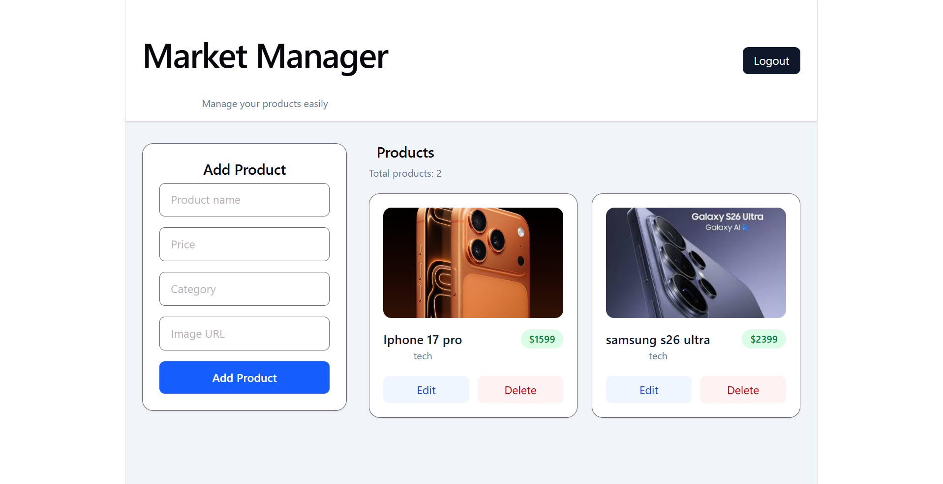
- Market Product Manager is a full-stack web application developed using the MERN stack (MongoDB, Express.js, React, and Node.js). The main purpose of the application is to provide users with a convenient system for managing products in a small online market or personal catalog.
- The application solves the problem of storing and organizing product information in one place. Authenticated users can add new products, view all existing products, edit product information, and delete products. Each product includes a name, category, price, and image URL.
- The target users of the system are students learning web development, individual users, and small business owners who need a simple product management tool. The typical usage scenario consists of registration, login, and performing CRUD operations on products through a modern dashboard interface.
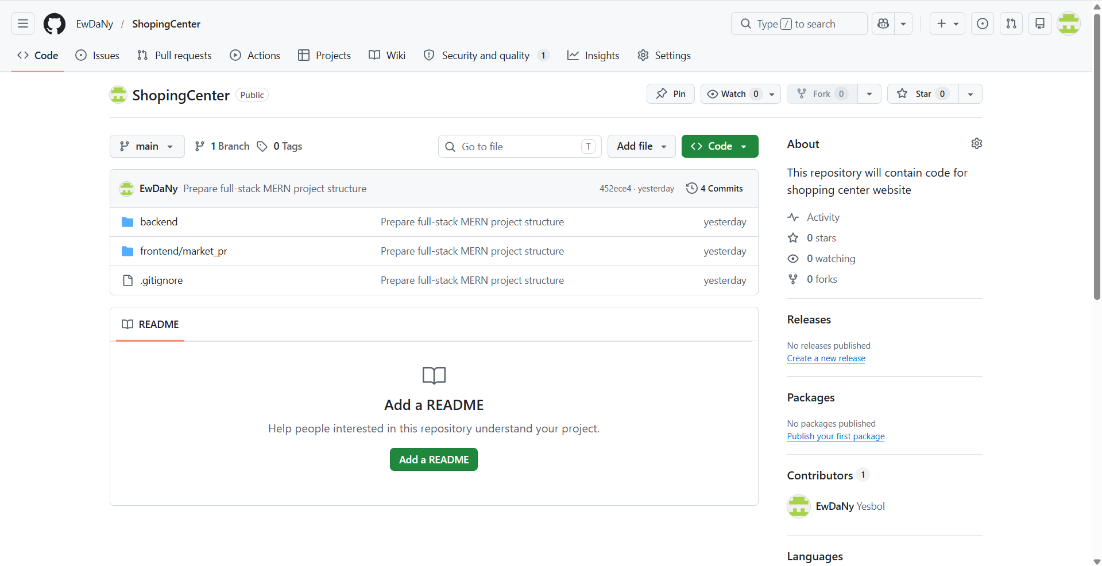
3. Target Users
The main target users of the application are:
- individual users who want to manage a small product catalog;
- students learning full-stack web development;
- small business owners who need a simple product management system;
- users who want to store and update product information through a web interface.

4. Core Functionalities
The application provides a set of core functionalities that allow authenticated users to manage products through a modern web interface.
Authentication
The authentication module ensures that only authorized users can access the system.
- User can register a new account using email and password.
- User can log in using previously created credentials.
- User can log out from the application.
- Protected pages are accessible only to authenticated users.
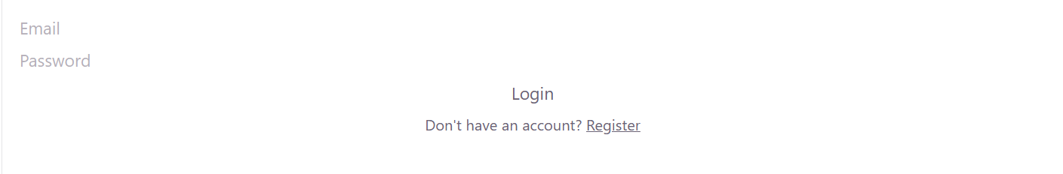
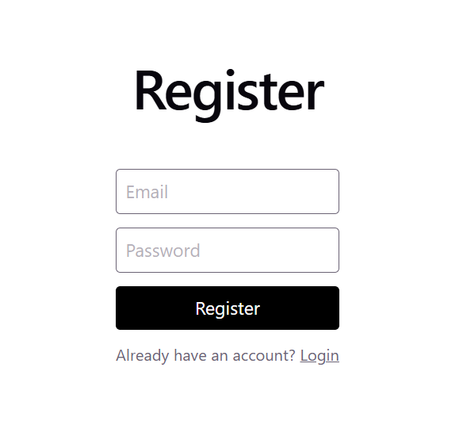

Product Management
The main feature of the application is product management.
- User can view all products stored in the database.
- User can create a new product.
- User can edit an existing product.
- User can delete a product.
- User can add an image URL to display product pictures.
- router.get("/", getAllProducts);
- router.get("/:id", getProductById);
- router.post("/", protect, createProduct);
- router.put("/:id", protect, updateProduct);
- router.delete("/:id", protect, deleteProduct);

User Interface
The frontend provides a responsive and user-friendly dashboard.
- Products are displayed as modern cards.
- Each card contains an image, product name, category, and price.
- The dashboard includes forms for creating and editing products.
- The interface adapts to different screen sizes.
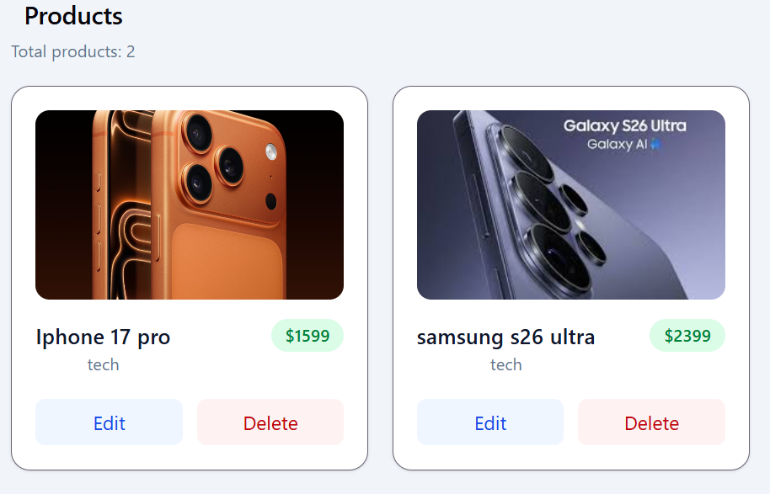
Data Persistence
All product and user data are stored in MongoDB. Changes made by users are saved permanently and remain available after restarting the application.
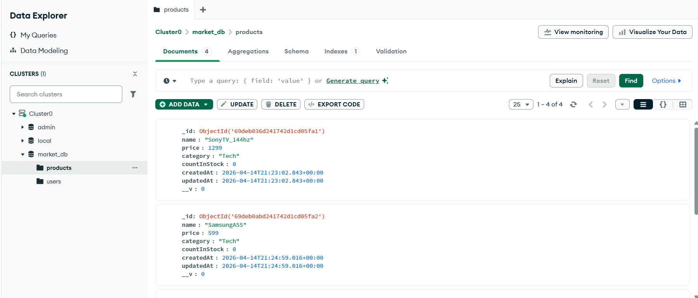

5. Non-Functional Requirements
The project was developed according to several non-functional requirements to ensure maintainability, security, and usability.
Programming Languages
- JavaScript is used for backend development.
- TypeScript is used for frontend development.
Code Quality
- The source code is organized into modules and folders.
- Naming conventions are consistent.
- The code is easy to read and maintain.
Input Validation
- Frontend validates required fields, email format, numeric product values, and image URLs before sending requests.
- Backend performs explicit validation and returns precise HTTP 400 responses for invalid authentication and product data.
Error Handling
- Errors are processed using try...catch.
- Appropriate HTTP status codes are returned.
- Error messages are displayed to the user.
Security
- Passwords are hashed using bcrypt.
- const isMatch = await bcrypt.compare(password, user.password);

- Authentication is implemented using JWT tokens.
- Protected routes restrict unauthorized access.
- const token = jwt.sign(
- { id: user._id },
- process.env.JWT_SECRET,
- { expiresIn: "7d" }
- );

Responsive Design
- Tailwind CSS is used to create a responsive interface.
- The dashboard adapts to desktop and mobile devices.
Containerization
- Docker and Docker Compose are used to run the entire application.
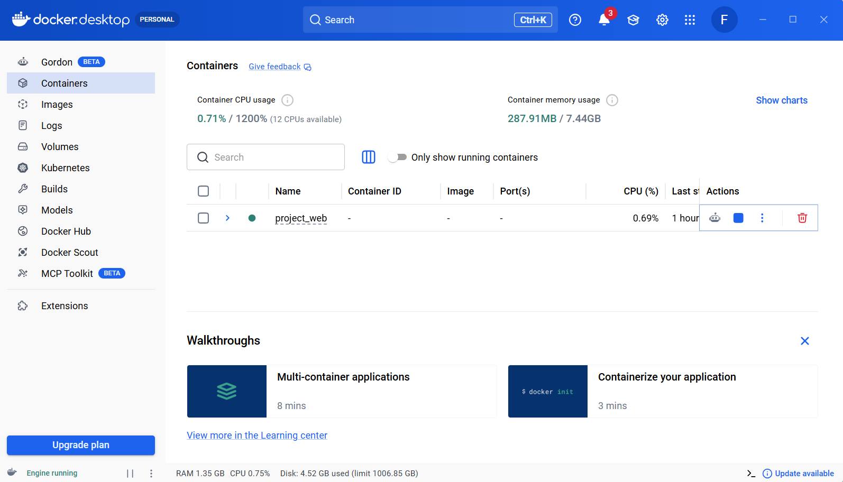
Version Control
- The project is maintained in a GitHub repository.
- Development history is documented through commits.
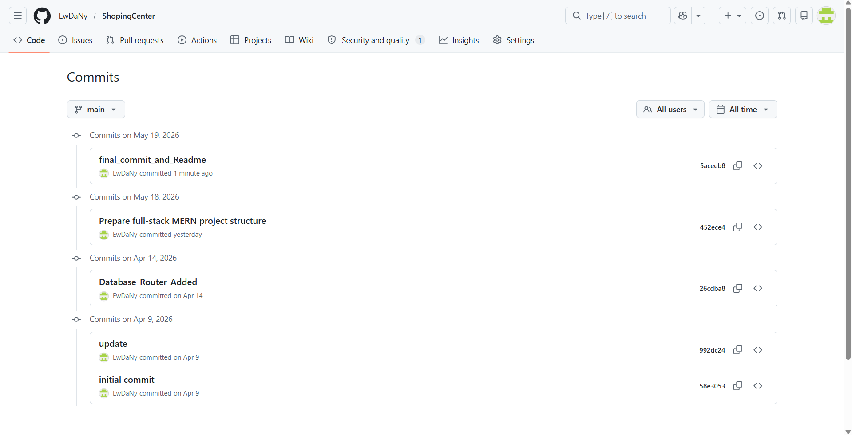

Documentation
- Technical documentation is provided in README.md.
- A detailed project report is prepared in Word/Google Docs format.

6. Technology Stack
The application was developed using the MERN stack and several supporting technologies.
Frontend Technologies
The frontend is implemented as a Single Page Application (SPA) using React and TypeScript.
- React 19
- TypeScript
- Vite
- React Router DOM
- Axios
- Tailwind CSS
Purpose of Frontend Technologies
- React is used to build reusable user interface components.
- TypeScript provides static typing and reduces runtime errors.
- Vite is used as a fast development and build tool.
- React Router DOM enables client-side navigation.
- Axios simplifies communication with the backend API.
- Tailwind CSS is used to create a responsive and modern design.
- const API = axios.create({
- baseURL: "http://localhost:5001/api",
- });

- API.interceptors.request.use((config) => {
- const token = localStorage.getItem("token");

- if (token && config.headers) {
- config.headers.Authorization = `Bearer ${token}`;
- }

- return config;
- });
Backend Technologies
The backend is implemented using Node.js and Express.js.
- Node.js
- Express.js
- Mongoose
- JSON Web Token (JWT)
- bcryptjs
- CORS
- dotenv
Purpose of Backend Technologies
- Node.js provides the JavaScript runtime environment.
- Express.js simplifies REST API development.
- Mongoose manages MongoDB schemas and models.
- JWT handles user authentication.
- bcryptjs hashes user passwords.
- CORS allows frontend and backend communication.
- dotenv manages environment variables.
Database
The application uses MongoDB as a NoSQL database.
- MongoDB
- MongoDB Atlas (for cloud development)
- Local MongoDB container (via Docker)
DevOps and Deployment Tools
- Docker
- Docker Compose
These tools allow the entire application to be launched in isolated containers with a single command.
Version Control
- Git
- GitHub
Git is used for source control, and GitHub stores the repository and commit history.
Development Tools
- Visual Studio Code
- Postman
- Docker Desktop
7. System Architecture
The system follows a three-tier architecture consisting of frontend, backend, and database layers.
Frontend Layer
The frontend is a React Single Page Application developed with TypeScript. It is responsible for:
- displaying the user interface;
- handling user input;
- sending HTTP requests to the backend;
- storing JWT tokens in localStorage;
- protecting routes based on authentication state.
Backend Layer
The backend is a REST API developed with Express.js. It is responsible for:
- processing HTTP requests;
- validating data;
- authenticating users;
- performing CRUD operations;
- interacting with MongoDB.
Database Layer
MongoDB stores user accounts and product data.
Communication Flow
- The user interacts with the React frontend.
- Axios sends HTTP requests to the Express backend.
- Express processes the request.
- Mongoose communicates with MongoDB.
- The response is returned to the frontend.
Authentication Flow
- The user logs in.
- The backend verifies credentials.
- The server generates a JWT token.
- The token is stored in localStorage.
- Axios sends the token in the Authorization header.
- The backend verifies the token using middleware.
Architecture Diagram
React + TypeScript (Frontend)
│
▼
Axios HTTP
│
▼
Express.js REST API (Backend)
│
▼
Mongoose ODM
│
▼
MongoDB

Docker Architecture
Frontend Container
Backend Container
MongoDB Container
All containers are orchestrated by Docker Compose.
8. Data Model
The application uses two main data models: User and Product. The User model is needed for registration and authentication, while the Product model represents the main data that users manage in the system.
The User model contains an email address and a password. For security reasons, the password is not stored as plain text. Before saving it to the database, the password is hashed using bcrypt. After a successful login, the system generates a JWT token, which is later used to authorize protected requests.
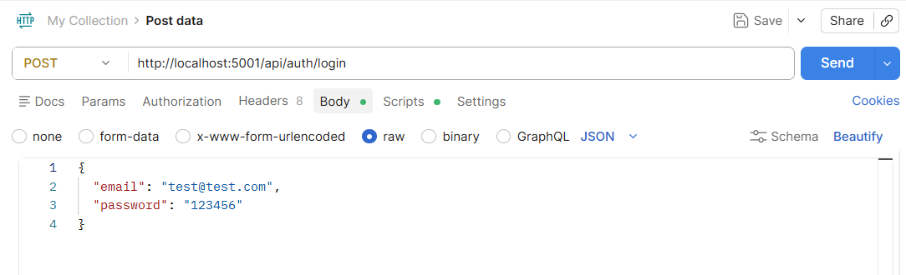
The Product model stores information about each product. It includes the product name, description, price, category, image URL, and stock quantity. The model also stores automatic timestamps, which show when the product was created and last updated. This structure makes it possible to display product information clearly in the dashboard and update it when needed.
User Model
Field | Type | Description
_id | ObjectId | Unique identifier
email | String | User email address
password | String | Hashed user password
Product Model
Field | Type | Description
_id | ObjectId | Unique identifier
name | String | Product name
description | String | Optional product description
price | Number | Product price
category | String | Product category
image | String | Product image URL
countInStock | Number | Product quantity in stock
createdAt | Date | Date when the product was created
updatedAt | Date | Date when the product was last updated

9. API Scope
To connect the frontend and backend parts of the application, I developed a REST API. All requests are sent through HTTP, and the data is transferred in JSON format. This makes the application structure clearer because the frontend is responsible for the interface, while the backend handles business logic, authentication, and database operations.
The API is divided into two main parts. The first part is responsible for user registration and login. The second part is responsible for product management. After a successful login, the backend returns a JWT token. This token is stored on the frontend and is sent with protected requests.
Authentication Endpoints
Method | Endpoint | Description
POST | /api/auth/register | Register a new user
POST | /api/auth/login | Authenticate the user and return a JWT token
Product Endpoints
Method | Endpoint | Description
GET | /api/market | Retrieve all products
GET | /api/market/:id | Retrieve a single product by id
POST | /api/market | Create a new product
PUT | /api/market/:id | Update an existing product
DELETE | /api/market/:id | Delete a product
When a product is created or edited, the frontend sends the product name, price, category, and image URL to the backend. The backend processes this request, saves the data in MongoDB, and sends a response back to the frontend. In this way, the user can manage products directly from the dashboard.
In my opinion, this API structure is simple and practical. Each endpoint has a clear purpose, and this makes the project easier to test, maintain, and extend in the future.
10. Project Management and Implementation Plan
The project was developed incrementally. I began by defining the application idea and selecting the technology stack. After that, I created the folder structure and initialized both the backend and frontend applications. The project was managed using Git and GitHub, which allowed me to save progress through meaningful commits and keep track of each stage of development.
At the beginning, I created the backend and implemented the connection to MongoDB. Then I developed the Product model and the REST API for CRUD operations. After the product API was working, I added user authentication using JWT and bcrypt.
The next stage was frontend development. I created the Login, Register, and Dashboard pages. Then I connected the frontend to the backend using Axios and implemented protected routes. After that, I added product creation, editing, deletion, and image URL support.
In the final stage, I improved the user interface using Tailwind CSS, added Docker and Docker Compose, and prepared the technical documentation in README.md and the project report.
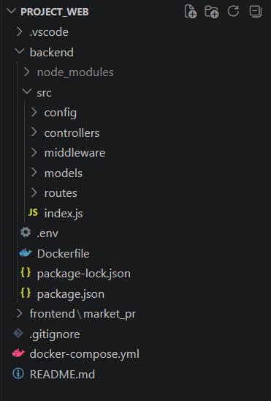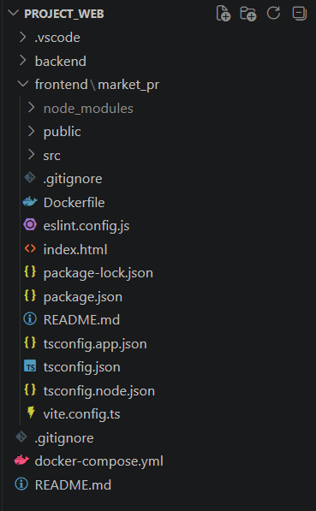
Main Development Milestones
- Project initialization and folder structure.
- MongoDB connection and Product model.
- Product CRUD API.
- User authentication with JWT.
- React frontend and routing.
- Product dashboard and CRUD interface.
- UI improvements and image support.
- Docker configuration.
- Documentation and final testing.

11. Testing
Testing was carried out throughout the development process. I tested both the backend API and the frontend interface to make sure that all features worked correctly.
The backend was tested using Postman. I sent requests to register users, log in, and perform CRUD operations on products. I verified that the server returned the correct HTTP status codes and JSON responses.
The frontend was tested manually in the browser. I checked registration, login, protected route access, logout, and all product operations. I also verified that the interface updated automatically after creating, editing, and deleting products.
Finally, I tested the entire application inside Docker containers. This confirmed that the frontend, backend, and MongoDB could run together without any configuration problems.
POST /api/auth/login
Content-Type: application/json
{
"email": "test@test.com",
"password": "123456"
}
12. Deployment and Execution
The application can be run either locally or inside Docker containers. During development, I usually started the backend and frontend separately using the npm run dev command. This approach was convenient for debugging and testing individual components.
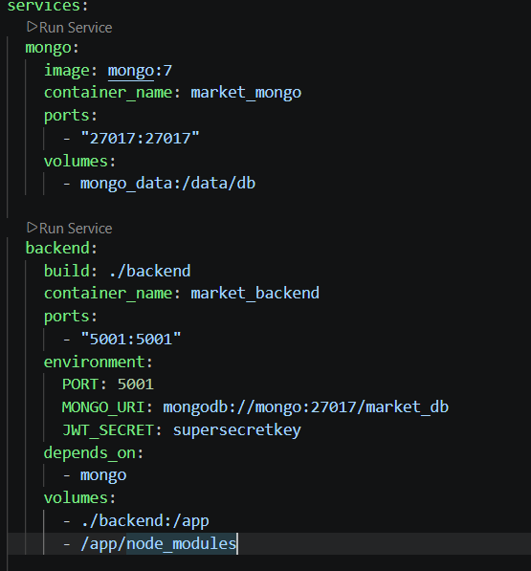
For the final version of the project, I configured Docker and Docker Compose. This made it possible to launch the frontend, backend, and MongoDB with a single command. In my opinion, this is one of the most useful parts of the project because it makes the application much easier to run on another computer.
To start the application in Docker, I used the following command:
docker compose up --build
After the containers were started, the frontend became available at http://localhost:5173, and the backend API was available at http://localhost:5001.
The application can also be deployed to cloud platforms such as Render, Railway, or Vercel. However, for this project I focused on Docker-based deployment because it fully satisfies the course requirements.
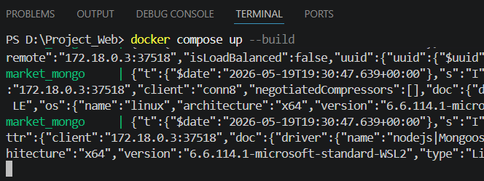
13. Final Documentation
The final project includes both technical documentation and a detailed written report. The technical documentation is provided in the README.md file located in the root directory of the GitHub repository. It contains a project overview, installation instructions, Docker usage, API endpoints, and screenshots.
In addition to the README file, I prepared this report in Word and Google Docs format. The report describes the project structure, architecture, implementation process, testing, and deployment.
The final submission includes the following materials:
- GitHub repository with the complete source code.
- README.md technical documentation.
- Docker and Docker Compose configuration.
- Project report in Word/PDF format.
- Screenshots demonstrating the application.
- GitHub commit history.
In my opinion, combining code, documentation, and deployment files makes the project complete and easy to understand for other developers and for the course instructor.
PROJECT_WEB/
├── backend/
├── frontend/
├── docker-compose.yml
├── README.md
└── .gitignore

