http://www.openannotation.org/spec/core/
Introduction
Annotating, the act of creating associations between distinct pieces of information, is a pervasive activity online in many guises but currently lacks a structured approach.
The Open Annotation data model provides an extensible, interoperable framework for expressing annotations such that they can easily be shared between platforms, with sufficient richness of expression to satisfy complex requirements while remaining simple enough to also allow for the most common use cases, such as attaching a piece of text to a single web resource.
An annotation is considered to be a set of connected resources, typically including a body and target, and conveys that the body is related to the target.
The primary aim of the Open Annotation Data Model is to provide a standard description mechanism for sharing Annotations between systems.
Namespaces
The Open Annotation model defines a namespace for its classes and properties, and uses several others as listed below. The namespace URI will always remain the same, even if the ontology changes. All versions of the ontology will remain available from version-specific URLs, and the namespace URI will provide access to the most recent version.
The following namespaces are used in this specification:
Prefix | Namespace | Description
oa | http://www.w3.org/ns/oa# | The Open Annotation ontology
cnt | http://www.w3.org/2011/content# | Representing Content in RDF
dc | http://purl.org/dc/elements/1.1/ | Dublin Core Elements
dcterms | http://purl.org/dc/terms/ | Dublin Core Terms
dctypes | http://purl.org/dc/dcmitype/ | Dublin Core Type Vocabulary
foaf | http://xmlns.com/foaf/0.1/ | Friend-of-a-Friend Vocabulary
prov | http://www.w3.org/ns/prov# | Provenance Ontology
rdf | http://www.w3.org/1999/02/22-rdf-syntax-ns# | RDF
rdfs | http://www.w3.org/2000/01/rdf-schema# | RDF Schema
skos | http://www.w3.org/2004/02/skos/core# | Simple Knowledge Organization System
trig | http://www.w3.org/2004/03/trix/rdfg-1/ | TriG Named Graphs

In general terms, an Annotation expresses the relationship between two or more resources, and their metadata, using an RDF graph. The Open Annotation Core framework explains how to identify and describe the related resources, and how to provide information concerning the creation and intent of the Annotation.
Typically an Annotation has a single Body, which is the comment or other descriptive resource, and a single Target that the Body is somehow "about". The Body provides the information which is annotating the Target.
Model
Vocabulary Item | Type | Description
oa:Annotation | Class | The class for Annotations  The oa:Annotation class MUST be associated with an Annotation.
oa:hasBody | Relationship | The relationship between an Annotation and the Body of the Annotation  There SHOULD be 1 or more oa:hasBody relationships associated with an Annotation but there MAY be 0.
oa:hasTarget | Relationship | The relationship between an Annotation and the Target of the Annotation  There MUST be 1 or more oa:hasTarget relationships associated with an Annotation.
All Annotations MUST be instances of the class oa:Annotation, and additional subclassing is ONLY RECOMMENDED in order to provide additional, community-specific constraints on the model. The model does not define classes for Body and Target, as the Body of one Annotation may be the Target of another, and thus the classes would not convey any usable information. Instead, typing based on the resource content is RECOMMENDED.
The model defines two relationships, oa:hasBody and oa:hasTarget, to associate the Body and Target resources, respectively, with the Annotation.
Model
Vocabulary Item | Type | Description
cnt:ContentAsText | Class | A class assigned to the Body for embedding textual resources within the Annotation.  This class SHOULD be assigned to the Body, however it can be inferred from the presence of the mandatory cnt:chars property.
cnt:chars | Property | The character sequence of the content.  There MUST be exactly 1 cnt:chars property associated with the ContentAsText resource.
dc:format | Property | The media type of the content.  There SHOULD be exactly 1 dc:format property associated with the resource.
dc:language | Property | The language of the content, if known.  There MAY be 0 or more dc:language properties. Each language SHOULD be expressed as a language tag, as defined by RFC 3066.
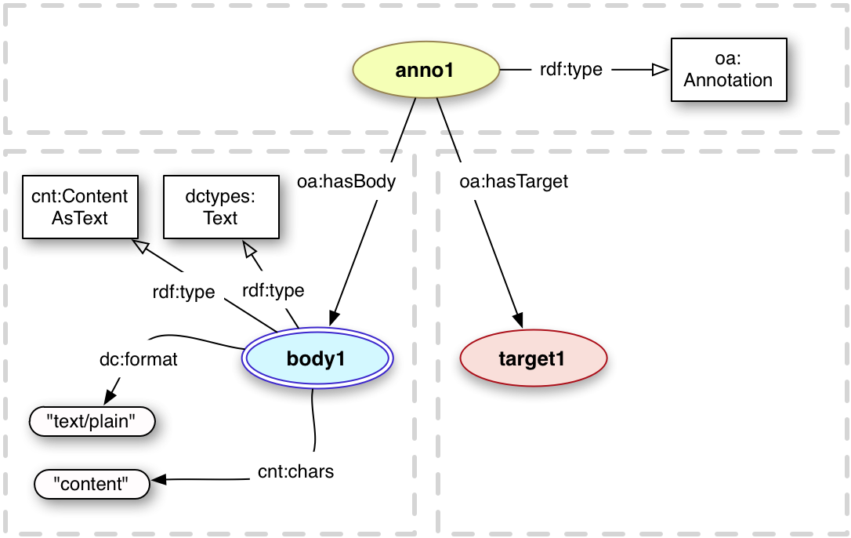

Tagging a resource, either with a short text string or a with a URI, is a common use case for Annotation. Tags are typically keywords or labels, and used for organization, description or discovery of the resource being tagged. In the Semantic Web, URIs are used instead of strings to avoid the issue of polysemy where one word has multiple meanings. In this situation, one would use two different URIs to refer to the "bank" of a river versus a financial institution.
For semantic tags, where the tag is expressed as a URI, the Body is the URI of the tagging resource. The above example might instead use the URI http://dbpedia.org/resource/Paris as the Body, and is typically a term from a controlled vocabulary intended to be widely reused. It is also necessary to know that this resource should not be retrieved and rendered for the user, and thus the oa:SemanticTag class MUST be associated with the tagging resource. Note well that semantic tags, and other URIs, may have a fragment component, where the purpose is NOT to select a segment of the document. As such, these resources MUST NOT be re-expressed using FragmentSelectors as that would mean they were selecting a segment of interest. The semantic tagging model is depicted in Figure 2.1.3.2.
In the Open Annotation Core model, the tag is represented as the Body of the Annotation, and the resource being tagged is the Target. For example, one might wish to associate the textual tag "paris" with an image of the capital of France to describe what is being depicted. Similarly, "capital", "city", "photo", "stunning" might all be used as tags for the same image. This situation is modeled using the same method as embedded textual bodies described in the previous section. The body resource SHOULD also have the oa:Tag class assigned to it, as applications render comments and tags in very different ways. Figure 2.1.3.1 below depicts this.
For semantic tags, where the tag is expressed as a URI, the Body is the URI of the tagging resource. The above example might instead use the URI http://dbpedia.org/resource/Paris as the Body, and is typically a term from a controlled vocabulary intended to be widely reused. It is also necessary to know that this resource should not be retrieved and rendered for the user, and thus the oa:SemanticTag class MUST be associated with the tagging resource. Note well that semantic tags, and other URIs, may have a fragment component, where the purpose is NOT to select a segment of the document. As such, these resources MUST NOT be re-expressed using FragmentSelectors as that would mean they were selecting a segment of interest. The semantic tagging model is depicted in Figure 2.1.3.2.
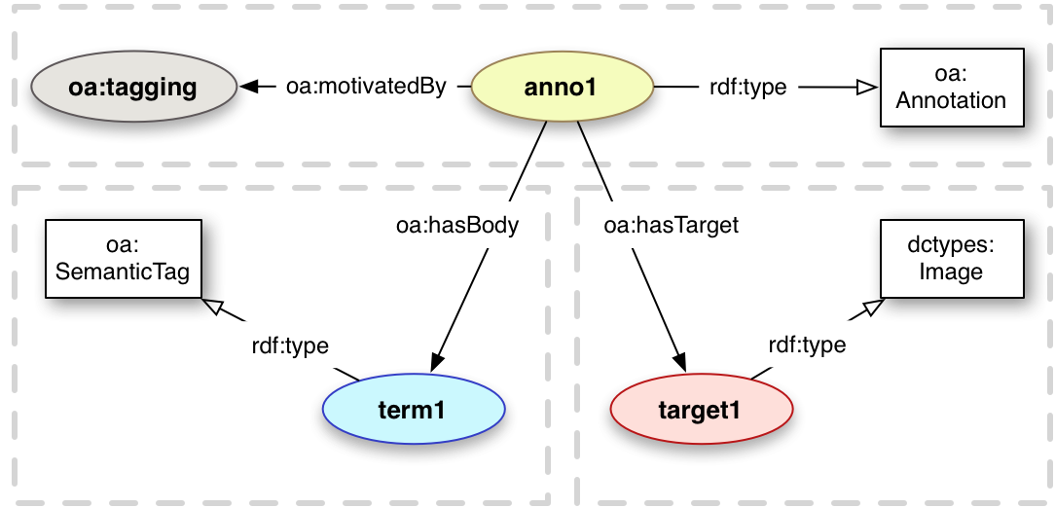
Figure 2.1.3.2. Semantic Tag
<anno1> a oa:Annotation ;
oa:motivatedBy oa:tagging ;
oa:hasBody <term1> ;
oa:hasTarget <target1> ;

<term1> a oa:SemanticTag .
<target1> a dctypes:Image .

It is NOT RECOMMENDED to use the URI of a document as a Semantic Tag, as it might also be used as a regular Body in other Annotations which would inherit the oa:SemanticTag class assignment. Instead it is more appropriate to create a new URI and link it to the document, as demonstrated in figure 2.1.3.3 using the foaf:page predicate.
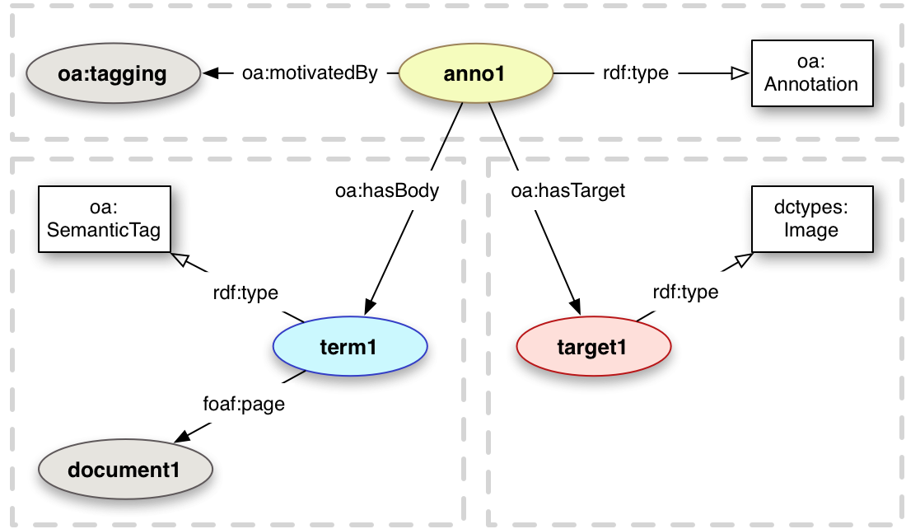

Vocabulary Item | Type | Description
oa:annotatedBy | Relationship | [subProperty of prov:wasAttributedTo] The object of the relationship is a resource that identifies the agent responsible for creating the Annotation. This may be either a human or software agent.  There SHOULD be exactly 1 oa:annotatedBy relationship per Annotation, but MAY be 0 or more than 1, as the Annotation may be anonymous, or multiple agents may have worked together on it.
oa:annotatedAt | Property | The time at which the Annotation was created.  There SHOULD be exactly 1 oa:annotatedAt property per Annotation, and MUST NOT be more than 1. The datetime MUST be expressed in the xsd:dateTime format, and SHOULD have a timezone specified.
oa:serializedBy | Relationship | [subProperty of prov:wasAttributedTo] The object of the relationship is the agent, likely software, responsible for generating the Annotation's serialization.  There MAY be 0 or more oa:serializedBy relationships per Annotation.
oa:serializedAt | Property | The time at which the agent referenced by oa:serializedBy generated the first serialization of the Annotation, and any subsequent substantially different one. The annotation graph MUST have changed for this property to be updated, and as such represents the last modified datestamp for the Annotation. This might be used to determine if it should be re-imported into a triplestore when discovered.  There MAY be exactly 1 oa:serializedAt property per Annotation, and MUST NOT be more than 1. The datetime MUST be expressed in the xsd:dateTime format, and SHOULD have a timezone specified.

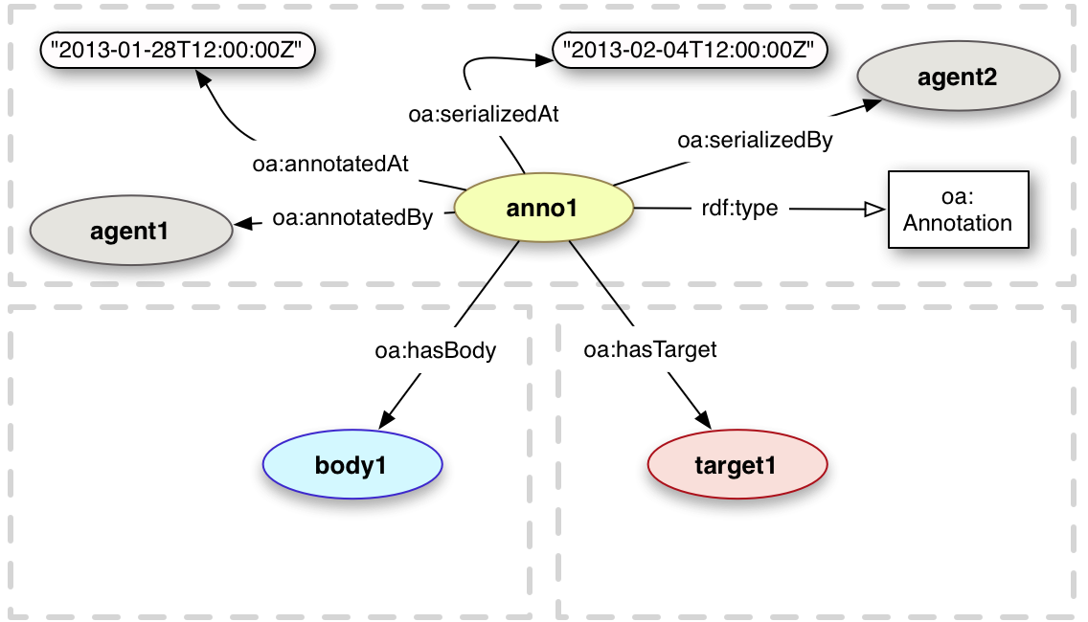
http://www.openannotation.org/spec/core/core.html
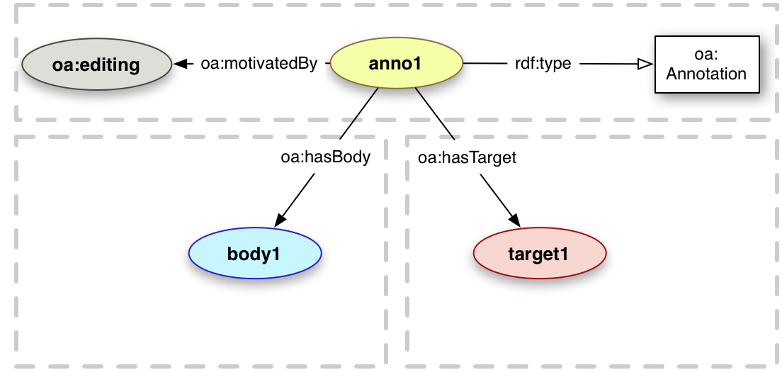
Text Position Selector
Choice
A Choice is a set of resources from which an application that is consuming the Annotation should select only one to process or display. For Specifiers, the Client should choose one of the constituent resources to use, as they are somehow comparable or equivalent. Clients MAY use any algorithm to determine which resource to choose, and SHOULD make use of the information present in the Annotation to do so automatically, or MAY present a list and require the user to make the decision.
The Choice SHOULD have a default option. This is the constituent resource that the Annotation's publisher recommends to be used if the client does not have a preference of its own. This feature should especially be used to express a preferred Selector or State. Note that rdf:Alt does not have an equivalent property.
Model
Vocabulary Item | Type | Description
oa:Choice | Class | [subClass of rdf:Alt] A multiplicity construct that conveys to a consuming application that it should select one of the constituent resources to display to the user, and not render all of them. This construct is equivalent to the rdf:Alt container class.
oa:default | Relationship | [subProperty of oa:item] The constituent resource to use as a default option, if there is no other means to determine which would be most appropriate.  There SHOULD be exactly 1 default relationship for each Choice.
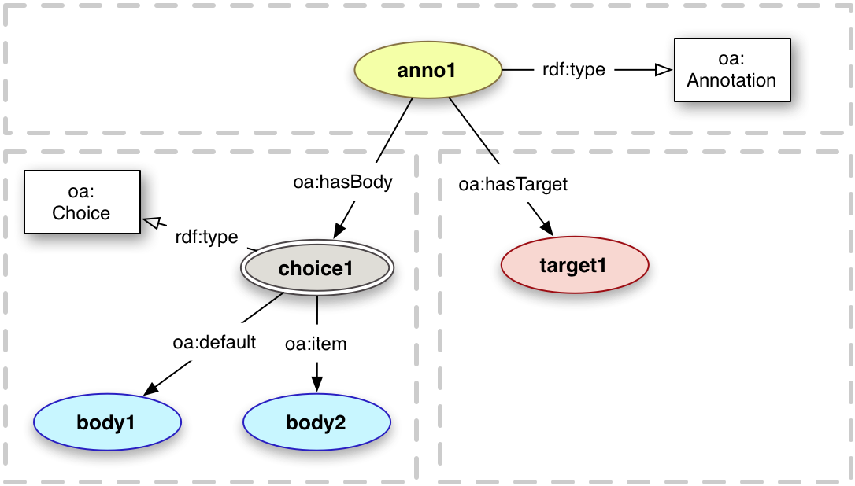
Figure 4.1 Choice
<anno1> a oa:Annotation ;
oa:hasBody <choice1> ;
oa:hasTarget <target1> .

<choice1> a oa:Choice ;
oa:default <body1> ;
oa:item <body2> .

