Problem 1:

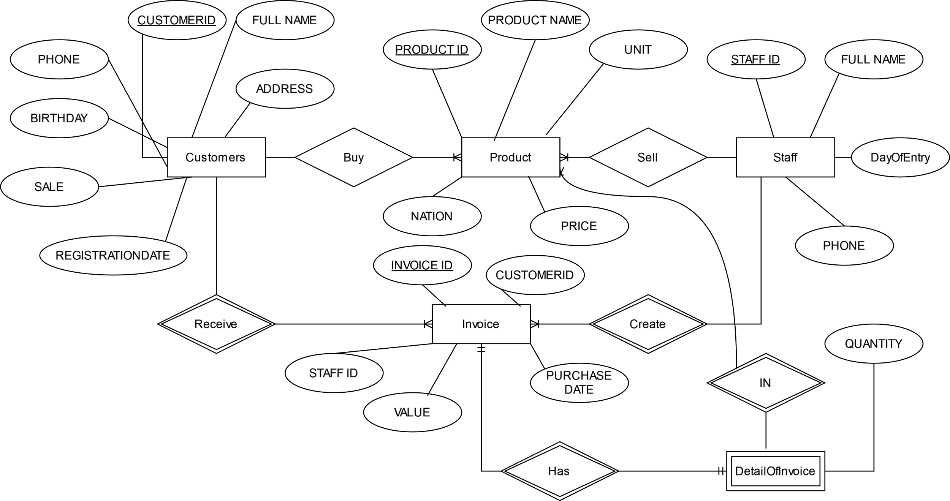

Problem 2:

