C#

1. Instalation:

Następujące elementy zostały zainstalowane w: „C:\Program Files\dotnet”

• Zestaw .NET Core SDK 3.1.201

• Środowisko uruchomieniowe platformy .NET Core 3.1.3

• Środowisko uruchomieniowe platformy ASP.NET Core 3.1.3

• Środowisko uruchomieniowe platformy .NET Core systemu Windows Desktop 3.1.3

Ten produkt gromadzi dane dotyczące użycia

• Więcej informacji i rezygnacja: https://aka.ms/dotnet-cli-telemetry

Zasoby

• Dokumentacja platformy .NET Core: https://aka.ms/dotnet-docs

• Dokumentacja zestawu SDK: https://aka.ms/dotnet-sdk-docs

• Informacje o wersji: https://aka.ms/netcore3releasenotes

• Samouczki: https://aka.ms/dotnet-tutorials

# **TWO .NET FRAMEWORKS:**

.NET:

1. .NET Framework (Windows only)
2. .NET Core - completely open-source for Windows, Linux, Mac, ARM
3. **CLR** - Common Language Runtime
4. **FCL** - Framework Class Library

CMD: type dotnet

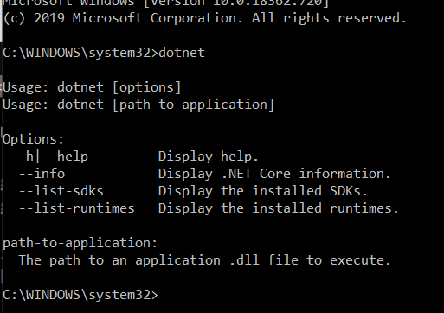

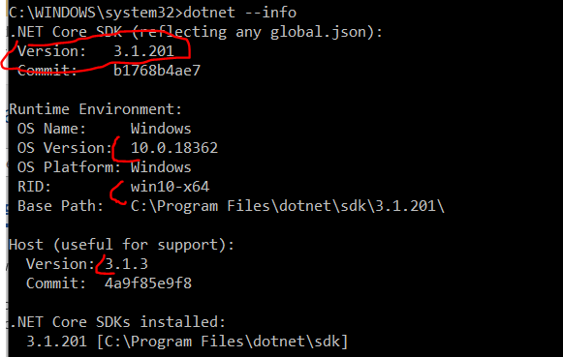

Version of SDK and of the runtime will be different

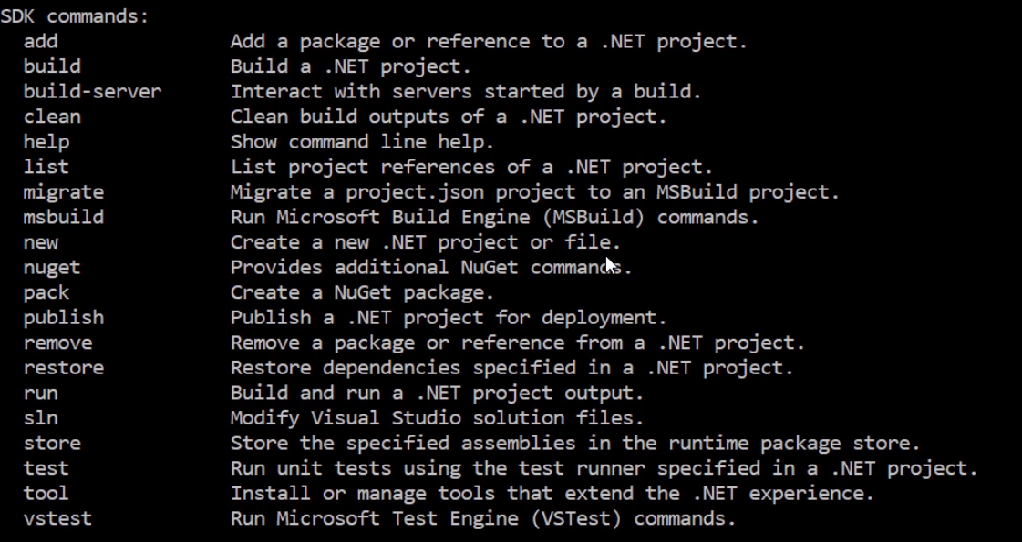

dotnet new console 🡪 console application

cls - clear and create a new application

extenstion .csproj - C# project

dotnet new console - command for new console app

dotnet run - prints Hello World

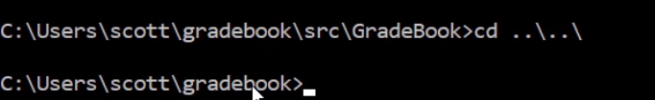

code . - launch VS Code

# **Steps while creating a project in CMD:**

(user location) mkdir gradebook

cd gradebook

dir

mkdir src

mkdir test

cd src

mkdir GradeBook

cd Gradebook

dotnet new console *(info displayed)*

dotnet run

cd ..\..\

code .

DOTNET RUN IS HERE 🡪 **C:\Users\stumm\gradebook\src\GradeBook>dotnet run**

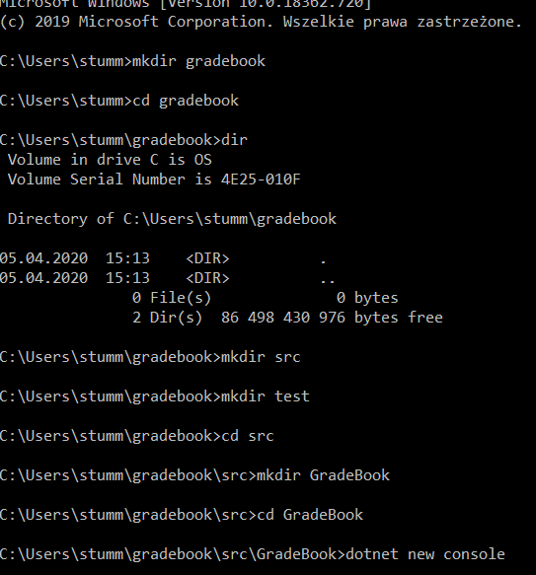

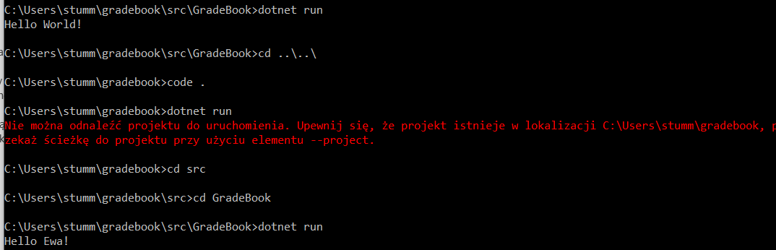

OR:

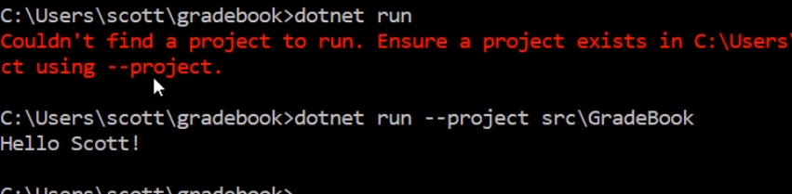

next 🡪 restore

dotnet restore



# **dotnet build 🡪 compilation**

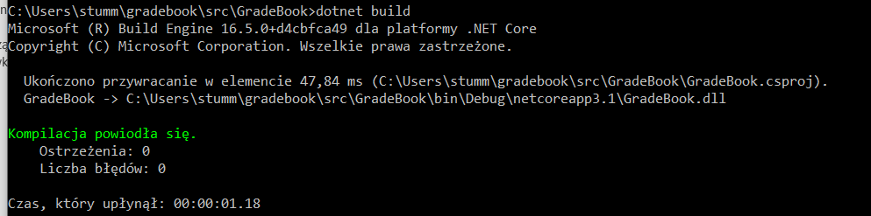

bin 🡪 binary: debug folder

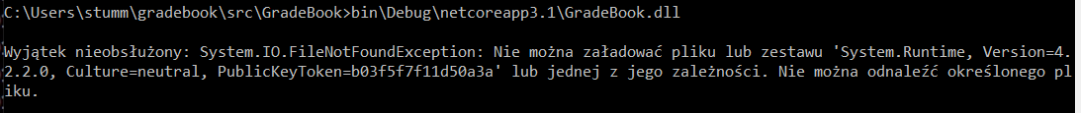

Ways to overcome:

1. dotnet run OR
2. dotnet bin as below:

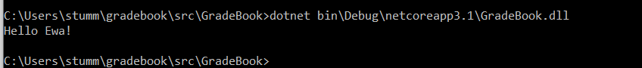

# **CODE DESCRIPTION:**

Overview:

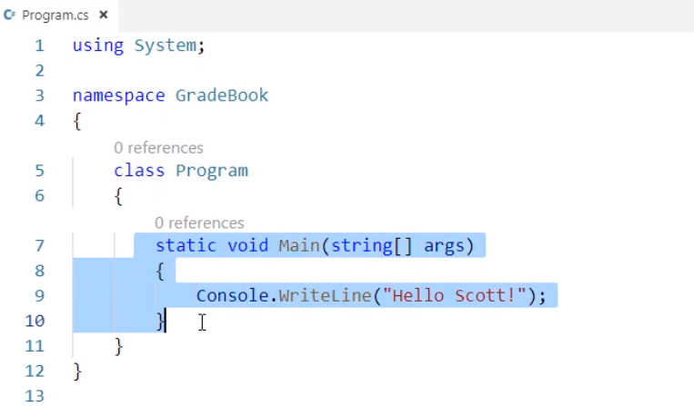

Selected static void (…) Console 🡪 method; method name is Main; executed code put in {}

string[] args 🡪 parameter and parameter name; args are arguments that are passed to the application, whereas type of this parameter is string

[] - an array

Add args[1] - because C# also has a zero-based indexing:

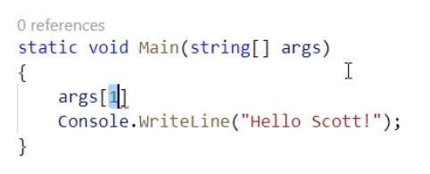

# **1st solution:**

Purpose: to build a string that consists of this writing of ‘Hello…’ and provides the given argument

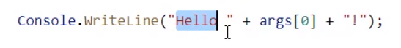

*Note: we are dealing with an array of strings!*

# **2nd solution 🡪 string interpolation:**

2nd solution: String interpolation

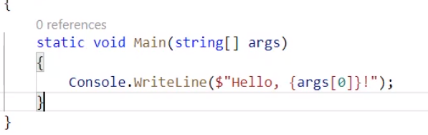

Result in my console:

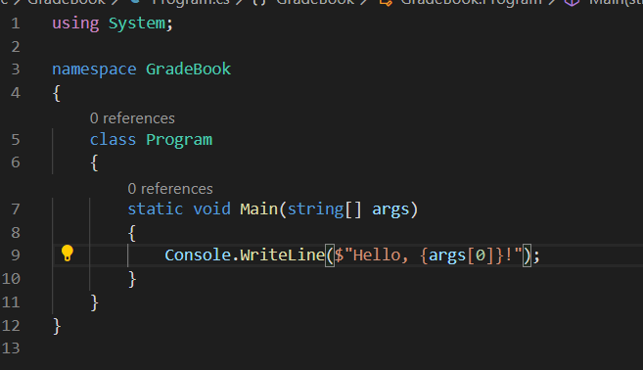

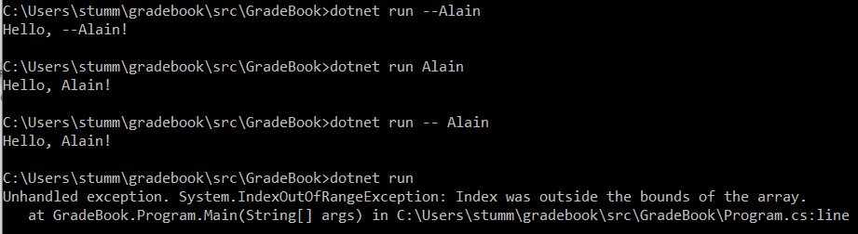

# **Debugging:**

Run 🡪 Start debugging, mark line 9 with red circle beforehand

Debugger tool bar:

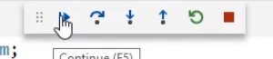

Someone has to pass an argument so that the algorithm is executed

Amend the code and add the condition which returns text even if argument is not provided

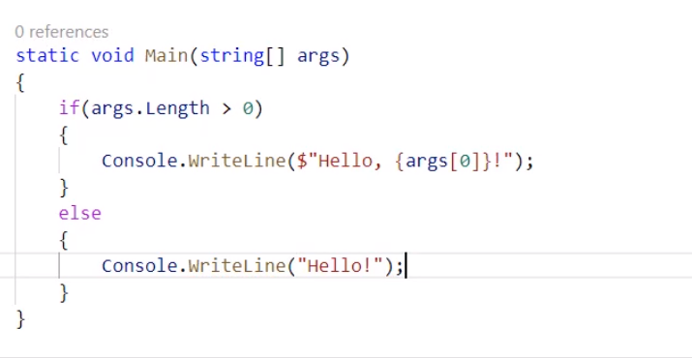

Mine:

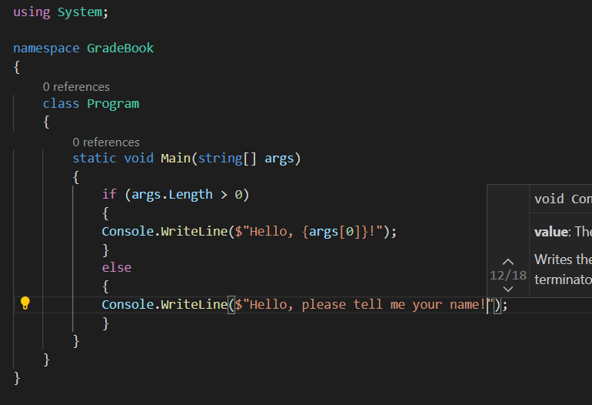

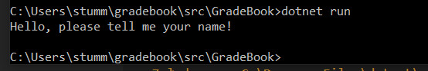

Coming back to files - choose launch.json

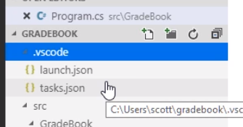

Important piece of code for us:

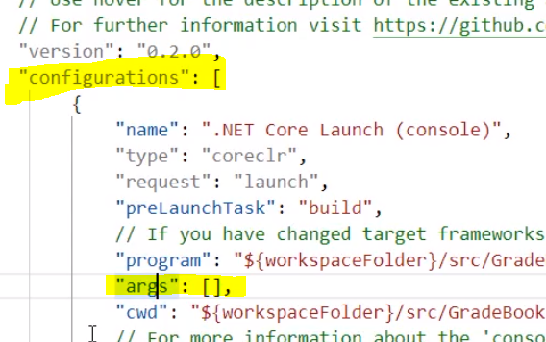

Type arg Scott:

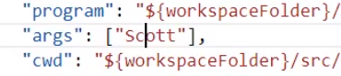

Ctrl+F5 to run the debugger

# **Summary**

1. Installation of .NET Core and VS Code
2. Finding first bug in the command line
3. Recognition that we need to provide a parameter in the command line
4. We need to provide condition in case if an argument is not provided

# **MODULE II**

Learning the C# Syntax

Assignment review:



When we execute/build/run an application, we will execute the lines of code which appear inside of this Main method (an entry point of an application).

In C#, we are also likely to use curly braces to denote the start and the end of different methods; start of a method begins with { and ends with } . What is inside, we call statements.

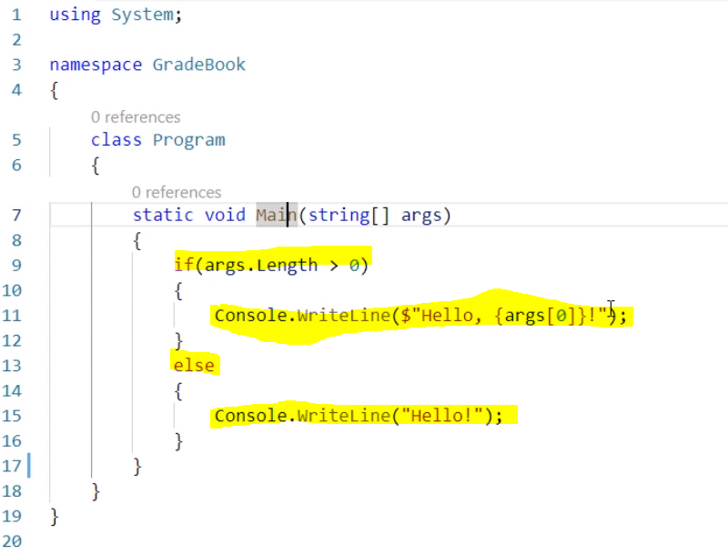

Line 9: an if statement

Line 11: a statement which invokes a WriteLine method

Some statements do not require a semi colon ( ; ) , e.g. if but in places then C# compiles the code into an efficient binary format already require it.

# **Variable declaration**

Another statement which we can have is called a variable declaration.

We will need to work with floating point numbers

There are some built-in data types in C# that can be used to hold floating point numbers in a variable. So in place when we declare the variable, we also declare a storage location to hold some value.

Every variable declaration consists of a name and type of a variable.

e.g float, double (double point number which is twice as precise as a float)

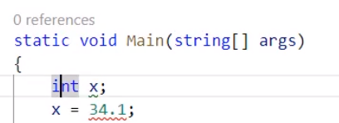

or



or



We can replace naming a variable type with “var”; however, we cannot store e.g. a string if a numeric value has been defined previously.

Also: we can state var result but the result must be stated

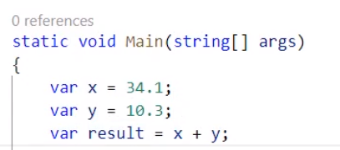

NOTE: in order to return the result, instead of “Console…” we can simply type **cw** and press tab:

Hereafter:



Full code: stored in .txt

*In our project, we gonna have a collection of collection point numbers that we can manage and which can grow when we add more grades; we don’t want to do it by declaring each grade as we don’t know how many grades there would be so we define a collection as an array*

C# does not allow to use an unassigned local variable as it typically leads to an error in a program

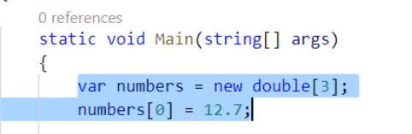

---Next sum example

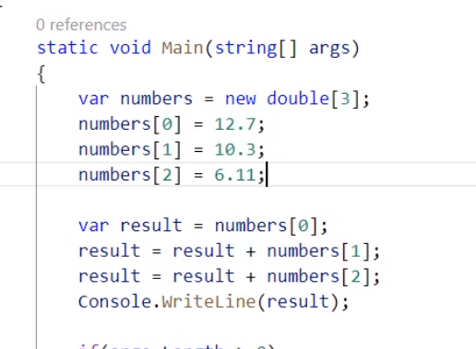

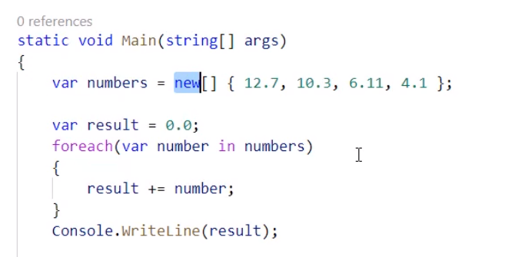

System.Connections.Generic

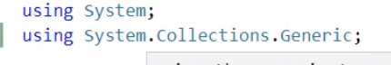

Type argument - certain types and classes in .NET libraries that require us to give some additional information how we will use this particular type

Now: a list that stores only double-precision float numbers

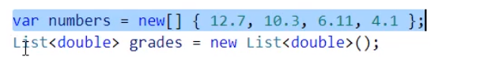

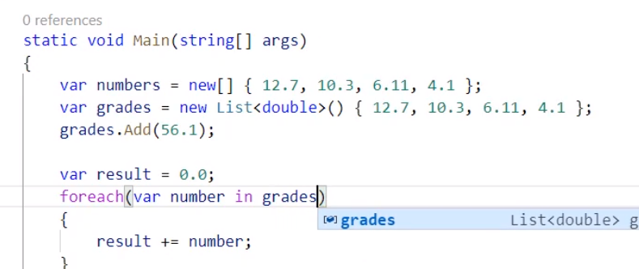

# **Counting average:**

result = result / grades.Count;

# **String interpolation**

**String interpolation** (or variable interpolation, variable substitution, or variable expansion) is the process of evaluating a string literal containing one or more placeholders, yielding a result in which the placeholders are replaced with their corresponding values. It is a form of simple template processing or, in formal terms, a form of quasi-quotation (or logic substitution interpretation). String interpolation allows easier and more intuitive string formatting and content-specification compared with string concatenation.

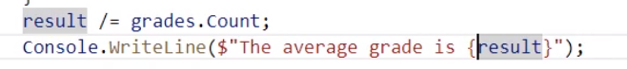

**Formatting floating point number** 🡪 search in Google

e.g.:

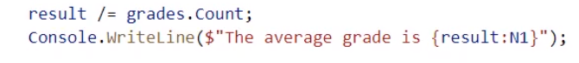

# **Module summary**

In this module, we learned how to:

1. Declare variables
2. Write statements (if, loop)
3. Arrays, list
4. Looping through a list of floating point numbers

# **MODULE III**

Creating a class:

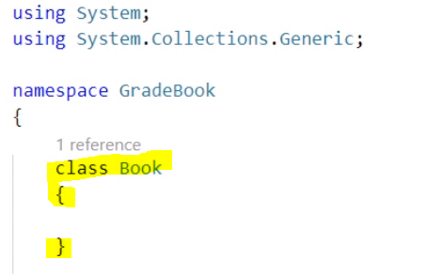

Usually, C# programmers create only one class per file.

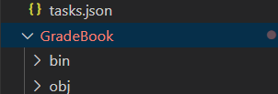

Right mouse button 🡪 new file

Create “Book.cs”

1. namespace GradeBook {}
2. class Book
3. namespace GradeBook
4. {
5. class Book
6. {
8. }
9. }

Important: how a class can be a right abstraction for what we need; giving the right members (understandable for other developers);

adding a member - see: List

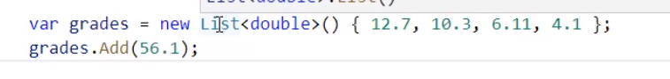

A list can hold a collection of different types of objects (here: double precision floating point numbers). After typing a dot after it, we can see:

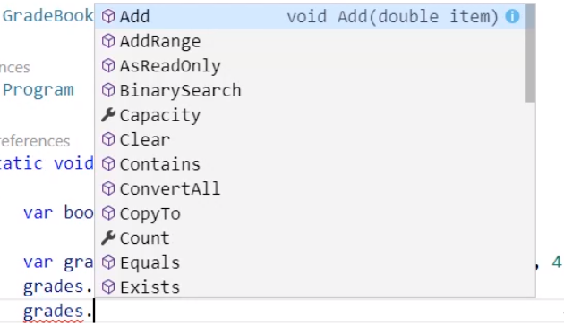

1. What the operations are
2. What the behaviour of this particular class is

We can say that a class consists of two things:

1. state/data it holds 🡪 we are holding the grades in our application
2. behaviour which typically acts on that state 🡪 we want to provide the behaviour which acts on these grades

# **How to state a behavior?**

i) define the method:

namespace GradeBook

{

    class Book

    {

        public void AddGrade(double grade)

        {

        }

    }

}

ii) then to Program.cs 🡪 system dedects this method:

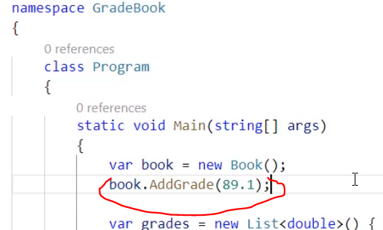

Adding a state to a class definition:

If we define a variable inside the class but outside of a method (here: inside class Book but outside the AddGrade method), it is a field, e.g.:

namespace GradeBook

{

    class Book

    {

        public void AddGrade(double grade)

        {

        }

        List <double> grades;

    }

}

In this situation, we cannot use implicit typing

Classes are used to create objects of certain types; class can be interpreted as a blueprint

New key word to instantiate an object of a class

(); 🡪 parenthesis

Constructor - constructs an object of type Book or type List; it is optional but helpful;

**Constructor** is another method on a class which has a special convention: **same name of a class**, **cannot have a return type** and inside of it we have a code which guaranteed execution each time when we use a key word

# **CREATING A CONSTRUCTOR:**

this.name 🡪 self.name (Python)

*FREE NOTES:*

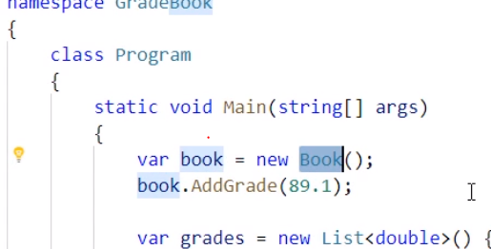

book is a variable which is going to refer to an object of type Book.

Each time when we are referring to an object Book, we have guaranteed to have an AddGrade method because that is a part of class definition Book

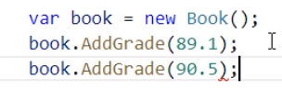

We also know that somewhere inside of that Book, we have a list of grades 🡪 why couldn’t we just come back to that field called grades and add whatever we want into that?

Warning message:

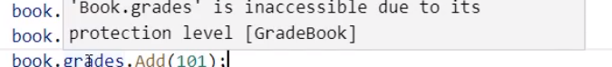

**We are building a class** to provide some abstraction and some encapsulation or we are trying to hide some complexity of that class. So again, we are coming back to an example where if we leave a program for few months, we will need to look into each line and remind ourselves what was happening inside of a particular line.

Encapsulation – hiding complexity and details that are not important at a certain level

Public – access modifier; they control the access to the particular class members; public means code outside the class will have an access to this particular method/member.

Usually we are very protective of our state so ‘public’ is not a rule.

We use ‘this’ if we want to refer to an object which is currently being operated on:

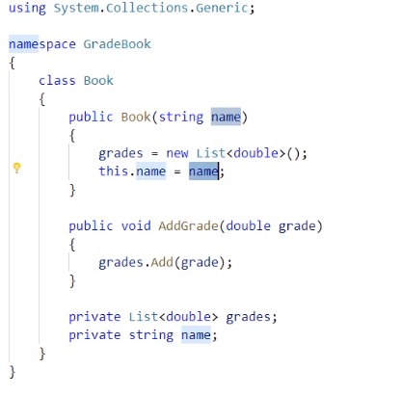

“This” is implicitly used whenever we are accessing a class member

# **Working with Static Members**

Statics are not associated with object members.

The opposite of Static is to have a method which does not use the “Static” keyword 🡪 an instance member of a class, like e.g. AddGrade and instance method of a class Book;

The fields of ‘Private…’ (marked in yellow) are instance fields which are associated with an object of type Book, so everytime when we have a Book object, it is containing and encapsulating a list of grades and a name.

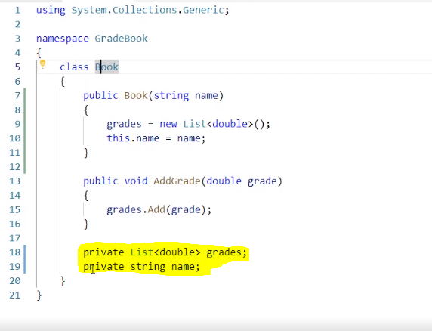

Statics are not associated with object members, e.g. Main method is not associated with an object instance; they are associated with the type defined inside of it:

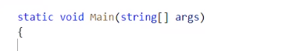

---

Cut out the following:

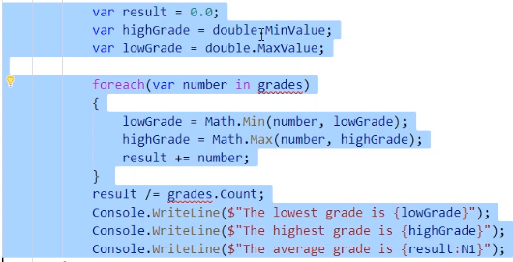

By the end of the 5th module first project (Project.cs) looks as follows 🡪 we are beginning to see the code encapsulation

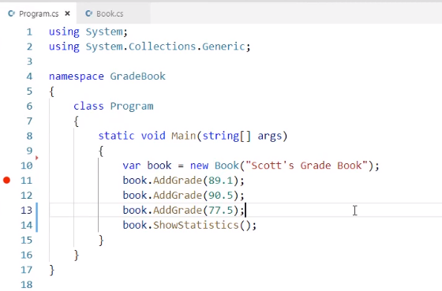

# **Summary:**

In this module, we saw some additional features of C#, we’ve learned how to declare classes and instantiate the objects, we know how to declare public instance members like AddGrade and ShowStatistics, we also have a constructor and some private field which is a part of our class;

In the next module, we will test this class. We can automate this test so that we would not have to run the program each time when we want to verify whether it is correct or not.

Module complete (code):



# **MODULE V**

# **Introduction**

We will learn how to write unit tests in C#. Unit tests are more just about to test a code. Primary purpose is to run the code and check whether it behaves correctly but its functionality is wider and can also expand to teach about the software design, experiment and explore a language and the environment.

Unit - source code that we want to test

Test runner - tool for testing automation

Folder for unit testing:

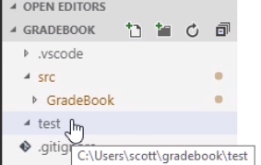

Type into cmd:

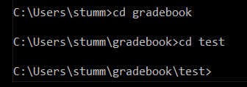

Then: dotnet new

console - to create console application

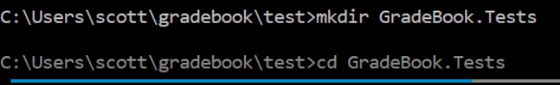

Then: dotnet new xunit



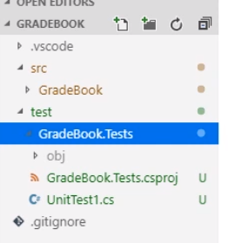

We have a C# file below with a source code for the unit tests.

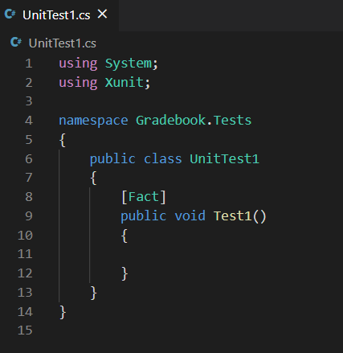

The test project needs some additional libraries because x unit is not a part of .net core.

X unit is a NuGet package available for .net core. 🡪 [www.nuget.org](http://www.nuget.org)

Command:

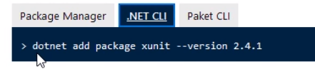

***We do not have to take this step, it was only FOA***