Mr Ewan Colquhoun

Curriculum Vitae

2021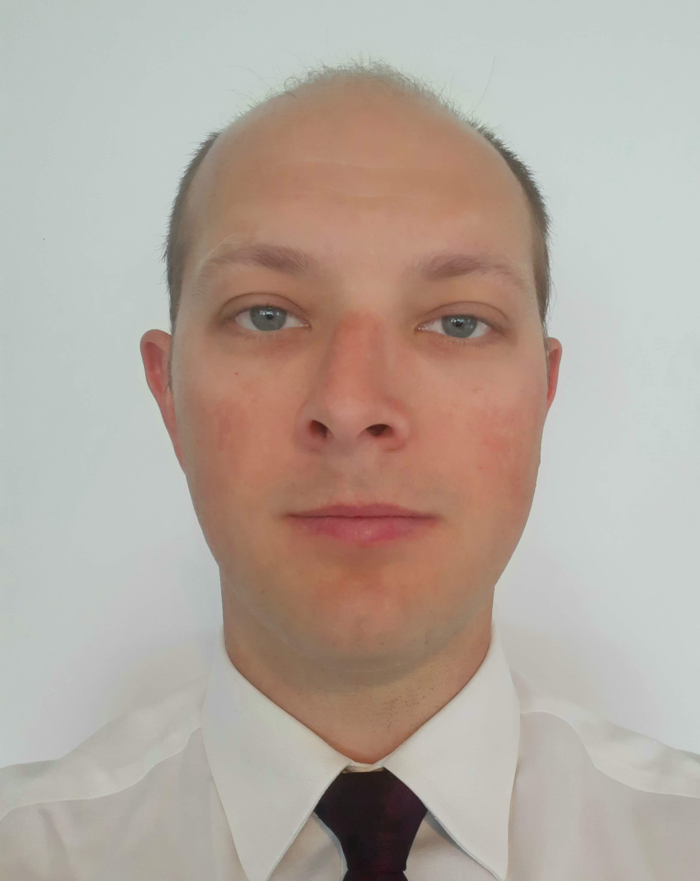

**Home Address:** 49 Gogarbank

Edinburgh

Scotland

EH12 9BY

**Contact:** +44 (0)7716725427

[ewancolquhoun@hotmail.com](mailto:ewancolquhoun@hotmail.com)

**Date of birth:** 23rd February 1988 (33)

**Education:** (IN PROGRESS) Full Stack Software Developer Diploma – The Code Institute.

Longcroft 6th Form, A’ Levels.

**Employment Details:**  Senior First Officer for British Airways on the Boeing 747-400 from April 2016

Captain for BA CityFlyer on the Embraer 170/190 from June 2014.

First Officer for Eastern Airways on the SAAB 2000 from December 2010, Aberdeen based. Specially trained for CAT C airfield operations.

First Officer for Eastern Airways on the Jetstream 41 from January 2010. Initially based in Sweden then contract extended and transferred to Wick.

First Officer for Highland Airways on the Jetstream 41 from September 2009. Inverness and Edinburgh based Charter and Schedule flying.

Trained by Marine Scotland as a Systems Operator (Radar) in a Scottish Fisheries Protection Agency reconnaissance aircraft

Sponsored Cadet Pilot for Highland Airways from August 2007 until September 2009.

**Experiences:** Member of the leadership team for a group of 40 young individuals for a charity expedition to Malawi in 2014.

Involved with the planning and co-ordination of numerous charter flights. The tasks involved ranged from liaising with the customer directly to detailed performance calculations for payloads.

Experience with the logistics of newspaper and mail delivery using aircraft to the remote islands off Scotland.

**Hobbies:** Computing, woodwork, cycling, playing sports, learning new skills,