Manual of DFT-Extractor

Environment Requirements
1) Java runtime environment.
2) R Project (http://www.r-project.org/).
DFT-EXTRACTOR needs igraph and Rserve packages, which can be installed with the following two commands within R console.
install.packages("igraph")
install.packages("Rserve")
3) Before launching DFT-Extractor, we should first start Rserve by issuing the following two commands in turn within R console.
library(Rserve)
Rserve()
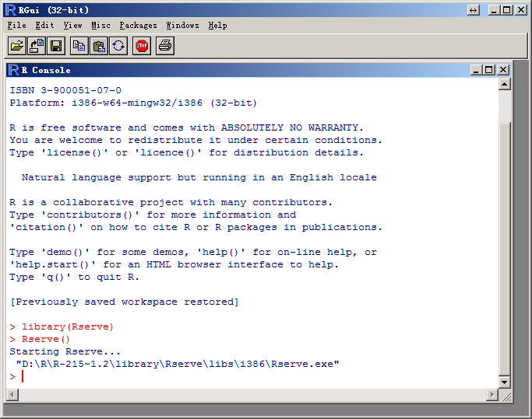

The process of faceted taxonomy extraction is divided into three steps.
Extracting DFT-Extractor Dataset.zip file to F:\ with zip tools. This zip file only contains three datasets at present and will contain more datasets in the near future.
Double clicking the Start DFT-Extractor.bat script to launch DFT-Extractor.
We recommend extracting faceted taxonomies from the second step with our crawled domain terms, because the first step need more than five hour to crawl Wikipedia pages.
1. The first step is Focused Crawling and Filtering.
1) Inputting the name of a specific domain, for example Data_mining.
2) setting the directory path of crawled pages, for example f:\DFT-Extractor.
3) Clicking the first Layer, second layer and third layer buttons to acquire terms and the domain-specific terms are saved in the directory F:\ DFT-Extractor \ DTExtraction.
Since It takes a long time to complete the crawling, we have crawled three domain-specific terms to accelerate the other two steps of faceted taxonomy extraction.
2. The second step is Hyponym Relation Extraction.
1) Providing the directory containing the terms of a specific domain. The default directory is the output directory of the first step; F:\DFT-Extractor\hyperExtraction\Data_mining\html.
2) Clicking the Automatic Annotation button to label training set. The labeling process often takes about one hour. Figure 1 shows the labeled instances of the training set.
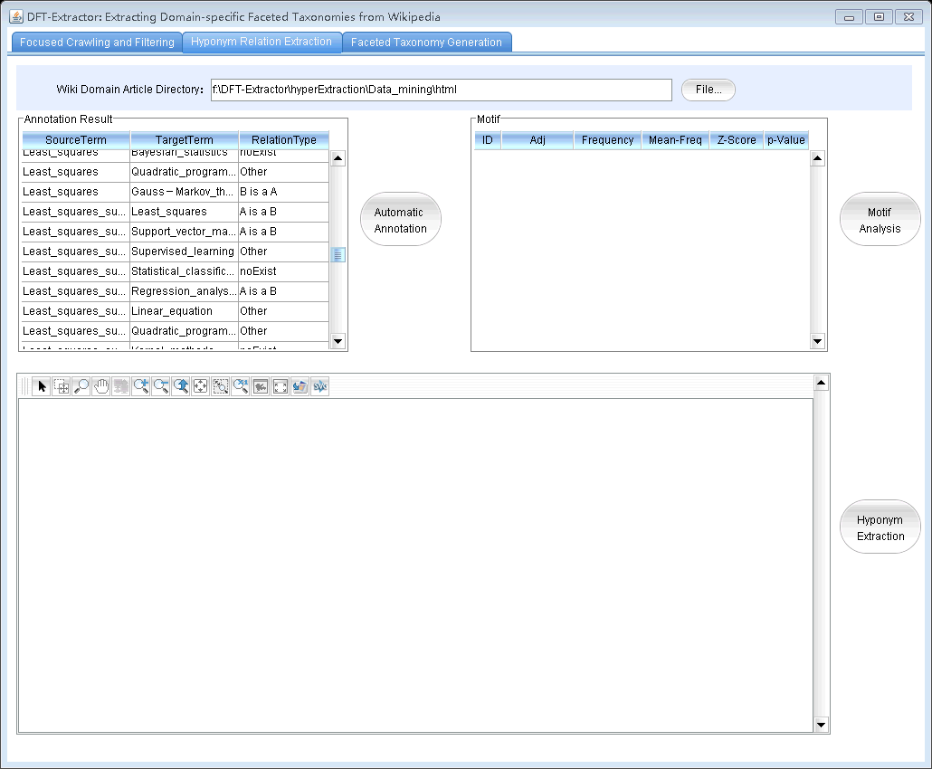
Fig. 1 Labeled instances of a training set
3) Clicking the Motif Analysis button to analyze three-node motifs of this domain. After about 30 seconds, the main window of FANMOD will show and the user must configure the software as follows. The input file is F:\DFT-Extractor\hyperExtraction\Data_mining\html-hypRelation\ relation_Edge.txt.
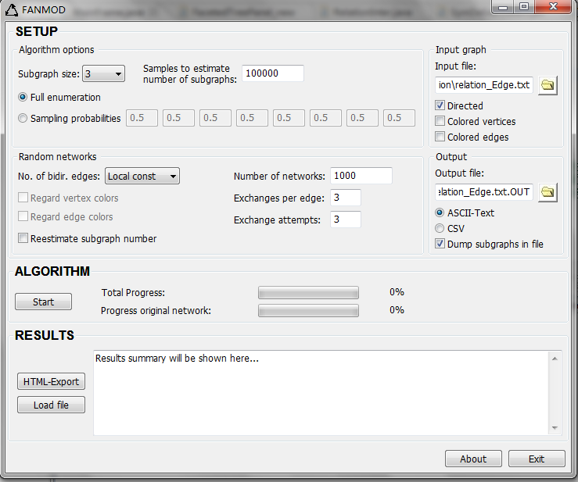
Fig. 2 Main window of FANMOD
Fig. 3 HTML-Export Window of FANMOD
4) Clicking the Hyponym Extraction button to discover the hyponym relation based on motifs. Figure 2 shows the discovered hyponym relations.
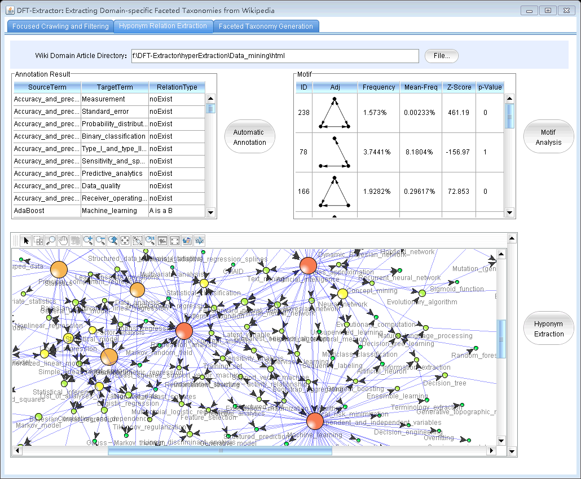
Fig. 4 Discovered hyponym relations
3. The second step is Hyponym Relation Extraction.
1) Clicking the Facet Detection button.
2) Clicking the Taxonomy Generation button.

