CSCU9N5 Project

2618009

Design an Interactive Instructional Course on how Logic Gates Work

Contents

Description of Project and Personas: 2

Description: 2

Persona 1: 2

Persona 2: 2

Details of Design: 3

Navigational Map: 3

Wireframes: 4

Home: 4

Other Pages: 5

Colours: 7

Scenarios: 8

Scenario 1: 8

Scenario 2: 8

Description of Prototype Contents: 9

Testing: 11

Purpose of Testing: 11

Objectives: 11

Test Design: 11

Equipment Required: 11

List of All Sources: 12

Bootstrap: 12

# Description of Project and Personas:

## Description:

This web based interactive instructive course is used to aid in the learning of logic gates. The application will have a brief description of the specific logic gate along with an image of how it is usually represented graphically. The program also contains testing for each of the corresponding logic gates as quick and easy problems are presented to the user. The application will be delivered on any web browser as it has been designed to work functionally on all browsers, also this application can be accessed on any computer system as the application is designed to be responsive meaning it should be able to fit to any screen size.

The target audience of this project would be mid to late upper school children and adults who are keen to expand their knowledge of logic gates. School children who are using this program would have no previous knowledge of logic gates as this application is designed to obtain the key fundamentals of logic gates. By using this application, they will adapt and enforce their knowledge of logic gates through the use of the testing section in each page. Adults will also be able to use the testing section however it isn’t designed for them as it is somewhat basic in its design and what it can achieve. The prototype won’t convey the benefit of the description area of each webpage, but this is where the adults will gather a majority of their relevant knowledge on this topic.

## Persona 1:

The first persona is Angela Scott who is 15 and has colour blindness. She is in her fourth year in high school at Stirling High School where she is taking computer science as one of her subjects. Angela is about to take a computing examination and her goal is to enhance her knowledge in this area as she is not feeling confident in working on logic gates which is why she has decided to use this application. Angela will be downloading this application on her phone as she is likely to use this tool to revise while taking the bus to school, this allows her to test herself each morning on how each logic gate works thus cementing her knowledge.

## Persona 2:

The second persona is David Michael who is a 32-year-old who has recently quit their job in the marketing field and has decided to change career direction into computing. David is applying to become an engineer at a hardware development company and is required to understand a wide array of computer fundamentals quickly which is why he has downloaded the application onto his personal home computer. By using this program David will learn how to use the logic gates shown and can use the testing section to enforce that knowledge, David might not use the testing section as much as Angela as they require different parts of the application more than the other.

# Details of Design:

## Navigational Map:

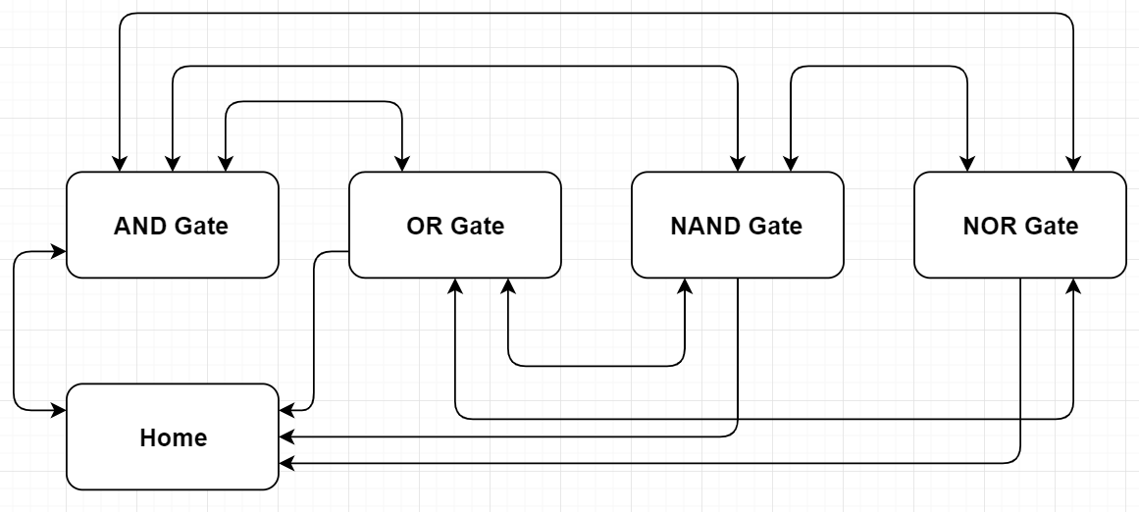

This is a navigational map of all the pages used in this prototype. The application starts at “Home” which acts as a splash screen, and then leads onto the AND gate page. As the diagram above shows the home screen can be accessed from any of the other pages, however the home page can only move onwards to the AND gate page, this can be seen by the direction of the arrows. The pages are setup in a linear method whilst still being able to navigate back and forwards through the pages through the use of the navigation bar implemented onto each webpage. The system navigating through the pages was chosen to be this way as the user can use “next” and “previous” buttons to get from page to page just like in a game with a level system but then a navigation bar to make each page easily accessible, examples of this will be shown later in the report.

## Wireframes:

### Home:

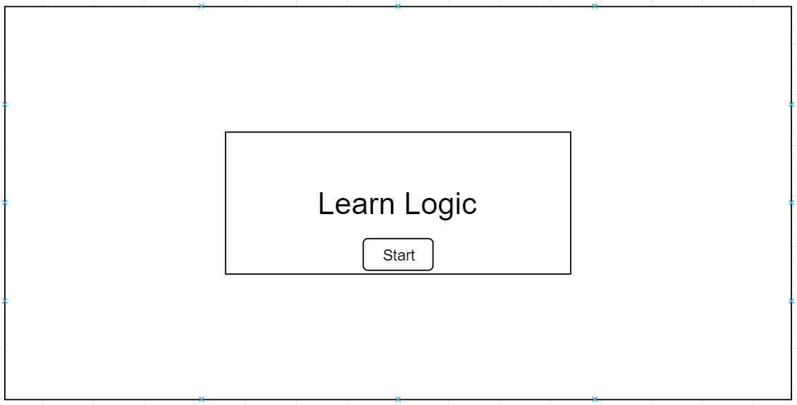

This is a wireframe of the home page (index.html) that the users will see first, it will look simple and easy to read. The web page does not have content however that is not its intended purpose, its purpose is to get the user to use the application. The user will first notice the box containing both the title and the button to begin the game, this is due to the box having shadow applied around it giving it a defined effect to catch the users eye. In this box is the title which displays “Learn Logic”, the name of the application, this making it clear to them the application in use. There is also a button labelled start, this button will be what takes the user to the first page on logic gates. The button will slightly change its style when hovered over or clicked to indicate to the user what they are doing. This feature is greatly appreciated on a computer system where the user can hover over the button with their mouse. The change in the design on this button will be that the text will be underlined and also a border will appear in white opposing the grey background making it clear to the user.

### Other Pages:

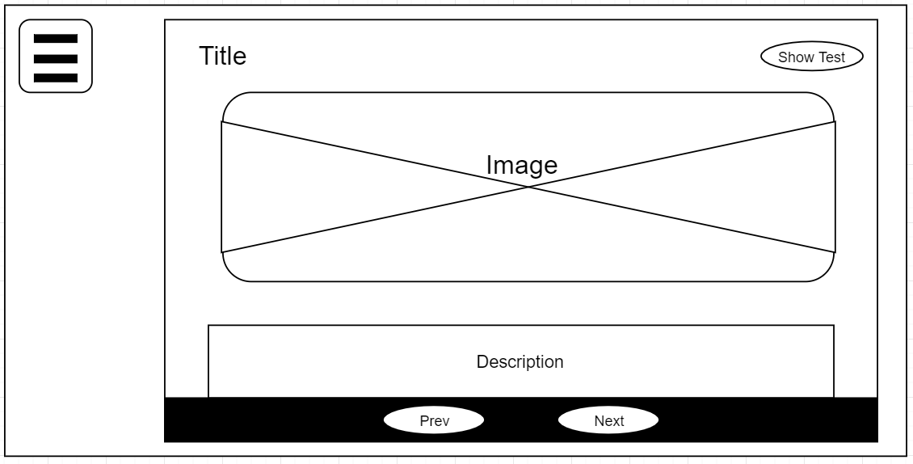

In this wireframe you can see all other pages in the application being represented as all the pages are consistently designed to aid with usability. The differences between the pages are cosmetic changes such as the title, image and description of the specific logic gate.

On this web page the user will be drawn to the outlined container which holds the title, image and description of the logic gate, this container will have the same style as the box containing the title on the homepage. The reason for this is to primarily keep the web pages consistent in design but to also draw the users attention to this section. On these pages there is a menu button in the top left of the page that can toggle the navigation bar which will appear on the left side of the screen, this will be shown in the next image. The button will have a hover feature much like the homepage however this will function differently as this button will change to a darker grey indicating the user to their next action. There is also a show tests button, which has the same styling properties as the menu button, that will switch out the content being displayed (image, title, and description) with another section containing the knowledge tests. The reason for this style of hiding and showing content is to keep all the content for each logic gate contained to a specific page, this is to keep the usability of this application high while also keeping it functional on multiple types of device.

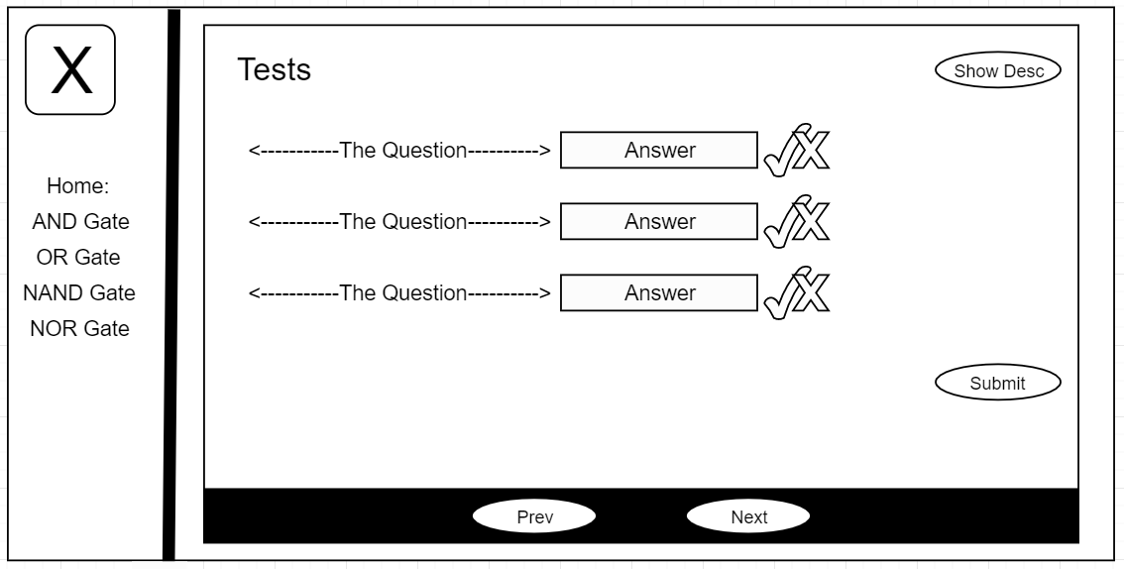

This wireframe shows the same page as the previous wireframe while solely showing the tests for the corresponding logic gate rather than the description. An additional change in this wireframe is the navigation bar situated on the left-hand side of the screen, this shows the navigation bar toggled to show the available links. This helps understand the system used in the navigational map above in which the pages were in a linear setup whilst still being able to navigate freely. On this navigation bar the button to close itself is situated in the same place as the button to open, this was intentional as it keeps the design consistent for the user. The text which links to the other pages will be separated by lines making the line between each more distinct, they will also have a hover effect where the text will fade to a lighter grey to make it clear when the user is hovering over them.

As stated previously the test section of the web page is shown in this wireframe, the tests you can see come in sets of three as this is only the prototype. Each test is situation in a horizontal fashion on both mobile and computer screens due to its responsiveness. There is a question which has an answer of either zero or one, the typical outputs from a logic gate. The user is able to insert their answer into an input box which is clear due to the placeholder it contains saying “answer”. Finally, there is the JavaScript animated canvases which will indicate whether the answer was correct or wrong by drawing either a green tick or a red cross, this is triggered by the submit button which upon being pressed will draw the canvas, revealing the tick and cross.

## Colours:

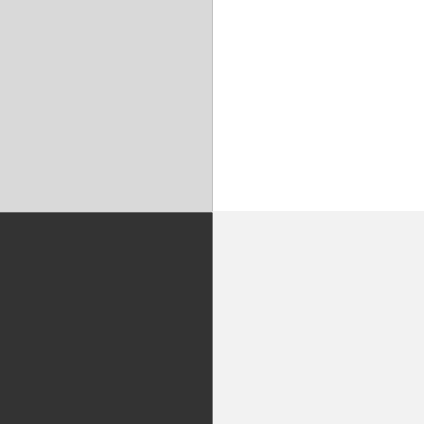 The colours used for this application weren’t broad or colourful however they were designed to make everything readable and functional as the purpose of this application is to educate not to entertain.

The colours are black, white and two shades of grey. Both of the greys used are similar but there is a slight variation in them and they never come in contact with each other therefore ensuring that usability is not hindered in any way and that all text is still readable.

All text that can be read in the container displaying the title, image and description of the logic gate will be in black. The reason for this is because the container itself will have a white background thus allowing for very clear and readable text. The container as mentioned before will have a shadow border around it, this shadow will be projected onto the background of the web page which is in a light shade of grey. The reason for this change in colour is because having the shadow being cast onto a colour that’s closer in darkness helps draw the users attention more towards the container.

The navigation bar has a white background which is different to the background of the web page so when the navigation bar is toggled to show it’s clear this is an overlaying container rather than a simple movement of the screen. Along the vertical axis of the navigation bar is a black line further highlighting that this is an overlaying container by clearly showing the edge, this being very helpful while watching the navigation bar slide from the left side of the screen.

 The red and green were used scarcely as they were used solely in the canvases displaying either a tick or a cross to inform the user of whether they have completed the test or failed it. I used both of these colours as they are the typical colour for their corresponding shape. A tick and green can both reflect positivity to the user, and a cross and red can convey failure to the user. This make the results very user friendly and accessible as the user can see their answer even if they have trouble with colours due to colour blindness for example.

## Scenarios:

The following scenarios are using the personas created earlier, first Angela and then David to follow.

### Scenario 1:

Angela is on the way to school before her computing test and needs a refresh on the logic gates available to her. She was told about this app by her friend who found it very useful so she searches “Learn Logic”. After selecting the search result she finds herself at the splash screen, it doesn’t seem to interesting to her due to the instantly noticeable lack of colour. She decides to stay on the site and proceed by pressing the start button. Afterwards she is taken to the “AND Gate” page in which she begins to read about the gate whilst also making note of how the gate is drawn. From here Angela decides to test herself by switching the container over using the clearly labelled “show tests” button. Here Angela reads through the questions and answers them quickly due to the tests being clearly labelled in the horizontal fashion they are in. After all tests have been answered Angela goes to submit her answers, the answers are revealed and it shows two ticks and a cross. Angela sees that there is a wrong answer and naturally goes to edit the answer she entered, submitted her answers again she now has all of them correct, which is clear to see as three green ticks have appeared. Since Angela is colour blind this may have caused an issue but she has also been presented with ticks rather than a meaningless shape or image therefore she can understand the difference of right and wrong in her work. Angela continues to do this throughout the entire web application until it is completed.

### Scenario 2:

David is at home self-teaching himself different aspects of what is takes to be a software engineer. He internet searches for a program or tutorial on logic gates and discovers “Learn Logic” which he launches on his home desktop pc. From here he finds himself on the homepage and proceeds by pressing the start button. David is on a computer system meaning he will get to fully see the design functions available such as the hover function implemented on the buttons. Now on the logic gate pages David gives the documentation for each logic gate a read, from this he will obtain most of his understanding for logic gates as the fully completed version of the descriptions will be thorough and direct. From here David may chose to complete some tests to ensure he fully understands the logic gates and how to take in a output a binary value. David will take some of these tests by entering his answers in the clearly stated input boxes, then he will submit his answers using the submit button. From this point either the green tick or red cross will appear clearly conveying how well David has done on the tests. David does this with the logic gates he isn’t fully confident with to ensure he has fully learned the logic gates available.

# Description of Prototype Contents:

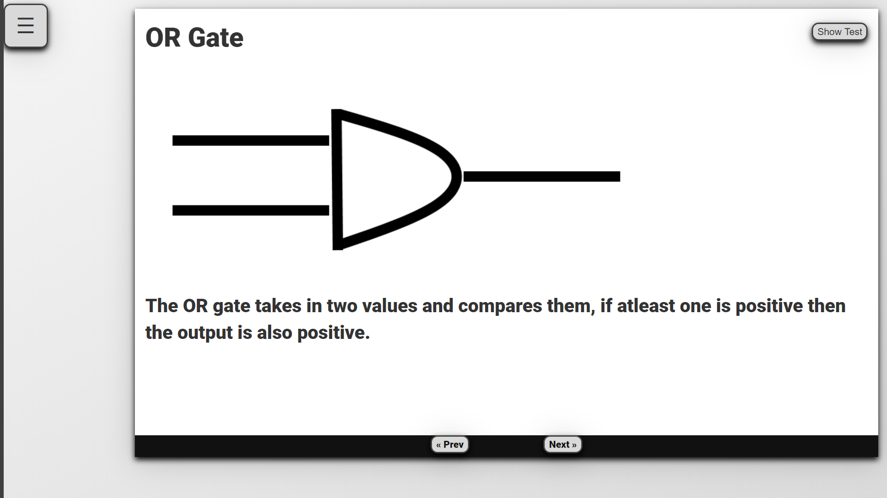

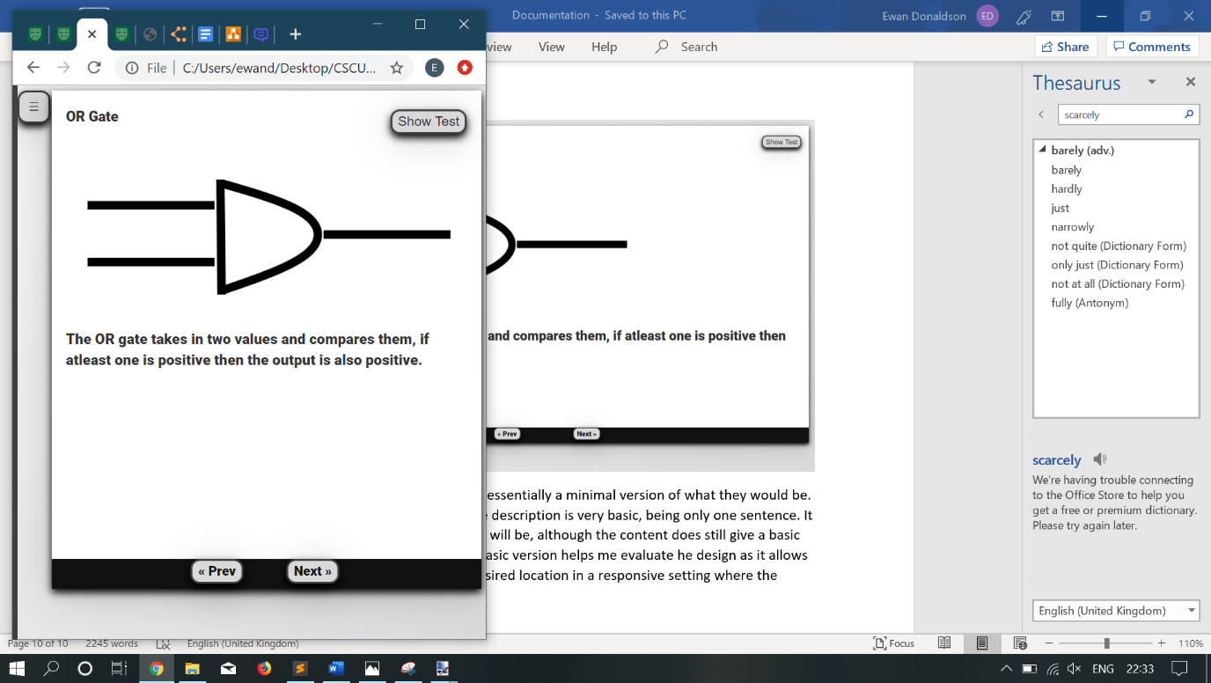 The prototype contains parts which are essentially a minimal version of what they would be. An example of this is the description as here the description is very basic, being only one sentence. It is simple right now as it simply conveys what it will be, although the content does still give a basic overview of the logic gate at hand. Having the basic version helps me evaluate the design as it allows me to see how the description will look in its desired location in a responsive setting where the screen size can be any resolution.

In this second image you can see the same page in a resolution of a phone screen. Here the description of the logic gate has reshaped to have less words per line but still fit within the container it was assigned to thus being responsive.

Another feature that the prototype is used to covey is the testing section of the web application. This section only contains three tests to enforce a users knowledge and understanding of each logic gate. This section in a fully completed version would have at least twenty tests to ensure that all available test cases are covered. Having only a few tests allowed me to visualise my idea of having the entirety of the test on a singular line, in doing so I was also able to see how it all looked in this style while also implementing responsiveness into the applications test cases.

As the prototype contains features that are of a more basic standard than what would be included in a full version, there are parts of this which would be kept as they are in the fully implemented version. The navigation bar is designed and implemented to its intended style as it was designed to be hidden from the user upon starting the page, the benefit of this design is that the content of the page isn’t being directly affected by the navigation bar. The navigation bar has been designed to be responsive to screen size similarly to the other aspects within this application. Another feature that would be kept consistent from prototype to completed version is the container itself which displays both the description and the tests depending on the selection of the user, this container is implemented using bootstrap which will be briefly discussed later. Having this will help me evaluate my design as I will be able to determine how the application looks while containing different types of information.

# Testing:

## Purpose of Testing:

The purpose of this testing is to determine if the implemented prototype meets expectations relating to the project description. I would also like to find out how the design of the application is in the eyes of the target audience. The design of the application is simplistic with the colours and how it is displayed but as this is an educational app this wasn’t my primary focus, the main focus being on the content being provided and how the user would be able to use that. The users testing this would provide feedback determining whether additional colours or a better designed web page be required.

## Objectives:

From the usability testing I would hope to find out how people find the design of the application I have developed. As the design of the website is a key component I would have this evaluated due to the wide array of opinions I could gather and in turn collate together to develop the perfect fully completed version. I would also have the users identify whether they find the test section of the application beneficial or in need of a design change as this section is important especially for the younger range within the target audience as completing examples will cement their knowledge.

## Test Design:

The people I will use in testing my application would be characters that fit my target audience, this being some high school students and adults. Having these people evaluate my design would be best as they will be able to comment on the applications functionality. These people would be novices in the computer science field as they are using the application to learn information for the first time, each of the testers would be used to test an individual page and evaluate the design.

The tests that these testers will complete will be focused on determining whether all the functions of the app are designed in a good manner. On each page they will evaluate if the input boxes work on the tests section take the answer and output the correct result. The animated navigation bar should also be evaluated with design in mind as I would like to see how users find the navigation bar as it could have been situated in another location or function is a completely differing manner. Another aspect to have the evaluators test is the buttons on the screen, it would be important that all buttons are tested to ensure that they are completing the correct functions.

## Equipment Required:

To complete the testing for this web application I require at least fifty percent of the testers to be using a mobile device as I want to test the responsiveness. Responsiveness was a very important aspect to test as having a responsive web page was key to good design. Any tests on a computer or laptop should be completed ideally on a windows operating system as this is the most commonly used OS, also anybody who fits the target audience would most likely be using the windows OS on their devices.

# List of All Sources:

## Bootstrap:

To program in responsiveness into my web application I used the bootstrap framework. The bootstrap framework is a free open source framework which primarily focuses on web page responsiveness, this also contains styling for certain web based components such as buttons. I used these component styles to benefit my program by having the button used on the page partially styled through the use of the bootstrap framework. The bootstrap framework was also used to style the content on the page, the separate sections were put into pace through the use of the bootstrap table styling methods. By doing this the page is responsive as the content within the containers will also be responsive due to its inherit nature.