COEN-320-PROJ

Brief Objectif Of the Project
The objective of the project is to build a real-time automobile monitoring system. This system will run in the real-time operating system QNX. Using the real-time capabilities of QNX, specifically its real-time guaranteed timers, we will simulate the monitoring of a vehicle's state and report it within defined real-time constraints. For this simulation, a file will provide the necessary data and we will read from this file to emulate reading from actual sensors. These readings will be displayed in a console, and a graphical user interface will also be provided for the end user to more easily interpret the results.

How to Get Started

Step 1: Uploading the Dataset Into the VM
1. From the main menu, select Window -> Show View -> Other
2. Select QNX Targets, then double-click Target File System Navigator
3. In the Target File System Navigator, select the "vm-target" (the program's target)
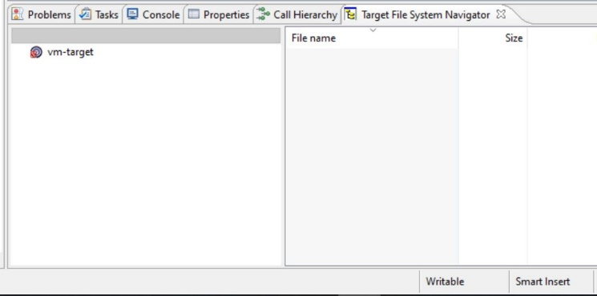
4. Paste the CSV file into the /home directory
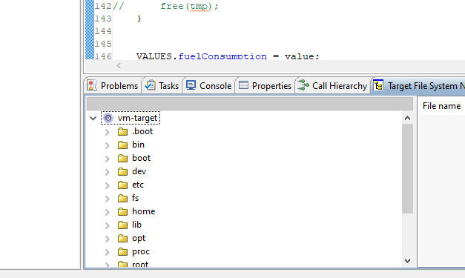

Step 2: Setting Up the GUI (For Frank)
1. ...
2. ...
3. ...

