Problem definition
The training dataset in task 2 has 18 attributes, and each record with a label 1, 2, 3, 4 or 5. However, given the 18 attributes, we need to predict the labels in test dataset based on the previously constructed models.

Data Analysis and Data Preprocess
- Data analysis
Acquire data: we achieved our data from https://www.kaggle.com/t/4995a1e12c04433ba1b36a40118fb45e which provided us with train.csv, test.csv and sample_submission.csv.
- Feature Distribution
First of all, we analyze the histograms of all features, we found that some features have obvious normal distributions some have no clues of certain distributions. We only show part of the representatives considering so many features.
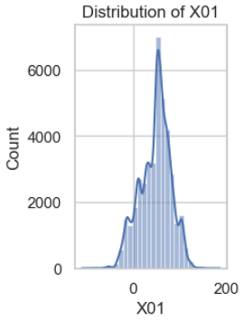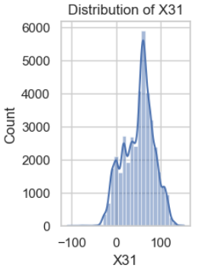
The graphs above both show normal distributions to some extent, which means in features X01 and features X31, the data are stable, with no obvious outliers affecting their distributions. And it’s much easier to make statistical predictions based on normal distributions data.
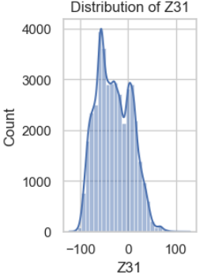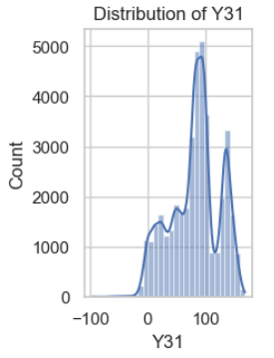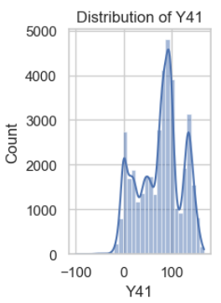
The left graph and the graph in the middle indicate positive skewness and negative skewness respectively which are asymmetric. And the right graph shows a random distribution pattern that may cause difficulty in improving models’ performance.
We then use box plots to further verify our assumptions and judgements:
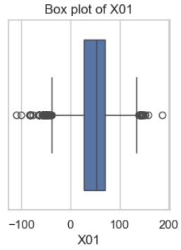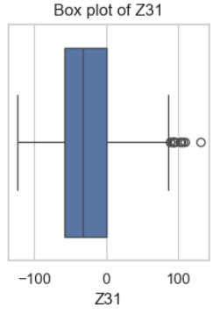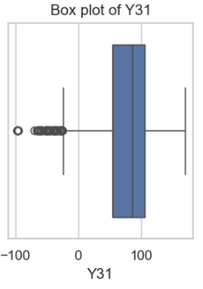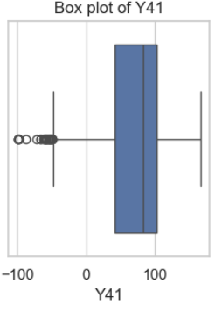
From the specific features box plots, we can achieve that almost all features have outliers more or less. However, not all outliers have much impact to the final distributions, but those one with only one side of outliers will show skewness. The one with both sides of outliers like X01 turn out to be somewhat symmetrical. We notice that the seemingly symmetrical box plots can’t infer normal ditribution proved in feature Z01.
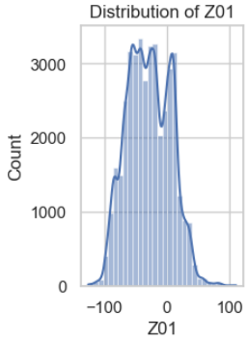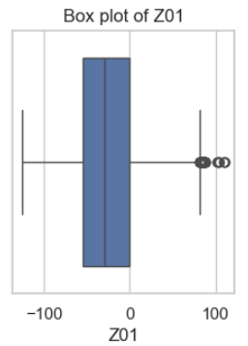

- Feature Relationships
We further explore the relationship between all features from X01 to Z51, in correlation heatmap, it displays the correlation coefficients between features which range from 0 to 1. A correlation coefficient of 1 means that the two features are fully positively related, and -1 means that the two features are completely negatively related, and 0 means that there is no linear relation.
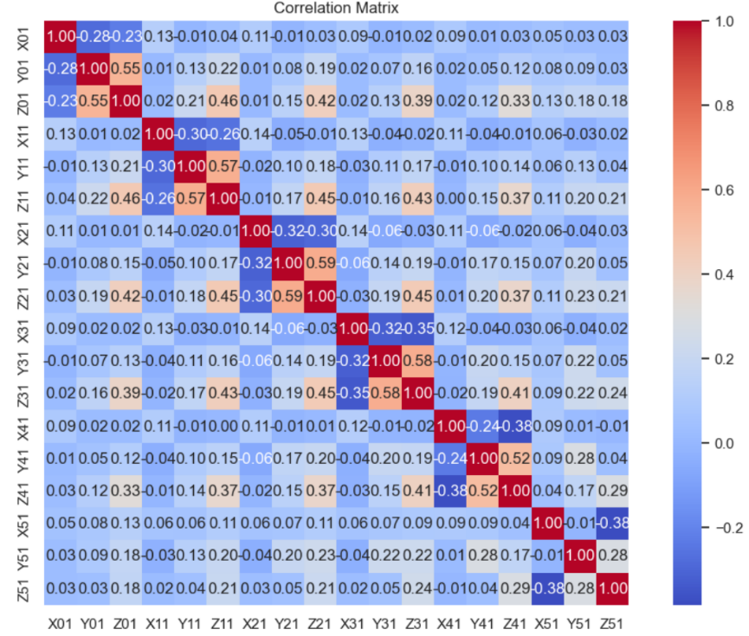
From the heatmap above, we can observe that there are median positive correlative (0.5-0.7) between Y01 and Z01, Y11 and Z11, Y21 and Z21, Y31 and Z31, Y41 and Z41 and there are no median negative correlations among them. However, the positive correlations displayed above may cause multiple common linear problems.
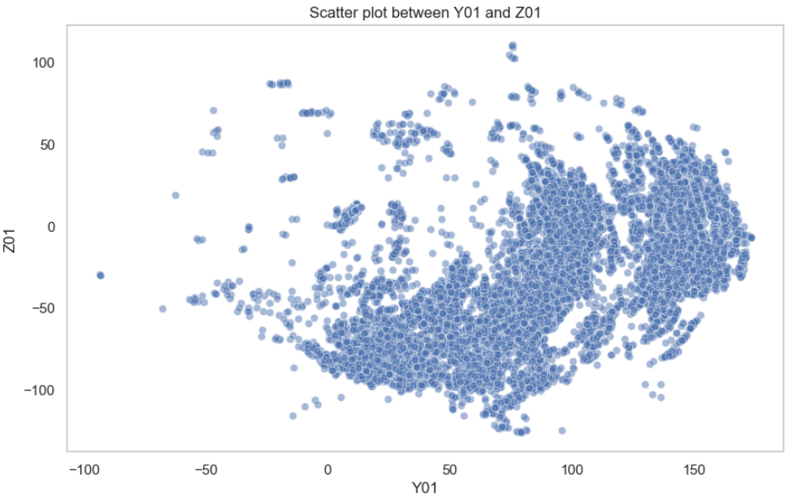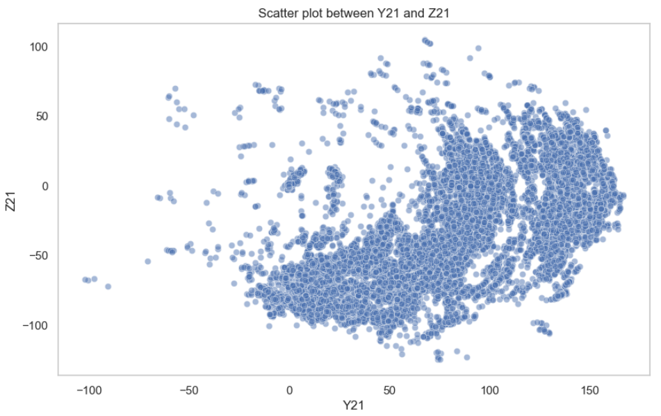
The representative scatter plots also show such correlations. So as the similar in the correlations we listed above. We will do some tests about this in the following experiments to see which features to be chosen in order to achieve better performances.
- Target Variable Distribution
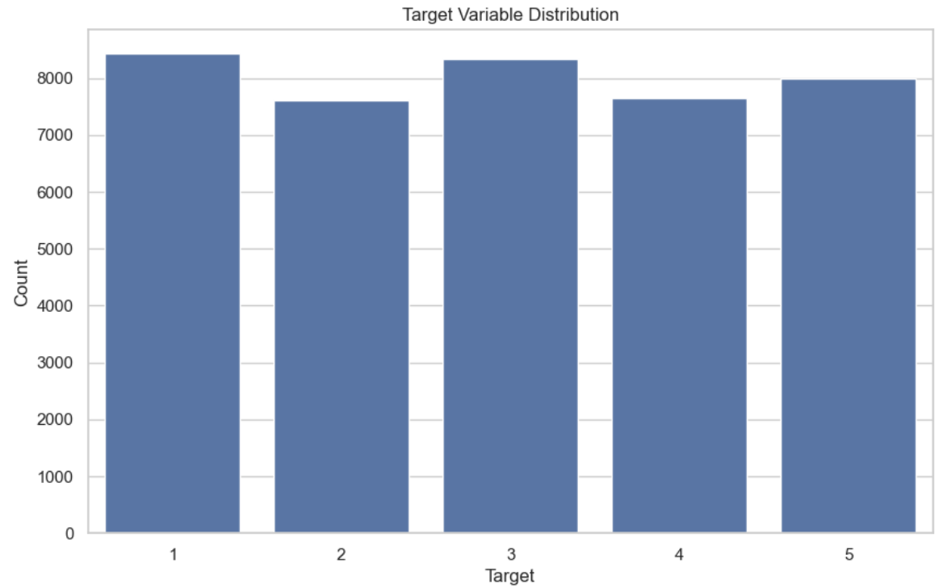
From the histograms of targets, we found that the dataset is quite balanced among all labels from 1 to 5. Therefore, It is easier for the model to learn the distinguishing features between each category and not likely to over-fit a few categories.
- Missing Value Analysis: Heatmaps or bar plots for missing values.
As for the heat maps and bar plots for missing values, we found that there are more than 6000 values missing in column X51, Y51 and Z51, and over 1500 values are missing in column X41, Y41, Z41, and over 350 values are missing in column X31, Y31 and Z31. Therefore, in the following procedures, we need to consider how to handle this missing values.
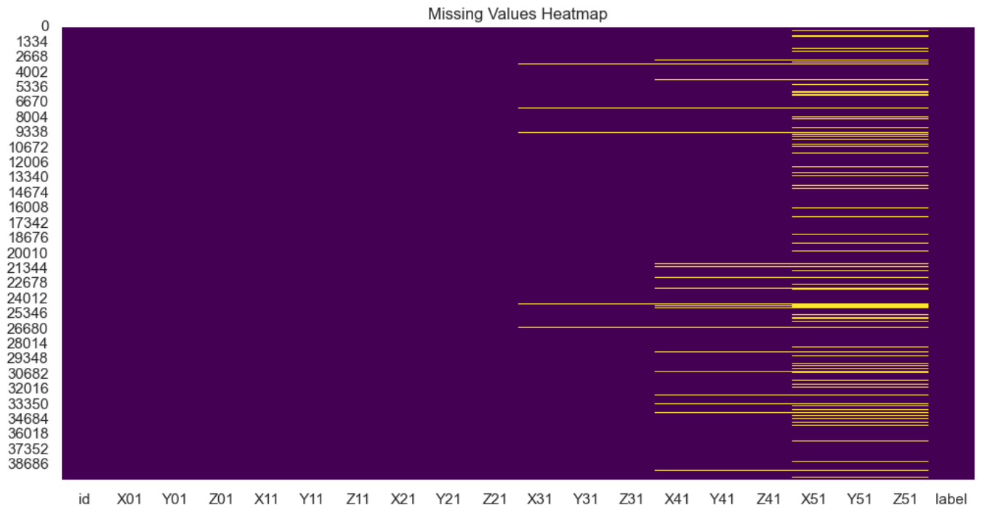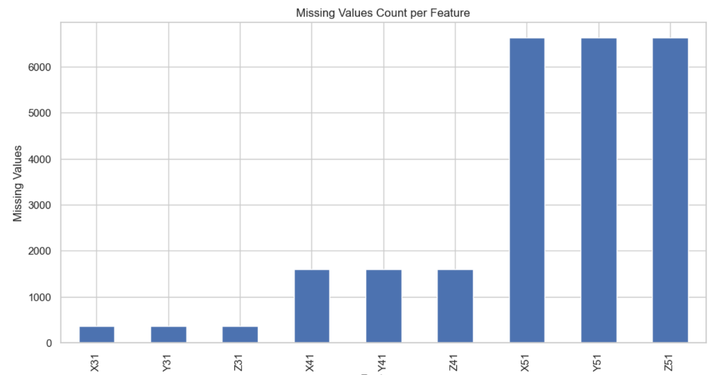
- Data Preprocess
- Data cleaning: As there are missing values in the dataset, we first consider deleting the records containing missing values, however, the missing values take nearly 17% of the total dataset, therefore we abandon this method. And then we consider some combinations of data filling and tested each of them on plain logistics regression model for short. Note that the test set also has missing values, we will fill the test size with the best performance from the training set to secure the validity of testing.
Cases | Accuracy | F1-score
Training median + Verification median | 0.6858 | 0.6785
Training median +Verification average | 0.6943 | 0.6860
Training median + Verification mode | 0.6804 | 0.6710
Training average + Verification median | 0.6812 | 0.6756
Training average + Verification average | 0.6905 | 0.6837
Training average + Verification mode | 0.6801 | 0.6716
Training mode + Verification median | 0.6679 | 0.6672
Training mode + Verification average | 0.6755 | 0.6741
Training mode + Verification mode | 0.6985 | 0.6941
- Feature extraction: We then found out that filling with mode with both training set and verification set outperforms the other combinations. Also, as the missing value in the original data marked as “?”, we should transform the data in X31, Y31, Z31, X41, Y41, Z41, X51, Y51, Z51 features columns from string type to numerical type like float64.
- One-hot encoding: change the label 1,2,3,4,5 to [1,0,0,0,0], [0,1,0,0,0], [0,0,1,0,0], [0,0,0,1,0] and [0,0,0,0,1]. This way it can eliminate the relationship between labels. This helps to avoid the model learning the order or size relationships between different labels incorrectly.
- Feature scaling: we also tried standardized data by scaler() method using z-score to provide a standardized way of understanding a value’s relationship to the mean in the distribution. However, in the following models, we will have a model performance comparison between normalized data and non-normalized data.

Solution and implementation details
- model construction
Our model is defined by using the Sequential class, building the model layer by layer. The first layer is a Dense layer with 128 neurons and a ReLU activation function. The input_shape specifies the number of features. And the model has two hidden layers, the second layer has 64 neurons and uses ReLU activation, the third layer has 32 neurons and also uses ReLU activation. We chose to halve the number of neurons in each layer to achieve dimensionality reduction and allowing the model to generalize. Before each hidden layer, a Dropout layer is added with a rate of 0.3. This means that during training, 30% of the neurons will be randomly set to zero to prevent overfitting. The final layer is a Dense layer with the number of classes and a SoftMax activation function. This layer will output the probability for each class.
We chose Adam as optimizer, and categorical cross entropy that is suitable for multi-class classification.
Also, we utilized early stopping to prevent overfitting. It will monitor validation loss; training will stop if there is no improvement in validation loss for 5 consecutive epochs. The model will revert to the best weight observed during the training process. The overall construction model can be seen in the picture below.
Noted: Dense layer is a fully connected layer.
- model improvement
We have the baseline model with 128 neurons in input layer, 64 neurons in the first hidden layer and 32 neurons in the second hidden layer. Both with 0.3 dropout rates. With early stopping and at most 100 iterations. Trained on a not standardized dataset and filling the missing values with zero with all 18 features.
However, we seek more opportunities to improve the performance of the original design. We have done several trials, some of them work effectively.
As we have analyzed before, we assume that filling the missing values with 0 will have better performance. However, we tested with average filling, the result outperformed the one with mode filling.
- Early stopping is aiming at avoiding over-fitting; however, we are not sure whether this mechanism helps improve performance. Therefore, we perform two tests one with early stopping and one without early stopping.
based on the results shown in model evaluation, we abandon the early stopping mechanism.
- Normalization: we initially didn’t do the normalization of data without early stopping, we also performed two tests on no normalized data and the other with normalized data.
Inferring from the results in evaluation, we chose to normalize all features data to achieve better F1-scores.
- Feature selection: we take all 18 features into consideration without filtering, however, we still try to do some feature engineering. First, we analyze the correlations between features; then, we utilized random forest model to evaluate the rankings of important features. Lastly, we select the best k features using ANOVA f-value. The correlation heatmap of processed data can be seen below in the picture. And the ranking of the important features is displayed in figure below.
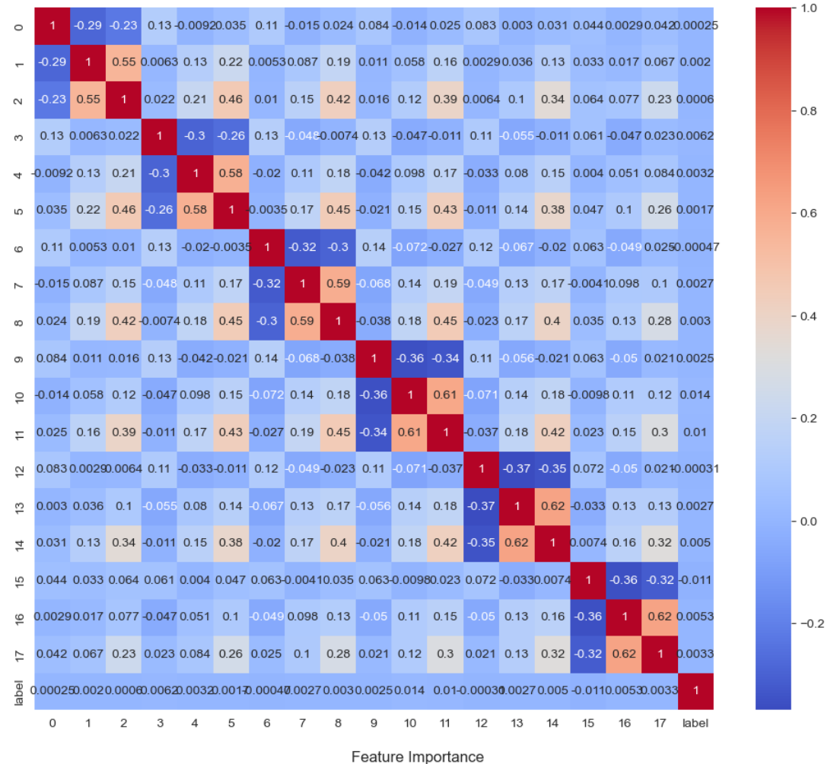
From the heatmap, we noticed that no high (correlation ecoefficiency > 0.7) correlations exist, therefore we looked into the importance rankings of features.
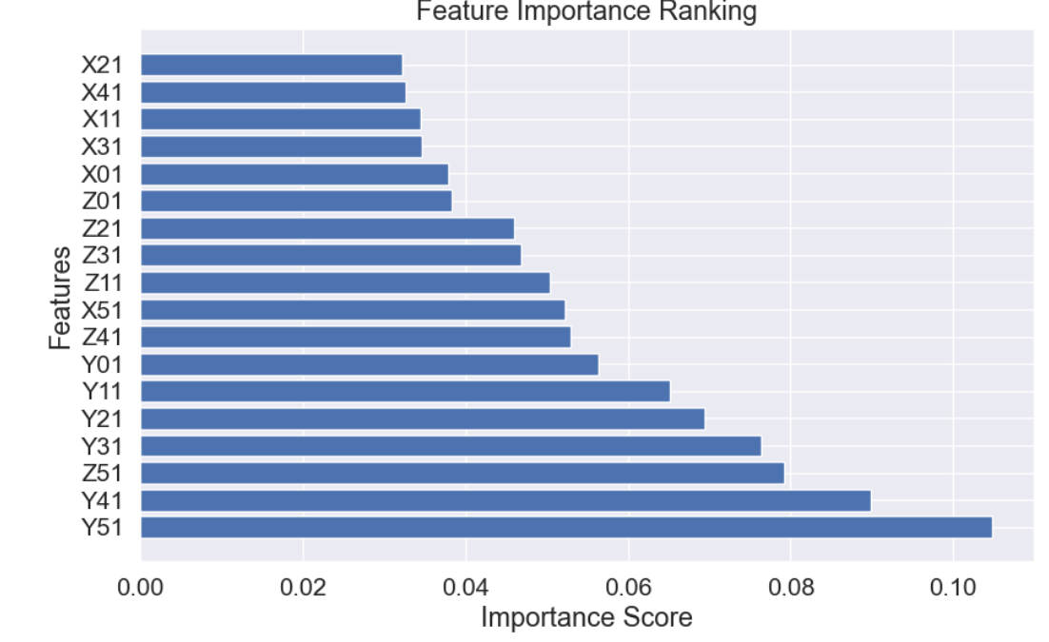
We got the important score for each feature, Y51, Y41, Z51 ranked the top 3, we assume that the higher importance scores a feature got, the more likely it will directly affect the classification result. So, we made two more trials to reduce the dimensions by only selecting more important features into the model input.
And we tried two different k when k=12, k=15 (k means the number of the top features selected), we found out from the results that even though we reduce the dimension, the F1-score of the model decreased too. So that we assume all 18 features contributed to the final decision.
- Increase neurons: we wanted to find out the better number of neurons in each layer. And we have learned from many architectures like CNN, we are still keen on halving the number of neurons in each afterward layer.
We have tried the structure with 128-64-32, 256-128-64 and 512-256-128, however, even though the 512 structures won the highest score, the real test file uploaded to Kaggle showed lower grades than the 256 one and it took much longer time to train. We made an assumption that the 512 structure may be over-fitting. So that we still adopt the 256 one.
- dropout rate: as we would like to try more possibilities on dropout rate, we test the 512 structure with rate 0.2, 0.3 and 0.4.
Therefore, the final best models will be structured without early stopping with 0.3 dropout rate. Trained on normalized data filled with average value and 18 features. The final best model structure is shown below:
Performance evaluation and discussion
- model evaluation
The evaluation results of the best model:
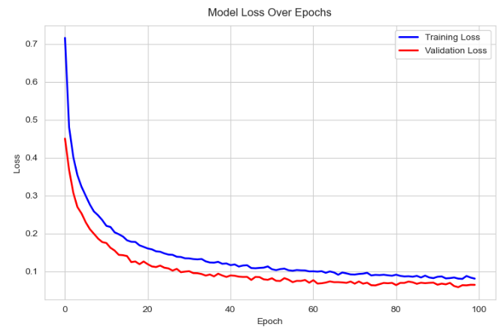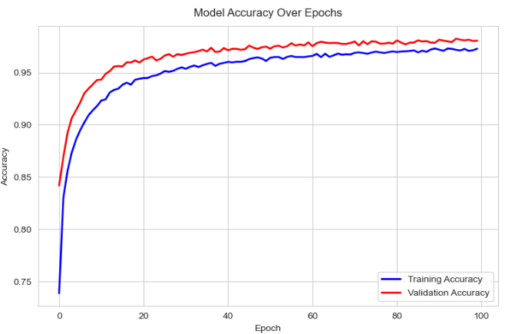
From the left picture, we can easily obtain that both the training loss and validation loss drop quickly with the epochs and gradually converge at nearly the 100 epoch with less than 0.1 loss score. From the right hand side, the model accuracy both training accuracy and validation accuracy climbed sharply between 0 to 20 epoch and reach a balance at the end with almost 0.99 score of validation and 0.97 score of training. From the records, we can make a judgement that the training is neither under fitting nor over fitting. The growing trend for both known and unknown datasets are nearly the same.
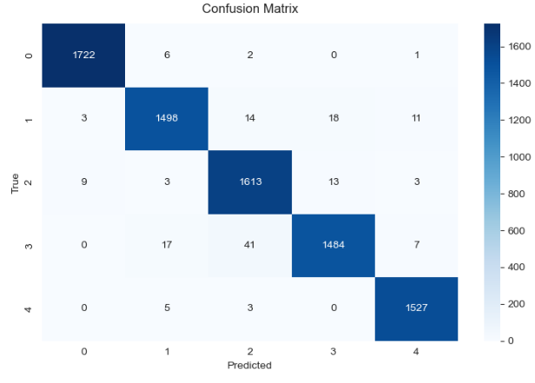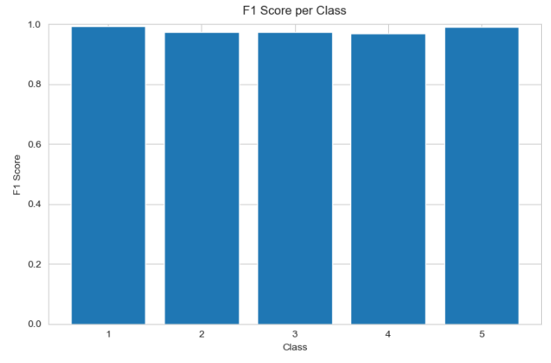
The confusion matrix and F1 Score per class bar show that nearly all five classes precisely classified the records that belong to them. However, class 1 got the highest score, and nearly recognized all his records. Class four may need to be further improved its accuracy if we want to raise the total F1-Score in the future. But in all, all classes show quite good results.
The detailed classification report for each class can be read below:
Class | Precision | Recall | F1-Score | Support
1 | 0.993080 | 0.994801 | 0.993939 | 1731
2 | 0.979725 | 0.970207 | 0.974943 | 1544
3 | 0.964136 | 0.982937 | 0.973446 | 1641
4 | 0.979538 | 0.958037 | 0.968668 | 1549
5 | 0.985797 | 0.994788 | 0.990272 | 1535
- Ablation study
- Comparison with our original design
We displayed our improvement trials step by step, some may successfully reach our expectations, some may not. However, each following step will be based on the best results gained from the previous step. So that we can generate the best model.
Improvement  Sequence | Design before | F1-Score | Design after | F1-Score
1 filling | Not normalized data, filling with mode, with early stopping | 0.9222 | Not normalized data, filling with average, with early stopping | 0.9336
2 early stopping | Not normalized data, filling with average, with early stopping | 0.9336 | Not normalized data, filling with average, without early stopping | 0.9399
3 normalization | Not normalized data, filling with average, without early stopping | 0.9399 | Normalized data, filling with average, without early stopping | 0.9703
4 feature selection | Normalized data, filling with average, without early stopping, with 18 features | 0.9703 | Normalized data, filling with average, without early stopping, with 12 top features | 0.8797
 | Normalized data, filling with average, without early stopping, with 18 features | 0.9703 | Normalized data, filling with average, without early stopping, with 15 top features | 0.8893
5 increase neurons | Normalized data, filling with average, without early stopping, with 18 features (128-64-32) | 0.9703 | Normalized data, filling with average, without early stopping, with 18 features (256-128-64) | 0.9825
 |  |  | Normalized data, filling with average, without early stopping, with 18 features (512-256-128) | 0.9829  (overfit)
6 dropout rate | Normalized data, filling with average, without early stopping, with 18 features (256-128-64) drop-rate =0.3 | 0.9825 | Normalized data, filling with average, without early stopping, with 18 features (512-256-128) drop-rate =0.2 | 0.9821
 |  |  | Normalized data, filling with average, without early stopping, with 18 features (512-256-128) drop-rate =0.4 | 0.9830  (overfit)
 |  |  | Normalized data, filling with average, without early stopping, with 18 features (256-128-64) drop-rate =0.4 | 0.9766
- Comparison with other models
We also compared our best model with other traditional machine learning models and some advanced models like neuron networks with different constructions.
Models | Parameters | F1-Score
KNN | - | 0.8686
SVM | Kernel = ‘rbf’, decision_function_shape = ‘ovr’ | 0.8807
CatBoost | - | 0.9804
Random forest | - | 0.9655
Simple XGBoost | Num_trees = 300, depth = 18 | 0.8856
Neuron network | Epoch =3000, hidden_size=128, hidden layer =1 | 0.8858
Neuron network | Epoch =5000, hidden_size=256-128, hidden layer =2 | 0.9239
Our model | Epoch = 100, hidden size = 256 – 128 -64, hidden layer = 2, drop rate = 0.3 | 0.9825
Notes: The F1-Score in all the tables above represents the best evaluation F1-Score, not the overall F1-Score, because it’s more close to the grade in Kaggle.
Summary of discoveries and future work
- Summary of Discoveries
With normalized data, the model tends to perform better than non-normalized data. Also, when training with layers like neuron network, it’s a better choice to increase the neurons of each layer to let the network learn more about the common feature. However, we should also be careful about overfitting by doing so.
And sometimes feature engineering is very important when it comes to a large amount of features, some features may be useless or linear correlation which are bad for models to capture useful information. However, in this task, our model didn’t outperform the one without features deduction.
- Future Work
In the future, we may try more kinds of activation functions in our layers meanwhile try to add or minus layers to see the progress. Moreover, we may try more optimizers and batch size to figure out further improvements.

