**Title**: Variation in intraspecific dung beetle body size across grassland grazing regimes

Authors: Ben Allgire1,2, Mary Liz Jameson3, Ellen A. R. Welti2

Author Affiliations:

1 Department of Biology, College of Arts and Sciences, University of Massachusetts Dartmouth, Dartmouth Massachusetts

2 Great Plains Science Program, Conservation Ecology Center, Smithsonian Institute, Front Royal Virginia

3 Wichita State University

Main question: What drives intraspecic body size variation in dung beetles?

Hypothesis 1: There is a negative correlation between air temperature and body size. As temperature increases, body size will decrease.

Hypothesis 2: There is a positive correlation between nutrient availability and body size. As nutrient availability increases, so does body size.

Hypothesis 3: There is a positive relationship between the presence of large grazers and body size. Areas with large grazers will have larger beetles than areas without them.

Hypothesis 4: There is a negative relationship between insecticides and body size. Areas with insecticide will have smaller beetles than sites without insecticide.

**Abstract**

1. Animal body size is an important trait with implications for species’ and individuals’ ecological roles. Larger dung beetles can bury more dung, increasing soil nitrogen retention, reducing greenhouse gas emissions, and helping control dung-consuming pest species. We used two focal dung beetle species to examine responses activity densities to grazing regimes and of interspecific body size to local temperature, nutrient availability, presence and density of large mammalian grazers, and insecticide use in a shortgrass prairie.
2. Dung beetles were collected using pitfall traps in the summer of 2022. Across the growing season we collected 18,068 specimens and measured 4,646 individuals of two common species of dung beetles found in northeastern Montana, USA: *Canthon pilularius*, a large native species, and *Onthophagus nuchicornis*, a smaller non-native species. For all specimens, we measured the length of beetle horns (if present), forearms, head, thorax, and elytra.
3. The lowest activity densities for both species were found in areas treated with insecticides and in ungrazed areas. *O. nuchicornis* was especially numerous on prairie dog towns. *C. pilularius* tended to have smaller body sizes in areas with insecticide use, in bison and cattle units, and in areas with more dung patties. *O. nuchicornis* was smaller on prairie dog towns and in areas with more prairie dog dung present. In contrast, increases in browser dung (from deer and antelope) paralleled increases in the body size of *C. pilularius*. Hotter temperatures within the 20 days prior to capture resulted in smaller individuals, especially of the native species, *C. pilularius*.
4. Dung beetle species varied in their responses to large herbivores and dung availability, with browsers being a potentially overlooked key resource for the most common native roller in our system. Additionally, warmer temperatures due to climate change can reduce body sizes of dung beetles. Both abundance and body size distributions of dung beetles affect the ability of local populations to provide ecosystem services related to animal waste removal and decomposition.

**Introduction**

Body size is an important life history trait that influences organisms in many ways including mortality (Goatley and Bellwood 2016) and breeding success (Honek 1993). Global change, especially rising temperatures, altered biogeochemistry, and changes in land management, may cause shifts in animal body sizes. Insects are a well-suited taxa in which to examine body size shifts (Chown and Gaston 2010) because they have short generation times, often exist in high densities, and play many key ecological roles (Elizalde et al 2020). Intraspecifically, key determinants of insect body size include temperature and nutrition. Higher temperatures can reduce insect body size (Horne, Hirst, Atkinson 2017; Macagno *et al*. 2018; Wonglersak *et al*. 2020; Davidowitz, Amico, and Nijhout 2003; Davidowitz, Amico, and Nijhout 2004), but there are exceptions to this trend (Walters and Hassall 2006; Wonglersak *et al*. 2020). Increasing diet quality is expected to increase insect body size (Chown and Gaston 2010; Thomas 1993; Davidowitz, Amico, and Nijhout 2003; Teder, Vellau, and Tammaru 2014; Pocas, Crosbie, and Mirth 2020). Insecticide use, which is common across many rangeland systems (Branson et al. 2006), may also influence body size in developing insects when applied at sublethal levels following application (Alexander, Heard, and Culp 2008). However, little is known about shifts in intraspecific insect traits in response to these chemicals in rangelands (Hayasaka et al 2012; Manning and Cutler 2020). Land management can indirectly affect factors controlling insect body size, including through altering temperature and nutrition. In rangelands, herbivory and excretion by large herbivores modify plant structure and provide manure, potentially affecting insect body sizes through changing ecosystem microclimate and resource availability. Resulting shifts in insect body size have implications for both intraspecific population fitness and ecosystem function.

Dung beetles are a paraphyletic group of Coleoptera genera that use dung as their main food source during both adult and larval stages (Matthews 1963). They are a key indicator species (McGeoch, Rensburg, and Botes 2002) because of the many ecosystem services they provide, including nitrogen retention (Kazuhira, Hideaki, and Hirofumi 1991; Maldonado *et al*. 2019), livestock parasite reduction (Fincher 1973), and reduction of greenhouse gas emissions (Slade et al. 2016). In a now updated estimate from 2006, dung beetles were valued to be worth $380 million to the US livestock industry (Losey and Vaughan 2006). Dung beetles are particularly critical members of the Earth’s grasslands, where large herbivore dung can pile up in the absence of this key taxa (Losey and Vaughan 2006). The amount of dung that individual dung beetles can bury increases with their body size (Hosler *et al*. 2021; Manning and Cutler 2020) and intraspecific body size of dung beetles can exhibit high variation in responses to environmental conditions (Emlen et al. 2007).

Here we asked how habitat conditions drive variation in body size using two dung beetles in the North American Northern Great Plains. Throughout an entire growing season we collected 18,068 specimens and measured body segments on 4,646 individuals of two common dung beetles in northeastern Montana, USA: *Canthon pilularius*, a large native species, and *Onthophagus nuchicornis*, a smaller non-native species. We investigated four main hypotheses: (H1) higher air temperatures reduce dung beetle body size, (H2) increased nutrient availability results in increased dung beetle body size, (H3) temperature and nutrient effects on dung beetle body size are mediated by the presence and density of large mammalian grazers, and (H4) insecticides reduce dung beetle body size. Identifying drivers of dung beetle body size in complex field conditions has important implications for retaining and managing the ecosystem services dung beetles provide.

**Methods**

***Study species***

Dung beetles include species from the Scarabaeidae and Geotrupidae beetle families that use dung as a food source for adults and larvae (Matthews 1963). Dung beetles can be grouped into three functional groups: dwellers, tunnellers, and rollers (Floate *et al*. 2017). Dwellers live within the dung, tunnellers bury portions of the dung directly below the original dung pat, and rollers process the dung extensively, removing pieces of dung pats, rolling them away as balls, and then burying dung (Floate *et al*. 2017).

We collected body size measurements on two species of dung beetle. The first is *Canthon pilularius*, a widespread species native to North America (Matthews 1963). *C. pilularius* is a relatively large species of dung beetle (10-19 mm in length), a roller, and has several color phases (black, blue, bronze, and green) (Matthews 1963). The second species is *Onthophagus nuchicornis*, a tunneling Eurasian species that has been in the United States for over a century (Floate *et al*. 2017; Manning and Cutler 2020). This species is considerably smaller in size (6-8mm) than *C. pilularius*, and has yellow or brown elytra with black spots (Hoebeke and Beucke 1997). Males of this species have a single horn on their head making them easily distinguishable from the females.

***Field site and environmental data***

The study was conducted in shortgrass prairie from late May to mid September of 2022 in Phillips county, Montana, USA on land owned or leased by American Prairie, Bowdoin National Wildlife Refuge, Charles M Russell National Wildlife Refuge, and the Bureau of Land Management. We sampled dung beetles on 24 total sites with 5 treatments: bison grazed, cattle grazed, ungrazed, prairie dog town in the bison area with insecticide treatment (10 years of continuous treatment with deltamethrin and treatment of fibronil grain in July 2022, between the second and third collection period), and prairie dog town in the bison area without insecticide treatment. Sites included 15 core sites (3 replicates per treatment) where corresponding data on temperature and dung counts, and 9 supplemental sites (3 additional replicates of bison grazed, cattle grazed, and ungrazed treatments) where only beetles and no environmental data was collected. Land owned by American Prairie or leased by BLM was formerly plowed and used for crop plants and cattle ranching. Bison stocking densities varied from 0.0126-0.0176 (bison/acre), while cattle stocking densities varied from 0.025-0.03 (cattle/acre). In bison areas, the conversion from cattle grazing to bison grazing took place 5 to 17 years before our study began (bison reintroduction year varied with American prairie properties: 2005 on Sun Prairie, 2016 on Dry Fork, and 2017 on White Rock).

In core sites, temperature data was collected with Onset HOBO data loggers. These devices recorded temperature every 6 hours. At the end of the field season, the loggers were collected and their data was downloaded and analyzed. Dung was quantified in order to estimate the type and number of herbivores passing through a particular site. Dung was counted at every core site in column 9 in 10 m X 10 m sections and differentiated between grazer patties (left by cows or bison), piles from browsing ungulates (e. g. deer, pronghorn antelope, and elk), and prairie dog pellets. The dung was then tallied into these three distinct groups. Plant clippings were taken from every site 10 m apart from each other in columns 2, 3, 6, and 7. Plant clippings were separated into grasses, forbs, woody plants, and litter. Grass samples within core sites and sampling months were combined and ground up using a coffee grinder and dumped into individual envelopes. These samples were then sent to the Cornell Nutrient Analysis Laboratory (Ithaca, NY, USA) which used combustion analysis for measuring grass nitrogen and hot plate digestion and inductively coupled plasma atomic emission spectroscopy to measure concentrations of grass Ca, K, Mg, Na, and P.

***Dung beetle sampling***

Dung beetles were collected in four pitfall traps per site, with traps arranged in a 50 m x 50 m square ordinated by cardinal directions. Dung beetle pitfall traps were baited using one tablespoon of homogenized pig dung rolled into balls and bound by 4” X 4” pieces of cheesecloth. Pig dung was sourced from the Swine Teaching and Research Center operated by the Department of Animal Sciences and Industry at Kansas State University and was frozen before deployment. The traps were made of 0.65 L plastic cups (9 cm diameter, 15 cm depth) and were filled ¼ full with soapy water, baited with pig dung using binder clips to attach cheesecloth balls to pitfall trap cups, and left open for 48 hours during each trapping period. Following exposure, the traps were collected and samples were washed three times using plain water. The specimens were then stored in 99.7% ethanol.

***Sorting and size measurements***

We measured 10 specimens of *C. pilularius*, 10 *Onthophagus nuchicornis* males, and 10 *O. nuchicornis* females from each sample. If fewer than 10 individuals of any group were found in a trap, all specimens available were measured. On each specimen, we measured head length, forearm length, central thorax length, and central elytra length using electronic calipers (0.01 mm accuracy). For *O. nuchicornis* males, we additionally measured horn length.

***Statistics***

We first calculated body size estimates of each of the three groups of *C. pilularius, O. nuchicornis* females, and *O. nuchicornis* males for each treatment and collection month.

The form of the body size models was:

brm(body.length ~ 1 + (1|trap:site)

Next, we examined environmental driver effects on body size of each of the three groups in three models. To simplify plant nutrient content as a driver, we ran a Principle Component Analysis (PCA) of elements in grass chemistry that are known to be important drivers of herbivory (i.e. N, P, K, Mg, Ca, and Na; Joern & Behmer 2012). The first PC axis explained 41% of the variation and was negatively correlated with all elements except C and Si. We multiplied PC1 values by -1 to create a simple index of grass nutrients where higher values indicate increasing forage quality. The first driver model examined body size responses to environmental conditions at the time of sampling and included as drivers the mean temperature in the 48 hour sampling period, grass nutrients, and dung densities from large grazers, browsers, and prairie dogs. The second driver model examined responses to past conditions and included as drivers the mean temperature in the 20 days prior to sampling, the grass nutrient index from the previous sampling month, and dung densities from the previous sampling month; this model was run separately as it was limited to the last two sampling periods from which prior temperature data was available. The third driver model looked at the treatment effects of grazer density and insecticide use; this model was run separately as treatment effects were predicted to indirectly affect dung beetle body sizes and covary with temperature and nutritional changes. For all analyses, we used Bayesian linear models fitted with the R package brms (Bürkner 2021). Models were run using four chains for 5000 iterations (50% burn-in) and default brms priors. Code for all analyses is available at: <https://github.com/Ewelti/AmongTheDung/tree/main/R>. All analyses were conducted using program R v. 4.2.2 (R Core Team, 2022).

**Results**

Across all samples, we collected 13,628 individual *C. pilularius* and 4,440 *O. nuchicornis*. Body size measurements were taken on 2,100 individual *C. pilularius* (non-sexually dimorphic), 1,344 female *O. nuchicornis*, and 1,202 male *O. nuchicornis*. Activity densities of *C. pilularius* were highest in areas grazed by cattle (mean = 75.7 ± 25.9 SE beetles/trap), followed by untreated prairie dog towns (61.9 ± 34.8 SE beetles/trap), bison grazed (40 ± 17.6 SE beetles/trap), ungrazed (23.4 ± 10.2 SE beetles/trap), and lowest in prairie dog towns treated with insecticide (9.4 ± 5 SE beetles/trap; Fig. 2A). Activity densities of *O. nuchicornis* were highest in untreated prairie dog towns (mean = 31.3 ± 8.1 SE beetles/trap), followed by cattle grazed (14.7 ± 6 SE beetles/trap), bison grazed (12.5 ± 2.7 SE beetles/trap), ungrazed (8 ± 2.2 SE beetles/trap), and lowest in prairie dog towns treated with insecticide (7.2 ± 2.6 SE beetles/trap; Table 1; Fig. 2B).

***Grazing treatment effects on dung beetle sizes***

Across the five sampled grazing regimes, *C. pilularius* tended to be the largest in ungrazed areas (overall Est. = 16.56 mm ± 0.11 SE) and were smallest but also more variable in body size in prairie dog towns treated with insecticide (overall Est. = 15.1 ± 0.49 SE; Fig. 1A). However, insecticide did not significantly reduce body size in the model comparing only prairie dog towns treated and not treated with insecticide (untreated overall Est. = 15.82 mm ± 0.14 SE; Table 2). Body sizes of *O. nuchicornis* were less clearly related to the five sampled grazing regimes, and females declined in body size in August compared to June and July (Fig. 1B & 1C; Table 2).

***Drivers of body size at time of sampling***

In response to environmental conditions at the time of sampling, the quantity of dung had the largest effects on dung beetle body sizes of the two species (Table S1, Fig. 3). *C. pilularius* was larger with increased presence of browser dung and had smaller body sizes with more prairie dog and large grazer (bison and cattle) patties (Fig. 3A). Both male and female *O. nuchicornis* decreased in body size with increased presence of prairie dog dung (Fig. 3D & 3G). It is worth noting that dung beetles also affect dung availability, so it could be that in the presence of larger beetles, more dung was removed, leading to a negative correlation between beetle size and dung presence.

***Lagged drivers of body size***

Different responses to environmental lag times may reflect responses of dung beetle development. In response to environmental conditions lagging 20-30 days prior, dung beetle body size varied with both dung quantity and temperature (Table S2 & S3, Fig. 3). Again, *C. pilularius* had larger body sizes with more browser dung and had smaller body sizes with more prairie dog and large grazer patties one month prior (Fig. 3B). *O. nuchicornis* also had larger body sizes in sites with more browser dung in the previous month (Fig. 3E & 3H). The average temperature of the 20 day period prior to sampling had a negative effect on body size of *C. pilularius* and a tendency to reduce body size of female *O. nuchicornis* (Fig. 3E & 3H). Finally, in response to environmental conditions two months prior to dung beetle collection, only the quantity of dung availability affected dung beetle body size. *C. pilularius* again had larger body sizes with more browser dung and had smaller body sizes with more prairie dog and large grazer patties two months prior (Fig. 3C). However, *O. nuchicornis* had a tendency to have smaller body sizes in sites with more browser dung and females were smaller in sites with more large grazer dung two months prior (Fig. 3F & 3I).

**Discussion**

We examined two responses of dung beetle fitness: body size and activity density for two species across 15 grassland sites subjected to grazing by bison, cattle, prairie dogs, ungrazed, and treated with insecticides in the Northern Great Plains. Dung beetle body size heavily influences the amount of dung these insects can process (Manning and Cutler 2020; deCastro-Arrazola *et al*. 2020), making it an important factor influencing dung beetle contributions to ecosystem function of grasslands including livestock rangelands (Bertone *et al*. 2006; Lopez-Collado *et al*. 2017; Yamada *et al*. 2007). Higher temperatures in the month preceding capture led to smaller dung beetle body sizes, particularly in the native species, *C*. *pilularius*, suggesting temperature hastens dung beetle development as has been shown in other beetle species (Schebeck and Schopf 2016; Cárdenas and Gallardo 2012). Plant nutrients had no discernable effects on dung beetle body size. The presence of browser dung (e.g. deer, antelope) positively correlated with body size in *C*. *pilularius* while increases in prairie dog dung were correlated with smaller individuals of *O*. *nuchicornis*, the non-native taxa. Insecticide use decreased the activity density of both dung beetle species.

In line with our first hypothesis, temperature during the previous month negatively impacted dung beetle body size in *C. pilularius*. This is likely due to the impacts temperature has on development from egg to adult. This species takes between 29 and 44 days to develop from egg to adult (Ratcliffe and Paulson 2008). In insects, a reduction in development times with higher temperatures is well documented (Velasquez and Viloria 2009; Floate *et al*. 2017). Shorter development times may lead to smaller larvae hatching from the eggs, creating a positive feedback for smaller body sizes. However, other work has found no relationship between development time and body size in insects (I have sources for this but I need to find them) or even the reverse relationship with shorter development times generating larger body sizes (I have sources for this but I need to find them). While *O. nuchicornis* females tended to be smaller with higher average temperatures, *O. nuchicornis* males had no relationship with temperature.

We did not find evidence for effects of plant nutrients on dung beetle body size. We predicted that higher concentrations of plant nutrients would improve diets for large herbivores, increasing the quality of dung for the dung beetles. Additionally, the presence of mammalian herbivores did not consistently lead to larger dung beetles compared to ungrazed plots (Fig. 1). Large herbivores generally have lower-quality diets than do smaller herbivores (Steuer *et al*. 2014). As the size of an herbivore increases, the harder it becomes to specialize on the highest quality plants or plant parts. However, we found a negative correlation between dung beetle body size and prairie dog towns. Dung beetle body sizes could also be more strongly driven by dung quantity rather than quality (Table S2, Fig. S2A).

Different grazing regimes did not have a consistent impact on dung beetle body size. Ungrazed areas occasionally resulted in larger beetles compared to cattle- and bison-grazed areas (Fig. 1c), potentially due to the increased presence of dung from pronghorn antelope and mule deer. Beetles caught on prairie dog towns tended to be smaller than those caught in ungrazed areas, especially in prairie dog towns treated with insecticide (Fig. 1a). This could mean that dung beetle body size is primarily temperature-driven, with the open areas of prairie dog towns providing a warm microclimate for fast development to small body sizes. Grazers influence dung beetles in ways other than body size. The activity density of both *C. pilularius* and *O. nuchicornis* was higher in bison-grazed areas than cattle-grazed in June but reversed to higher activity densities in cattle-grazed areas in July and August. Species composition of dung beetle communities can also differ between cattle- and bison-grazed grasslands (Trible et al. 2021), which may affect interspecific competition, with potential implications for body size.

We did not find evidence for strong effects of insecticides on body size of our two dung beetle species. On average, the native species *C. pilularius* were smaller in prairie dog towns treated with insecticides compared to prairie dog towns not treated with insecticides, but these effects were not significant. Previous work has found mixed effects of insecticides on arthropod body size. For example, mayfly larvae exposed to low concentrations of imidacloprid, a common pesticide, have been shown to be smaller and hatch sooner than control populations (Alexander, Heard, and Culp 2008). However and oddly, *O. nuchicornis* exposed to low levels of ivermectins (an insecticide used for livestock deworming) may grow larger and be able to bury more dung (Manning and Cutler 2020). *O. nuchicornis* in our study also exhibited a weak (but non-significant) tendency to have larger body sizes in the presence of prairie dog insecticide treatments (deltamethrin and fibronil). In contrast to body size, insecticides lowered the activity densities of both *C. pilularius* and *O. nuchicornis*. This suggests that insecticide at this site had larger effects on dung beetle mortality rather than on development rates and body size.

Dung beetles exhibit high intraspecific variation in body size. Across 15 grasslands, we find this variation is partially explained by grassland grazing regime, with implications for the ecosystem services dung beetles provide. Additionally, temperature during the month prior to collection and insecticide use led to decreases in dung beetle body size, foreshadowing detrimental effects of climate changes and the continued use of pesticides in managed ecosystems for dung removal services. Fluctuating populations of grassland browsers may also affect these services given their dung’s positive influence on dung beetle body size. Mule deer are declining in population while pronghorn antelope and elk have relatively large populations (Add what I found from Montana government), but specific diet preferences of Montana’s dung beetles require further study. Finally, these data offer only a spatial snapshot of North American dung beetle communities that have likely undergone major shifts in abundance distributions and extant taxa following the loss of bison migrations and conversion of grasslands to agriculture and ranchlands (XX). Ranchlands contain livestock subject to veterinary medicines and many are release sites for non-native dung beetles (XX). Without targeted investment in grassland conservation and restoration with insects included in management plans, we predict future reductions in the ecosystem services provided by native North American dung beetles.

**Acknowledgements**

Field research for this study would not have been possible without the assistance of Julie Rebh. Managers of American Prairie, BLM, Bowdoin National Wildlife Refuge, and the Charles M Russell National Wildlife Refuge, especially Danny Kinka, Damien Austin, and Jessica Larson, provided support and use of the lands where beetles were collected. Additional help with dung beetle sorting and identification came from XX.

**References**

**Table**

**Table 1.** Body size responses of *C. pilularius*, *O. nuchicornis* females, and *O. nuchicornis* males to insecticides. Models compared body sizes on prairie dog towns treated with insecticide to those to prairie dog towns not treated with insecticide, and included an intercept and effect of sampling month.

| Model | Parameter | Est. | Est. Error |
| --- | --- | --- | --- |
| C. pilularius | intercept | 15.862 | 0.128 |
| C. pilularius | insecticide | -0.050 | 0.103 |
| C. pilularius | month | -0.286 | 0.152 |
| O. nuchicornis females | intercept | 7.792 | 0.077 |
| O. nuchicornis females | insecticide | -0.021 | 0.067 |
| O. nuchicornis females | month | -0.165 | 0.088 |
| O. nuchicornis males | intercept | 7.988 | 0.078 |
| O. nuchicornis males | insecticide | 0.060 | 0.070 |
| O. nuchicornis males | month | 0.020 | 0.081 |

**Table 2.** Responses of dung beetle body size to grazing regime.

|  | spp | Est | SE |
| --- | --- | --- | --- |
| Intercept | CP | 16.09 | 0.12 |
| sbison_dens | CP | -0.38 | 0.15 |
| scattle_dens | CP | -0.10 | 0.11 |
| sPD_pres | CP | -0.08 | 0.14 |
| sCP_dens | CP | 0.01 | 0.08 |
| Intercept | onF | 7.72 | 0.09 |
| sbison_dens | onF | 0.00 | 0.12 |
| scattle_dens | onF | -0.02 | 0.10 |
| sPD_pres | onF | -0.03 | 0.10 |
| sON_dens | onF | 0.09 | 0.05 |
| Intercept | onM | 7.92 | 0.12 |
| sbison_dens | onM | -0.02 | 0.15 |
| scattle_dens | onM | -0.07 | 0.13 |
| sPD_pres | onM | -0.14 | 0.13 |
| sON_dens | onM | 0.10 | 0.06 |

**Figures**

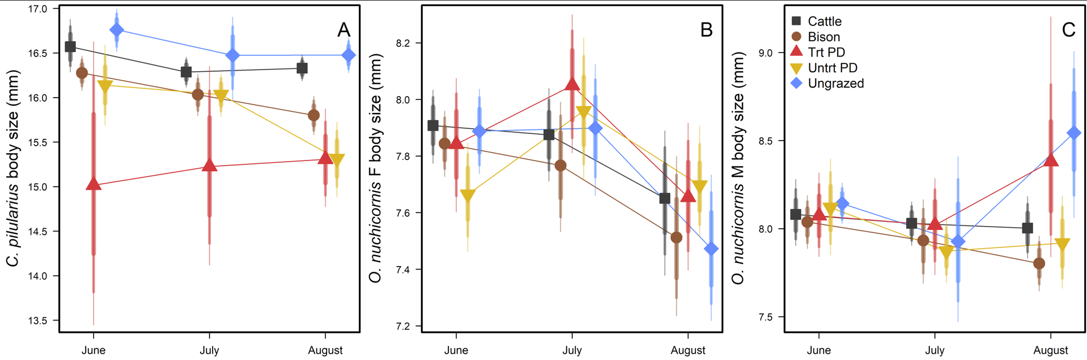

**Figure 1.** Changes in body size of *C. pilularius* (A), *O. nuchicornis* females (B), and *O. nuchicornis* males (C) over the three sampling periods and five grazing regimes. Error bars show 95%, 90%, and 80% Credible Intervals. Trt PD refers to sites located in prairie dog towns with insecticide application while Untrt PD sites located in prairie dog towns without insecticide application.

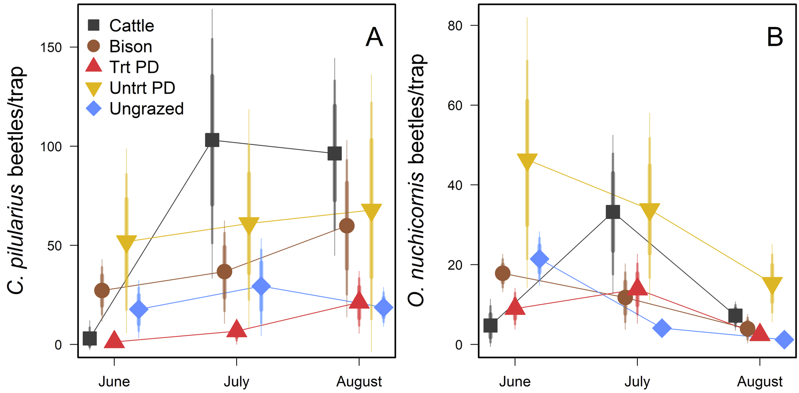

**Figure 2.** Activity densities of *C. pilularius* (A) and *O. nuchicornis* (B) over the three sampling periods and five grazing regimes. Error bars show 95%, 90%, and 80% Credible Intervals. Trt PD refers to sites located in prairie dog towns with insecticide application while Untrt PD sites located in prairie dog towns without insecticide application.

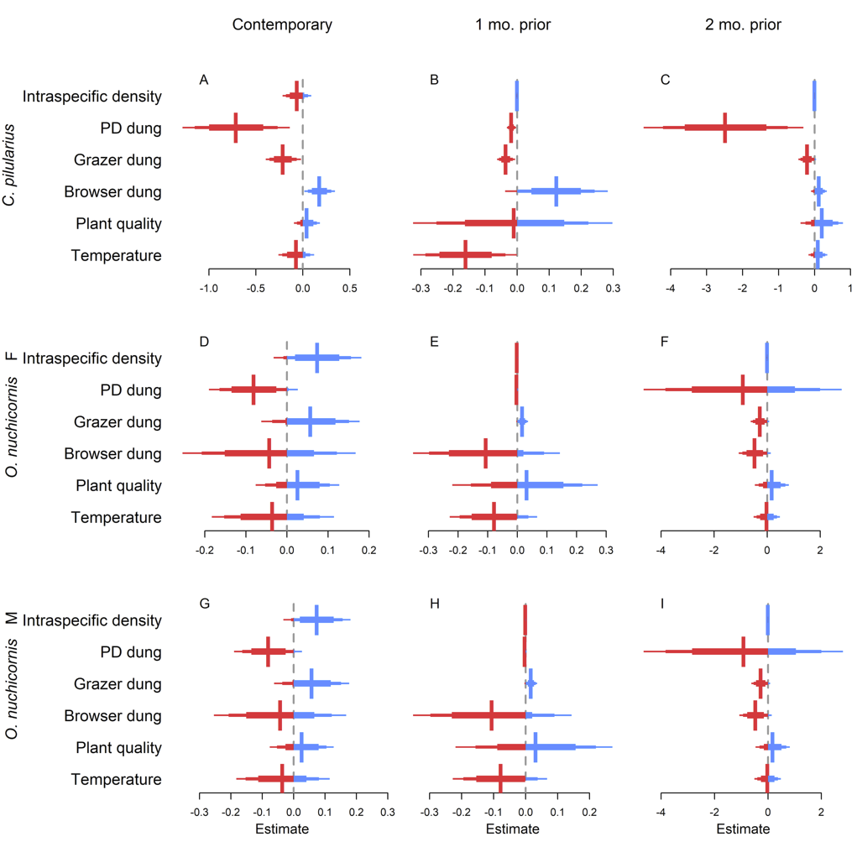

**Figure 3.** Estimates of effects of environmental drivers on dung beetle body size. Examined responses include length of dung beetles (sum of length of head, pronotum, and wing length) for *C. pilularius* (panels A-C), *O. nuchicornis* females (panels D-F), and *O. nuchicornis* males (panels G-I). Examined drivers were number of beetles of the same species trapped at the same site and date (Intraspecific density), densities of dung of: prairie dogs (PD), grazers including bison and cattle, and browsers including deer, elk, and antelopes, plant quality from local live grass (see Methods for quantification), and site temperature. Models were run using driver variables collected at the time of sampling (panels A, C, and G), and two lag times: the state of the site one month prior to dung beetle collection (panels B, E, and H), and two months prior to collection (panels C, F, and I). Plots depict overall estimates as vertical lines (blue for positive effects, red for negative effects) with horizontal lines showing 80%, 90%, and 95% Credible Intervals).

**Supplemental Information**

**Table S1.** Responses of dung beetle body size to contemporary conditions of environmental drivers.

|  | spp | Estimate | Est.Error |
| --- | --- | --- | --- |
| Intercept | CP | 16.12319 | 0.141892 |
| sTemp48hr | CP | -0.07008 | 0.116138 |
| grass_PC1 | CP | 0.0422 | 0.083603 |
| sbrowser_100m2 | CP | 0.177403 | 0.10203 |
| spatty_100m2 | CP | -0.21239 | 0.115736 |
| sPD_1m2 | CP | -0.7111 | 0.346418 |
| sCP_dens | CP | -0.06166 | 0.092764 |
| Intercept | onF | 7.727946 | 0.081356 |
| sTemp48hr | onF | -0.03566 | 0.090333 |
| grass_PC1 | onF | 0.025901 | 0.062525 |
| sbrowser_100m2 | onF | -0.04255 | 0.127854 |
| spatty_100m2 | onF | 0.057438 | 0.073757 |
| sPD_1m2 | onF | -0.08068 | 0.067375 |
| sON_dens | onF | 0.073849 | 0.06433 |
| Intercept | onM | 7.937099 | 0.108421 |
| sTemp48hr | onM | 0.019045 | 0.104993 |
| grass_PC1 | onM | 0.050218 | 0.068974 |
| sbrowser_100m2 | onM | -0.01787 | 0.109651 |
| spatty_100m2 | onM | 0.038201 | 0.093267 |
| sPD_1m2 | onM | -0.14333 | 0.086948 |
| sON_dens | onM | 0.098983 | 0.089327 |

**Table S2.** Responses of dung beetle body size to conditions of environmental drivers in the month prior to collection.

|  | spp | Estimate | Est.Error |
| --- | --- | --- | --- |
| Intercept | CP | 16.53217 | 0.225266 |
| sTemp20day | CP | -0.1602 | 0.097996 |
| sgrass_PC_tm1 | CP | -0.00975 | 0.188176 |
| sbrowser_lastMo | CP | 0.12286 | 0.10036 |
| patty_lastMo | CP | -0.03532 | 0.017395 |
| PD_lastMo | CP | -0.01758 | 0.008736 |
| CP_dens_tm1 | CP | 4.53E-05 | 0.000585 |
| Intercept | onF | 7.633241 | 0.181982 |
| sTemp20day | onF | -0.07767 | 0.090981 |
| sgrass_PC_tm1 | onF | 0.031876 | 0.150779 |
| sbrowser_lastMo | onF | -0.10569 | 0.151698 |
| patty_lastMo | onF | 0.0168 | 0.012145 |
| PD_lastMo | onF | -0.00217 | 0.00316 |
| ON_dens_tm1 | onF | -0.00061 | 0.000856 |
| Intercept | onM | 7.822684 | 0.205582 |
| sTemp20day | onM | -0.0481 | 0.096696 |
| sgrass_PC_tm1 | onM | 0.080465 | 0.154149 |
| sbrowser_lastMo | onM | -0.05734 | 0.125325 |
| patty_lastMo | onM | 0.02246 | 0.012346 |
| PD_lastMo | onM | -0.00074 | 0.004784 |
| ON_dens_tm1 | onM | -0.00098 | 0.001229 |

**Table S3.** Responses of dung beetle body size to conditions of environmental drivers two months prior to collection.

|  | spp | Estimate | Est.Error |
| --- | --- | --- | --- |
| Intercept | CP | 15.27 | 0.441441 |
| sTemp60day | CP | 0.096712 | 0.157028 |
| sgrass_PC_tm1 | CP | 0.20577 | 0.354366 |
| sbrowser_2MoPrior | CP | 0.122634 | 0.131334 |
| spatty_2MoPrior | CP | -0.20216 | 0.147272 |
| sPD_2MoPrior | CP | -2.48048 | 1.350472 |
| CP_dens_tm2 | CP | 0.000501 | 0.000951 |
| Intercept | onF | 7.414774 | 0.977901 |
| sTemp60day | onF | -0.01563 | 0.299105 |
| sgrass_PC_tm1 | onF | 0.178045 | 0.392619 |
| sbrowser_2MoPrior | onF | -0.46676 | 0.36731 |
| spatty_2MoPrior | onF | -0.2709 | 0.21192 |
| sPD_2MoPrior | onF | -0.90849 | 2.274852 |
| ON_dens_tm2 | onF | 0.000244 | 0.004334 |
| Intercept | onM | 8.089482 | 1.255028 |
| sTemp60day | onM | 0.037827 | 0.526648 |
| sgrass_PC_tm1 | onM | -0.07522 | 0.496723 |
| sbrowser_2MoPrior | onM | -0.03042 | 0.267909 |
| spatty_2MoPrior | onM | -0.41241 | 0.439091 |
| sPD_2MoPrior | onM | 0.287699 | 2.592678 |
| ON_dens_tm2 | onM | -4.42E-05 | 0.006387 |