**Title: Increases in interspecific but mixed trends in intraspecific body sizes over time in a German freshwater macroinvertebrate community**

**Authors:** David Mittag1, Nathan Jay Baker2, Laura Antão3, Lucie Kuczynski4, Peter Haase1,5, Ellen A. R. Welti1,6*

**Author Affiliations**

1 Department of River Ecology and Conservation, Senckenberg Research Institute and Natural History Museum Frankfurt, Germany

2 Institute of Ecology, Nature Research Centre, Vilnius, Lithuania

3 Research Centre for Ecological Change, University of Helsinki, Helsinki, Finland

4 ICBM – University of Oldenburg, Wilhemshaven, Germany

5 Faculty of Biology, University of Duisburg-Essen, Germany

6 Smithsonian National Zoo and Conservation Biology Institute, Front Royal, VA, USA

* corresponding author: weltie@si.edu

**Abstract**

The Anthropocene has accelerated the rates of species turnover globally, likely altering the functional trait composition of ecological communities. Animal body size, a “master trait” linked to processes across the biological hierarchy - from individuals’ metabolism and life span to flows of energy within ecosystems - is expected to decline with rising temperatures.

**Introduction**

Body size is a fundamental characteristic of all animals (Brown *et al.*, 2004), linked to physiological, life-history, and ecological traits of organisms, and with direct implications for species, community, and ecosystem responses to climate change (Daufresne *et al.*, 2009; Santini & Isaac, 2021). At the species level, body size has implications for nutritional needs, fecundity, and the likelihood of being consumed by predators. The range of body sizes within and across trophic levels affect the function of the ecosystems through trophic and competitive interactions (Chown *et al.*, 2010; Horne *et al.*, 2017). Interspecifically, body size tends to increase with latitude, a phenomenon known as ‘Bergmann’s rule’ (Bergmann, 1848), and is well established for many endothermic taxa (e.g. Meiri & Dayan, 2003) but less validated for ectothermic taxa (Audzijonyte *et al.*, 2017). Intraspecifically, ‘James’ rule’ predicts smaller body sizes in warmer areas, with both terrestrial (James, 1970; Henry *et al.*, 2022) and aquatic (Killen *et al.*, 2010; Deutsch *et al.*, 2022) species known to shift in body size along spatial thermal clines. The Temperature-Size Rule (TSR) predicts declining body sizes with rising temperatures through time. Adherence to the TSR has been documented for fish (Huss *et al.*, 2019) and birds (Weeks *et al.*, 2022), with these macroecological patterns being primarily ascribed to smaller animals having increased heat tolerance due to larger surface area to volume ratios. However, few studies have investigated macroinvertebrate traits using long-term sampling and evidence for these patterns in ectotherms remains mixed (Walters & Hassall, 2006; Shelomi, 2012; Horne *et al.*, 2017; Brehm *et al.*, 2019).

In freshwater ecosystems, declining average body size may be one of the universal responses to rising global temperatures (Daufresne *et al.*, 2009). In a warming world, smaller body sizes are an advantageous trait due to the low oxygen availability underwater (>5 orders of magnitude lower than air), the increased need for oxygen with increasing metabolic rate, and the increased ability for oxygen exchange with larger surface area to volume ratios (Verberk *et al.*, 2021). Oxygen levels in water decrease with increasing temperature, with likely repercussions for community composition of freshwater systems in a warming world. Thus, aquatic species are expected to more closely adhere to the TSR than terrestrial species (Forster et al., 2012).

While temperature and latitudinal clines are well defined as drivers of body size (Daufresne *et al.*, 2009), phenology presents an additional factor essential for controlling invertebrate body sizes (Chown & Gaston, 2010; Horne *et al.*, 2017a). Specifically, phenology is a driver of growth rates, fecundity, and survival. Further, with increasing latitudinal clines, the effects of phenology increases, and its associated impacts tend to affect invertebrate life cycles more prominently and directly. For example, univoltine species - adapted to seasonal shifts in resources as well as hydrological, thermal, light regimes - synchronize their development with seasonal patterns, with these patterns in turn controlling hormone secretion, molting patterns, and egg production. Given that each of these physiological processes impact adult body size, the impacts of changes to these physiological processes have the potential to alter the fecundity, development, and voltinity of future generations. For example, long-term circadian rhythms in the form of varying length of days (seasonal diel cycles) are essential for initiating or halting growth in the larval instars of invertebrates. While seasonal patterns are shifting (REF XX), seasonal diel length remains unchanged. The resulting desynchronization has the potential to impact the development and success of present and future generations. In this light, voltinism is particularly important and changes to the proportion of different voltine groups within a community are expected (REF XX). At evolutionary scales, rules explaining thermal and latitudinal body size clines only present one side of the coin, with seasonal predictability and the adaptations of organisms to this predictability being the other.

Not all insects follow the TSR (Walters & Hassall, 2006; Chown *et al.*, 2009). While many factors like primary production of the environment and life cycle type could have a significant influence on the change of body size, these seem to be of minor impact. Temperature appears to be the driving factor behind the changes in morphology and taxonomy remains the best predictor for temperature-size responses (Wonglersak *et al.*, 2020; Horne *et al.*, 2017). Of course temperature can have many different consequences. A warmer climate gives insects longer growing seasons, potentially resulting in larger body sizes (REF XX). Univoltine species or populations may particularly benefit from longer seasons as this would allow them to mature at a larger size before reproduction (Chown & Gaston, 2010). As physiological fitness increases, reproductive fitness is likely to increase as well, resulting in a higher potential fecundity of females. Meanwhile the effect for multivoltine species may be weaker as the possible effects could be shared with successive generations (Walters *et al.*, 2006). Furthermore, with rising temperatures, the voltinism type of some insects may shift, altering average life-stage at a given time point in the year (Horne *et al.****,*** 2017a). The subsequent generations then experience great differences in their developmental phase leading to seasonal body size variations (Wonglersak *et al.*, 2020; Horne *et al.*, 2017b).

Overall, how ectothermic body sizes, particularly invertebrates, vary over time remains largely unexplored, especially across larger spatial scales and phylogenetic groups (Chown & Gaston, 2009; Wonglersak *et al.*, 2020). Body size has profound ecological consequences across biological levels and is expected to be both indirectly and directly affected by climate change (Horne *et al.*, 2017b). Accordingly, not only could smaller individuals within a species be favored with rising temperatures (i.e., intraspecific size reductions), but smaller species could generally become more dominant (i.e., interspecific size reduction). Collectively, these mechanisms are expected to result in an average decrease in body size across communities (Daufresne *et al.*, 2009).

We collected body size traits quantifying both inter- and intraspecific variability to investigate decadal responses across a long-term collection of aquatic macroinvertebrates from central Germany. We measured 3427 individuals from nine macroinvertebrate species collected in four different stream locations between 2001 and 2019. Given the documented impacts of latitudinal, thermal, and seasonal clines on invertebrate body size, we paired our body size measurements with local temperature data to test contrasting hypotheses pertaining to the drivers of temporal changes in ectothermic body size (Fig. 1). First, if temperature increases are driving responses in accordance with the TSR, we predict that intraspecific body size of the measured macroinvertebrate taxa will decrease through time in response to warming global temperatures, reflecting the oxygen constraints of surface area to volume ratios of larger species (H1a). Second, if phenological shifts associated with changing climate conditions are driving responses, we expect intraspecific body size of the measured macroinvertebrate taxa to increase through time, corresponding to earlier hatching, shifted and prolonged growing seasons, and later instars captured during sampling (H1b). Thereafter and in accordance with the ‘*community body size shift hypothesis*’, we predict that a decline or increase in intraspecific body size will be reflected by a decrease (H2a) or increase (H2b) in mean interspecific body size, respectively. Understanding the mechanics behind changes in ectothermic body sizes helps identify future pressures on invertebrates in a warming world. While changes in ectothermic body size may not seem like a pertinent environmental issue, evidence of body size variation from pollinator (Willmer & Finlayson, 2014) research already demonstrates its direct impacts to society.

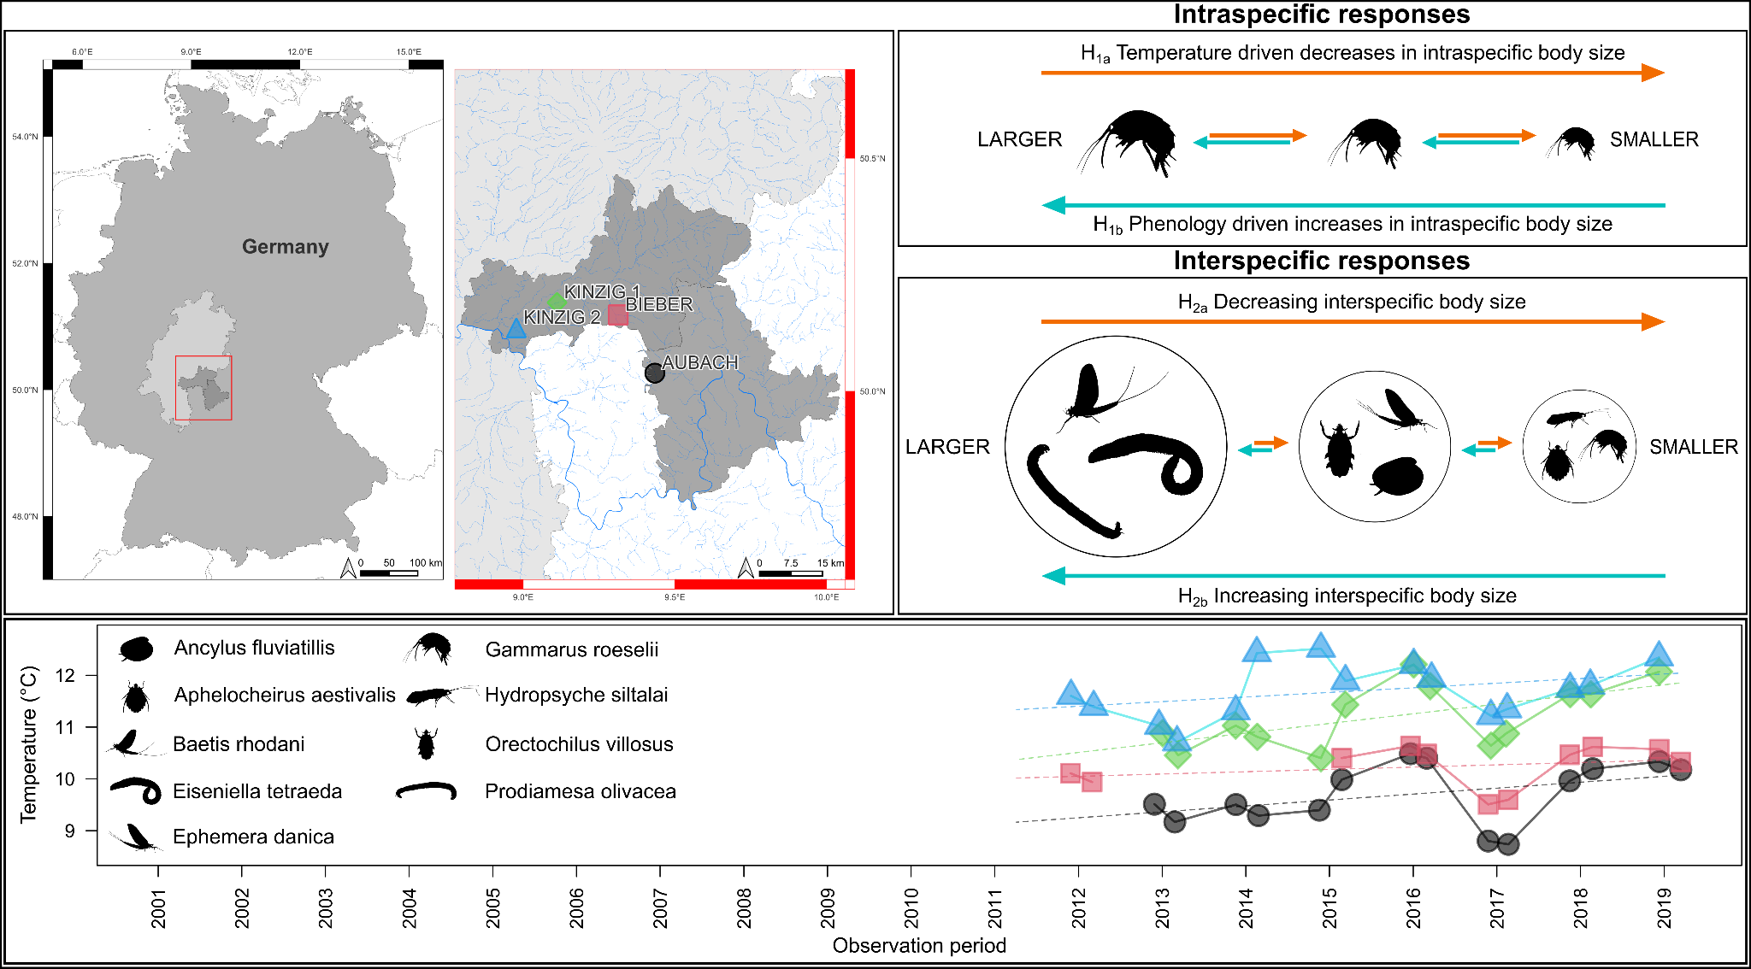

**Figure 1**. XX

**Methods**

*Study sites*

Four sites located in Central Germany were chosen as the focal points of our study (Fig. 1). Three sites, namely Kinzig 1, Kinzig 2, and Bieber are situated within the Kinzig River drainage basin (~1060 km²) and are included as part of the Rhine-Main-Observatory (RMO), an established site for long-term ecological research (LTER). The other site, Aubach, is situated within the Eslava River drainage basin (~143.80 km²) and, although not directly within the scope of the RMO, has been continuously monitored over an extended period due to its significant monitoring history, making it one of the longest consecutively observed sites in the region. Both the Kinzig and Eslava rivers are tributaries of the Main River, a major contributor to the Rhine River. Consequently, for the purpose of this study, all four sampling sites will be discussed within the context of the RMO. The RMO encompasses diverse environments, ranging from densely populated regions on the outskirts of the Rhine-Main metropolitan area to unimpacted natural landscapes. As a result, it showcases a wide array of land use types, including urban centers, industrial zones, cultivated farmlands, managed forests, and protected areas. The four selected sites reflect this land use continuum, with Bieber and Aubach representing streams that have experienced less anthropogenic perturbation, while Kinzig 1 and Kinzig 2 showcase streams with higher levels of human impact. Average elevation across the RMO is 110 m.a.s.l, while mean annual air temperature and precipitation are 9.62℃ and 837.88 mm, respectively. Further details of the RMO LTER can be found at <https://deims.org/9f9ba137-342d-4813-ae58-a60911c3abc1>.

*Field and lab procedures*

We measured intraspecific body sizes of nine aquatic macroinvertebrate taxa from a long-term collection at RMO. We selected species based on their prevalence across all sites over the time-series and spanning different representative invertebrate groups. Samples were collected during 2 sampling seasons (spring and summer) between 2001 and 2019 and from four targeted stream sites (see above). In total, we measured head size and total body length of 848 *Ephemera danica* (Ephemeroptera), 643 *Baetis rhodani* (Ephemeroptera), 390 *Hydropsyche siltalai* (Trichoptera), 510 *Prodiamesa olivacea* (Diptera), 320 *Aphelocheirus aestivalis* (Hemiptera), and 94 *Orectochilus villosus* (Coleoptera). Of the snail *Ancylus fluviatilis* (281, Gastropoda), the shell length, width, and height was measured. For the worm *Eiseniella tetraeda* (135, Annelida) the body length and width was measured. Of the 206 *Gammarus roeselii* (Gammaridae) the body length and length of 1st antennae was measured.

Up to 10 individuals per probe were chosen randomly. Specimens were measured under a microscope using calipers (0.01 mm accuracy). The gammarids were measured using a microscope camera connected to a computer with the software Cell^A; as gammarids usually bend, all specimens were brought into a similar pose and then measured by drawing a line from the specimen head to the urosom.

*Statistical analyses*

We analyzed changes over time in both the intraspecific body sizes of the three targeted species, and interspecific body size structure of the whole RMO macroinvertebrate community. Body size classes for species and other traits were extracted from the DISPERSE database (Sarremejane et al. 2020), and freshwaterecology.info (Schmidt-Kloiber and Hering 2015). Intraspecifically, we analyzed change over time, while accounting for the day of year (phenology), intraspecific density from the same sample (intraspecific density dependence), and sampling sites. Interspecifically, we analyzed the change in Community Weighted Mean (CWM) of body size with year, while accounting for sampling day of year and sampling sites. In addition, we analyzed the abundance trends over time for the 59 most common species (species present in at least 12 samping years), and tested whether species body size predicted abundance trends.

From 2011 onwards, biological datasets of each site were supplemented with in-stream temperature measurements, taken hourly or bihourly via automatic temperature loggers. In cases where temperature time series contained missing data (due to the loggers malfunctioning or being lost), data were interpolated using the ‘interpolate_gaps_hourly’ function in the *chillR* R package (REF XX). When interpolation provided unrealistic temperature estimates (EXAMPLE NEEDED), these data were removed and left blank. Interpolated hourly temperature data were then aggregated to daily means and used to calculate annual mean temperatures from the 365 days (12 months) prior to the date of biological sampling; the 12 month time interval was selected as most european aquatic invertebrates have univoltine lifecycles (68% of taxa listed in Tachet et al., 2010). For example, if biological sampling was conducted on 12.06.2023, the annual mean temperature for this day was calculated using daily mean temperatures from 12.06.2022 to 11.06.2023. It is important to note that annual mean temperatures were only calculated if daily mean temperature data were available for >98% (360 days) of the days leading up to the biological sampling. This approach generated complimentary temperature datasets for XX number of site years which were used to explore temporal relationships between intra- and inter-specific body size and temperature.

**Results**

The nine measured macroinvertebrates ranged in body size from the smallest species, the limpet *A. fluviatilis* (average body length: 4.8 mm ± 0.08 SE), to the largest species of the worm *E. tetraedra* (27.29 mm ± 0.86 SE). A total of 223 taxa were collected over all years and across the four sites. The temperature at each of the four sites tended to increase through time, with Aubach (est = 0.0002435, p = 0.174), Bieber (est = 0.0001216, p = 0.420), and Kinzig 2 (est = 0.0002435, p = 0.174) exhibiting trend effects, while Kinzig 1 (est = 0.0005111, p = 0.0322) showed significant overall increases.

*Intraspecific body size patterns*

Intraspecific shifts in body size over time were taxa-specific. After accounting for the day of year of sampling and intraspecific densities, four species: the limpet *A. fluviatilis*, the hemiptera *A. aestivalis,* the worm, *E. tetraedra*, and the trichoptera *H. siltalai*, did not vary in body size over time on any measured component (Fig. 2, Table S1). The midge *P. olivacea*, increased over time in both body and head length (Fig. 2i, Table S1 & S2). The beetle *O. villosus* marginally increased in head width over time (Fig. S1, Table S2). The two Ephemeroptera, *B. rhodani* and *E. danica*, decreased in both body length and head width over time, while the amphipod *G. roeselii* decreased in body length (head width of *G. roeselii* was not measured; Fig. 2 & S1, Tables S1 & S2).

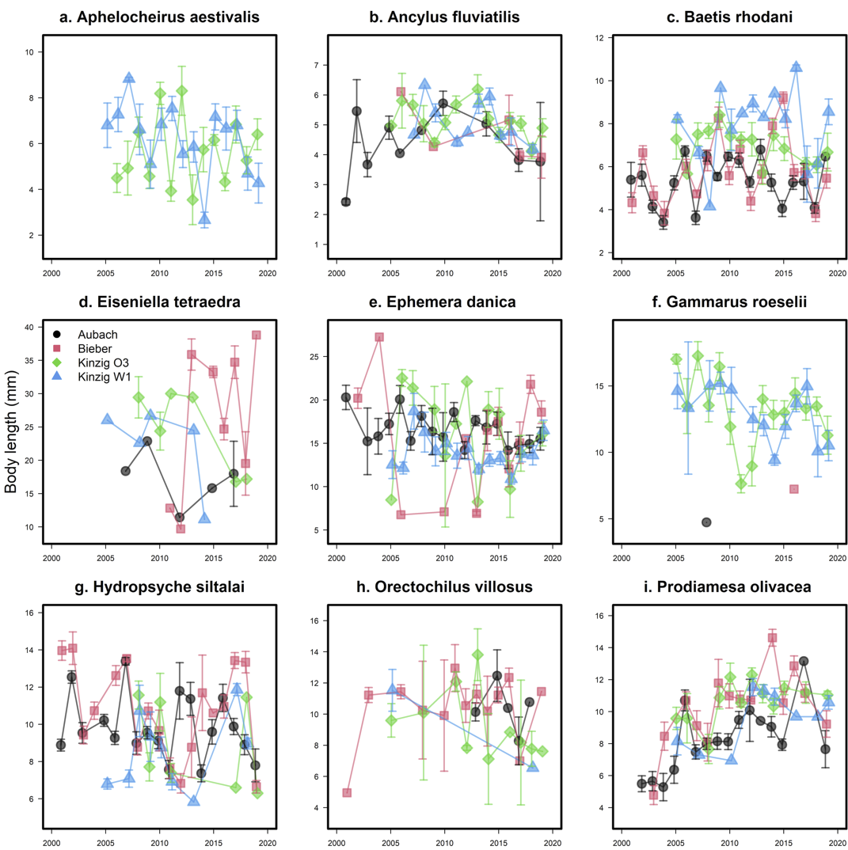

**Figure 2.** Changes in intraspecific body length over time and in the four study sites for nine freshwater aquatic macroinvertebrate species: *Aphelocheirus aestivalis* (a), *Ancylus fluviatilis* (b), *Baetis rhodani* (c), *Eiseniella tetraeda* (d), *Ephemera danica* (e), *Gammarus roeselii* (f), *Hydropsyche siltalai* (g), *Orectochilus villosus* (h), and *Prodiamesa olivacea* (i).

Changes in intraspecific body size over time for the nine species were not well explained by temperature over the previous 12 month period. The limpet *A. fluviatilis*, one of the species with no annual body size trends (Fig. S2, Tables S1, S2, & S3), was the only species to shift in body length with temperature overall across the four sites, with *A. fluviatilis* increasing in body length, height, and width in warmer years (Fig. S3, S4 & S5, Tables S4, S5, & S6)

*Interspecific body size patterns*

Contrary to the mixed intraspecific body size shifts of time, interspecific body sizes tended to increase, with larger species increasing in abundance over time. The CWM of body size increased over time (year estimate.across all four sites = 0.06, SE = 0.01, *P* < 0.001; Fig 3a) and increased and then plateaued with water temperature, fitting a XXshape (temperature estimate across all four sites = , SE = , *P* < 0.001; Fig 3b). Using the 59 most common species that allowed sufficient quantification of temporal trends, we found that despite abundance trends being variable among species, larger species were more likely to increase their abundance over time (Year Est. = 0.04, SE = 0.01, *P* = 0.007; Fig. 3).

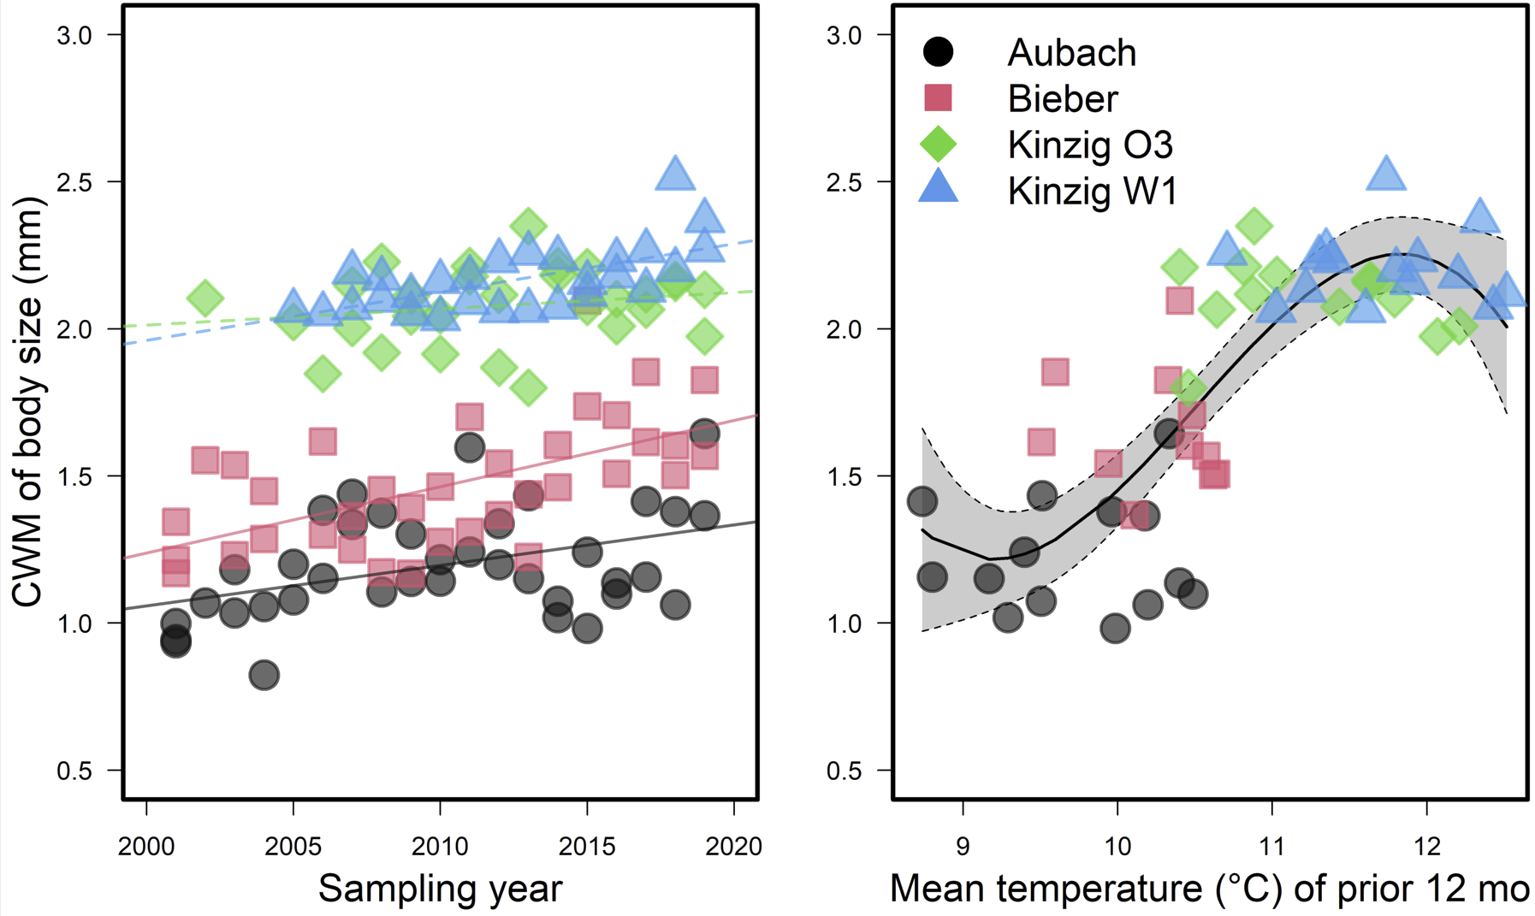

**Figure 3.** Change in the Community Weighted Mean (CWM) of interspecific body size over year (a) and water temperature (b).

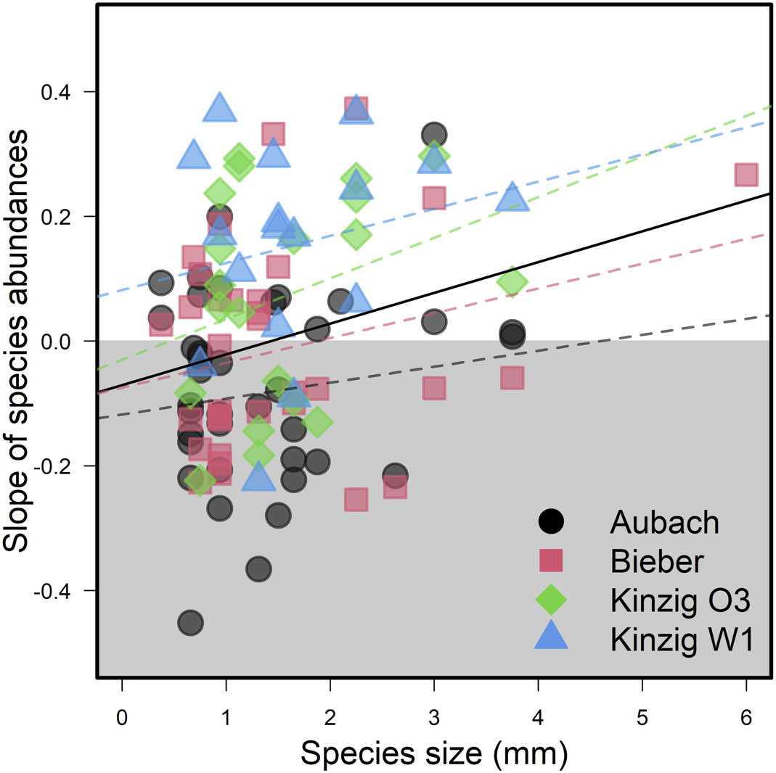

**Figure 4.** Slope of species abundances over time, regressed over species interspecific body sizes. Each point represents the slope of one species within one site, using only species sampled for at least 12 years.

**Discussion**

*Summary of Results. Start the Discussion with a statement or paragraph that summarizes the main results of the study. The last sentence of this section should be a topic sentence that outlines the major points that will be considered in the remainder of the Discussion.*

We found highly divergent trends for the different species we measured to obtain intraspecific measurements over time. Our preliminary results suggest that body size changes are species-specific and potentially size-dependent. In particular, while the biggest species (*E. danica*) experienced a decrease in body size, the smallest (*P. olivacea*) increased in body size over time.

*Interpretation. When interpreting the Results, try to be even-handed. Do not make conclusions that the data do not support or fail to address. Present alternative explanations if caveats are appropriate. Being self-critical takes this option away from a reviewer. Keep in mind that sample sizes and the size of the differences between your treatments may be small.*

In addition, based on our preliminary analysis at the community level, the averaged size in the community increased over time. The overall increase in average body size is contrary to our initial hypothesis (i.e., a decrease in body size with increasing temperature following the Temperature Size Rule). This could result from two non-mutually exclusive mechanisms: i) large species could have become more abundant over time and, ii) small species could be experiencing population declines. Alternatively, the observed pattern could reflect shifts in phenology such that i) the peak occurrence of larger species has greater overlap with the sampling periods or ii) smaller species are shifting to have peak abundances outside of the sampling periods. Within common species, increases in abundance over time were positively predicted by body size, suggesting the occurrence of changes in either body size or phenology of both larger and smaller species. We have not yet obtained temperature data for the different locations over time to explicitly test the Temperature Size Rule in driving these patterns. Moreover, we have not yet disentangled potential effects of sampling sites (and initial visual inspection suggests there may be non-linear patterns over time). Finally, we aim to investigate potential mechanisms related to life history traits to better understand the intraspecific variability in body size trends over time underlying trends at the community level.

*Broader perspective. Conclude the Discussion by addressing the broader implications of the research. This can include: questions that remain unanswered, suggestions of areas where further research is necessary, implications of the results for problems in other taxa or areas of theory, development of new hypotheses, or implications for management and conservation.*

In ectothermic species, size greatly depends on environmental temperature often leading to faster developmental rates but smaller size at maturity. As most insects have very complex life cycles, commonly including several generations per year (voltinism type) and different life stages (larvae, imago) it can be difficult to separate the effect of temperature from other factors (Horne *et al*., 2017; Brehm *et al*., 2018; Daufresne *et al*., 2009).

Knowing an animal’s body size alone allows approximations of many additional key functional traits, including metabolic rate, habitat size, dispersal capacity, nutritional requirements, and life span. Body size distributions of ecological communities are constrained by temperature, through regulation of species’ metabolic rates.

**References**

Baselga, A. (2010) Partitioning the turnover and nestedness components of beta diversity. *Global Ecology and Biogeography*, 19, 134–143.

Bergmann, C. (1848) *Über die Verhältnisse der Wärmeökonomie der Thiere zu ihrer Größe*,.

Brehm, G., Zeuss, D. & Colwell, R.K. (2019) Moth body size increases with elevation along a complete tropical elevational gradient for two hyperdiverse clades. *Ecography*, 42, 632–642.

Brown, J.H., Gillooly, J.F., Allen, A.P., Savage, V.M. & West, G.B. (2004) Toward a metabolic theory of ecology. *Ecology*, 85, 1771–1789.

Crisp, M. & Cook, L. (2012) Phylogenetic niche conservatism: What are the underlying evolutionary and ecological causes? *The New phytologist*, 196, 681–94.

Daufresne, M., Lengfellner, K. & Sommer, U. (2009) Global warming benefits the small in aquatic ecosystems. *Proceedings of the National Academy of Sciences*, 106, 12788–12793.

Dornelas, M., Antão, L.H., Moyes, F., Bates, A.E., Magurran, A.E., Adam, D., Akhmetzhanova, A.A., Appeltans, W., Arcos, J.M., Arnold, H., Ayyappan, N., Badihi, G., Baird, A.H., Barbosa, M., Barreto, T.E., Bässler, C., Bellgrove, A., Belmaker, J., Benedetti-Cecchi, L., Bett, B.J., Bjorkman, A.D., Błażewicz, M., Blowes, S.A., Bloch, C.P., Bonebrake, T.C., Boyd, S., Bradford, M., Brooks, A.J., Brown, J.H., Bruelheide, H., Budy, P., Carvalho, F., Castañeda-Moya, E., Chen, C.A., Chamblee, J.F., Chase, T.J., Collier, L.S., Collinge, S.K., Condit, R., Cooper, E.J., Cornelissen, J.H.C., Cotano, U., Crow, S.K., Damasceno, G., Davies, C.H., Davis, R.A., Day, F.P., Degraer, S., Doherty, T.S., Dunn, T.E., Durigan, G., Duffy, J.E., Edelist, D., Edgar, G.J., Elahi, R., Elmendorf, S.C., Enemar, A., Ernest, S.K.M., Escribano, R., Estiarte, M., Evans, B.S., Fan, T.-Y., Farah, F.T., Fernandes, L.L., Farneda, F.Z., Fidelis, A., Fitt, R., Fosaa, A.M., Franco, G.A.D.C., Frank, G.E., Fraser, W.R., García, H., Gatti, R.C., Givan, O., Gorgone-Barbosa, E., Gould, W.A., Gries, C., Grossman, G.D., Gutierréz, J.R., Hale, S., Harmon, M.E., Harte, J., Haskins, G., Henshaw, D.L., Hermanutz, L., Hidalgo, P., Higuchi, P., Hoey, A., Hoey, G.V., Hofgaard, A., Holeck, K., Hollister, R.D., Holmes, R., Hoogenboom, M., Hsieh, C., Hubbell, S.P., Huettmann, F., Huffard, C.L., Hurlbert, A.H., Ivanauskas, N.M., Janík, D., Jandt, U., Jażdżewska, A., Johannessen, T., Johnstone, J., Jones, J., Jones, F.A.M., Kang, J., Kartawijaya, T., Keeley, E.C., Kelt, D.A., Kinnear, R., Klanderud, K., Knutsen, H., Koenig, C.C., Kortz, A.R., Král, K., Kuhnz, L.A., Kuo, C.-Y., Kushner, D.J., Laguionie-Marchais, C., Lancaster, L.T., Lee, C.M., Lefcheck, J.S., Lévesque, E., Lightfoot, D., Lloret, F., Lloyd, J.D., López-Baucells, A., Louzao, M., Madin, J.S., Magnússon, B., Malamud, S., Matthews, I., McFarland, K.P., McGill, B., McKnight, D., McLarney, W.O., Meador, J., Meserve, P.L., Metcalfe, D.J., Meyer, C.F.J., Michelsen, A., Milchakova, N., Moens, T., Moland, E., Moore, J., Moreira, C.M., Müller, J., Murphy, G., Myers-Smith, I.H., Myster, R.W., Naumov, A., Neat, F., Nelson, J.A., Nelson, M.P., Newton, S.F., Norden, N., Oliver, J.C., Olsen, E.M., Onipchenko, V.G., Pabis, K., Pabst, R.J., Paquette, A., Pardede, S., Paterson, D.M., Pélissier, R., Peñuelas, J., Pérez-Matus, A., Pizarro, O., Pomati, F., Post, E., Prins, H.H.T., Priscu, J.C., Provoost, P., Prudic, K.L., Pulliainen, E., Ramesh, B.R., Ramos, O.M., Rassweiler, A., Rebelo, J.E., Reed, D.C., Reich, P.B., Remillard, S.M., Richardson, A.J., Richardson, J.P., Rijn, I. van, Rocha, R., Rivera-Monroy, V.H., Rixen, C., Robinson, K.P., Rodrigues, R.R., Rossa-Feres, D. de C., Rudstam, L., Ruhl, H., Ruz, C.S., Sampaio, E.M., Rybicki, N., Rypel, A., Sal, S., Salgado, B., Santos, F.A.M., Savassi-Coutinho, A.P., Scanga, S., Schmidt, J., Schooley, R., Setiawan, F., Shao, K.-T., Shaver, G.R., Sherman, S., Sherry, T.W., Siciński, J., Sievers, C., Silva, A.C. da, Silva, F.R. da, Silveira, F.L., Slingsby, J., Smart, T., Snell, S.J., Soudzilovskaia, N.A., Souza, G.B.G., Souza, F.M., Souza, V.C., Stallings, C.D., Stanforth, R., Stanley, E.H., Sterza, J.M., Stevens, M., Stuart-Smith, R., Suarez, Y.R., Supp, S., Tamashiro, J.Y., Tarigan, S., Thiede, G.P., Thorn, S., Tolvanen, A., Toniato, M.T.Z., Totland, Ø., Twilley, R.R., Vaitkus, G., Valdivia, N., Vallejo, M.I., Valone, T.J., Colen, C.V., Vanaverbeke, J., Venturoli, F., Verheye, H.M., Vianna, M., Vieira, R.P., Vrška, T., Vu, C.Q., Vu, L.V., Waide, R.B., Waldock, C., Watts, D., Webb, S., Wesołowski, T., White, E.P., Widdicombe, C.E., Wilgers, D., Williams, R., Williams, S.B., Williamson, M., Willig, M.R., Willis, T.J., Wipf, S., Woods, K.D., Woehler, E.J., Zawada, K. & Zettler, M.L. (2018) BioTIME: A database of biodiversity time series for the Anthropocene. *Global Ecology and Biogeography*, 27, 760–786.

Faurby, S. & Araújo, M.B. (2017) Anthropogenic impacts weaken Bergmann’s rule. *Ecography*, 40, 683–684.

Geist, V. (1987) Bergmann’s rule is invalid. *Canadian Journal of Zoology*, 65, 1035–1038.

Gelman, A. & Hill, J. (2006) *Data analysis using regression and multilevel/hierarchical models*, Cambridge University Press.

Gotelli, N.J. & Graves, G.R. (1996) *Null models in ecology*,.

Harper, E.M. & Peck, L.S. (2016) Latitudinal and depth gradients in marine predation pressure. *Global Ecology and Biogeography*, 25, 670–678.

Horne, C.R., Hirst, A.G. & Atkinson, D. (2017) Seasonal body size reductions with warming covary with major body size gradients in arthropod species. *Proceedings of the Royal Society B: Biological Sciences*, 284, 20170238.

Karger, D.N., Conrad, O., Böhner, J., Kawohl, T., Kreft, H., Soria-Auza, R.W., Zimmermann, N.E., Linder, H.P. & Kessler, M. (2017) Climatologies at high resolution for the earth’s land surface areas. *Scientific Data*, 4, 170122.

Lehner, B., Verdin, K.L. & Jarvis, A. (2008) New global hydrography derived from spaceborne elevation data. *Eos, Transactions, American Geophysical Union*, 89, 2.

McElreath, R. (2018) *Statistical rethinking: A Bayesian course with examples in R and Stan*, Chapman and Hall/CRC.

Meiri, S. & Dayan, T. (2003) On the validity of Bergmann’s rule. *Journal of Biogeography*, 30, 331–351.

Pinsky, M.L., Eikeset, A.M., McCauley, D.J., Payne, J.L. & Sunday, J.M. (2019) Greater vulnerability to warming of marine versus terrestrial ectotherms. *Nature*, 569, 108–111.

Santini, L. & Isaac, N.J.B. (2021) Rapid Anthropocene realignment of allometric scaling rules. *Ecology Letters*, In Press.

Sarremejane, R., Cid, N., Stubbington, R., Datry, T., Alp, M., Cañedo-Argüelles, M., Cordero-Rivera, A., Csabai, Z., Gutiérrez-Cánovas, C., Heino, J., Forcellini, M., Millán, A., Paillex, A., Pařil, P., Polášek, M., Tierno de Figueroa, J.M., Usseglio-Polatera, P., Zamora-Muñoz, C. & Bonada, N. (2020) DISPERSE, a trait database to assess the dispersal potential of European aquatic macroinvertebrates. *Scientific Data*, 7, 386.

Schmidt-Kloiber, A. & Hering, D. (2015) www.freshwaterecology.info – An online tool that unifies, standardises and codifies more than 20,000 European freshwater organisms and their ecological preferences. *Ecological Indicators*, 53, 271–282.

Shelomi, M. (2012) Where are we now? Bergmann’s rule sensu lato in insects. *The American Naturalist*, 180, 511–519.

Soininen, J., Heino, J. & Wang, J. (2018) A meta-analysis of nestedness and turnover components of beta diversity across organisms and ecosystems. *Global Ecology and Biogeography*, 27, 96–109.

Sunday, J., Bennett, J.M., Calosi, P., Clusella-Trullas, S., Gravel, S., Hargreaves, A.L., Leiva, F.P., Verberk, W.C.E.P., Olalla-Tárraga, M.Á. & Morales-Castilla, I. (2019) Thermal tolerance patterns across latitude and elevation. *Philosophical Transactions of the Royal Society B: Biological Sciences*, 374, 20190036.

**Supplemental Information**

**Supplemental Tables**

**Supplemental Figures**

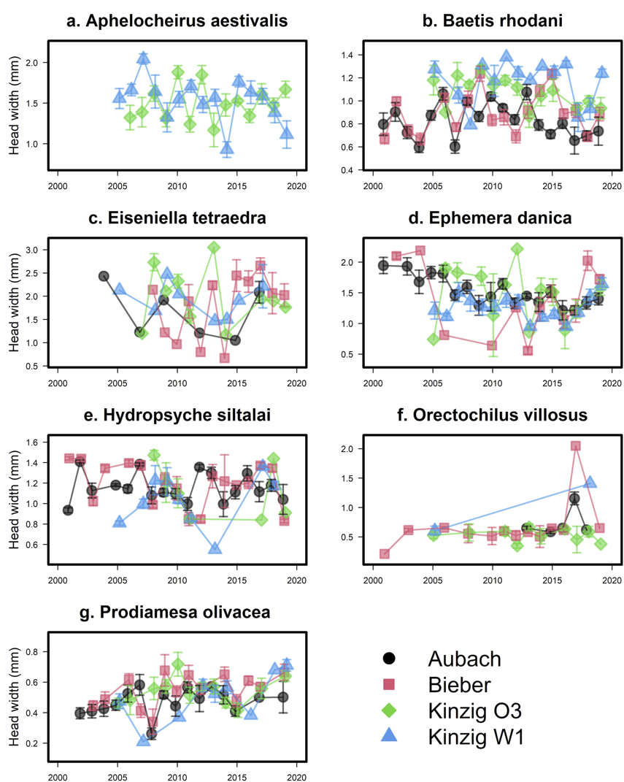

**Figure S1.** Changes in intraspecific head width over time and in the four study sites for nine freshwater aquatic macroinvertebrate species: *Aphelocheirus aestivalis* (a), *Baetis rhodani* (b), *Eiseniella tetraeda* (c), *Ephemera danica* (d), *Hydropsyche siltalai* (e), *Orectochilus villosus* (f), and *Prodiamesa olivacea* (g).

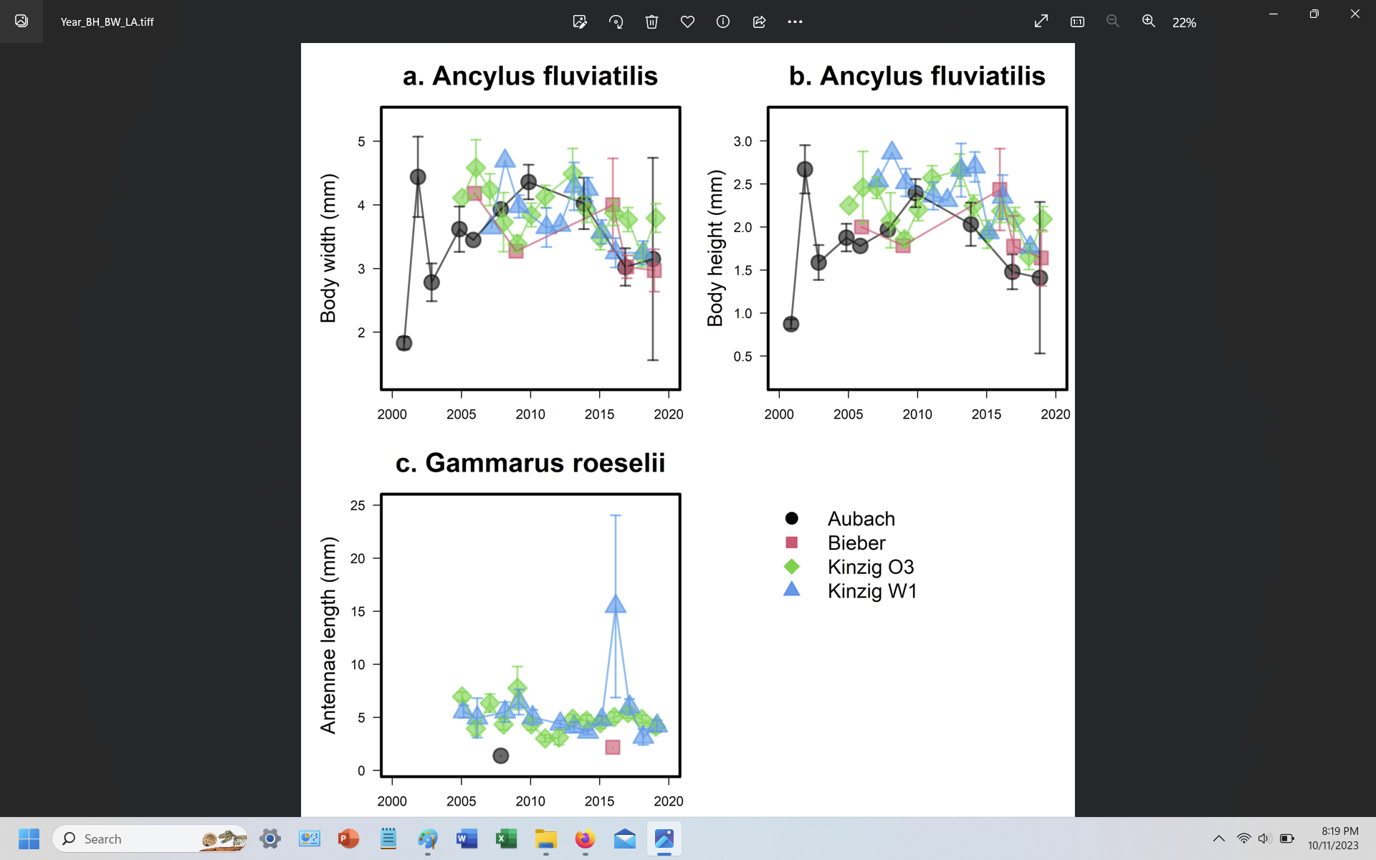

**Figure S2.** Changes in intraspecific body width (a) and body height (b) of *Aphelocheirus aestivalis* and antennae length of *Gammarus roeselii* (c) over time and in the four study sites.

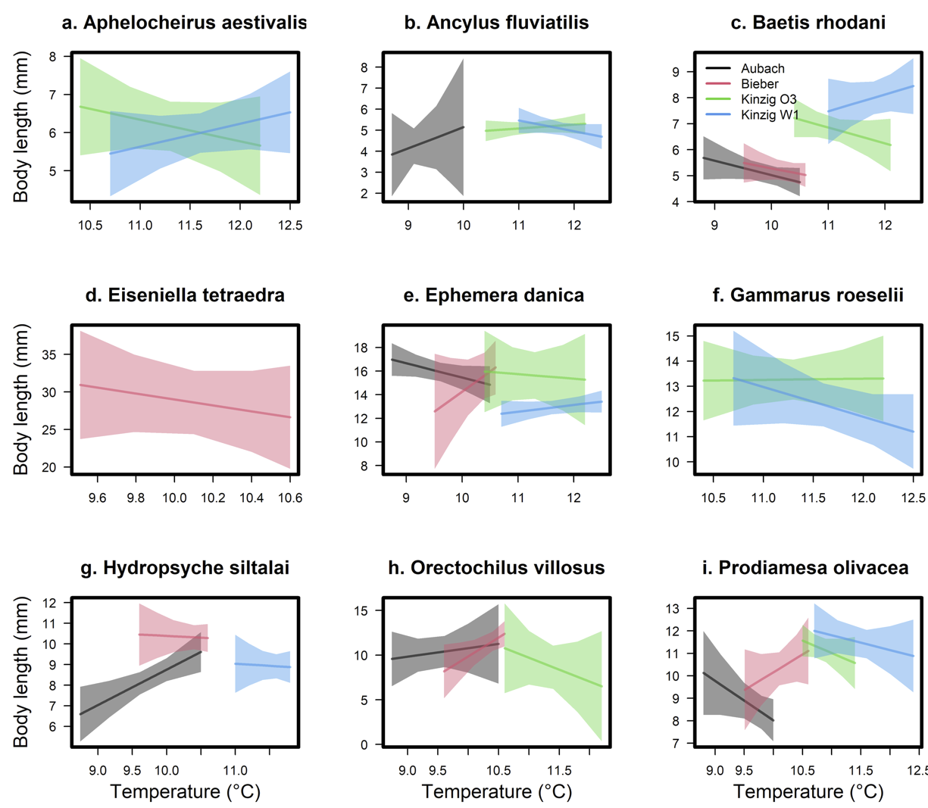

**Figure S3.** Changes in intraspecific body length with water temperature in the four study sites for nine freshwater aquatic macroinvertebrate species: *Aphelocheirus aestivalis* (a), *Ancylus fluviatilis* (b), *Baetis rhodani* (c), *Eiseniella tetraeda* (d), *Ephemera danica* (e), *Gammarus roeselii* (f), *Hydropsyche siltalai* (g), *Orectochilus villosus* (h), and *Prodiamesa olivacea* (i).

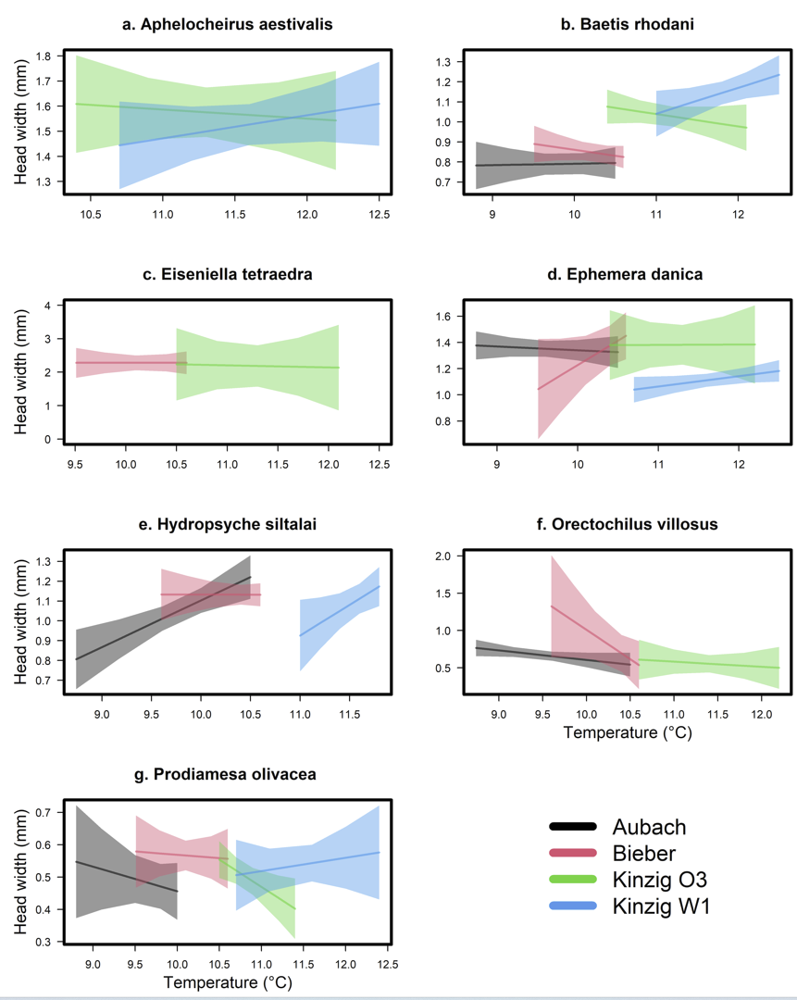

**Figure S4.** Changes in intraspecific head width with water temperature in the four study sites for nine freshwater aquatic macroinvertebrate species: *Aphelocheirus aestivalis* (a), *Baetis rhodani* (b), *Eiseniella tetraeda* (c), *Ephemera danica* (d), *Hydropsyche siltalai* (e), *Orectochilus villosus* (f), and *Prodiamesa olivacea* (g).

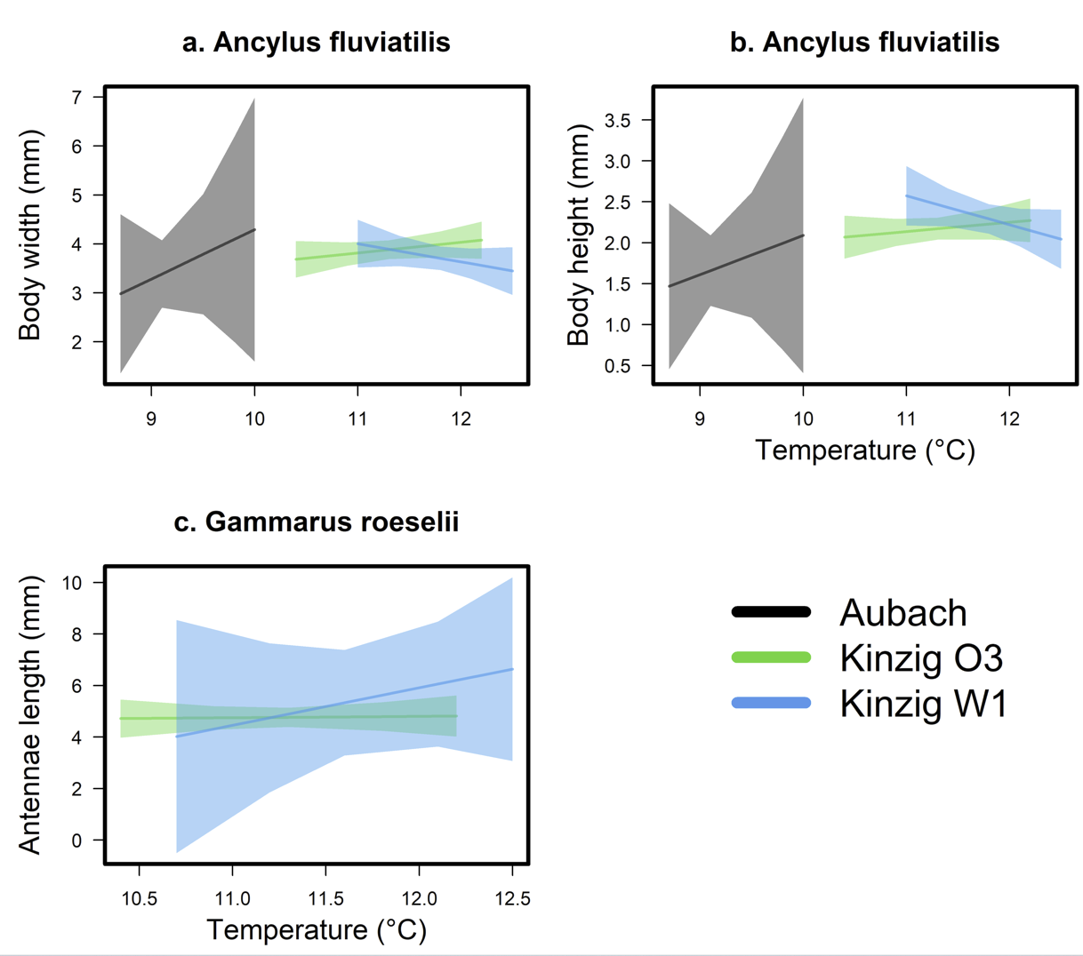

**Figure S5.** Changes in intraspecific body width (a) and body height (b) of *Aphelocheirus aestivalis* and antennae length of *Gammarus roeselii* (c) with water temperature in the four study sites.