**Title: Increases in interspecific but mixed trends in intraspecific body sizes over time in a German freshwater macroinvertebrate community**

**Authors:** David Mittag1, Nathan Jay Baker2, Laura Antão3, Lucie Kuczynski4, Peter Haase1,5, Ellen A. R. Welti1,6*

**Author Affiliations**

1 Department of River Ecology and Conservation, Senckenberg Research Institute and Natural History Museum Frankfurt, Germany

2 Institute of Ecology, Nature Research Centre, Vilnius, Lithuania

3 Research Centre for Ecological Change, University of Helsinki, Helsinki, Finland

4 ICBM – University of Oldenburg, Wilhemshaven, Germany

5 Faculty of Biology, University of Duisburg-Essen, Germany

6 Smithsonian’s National Zoo and Conservation Biology Institute, Front Royal, VA, USA

* corresponding author: weltie@si.edu

**Abstract**

The Anthropocene has accelerated both species turnover and rates of intraspecific change globally, likely altering the functional trait composition of ecological communities. Body size is expected to decline with rising temperatures, with implications for ecosystem production, resource use, and food provisioning for predators. To test for changes in body size both over time and with water temperature, we measured intraspecific body sizes for nine common macroinvertebrate taxa in four German streams between 2001 and 2019. We further examined both interspecific body size shifts using community weighted means, and the relationship between a given taxa’s body size and its abundance trends over time in the same four streams. Intraspecifically, taxa exhibited high variability in changes in body size over time but temperature was not a strong predictor of these patterns. Interspecifically, weighted means of the distributions of body sizes increased over time, and sites with higher temperatures had communities more dominated by larger taxa. Additionally, taxa with larger body sizes tended to have greater increases in abundance over time. These changes do not align with previous predictions of negative effects of rising temperatures on invertebrate body sizes. Other changes in the system including improvements in water quality over time, may underlie body size shifts in this system. Identifying changes in animal body size provides insight into processes across the biological hierarchy - from individuals’ metabolism to flows of energy within ecosystems.

**Introduction**

Body size is a fundamental characteristic of all animals (Brown *et al.*, 2004), linked to physiological, life-history, and ecological traits of organisms. Shifts in body size due to climate change will have direct implications for species’ populations, ecological communities, and ecosystem energy flows (Daufresne *et al.*, 2009; Santini & Isaac, 2021). At the species level, body size can affect nutritional needs, fecundity, dispersal abilities, and the likelihood of being consumed by predators (Chown *et al.*, 2010). The distribution of taxa’s body sizes within and across trophic levels affects trophic and competitive interactions (Chown *et al.*, 2010; Horne *et al.*, 2017). Shifts in body size variation can directly alter ecosystem functioning. For example, both lab and field experiments have indicated that larger species are more effective pollinators (Willmer & Finlayson, 2014), while theoretical and experimental research has shown that predator-prey interactions (with few exceptions, e.g., host-parasite relationships) as well as basal food-web dynamics (i.e., decomposition and production) are both size-delimited (de Roos et al., 2002; Scheffer & Carpenter, 2003; Woodward et al., 2005).

Three hypotheses predict shifts in animal body size over time and space. Interspecifically, body size tends to increase with latitude, a phenomenon known as ‘Bergmann’s rule’ (Bergmann, 1848). Bergmann’s rule is followed by many endothermic taxa (e.g. Meiri & Dayan, 2003) but is less validated for ectothermic taxa (Audzijonyte *et al.*, 2017). The mechanism behind Bergmann’s rule is likely variation in temperature across latitudes (Horne *et al.*, 2017). Intraspecifically, ‘James’ rule’ predicts smaller body sizes in warmer areas. Body sizes of both terrestrial (James, 1970; Henry *et al.*, 2022) and aquatic (Killen *et al.*, 2010; Deutsch *et al.*, 2022) species have demonstrated conformity to James’ rule along spatial thermal clines. The Temperature-Size Rule (TSR) predicts declining body sizes with rising temperatures through time. Adherence to the TSR has been documented for fish (Huss *et al.*, 2019) and birds (Weeks *et al.*, 2022), with these macroecological patterns being primarily ascribed to smaller animals having increased heat tolerance due to larger surface area to volume ratios. However, evidence for these patterns in ectotherms remains mixed, and few studies have examined long-term shifts in invertebrate body sizes (Walters & Hassall, 2006; Shelomi, 2012; Horne *et al.*, 2017; Brehm *et al.*, 2019).

In a warming world, smaller body sizes, and thus larger surface area to volume ratios, can be an advantageous trait that increases the ability for oxygen exchange in freshwater ecosystems (Daufresne *et al.*, 2009, Verberk *et al.*, 2021). This need is exacerbated due to the low oxygen availability underwater (>5 orders of magnitude lower than air) and the increased need for oxygen with increasing metabolic rate as temperatures rise. Oxygen levels in water decrease with increasing temperature, with likely repercussions for community composition of freshwater systems as water temperatures increase. Due to this additional oxygen constraint, aquatic species are expected to more closely adhere to the TSR than terrestrial species (Forster et al., 2012).

Not all invertebrates follow the TSR (Walters & Hassall, 2006; Chown *et al.*, 2009). Another key driver of invertebrate body size of individuals sampled at the same time of year is shifts in phenology (Chown & Gaston, 2010; Horne *et al.*, 2017a). Invertebrate life cycles can be adapted to seasonal shifts in resources as well as hydrological, thermal, and light regimes. Climate change is affecting all of these potential cues (Kwon et al. 2019). In particular, warmer temperatures are expected to shift growing seasons earlier, resulting in earlier invertebrate emergence in temperate climates (Linderholm 2006; Verheyen et al., 2018). For univoltine species, earlier emergence is expected to increase invertebrate body size over time for a fixed time point/sampling period in the growing season (Chown & Gaston, 2010). For bivoltine and multivoltine taxa, predicting body size shifts across years at a given seasonal time point in response to earlier emergence becomes more challenging as shifts can capture different generations (Walters *et al.*, 2006). In this light, voltinism is particularly important for predicting body sizes of the organisms at a given seasonal time point.

We collected body size traits quantifying both inter- and intraspecific variability to investigate decadal responses across a long-term collection of aquatic macroinvertebrates from central Germany. We measured 3,427 individuals from nine macroinvertebrate species collected in four different stream locations between 2001 and 2019. To test the effects of thermal clines on invertebrate body size, we examined responses to water temperature over time and across our four sampling sites (Fig. 1). First, if temperature increases are driving responses in accordance with the TSR, we predict that intraspecific body size of the measured macroinvertebrate taxa will decrease through time (H1a). Second, if phenological shifts associated with changing climate conditions are driving responses, we expect intraspecific body size of univoltine macroinvertebrate taxa to increase through time, and mixed responses of bi- and multivoltine taxa as a result of earlier growing seasons and hatching (H1b). We expect shifts in average interspecific body size to mirror changes in intraspecific body size with responses to temperature resulting in decreasing interspecific body size (H2a) or earlier emergence resulting in increases in interspecific body size (H2b) over time.

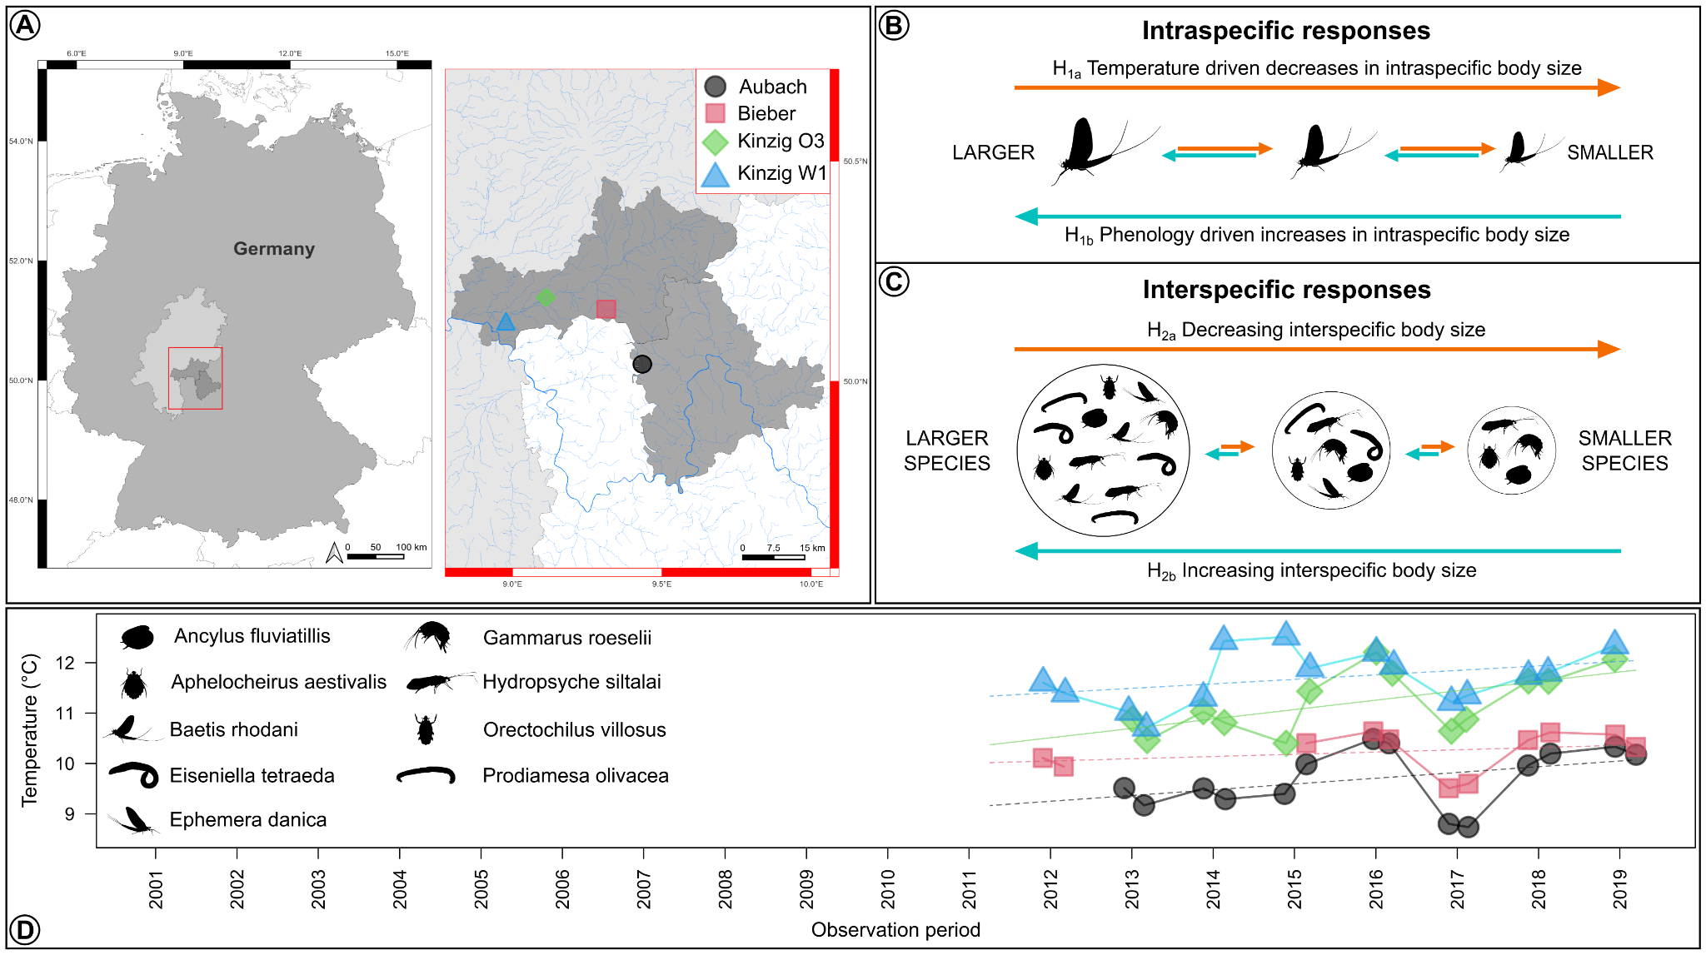

**Figure 1**. **Study location and sampling sites (A), hypothesized variation in intraspecific (B) and interspecific (C) invertebrate body size in response to temperature and phenology, and changes in annual temperatures through time (D).** In B and C, silhouettes used are for illustrative purposes only and do not reflect study results. In D, solid lines indicate a significant (p ≤ 0.05) temperature trend and invertebrate silhouettes are indicative of the investigated species.

**Methods**

*Study sites*

Four sites located in Central Germany were chosen as the focal points of our study (Fig. 1). Three sites, namely Kinzig O3, Kinzig W1, and Bieber are situated within the Kinzig River drainage basin (~1060 km²) and are included as part of the Rhine-Main-Observatory (RMO), an established site for European long-term ecological research (eLTER). The other site, Aubach, is situated within the Eslava River drainage basin (~143.80 km²) and, although not directly within the scope of the RMO, has been continuously monitored over an extended period due to its significant monitoring history, making it one of the longest consecutively observed sites in the region. Both the Kinzig and Eslava rivers are tributaries of the Main River, a major contributor to the Rhine River. Consequently, for the purpose of this study, all four sampling sites will be discussed within the context of the RMO. The RMO encompasses diverse environments, ranging from densely populated regions on the outskirts of the Rhine-Main metropolitan area to unimpacted natural landscapes. As a result, it showcases a wide array of land use types, including urban centers, industrial zones, cultivated farmlands, managed forests, and protected areas. The four selected sites reflect this land use continuum, with Bieber and Aubach representing streams that have experienced less anthropogenic perturbation, while the two Kinzig sites exhibit higher levels of human impact. Average elevation across the RMO is 110 m.a.s.l, while mean annual air temperature and precipitation are 9.62℃ and 837.88 mm, respectively. Further details of the RMO eLTER can be found at <https://deims.org/9f9ba137-342d-4813-ae58-a60911c3abc1>.

*Field sampling*

Macroinvertebrate communities in these sites were sampled biannually (spring: March or April and summer: June or July) and varied by site in time series length with Aubach sampled from 2001-2019, Bieber sampled 2001-2019 but missing 2005, and Kinzig O3 and Kinzig W1 sampled 2005-2019. Sampling followed the European Water Framework Directive’s standardized multi-habitat sampling protocol (Haase et al. 2004) with 20 subsamples collected from a 100m section of stream at each sampling site and period. Specimens were then preserved in 70% ethanol, identified primarily to genus and species levels using an operational taxa list (Haase et al. 2006), and deposited in a storage facility at the RMO eLTER research station in Gelnhausen, Germany.

*Measuring body size*

We measured intraspecific body sizes of nine aquatic macroinvertebrate taxa from a long-term collection at RMO. We selected species based on their prevalence across all sites over the time-series and spanning different representative invertebrate groups and life histories (Table 1). Samples were collected during 2 sampling seasons (spring and summer) between 2001 and 2019 and from four targeted stream sites (see above). In total, we measured head size and total body length of 848 *Ephemera danica* (Ephemeroptera), 643 *Baetis rhodani* (Ephemeroptera), 390 *Hydropsyche siltalai* (Trichoptera), 510 *Prodiamesa olivacea* (Diptera), 320 *Aphelocheirus aestivalis* (Hemiptera), and 94 *Orectochilus villosus* (Coleoptera). For the limpet *Ancylus fluviatilis* (281, Gastropoda), the shell length, width, and height was measured. For the worm *Eiseniella tetraeda* (135, Annelida) the body length and width was measured. Of the 206 *Gammarus roeselii* (Gammaridae), the body length and length of 1st antennae was measured.

**Table 1.** Relationship between modeled temporal changes (**𝚫)** in abundance, body size, and head sizes and species-specific voltinism. Mean body length and head size are averages *± standard error.* Change in abundance provides an overall trend for the taxa *±* trend *standard error* (gls estimate of year for a model of abundance ~ year + Second degree polynomial of day year + site). Four species exhibited significant (p < 0.01) trends in abundance over years (*Ephemera danica*: p < 0.001, *Gammarus roeselii*: p < 0.001, *Hydropsyche siltalai*: p = 0.003, and *Baetis rhodani*: p = 0.03). Downward arrows indicate decreasing size trends, upward arrows indicate increasing size trends, and hyphens indicate no change. Taxa are listed from largest to smallest body length.

| **Species** | **Mean body length** | **Mean head size** | **𝚫 Abundance** | **𝚫 Body length** | **𝚫 Head size** | **Voltinism** | **References** |
| --- | --- | --- | --- | --- | --- | --- | --- |
| *Eiseniella tetraeda* | 27.29 *± 0.86* | 2.19 *± 0.06* | 0.06 *± 0.07* | ‒ | ‒ | Univoltine | Tachet et al., 2010 |
| *Ephemera danica* | 14.94 *± 0.20* | 1.32 *± 0.02* | **0.27 *± 0.04 \*\*\**** | ↘ | ↘ | Voltinism plasticity - semivoltine | Bennett, 2007 |
| *Gammarus roeselii* | 12.69 *± 0.27* | Not measured | **0.28 *± 0.08 \*\*\**** | ↘ | Not measured | Voltinism plasticity - bivoltine, multivoltine | Grabowski et al., 2007 |
| *Orectochilus villosus* | 10.59 *± 0.27* | 0.61 *± 0.02* | -0.04 *± 0.07* | ‒ | ↗ | Univoltine | Tachet et al., 2010 |
| *Hydropsyche siltalai* | 9.67 *± 0.17* | 1.12 *± 0.02* | **-0.17 *± 0.06 \*\**** | ‒ | ‒ | Univoltine | Anderson & Klubnes, 2008 |
| *Prodiamesa olivacea* | 9.62 *± 0.14* | 0.52 *± 0.01* | -0.01 *± 0.08* | ↗ | ↗ | Voltinism plasticity - bivoltine | Schmid, 1992 |
| *Aphelocheirus aestivalis* | 6.27 *± 0.14* | 1.57 *± 0.02* | 0.06 *± 0.08* | ‒ | ‒ | Univoltine | Tachet et al., 2010 |
| *Baetis rhodani* | 5.93 *± 0.08* | 0.92 *± 0.01* | **-0.1 *± 0.04 \**** | ↘ | ↘ | Voltinism plasticity - univoltine, bivoltine, multivoltine | Sand & Brittain, 2008 |
| *Ancylus fluviatilis* | 4.8 *± 0.08* | Not measured | 0.1 *± 0.06* | ‒ | ‒ | Univoltine | Tachet et al., 2010 |

Up to 10 individuals per probe were chosen randomly. Specimens were measured under a microscope using calipers (0.01 mm accuracy). The gammarids were measured using a microscope camera connected to a computer with the software Cell^A; as gammarids usually bend, all specimens were brought into a similar pose and then measured by drawing a line from the specimen’s head to the urosome.

*Statistical analyses*

We analyzed changes over time in both the intraspecific body sizes of the three targeted species, and interspecific body size structure of the whole RMO macroinvertebrate community. Body size classes for species and other traits were extracted from the DISPERSE database (Sarremejane et al. 2020) and freshwaterecology.info (Schmidt-Kloiber and Hering 2015). Intraspecifically, we analyzed change over time, while accounting for the day of year (phenology), intraspecific density from the same sample (intraspecific density dependence), and sampling sites. Interspecifically, we analyzed the change in Community Weighted Mean (CWM) of body size with year, while accounting for sampling day of year and sampling sites. In addition, we analyzed the abundance trends over time for the 59 most common species (species present in at least 12 samping years), and tested whether species body size predicted abundance trends.

From 2011 onwards, biological datasets of each site were supplemented with in-stream temperature measurements, taken hourly or bihourly via automatic temperature loggers. In cases where temperature time series contained missing data (due to the loggers malfunctioning or being lost), data were interpolated using the ‘interpolate_gaps_hourly’ function in the *chillR* R package (Luedeling et al., 2023). When interpolation was unable to provide satisfactory temperature estimates due to gaps in the dataset being larger than 2% of the time-series, interpolated data were removed and left blank. Interpolated hourly temperature data were then aggregated to daily means and used to calculate annual mean temperatures from the 365 days (12 months) prior to the date of biological sampling; the 12 month time interval was selected as most european aquatic invertebrates have univoltine life cycles (68% of taxa listed in Tachet et al., 2010). For example, if biological sampling was conducted on June 12th of a given year, the annual mean temperature for this day was calculated using daily mean temperatures from June 12th of the prior year to June 11th of the sampling year. Annual mean temperatures were only calculated if daily mean temperature data were available for >98% (360 days) of the days leading up to the biological sampling. This approach generated complimentary temperature datasets for 53 site-years (40.5%) which were used to explore temporal relationships between intra- and inter-specific body size and temperature.

**Results**

The nine measured macroinvertebrates ranged in body size from the smallest species, the limpet *A. fluviatilis* (average body length: 4.8 mm ± 0.08 SE), to the largest species of the worm *E. tetraedra* (27.29 mm ± 0.86 SE). A total of 223 taxa were collected over all years and across the four sites. The temperature at each of the four sites tended to increase through time, with average annual increases of 0.003℃ at Aubach (est = 0.0003132, p = 0.149), 0.001℃ at Bieber (est = 0.0001216, p = 0.420), 0.006℃ at Kinzig O3 (est = 0.0005111, p = 0.0322), and 0.003℃ at Kinzig W1 (est = 0.0002435, p = 0.174).

*Intraspecific body size patterns*

Some species decreased in body size over time, although changes were species-specific with some species exhibiting stable body sizes over time and one species increased. After accounting for the day of year of sampling and intraspecific densities, the two Ephemeroptera, *B. rhodani* and *E. danica*, decreased in both body length and head width over time, while the amphipod *G. roeselii* decreased in body length (head width of *G. roeselii* was not measured; Fig. 2 & S1, Tables S1 & S2). Four species: the limpet *A. fluviatilis*, the hemiptera *A. aestivalis,* the worm, *E. tetraedra*, and the trichoptera *H. siltalai*, did not vary in body size over time on any measured body component (Fig. 2, Table S1). The midge *P. olivacea*, increased over time in both body and head length (Fig. 2i, Table S1 & S2). The beetle *O. villosus* marginally increased in head width over time (Fig. S1, Table S2).

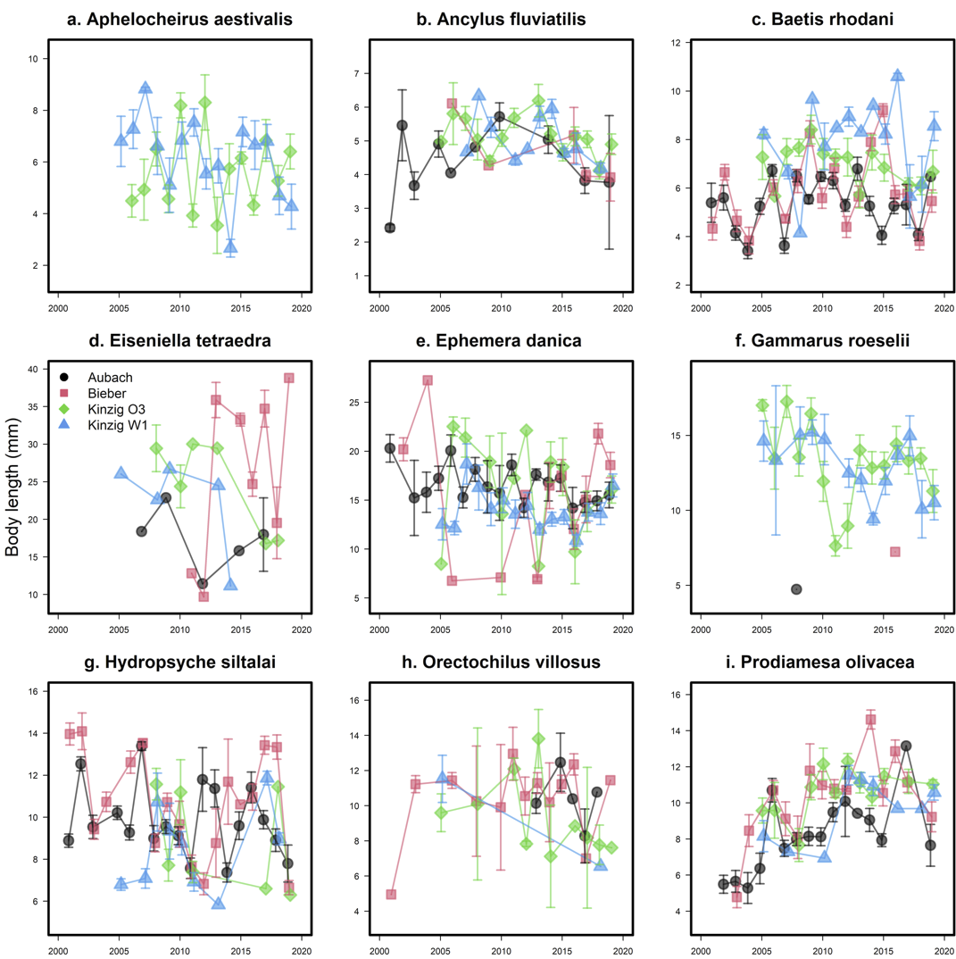

**Figure 2.** Changes in intraspecific body length over time and in the four study sites for nine freshwater aquatic macroinvertebrate species: *Aphelocheirus aestivalis* (a), *Ancylus fluviatilis* (b), *Baetis rhodani* (c), *Eiseniella tetraeda* (d), *Ephemera danica* (e), *Gammarus roeselii* (f), *Hydropsyche siltalai* (g), *Orectochilus villosus* (h), and *Prodiamesa olivacea* (i).

Changes in intraspecific body size over time for the nine species were not well explained by temperature over the previous 12 month period. The limpet *A. fluviatilis*, one of the species with no annual body size trends (Fig. S2, Tables S1, S2, & S3), was the only species to shift in body length with year-to-year temperature fluctuations across the four sites,increasing in body length, height, and width in warmer years (Fig. S3, S4 & S5, Tables S4, S5, & S6)

*Interspecific body size patterns*

Contrary to the mixed intraspecific body size shifts of time, interspecific body sizes tended to increase, with larger species increasing in abundance over time. The CWM of body size increased over time (year estimate.across all four sites = 0.06, SE = 0.01, *P* < 0.001; Fig 3a) and increased and then plateaued with water temperature, fitting a sigmoidal (temperature estimate across all four sites = , SE = , *P* < 0.001; Fig 3b). Using the 59 most common species that allowed sufficient quantification of temporal trends, we found that despite abundance trends being variable among species, larger species were more likely to increase their abundance over time (Year Est. = 0.04, SE = 0.01, *P* = 0.007; Fig. 3).

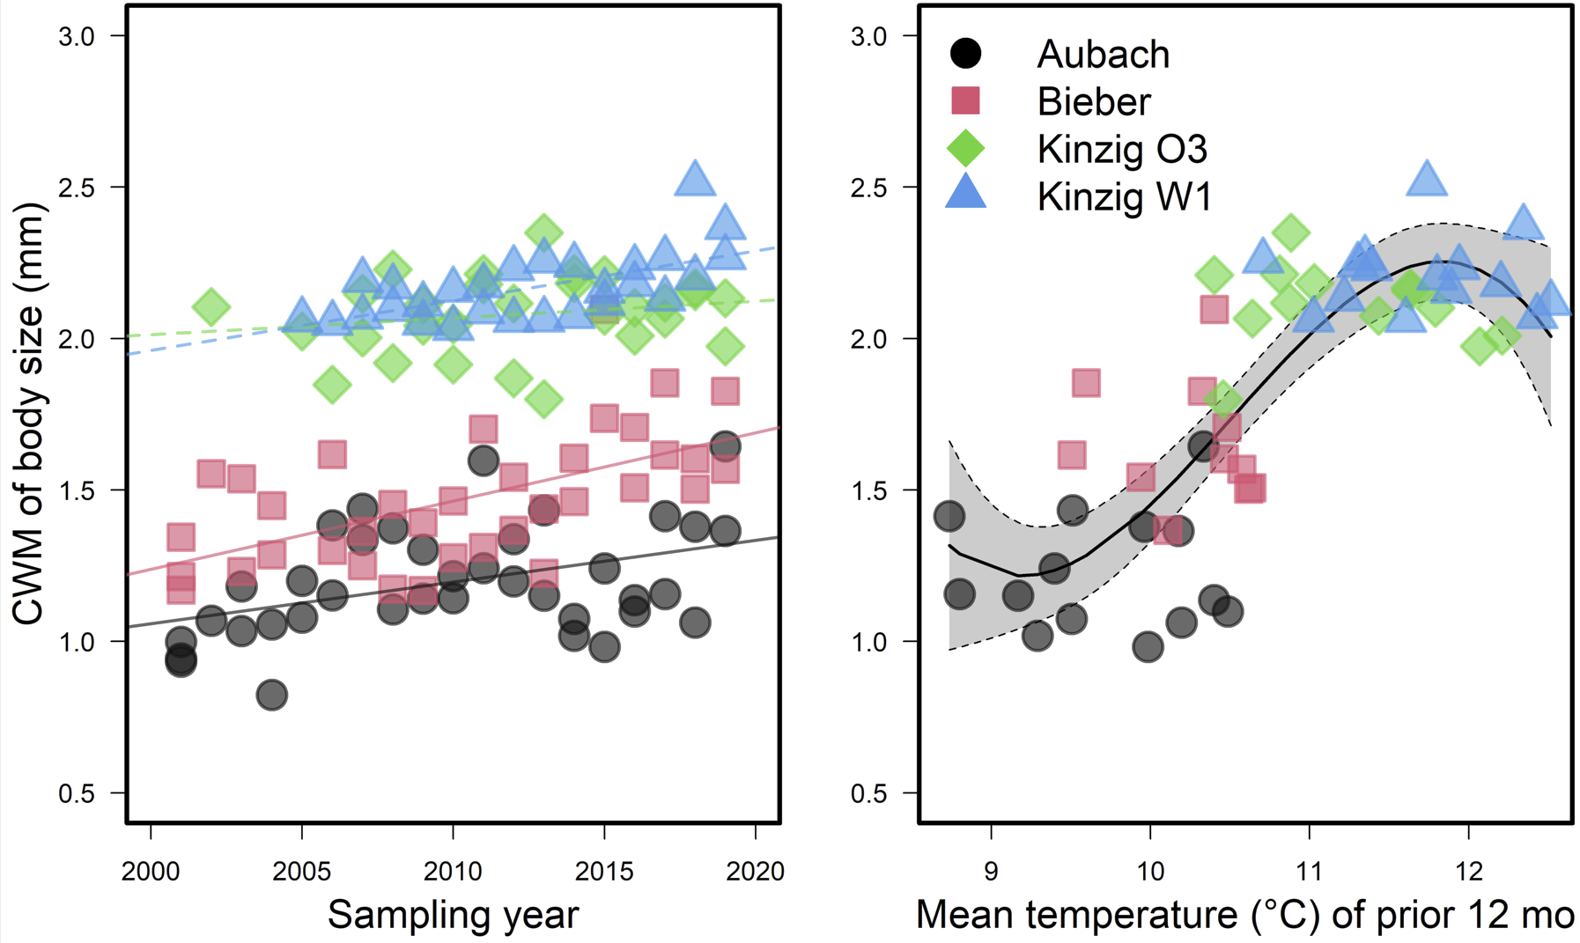

**Figure 3.** Change in the Community Weighted Mean (CWM) of interspecific body size over year (a) and water temperature (b). In panel a, dashed lines indicate non-significant (*P* > 0.05) changes over time while solid lines indicate a significant time effect.

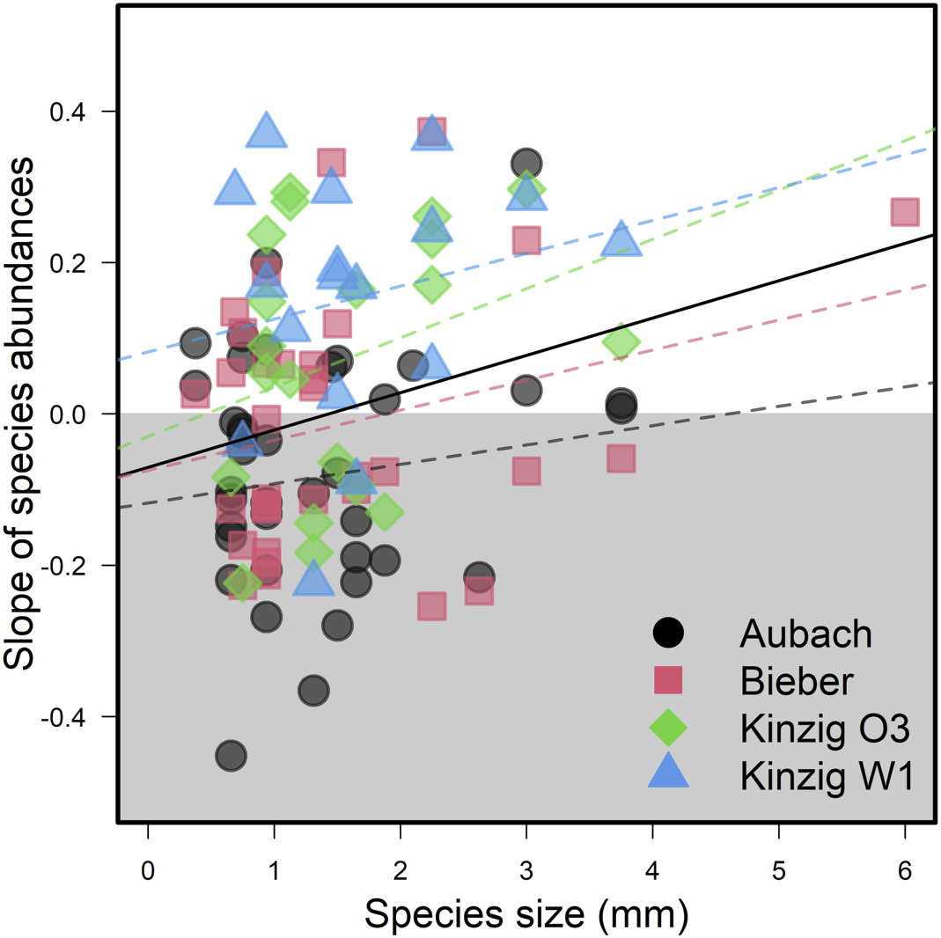

**Figure 4.** Change in species abundances over time, regressed over species interspecific body sizes. Each point represents the slope of one species within one site, using only species sampled for at least 12 years.

**Discussion**

Animal body size has ecological consequences across biological levels, from an individual’s risk of predation to a community’s use of resources (Horne *et al.*, 2017b). Intraspecifically, we found divergent trends for the nine freshwater macroinvertebrate species we measured across two decades. Species that do not have strictly univoltine life cycles had the greatest shifts in body size over time. Specifically, body size of the two Ephemeroptera species (one univoltine, bivoltine or multivoltine, and one mostly semivoltine, but in rare cases univoltine)and the gammarid (bivoltine or multivoltine) decreased, the midge (bivoltine) increased, the aquatic beetle (univoltine) increased in head size but not body size and four species did not exhibit changes (all univoltine) over time. This suggests changes in emergence time are more important in this system and studied time period than changes in temperature-induced decreases that we predicted. Interspecifically, we found both a shift in community composition towards larger species and that larger species were more likely to increase in their abundances. Increased average body size may reflect improvements in water quality in studied streams (Nguyen et al. 2024). Identifying how and why changes are occurring is critical given the multitude of ongoing pressures to freshwater communities.

*Interpretation. When interpreting the Results, try to be even-handed. Do not make conclusions that the data do not support or fail to address. Present alternative explanations if caveats are appropriate. Being self-critical takes this option away from a reviewer. Keep in mind that sample sizes and the size of the differences between your treatments may be small.*

*Intraspecific variation in body size*

*Paragraph 2: Figure 2 results: Nathan🙂*

Alongside changes to phenology and distribution, body size reductions have been suggested to be a third universal response of organisms to global environmental change (Gardner et al., 2011). Contrastingly, we did not find strong support for our first hypothesis that intraspecific body sizes would exhibit ubiquitous decreasing trends amongst the nine examined species. Instead, temporal changes in intraspecific body size were mixed, suggesting that phenological shifts more strongly drive variation in intraspecific body size (at least over the short-term) compared to temperature. However, in contrast to our second hypothesis, variation in intraspecific body size, be it increase or decrease, was always linked to organisms that exhibited voltinism plasticity (*B. rhodani, E. danica, G. roeselii, P. olivacea*) instead of organisms with “strict” univoltine life cycles (*A fluviatilus, A aestivalis, E. tetraedra, and H. siltalai*), which showed no general changes in body size over time, with the exception of *O. villosus*. We do not dispute the role temperature has in influencing the body sizes of ectotherms, however, phenological shifts have important consequences for the development stages of organisms at the time of sampling. Accordingly, our results highlight that the interplay between changes in thermal and phenological regimes cannot be easily disentangled. Broadly speaking, the responses we observed in our data can be broken down into three broad categories. First, we found no strong variations in body size for species classified as strictly univoltine, which may suggest that the that the that We do not dispute the role temperature has on ectothermic body size, however, if phenological shifts are not considered in sampling designs, the effects of temperature may be hidden by earlier growing seasons, specifically for univoltine species.

Phenological cues control growth rates, fecundity, and survival (REF XX) and with increasing latitudinal clines, the effects of phenology become stronger. For example, univoltine species are more associated with northerly latitudes as they are adapted to seasonal shifts in resources as well as hydrological, thermal, light regimes, thereby synchronizing their development with seasonal patterns, which control hormone secretion, molting, and egg production. Given that each of these physiological processes impact adult body size, changes to these processes have the potential to alter the fecundity, development, and voltinity of future generations. For instance, long-term circadian rhythms in the form of varying length of days (seasonal diel cycles) are essential for initiating or halting growth in the larval instars of invertebrates. While seasonal patterns are shifting (Linderholm 2006), seasonal diel length remains unchanged. The resulting desynchronization has the potential to impact the development and success of present and future generations. In this light, voltinism is particularly important and changes to the proportion of different voltine groups within a community are expected (Verheyen et al., 2018). At evolutionary scales, rules explaining thermal and latitudinal body size clines only present one side of the coin, with seasonal predictability and the adaptations of organisms to this predictability being the other.

This is in line with This corresponds to observations of ectotherm body sizes of insects (Martins et al., 2023) and fish (Audzionyte et al., YEAR).

*Interspecific variation in body size*

*Paragraph 3: Figure 3 results*

The Community Weighted Mean of interspecific body size (CWM) increased significantly over the research period at the two smaller, colder sites Aubach and Bieber. Meanwhile the trend was also increasing non-significantly at both Kinzig sites O3 and W1. Overall the CWM was bigger at the Kinzig sites, but the gap shrank considerably. Possibly the smaller starting CWM gave more room to quick change, while in the bigger river the community was already more tolerant to warmer temperatures. Also a bigger size could be beneficial against a stronger current. The temperature change correlates with the CWM in a sigmoid change, meaning after a rapid increase in size, it starts to plateau and even slightly decrease again with temperatures above 12°C. The increase in bigger species is contrary to the expectation that warmer temperatures lead to smaller body sizes.

The change in CWM could possibly be connected to a change in the hydrological properties, which would especially affect the smaller rivers Aubach and Bieber.

*Paragraph 4: Figure 4 results*

In addition, based on our preliminary analysis at the community level, the averaged size in the community increased over time. The overall increase in average body size is contrary to our initial hypothesis (i.e., a decrease in body size with increasing temperature following the Temperature Size Rule). This could result from two non-mutually exclusive mechanisms: i) large species could have become more abundant over time and, ii) small species could be experiencing population declines. Alternatively, the observed pattern could reflect shifts in phenology such that i) the peak occurrence of larger species has greater overlap with the sampling periods or ii) smaller species are shifting to have peak abundances outside of the sampling periods. Within common species, increases in abundance over time were positively predicted by body size, suggesting the occurrence of changes in either body size or phenology of both larger and smaller species. Moreover, we have not yet disentangled potential effects of sampling sites (and initial visual inspection suggests there may be non-linear patterns over time). Finally, we aim to investigate potential mechanisms related to life history traits to better understand the intraspecific variability in body size trends over time underlying trends at the community level.

*Paragraph 5: Water quality and temperature - confounding relationship*

*Broader perspective. Conclude the Discussion by addressing the broader implications of the research. This can include: questions that remain unanswered, suggestions of areas where further research is necessary, implications of the results for problems in other taxa or areas of theory, development of new hypotheses, or implications for management and conservation.*

*Conclusion*

Knowing an animal’s body size alone allows approximations of many additional key functional traits, including metabolic rate, habitat size, dispersal capacity, nutritional requirements, and life span (Woodward et al., 2005). However, how invertebrate body sizes vary over time is a poorly explored topic (Chown & Gaston, 2009; Wonglersak *et al.*, 2020). Intraspecifically, increases in environmental temperature can lead to faster developmental rates but smaller size at maturity of ectothermic species. Many insects have complex life cycles, varying in voltinism type, and it can be difficult to separate the effect of temperature from other factors (Horne *et al*., 2017; Brehm *et al*., 2018; Daufresne *et al*., 2009). We found mixed temporal trends in body size of nine freshwater macroinvertebrate taxa collected over 19 years of sampling suggesting ….

**Acknowledgements**

Natalie and Beatrice; European Long-Term Ecological Research Transnational Access grant: BOSCH: BOdy Size CHanges over time; eLTER funding

**References**

Baselga, A. (2010) Partitioning the turnover and nestedness components of beta diversity. *Global Ecology and Biogeography*, 19, 134–143.

Bergmann, C. (1848) *Über die Verhältnisse der Wärmeökonomie der Thiere zu ihrer Größe*,.

Brehm, G., Zeuss, D. & Colwell, R.K. (2019) Moth body size increases with elevation along a complete tropical elevational gradient for two hyperdiverse clades. *Ecography*, 42, 632–642.

Brown, J.H., Gillooly, J.F., Allen, A.P., Savage, V.M. & West, G.B. (2004) Toward a metabolic theory of ecology. *Ecology*, 85, 1771–1789.

Crisp, M. & Cook, L. (2012) Phylogenetic niche conservatism: What are the underlying evolutionary and ecological causes? *The New phytologist*, 196, 681–94.

Daufresne, M., Lengfellner, K. & Sommer, U. (2009) Global warming benefits the small in aquatic ecosystems. *Proceedings of the National Academy of Sciences*, 106, 12788–12793.

de Roos, A.M. & Persson, L. (2002) Size-dependent life-history traits promote catastrophic collapses of top predators. *Proceedings of the National Academy of Sciences of the United States of America*, 99, 12907–12912.

Dornelas, M., Antão, L.H., Moyes, F., Bates, A.E., Magurran, A.E., Adam, D., Akhmetzhanova, A.A., Appeltans, W., Arcos, J.M., Arnold, H., Ayyappan, N., Badihi, G., Baird, A.H., Barbosa, M., Barreto, T.E., Bässler, C., Bellgrove, A., Belmaker, J., Benedetti-Cecchi, L., Bett, B.J., Bjorkman, A.D., Błażewicz, M., Blowes, S.A., Bloch, C.P., Bonebrake, T.C., Boyd, S., Bradford, M., Brooks, A.J., Brown, J.H., Bruelheide, H., Budy, P., Carvalho, F., Castañeda-Moya, E., Chen, C.A., Chamblee, J.F., Chase, T.J., Collier, L.S., Collinge, S.K., Condit, R., Cooper, E.J., Cornelissen, J.H.C., Cotano, U., Crow, S.K., Damasceno, G., Davies, C.H., Davis, R.A., Day, F.P., Degraer, S., Doherty, T.S., Dunn, T.E., Durigan, G., Duffy, J.E., Edelist, D., Edgar, G.J., Elahi, R., Elmendorf, S.C., Enemar, A., Ernest, S.K.M., Escribano, R., Estiarte, M., Evans, B.S., Fan, T.-Y., Farah, F.T., Fernandes, L.L., Farneda, F.Z., Fidelis, A., Fitt, R., Fosaa, A.M., Franco, G.A.D.C., Frank, G.E., Fraser, W.R., García, H., Gatti, R.C., Givan, O., Gorgone-Barbosa, E., Gould, W.A., Gries, C., Grossman, G.D., Gutierréz, J.R., Hale, S., Harmon, M.E., Harte, J., Haskins, G., Henshaw, D.L., Hermanutz, L., Hidalgo, P., Higuchi, P., Hoey, A., Hoey, G.V., Hofgaard, A., Holeck, K., Hollister, R.D., Holmes, R., Hoogenboom, M., Hsieh, C., Hubbell, S.P., Huettmann, F., Huffard, C.L., Hurlbert, A.H., Ivanauskas, N.M., Janík, D., Jandt, U., Jażdżewska, A., Johannessen, T., Johnstone, J., Jones, J., Jones, F.A.M., Kang, J., Kartawijaya, T., Keeley, E.C., Kelt, D.A., Kinnear, R., Klanderud, K., Knutsen, H., Koenig, C.C., Kortz, A.R., Král, K., Kuhnz, L.A., Kuo, C.-Y., Kushner, D.J., Laguionie-Marchais, C., Lancaster, L.T., Lee, C.M., Lefcheck, J.S., Lévesque, E., Lightfoot, D., Lloret, F., Lloyd, J.D., López-Baucells, A., Louzao, M., Madin, J.S., Magnússon, B., Malamud, S., Matthews, I., McFarland, K.P., McGill, B., McKnight, D., McLarney, W.O., Meador, J., Meserve, P.L., Metcalfe, D.J., Meyer, C.F.J., Michelsen, A., Milchakova, N., Moens, T., Moland, E., Moore, J., Moreira, C.M., Müller, J., Murphy, G., Myers-Smith, I.H., Myster, R.W., Naumov, A., Neat, F., Nelson, J.A., Nelson, M.P., Newton, S.F., Norden, N., Oliver, J.C., Olsen, E.M., Onipchenko, V.G., Pabis, K., Pabst, R.J., Paquette, A., Pardede, S., Paterson, D.M., Pélissier, R., Peñuelas, J., Pérez-Matus, A., Pizarro, O., Pomati, F., Post, E., Prins, H.H.T., Priscu, J.C., Provoost, P., Prudic, K.L., Pulliainen, E., Ramesh, B.R., Ramos, O.M., Rassweiler, A., Rebelo, J.E., Reed, D.C., Reich, P.B., Remillard, S.M., Richardson, A.J., Richardson, J.P., Rijn, I. van, Rocha, R., Rivera-Monroy, V.H., Rixen, C., Robinson, K.P., Rodrigues, R.R., Rossa-Feres, D. de C., Rudstam, L., Ruhl, H., Ruz, C.S., Sampaio, E.M., Rybicki, N., Rypel, A., Sal, S., Salgado, B., Santos, F.A.M., Savassi-Coutinho, A.P., Scanga, S., Schmidt, J., Schooley, R., Setiawan, F., Shao, K.-T., Shaver, G.R., Sherman, S., Sherry, T.W., Siciński, J., Sievers, C., Silva, A.C. da, Silva, F.R. da, Silveira, F.L., Slingsby, J., Smart, T., Snell, S.J., Soudzilovskaia, N.A., Souza, G.B.G., Souza, F.M., Souza, V.C., Stallings, C.D., Stanforth, R., Stanley, E.H., Sterza, J.M., Stevens, M., Stuart-Smith, R., Suarez, Y.R., Supp, S., Tamashiro, J.Y., Tarigan, S., Thiede, G.P., Thorn, S., Tolvanen, A., Toniato, M.T.Z., Totland, Ø., Twilley, R.R., Vaitkus, G., Valdivia, N., Vallejo, M.I., Valone, T.J., Colen, C.V., Vanaverbeke, J., Venturoli, F., Verheye, H.M., Vianna, M., Vieira, R.P., Vrška, T., Vu, C.Q., Vu, L.V., Waide, R.B., Waldock, C., Watts, D., Webb, S., Wesołowski, T., White, E.P., Widdicombe, C.E., Wilgers, D., Williams, R., Williams, S.B., Williamson, M., Willig, M.R., Willis, T.J., Wipf, S., Woods, K.D., Woehler, E.J., Zawada, K. & Zettler, M.L. (2018) BioTIME: A database of biodiversity time series for the Anthropocene. *Global Ecology and Biogeography*, 27, 760–786.

Faurby, S. & Araújo, M.B. (2017) Anthropogenic impacts weaken Bergmann’s rule. *Ecography*, 40, 683–684.

Geist, V. (1987) Bergmann’s rule is invalid. *Canadian Journal of Zoology*, 65, 1035–1038.

Gelman, A. & Hill, J. (2006) *Data analysis using regression and multilevel/hierarchical models*, Cambridge University Press.

Gotelli, N.J. & Graves, G.R. (1996) *Null models in ecology*,.

Harper, E.M. & Peck, L.S. (2016) Latitudinal and depth gradients in marine predation pressure. *Global Ecology and Biogeography*, 25, 670–678.

Horne, C.R., Hirst, A.G. & Atkinson, D. (2017) Seasonal body size reductions with warming covary with major body size gradients in arthropod species. *Proceedings of the Royal Society B: Biological Sciences*, 284, 20170238.

Karger, D.N., Conrad, O., Böhner, J., Kawohl, T., Kreft, H., Soria-Auza, R.W., Zimmermann, N.E., Linder, H.P. & Kessler, M. (2017) Climatologies at high resolution for the earth’s land surface areas. *Scientific Data*, 4, 170122.

Lehner, B., Verdin, K.L. & Jarvis, A. (2008) New global hydrography derived from spaceborne elevation data. *Eos, Transactions, American Geophysical Union*, 89, 2.

Linderholm, H.W. (2006) Growing season changes in the last century. *Agricultural and Forest Meteorology*, 137, 1–14.

Luedeling, E., Caspersen, L. & Fernandez, E. (2023) chillR: Statistical Methods for Phenology Analysis in Temperate Fruit Trees (R Package).

McElreath, R. (2018) *Statistical rethinking: A Bayesian course with examples in R and Stan*, Chapman and Hall/CRC.

Meiri, S. & Dayan, T. (2003) On the validity of Bergmann’s rule. *Journal of Biogeography*, 30, 331–351.

Pinsky, M.L., Eikeset, A.M., McCauley, D.J., Payne, J.L. & Sunday, J.M. (2019) Greater vulnerability to warming of marine versus terrestrial ectotherms. *Nature*, 569, 108–111.

Santini, L. & Isaac, N.J.B. (2021) Rapid Anthropocene realignment of allometric scaling rules. *Ecology Letters*, In Press.

Sarremejane, R., Cid, N., Stubbington, R., Datry, T., Alp, M., Cañedo-Argüelles, M., Cordero-Rivera, A., Csabai, Z., Gutiérrez-Cánovas, C., Heino, J., Forcellini, M., Millán, A., Paillex, A., Pařil, P., Polášek, M., Tierno de Figueroa, J.M., Usseglio-Polatera, P., Zamora-Muñoz, C. & Bonada, N. (2020) DISPERSE, a trait database to assess the dispersal potential of European aquatic macroinvertebrates. *Scientific Data*, 7, 386.

Scheffer, M. and Carpenter, S.R. (2003) Catastophic regime shifts in ecosystems: linking theory to observation. *Trends in Ecology & Evolution*, 18, 648–656

Schmidt-Kloiber, A. & Hering, D. (2015) www.freshwaterecology.info – An online tool that unifies, standardises and codifies more than 20,000 European freshwater organisms and their ecological preferences. *Ecological Indicators*, 53, 271–282.

Shelomi, M. (2012) Where are we now? Bergmann’s rule sensu lato in insects. *The American Naturalist*, 180, 511–519.

Soininen, J., Heino, J. & Wang, J. (2018) A meta-analysis of nestedness and turnover components of beta diversity across organisms and ecosystems. *Global Ecology and Biogeography*, 27, 96–109.

Sunday, J., Bennett, J.M., Calosi, P., Clusella-Trullas, S., Gravel, S., Hargreaves, A.L., Leiva, F.P., Verberk, W.C.E.P., Olalla-Tárraga, M.Á. & Morales-Castilla, I. (2019) Thermal tolerance patterns across latitude and elevation. *Philosophical Transactions of the Royal Society B: Biological Sciences*, 374, 20190036.

Verheyen, J., Temmerman, K., De Block, M. & Stoks, R. (2018) Voltinism-associated differences in winter survival across latitudes: integrating growth, physiology, and food intake. *Oecologia*, 186, 919–929.

Woodward, G., Ebenmann, B., Emmerson, M., Montoya, J.M., Olesen, J.M., Valido, A. & Warren, P.H. (2005). Body size in ecological networks. *Trends in Ecology & Evolution*, 20, 402–409.

**Supplemental Information**

**Supplemental Tables**

**Supplemental Figures**

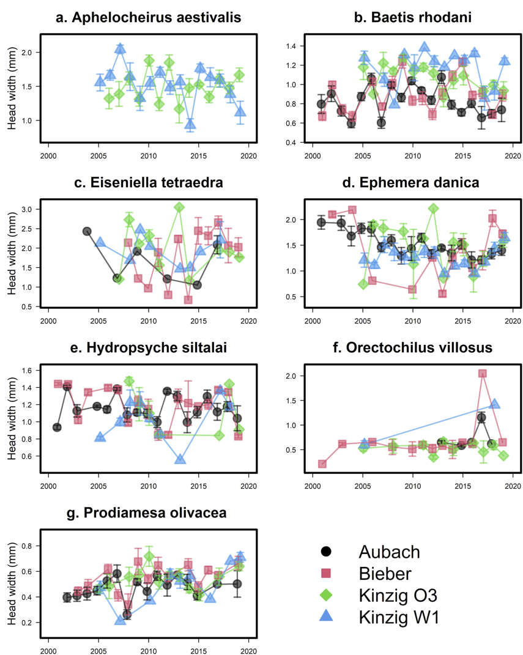

**Figure S1.** Changes in intraspecific head width over time and in the four study sites for nine freshwater aquatic macroinvertebrate species: *Aphelocheirus aestivalis* (a), *Baetis rhodani* (b), *Eiseniella tetraeda* (c), *Ephemera danica* (d), *Hydropsyche siltalai* (e), *Orectochilus villosus* (f), and *Prodiamesa olivacea* (g).

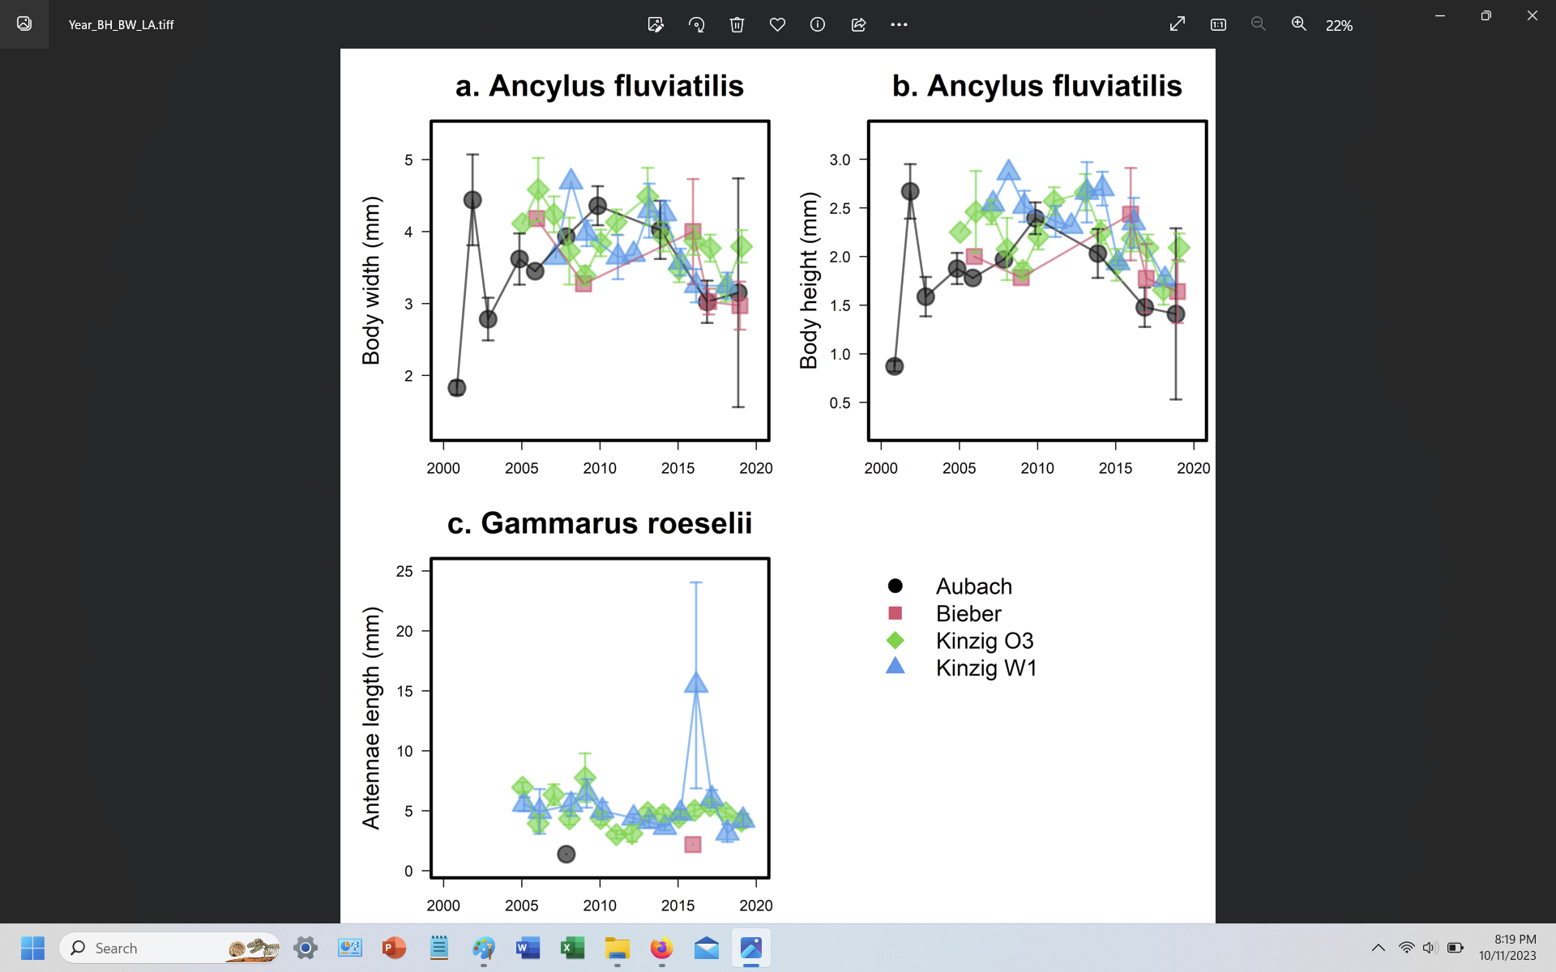

**Figure S2.** Changes in intraspecific body width (a) and body height (b) of *Aphelocheirus aestivalis* and antennae length of *Gammarus roeselii* (c) over time and in the four study sites.

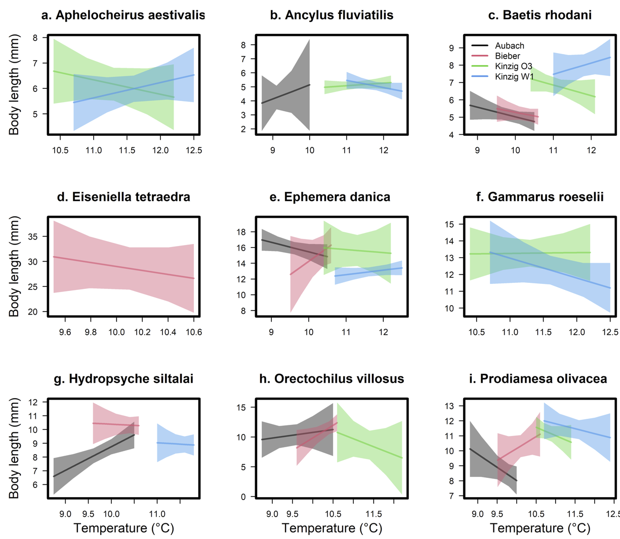

**Figure S3.** Changes in intraspecific body length with water temperature in the four study sites for nine freshwater aquatic macroinvertebrate species: *Aphelocheirus aestivalis* (a), *Ancylus fluviatilis* (b), *Baetis rhodani* (c), *Eiseniella tetraeda* (d), *Ephemera danica* (e), *Gammarus roeselii* (f), *Hydropsyche siltalai* (g), *Orectochilus villosus* (h), and *Prodiamesa olivacea* (i).

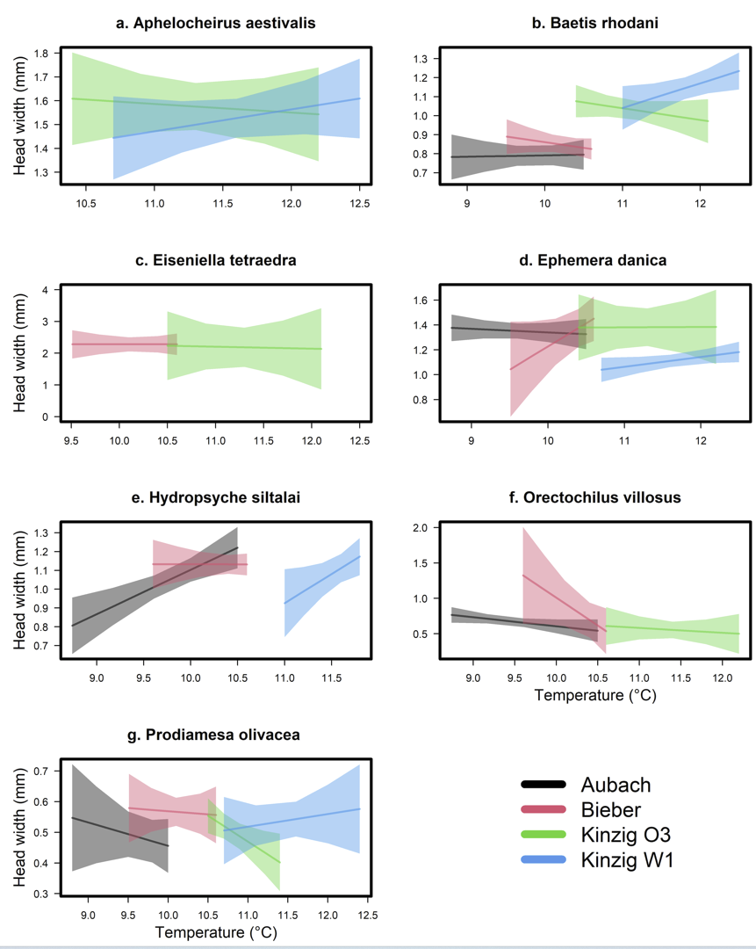

**Figure S4.** Changes in intraspecific head width with water temperature in the four study sites for nine freshwater aquatic macroinvertebrate species: *Aphelocheirus aestivalis* (a), *Baetis rhodani* (b), *Eiseniella tetraeda* (c), *Ephemera danica* (d), *Hydropsyche siltalai* (e), *Orectochilus villosus* (f), and *Prodiamesa olivacea* (g).

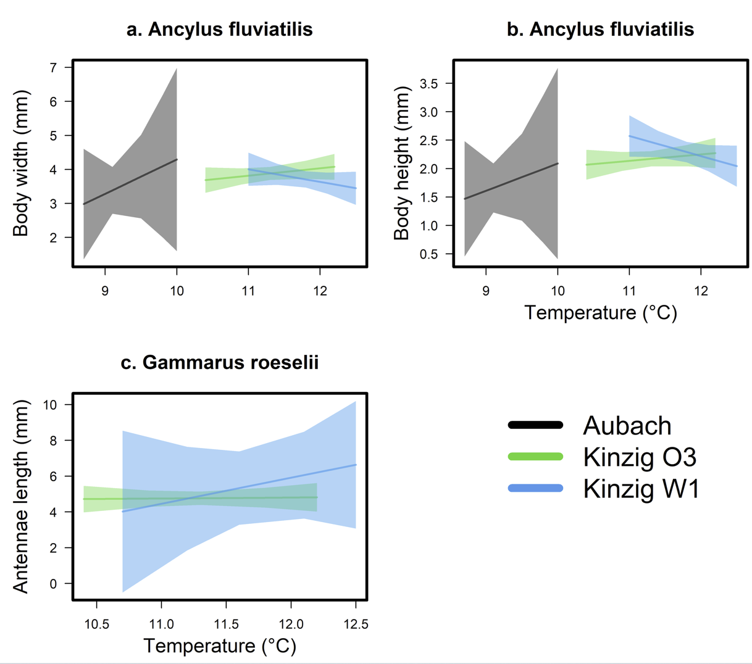

**Figure S5.** Changes in intraspecific body width (a) and body height (b) of *Aphelocheirus aestivalis* and antennae length of *Gammarus roeselii* (c) with water temperature in the four study sites.