To download and install R:
(1) Go to: www.r-project.org
(2) Click “CRAN” in the left panel of the screen:
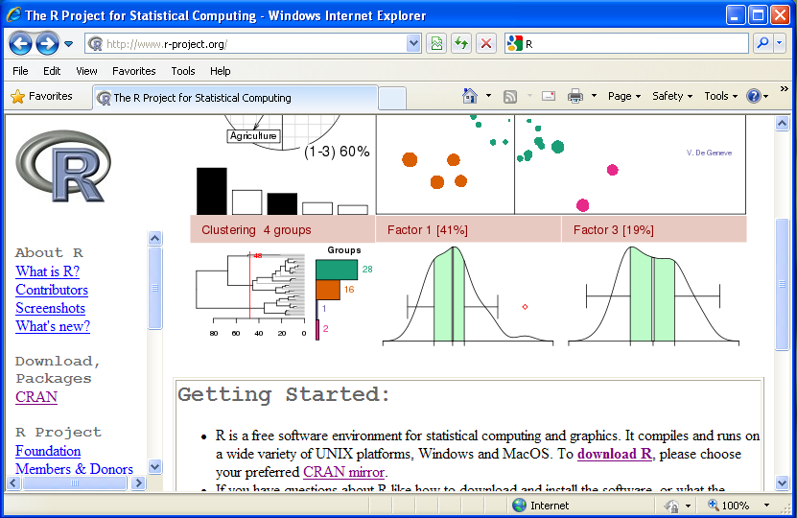

(3) Select your nearest site from the list of CRAN Mirrors, e.g., any of the three links in Brazil:
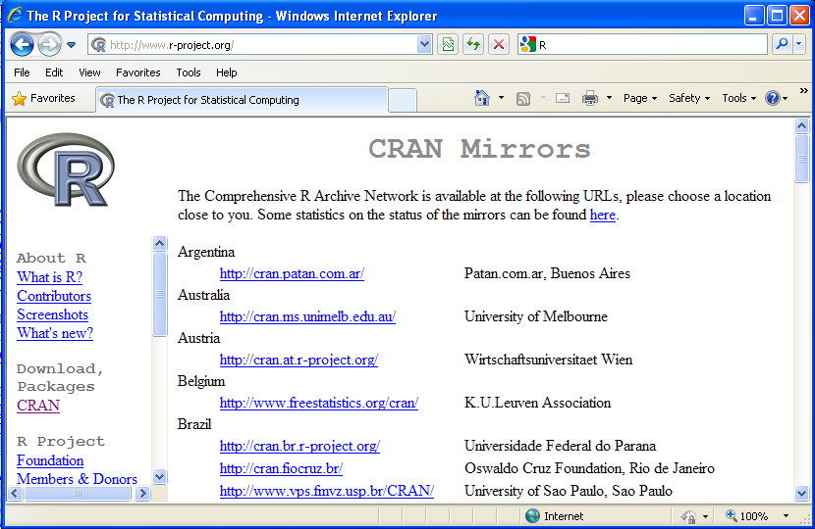

(4) Select the target operating system, e.g., Windows, from the main panel:
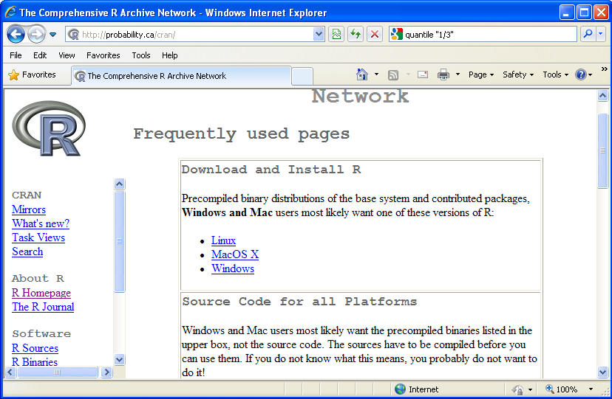

(5) Select the module “base”:
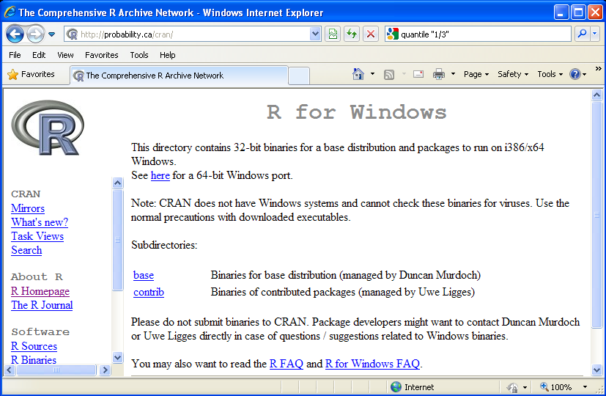

(6) Click on “Download R 2.10.1 for Windows” (the version number may change due to the R group development)
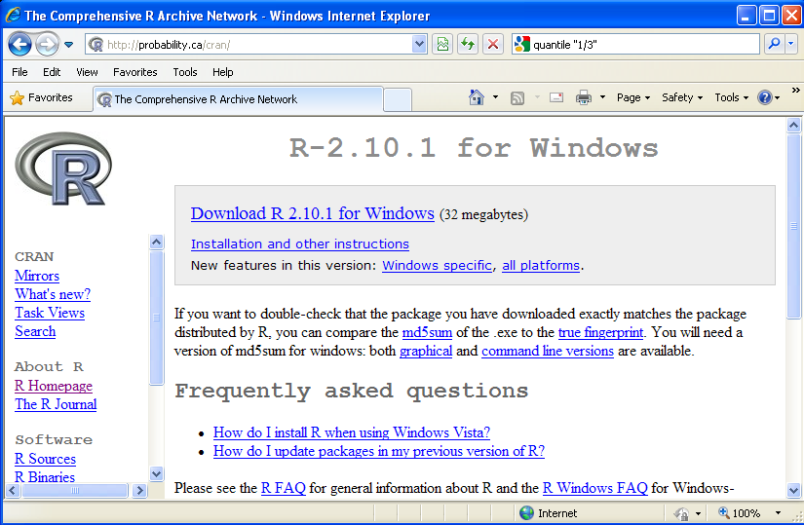

(6) Choose “Run” to run the setup to install R directly without saving the .exe setup file, or “Save” to save the .exe file to your machine and run it later.
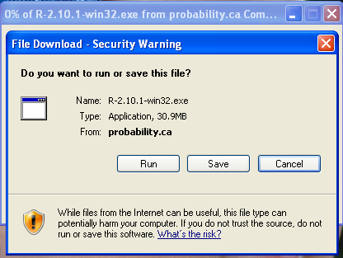

If you choose “Run”, it will download the .exe file to your Windows temporary folder and then run it. The following windows will pop up subsequently:
- Choose the language, then click “Next”.
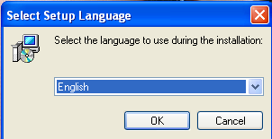
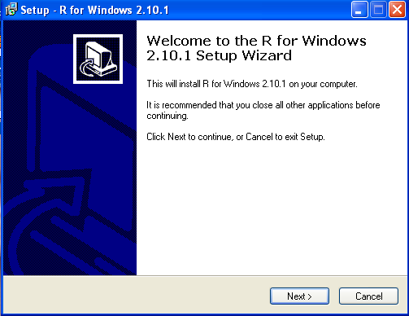

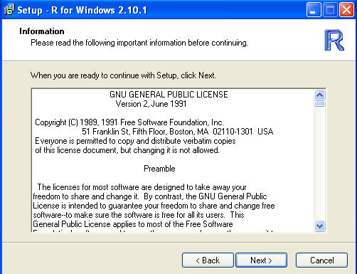

By default, R will be installed under: “C:\Program Files\R\R-…”:
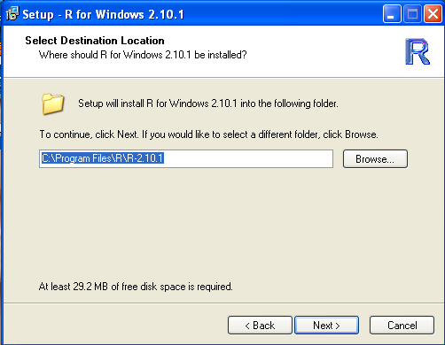

It will show “Select Components” with “default options”. If you have no specific requirements, just click “Next”:
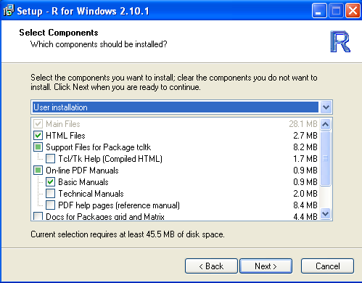

- Then, choose “No” to accept the default settings, and just keep clicking on “Next” in the following windows, until “Finish”.

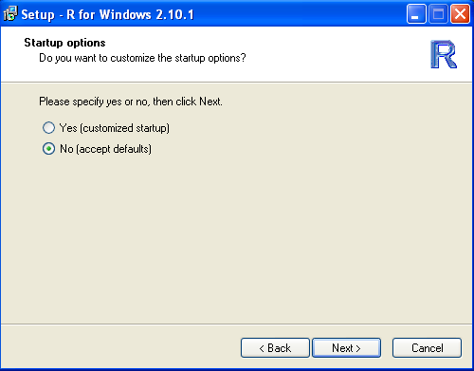

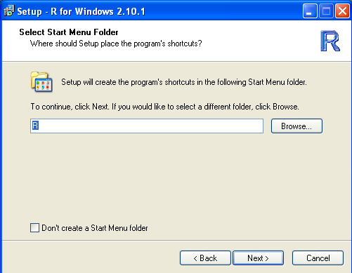

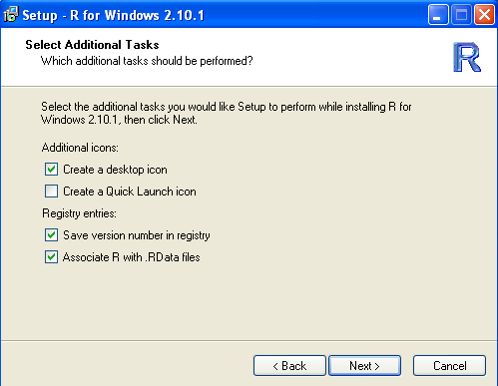

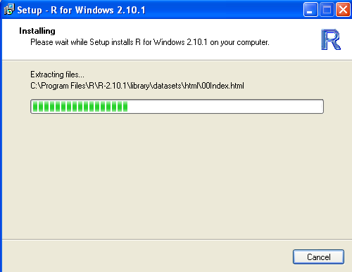

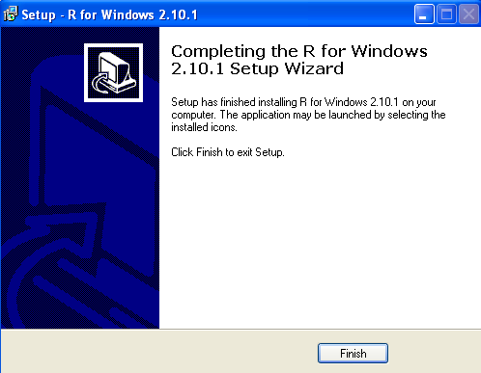

To work in R:

When the installation is finished, you can run R by double-click the shortcut icon on your desktop:
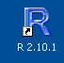
or by choosing to run R in your “All Programs”.

Then, you can either use the drop-down menu or type-in command lines. Most items in the drop-down menu can be translated to command lines of function names along with parameters.

To run RHtests functions:

(1) Save the RHtests codes in a directory, e.g., “D:\RHtests\”, and make a subdirectory, say “data”, in this directory.

(2) Change the working directory to your “data” directory:
In drop-down menu, click “File” and choose “Change dir…” to go to your data directory (your desired working directory), e.g., “D:\RHtests\data”.
Or type in command line at the R prompt (>):
setwd(“D:\\RHtests\\data”)

(3) Source the RHtests codes:
In drop-down menu, click “File” and choose “Source R code” to choose the R codes to be used, e.g., “D:\RHtests\RHtestsV3.r”

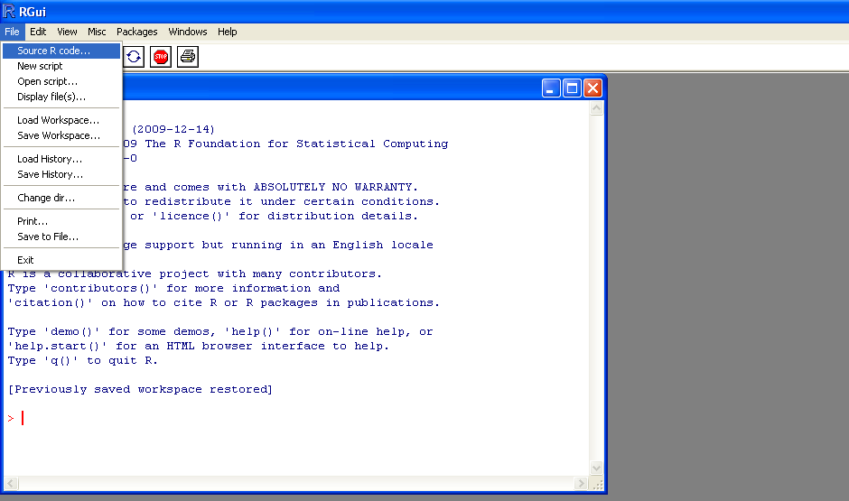

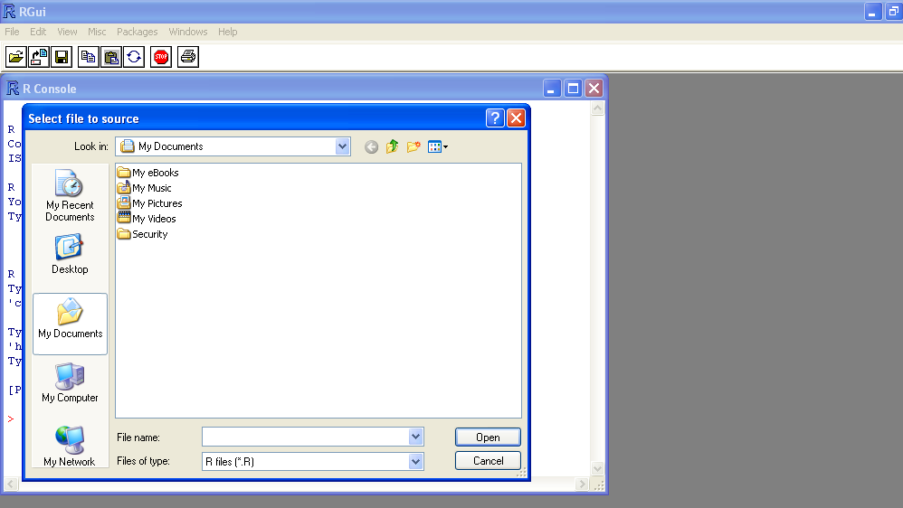

Or, type in following line at the R prompt (>):
source(“D:\\RHtests\\RHtestsV3.r”)

(4) Type-in “StartGUI()” to use the RHtestsV3 functions in the GUI mode, or type-in a command line to run a function (see RHtestsV3 User Manual).

After above steps, user can follow steps outlined in the RHtests User Manual: http://cccma.seos.uvic.ca/ETCCDI/RHtest/RHtestsV3_UserManual.doc

