This test was done to see what would happen if we were to swap the PreSens Fibox 4 optic cable from one flow through housing with luminophore to another. Each housing in contact with different oxygen levels.

For clarity, this is the PreSens Fibox 4 including optic cable:

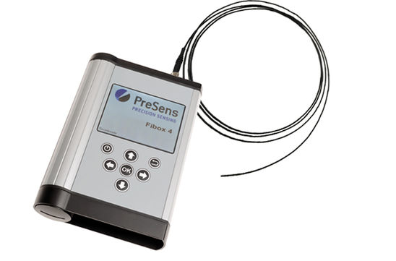

This is the housing:

