Verwijder dit na verslag af is
PART I: Finding a Fixed Food Dot

- Run the DFS, BFS, UCS and A* algorithms on the CornersProblem with the mediumMaze, bigMaze, and openMaze layouts. Present the total cost of the path, the number of nodes expanded, as well as a screenshot of the game for all combinations in a table.

PART II: Finding All the Corners

- Discuss your heuristic for the corners problem. Explain why it is admissible and consistent.
- Run the UCS and A* algorithms on the CornersProblem with the bigCorners layout. Present the total cost of the path, the number of nodes expanded, and the elapsed time for both combinations in a table.

Extra: Eating All The Dots (Optional)

- Discuss your heuristic for the food search problem. Explain why it is admissible and consistent.
- Run the AStarFoodSearchAgent and the ClosestDotSearchAgent on the FoodSearchProblem with the trickySearch, mediumSearch and bigSearch layouts. Present the total cost of the path, the number of nodes expanded, and the elapsed time for all combinations in a table.

Finding a fixed food dot

DFS
Maze type | Path cost | Expanded nodes | Screenshot
Medium | 130 | 146 | 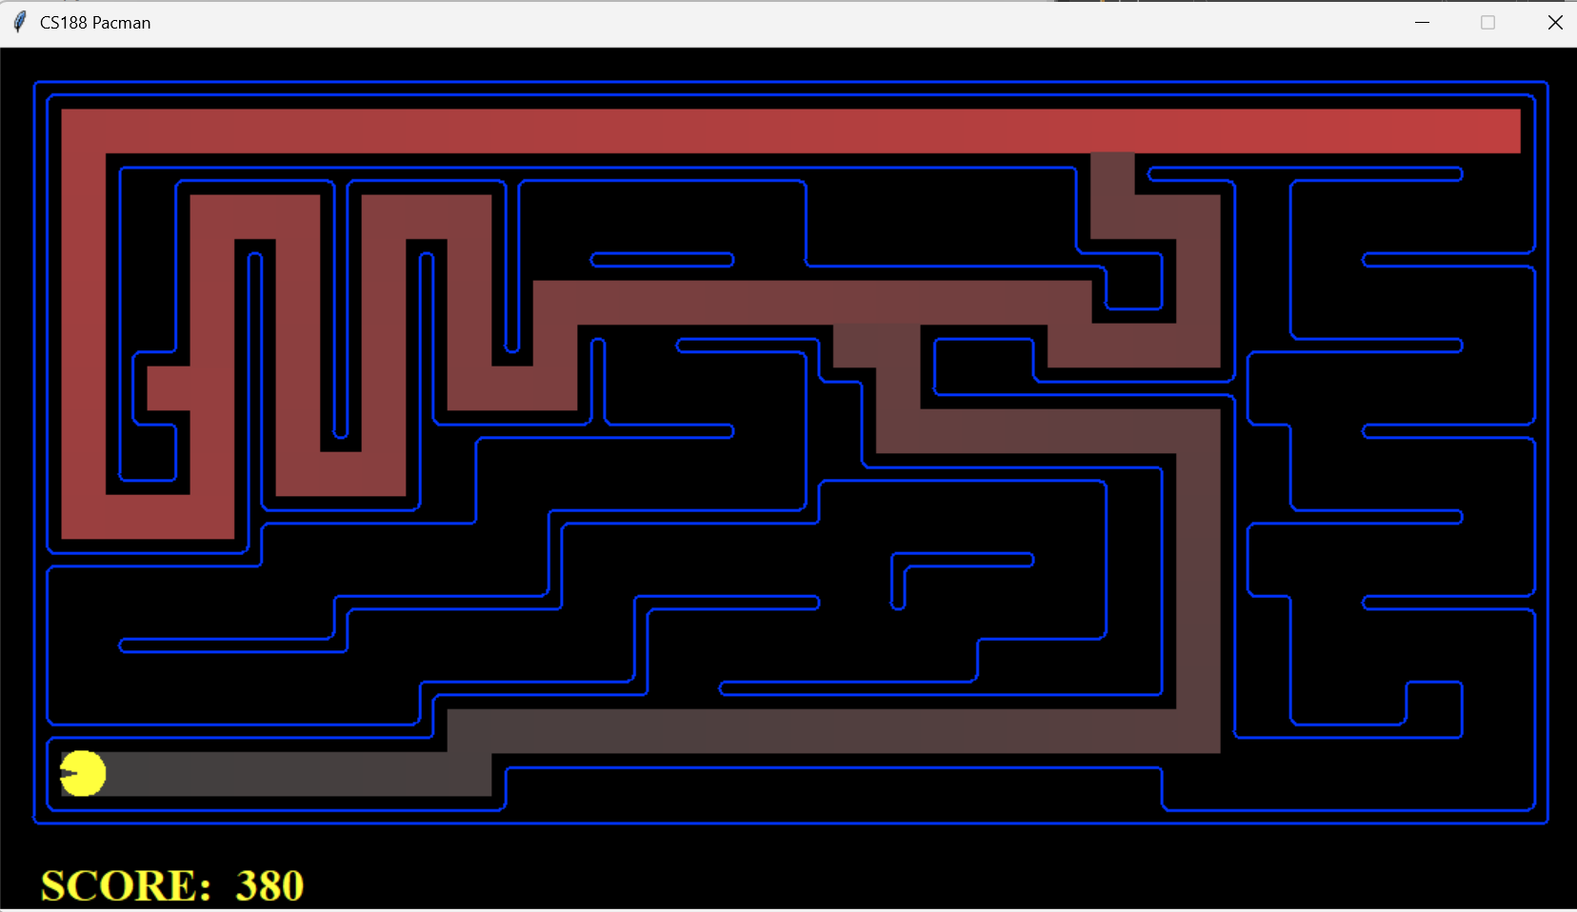
Big | 210 | 390 | 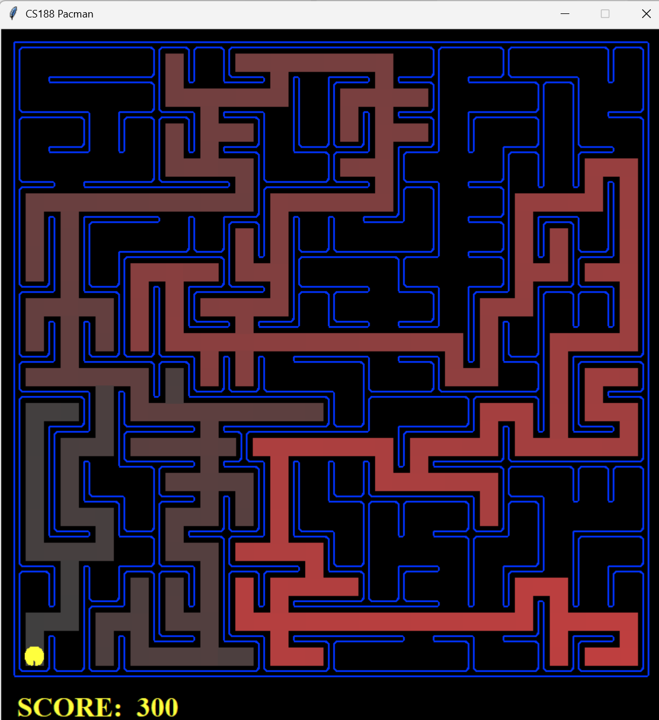
Open | 298 | 806 | 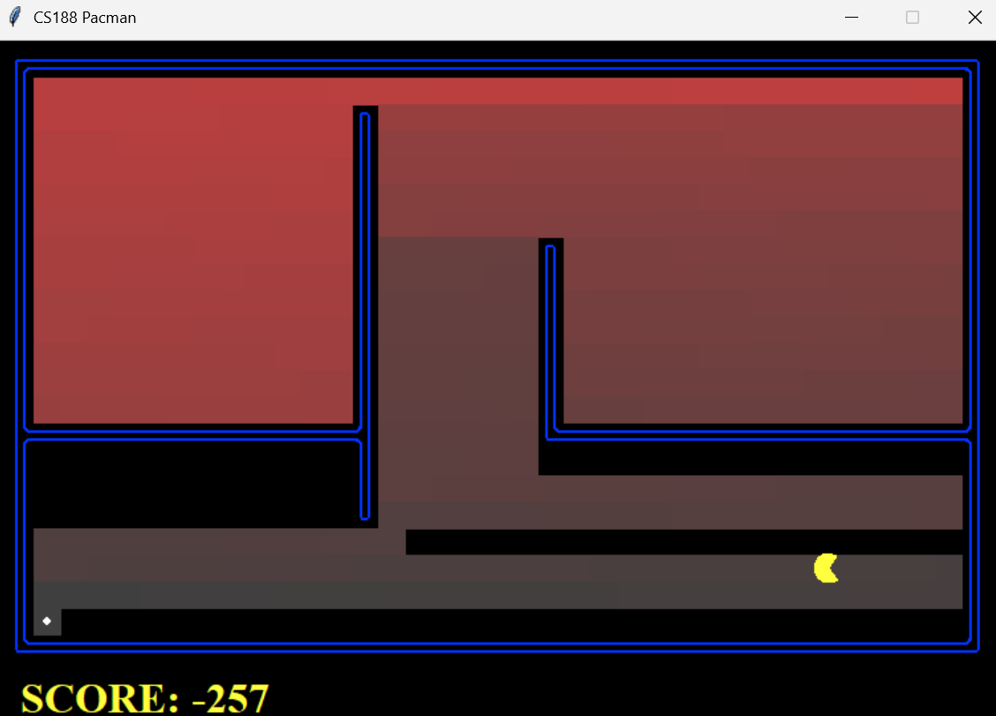

BFS
Maze type | Path cost | Expanded nodes | Screenshot
Medium | 68 | 275 | 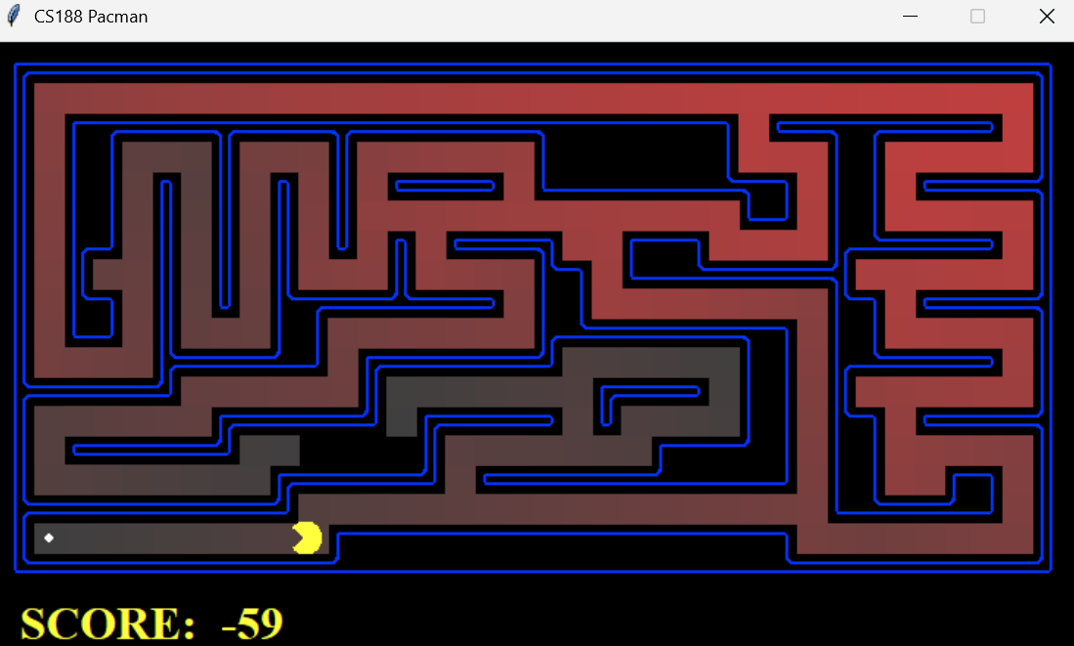
Big | 210 | 620 | 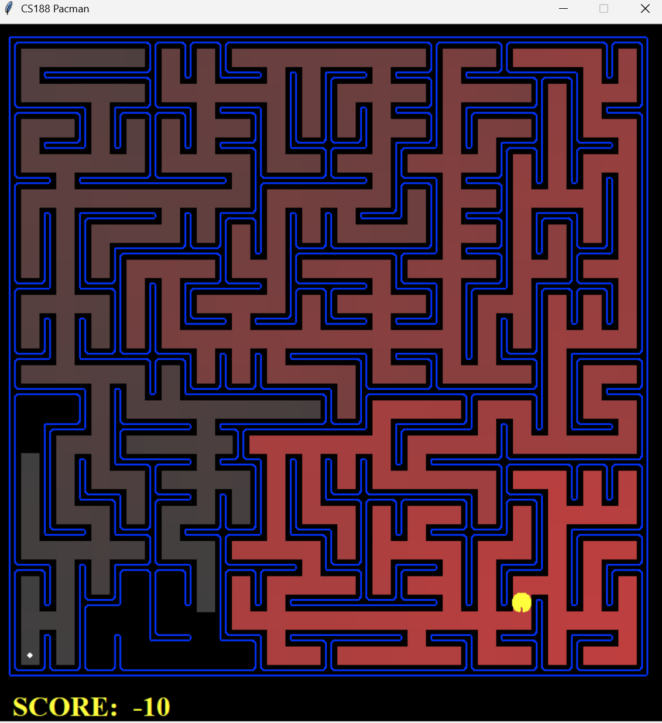
Open | 54 | 682 | 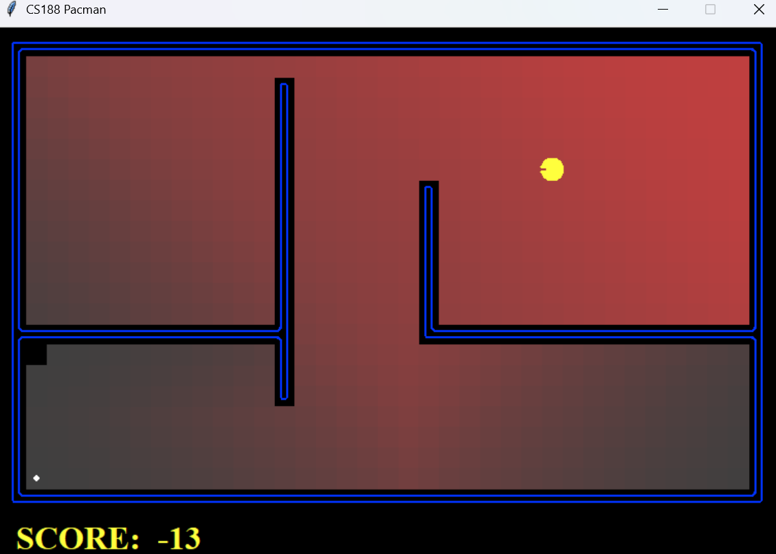

UCS
Maze type | Path cost | Expanded nodes | Screenshot
Medium | 68 | 269 | 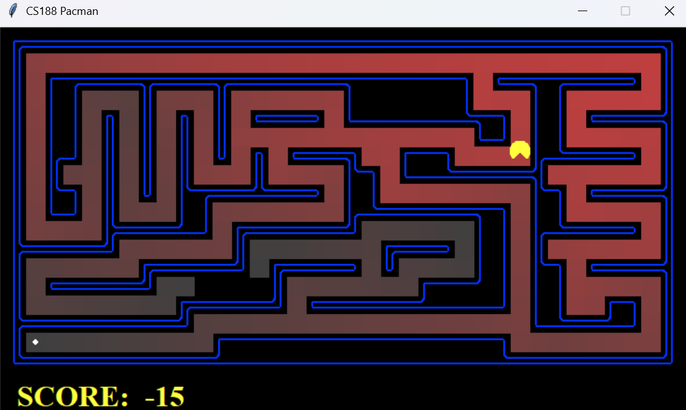
Big | 210 | 620 | 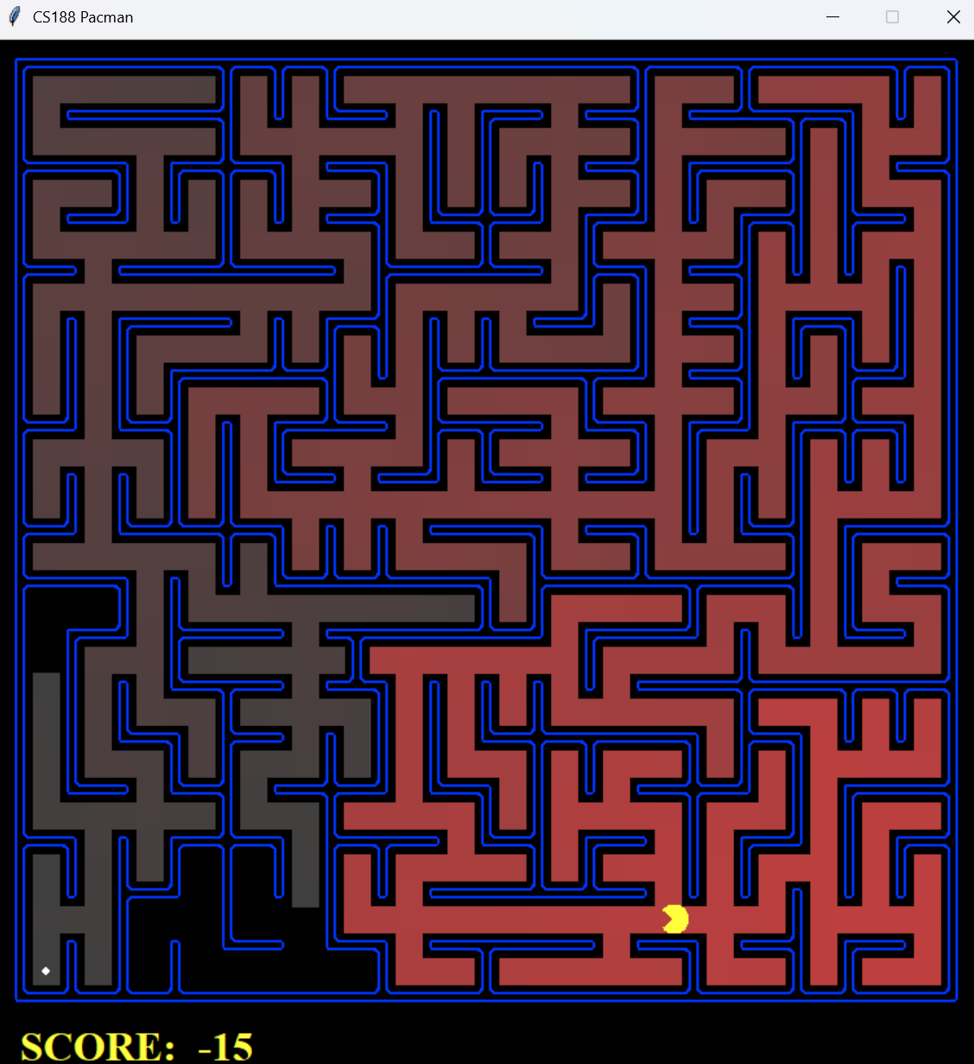
Open | 54 | 682 | 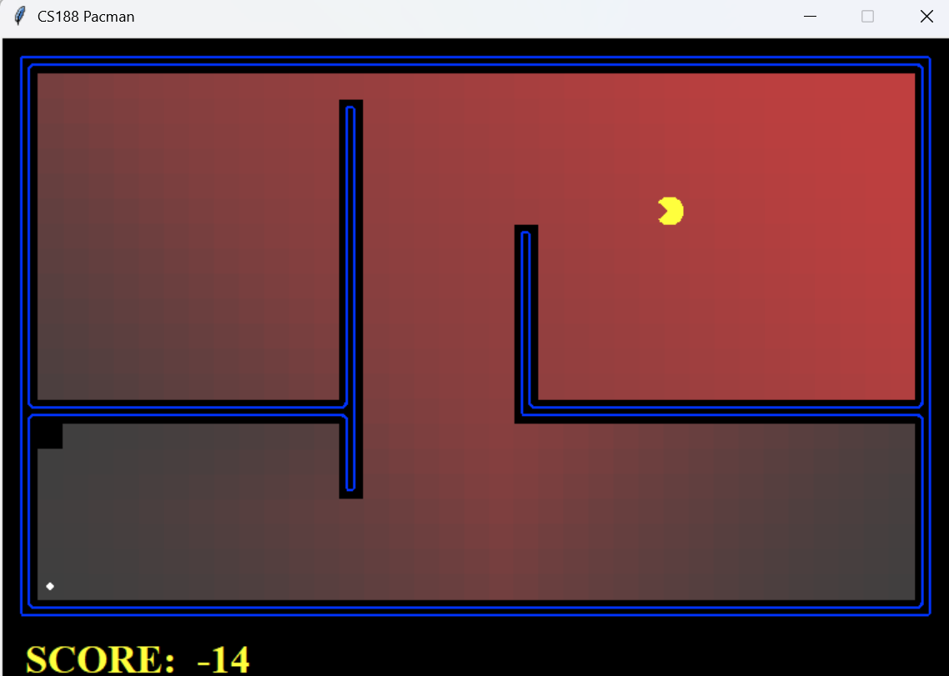

ASTAR
Maze type | Path cost | Expanded nodes | Screenshot
Medium | 68 | 221 | 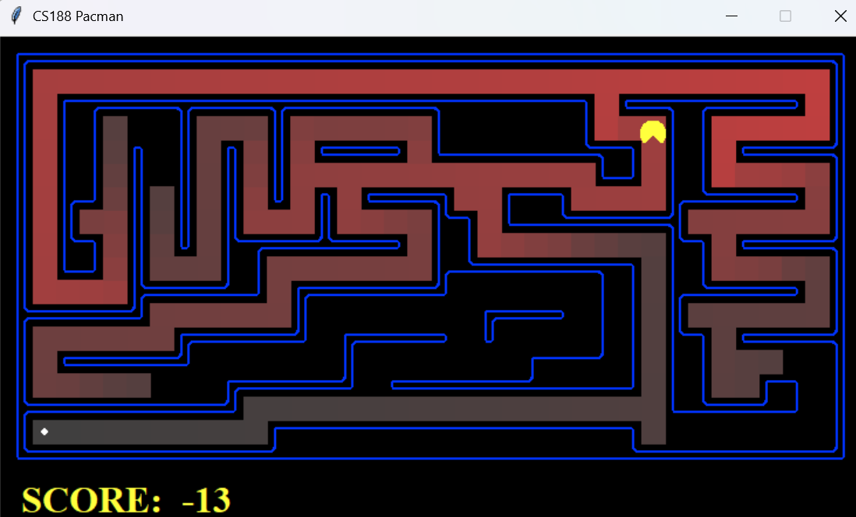
Big | 210 | 549 | 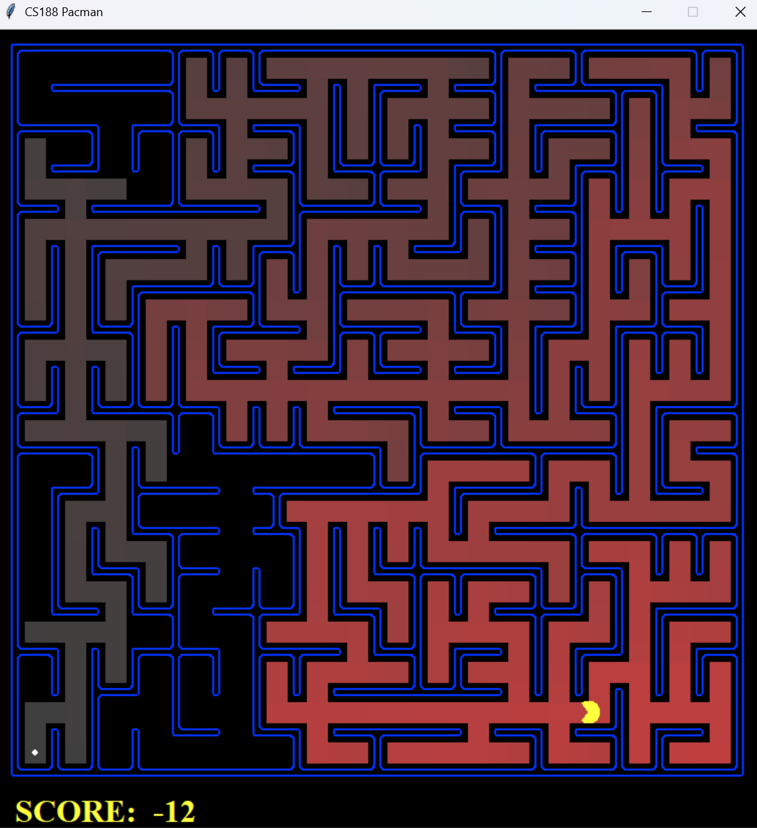
Open | 54 | 535 | 