Finding a fixed food dot

DFS
Maze type | Path cost | Expanded nodes | Screenshot
Medium | 130 | 146 | 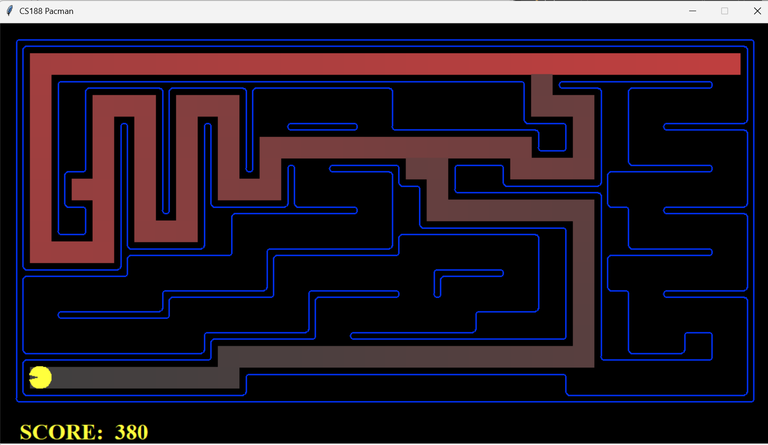
Big | 210 | 390 | 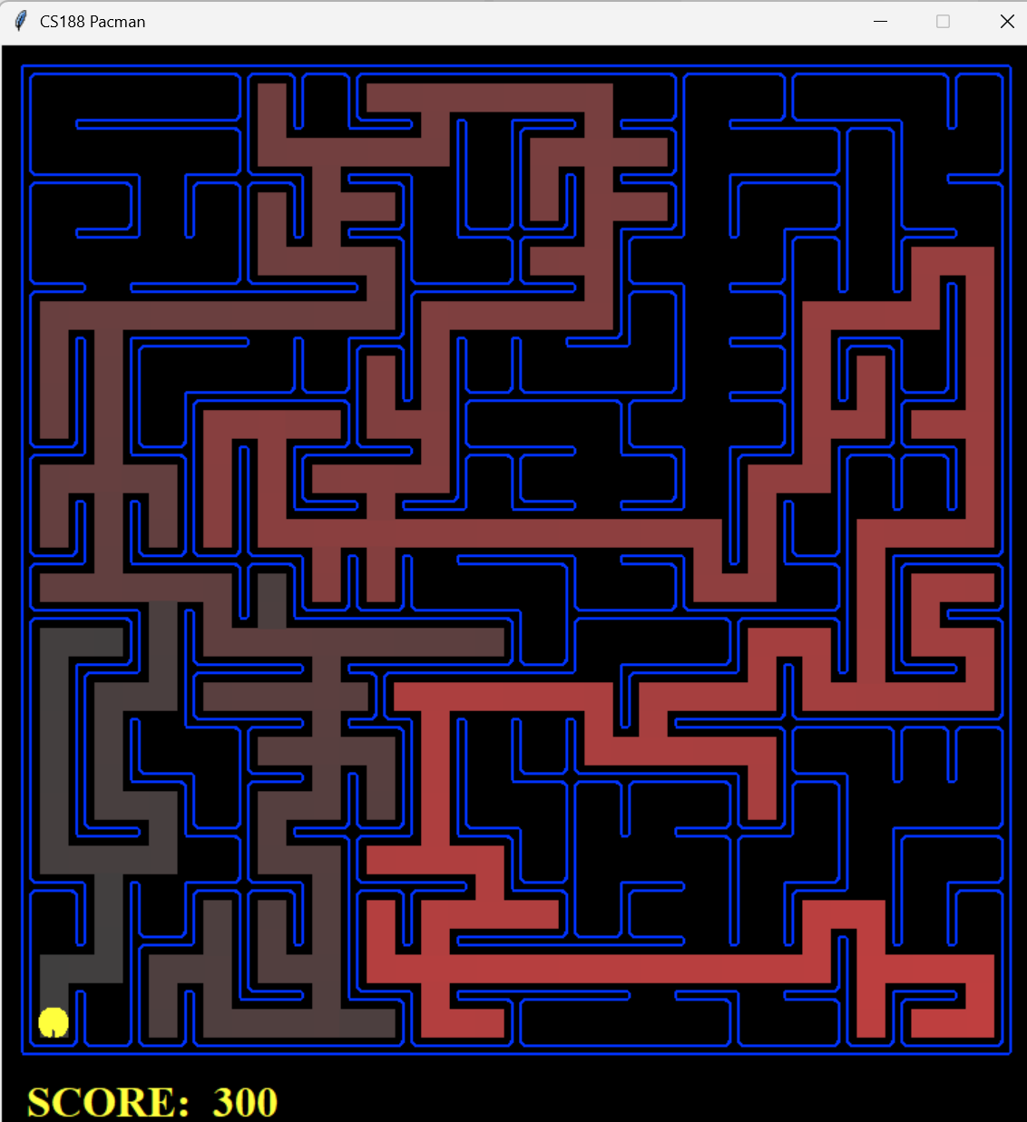
Open | 298 | 806 | 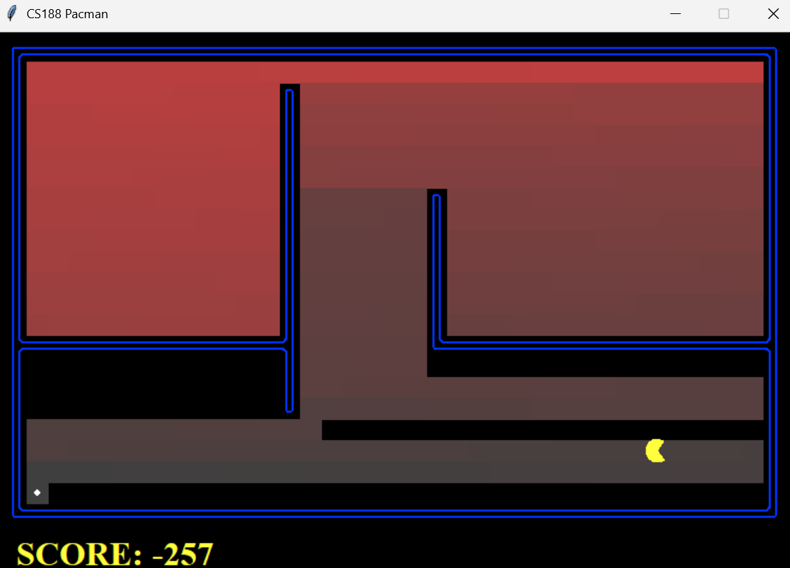

BFS
Maze type | Path cost | Expanded nodes | Screenshot
Medium | 68 | 275 | 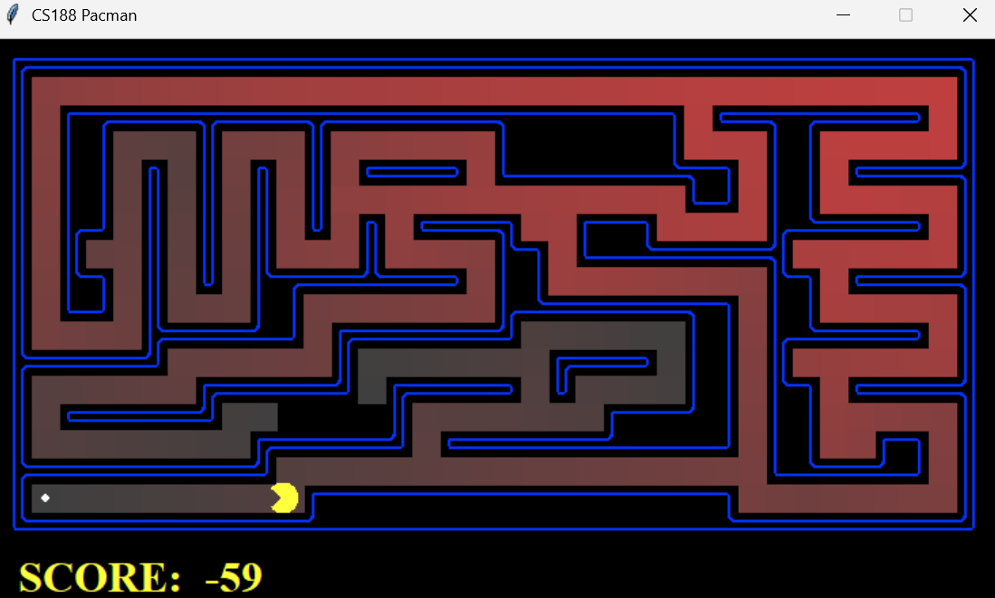
Big | 210 | 620 | 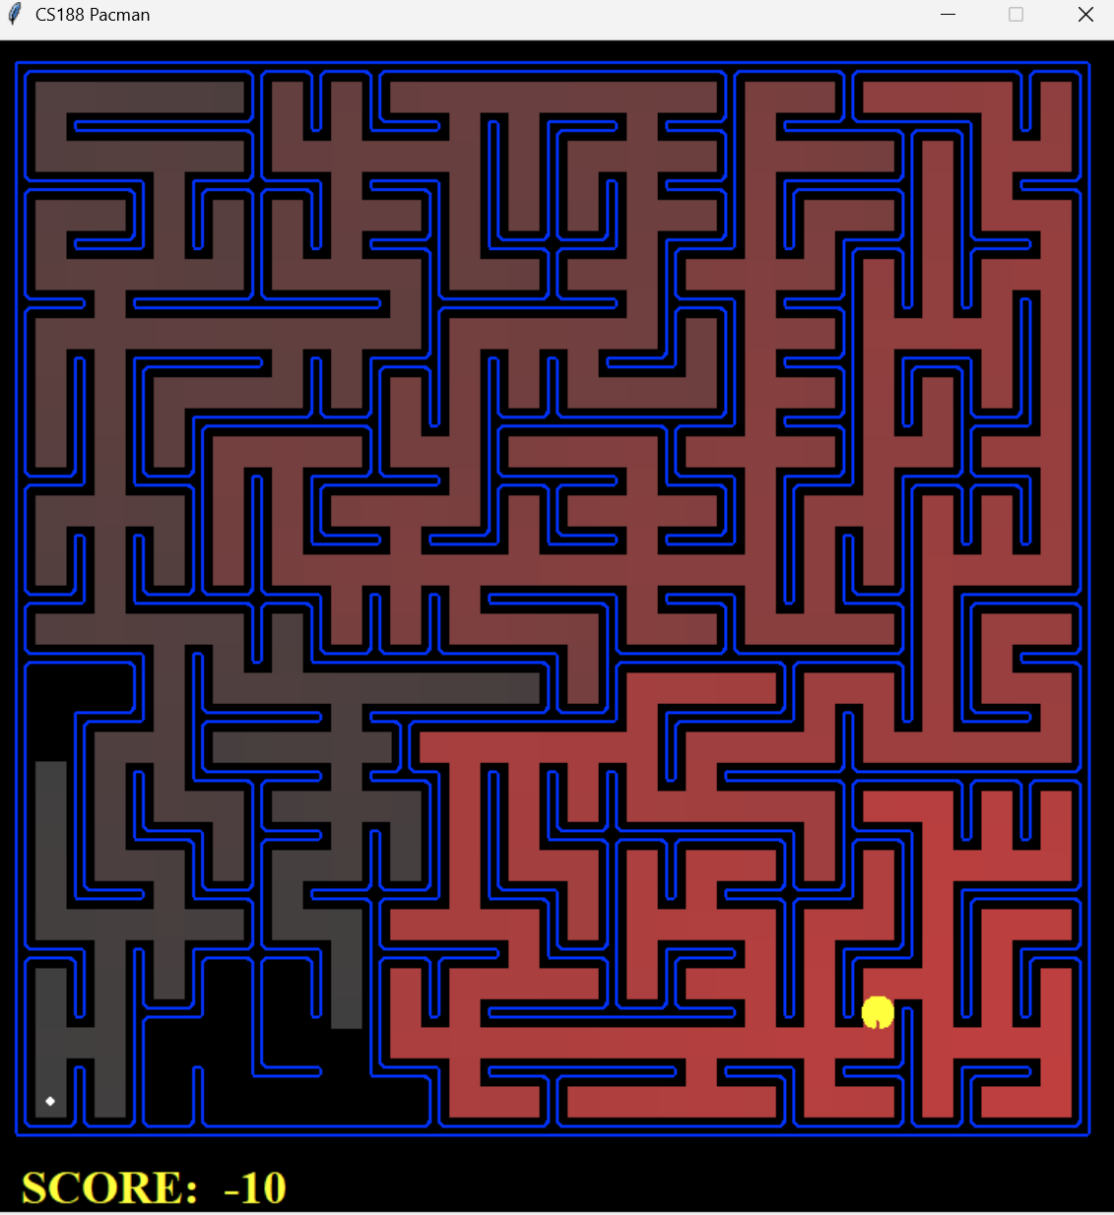
Open | 54 | 682 | 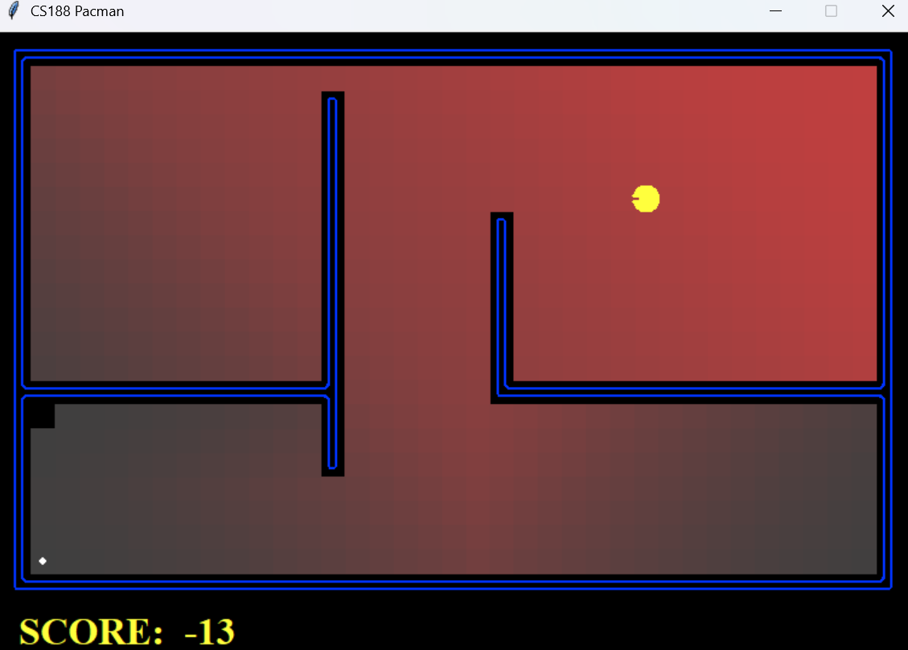

UCS
Maze type | Path cost | Expanded nodes | Screenshot
Medium | 68 | 269 | 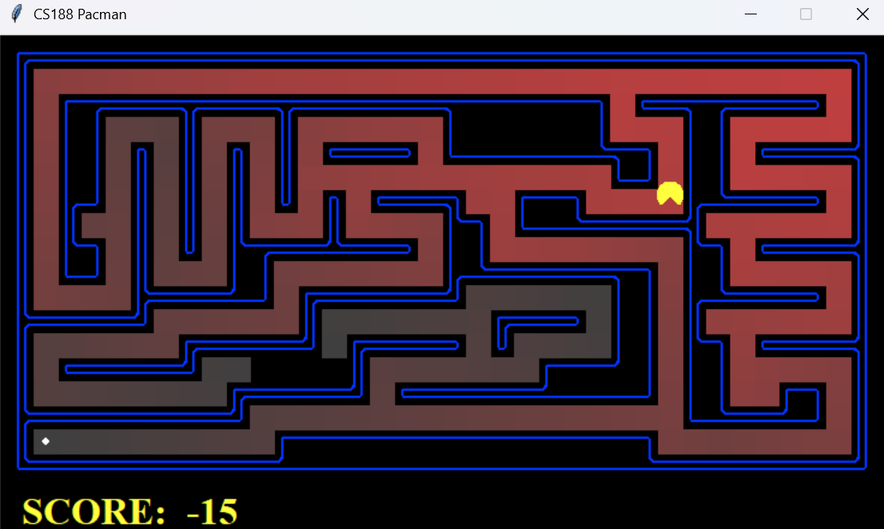
Big | 210 | 620 | 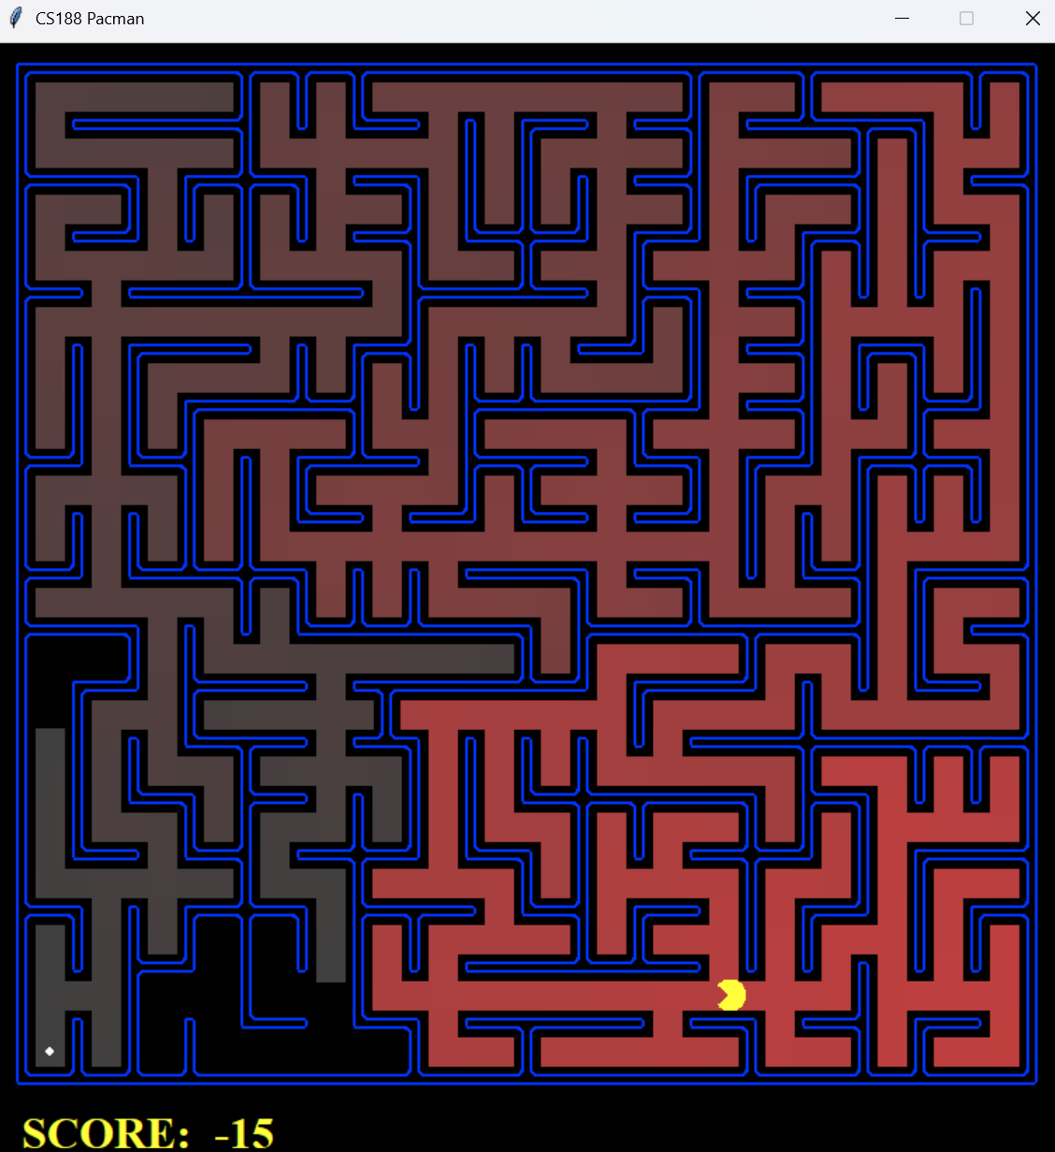
Open | 54 | 682 | 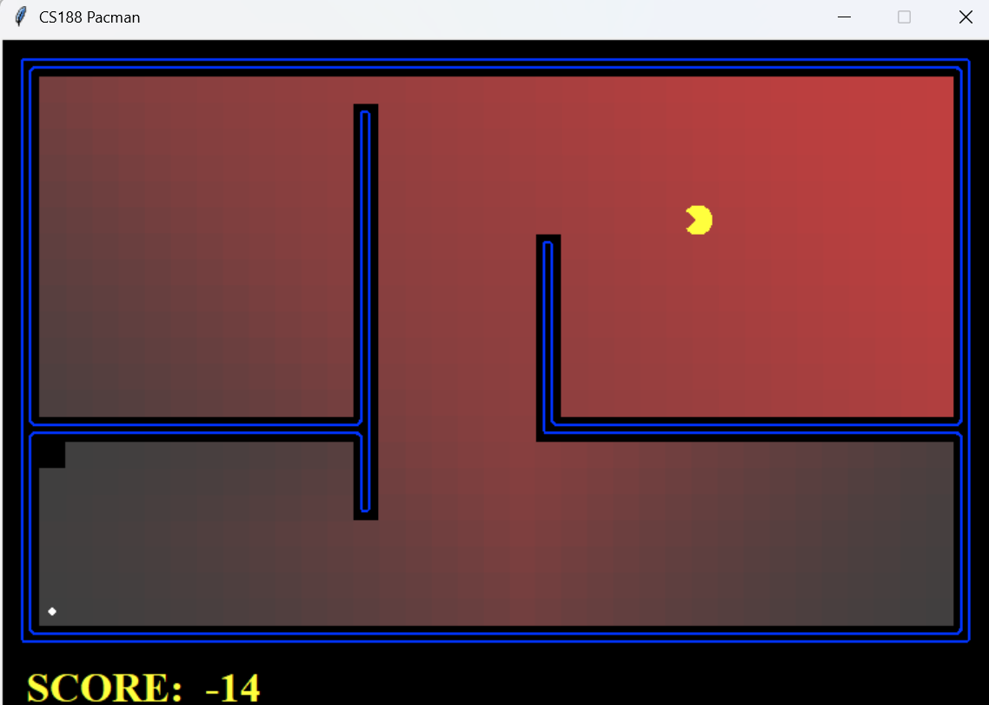

ASTAR
Maze type | Path cost | Expanded nodes | Screenshot
Medium | 68 | 221 | 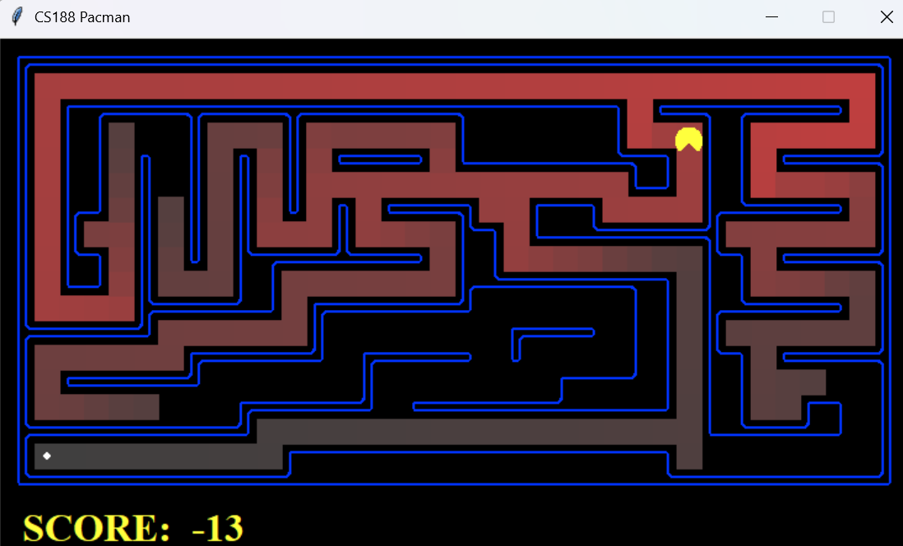
Big | 210 | 549 | 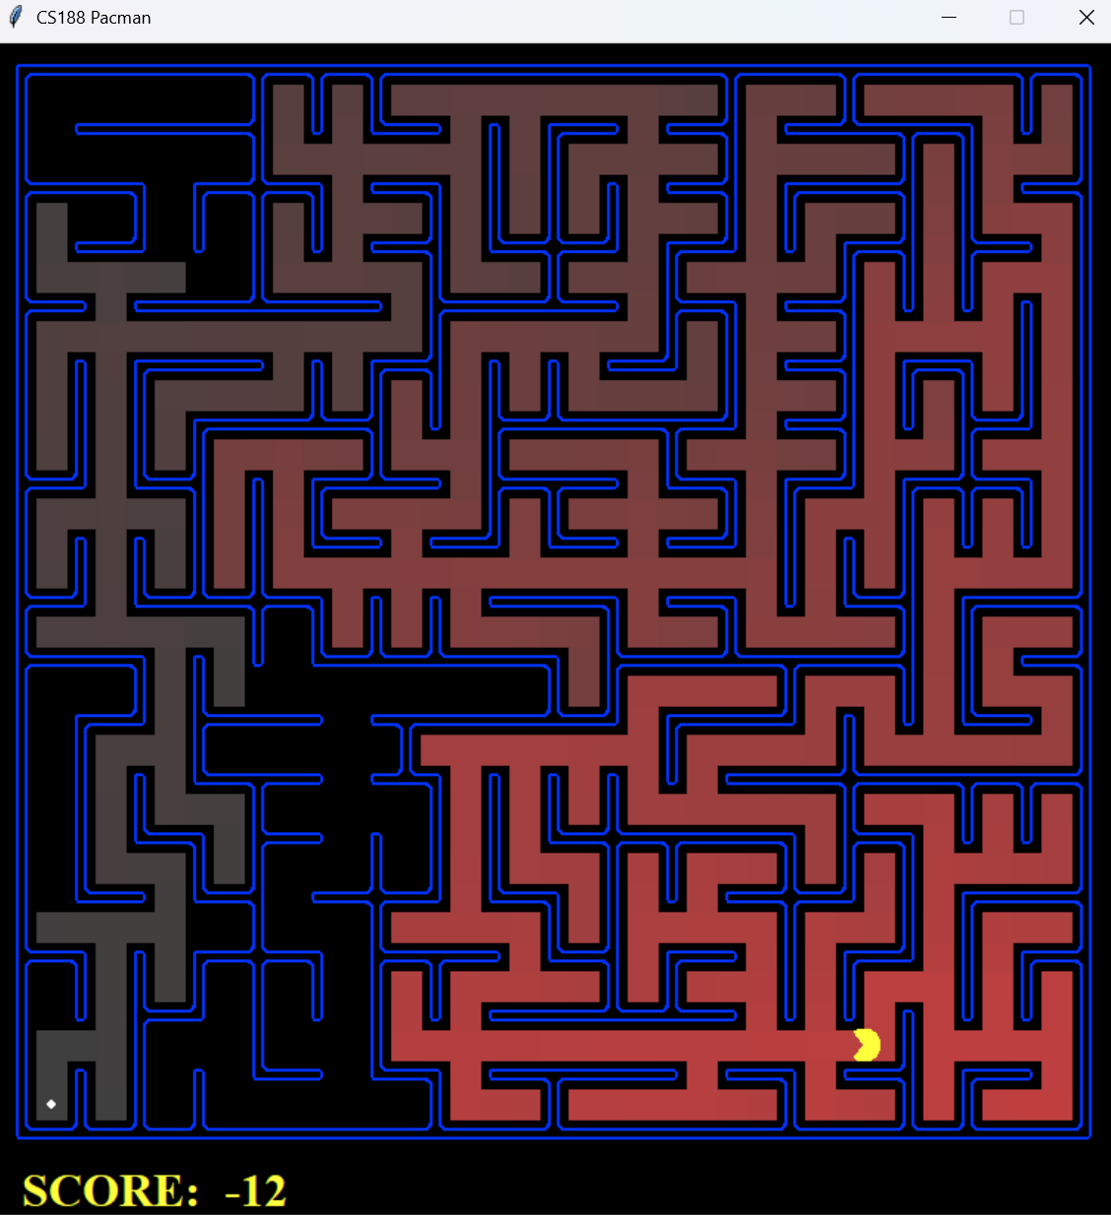
Open | 54 | 535 | 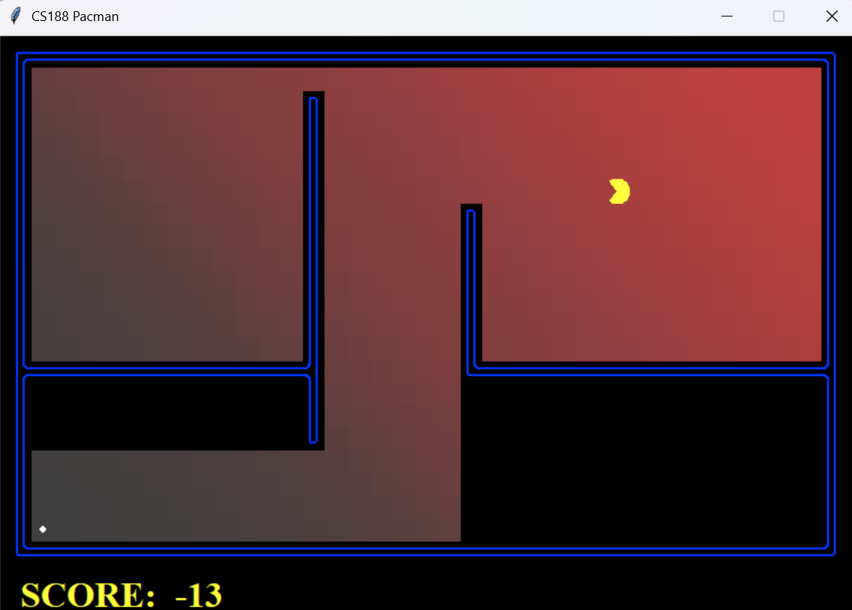

Finding all the corners
What we do: Our heuristic goes over each corner that still needs to be visited. For each corner it checks what the shortest path is from our node to that corner. The longest path between the corners is the value returned by the heuristic.
Admissible: Our heuristic will always bring a good guess for how long we still have to go while also not overestimating. If more than one corner still needs to be visited, the shortest path could, in theory, cost exactly as much as the distance to the farthest corner. For example when multiple corners lie on the path to the farthest one.
Consistent: For each step taken our heuristic only changes as much as that step.
 | Cost of path | Nodes expanded | Elapsed time
Uniform cost | 162 | 7949 | 0.0 seconds
Astar | 162 | 2896 | 1.3 sec3onds

Eating all the dots
- Discuss your heuristic for the food search problem. Explain why it is admissible and consistent.
- Run the AStarFoodSearchAgent and the ClosestDotSearchAgent on the FoodSearchProblem with the trickySearch, mediumSearch and bigSearch layouts. Present the total cost of the path, the number of nodes expanded, and the elapsed time for all combinations in a table.1

