Finding a fixed food dot

DFS
Maze type | Path cost | Expanded nodes | Screenshot
Medium | 130 | 146 | 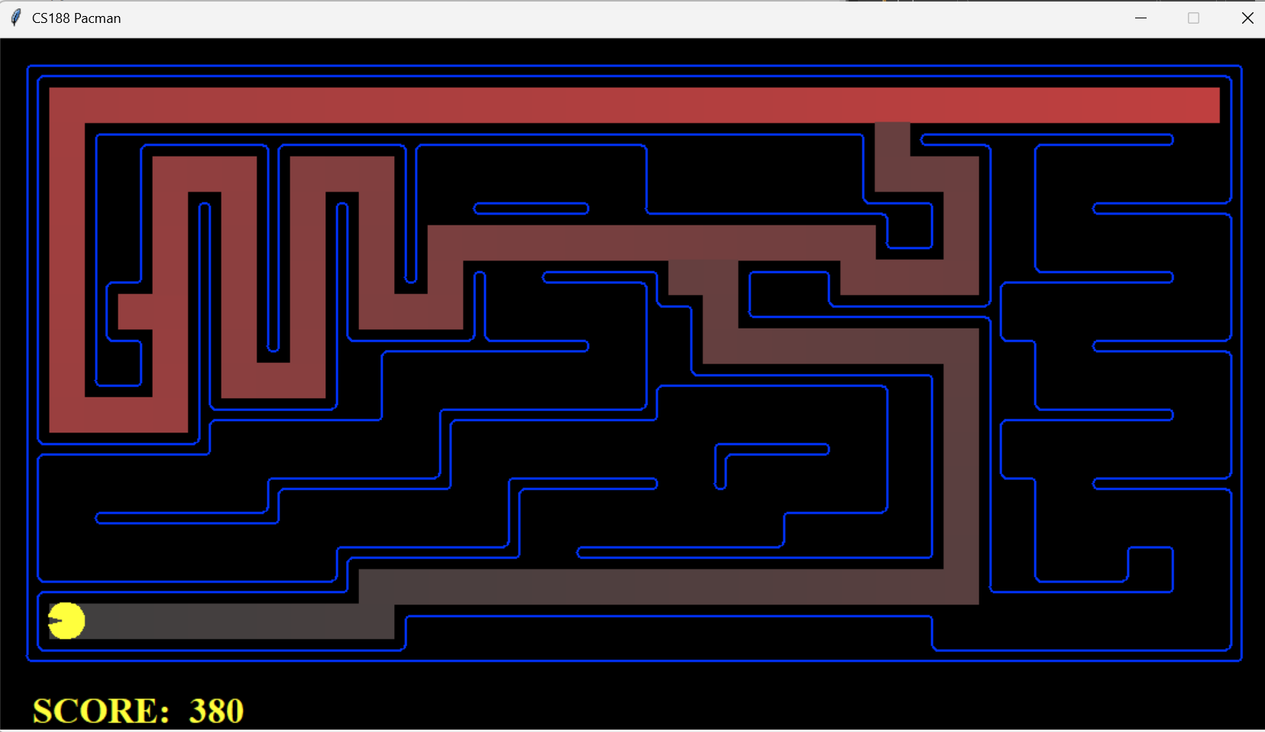
Big | 210 | 390 | 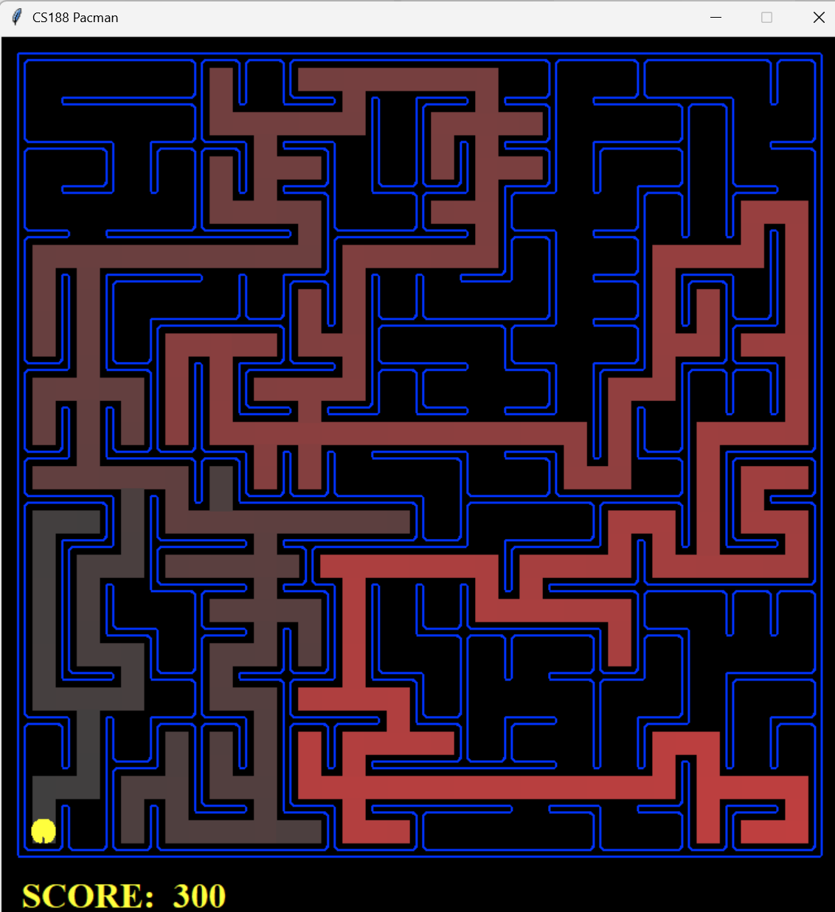
Open | 298 | 806 | 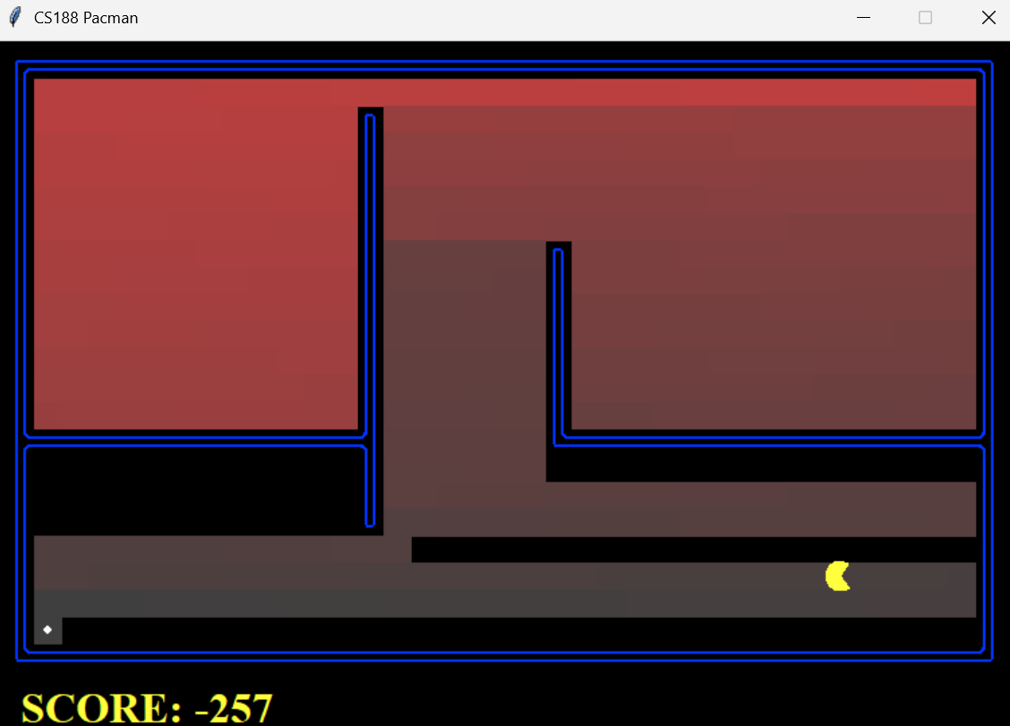

BFS
Maze type | Path cost | Expanded nodes | Screenshot
Medium | 68 | 275 | 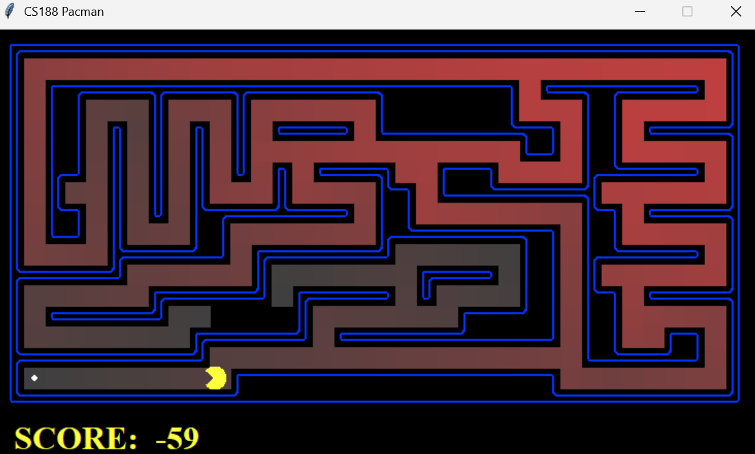
Big | 210 | 620 | 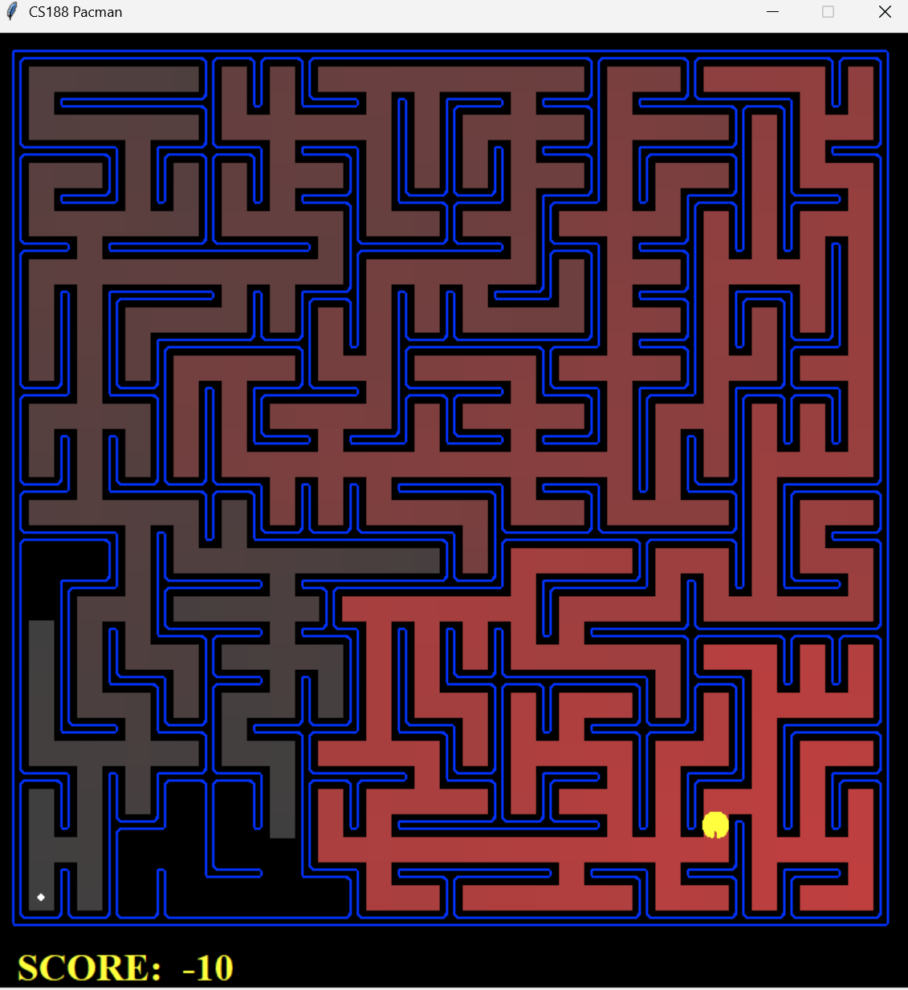
Open | 54 | 682 | 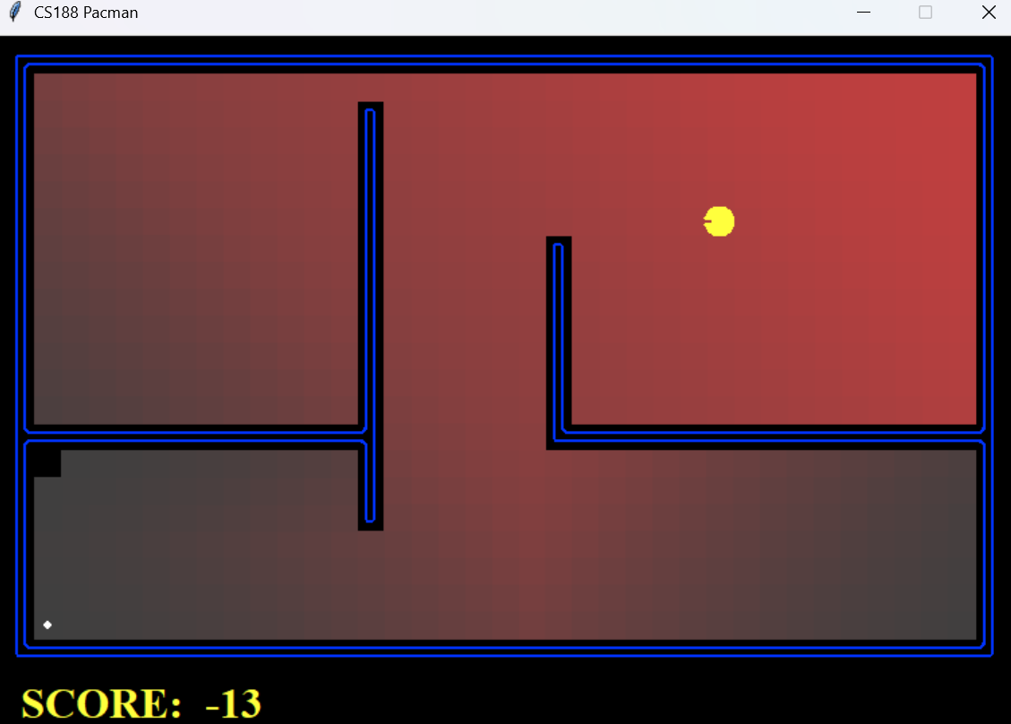

UCS
Maze type | Path cost | Expanded nodes | Screenshot
Medium | 68 | 269 | 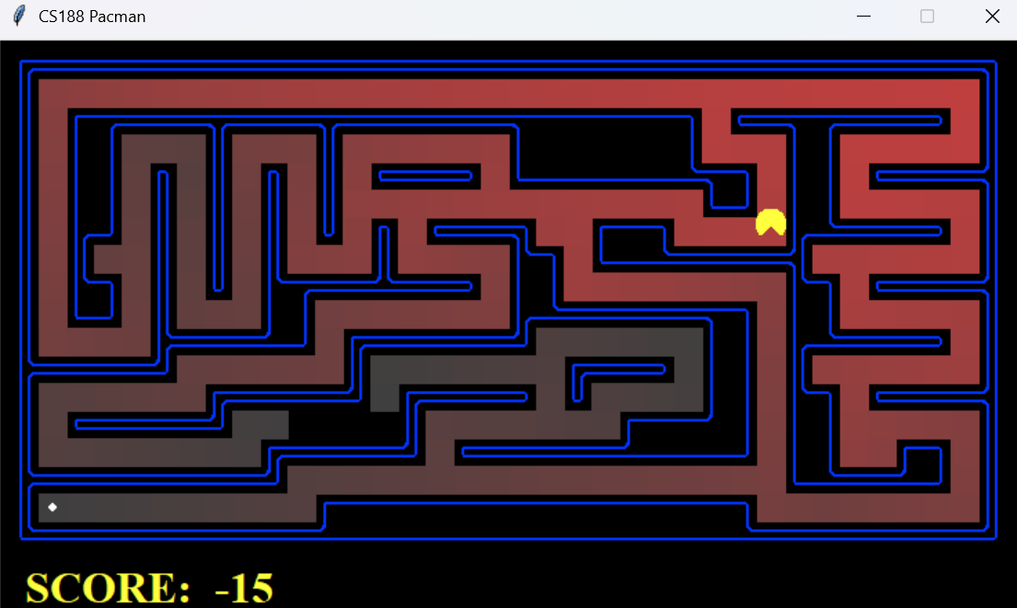
Big | 210 | 620 | 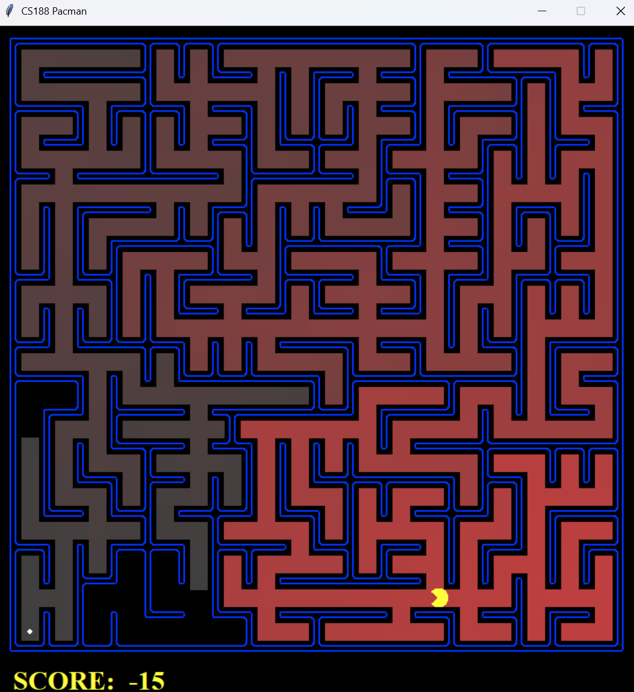
Open | 54 | 682 | 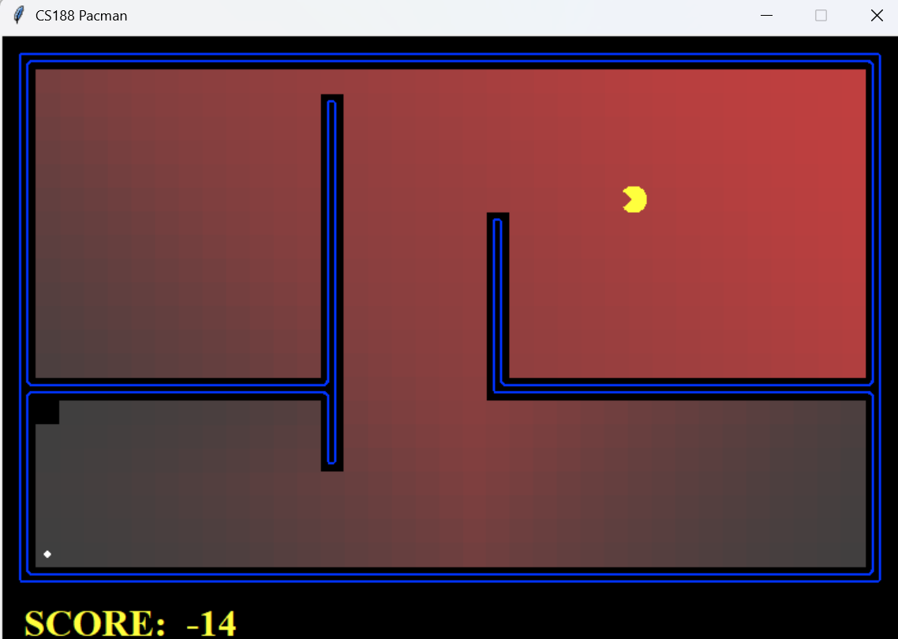

ASTAR
Maze type | Path cost | Expanded nodes | Screenshot
Medium | 68 | 221 | 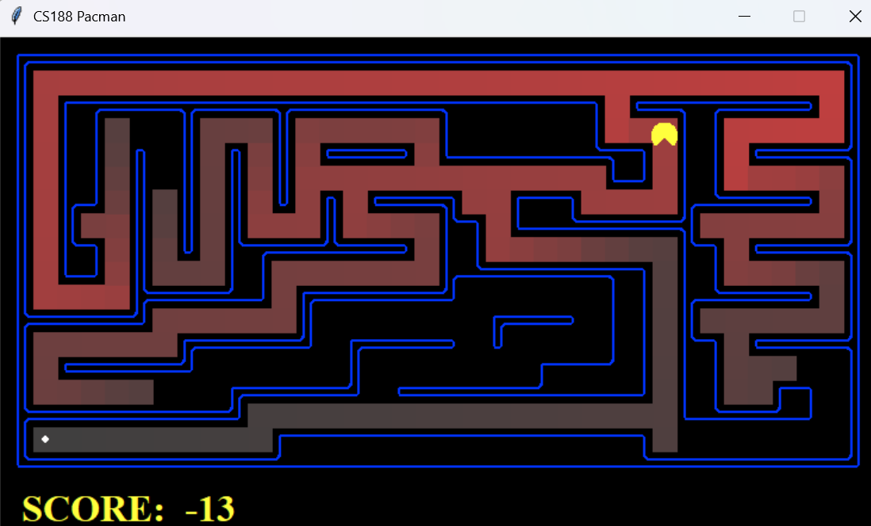
Big | 210 | 549 | 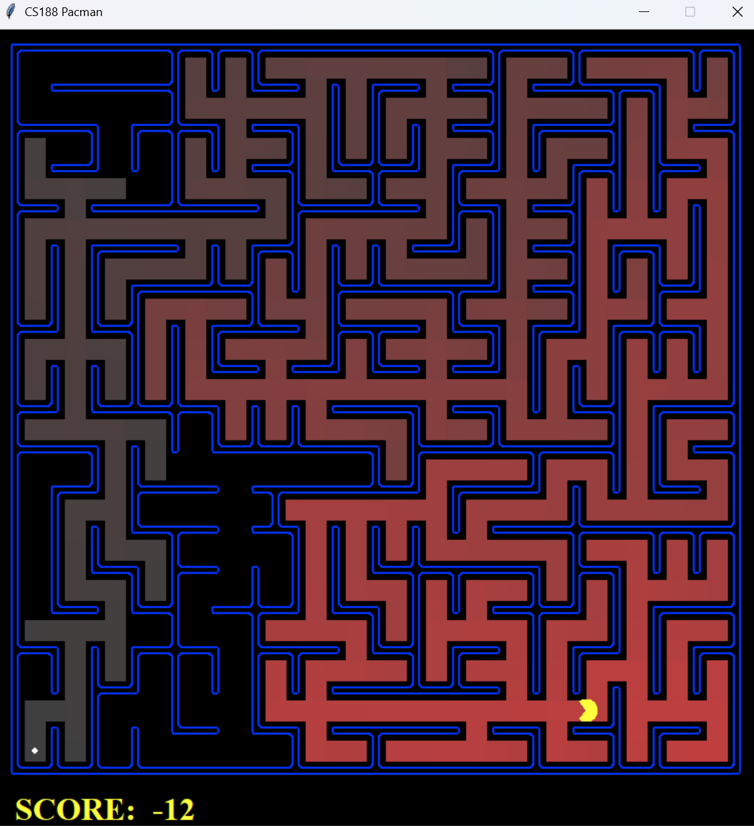
Open | 54 | 535 | 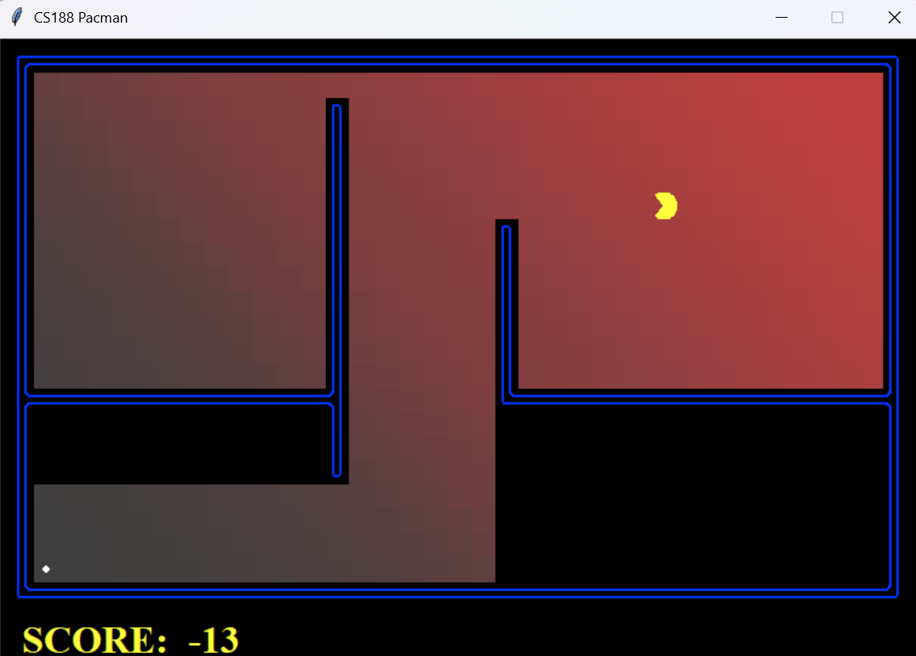

Finding all the corners
What we do (heuristic): Our heuristic goes over each corner that still needs to be visited. For each corner it computes the maze distance from our node to that corner. The longest of these paths is returned by our heuristic.
Admissible: The Pacman still has to reach every unvisited corner, including the farthest one. The real remaining cost is therefore at least the shortest-path distance to that farthest corner, so the heuristic never overestimates.
Consistent: For each step taken our heuristic only changes as much as that step.
 | Cost of path | Nodes expanded | Elapsed time
Uniform cost | 162 | 7949 | 0.0 seconds
Astar | 162 | 2896 | 1.3 seconds

Eating all the dots
What we do (heuristic): For the current state, our heuristic looks at all the food that hasn’t been eaten yet/ For each food, it computes the maze distance from Pacman’s current position to that food. The heuristic returns the largest distances to a remaining food.
Admissible: To finish, the Pacman has to eat every food, including the farthest one. Reaching that food takes at least its maze distance, so the heuristic never overestimates the real remaining cost.
Consistent: For each step taken our heuristic only changes as much as that step.

trickySearch | Total cost | Nodes expanded | Elapsed time
AStarFoodSearch | 60 | 16688 | 0.6
ClosestDotSearch | 68 | Not displayed | 0.0

mediumSearch | Total cost | Nodes expanded | Elapsed time
AStarFoodSearch | Too complex for given problem
ClosestDotSearch | 171 | Not displayed | 0.0

bigSearch | Total cost | Nodes expanded | Elapsed time
AStarFoodSearch | Too complex for given problem
ClosestDotSearch | 350 | Not displayed | 0.0

