**Introduction:**

This system is using for collecting annual magazine contribution from the student to the faculty. This is a magazine management system for a large university. As it is a group course work, Tech Warrior team is doing the group task to develop a web-based system and secure individual role base access. This team consist of five member. The entire team member play some individual role for developing the system.

* A system analyst, who analyses the whole system features and identify the requirements for the magazine management system.
* A database designer create the database for this system to keep all the magazine related information.
* A web designer give the physical structure to the system and create a user-friendly interface so that user can operate and interact with the magazine management system.
* A programmer create the backhand by functional code in the web designee structure according to the magazine management system required and synchronized the database.
* A tester follow the acceptance criteria so the all the requirements can met the goals and it need to be tested.

As a tester, this documentation consist all my contribution, which will show by all test plans and test loges. This system is also evaluated by the group and individually.

**Appendix-A**

**Test plan:**

A planning of justify the functions and its requirements based on the activity which need to be tested and create a document according to the test. It helps to test the accuracy of the functional requirements so that all the task ca be done and fulfill the acceptance criteria. All the test should be done in a proper planning and create a test plan environment for the system.

**Testing for web application**:

Testing is important for a web application to confirm the security and to see the working functions base on the requirements. The magazine management system is a web-based application so that it need to be maintained the appropriate test plan and ensure the perfection of the required features and its security.

**Testing scope and testing strategies:**

To justify the requirements, there should be some testing strategies and criteria to processing the testing for a web-based application. There are some important parts of a web-based testing, which need to be perform for testing.

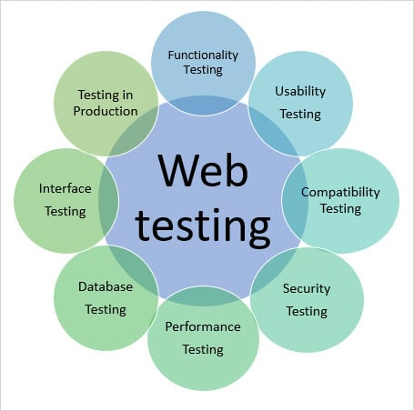

Figure testing parts (softwaretestinghelp, 2019)

The farther description about testing is given bellow.

1. **Functional testing:**

The web system need to function properly and this is include all the features to be function. The system has to fulfil all the requirements as the client want. Make sure the usability and proper security. This testing is includes link testing, cookies and web forms. It also verify the access, validations and checks the magazine management system features individually.

There are some functional testing of magazine management system is given bellow.

* **User login and logout.**
* Need to go to the login page URL link.
* Access should be role based
* Verify the username and password.
* Show invalid login if wrong password enters.
* If password forgotten then there should be a procedure to reset password by confirming a valid email.
* After logout from the system, user cannot access to the system and redirect to the login page.
* **User views:**
* Marketing manager, Administrator, faculty, student and gust user has different view of their own profile and has access limitation.
* The administrator, marketing manager and faculty, can approve only valid data.
* **Working functions:**
* All the links, forms and cookies need to be tested.