CONFIDENTIAL — BOARD & INVESTOR RELATIONS USE ONLY
INVESTOR DAY POSITIONING MEMO
Meridian Technologies (MRDN) | March 11, 2026 | Prepared by: Catherine Park, CEO

EXECUTIVE SUMMARY
Meridian Technologies is declaring itself the agentic work platform that enterprise governance teams trust — built on the most auditable, compliance-ready agent infrastructure in the collaboration software category. This memo records the strategic rationale for that declaration, the competitive evidence that supports it, the risks we are carrying knowingly, and the three commitments we are making to investors today. Meridian enters Investor Day with $506M in liquidity, zero debt, a 44% enterprise Copilot attach rate, and a governance moat that no direct competitor has matched. We are moving — deliberately and with financial capacity — from the center of the competitive map to the upper-right quadrant: agentic ambition, premium pricing, enterprise trust. That quadrant has one occupant today (Atlassian, in developer tooling). Meridian will own it in project management and regulated-industry work.

SECTION 1 The Position
Effective today, Meridian's public positioning is:
"Meridian is the agentic work platform for enterprises that cannot afford to get AI wrong — built on the governance infrastructure that regulated industries already trust."
This replaces "the project management and team collaboration platform." PM is not abandoned — it is repositioned as the surface through which agents operate, not the product we are selling. The pricing model will shift in H2 2026 to a per-seat-plus-consumption hybrid. The sales motion will shift to agent-led for new logos and net-new expansion; the PM motion is preserved for renewals.
SECTION 2 Why This Position — The Strategic Logic
Four inputs drove this decision:
- Customer signal: In 18 of 22 enterprise advisory board sessions (Dec 2025–Feb 2026), the top ask was agent governance — auditability, role-based agent permissions, model selection controls, data residency. No competitor has built all four. Meridian is closest.
- Competitive white space: Asana and Atlassian have both claimed "agentic platform" — but neither has the governance depth for regulated industries. Smartsheet has the governance posture but has explicitly rejected the word "agentic." The upper-right quadrant of the competitive map (agentic + premium + governed) is unclaimed in PM.
- Financial capacity: $506M in liquidity, $67M in 2025 FCF, $250M in estimated M&A capacity, and $55M in AI-specific R&D already budgeted. We can absorb an 18-month revenue ramp lag without covenant risk or capital raises.
- Team signal: The Helio acquisition gave us an agent framework and 28 applied AI engineers. They did not join to build AI features for a PM tool. Option B retains the talent that makes the roadmap executable.

SECTION 3 Competitive Landscape
The table below maps the four primary competitors across the dimensions most relevant to Meridian's positioning decision. Sources: competitors_cached/ (Feb 2026 snapshots).
Competitor | AI Positioning | Pricing Posture | Latest Flagship Announcement | Closer to Option…
Asana | "Work management platform with AI built in." Calls itself an "agent operating system." De-emphasizes classic PM in marketing. | Bundled into Advanced+ tiers at no extra cost. No consumption pricing. Explicitly rejected consumption model. | Nov 2025: AI Studio and Smart Workflows bundled into Advanced/Enterprise — direct competitive escalation vs. add-on competitors. | B — agentic claim, no governance depth
Monday.com | "Work OS supercharged with AI everywhere." AI as a horizontal layer, not a separate product. Breadth and price as differentiators. | Bundled into Pro+ at no extra cost. No consumption pricing. "Consumption creates buying friction we don't want." | Jan 2026: monday AI Agents GA — customer-buildable agents in natural language, bundled into Pro tier. | A/B hybrid — agentic framing, bundled execution; no vertical or governance moat
Smartsheet | "Enterprise work platform you can trust with AI." Avoids "agentic." Emphasizes trust, compliance, audit-committee approval. | AI bundled into Business/Enterprise tiers. AI Compliance Pack as premium add-on (~$15/seat/month). | Dec 2025: AI Compliance Pack — agent-level audit logs, model selection, data residency. Priced as enterprise premium. | A — PM-centric, governance-forward, cautious on agentic ambition
Atlassian | "Agentic enterprise platform for software and IT teams." Most explicit agentic bet; internal language: "an agent company that ships software." | Rovo sold as separate paid product: per-seat (~$20/seat/mo) + per-action consumption. Only competitor with consumption pricing today. | Jan 2026: Rovo Studio — developer-targeted agent builder on Jira/Confluence/Bitbucket infrastructure. Consumption-priced. | B — closest to Meridian's Option B, but dev/IT-shaped not PM-shaped; thin outside engineering orgs

Figure 1: Competitive Positioning Matrix — AI Strategy × Pricing Posture
The matrix below plots all four competitors and Meridian's current and proposed positions. The target white space (upper right: agentic + premium governance) has one occupant (Atlassian, in developer tooling). Meridian's proposed move positions it as the agentic+governance platform for PM and regulated industries.
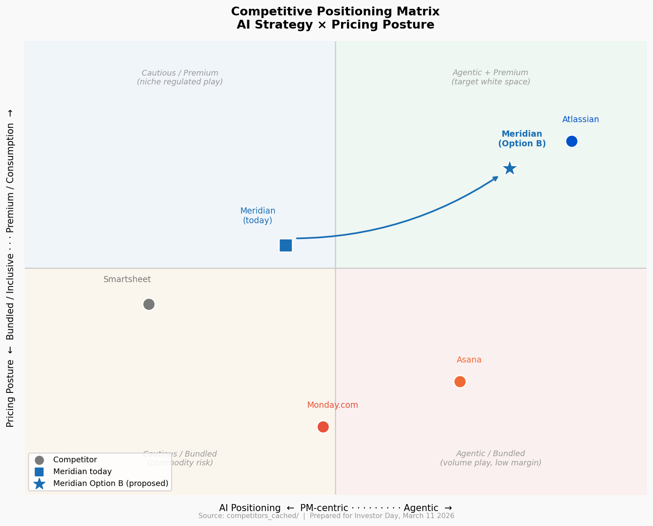

SECTION 4 Risks We Are Carrying Knowingly
Risk 1 — The revenue air gap.
Declaring "agentic platform" and transitioning to consumption pricing while deemphasizing the PM sales motion creates a 12–18 month period in which agentic ARR must ramp before PM growth slows further. AI Copilot ended 2025 at $3.5M ARR. If enterprise consumption adoption is slower than modeled — customers told us they want human-in-the-loop checkpoints, not autonomous workflows — 2026 ARR growth could land at the low end of guidance (10%) or below. Mitigation: $506M liquidity buffer; FCF positive at any growth rate above 5%; PM renewals preserved under both motions.
Risk 2 — Atlassian moves into our verticals.
Atlassian is the only competitor already in the upper-right quadrant of the positioning map, and their install base is enormous. If they decide to invest in financial services and life sciences vertical depth — or acquire a compliance tooling company — our differentiated moat narrows. Mitigation: our FedRAMP Moderate, HIPAA, and (2026) GxP certifications are 12–18 months ahead; six of the top-10 North American retail banks are active customers; Atlassian's developer-shaped product is a structural disadvantage in these verticals.
Risk 3 — Helio retention and talent execution.
The agent builder roadmap depends on retaining the Helio team through their 2026 compensation cliff. Twenty-six of twenty-eight Helio engineers remain today. The compensation program runs through 2029, but the largest vesting event is in mid-2026. If key engineers leave after that cliff, the Q2 2026 agent-builder shipment is at risk and the Option B narrative loses its primary technical proof point. Mitigation: People & Compensation Committee to review and top-up retention agreements by Q1 2026; broader senior IC engineering refresh approved concurrently.

SECTION 5 Three Commitments to Investors
Commitment 1 — Ship the governance suite in Q1 2026.
The enterprise governance suite for AI agents (audit logs, role-based agent permissions, model selection, data residency controls) will reach GA in Q1 2026. This is the product that converts our positioning claim into a proof point. We will report enterprise governance suite attach rate at each quarterly call starting Q1 2026.
Commitment 2 — Announce consumption pricing model in H2 2026.
We will announce the hybrid per-seat-plus-consumption pricing model no later than Q3 2026. We will provide investors with a framework for modeling consumption revenue contribution — including assumptions, leading indicators, and a range of outcomes — at the time of announcement. We will not guide consumption revenue until we have two full quarters of data.
Commitment 3 — Report three new Copilot metrics beginning Q1 2026.
As committed on the Q3 2025 earnings call: (1) Copilot attach rate on enterprise renewals (target: above 40% sustained; Q4 2025 actual: 44%), (2) weekly agentic-feature usage rate across active users, and (3) Copilot appearance in win-loss data. These are the metrics by which we ask investors to judge our AI execution.

Sources: meridian_internal_brief.md · meridian_ai_strategy_options.md · meridian_recent_customer_feedback.md · meridian_financials_summary.csv · competitors_cached/ (Feb 2026) | For board and IR use only. Not for public distribution prior to March 11, 2026.

