CONFIDENTIAL — BOARD USE ONLY
Meridian is strong where it counts — and needs a decision
where the window is closing.
Catherine Park, CEO | Annual Board Strategic Review | 2026

Thank you. This is my first annual strategic review with you as CEO, and I want to use these five minutes to give you my honest read — not a curated highlight reel. We have real strengths, two issues that demand board-level attention, and one decision I need from this room today.

ISSUE 1 OF 3 — The AI execution window is closing.
AI Copilot reached GA in September 2025. We closed Q4 with 710 paying seats and a 44% attach rate on enterprise renewals — ahead of our internal 40% target. The Helio acquisition gives us an agent framework that our CPO estimates compresses our roadmap by 15 months. That is the good news.
The sobering news: Asana bundled agents into their standard tier in October. Monday is now larger than us by ARR. ClearAI Work raised $120M at a $1B+ valuation. Atlassian announced agentic Jira in January. We have two acquisition targets in early diligence — both AI-native — and the board needs to understand that doing nothing is also a choice, and that choice has a cost. Our 2026 roadmap (agent builder Q2, workflow marketplace Q3, consumption pricing Q3) is credible only if we hire ~80 engineers net in H1. At current 15% attrition, we will net approximately 25. That gap is the binding constraint.
Evidence: meridian_kpis_2024.csv — AI Copilot paying seats: 0 (Q1–Q1 2025) → 710 (Q4 2025). meridian_product_roadmap_2025.md — "Net adds closer to 25 [not 80]… agent-builder depends on Helio retention." meridian_earnings_call_q4_2025.txt — two additional AI-native acquisition targets in early diligence.

ISSUE 2 OF 3 — Mid-market is plateauing and sales efficiency has broken.
Mid-market is 47% of ARR — our single largest segment. NRR has compressed from 115% (2022) to 102% (Q4 2025), eight consecutive quarters of decline. The magic number — a measure of how efficiently each sales dollar generates new ARR — crossed below 1.0 in Q2 2025 and ended Q4 at 0.92. Below 1.0 means we are spending more to acquire ARR than we are efficiently getting back. CAC payback has stretched from 18 to 22 months.
The resource management module — the top-3 ask from our customer advisory board — was deferred twice in 2025 in favor of AI work. It is now on the 2026 draft roadmap for Q2. If mid-market NRR slips through 100% before Copilot generates meaningful attach in this segment, we face ARR contraction in our largest segment simultaneously with elevated go-to-market spend. That is the scenario that breaks 2026 margin guidance.
Evidence: meridian_kpis_2024.csv — magic number 1.20 (Q1 2024) → 0.92 (Q4 2025); CAC payback 18.2 → 22.4 months. meridian_segments_overview.md — mid-market NRR 102%, gross logo churn 10.2%. meridian_earnings_call_q3_2025.txt — "renewals push for price hold, expanded seats, or AI Copilot bundled in at no cost." See chart below.

ISSUE 3 OF 3 — The organization is running hot, and a talent cliff is 90 days away.
Our October 2025 employee survey (81% response rate, N=1,945) surfaced three signals the board should know. First, "roadmap thrash" is the single most common theme in engineering and product (31% of engineering open-ends) — the organization needs to believe the current direction is durable. Second, 27% of senior engineers flagged compensation as a concern; our People team has specifically identified a risk of losing 15–25 senior engineers if equity is not refreshed in Q1 2026. Third, 19% of all respondents — and 28% of sales — said they can no longer clearly articulate what makes Meridian different from a competitor with AI features.
Investor Day is March 11. Our new plan is due to the board by Q1 2026. We are asking the organization to execute a pricing model shift, three segment P&Ls, 80 engineer hires, and a Helio integration simultaneously. Burnout is a real risk. The comp refresh is not optional.
Evidence: meridian_employee_survey_2025.md — "specific risk of losing 15–25 senior engineers"; "roadmap thrash" 31% of engineering; identity confusion 28% of sales. meridian_product_roadmap_2025.md — "net adds closer to 25 [engineers], not 80."

Supporting data — Key Performance Indicators Q1 2024–Q4 2025
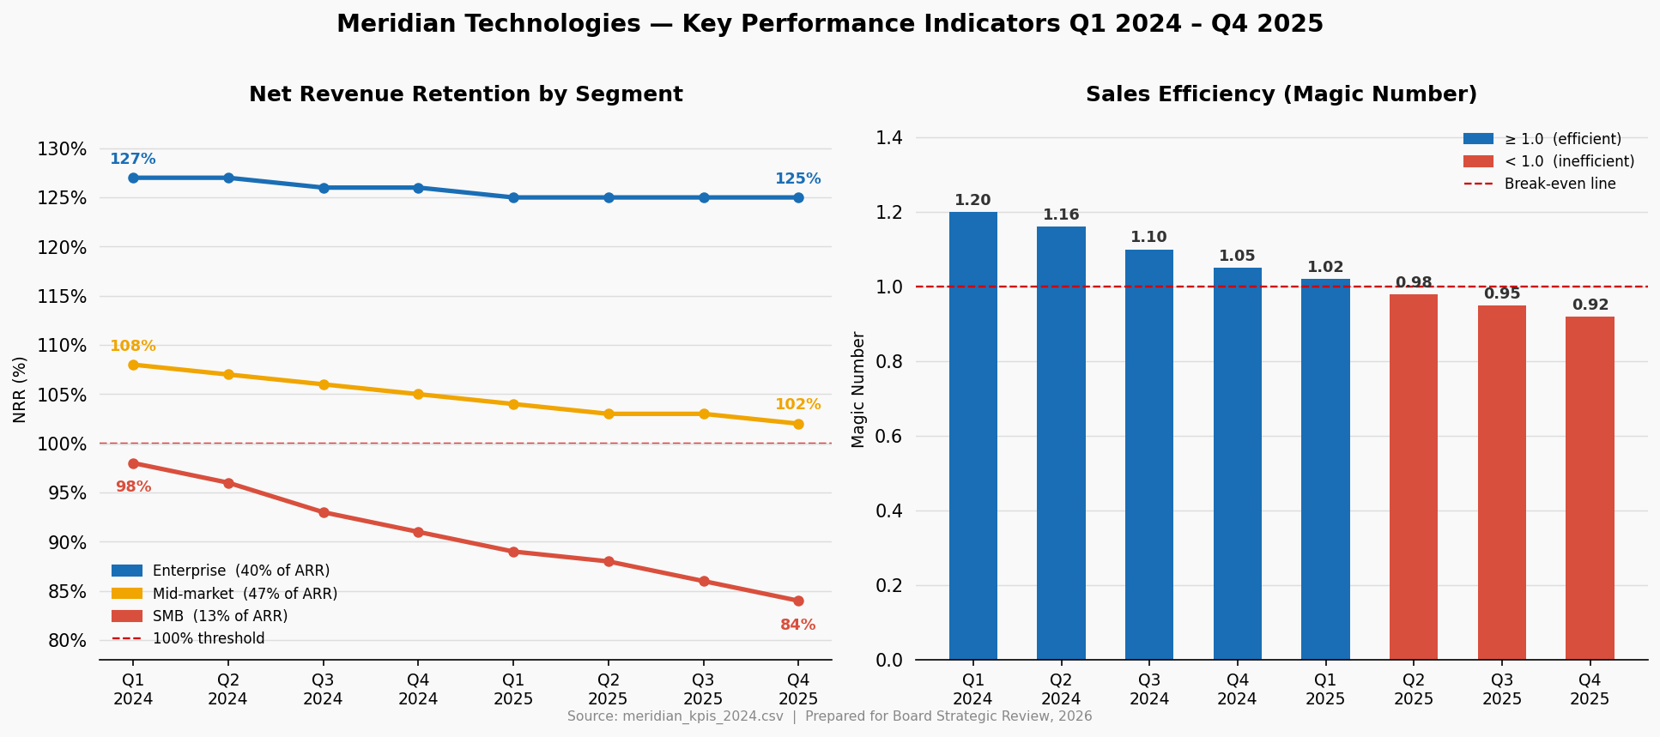
Left: NRR by segment — enterprise holding at 125%, mid-market compressing toward 100%, SMB at 84% and declining. Right: Magic number crossed below 1.0 in Q2 2025 and has not recovered — sales efficiency is deteriorating.
Source: meridian_kpis_2024.csv

MY ONE ASK OF THIS BOARD
Authorize the People & Compensation Committee to approve a senior IC engineering equity refresh in Q1 2026, sized to re-benchmark against AI-native startup compensation. The cost is estimated at $4–7M in additional equity. The cost of losing 15–25 senior engineers in the six months before Investor Day — when we are building the product that defines our next chapter — is not recoverable. Everything else I will bring back to you at the March session. This one cannot wait.
I am proud of what this team has built. I am clear-eyed about what we have to do. Let's get to work.

Prepared from internal source documents: meridian_financials_2022_2025.csv, meridian_kpis_2024.csv, meridian_segments_overview.md, meridian_board_memo_strategic_outlook_2024.md, meridian_strategic_plan_2023_2026.md, meridian_earnings_call_q1–q4_2025.txt, meridian_employee_survey_2025.md, meridian_product_roadmap_2025.md

