|  |  |
| --- | --- |
| INPUT | NEW OUTPUT |
| http://www.hivehealthmedia.com/wp-content/uploads/2013/05/child-drinking-coke.jpg | H:\My Documents\GitHub\Prob_1_4_7\PepsiImages\modified\child-drinking-coke.png |
| http://www.comms-express.com/blog/assets/images/family-meal-time\_photo.jpg | H:\My Documents\GitHub\Prob_1_4_7\PepsiImages\modified\family-meal-time_photo.png |
| http://ecowatch.com/wp-content/uploads/2014/10/Soda.jpg | H:\My Documents\GitHub\Prob_1_4_7\PepsiImages\modified\Soda.png |

The Concept Drawing

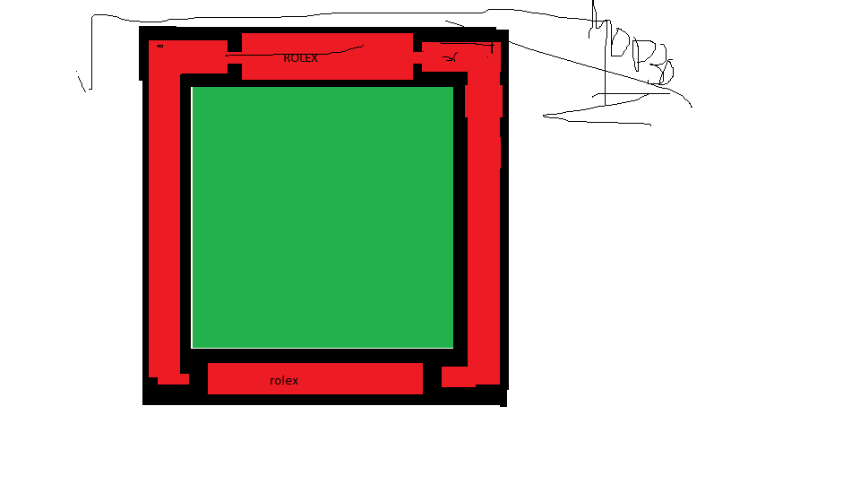

The algorithm we used made use of the image found at: <http://upload.wikimedia.org/wikipedia/en/thumb/5/58/Pepsi_logo.svg/1280px-Pepsi_logo.svg.png>

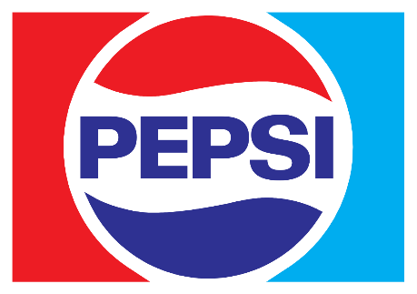

NEW STAGES OF EXECUTION

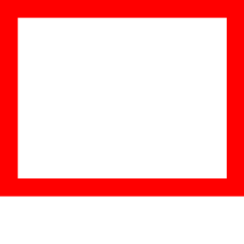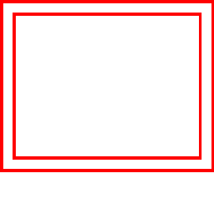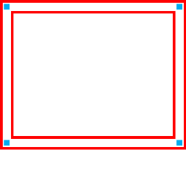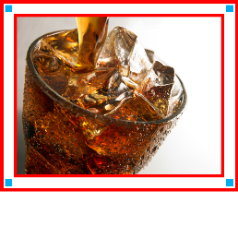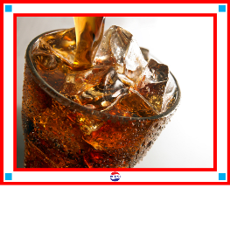

Prose discussing the processes:

The effect that we created produces a frame of two colors around an image, with a logo in the bottom center. To do this, we used the Python imaging library’s functions to draw rectangles on the outside of a new image that was 2x the border’s width more than the size of the image on all sides. Then smaller rectangles were drawn inside the larger rectangles (except for a small part at the bottom where the logo will go) and then squares were drawn in the smaller rectangles at corner points, and then the image was pasted into the clear area and then the logo was pasted onto the frame.