|  |  |
| --- | --- |
| INPUT | OUTPUT |
| http://www.hivehealthmedia.com/wp-content/uploads/2013/05/child-drinking-coke.jpg |  |
| http://www.comms-express.com/blog/assets/images/family-meal-time_photo.jpg |  |
| http://ecowatch.com/wp-content/uploads/2014/10/Soda.jpg |  |

The Concept Drawing

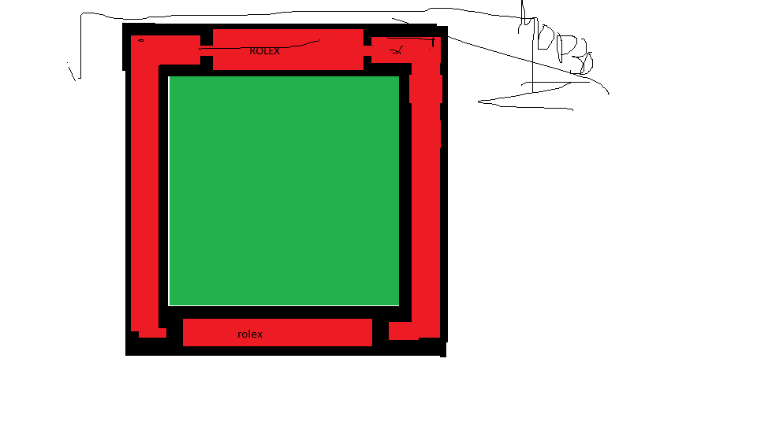

The algorithm we used made use of the image found at: <http://upload.wikimedia.org/wikipedia/en/thumb/5/58/Pepsi_logo.svg/1280px-Pepsi_logo.svg.png>

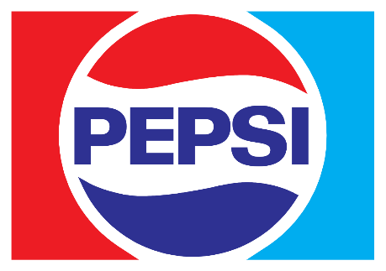

STAGES OF EXECUTION

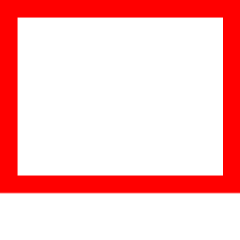 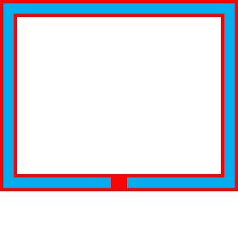 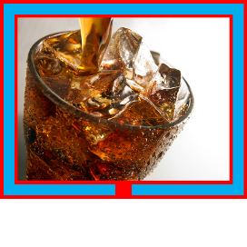 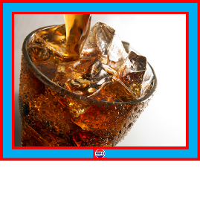

Prose discussing the processes:

The effect that we created produces a frame of two colors around an image, with a logo in the bottom center. To do this, we used the Python imaging library’s functions to draw rectangles on the outside of a new image that was 2x the border’s width more than the size of the image on all sides. Then smaller rectangles were drawn inside the larger rectangles (except for a small part at the bottom where the logo will go) and then the image was pasted into the clear area and then the logo was pasted onto the frame.