illeosia-lost_realm
Contents

- System Requirements

- Recommended Requirements

- Installation Process

- Features

5. How to play

5.1. Main Menu

5.2. Game settings

5.3. Player controls

Illeosia-lost_realm ​is a sandbox open world game which has similar game mechanics like minecraft. In this virtual game world we can create objects using voxels and gathered materials. We have different types of cubes to make objects and it has an infinite terrain map which is never ending.
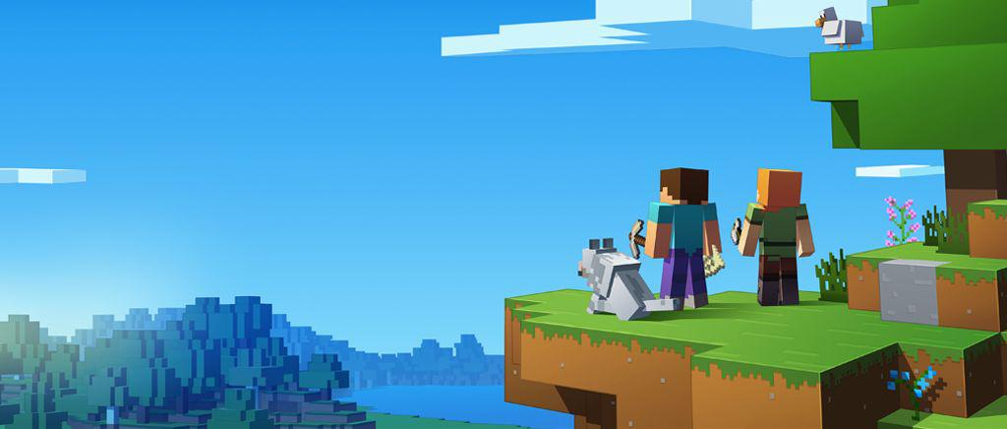

SYSTEM REQUIREMENTS:

Minimum Requirements:

Intel Core i3 3rd generation

4 GB ram

1 GB HDD space

Directx 9

Intel HD 2500

Recommended Requirements:

Intel Core i5 5th generation

8 GB Ram

1 GB HDD Space

DirectX 11

Nvidia Geforce 940 mx

Installation Process:

- After clicking install then select the desired drive you want to install the game.
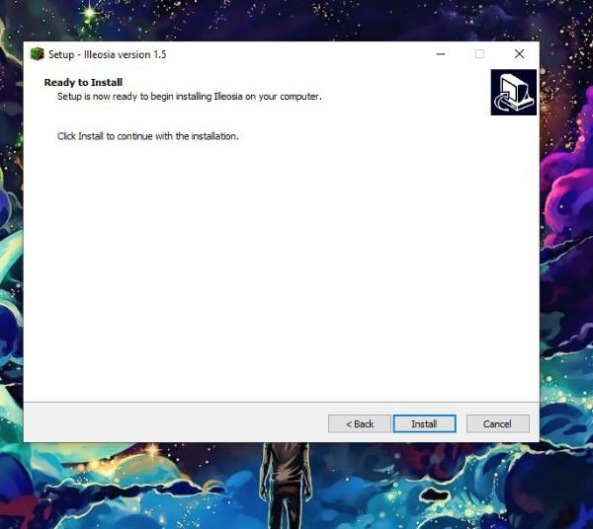

2. Then click Next
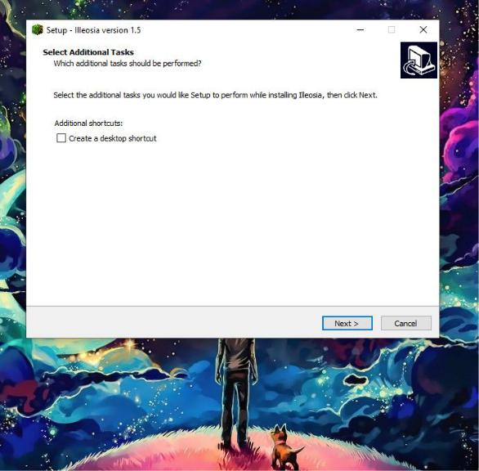

3. After wait for the installation to complete
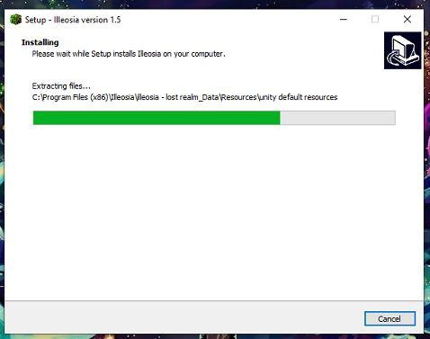

4. Lastly click finish and the game is ready to run
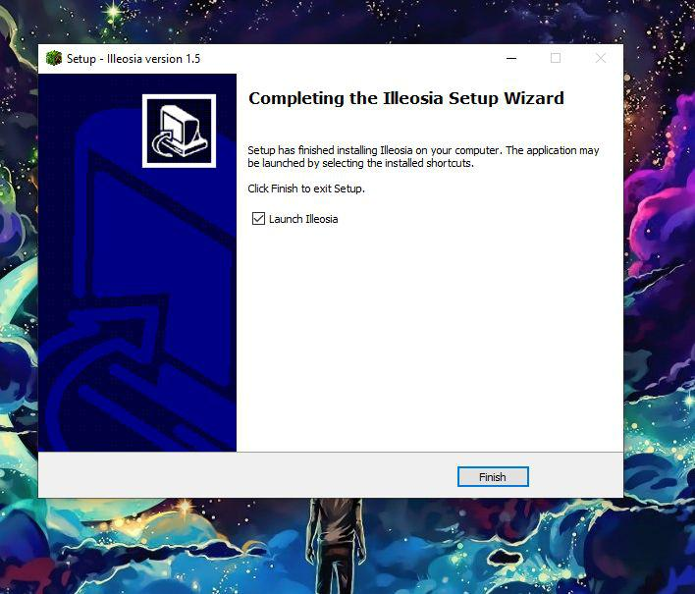

Features:

Now we get to the actual game area. When you begin the game, you can build and destroy. You can destroy a chunk and re-built it. You can also modify anything.

Procedural terrain generation:​ In computing, procedural generation is a method of creating data algorithmically as opposed to manually, typically through a combination of human-generated assets and algorithms coupled with computer-generated randomness and processing power .

The player must continue to generate new worlds in the view area where he is , and when he goes to the world , the world behind him will be destroyed . Here , the full map is infinite.

Blocks :​​Blocks are arranged in a ​3-dimensional grid​of 1-cubic-meter cells. Each cell usually contains exactly one block; exceptions exist in the form of ​slabs​, ​vines​, snow​layers, ​turtle eggs​and ​sea pickles​.

Together, blocks and ​fluids​build up the in-game environment, and most can be harvested and utilized in various fashions. Some blocks, such as ​dirt​and ​sandstone​, are ​opaque​and occupy their entire cubic meter, while other blocks, such as ​glass​and flowers​, are ​transparent​or non-solid. ​Explosions​destroy some blocks more easily than they destroy others.

Chunk :​ Chunks are referred to a collection of blocks to create individual places in the world.

Trees : ​We have trees, made of chunks and blocks. We have to kind of trees. One is regular tree and other is cactus.

Seed: We have a seed function which generates different worlds as per user request.

We are trying to make some more improvements as we are adding more and more features day by day.
How to play:
Main Menu:
Here is a screenshot of the game main menu.
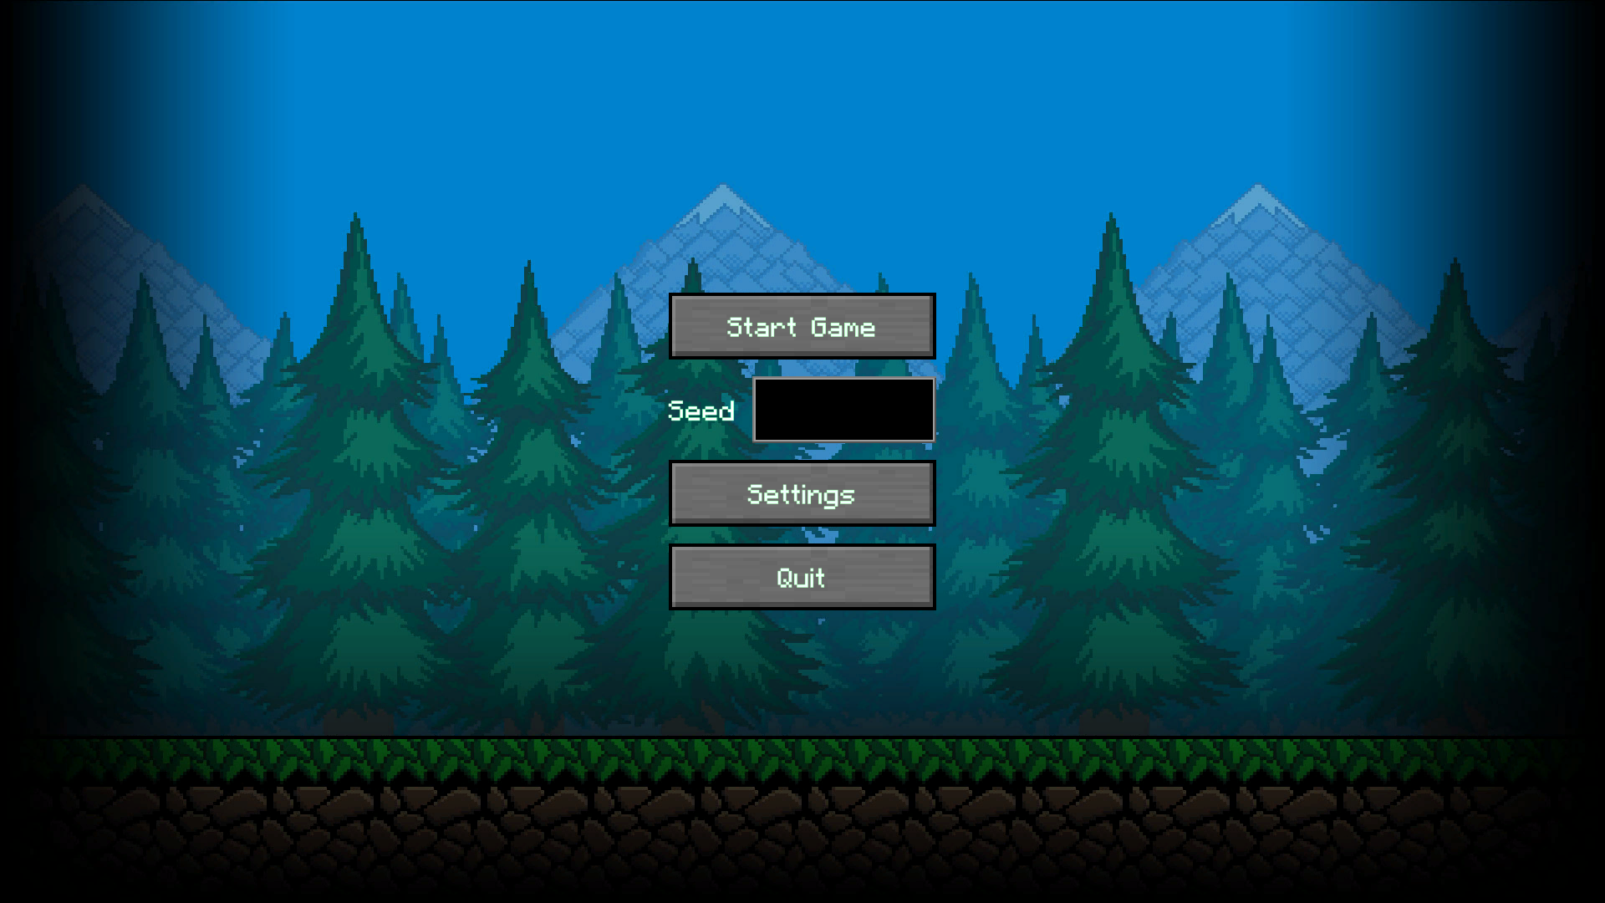

Start Game: Start game button will start the game.
Seed: Seed is a function that generates random world. If seed is not provided, then the game will load default seed. Ex: “Hello”, “New world”, “1234567”
Settings: By clicking the settings button, user can choose different settings for the game.
Quit: Quit button will close the game.
Settings Menu:
Here is a screenshot of settings menu. 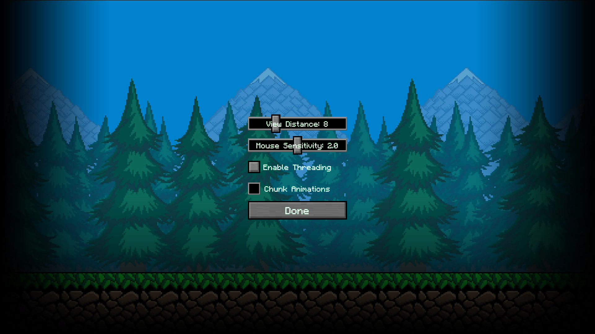

View Distance: View distance refers to how far a player can see. This was added to improve performance. Lower view distance means greater performance.
Mouse Sensitivity: Mouse sensitivity is to control the speed of the mouse movement.
Enable threading: By enabling threading, the game will use multiple cores of the cpu and it will improve performance.
Chunk Animations: Chunk animation is the animation of the world generation. Turning this off will improve performance.
Player Controls:
Movement: Use ‘W’ ‘S’ ‘A’ ‘D’ key to move the player
Jump: Use the space bar to jump
Mouse: Use the Left button mouse to destroy blocks and Right mouse button to place a block. Use the scroll bar to select different blocks from the toolbar.
Inventory: Press ‘I’ for the inventory menu and select different objects from the inventory with mouse click.
Future Plans:
- We will add more biomes in future which will add more variance to the game
- We are planning to add water and water plants to add more variance.
- We will add quests for the player
- We will add day night cycle and special objectives for night mode.

Github project link: https://github.com/sushmoyr/illeosia-lost_realm
Build link: https://github.com/sushmoyr/illeosiaBuild

