azure oryx Error: Couldn't detect a version for the platform 'nodejs' in the repo

https://www.google.com/search?q=azure+oryx+Error%3A+Couldn%27t+detect+a+version+for+the+platform+%27nodejs%27+in+the+repo

Azure Web App + Angular: Couldn’t detect a version for the platform ‘nodejs’ in the repo (https://medium.com/@theartemkovtun/azure-web-app-angular-couldnt-detect-a-version-for-the-platform-nodejs-in-the-repo-3d93892a514e)

1. Web App → Configuration → Application settings → SCM_DO_BUILD_DURING_DEPLOYMENT=false

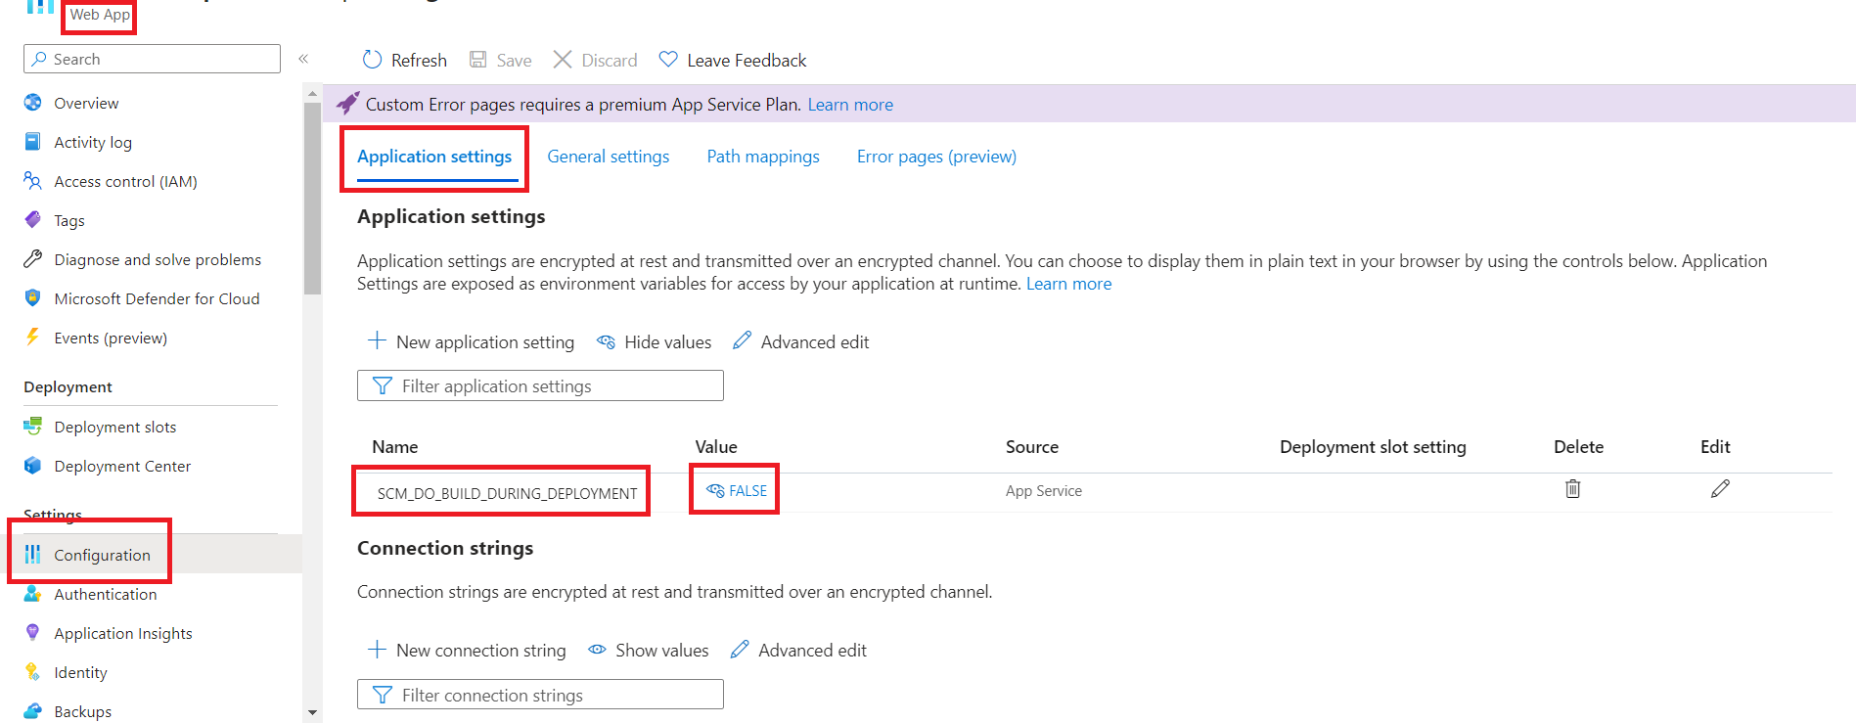

2. Web App → Configuration → General settings → Startup Command=pm2 serve /home/site/wwwroot --no-daemon --spa

