AVERAGE LENGTH OF STAY (ALOS) IN HOSPITALS

Curative Care ALOS vs Impatient Care ALOS

Report by **B239464** to Healthcare Researchers

08-12-2023

Table of Contents

1 INTRODUCTION 2

1.1 Average Length of Stay (ALOS) 2

1.2 Load Raw Dataset 2

1.3 Raw Data Structure and Summary 2

1.4 Data Cleaning 1.0 3

1.5 Vizualizing Average Length of Stay 4

1.6 Pivoting from long to wide data 5

1.7 Data Cleaning 2.0 5

2 INPATIENT CARE ALOS 6

3 CURATIVE CARE ALOS 6

4 FACTORS AFFECTING ALOS & IT’S IMPLICATIONS 6

4.1 Factors: 6

4.2 Implications: 6

5 INPATIENT CARE ALOS vs CURATIVE CARE ALOS 7

5.1 Data Table 7

5.2 Inpatient Care ALOS 7

5.3 Curative Care ALOS 8

6 TRENDS IN ALOS 9

6.1 Trend 1.0 9

6.2 Significance 11

6.3 Data from OECD & Non-OECD Nations 11

6.4 Trend 2.0 11

6.5 Significance 12

7 CONCLUSION 12

8 RECOMMENDATION 13

9 REFERNCES 13

10 REFLECTION 13



# 1 INTRODUCTION

## 1.1 Average Length of Stay (ALOS)

The average length of stay is a broad term that that is used to evaluate hospital efficiency and patient management. It mainly consists of two kinds:

* **Impatient Care Average Length of Stay**
* **Curative Care Average Length of Stay**

Data regarding the above topic is found within the Healthcare Utilization: Hospital aggregate data set. Click [Here](https://stats.oecd.org/index.aspx?queryid=30145) to view the dataset.

This report focuses more on the Average length of stay in the organisation for economic co-operation & development countries.

The code chunk written below will contains libraries that will be loaded from respective packages which will be used on the course of this Analytic report.

pacman:: p_load(  
 "rmarkdown", "tinytex", "tidyverse",   
 "knitr", "rmdformats", "visdat",  
 "here", "finalfit", "gt", "janitor")

## 1.2 Load Raw Dataset

This is the Hospital Aggregates raw data set which includes the Impatient care Average length of stay and Curative care average length of stay that will be extracted for insights

# Importing and loading Hospital Aggregates Data set in a directory  
Hospital_Aggregates_raw <- read_csv(here("Data/HU_HA.csv"))

## 1.3 Raw Data Structure and Summary

Now let’s look at the structure and summmary of our dataset and prior to data cleaning

# familiarizing and understanding the dataset  
head(Hospital_Aggregates_raw)

## # A tibble: 6 × 11  
## VAR Variable UNIT Measure COU Country YEA Year Value `Flag Codes`  
## <chr> <chr> <chr> <chr> <chr> <chr> <dbl> <dbl> <dbl> <chr>   
## 1 HUTIJOCS Curative … NBPH… Number… AUS Austra… 2010 2010 0.8 <NA>   
## 2 HUTIJOCS Curative … NBPH… Number… AUS Austra… 2011 2011 0.8 <NA>   
## 3 HUTIJOCS Curative … NBPH… Number… AUS Austra… 2012 2012 0.8 B   
## 4 HUTIJOCS Curative … NBPH… Number… AUS Austra… 2013 2013 0.8 <NA>   
## 5 HUTIJOCS Curative … NBPH… Number… AUS Austra… 2014 2014 0.8 <NA>   
## 6 HUTIJOCS Curative … NBPH… Number… AUS Austra… 2015 2015 0.8 B   
## # ℹ 1 more variable: Flags <chr>

# Visualizing the variable types  
vis_dat(Hospital_Aggregates_raw)

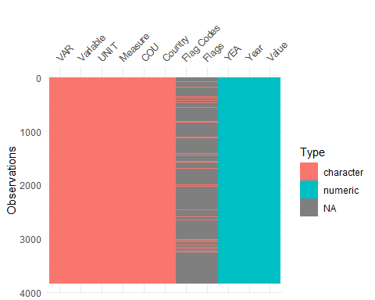

distinct(Hospital_Aggregates_raw , Variable) # No. of Variables present

## # A tibble: 6 × 1  
## Variable   
## <chr>   
## 1 Curative care bed-days   
## 2 Curative care occupancy rate   
## 3 Curative care discharges   
## 4 Inpatient care discharges (all hospitals)   
## 5 Inpatient care average length of stay (all hospitals)  
## 6 Curative care average length of stay

## 1.4 Data Cleaning 1.0

The Hospital Aggregate raw data set is explored and wrangled to get complete and sufficient data as the average days for both Inpatient care ALOS and Creative care ALOS is determined in the last decade. Only countries with complete values in the last decade will be used in for further analysis. Those with NA or missing values are dropped out or filtered out.

data_hg <- Hospital_Aggregates_raw %>%   
 select(Year, Country, Variable, Measure, Value) %>%  
 filter(Variable %in% c("Inpatient care average length of stay (all hospitals)",   
 "Curative care average length of stay")) %>%   
 clean_names() %>%   
 filter(!(year %in% c(2021:2022)) & !(country %in% c("Brazil",  
 "Bulgaria",  
 "China (People's Republic of)",   
 "Croatia",  
 "Romania",  
 "Russia",  
 "South Africa"))) %>% # exclude all non-oecd countries  
 drop_na() %>% #drop all rows with NA values   
 arrange(year)  
  
data_hg %>%   
 distinct(measure) # check for distinct observation

## # A tibble: 1 × 1  
## measure  
## <chr>   
## 1 Days

data_hg %>%   
 tabyl(country) %>% # Tabulate the data by country and counts no. of values   
 filter(n < 22) # 22 values for each year and remove countries less than 22

## country n percent  
## Canada 11 0.014627660  
## Chile 11 0.014627660  
## Colombia 8 0.010638298  
## Denmark 11 0.014627660  
## Greece 12 0.015957447  
## Mexico 11 0.014627660  
## Netherlands 7 0.009308511  
## Slovak Republic 21 0.027925532

mean_year <- data_hg %>%   
 filter(!(country %in% c("Canada",  
 "Chile",  
 "Colombia",   
 "Denmark",  
 "Greece",  
 "Mexico",  
 "Netherlands",  
 "Slovak Republic"))) %>%  
 group_by(year, variable, measure) %>%   
 summarize(mean_value = mean(value)) %>%   
 mutate(mean_value = round(mean_value, 1)) %>%   
 ungroup()

## 1.5 Vizualizing Average Length of Stay

A line graph showing the difference between the Curative care ALOS and Inpatient care ALOS from 2010-2020.

gap_years <- seq(from = 2010, to = 2020, by = 1) # gap of 1 year from 2010-2020  
  
 ggplot(mean_year, mapping = aes(x = year, y = mean_value, color = variable)) +  
 geom_line(linewidth = 1) + geom_point(color = "black") +   
 scale_x_continuous(breaks = gap_years)+   
 geom_text(aes(label = mean_value, vjust = -0.3)) +   
 theme(legend.title = element_blank()) + theme(legend.position = "top") +  
 labs(title = "AVERAGE LENGTH OF STAY",  
 subtitle = "Curative care ALOS vs Impatient care ALOS in the Last Decade",  
 x = "Year", y = "Average Days",  
 caption = "source: https://stats.oecd.org  
 Accessed Sunday 7th November, 2023")

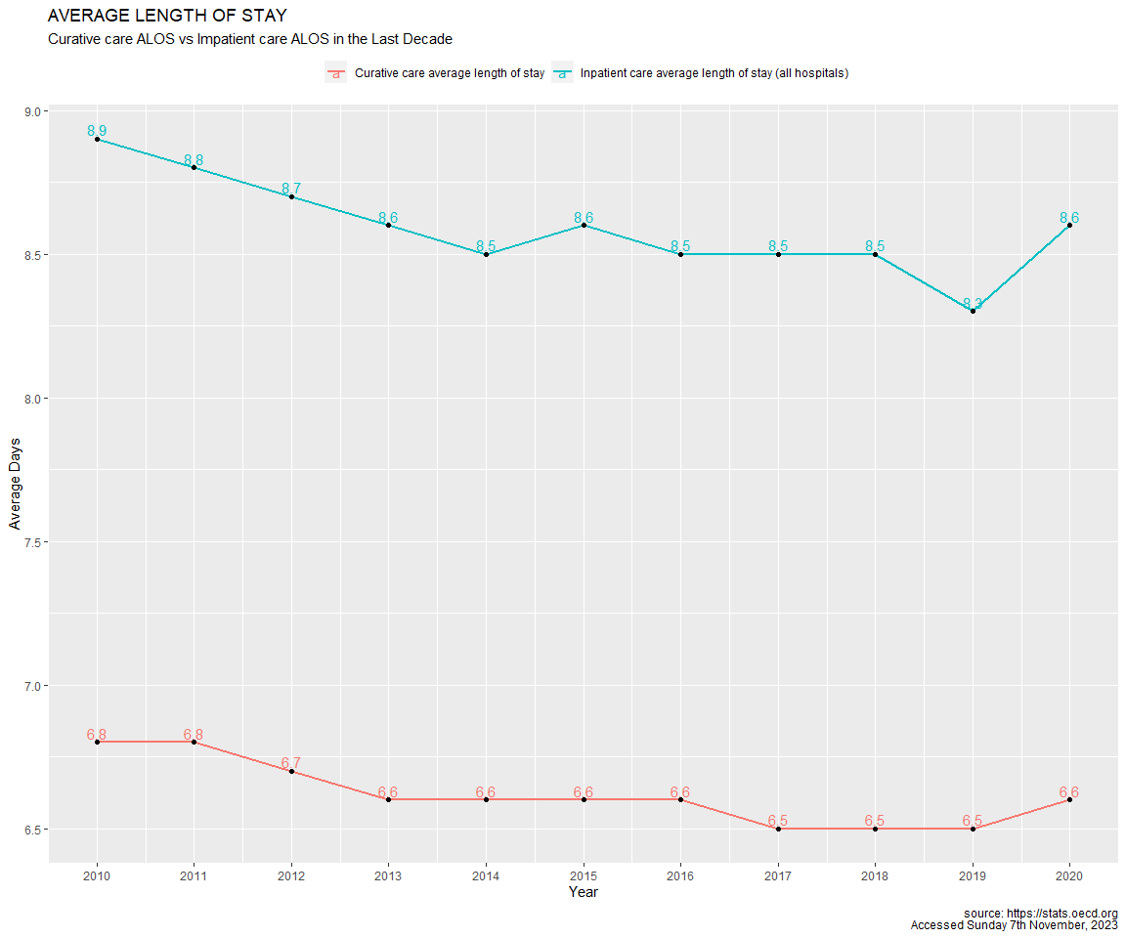

From the Plot above, one can tell that Impatient ALOS tends to be higher than the Curative ALOS. Going further, the two variables down trended as years went by in the last decade with a marked uptrend in 2020. This is sign that most OECD countries are doing fine in terms of Healthcare efficiency

Overall, It shows that curative care could be a subset to inpatient care since curative care may lead to inpatient care if triggered by some factors and not the other way round.

## 1.6 Pivoting from long to wide data

The dataset is currently a long data but we need to change to wide data in other to access and easily wrangle the Variable and Measure columns with there respective Values. At the end, the column names are cleaned to snake case for better manipulation.

# Pivoting from long to wide data  
wide_data <- Hospital_Aggregates_raw %>%  
 pivot_wider(names_from = c(Variable, Measure),  
 values_from = Value,  
 id_cols = c(Year, Country))%>%   
 clean_names() # clean names to lower and snake case for easy manipulation

## 1.7 Data Cleaning 2.0

Now Data cleaning is done by selecting and renaming the main variables for the report:

* Impatient Care Average Length of Stay
* Curative Care Average Length of Stay

The year and country variables are needed too during the analysis.

Going forward, since the report is on about the last decade, the year 2021 & 2022 is filtered out of the data and the Non-organisation for economic co-operation & development countries (Non-OECD), thereby isolating only the organisation for economic co-operation & development countries (OECD) for the report.

All rows containing NA values are dropped as only countries with complete data on the Inpatient ALOS Care and Curative Care ALOS are needed for further analysis

clean_data <- wide_data %>%  
 select(year, country,   
 inpatient_care_alos = inpatient_care_average_length_of_stay_all_hospitals_days,   
 curative_care_alos = curative_care_average_length_of_stay_days)%>%  
 filter(!(year %in% c(2021:2022)) & !(country %in% c("Brazil",  
 "Bulgaria",  
 "China (People's Republic of)",   
 "Croatia",  
 "Romania",  
 "Russia",  
 "South Africa"))) %>% # exclude year: 2021-2022 a& all non-oecd countries  
 drop_na() %>% # Drop all rows with NA values  
 arrange(country) # Arrange by ascending order by default

It appears **Greece** and **Slovakia Republic** had empty cells for 5 years and a year respectively. So, we filter them out as other countries with NA values has already been dropped too. All these filtering and dropping helps to give a good sample of complete data to work with.

# Check and view for missing value either in Impatient ALOS or Curative ALOS  
clean_data %>%   
 tabyl(country, year) %>% # tabulates country on rows and year columns   
 View()  
  
oecd_countries <- clean_data %>%   
 filter(!(country %in% c("Greece", "Slovak Republic")))   
# Both countries had empty values in 1 or more years  
  
# Cross check if code was successful  
oecd_countries %>%  
 tabyl(country, year) %>%   
 View()

# 2 INPATIENT CARE ALOS

The Inpatient care average length of stay (ALOS) is a crucial metric that measures the duration of a patient’s hospitalization. It is often used as an indicator of efficiency. Understanding the determinants of ALOS can shed light on healthcare resource utilization, patient outcomes, and the efficiency of healthcare delivery. This is done in a hospital.

**Formula**:

**Total number of days stayed by all inpatients during a year** divided by **the number of admissions or discharges**. The indicator excludes days cases.

# 3 CURATIVE CARE ALOS

Curative care, also known as acute care, is the type of medical care focused on diagnosing and treating acute conditions or injuries. It involves hospitalization and is generally aimed at providing immediate relief and restoring health. This can be done in hospital, clinics, homes etc. This technically means that the curative care ALOS is a subset of Inpatient Care ALOS.

**Formula**:

**Number of curative care bed-days divided** divided by **number of curative care discharge during the year**

# 4 FACTORS AFFECTING ALOS & IT’S IMPLICATIONS

## 4.1 Factors:

1. **Severity and Complexity of Illness**: The severity and complexity of a patient’s condition significantly impact the ALOS. Patients with more severe or complex illnesses such as cancer or cardiovascular disorders, tended to have longer hospital stays for diagnosis, treatment, and monitoring (Verweij *et al*., 2017).
2. **Comorbidities**: The presence of comorbidities, which refers to the simultaneous occurrence of multiple medical conditions, can complicate treatment plans and extend the hospital stay (Rothberg *et al*., 2017).
3. **Diagnostic Evaluations**: The length of hospital stay can be influenced by the time required to conduct diagnostic evaluations. Diagnostic procedures, including laboratory tests, radiological investigations, and specialized consultations, contribute to the ALOS (Gandelman *et al*., 2019).
4. **Bed Availability and Resource Constraints**: Hospital resource availability, such as the number of available beds or healthcare personnel, plays a role in determining ALOS. When hospitals experience bed shortages or resource constraints, patients may experience longer waits for admission or discharge. Additionally, limited resources can impact patient flow, leading to extended stays (Hamblin *et al*., 2016).

## 4.2 Implications:

The above factors has far-reaching implications on:

1. **Healthcare Resource Utilization**
2. **Cost Implications**
3. **Patient Experience and Outcomes**
4. **Capacity Management and Access**

# 5 INPATIENT CARE ALOS vs CURATIVE CARE ALOS

From the data frame of the oecd_countries, the mean ALOS for respective countries can be calculated by grouping by country and summarizing the mean for both Impatient Care ALOS and Curative Care ALOS

mean_oecd_countries <- oecd_countries %>%   
 group_by(country) %>%   
 summarise(mean_inpatient_care_alos = mean(inpatient_care_alos),   
 mean_curative_care_alos = mean(curative_care_alos)) %>%   
 mutate(mean_inpatient_care_alos = round(mean_inpatient_care_alos, 1),   
 mean_curative_care_alos = round(mean_curative_care_alos, 1)) %>%   
 arrange(country)

## 5.1 Data Table

Now a glimpse of a structured table for the cleaned data set is produced. A randomly selected rows of the data table mean_oecd_countries can be seen and understood according to respective variable.

mean_oecd_countries %>%   
 slice(1:3, 15:17, 27:30) %>%   
 gt() %>%   
 tab_header(title = "Average Length of Stay in the Last Decade",  
 subtitle = "The Mean Average Length of Stay in Randomly Selected OECD Countries") %>%   
 cols_label(country = "Country",  
 mean_inpatient_care_alos = "Mean Inpatient Care ALOS",  
 mean_curative_care_alos = "Mean Curative Care ALOS") %>%   
 cols_align(align = "center")

Table : Average Length of Stay in the Last Decade

The Mean Average Length of Stay in Randomly Selected OECD Countries

| Country | Mean Inpatient Care ALOS | Mean Curative Care ALOS |
| --- | --- | --- |
| Australia | 5.4 | 4.7 |
| Austria | 8.2 | 6.4 |
| Belgium | 7.5 | 6.8 |
| Japan | 29.6 | 16.8 |
| Korea | 17.4 | 8.4 |
| Latvia | 8.3 | 5.9 |
| Switzerland | 8.5 | 7.2 |
| Türkiye | 4.1 | 4.0 |
| United Kingdom | 7.1 | 6.1 |
| United States | 6.1 | 5.5 |

## 5.2 Inpatient Care ALOS

**Plotting the Mean Inpatient care ALOS for respective OECD Countries in the past decade**

ggplot(mean_oecd_countries, mapping = aes(x = reorder(country, mean_inpatient_care_alos),   
 y = mean_inpatient_care_alos,   
 group = country, fill = country)) +   
 geom_col() + coord_flip() + theme_bw() +  
 geom_text(aes(label = mean_inpatient_care_alos, vjust = 0.4, hjust = -0.1)) +  
 theme(legend.position = "none") +  
 labs(title = "Inpatient Care Average Length of Stay within the last decade",   
 subtitle = "Inpatient Care ALOS across the OECD Countries in Days",   
 x = "OECD Countries", y = "Inpatient Care Average Lenght of Stay",  
 caption = "source: https://stats.oecd.org  
 Accessed Sunday 17th November, 2023")

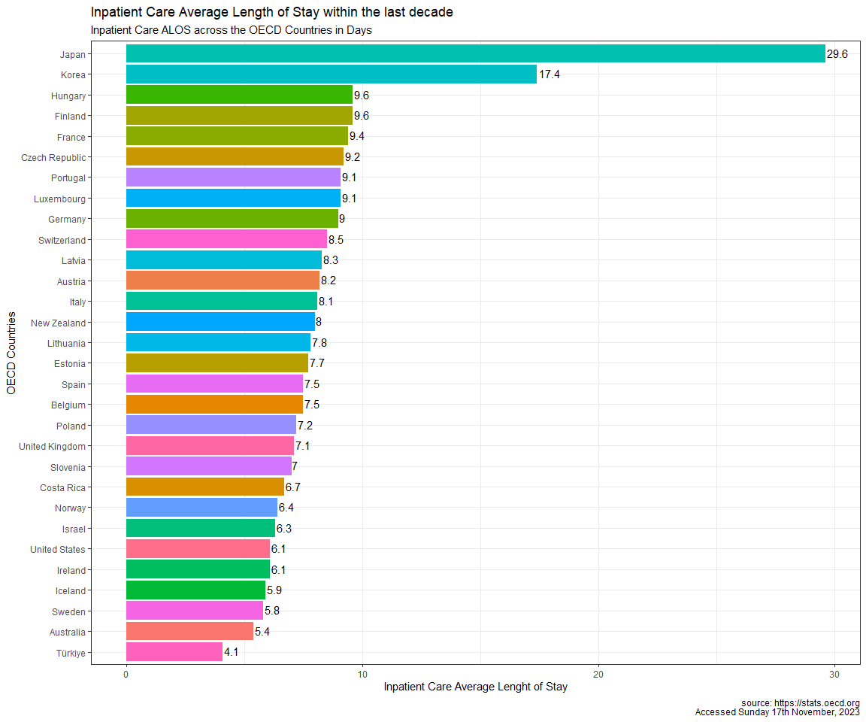

Although both curative care ALOS and inpatient care ALOS are dropping over the years, countries such as Japan and Korea had the longest Inpatient average length of stay with **29.6** and **17.4** days respectively. Majority of the countries fell between **5.4** and **9.6** days, with Turkiye standing out with the best Days of **4.1**

This means Japan and Korea has a poor healthcare efficiency and patient management and would be needing more investment in to healthcare facilities and resources from the health government to mitigate this high days.

## 5.3 Curative Care ALOS

**Plotting the Mean Curative care ALOS for respective OECD Countries in the past decade**

ggplot(mean_oecd_countries, mapping = aes(x = reorder(country, mean_curative_care_alos),   
 y = mean_curative_care_alos,   
 fill = country)) +   
 geom_col() + coord_flip() + theme_bw() +  
 geom_text(aes(label = mean_curative_care_alos, vjust = 0.4, hjust = -0.1)) +  
 theme(legend.position = "none") +  
 labs(title = "Curative Care Average Length of Stay within the last decade",   
 subtitle = "Curative Care ALOS across the OECD Countries in Days",   
 x = "OECD Countries", y = "Curative Care Average Lenght of Stay",  
 caption = "source: https://stats.oecd.org  
 Accessed Sunday 17th November, 2023")

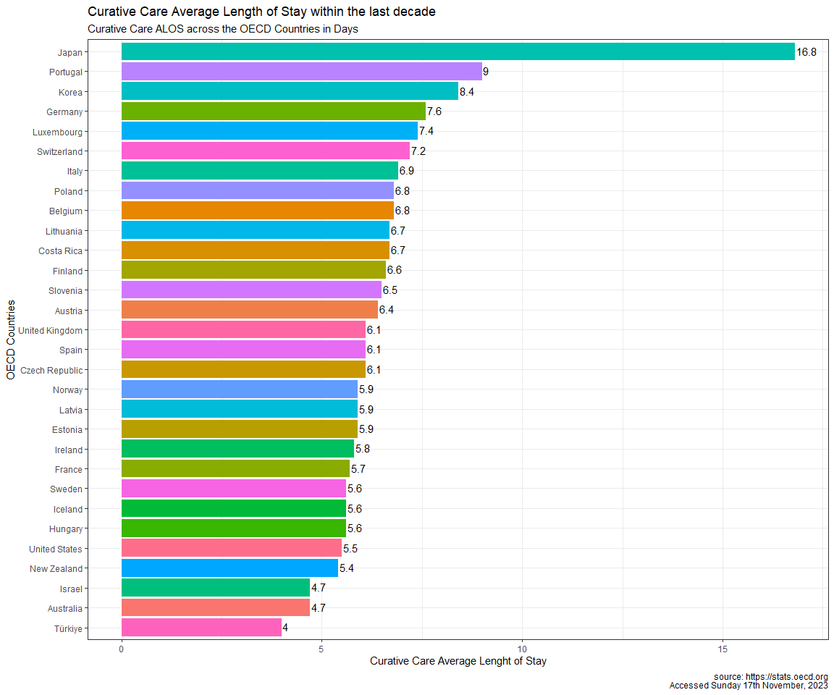

Japan still had the longest Curative care average length of stay with **16.8** days

This is a confirmation that Japan has a poor healthcare efficiency and patient management and would be needing more investment in to healthcare facilities and resources from the health government.

It appears Turkiye is still the best overall with just **4** days, followed by Australia and Israel. This signifies a very productive, organised and efficient healthcare system.

# 6 TRENDS IN ALOS

1. **Advancements in Medical Technology**:
2. **Shift to Ambulatory Care**
3. **Enhanced Discharge Planning**
4. **Emphasis on Home Healthcare**

## 6.1 Trend 1.0

**Visualizing the Trend between Inpatient average length of stay and Curative care average length of stay in the OECD Countries from 2010-2020**

ggplot(oecd_countries, mapping = aes(x = curative_care_alos,   
 y = inpatient_care_alos)) +  
geom_point(aes(color = country)) + scale_x_log10() + scale_y_log10() +   
geom_smooth(method = "glm", se = FALSE) + theme(legend.position = "none") +  
labs(title = "Impatient Care ALOS vs Curative Care ALOS (OECD Nations) ",   
 subtitle = "Trend Between the Curative Care ALOS and Inpatient Care ALOS in the last decade",   
 x = "Curative Care ALOS", y = "Inpatient Care ALOS",   
 caption = "Source: https://stats.oecd.org")

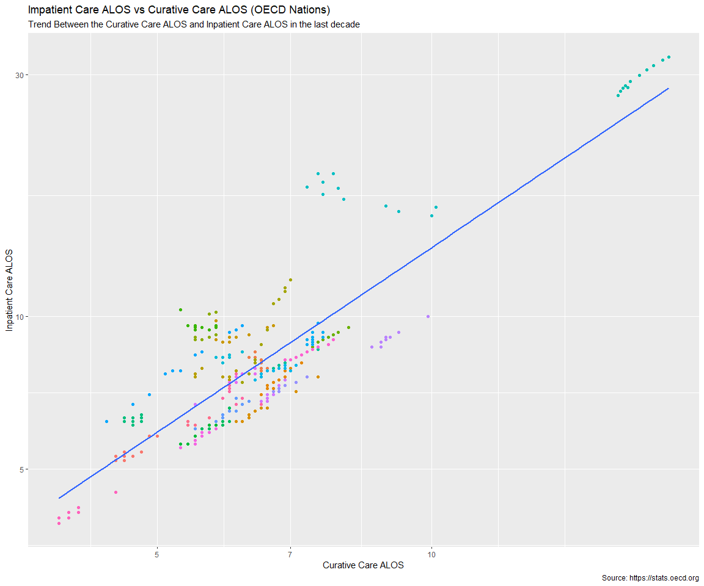

Majority of the data point ranged between **3.9-12** and **3.9-10** days for *Inpatient care ALOS* and *Curative care ALOS* respectively, with data points from Japan and Korea looking like outliers from the rest of data points from other countries as a result of their higher Inpatient average length of Stay in Hospitals.

The General linear model method checks for correlation between the Impatient ALOS and Curative ALOS for respective countries. This concluded that there is a positive correlation between the Curative Care ALOS and Inpatient Care ALOS

**Visualizing the Trend between Inpatient average length of stay and Curative care average length of stay in the OECD Countries for each years**

ggplot(oecd_countries, mapping = aes(x = curative_care_alos,   
 y = inpatient_care_alos)) +  
geom_point(aes(color = country)) + scale_y_log10() + scale_x_log10() +  
geom_smooth(method = "glm", se = FALSE) + facet_wrap(~year) +  
labs(title = "Impatient Care ALOS vs Curative Care ALOS",   
 subtitle = "Understanding the Trend Between the Curative Care ALOS and Inpatient Care ALOS for Respective Year",   
 x = "Curative Care ALOS", y = "Inpatient Care ALOS",   
 caption = "Source: https://stats.oecd.org")

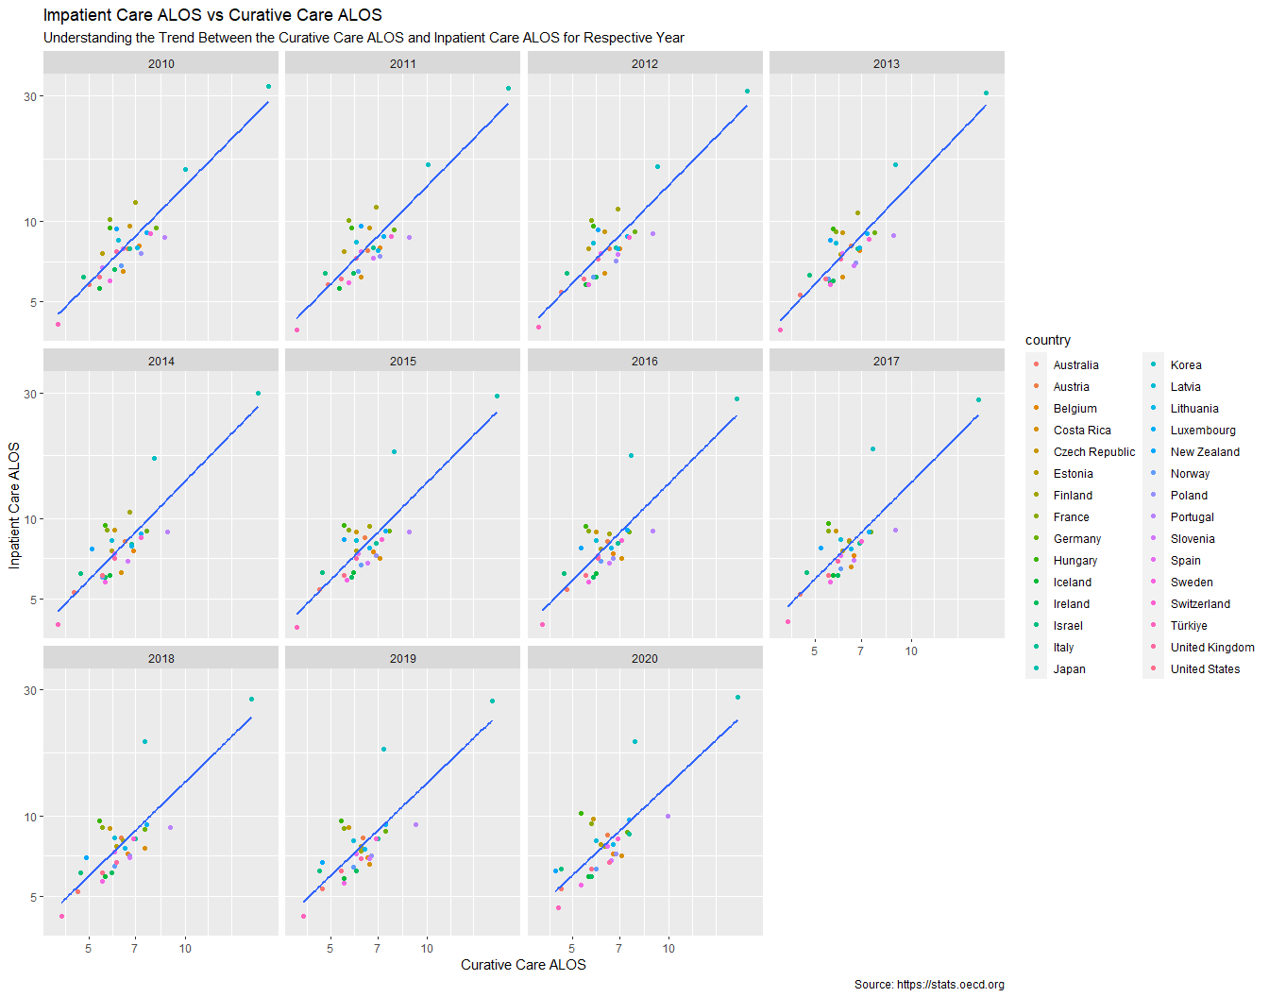

## 6.2 Significance

The above plots indicating trend lines proves that the both curative care ALOS and inpatient care ALOS has a positive correlation and it statistically proven with a low p-valve of 0.001. This means that as Curative care ALOS decrease, Inpatient care ALOS also decreased respectively, and an increase in one variable could also result in a increase in the other.

oecd_countries %>%   
summary_factorlist(dependent = "inpatient_care_alos",   
 explanatory = "curative_care_alos",  
 p = TRUE,  
 column = TRUE) %>%   
 gt() %>%   
 cols_align(align = "center")

| **Label** | **Levels** | **Unit** | **Value** | **P** |
| --- | --- | --- | --- | --- |
| curative_care_alos | [3.9,18.2] | Mean (sd) | 8.6 (4.5) | <0.001 |

## 6.3 Data from OECD & Non-OECD Nations

**Including data from both oecd and non-oecd countries in the last decade without dropping any NA or Missing values**

allclean_data <- wide_data %>%  
 select(year, country,   
 inpatient_care_alos_days = inpatient_care_average_length_of_stay_all_hospitals_days,   
 curative_care_alos_days = curative_care_average_length_of_stay_days) %>%  
 filter(!(year %in% c(2021:2022)))

## 6.4 Trend 2.0

**Visualizing the Trend between Inpatient average length of stay and Curative care average length of stay in both OECD & Non-OECD Countries from 2010-2020**

ggplot(allclean_data, mapping = aes(x = curative_care_alos_days,   
 y = inpatient_care_alos_days)) +  
geom_point(aes(color = country)) + geom_smooth(method = "glm", se = F) +   
scale_y_log10() + scale_x_log10() + theme(legend.position = "none") +  
labs(title = "Impatient Care ALOS vs Curative Care ALOS (OECD & Non-OECD Nations)",   
 subtitle = "Trend Between the Curative Care ALOS and Inpatient Care ALOS in the last decade",   
 x = "Curative Care ALOS_Days", y = "Inpatient Care ALOS_Days",   
 caption = "Source: https://stats.oecd.org  
 accessed Sunday 7th November, 2023")

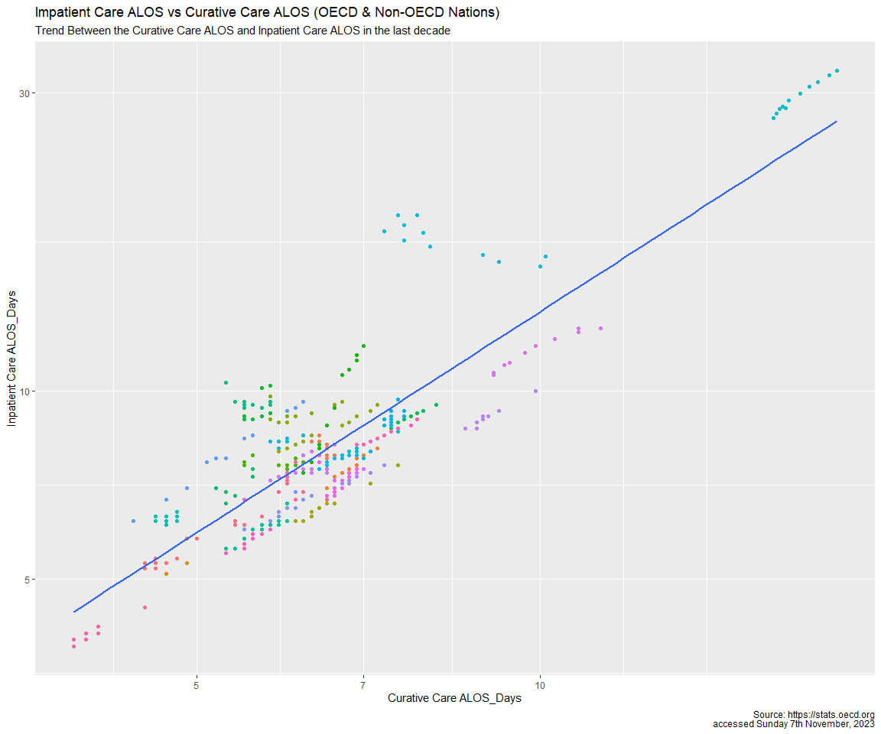

## 6.5 Significance

The above plots still proves that the curative care ALOS has a positive impact on the inpatient care ALOS and it statistically proven with a low p-valve of 0.001

allclean_data %>%   
 summary_factorlist(dependent = "inpatient_care_alos_days",   
 explanatory = "curative_care_alos_days",  
 p = TRUE,  
 column = TRUE) %>%   
 gt() %>%   
 cols_align(align = "center")

| **Label** | **Levels** | **Unit** | **Value** | **P** |
| --- | --- | --- | --- | --- |
| curative_care_alos_days | [3.9,18.2] | Mean (sd) | 8.1 (4.0) | <0.001 |

# 7 CONCLUSION

It was observed that as Curative care days dropped, Inpatient care days dropped as years went on across most countries. This indicates a positive correlation between the two variables.

This could mean that aiming for shorter Curative care days could further shorten the Inpatient care days since the former can be a subset of the later thereby improving healthcare efficiency in a given country and across the globe. A subset in the sense that at times, some factors can influence a curative care to lead to inpatient care and if not well managed, can further increase the inpatient care ALOS

Some of the times, Patients who require curative care could end up receiving impatient care due to some of the factors that can increase the length of stay. This is are most time beyond the hospital power and could have negative impact on the healthcare system.

# 8 RECOMMENDATION

Recent trends signify a shift towards shorter hospital stays due to advancements in medical technology, increased emphasis on ambulatory care, improved discharge planning, and the integration of home healthcare services (Curative Care).

As healthcare continues to evolve, improving efficiency and reducing the ALOS should remain a priority to enhance patient outcomes and optimize resource utilization.

Healthcare Researchers can understand ALOS in hospitals and know that the inpatient care ALOS is the major indicator for efficiency.

Although Having fully equipped hospitals settings is paramount to measuring the Inpatient Care ALOS, investment into curative care by integration of home care services and more ambulatory care is a big advantage as this can positively impact Inpatient ALOS days by reducing the amount of beds occupied my patients, thereby facilitating better patient management for the few admitted patient. This topic appears to be statistically proven.

# 9 REFERNCES

1. Chakkera, H. A., *et al.* (2018). Surgical Procedures and Length of Stay for Kidney Transplantation: A Single-Center Experience. Transplantation Proceedings, 50(6), 1713-1716.
2. Gandelman, G., *et al.* (2019). A novel laboratory-based admissions risk score to predict the average length of stay. PloS One, 14(6), e0218671.
3. Hamblin, P., *et al.* (2016). Hospital utilization and average length of stay in the emergency department: a benchmarking approach. BMC Health Services Research, 16(1), 1-7.
4. Rothberg, M. B., *et al.* (2017). Factors associated with the costs and outcomes of hospitalized patients with exacerbation of chronic obstructive pulmonary disease. Journal of General Internal Medicine, 32(2), 159-165.
5. Verweij, L., *et al.* (2017). Patient characteristics and treatment patterns contributing to long hospital stays in patients with major depressive disorder. PloS One, 12(3), e0170748.

# 10 REFLECTION

* First, familiarizing my data and Understanding the meaning of average length of stay (ALOS) and the difference between the inpatient care ALOS and Curative care ALOS using data from the organisation for economic co-operation & development countries (OECD).
* Well at some point, I thought why did I focus on just the OECD countries and leaving out the Non-OECD countries? Perhaps I could find some hide pattern or information. I just thought it will make the report lengthy, so i just included data from there in the last scatter plot
* I had to filter out few countries out of the data set as I wished to work with a complete data set. Although I felt it could be bad at the beginning, it turned out all fine as it helped me focus on limited countries with complete data.
* During the analysis, I came to understand the importance data quality collection, as it could help scientist better understand the data better and how handy data manipulation tools can be to wrangle and transform data to extract insights and patterns. Academically, I see the significance of data and knowing your audience and professionally, I think critical thinking necessary to survive in the field of data science.
* Inclusion from my reflection, I have come to understand the importance of working as a team to help utilize energy, skill and focus on respective task goals, because data is big and still growing enormously. I also see why story telling is important because it shows one’s communication skill from the analysis/report generated.
* I think I need to practice more R programming skill and improve my critical thinking to help me speed up my data manipulation and interpretation ability.

**by B239464 to Healthcare Researchers**

*THANK YOU*