## NMEA files:

In the first part of our project we asked to create NMEA files with our cellphones or using software, and search at the internet special NMEA files (plane, hot air balloon, ship ...).

We choose a system that can read the NMEA files and produce such.

The system we choose is - **SatGen 3**.

The system allows to read NMEA files and shows the file details on the route – time, final distance, graph of speed, and show the route graph.

In addition the system can read also KML files and show the same details as the NMEA file.

The system can create demo files by two options :

* Create a route from one point on the map and set the time.
* Creating a route by selecting points on the map.

After it create the demo file it shows the same details as the NMEA file.

Here is the software website - <http://www.labsat.co.uk/index.php/en/products/satgen-simulator-software>.

Converting NMEA files to CSV and KML files

In our project we ask to convert NMEA files to CSV and KML files by using python language. We built a system that can do this conversion.

**Options the system offers:**

* Upload NMEA files to database by MySQL
* Select the wanted data from the NMEA files (height, speed, time ...).
* Choose the file type that we want to convert to – KML or CSV – from the database.
* Create the file requested

## About the system:

The system allows to download NMEA files and save them into a database, also the system allows to make CSV and KML files from the database.

Here is our UML :

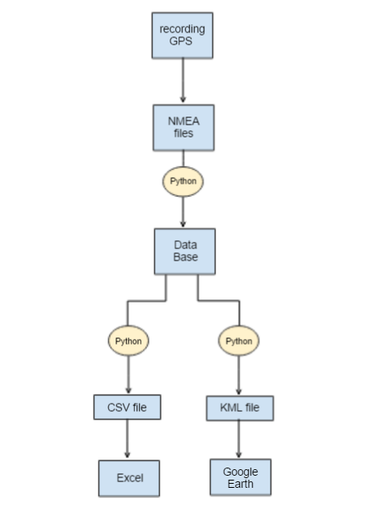

## Authors:

* Chen Maman
* Tom Suad
* Doodi Yehezkel
* Roi Yadai