SUPPLY CHAIN STRATEGY · 2022–2026 RESEARCH SYNTHESIS
Going Circular to Stay Resilient
How Circular Economy Practices Are Redefining Supply Chain Optimization in Fashion, Textile & Manufacturing
By Abdulla Daabal · April 2026 · 3-min read

Circular economy is no longer just a sustainability signal. Recent empirical research shows it can also strengthen cost efficiency, recovery speed, and resource resilience. (Pellegrino et al., 2025; Colombo et al., 2025; Cafforio et al., 2025).
This is particularly relevant in an era of repeated supply uncertainty, shaped by geopolitical risks, pandemic shocks, and maritime chokepoint disruptions, all of which have exposed the vulnerability of linear supply chains. Across fashion, textile, and manufacturing, the message is consistent: circularity works best when it is designed as a supply chain strategy rather than a CSR add-on. (Colombo et al., 2025; Vietnam GSCM Study, 2022; Circular Fashion SC Empirical Study, 2024-2025).

1. The Linear Model Is Broken — and Regulators Know It
Linear supply chains are fragile because value leaves the system after use. Recent disruptions across sourcing regions and trade routes have shown how quickly that model can break under pressure, especially when firms remain dependent on virgin inputs and narrow supply channels. The emerging evidence base suggests that reuse, remanufacturing, reverse logistics, and supplier collaboration create alternative material pathways that reduce disruption risk and strengthen resilience. (Pellegrino et al., 2025; Cafforio et al., 2025).
That matters most in sectors facing input volatility, waste pressure, and sustainability scrutiny, where resilience and resource efficiency increasingly move together. (Colombo et al., 2025; Vietnam GSCM Study, 2022).

📖 DEFINITION: What Is a Circular Supply Chain?
A circular supply chain keeps materials in productive use through reuse, remanufacturing, take-back, and closed-loop supplier collaboration, reducing reliance on virgin inputs over time. (Pellegrino et al., 2025).

2. The Evidence: CE Practices Deliver Measurable Gains
Pellegrino et al. (2025) show a clear pathway: CE adoption improves supply chain resilience and risk mitigation, and both feed into stronger economic, operational, and environmental performance. The effect is strongest under high supply risk, making circularity especially relevant in volatile markets. (Pellegrino et al., 2025).
- CE practices -> Supply Chain Resilience (robustness, agility, recovery speed)
- CE practices -> Risk Mitigation (reduced raw material exposure)
- Both pathways -> Improved Firm Performance (economic, operational, and environmental)
In other words, circularity is not just greener operations; it is a practical way to recover faster and perform better when disruption hits. (Pellegrino et al., 2025).

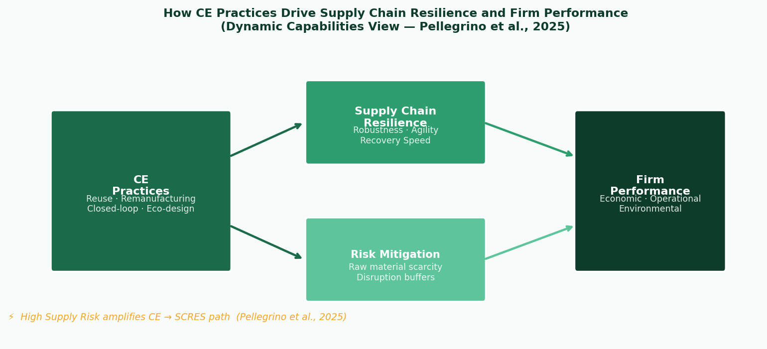
Figure 1: CE -> SCRES -> Performance Pathway (Pellegrino et al., 2025)

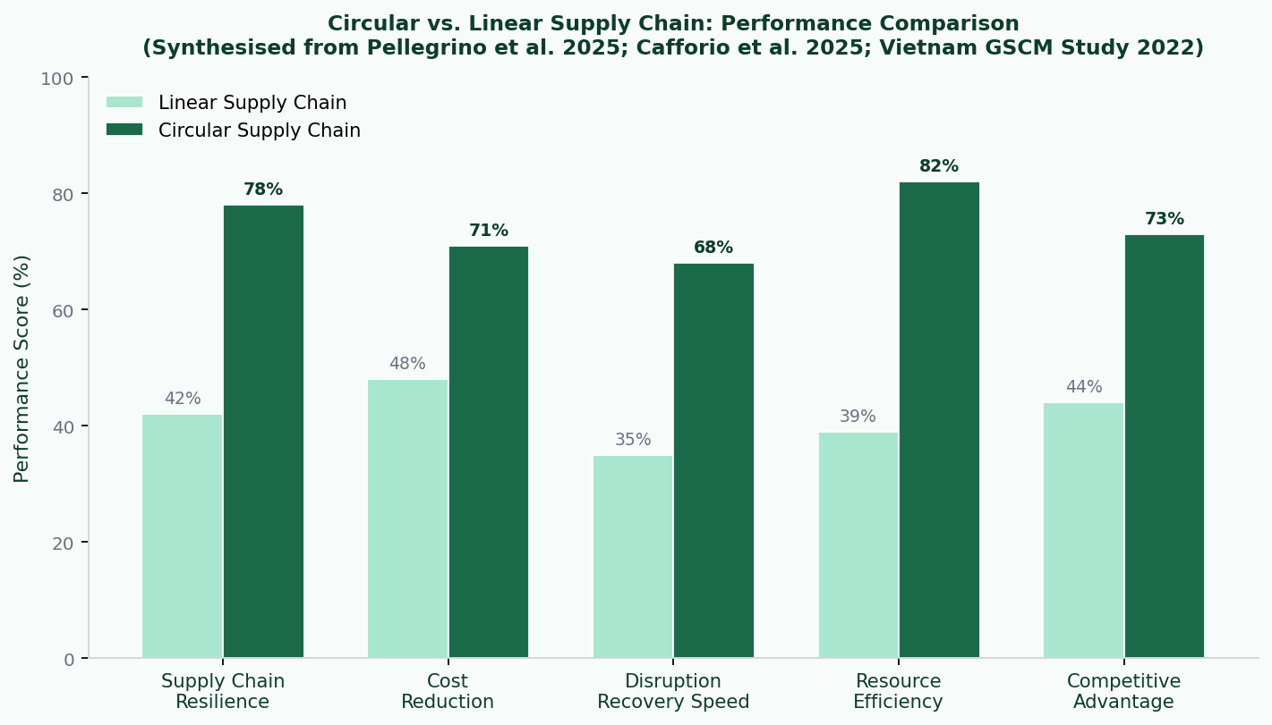
Figure 2: Performance Comparison - Circular vs Linear Supply Chains (Synthesised from 2022-2025 empirical studies)

3. Take-Back Programs: The Resilience Buffer Nobody Planned For
Cafforio et al. (2025) find that take-back programs act as a resilience buffer by creating a secondary material reservoir. In disruption scenarios, firms with reverse logistics recovered equilibrium performance about four months faster than linear peers. (Cafforio et al., 2025).
For operations teams, that makes take-back more than a waste initiative - it is a form of inventory and sourcing insurance. (Cafforio et al., 2025).

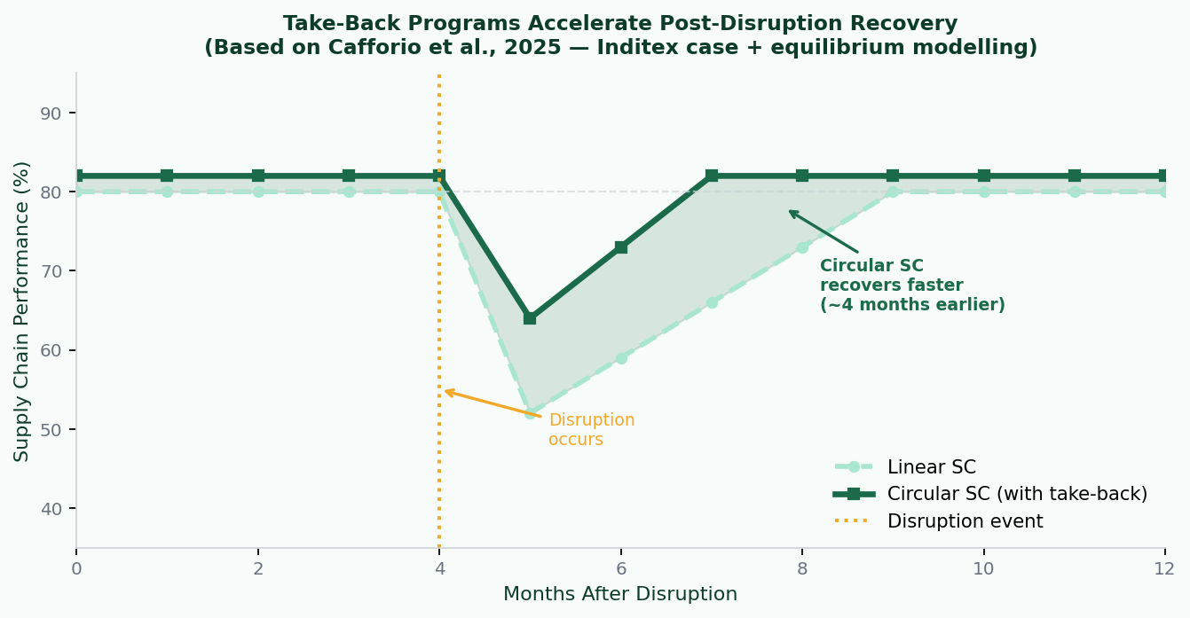
Figure 3: Post-Disruption Recovery - Circular vs Linear Supply Chains (Based on Cafforio et al., 2025)

🏭 CASE SNAPSHOT: Inditex Take-Back
Using the Inditex case, Cafforio et al. (2025) show that garment take-back can lower long-run cost and emissions while accelerating post-disruption recovery. (Cafforio et al., 2025).

4. Sector Deep-Dives: Fashion vs. Manufacturing
The sector pattern is similar, but the route differs: fashion advances through collaboration and visibility, while manufacturing gains through scale, recovery, and cost leverage. (Colombo et al., 2025; Vietnam GSCM Study, 2022).
Fashion & Apparel: Colombo et al. (2025) show that shared take-back logistics and eco-design with suppliers reduce virgin material dependence and improve adaptability to supply shocks. (Colombo et al., 2025).

General Manufacturing: The 2022 Vietnam study finds that green purchasing, eco-design, and reverse logistics improve firm performance, especially when supply chain integration is strong. (Vietnam GSCM Study, 2022).

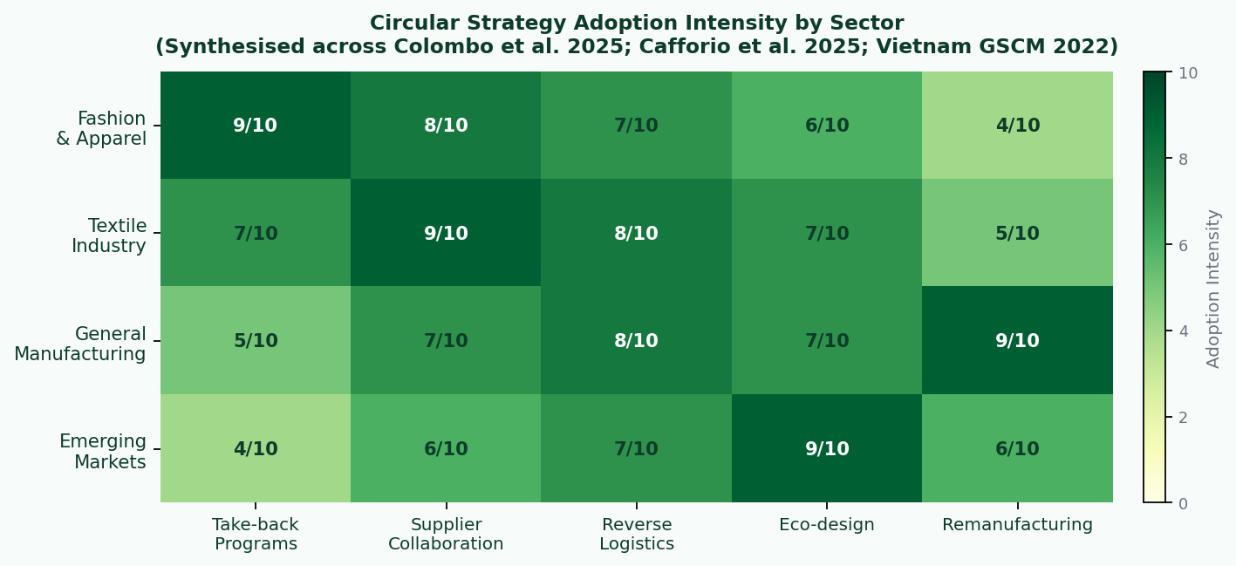
Figure 4: Circular Strategy Adoption Intensity by Sector (Synthesised from Colombo et al., 2025; Cafforio et al., 2025; Vietnam GSCM Study, 2022)

5. Evidence Scorecard: What Do the Studies Actually Show?
The five studies below point in the same direction: better resilience, lower material risk, and stronger performance when circular practices are embedded into the network. (Pellegrino et al., 2025; Colombo et al., 2025; Cafforio et al., 2025; Vietnam GSCM Study, 2022).

Study | Context | Key Metric | Outcome
Pellegrino et al. (2025) | Italian enterprises, PLS-SEM survey | SCRES improvement | CE adoption boosts resilience; effect is stronger under high supply risk
Colombo et al. (2025) | Textile/fashion multi-case | Material cost efficiency | Collaborative loops reduce virgin input reliance and improve shock adaptability
Cafforio et al. (2025) | Circular SC modelling + Inditex | Recovery speed | About 4 months faster post-disruption equilibrium; lower long-run cost and emissions
Vietnam GSCM Study (2022) | 313 manufacturing firms, PLS-SEM | Competitive advantage → performance | Green purchasing, eco-design, and reverse logistics improve economic and environmental KPIs
Springer CE Synthesis (2024–25) | Fashion SC survey + industry data | Resource efficiency | Circular orchestration improves efficiency and reduces disruption vulnerability

6. The Trade-Off Nobody Talks About
Circular supply chains still require upfront investment in reverse logistics, supplier coordination, and eco-design. But the evidence shows that those costs can translate into faster recovery, lower dependence on virgin inputs, and stronger long-term efficiency. (Pellegrino et al., 2025; Colombo et al., 2025; Cafforio et al., 2025).
⚠️ Short-Term Investment | ✅ Long-Term Resilience Gain
Reverse logistics setup | Material buffer against supply shocks
Supplier collaboration | Diversified sourcing and fewer single points of failure
Eco-design investment | Stronger compliance and resource efficiency
Take-back operations | Recovered material as cost-effective input

The trade-off is simple: spend earlier to reduce fragility later. (Pellegrino et al., 2025; Cafforio et al., 2025).

7. A Manager's Starting Toolkit
For managers, the practical starting point is to map material loss, collaborate with suppliers, pilot take-back, and track resilience metrics alongside sustainability KPIs. (Pellegrino et al., 2025; Colombo et al., 2025; Cafforio et al., 2025; Vietnam GSCM Study, 2022).

1 | Audit Material Loops | Identify where material exits permanently and where circular loops can reduce exposure.(Pellegrino et al., 2025; Cafforio et al., 2025).
2 | Co-Design with Suppliers | Engage suppliers early in recyclability and reverse-flow design. (Colombo et al., 2025).
3 | Pilot a Take-Back Scheme | Start with one product category and measure recovered-material yield. (Cafforio et al., 2025).
4 | Measure Resilience, Not Just Sustainability | Track recovery speed, material risk, and supplier diversification alongside carbon KPIs. (Pellegrino et al., 2025; Vietnam GSCM Study, 2022).

The Bottom Line
The evidence from 2022-2026 is consistent: circular economy practices are operational resilience tools, not just sustainability messaging. They help firms recover faster, use materials more efficiently, and reduce exposure to supply shocks. (Pellegrino et al., 2025; Colombo et al., 2025; Cafforio et al., 2025; Vietnam GSCM Study, 2022).
In an environment shaped by repeated supply uncertainty, this makes circularity increasingly relevant as a practical response to risk, not just a long-term sustainability ambition.
For fashion, textile, and manufacturing firms, the strategic question is no longer whether circularity matters, but how quickly it can be built into sourcing, design, and reverse-flow decisions. (Colombo et al., 2025; Cafforio et al., 2025; Vietnam GSCM Study, 2022).

📌 CLOSING THOUGHT
"CE practices might be theorised as factors promoting supply chain resilience towards better firm performance, especially in contexts characterised by high supply risks." - Pellegrino et al., Business Strategy and the Environment (2025)

References
Pellegrino, R. et al. (2025). Can the Adoption of Circular Economy Practices Foster Supply Chain Resilience and Performance Improvements? Business Strategy and the Environment, 35(1), 438-457. [PDF]
Colombo, S. et al. (2025). How Can Supply Chain Collaboration Foster Circular Economy in the Textile Industry? Supply Chain Management: An International Journal, 30(7), 60-80. [PDF]
Cafforio, A. et al. (2025). Resilience of Circular Supply Chains: Analyzing the Impact of Take-Back Strategies. Sustainable Development. [DOI]
Vietnam GSCM Empirical Study (2022). Impact of Green Supply Chain Management on Competitive Advantage and Firm Performance. Uncertain Supply Chain Management, Vol. 10. [PDF]
Circular Fashion SC Empirical Study (2024-2025 cluster). Springer proceedings chapter on circular fashion supply chains and resilience. [PDF]

© 2026 · Research Synthesis Blog · Supply Chain Strategy Series

