# Working Plan

## Introduction

In recent years, growing attention has been paid to electronic business. And among these business activities, the online shopping mall is one of the major activities. In this case, we tend to develop an online shopping mall. And in this document, we will explain the basic idea of the project scope, schedule, and job allocation of our online shopping mall.

## Project Scope

Our project will include all basic functions and the additional function Z0. In this part, work breakdown structure, milestones, and summary tasks are shown.

### Work Breakdown Structure

Work Breakdown Structure (WBS) is used to break the whole project into smaller components to make the work more manageable and elastic. Specifically, for this project, we have divided the whole project into parts -- analysis, design, implementation, and deployment. And several work packages have been grouped into these four parts separately.

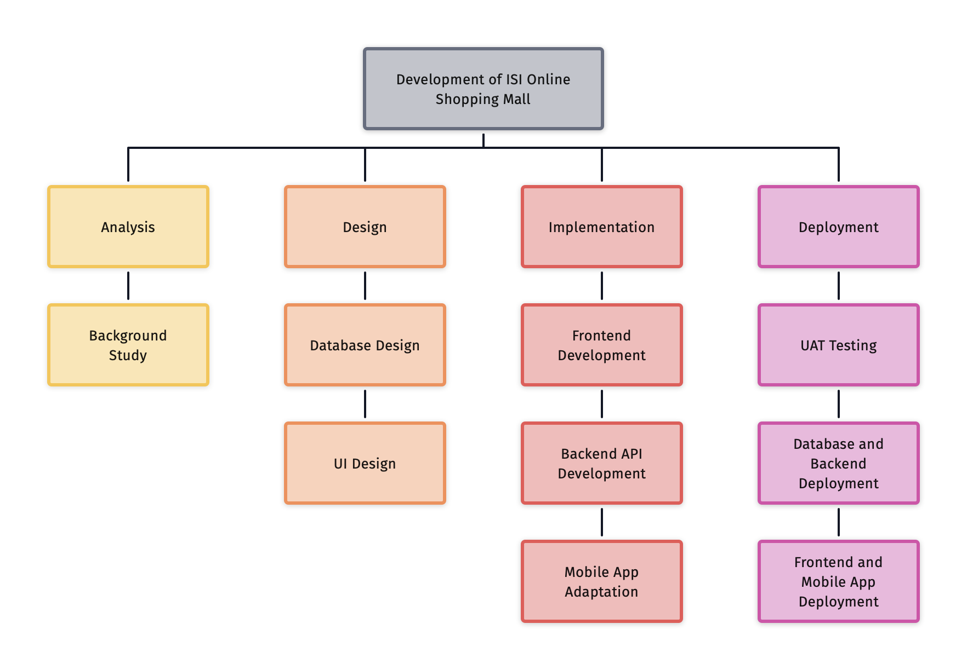

### Milestones

Milestones are significant events that normally have no duration. To be more specific for this project, several milestones are created -- project work plan (Jan 21), Gantt chart and progress check form (Feb 18), accomplishing the implementation of basic requirements (Mar 18), accomplishing the advanced requirements, and final report (Apr 8) and presentation and demo (Apr 11).

### Summary tasks

Summary tasks are the top-level tasks that group several related subtasks. In this project, there are four summary tasks in the project -analysis, design, implementation, and deployment.

## Project schedule

In this part, Gantt chart is shown.

### Gantt chart

The following is the draft Gantt chart. The Gantt chart describes the duration of each task, the start and finish of each task, and milestones (indicated by green square).

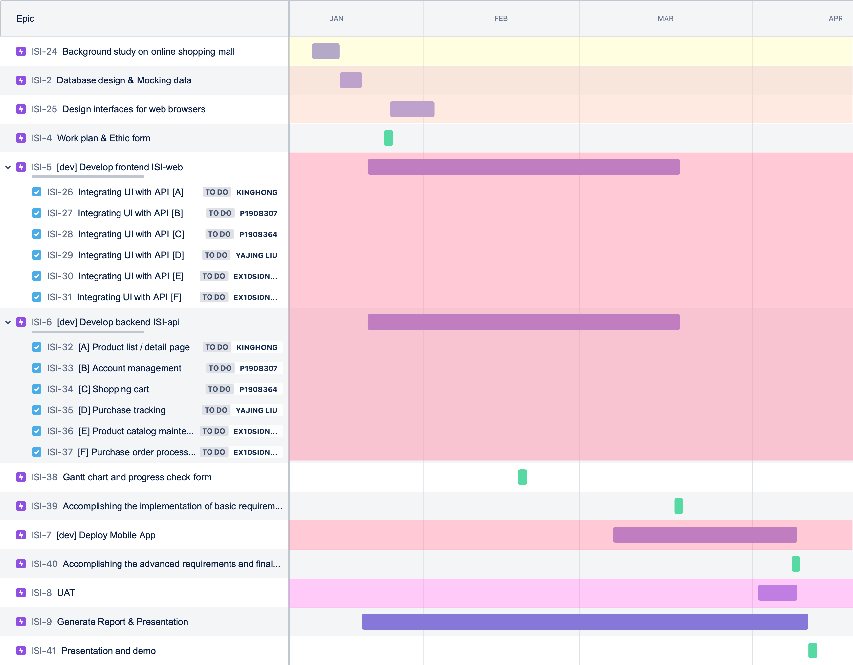

## Work plan table

|  |  |  |  |
| --- | --- | --- | --- |
| Schedule | Work | Assignee | Comments |
| W1 | System Analyse | Stephen, King, Freddie, Jane, Steve |  |
| W2 | Database Design | Stephen, Freddie |  |
| W2 | Data Entry | Jane, King, Steve |  |
| W1-W13 | Report Writing | Stephen, King, Freddie, Jane, Steve |  |
| W3-W9 | **[A]** Product list / detail page | King |  |
| W3-W9 | **[B]** Account management | Freddie |  |
| W3-W9 | **[C]** Shopping cart | Stephen |  |
| W3-W9 | **[D]** Purchase tracking | Jane |  |
| W3-W9 | **[E]** Product catalog maintenance | Steve |  |
| W3-W9 | **[F]** Purchase order processing | Steve |  |
| W6-W12 | **[Z]** Additional features | Stephen, King, Freddie, Jane, Steve |  |
| W8-W10 | UAT | Stephen, King, Freddie, Jane, Steve |  |
| W6 | Gantt Chart | Jane |  |