NEA

Table of contents

Introduction 1

Research 1

Pre-requisites 1

Partial solutions 2

Key features 3

Stakeholder 5

To Do: 5

# Introduction

*InsertNameHere*: A block based coding editor to allow secondary school students to begin working with microcontrollers, by giving them a familiar interface of block based coding, to allow them to learn how to code microcontrollers and have a basic understanding of electronics. My main goal with this project is to be able to help other to understand where I get my passion for microcontrollers. This passion of mine started off when I was young when my dad bought me my first raspberry pi microcomputer. This then got me hooked on working on these sorts of devices, as I found them challenging and this love for them set me up for later in my school journey. In lower school I was doing electronics for my GCSEs, part of it was working with microcontrollers as a piece of coursework, and from there I went home and continued working with them to a point where I was gaining knowledge that I have used countless time throughout the following years on multiple different occasions. These skills I feel are core to this project as I feel that microcontrollers are key to any person who wants to go into any electronics or computer science based courses later in life. Within the project microcontrollers will have a small part as the project, they will have the ability to have code transferred to them as the block will be able to compiled into code that then will be able to run on the said microcontroller when compiled. The stakeholder for my project is Mr Turner, who is Head of Computing/Electronics/DT/Food, so he has the skills required to allow me to develop this project further through his expertise in this area. His skillset is similar to mine but he has more understanding on what students would want for coding with microcontrollers. This will allow me to tailor the way the editor works to how he/the students would want it to be. I have had previous experiences working with students and a block based coding editor, in the past I have used microbits makecode editor (Microsoft Microbit. (2022). *Makecode Editor*. [Online]. makecode.microbit.org. Last Updated: 4 Sep 2024. Available at: https://makecode.microbit.org [Accessed 8 October 2025].) for a tech club I ran with some fellow students to hopefully gain interest in this area for younger students. This club allowed me to gain knowledge into how the students use the editor and what features they found useful and what was least used, from this I can then pull this information and use It as a basis for the project.

# Research

## Pre-requisites

For this project I am going to require certain requirements that will allow me to be successful in completing this project:

* A window library to create a GUI for ease of use
* A way to save files and reopen them within the editor
* A way to compile the blocks into code that can then be used on the microcontroller
* I am going to use Visual studio code to develop this project
* This project will be compatible with Arduinos

For this project I was originally going to use Golang as it is a modern compiled language that I had seen used for other complex projects, but when doing some simple testing with the window framework I was going to use I found that it would either take an unusually long time to compile or not compile at all. So I have made the decision to change my coding language to using Rust, this is because I am more familiar with the language and have used it in the past for similar GUI based projects and I know that it will compile, and the window library will work.

## Partial solutions

There are a few solutions similar to what I am wanting to do:

* Blockly, A block based coding editor that is the basis for multiple well know solutions e.g. scratch and hour of code both use blockly

Google. (13 May 2012). *Blockly*. [Online]. google.github.io/blockly. Last Updated: 28 August 2025. Available at: https://google.github.io/blockly/ [Accessed 21 September 2025].

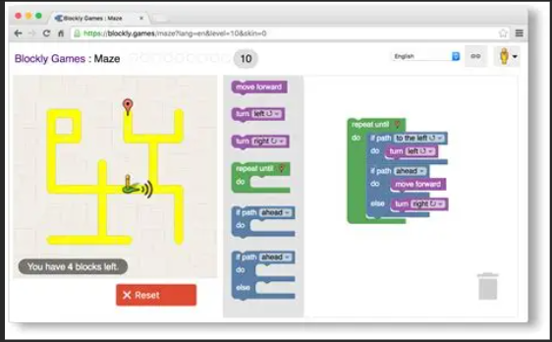

* BlocklyDuino, A block based coding editor that has used the blockly as its basis, but has adapted it to work for Arduinos

Fred Lin. (12 November 2012). *Blocklyduino*. [Online]. Blocklyduino.github.io. Last Updated: 4 July 2023. Available at: http://blocklyduino.github.io [Accessed 24 September 2025].

* mBlock, A code editor that uses blocks to create code and then compiles and can send the code over serial or Bluetooth

Makeblock Co., Ltd. (19 February 2017). *mBlock*. [Online]. mblock.cc. Last Updated: 8 April 2025. Available at: https://mblock.cc/ [Accessed 24 September 2025].

## Key features

From the partial solutions above I can see that they all use a very similar interface. For my interface I am going to include some similar things to the partial solutions above, but I am also going to add some features of my own which I think will be helpful.

|  |  |
| --- | --- |
| Core key features | Reason |
| Blocks for coding | To make the coding process easy and recognisable for student |
| Window framework | To allow me to create the application for the user to use |
| Open/Close/Save files | Allows the users to open a file or close a file and save the files if they want to come back to the code later |

|  |  |
| --- | --- |
| Additional key features | Reason |
| Debugging | To allow more experienced user to go more in depth into there code and fix any errors |
| Access to usb ports | To allow the user to connect the Arduino to the computer and transfer the code to the Arduino |

To allow me to create the window for the window framework, I am going to need to use an external library for rust that can make windows and allow me to make the application have a usable GUI. There are multiple different options to create windows within rust, each has a different use case. By searching for Rust Gui libraries, I have narrowed it down to:

* Egui, a window framework centred around simplicity and portability

emilk. (30 May 2020). *Egui*. [Online]. Egui. Last Updated: 12 September 2025. Available at: https://github.com/emilk/egui [Accessed 24 September 2025].

* Slint, a rust native window library that is used a lot for embedded devices

Slint UI. (30 June 2021). *Slint*. [Online]. Slint. Last Updated: 10 September 2025. Available at: https://github.com/slint-ui/slint [Accessed 24 September 2025].

* Gtk-rs, a rust port of the well know gtk framework, this allows for the power of the gtk framework to be used by rust

gtk-rs. (12 July 2021). *GTK-rs*. [Online]. gtk4-rs. Last Updated: 17 September 2025. Available at: https://github.com/gtk-rs/gtk4-rs [Accessed 24 September 2025].

From these libraries

* I have chosen to use Egui as it is the library that I am most familiar with and have used it in the past to create applications.
* To open/close/save files I am going to need to use the inbuilt std::io library that is inbuilt into rust. This will allow the saving of files to allow the user to close the project and come back to it at another time.
* When in the editor, there will be blocks within the editor that will have a Json file attached that will have the “Show” element that is what is seen within the editor, and It will have a an “Arduino code equivalent” that is used when compiling the code so that the code will be able to compiled and sent to the Arduino. This library will allow me to read each block from the Json file and allow me to have the show attributes. To use Json files I am going to use serde/serde_json:

serde-rs. (14 May 2016). *Serde*. [Online]. Serde github. Last Updated: 20 September 2025. Available at: https://github.com/serde-rs/serde [Accessed 24 September 2025].

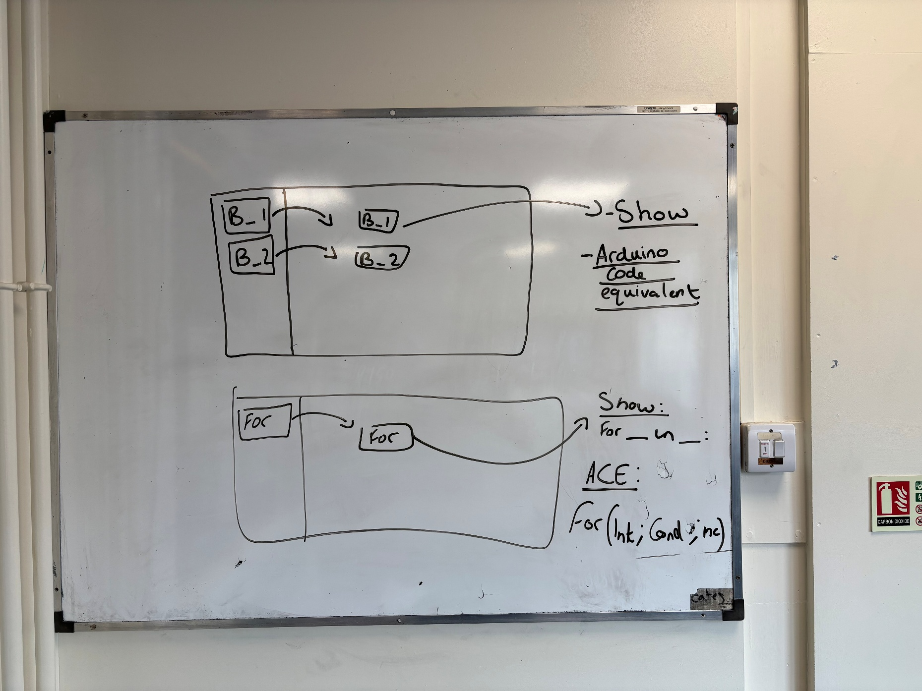

## Stakeholder

For this project I decided to contact the Head of Computing/Electronics/DT/Food, I have chosen to contact him as he has experience both using Arduinos but also has some experience coding as well. This will allow me to gain insight into what he would want to be able to teach KS3 student about Arduinos and begin to teach them how to code and use them. I have also chosen him as I see him on a regular basis within school, allowing me to catch up and discuss ideas with him often

# To Do:

*Email Mr turner!!!*