Computer Science Project report
OCR H446-03

Candidate Name: Dexter Jeal
Candidate Number: 1112
Centre Name: Clevedon school
Centre Number: 50629
Title of Project: Blocks For Arduino

NEA
Table of contents
Introduction 3
Research 4
Pre-requisites 4
Partial solutions 4
Key features 6
Stakeholder 9
Design 9
Hardware specifications 9
Software specifications 10
Sprints: 10
Sprint 1 10
Intro 10
Analysis 10
Success Criteria 11
Pre development tests 11
Design 11
Development 12
Post development testing 13
Evaluation 13
Sprint 2 14
Intro 14
Analysis 14
Success criteria 14
Pre-Development Tests 15
Design 15
Development 15
Post-Development Tests 15
Evaluation 15
To Do: 15

Introduction
InsertNameHere: A block based coding editor to allow secondary school students to begin working with microcontrollers, by giving them a familiar interface of block based coding, to allow them to learn how to code microcontrollers and have a basic understanding of electronics. My main goal with this project is to be able to help other to understand where I get my passion for microcontrollers. This passion of mine started off when I was young when my dad bought me my first raspberry pi microcomputer. This then got me hooked on working on these sorts of devices, as I found them challenging and this love for them set me up for later in my school journey. In lower school I was doing electronics for my GCSEs, part of it was working with microcontrollers as a piece of coursework, and from there I went home and continued working with them to a point where I was gaining knowledge that I have used countless time throughout the following years on multiple different occasions. These skills I feel are core to this project as I feel that microcontrollers are key to any person who wants to go into any electronics or computer science based courses later in life. Within the project microcontrollers will have a small part as the project, they will have the ability to have code transferred to them as the block will be able to compiled into code that then will be able to run on the said microcontroller when compiled. The stakeholder for my project is Mr Turner, who is Head of Computing/Electronics/DT/Food, so he has the skills required to allow me to develop this project further through his expertise in this area. His skillset is similar to mine but he has more understanding on what students would want for coding with microcontrollers. This will allow me to tailor the way the editor works to how he/the students would want it to be. I have had previous experiences working with students and a block based coding editor, in the past I have used microbits makecode editor (Microsoft Microbit. (2022). Makecode Editor. [Online]. makecode.microbit.org. Last Updated: 4 Sep 2024. Available at: https://makecode.microbit.org [Accessed 8 October 2025].) for a tech club I ran with some fellow students to hopefully gain interest in this area for younger students. This club allowed me to gain knowledge into how the students use the editor and what features they found useful and what was least used, from this I can then pull this information and use It as a basis for the project.

Research

Pre-requisites
For this project I am going to require certain requirements that will allow me to be successful in completing this project:
- A window library to create a GUI for ease of use
- A way to save files and reopen them within the editor
- A way to compile the blocks into code that can then be used on the microcontroller
- I am going to use Visual studio code to develop this project
- This project will be compatible with Arduinos

For this project I was originally going to use Golang as it is a modern compiled language that I had seen used for other complex projects, but when doing some simple testing with the window framework. When trying to compile the Golang program to check that the framework would work and has the necessary components for me to complete my project. During the testing for the framework, I found that it would not compile, and it would get stuck compiling, then when I tested it without the framework it would compile with no problems. . So I have made the decision to change my coding language to using Rust, this is because I am more familiar with the language and have used it in the past for similar GUI based projects and I know that it will compile, and the window library will work.

Partial solutions
There are a few solutions similar to what I am wanting to do:
- Blockly, A block based coding editor that is the basis for multiple well know solutions e.g. scratch and hour of code both use blockly
Google. (13 May 2012). Blockly. [Online]. google.github.io/blockly. Last Updated: 28 August 2025. Available at: https://google.github.io/blockly/ [Accessed 21 September 2025].
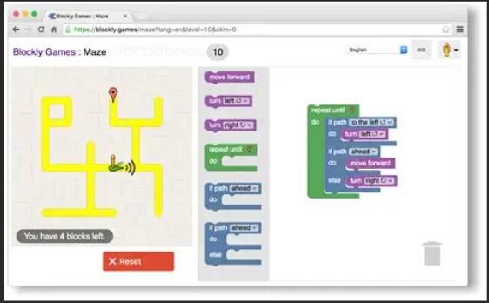
- BlocklyDuino, A block based coding editor that has used the blockly as its basis, but has adapted it to work for Arduinos
Fred Lin. (12 November 2012). Blocklyduino. [Online]. Blocklyduino.github.io. Last Updated: 4 July 2023. Available at: http://blocklyduino.github.io [Accessed 24 September 2025].
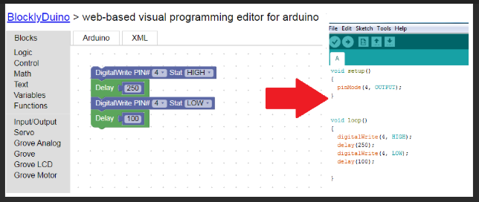
- mBlock, A code editor that uses blocks to create code and then compiles and can send the code over serial or Bluetooth
Makeblock Co., Ltd. (19 February 2017). mBlock. [Online]. mblock.cc. Last Updated: 8 April 2025. Available at: https://mblock.cc/ [Accessed 24 September 2025].

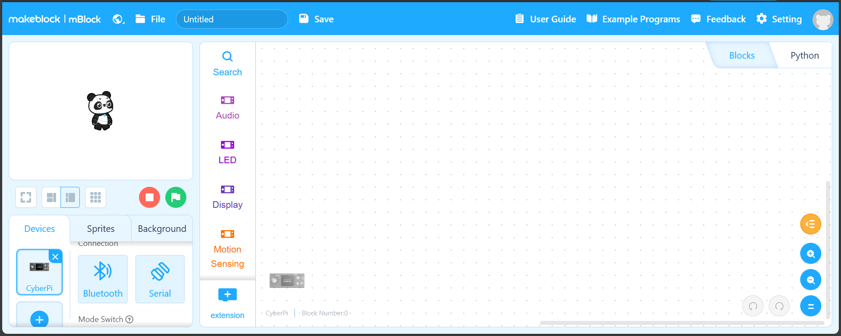

Pros and cons
Software | Pros | Cons
Blockly | - Established code base  - Used across multiple platforms and is a trusted basis  - Easy to use for beginners | - Does not work with Arduino/microcontroller  - Older looking interface  - It is web based, whereas I would like it to be a standalone app
Blocklyduino | - Compatible with Arduinos  - Uses blockly as a basis for the coding element | - Is natively web based, so cannot run as a standalone app  - Requires the Arduino cli to be installed
mBlock | - Is a fully build web block-based coding editor  - Allows for devices to connect and upload code natively | - Requires that you use there hardware only  - Only runs in the browser, whereas I would want it to be an app

Key features
From the partial solutions above I can see that they all use a very similar interface. For my interface I am going to include some similar things to the partial solutions above, but I am also going to add some features of my own which I think will be helpful.
Core key features | Reason
Blocks for coding | To make the coding process easy and recognisable for student
Window framework | To allow me to create the application for the user to use
Open/Close/Save files | Allows the users to open a file or close a file and save the files if they want to come back to the code later

Additional key features | Reason
Debugging | To allow more experienced user to go more in depth into there code and fix any errors
Access to usb ports | To allow the user to connect the Arduino to the computer and transfer the code to the Arduino
Compiling and uploading the code to the arduino | To allow the user to compile the code and download it to the arduino

To allow me to create the window for the window framework, I am going to need to use an external library for rust that can make windows and allow me to make the application have a usable GUI. There are multiple different options to create windows within rust, each has a different use case. By searching for Rust Gui libraries, I have narrowed it down to:
- Egui, a window framework centred around simplicity and portability
emilk. (30 May 2020). Egui. [Online]. Egui. Last Updated: 12 September 2025. Available at: https://github.com/emilk/egui [Accessed 24 September 2025].

- Slint, a rust native window library that is used a lot for embedded devices
Slint UI. (30 June 2021). Slint. [Online]. Slint. Last Updated: 10 September 2025. Available at: https://github.com/slint-ui/slint [Accessed 24 September 2025].

- Gtk-rs, a rust port of the well know gtk framework, this allows for the power of the gtk framework to be used by rust
gtk-rs. (12 July 2021). GTK-rs. [Online]. gtk4-rs. Last Updated: 17 September 2025. Available at: https://github.com/gtk-rs/gtk4-rs [Accessed 24 September 2025].

Framework | Pros | Cons
Egui | - Most beginner friendly for new user of rust  - Is cross platform and will work with any os  - It is a lightweight so it does not use much system memory | - The lightweight feel decreases as the size of the program increases  - The theme of the framework is non-native looking so it does not match any one os
Slint | - Framework is actively developed so it will always be up to date  - Has consistent design across any platform | - Has a limited ecosystem compared to other frameworks  - Has a smaller following compared to other frameworks
Gtk-rs | - Has a large range of widget libraries for expandable GUIs  - Stable ecosystem that is used across multiple industries | - Has a complex code system  - Has an inconsistent performance across different platforms

From these libraries
- I have chosen to use Egui as it is the library that I am most familiar with and have used it in the past to create applications.
- To open/close/save files I am going to need to use the inbuilt std::io library that is inbuilt into rust. This will allow the saving of files to allow the user to close the project and come back to it at another time.
- When in the editor, there will be blocks within the editor that will have a Json file attached that will have the “Show” element that is what is seen within the editor, and It will have a an “Arduino code equivalent” that is used when compiling the code so that the code will be able to compiled and sent to the Arduino. This library will allow me to read each block from the Json file and allow me to have the show attributes. To use Json files I am going to use serde/serde_json:
serde-rs. (14 May 2016). Serde. [Online]. Serde github. Last Updated: 20 September 2025. Available at: https://github.com/serde-rs/serde [Accessed 24 September 2025].

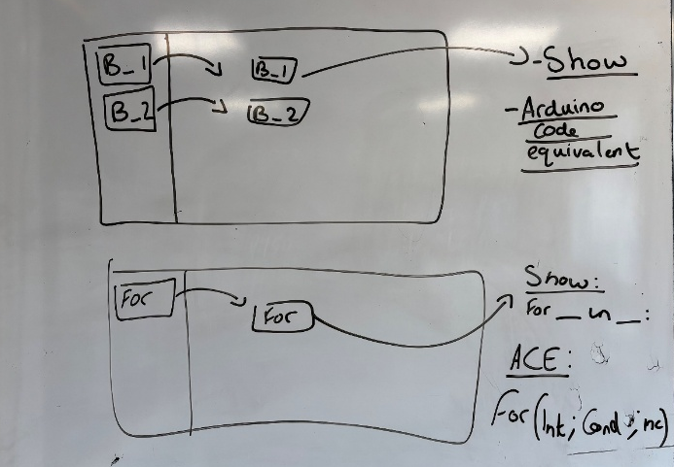

Stakeholder
For this project I decided to contact Mr Turner, Head of Computing/Electronics/DT/Food, I have chosen to contact him as he has experience both using Arduinos but also has some experience coding as well. This will allow me to gain insight into what he would want to be able to teach KS3 student about Arduinos and begin to teach them how to code and use them. I have also chosen him as I see him on a regular basis within school, allowing me to catch up and discuss ideas with him often. Throughout this project I will have discussions with him to find out what students would want when coding and using an Arduino so that they have the most tailored experience.

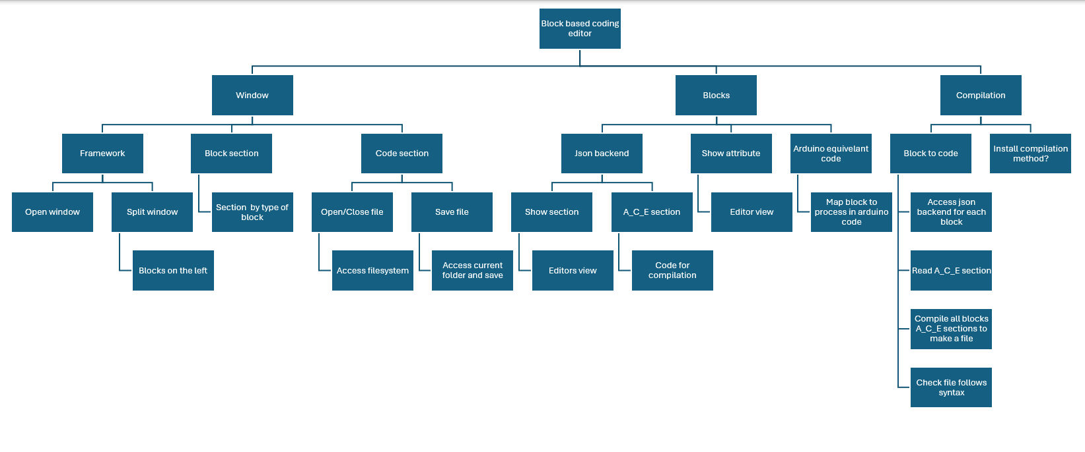
Design

Hardware specifications
For this program to be available to as many students as possible this program will have to work on as wide a range of devices of different specifications as possible. Normally the program will work on the machines within school, they are Dell OptiPlex 3280 AIO computers with Intel core I3 10100T CPU and 8GB of RAM with integrated Intel UHD graphics 630. This will allow any machine within the school to be able to run the program. In addition to this I need it to be able to run on my laptop, which is a Lenovo ThinkPad 14s Gen 2 with an Intel i7 1165G7 and 8GB and Intel iris Xe graphics which are integrated.

Software specifications
For this program I am going to use windows 11 as this is the current operating system that is used by both my laptop and the machines within school. Windows 11 also happens to be the most up to date version of windows that Microsoft offer so it will have the best support.
For the programming language I am going to use rust version 1.92.0 nightly with rustc 1.92.0 and cargo 1.92.0 as this is what I currently have installed on my machine and this will allow me to code in rust and compile my code into a executable file. With this I am going to be using Egui 0.33 as the library I use for creating the window, and serde_json 1.0.145 for access to the blocks json files for compilation of the code ready for the Arduino, for this I am going to need to use Arduino Cli Insert version

List of sprints in order
Unique ID | Sprint
S1 | Opening a window
S2 | Creating a divider on the window
S3 | Creating a block for the window
S4 | Having blocks join up
S5 | Converting blocks to code

Sprints:
SX SCX/TX S=sprint, X=number of sprint or success criteria or test, T = test

Sprint 1

Intro
For this sprint I am going to begin by having a simple window open using Egui that will act as the basis for the rest of my project to work on top of. I am doing this as this will act as the basic structure for the entire project as this is where the editor is going to work within so if I cannot open the window I will not be able to complete this project.

Analysis
This sprint is going to be the beginning of the project as this is the opening of the window that the rest of the project will work in. For this I am going to use the Egui library that will be the basis for the project, and I will build upon in later sprints. For this sprint the window needs to be able to open and have the ability to be resizable. For this sprint I have done research into different window frameworks and it seems that Egui is the choice for many people as it has the easiest learning curve in terms of going from not knowing anything to having a full working window.

Success Criteria
Unique ID | Success criteria | Explanation | Justification | Limitations
S1SC1 | The window must open | The window must open with a known size for future reference | This will allow me to begin building the project into the window | The framework does not have certain necessities inbuilt so more libraires are needed.
S1SC2 | The window must be 800x600 pixels in size | I feel that this size window would be big enough to allow a good space to work in and still have some room for the block section on one side | This allows for good working space to block space | The window will not be fixed to that size as the framework has the resizable option on by default
S1SC3 | The window must have the title of “Blocks for Arduino” | This will be the title of the project allowing for easier reference when opening the window | This is a simple enough name that is not confusing but also not too simple | The name is only seen at the top of the window and nowhere else

Pre development tests
Unique ID | Test ID | What is being tested? | Positive result
S1SC1 | S1T1 | Does the window open | The window opens
S1SC2 | S1T2 | Does the window have the correct size | The window is 800x600 pixels
S1SC3 | S1T3 | Does the title match that of the title of the project | The title is the same name of the project

Design
To help me to undergo the development of the first sprint, I am going to use pseudocode to help me to understand how the code is going to work.

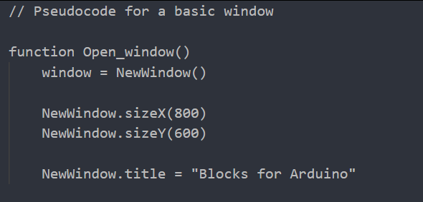

Development
To begin the development I searched for how egui windows work and found this link, (w3resources. (23/11/2024). Learn Rust Egui. [Online]. w3resources. Last Updated: 23/11/2024. Available at: https://www.w3resource.com/rust-tutorial/learn-rust-egui-gui-development.php [Accessed 12 November 2025].), from this link I began the process of coding up the program so it opens.

To begin the process I began by setting up the environment to code in by creating a rust project using cargo
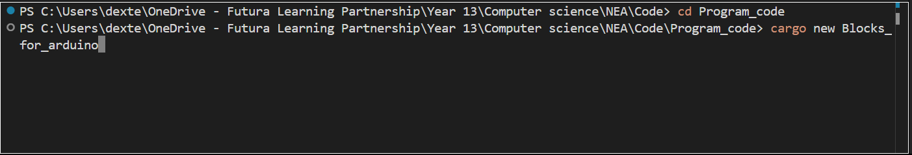
This creates a new rust project that I can work in
Next I moved on to adding the dependencies to the project to allow me to open the window:
From this point I began to code up the window opening
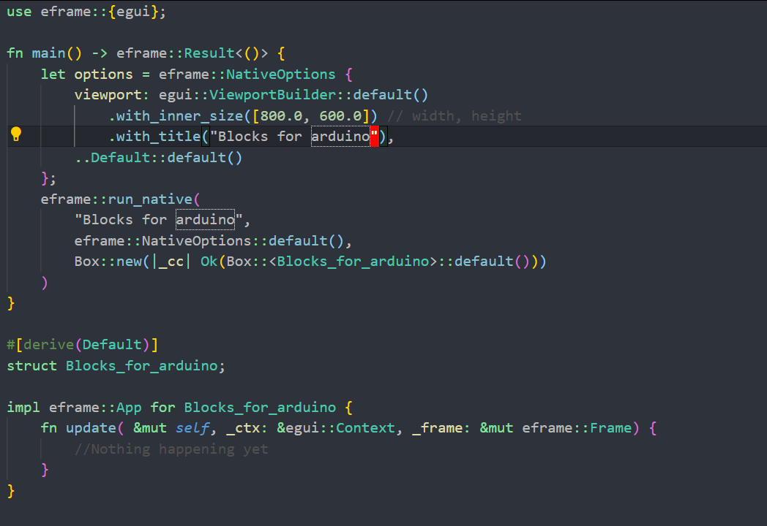
The code allows me to open a window with nothing in it, this will be the basis for my project

Post development testing
Looking at the test I set out above:
Test ID | What is being tested? | Outcome | Pass/Fail
S1T1 | Does the window open | Yes the window opens once the program has been compiled | Pass
S1T2 | Does the window have the correct size | The window is 800x600px | Pass
S1T3 | Does the title match that of the title of the project | The window does have the title “Blocks for arduino” | Pass

Evaluation
From the tests above I can conclude that this sprint was a success as all three tests passed, and all of the success criteria were met as the test mirrored what was set in the success criteria. This module I feel is complete and I can move onto another part as this sprint is going to be built upon so there will be opportunities to work on it further if needed. There was one limitation that was the resizing of the window, this is not able to be got around without adding lots of extra code that I do not yet know how to do so I have decided to work around It by keeping the window dynamically sized to it adjust when the window changes size.

Sprint 2

Intro
For my second sprint I am going to work on separating the screen into two distinct sections for the coding section and the section for where the blocks are displayed. This sprint is going to build on the work in the sprint before, using it as the basis.

Analysis
This sprint is going to build upon the work done in the previous sprint, but now building on it to allow it to have functionality rather than just to be a window that doesn’t do anything. Using (Rust Docs. (20 May 2020). Egui Seperators. [Online]. Docs.rs. Last Updated: 10 November 2025. Available at: https://docs.rs/egui/latest/egui/widgets/struct.Separator.html [Accessed 19 November 2025]), this website I began to research into Seperators which are inbuilt into egui to allow you to separate your window into distinct sections.

Success criteria
Unique ID | Success criteria | Explanation | Justification | Limitations
S2SC1 | The window will have a separator | This will allow me to have a split in the window to allow me to separate the section for blocks from the section for coding | This will be used later in the project for further development | The separator hasn’t got very much customisation for size or line type
S2SC2 | Each section will have a title | This will allow me to distinguish the different sections | This will help with later development when It comes to distinguishing the sections | The titles have to be manually places so the title may be off it the window size changes
S2SC3 | The line will be visible | This will have the highest contrast against the dark grey background of the window | This is so there is a clear separation between sections | To have custom colours for the separator it has to be done manually, there is no inbuilt function in egui for it

Pre-Development Tests
Unique ID | Test ID | What is being tested? | Positive result
S2SC1 | S2T1 | Is there a separator in the window | There is a separator on the window
S2SC2 | S2T2 | Is there a title for each section of the window | There are two title:  “Code section”  “Block section”
S2SC3 | S2T3 | Is the separator visible | The separator is visbale within the window

Design
To help me further to understand what needs to be done I have decided to continue adding to the pseudocode that I had begun in the last sprint.
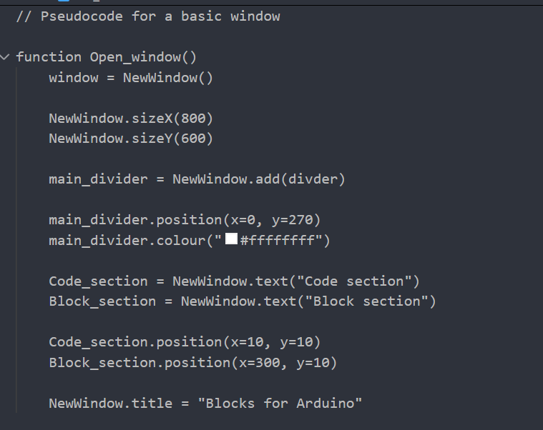

Development
Using the research done in my analysis I am able to now go on to implement the features I stated in my introduction of this sprint. This code will be added to the code that I wrote in the last sprint.
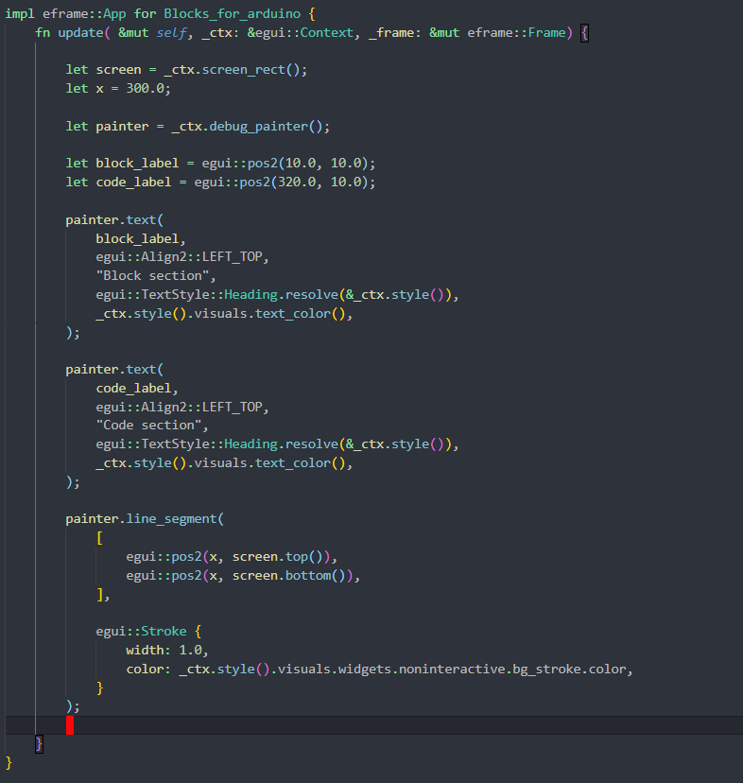
From what I found with the analysis research, I found that the inbuilt separators could not do a line across the whole screen, so I decided to have the program manually draw the line and then also add the labels in so it worked contiguously across the whole window

Post-Development Tests
Test ID | What is being tested? | Outcome | Pass/Fail
S2T1 | Is there a separator in the window | Yes there is a separator on the window | Pass
S2T2 | Is there a title for each section of the window | Yes there is a title for the code and blocks section | Pass
S2T3 | Is the separator visible | Yes the separator is visible within the window | Pass

Evaluation
From the tests seen above I can say that this sprint has been successful in fulfilling the criteria I set out before. I feel that after this I am ready to move on to coding another section of code for this project. The main limitation of this sprint was that egui does not support full window separators, so I had to code them myself within the program.

Sprint 3

Intro
For my third sprint, I have decided to begin to create the blocks that are used to code the Arduino. This will require me to setup a json file for the main program to read to have the onscreen characteristics of the block within the window. This will also allow me to also create new blocks that can be saved and then be brought back into the program.

Analysis
For this I am going to need to have a way to read and write to a json file, doing some research online I found people use serde.json (Buhr, E. and Serde Contributors. (20 April 2017). Serde. [Online]. Docs.rs. Last Updated: 27 September 2025. Available at: https://crates.io/crates/serde_json [Accessed 26 November 2025].), for my project I have chosen to use serde json as I have similar use case.

Success criteria
Unique ID | Success criteria | Explanation | Justification | Limitations
S3SC1 | The block will be red and 100x100 pixels in size with a name of “Test_block” | I feel for a first block this is a good size that is big enough for the text to be legible | This is just a test block for a proof of concept for how a block will work | The block will have no use as such
S3SC2 | The block will have a Json file that has the correct attributes that it reads from | This is to allow for the blocks to be compiled in the future | This will allow me to then create more blocks that are read from for each | The block json is in another place and may read the wrong file if names are similar
S3SC3 | The block will appear in the block section of the screen | This is to mimic the rest of the blocks | This is to help me see what the layout will be for future sprints | The block section is not a fixed area

Pre-Development Tests
Unique ID | Test ID | What is being tested? | Positive result
S3SC1 | S3T1 | The box is red, 100x100 and has the title “Test_block” | There is a red box that is 100x100 and has the title “Test_block”
S3SC2 | S3T2 | The block reads from the Json file that is associated with it | There will be a output in the terminal that outputs that it has read the json
S3SC3 | S3T3 | The block is in the correct position | It will be in the block section

Design
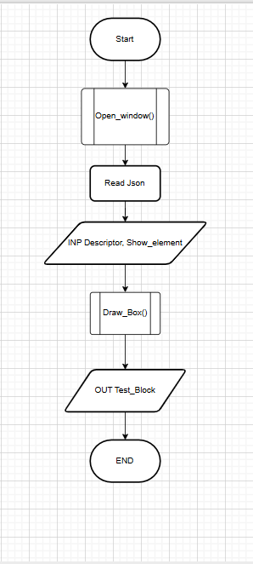
For my design I chose to create a flow chart to help me develop the next piece of code. From this I am able to go ahead with development of this sprint

Development
For the development stage I first worked on having my program read a json file. To do this I used serde_json which is a rust library that is able to read json. Next I made it so It read only the first section of the json file so it created the block with the correct title. The next step for development was creating the block onscreen. Finally I made sure that the block was in the correct position
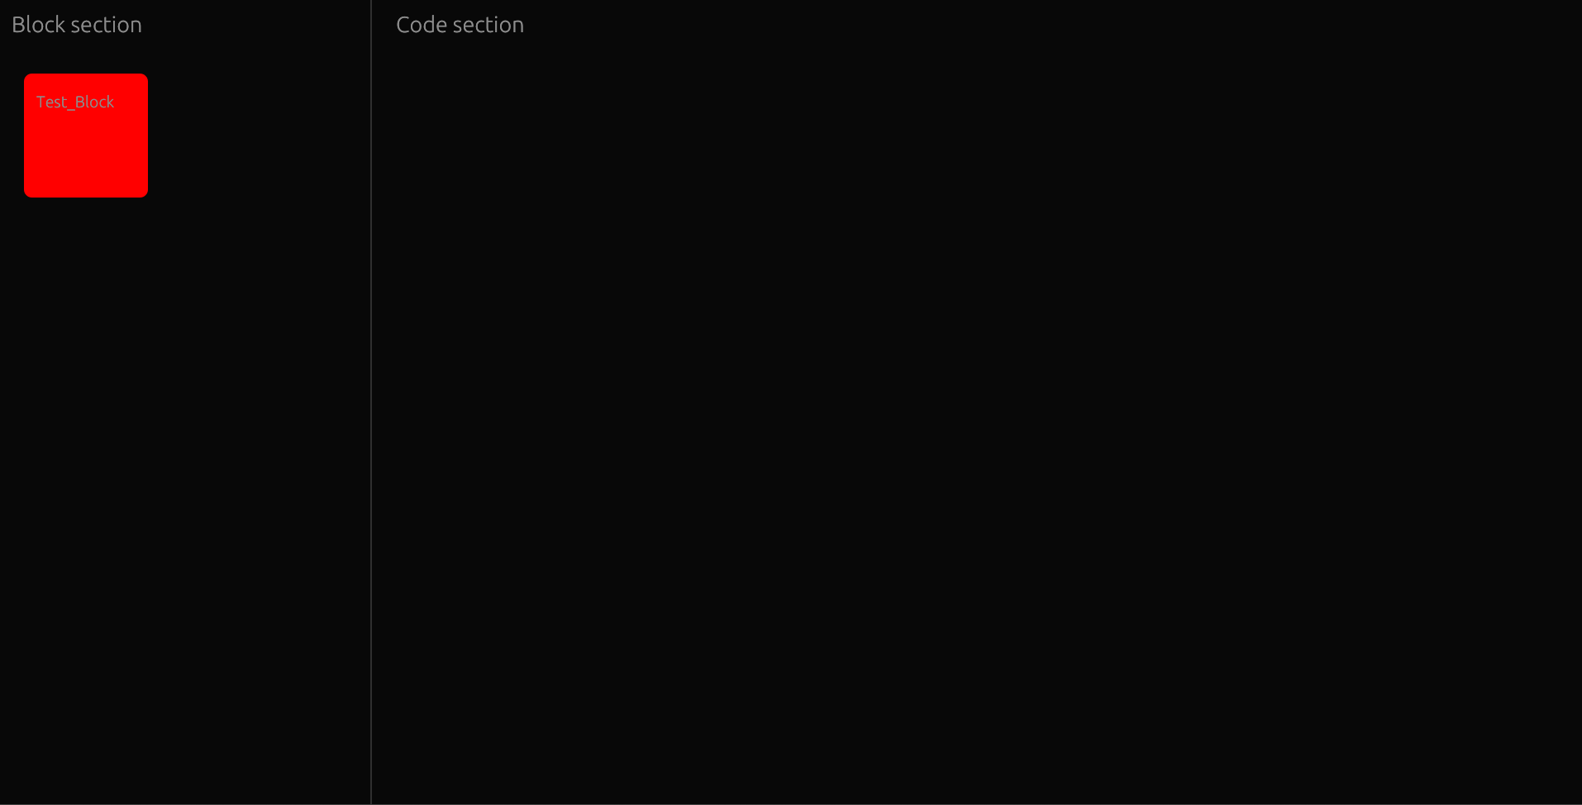
Talk about

Post-Development Tests
Test ID | What is being tested? | Outcome | Pass/Fail
S3T1 | The box is red, 100x100 and has the title “Test_block” | The box was red and 100x100 with the title of Test_block | Pass
S3T2 | The block reads from the Json file that is associated with it | The block has read the correct information from the json | Pass
S3T3 | The block is in the correct position | The block was in the correct section | Pass

Evaluation
From this sprint I can say that it was successful, but I feel there is more to do in this area as the blocks are currently unable to be moved and there is only one, my next steps will be to make the blocks moveable and have more blocks for the ability to code

To Do:
Next sprint ->Nea help team for a loose framework
High level success criteria
Logic for logical areas!!!!
Sprint 4: Read sprint 3 evaluation

