Computer Science Project report
OCR H446-03

Candidate Name: Dexter Jeal
Candidate Number: 1112
Centre Name: Clevedon school
Centre Number: 50629
Title of Project: Blocks For Arduino

NEA
Table of contents
Introduction 6
Research 7
Pre-requisites 7
Partial solutions 8
Key features 9
Stakeholder 12
Design 13
Hardware specifications 13
Software specifications 13
Sprints: 14
Sprint 1 (S1) 14
Intro 14
Analysis 14
Success Criteria 14
Pre development tests 15
Design 15
Development 16
Post development testing 17
Evaluation 17
Sprint 2 (S2) 18
Intro 18
Analysis 18
Success criteria 18
Pre-Development Tests 19
Design 19
Development 20
Post-Development Tests 21
Evaluation 22
Sprint 3 (S3) 22
Intro 22
Analysis 22
Success criteria 22
Pre-Development Tests 23
Design 24
Development 24
Post-Development Tests 25
Evaluation 25
Sprint 4 (S4) 25
Introduction 25
Analysis 26
Success Criteria 26
Pre-Development Tests 26
Development 27
Post-Development Tests 27
Evaluation 28
Sprint 5 (S5) 28
Introduction 28
Analysis 28
Success criteria 28
Pre-development test 29
Design 29
Development 29
Post-development test 30
Evaluation 30
Sprint 6 (S6) 31
Introduction 31
Analysis 31
Success Criteria 31
Pre-Development test 31
Design 32
Development 32
Post-development test 33
Evaluation 33
Sprint 7 (S7) 33
Introduction 33
Analysis 34
Success Criteria 34
Pre-Development test 34
Design 35
Development 35
Post-development test 36
Evaluation 36
Sprint 8 (S8) 36
Introduction 36
Analysis 36
Success Criteria 37
Pre-Development test 37
Design 37
Development 38
Post-development test 39
Evaluation 39
Sprint 9 (S9) 40
Introduction 40
Analysis 40
Success Criteria 40
Pre-Development test 41
Design 41
Development 42
Post-development test 43
Evaluation 43
Sprint 10 (S10) 43
Introduction 43
Analysis 43
Success Criteria 44
Pre-Development test 44
Design 44
Development 45
Post-development test 45
Evaluation 46
Post Sprint Testing 46
Evaluation 47
Usability 47
Incomplete sections 47
Maintenance 47
Future development 47
Final evaluation 48
Bibliography 48
Code 48
Main.rs 49
App.rs 51
Model.rs 111
Helper.rs 118
While_loop.json 119
PinMode.json 120
Pin_toggle.json 120
Delay.json 121
Valid_sequences.txt 122

Introduction
Blocks for Arduino: A block-based coding editor to allow secondary school students to begin working with microcontrollers, by giving them a familiar interface of block-based coding, to allow them to learn how to code microcontrollers and have a basic understanding of electronics.
My main goal with this project is to be able to help others to understand where I get my passion for microcontrollers. This passion of mine started off when I was young when my dad bought me my first raspberry pi microcomputer. This then got me hooked on working on these sorts of devices, as I found them challenging and this love for them set me up for later in my school journey. In lower school I was doing electronics for my GCSEs, part of it was working with microcontrollers as a piece of coursework, and from there I went home and continued working with them to a point where I was gaining knowledge that I have used countless times throughout the following years on multiple different occasions. For example, I have created a system that detects every time a flap opens and takes a dated photo to the be reviewed and compiled and shown as a graph on a locally hosted web page. These skills I feel are core to this project as I feel that microcontrollers are key to any person who wants to go into any electronics or computer science-based courses later in life.
Within the project microcontrollers will have a small part as the project as they will only be involved toward the end of the project, they will have the ability to have code transferred to them as the block will be able to be compiled into code that then will be able to run on the said microcontroller when compiled.
The stakeholder for my project is Mr Turner, who is Head of Computer science, Electronics, Design Technology and Food technology, so he has the skills required to allow me to develop this project further through his expertise in this area. His skillset is like mine but he has more understanding on what students would want for coding with microcontrollers. This will allow me to tailor the way the editor works to how he/the students would want it to be.
I have had previous experiences working with students and a block based coding editor, in the past I have used microbits makecode editor (Microsoft, 2022) for a tech club I ran with some fellow students to hopefully gain interest in this area for younger students. This club allowed me to develop knowledge into how the students used the editor and what features they found useful and what was least used, from this I can then pull this information and use It as a basis for the project.

Research

Pre-requisites
For this project I am going to require certain requirements that will allow me to be successful in completing this project:
- A window library to create a GUI for ease of use
- A way to save files and reopen them within the editor
- A way to compile the blocks into code that can then be used on the microcontroller
- I am going to use Visual studio code to develop this project
- This project will be compatible with Arduinos, rather than raspberry pi’s as the pi is less compatible with simple coding as it closer to a full computer than a microcontroller. So, I have chosen arduinos as they have the easiest path to compilation through a command line tool which I have used before

For this project I was originally going to use Golang. Golang is a modern compiled language that I had seen used for other complex projects. During the testing for the framework, I found that it would not compile, and it would get stuck compiling, then when I tested it without the framework it would compile with no problems. So I have made the decision to change my coding language to using Rust, this is because I am more familiar with the language and have used it in the past for similar GUI based projects, for example I created a very simple dashboard with multiple graphs on it that was going to be used for a monitoring system for a future project. The main drawback to using Rust is that it has a significantly slower compile time compared to go which means that prototyping takes longer, but with rust I know that it will compile, and the window library will work. Within rust there is an inbuilt package manager called cargo that is used to add different libraries into the projects dependencies from a website called crates.io.

Partial solutions
There are a few solutions like what I am wanting to do:
- Blockly, A block-based coding editor that is the basis for multiple well-known solutions e.g. scratch and hour of code both use blockly (Blockly, 2012)
In this program the user can create programs using blocks of code that is then shown on a preview on the left.
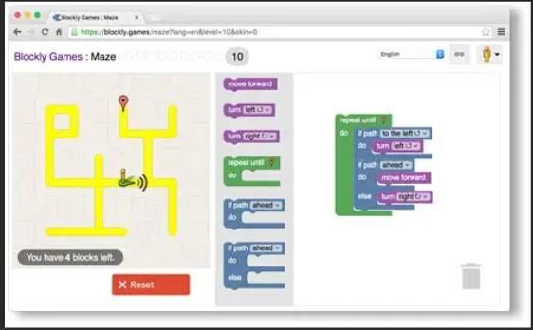

- BlocklyDuino, A block based coding editor that has used the blockly as its basis, but has adapted it to work for Arduinos (Blocklyduino, 2012)
Within this program the user is able to create programs for an Arduino using blocks that then compile down into a file that can run on the Arduino
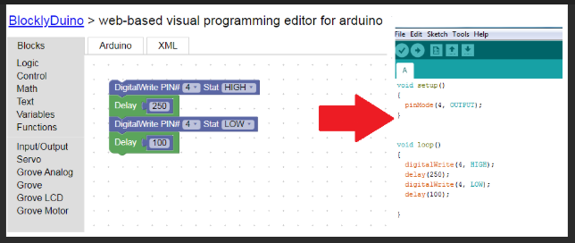

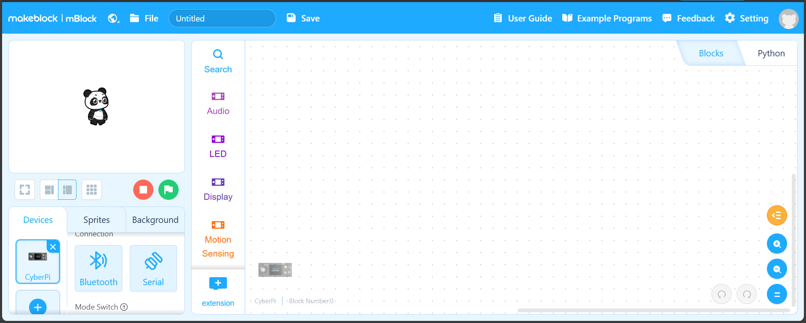

- mBlock, A code editor that uses blocks to create code and then compiles and can send the code over serial or Bluetooth (Co, 2017)

Pros and cons
Software | Pros | Cons
Blockly | - Established code base  - Used across multiple platforms and is a trusted basis  - Easy to use for beginners | - Does not work with Arduino/microcontroller  - Older looking interface  - It is web based, whereas I would like it to be a standalone app
Blocklyduino | - Compatible with Arduinos  - Uses blockly as a basis for the coding element | - Is natively web based, so cannot run as a standalone app  - Requires the Arduino cli to be installed
mBlock | - Is a fully build web block-based coding editor  - Allows for devices to connect and upload code natively | - Requires that you use their hardware only  - Only runs in the browser, whereas I would want it to be an app

Key features
From the partial solutions above I can see that they all use a very similar interface. For my interface I am going to include some similar things to the partial solutions above, but I am also going to add some features of my own which I think will be helpful.
Core key features | Reason | Explanation | Justification
Blocks for coding | To make the coding process easy and recognisable for student | This will allow the use to then create programs | This will then be used to then make the program work on the Arduino
Window framework | To allow me to create the application for the user to use | This will be what runs the program with. | This will give the user an interface that they can use to create the program
Open/Close/Save files | Allows the users to open a file or close a file and save the files if they want to come back to the code later | This will allow the user to come back to different files later | Allows them to keep what they had been working on and have it accessible without having to recreate the whole file from scratch again

Additional key features | Reason
Debugging | To allow more experienced user to go more in depth into their code and fix any errors
Access to USB ports | To allow the user to connect the Arduino to the computer and transfer the code to the Arduino
Compiling and uploading the code to the Arduino | To allow the user to compile the code and download it to the Arduino

To allow me to create the window for the window framework, I am going to need to use an external library for rust that can make windows and allow me to make the application have a usable GUI. There are multiple different options to create windows within rust, each has a different use case. By searching for Rust Gui libraries, I have narrowed it down to:
- Egui, a window framework centred around simplicity and portability (Emilk, 2020)

- Slint, a rust native window library that is used a lot for embedded devices
(UI, 2021)

- Gtk-rs, a rust port of the well-known gtk framework, this allows for the power of the gtk framework to be used by rust (gtk-rs, 2021)

Framework | Pros | Cons
Egui | - Most beginner friendly for new user of rust  - Is cross platform and will work with any operating systems  - It is a lightweight, so it does not use much system memory | - The lightweight feel decreases as the size of the program increases  - The theme of the framework is non-native looking so it does not match any one os
Slint | - Framework is actively developed so it will always be up to date  - Has consistent design across any platform | - Has a limited ecosystem compared to other frameworks  - Has a smaller following compared to other frameworks
Gtk-rs | - Has a large range of widget libraries for expandable GUIs  - Stable ecosystem that is used across multiple industries | - Has a complex code system  - Has an inconsistent performance across different platforms

(A_C_E is Arduino code equivalent)
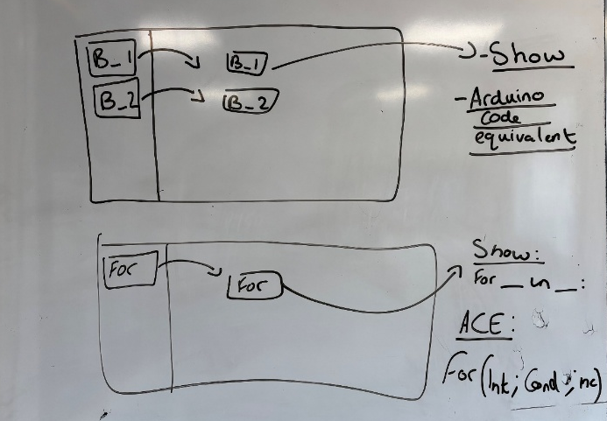

From these libraries
- I have chosen to use Egui as it is the library that I am most familiar with and have used it in the past to create applications. The explanation and for me using this is that I am familiar with the library and I have an understanding the way the library works. The justification for this is my familiarity with this library from previous projects.
- To open/close/save files I am going to need to use the inbuilt std::io library that is inbuilt into rust. This will allow the saving of files to allow the user to close the project and come back to it at another time. The explanation for doing this is so that the user can have a copy of the file saved for a later use if they want to. The justification for this is that it is a standard feature on any and or Integrated Development Environment.
- When in the editor, there will be blocks within the editor that will have a Json file attached that will have the “Show” element that is what is seen within the editor, and it will have an “Arduino code equivalent” that is used when compiling the code so that the code will be able to compiled and sent to the Arduino. This library will allow me to read each block from the Json file and allow me to have the show attributes. To use Json files, I am going to use serde/serde_json:
serde-rs. (Serde, 2016) The explanation for this is that the program needs a way to read Json files. The justification for this is that without this library the blocks wouldn’t be able to work the way they do.

These three libraries were the most used libraries and there are very few other libraries that are like these, so the pool was small to choose from and my choice for this was based on what I was most familiar with.

Stakeholder
For this project I decided to contact Mr Turner, Head of Computer science, Electronics, Design Technology and Food technology, I have chosen to contact him as he has experience both using Arduinos but also has some experience coding as well. This will allow me to gain insight into what he would want to be able to teach KS3 student about Arduinos and begin to teach them how to code and use them.
I have also chosen him as I see him on a regular basis within school, allowing me to catch up and discuss ideas with him often. Throughout this project I will have discussions with him to find out what students would want when coding and using an Arduino so that they have the most tailored experience. From our first meeting, he suggested having the program with intuitive blocks so that the users can easily create a program from the blocks.

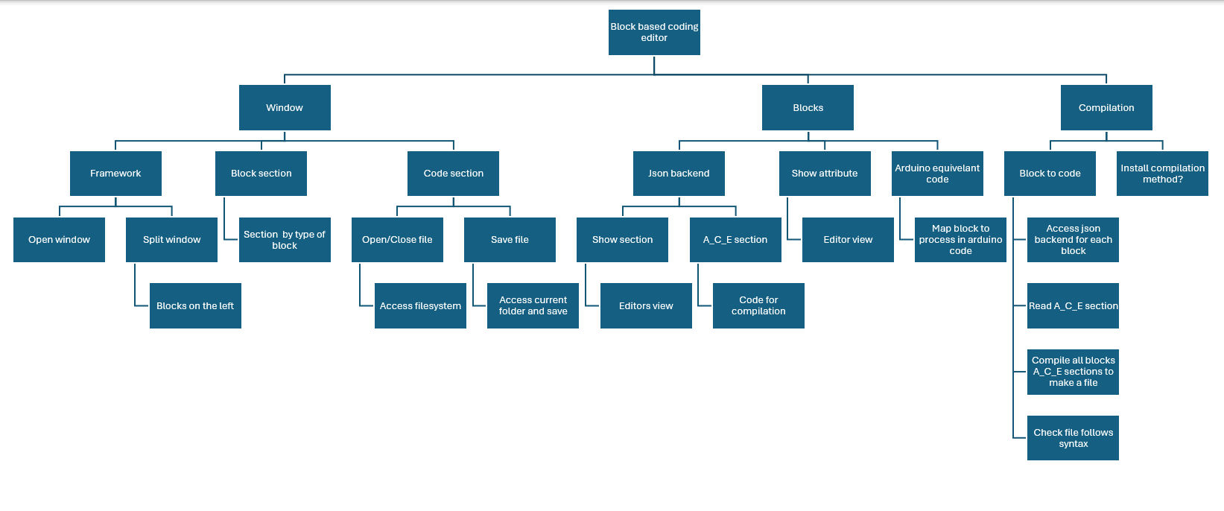
Design

Hardware specifications
For this program to be available to as many students as possible this program will have to work on as wide a range of devices of different specifications as possible. Normally the program will work on the machines within school, they are Dell OptiPlex 3280 AIO computers with Intel core I3 10100T CPU and 8GB of RAM with integrated Intel UHD graphics 630. This will allow any machine within the school to be able to run the program. In addition to this I need it to be able to run on my laptop, which is a Lenovo ThinkPad 14s Gen 2 with an Intel i7 1165G7 and 8GB and Intel iris Xe graphics which are integrated.

Software specifications
For this program I am going to use windows 11 as this is the current operating system that is used by both my laptop and the machines within school. Windows 11 also happens to be the most up to date version of windows that Microsoft offer so it will have the best support.
For the programming language I am going to use rust version 1.92.0 nightly with Rustc 1.92.0 and cargo 1.92.0 as this is what I currently have installed on my machine, and this will allow me to code in rust and compile my code into an executable file. With this I am going to be using Egui 0.33 as the library I use for creating the window, and serde_json 1.0.145 for access to the blocks Json files for compilation of the code ready for the Arduino, for this I am going to need to use Arduino Cli 1.2.0.

Sprints:

Sprint 1 (S1)

Intro
For this sprint I am going to begin by having a simple window open using Egui that will act as the basis for the rest of my project to work on top of. I am doing this as this will act as the basic structure for the entire project as this is where the editor is going to work within so if I cannot open the window I will not be able to complete this project.

Analysis
This sprint is going to be the beginning of the project as this is the opening of the window that the rest of the project will work in. For this I am going to use the Egui library that will be the basis for the project, and I will build upon in later sprints. For this sprint the window needs to be able to open and can be resizable. For this sprint I have done research into different window frameworks, and it seems that Egui is the choice for many people as it has the easiest learning curve in terms of going from not knowing anything to having a full working window. Egui is the main choice for most people as it is native to rust so it has the easiest setup and lowest threshold to getting a simple window working. The other libraries that I had stated before are less easy to work with as they are not native to the rust ecosystem so require more setup before creating a simple window.

Success Criteria
Unique ID | Success criteria | Explanation | Justification | Limitations
S1SC1 | The window must open | The window must open with a known size for future reference | This will allow me to begin building the project into the window | The framework does not have certain necessities, such as json parsing which is needed for reading the blocks inbuilt so more libraires are needed.
S1SC2 | The window must be 800x600 pixels in size | I feel that this size window would be big enough to allow a good space to work in and still have some room for the block section on one side | This allows for good working space to block space | The window will not be fixed to that size as the framework has the resizable option on by default
S1SC3 | The window must have the title of “Blocks for Arduino” | This will be the title of the project allowing for easier reference when opening the window | This is a simple enough name that is not confusing but also not too simple | The name is only seen at the top of the window and nowhere else

Pre-development tests
Unique ID | Test ID | What is being tested? | Positive result
S1SC1 | S1T1 | Does the window open | The window opens
S1SC2 | S1T2 | Does the window have the correct size | The window is 800x600 pixels
S1SC3 | S1T3 | Does the title match that of the title of the project | The title is the same name of the project

Design
To help me to undergo the development of the first sprint, I am going to use pseudocode to help me to understand how the code is going to work.

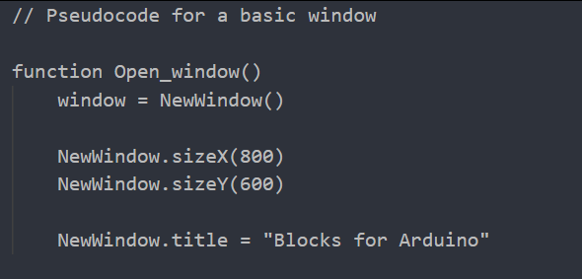

Development
To begin the development I searched for how egui windows work and found this link, (w3resources, 2024), I used this tutorial to allow me to begin the opening of the window as I was not 100% sure on how to so I chose to use a tutorial and the build upon it.

To begin the process I began by setting up the environment to code in by creating a rust project using cargo.
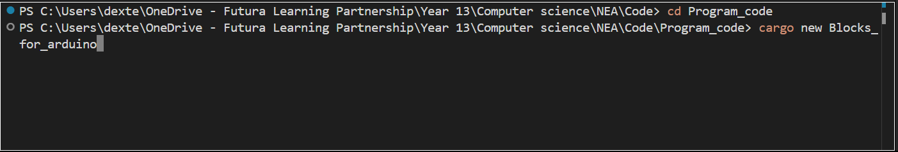
This creates a new rust project that I can work in.
Next I moved on to adding the dependencies to the project to allow me to open the window:
From this point I began to code up the window opening:
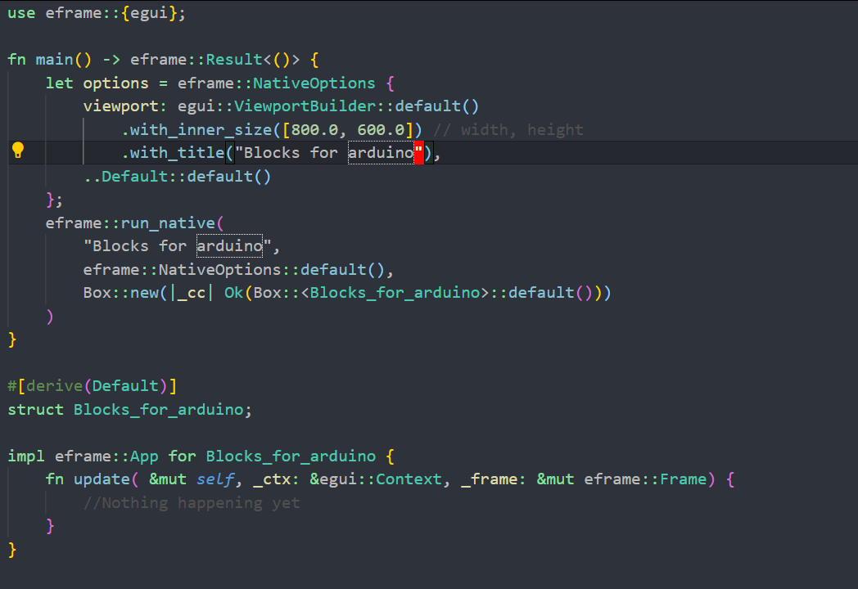
The code allows me to open a window with nothing in it, this will be the basis for my project.

Post development testing
Looking at the test I set out above:
Test ID | What is being tested? | Outcome | Pass/Fail
S1T1 | Does the window open | Yes the window opens once the program has been compiled | Pass
S1T2 | Does the window have the correct size | The window is 800x600px | Pass
S1T3 | Does the title match that of the title of the project | The window does have the title “Blocks for Arduino” | Pass

Evaluation
From the tests above I can conclude that this sprint was a success as all three tests passed, and all the success criteria were met as the test mirrored what was set in the success criteria. I feel this module is complete and I can move onto another part as this sprint is going to be built upon so there will be opportunities to work on it further if needed. There was one limitation that was the resizing of the window, this cannot be solved without adding lots of extra code that I do not yet know how to do so I have decided to work around It by keeping the window dynamically sized to it adjust when the window changes size.

Sprint 2 (S2)

Intro
For my second sprint I am going to work on separating the screen into two distinct sections for the coding section and the section for where the blocks are displayed. This sprint is going to build on the work in the sprint before, using it as the basis for this sprint.

Analysis
This sprint is going to build upon the work done in the previous sprint, building on it to allow it to have functionality rather than just to be a window that doesn’t do anything. Using (Docs, 2020), this website I began to research into Separators which are inbuilt into egui to allow you to separate your window into distinct sections.

Success criteria
Unique ID | Success criteria | Explanation | Justification | Limitations
S2SC1 | The window will have a separator | This will allow me to have a split in the window to allow me to separate the section for blocks from the section for coding | This will be used later in the project for further development | The separator hasn’t got very much customisation for size or line type
S2SC2 | Each section will have a title | This will allow me to distinguish the different sections | This will help with later development when it comes to distinguishing the sections | The titles have to be manually places so the title may be off it the window size changes
S2SC3 | The line will be visible | This will have the highest contrast against the dark grey background of the window | This is so there is a clear separation between sections | To have custom colours for the separator it has to be done manually, there is no inbuilt function in egui for it

Pre-Development Tests
Unique ID | Test ID | What is being tested? | Positive result
S2SC1 | S2T1 | Is there a separator in the window | There is a separator on the window
S2SC2 | S2T2 | Is there a title for each section of the window | There are two title:  “Code section”  “Block section”
S2SC3 | S2T3 | Is the separator visible | The separator is visible within the window

Design
To help me further to understand what needs to be done I have decided to continue adding to the pseudocode that I had begun in the last sprint.

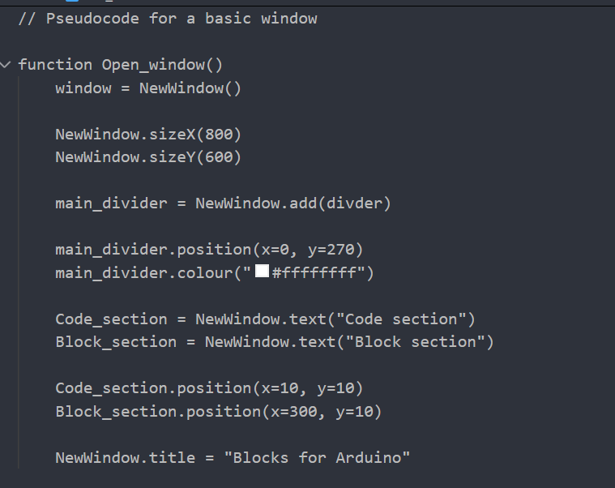

Development
Using the research done in my analysis I am able to now go on to implement the features I stated in my introduction of this sprint. This code will be added to the code that I wrote in the last sprint. Below I have included a code snippet that illustrates how the separators into the code.
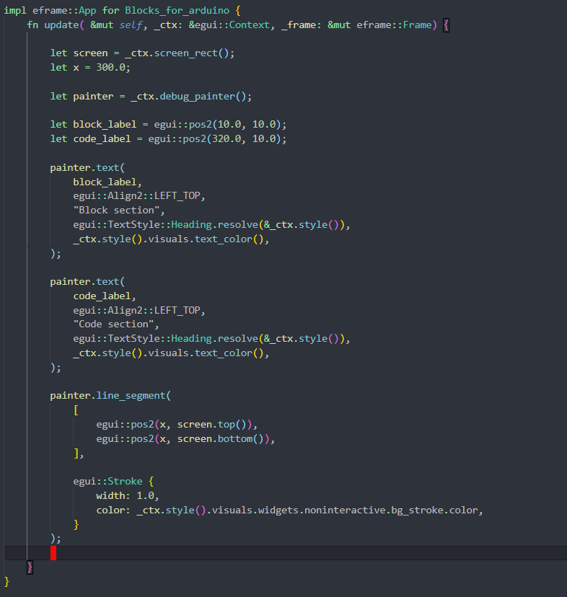
From what I found with the analysis research, I found that the inbuilt separators could not insert a line across the whole screen, so I decided to have the program manually draw the line and then also add the labels in, so it worked contiguously across the whole window.

Post-Development Tests
Test ID | What is being tested? | Outcome | Pass/Fail
S2T1 | Is there a separator in the window | Yes there is a separator on the window | Pass
S2T2 | Is there a title for each section of the window | Yes there is a title for the code and blocks section | Pass
S2T3 | Is the separator visible | Yes the separator is visible within the window | Pass

Evaluation
From the tests seen above I can say that this sprint has been successful in fulfilling the criteria I set out before. I feel that after this I am ready to move on to coding another section of code for this project. The main limitation of this sprint was that egui does not support full window separators, so I had to code them myself within the program.

Sprint 3 (S3)

Intro
For my third sprint, I have decided to begin to create the blocks that are used to code the Arduino. This will require me to setup a Json file for the main program to read to have the onscreen characteristics of the block within the window. This will also allow me to also create new blocks that can be saved and then be brought back into the program.

Analysis
For this I am going to need to have a way to read and write to a json file, doing some research online I found people use serde.json (contributors, 2017), for my project I have chosen to use serde_json as I have similar use case. Serde_json is a library that is used when the user wants to read and work with json files for rust, I chose this as I am needing to read from json files so I feel that this will allow me to gain the functionality that I need.

Success criteria
Unique ID | Success criteria | Explanation | Justification | Limitations
S3SC1 | The block will be red and 100x100 pixels in size with a name of “Test_block” | I feel for a first block this is a good size that is big enough for the text to be legible | This is just a test block for a proof of concept for how a block will work | The block will have no use as such
S3SC2 | The block will have a Json file that has the correct attributes that it reads from | This is to allow for the blocks to be compiled in the future | This will allow me to then create more blocks from a base template; this allows me to have all of them brought into the program | The blocks will only work with a certain structure so any imperfections may cause errors
S3SC3 | The block will appear in the block section of the screen | This is to mimic the rest of the blocks | This is to help me see what the layout will be for future sprints | The block section is not a fixed area

Pre-Development Tests
Unique ID | Test ID | What is being tested? | Positive result
S3SC1 | S3T1 | The box is red, 100x100 and has the title “Test_block” | There is a red box that is 100x100 and has the title “Test_block”
S3SC2 | S3T2 | The block reads from the Json file that is associated with it | There will be a output in the terminal that outputs that it has read the json
S3SC3 | S3T3 | The block is in the correct position | It will be in the block section

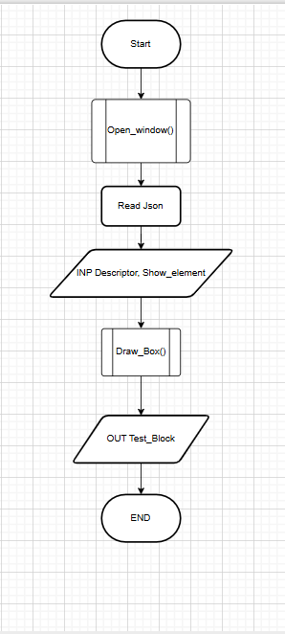
Design
For my design I chose to create a flow chart to help me develop the next piece of code. From this I can go ahead with development of this sprint, The Open_window() is a section of code that was made during the first sprint. Draw_box() is a piece of code that has been written in the first sprint as well.

Development
For the development stage I first worked on having my program read a json file. To do this I used serde_json which is a rust library that is able to read json. Next I made it so It read only the first section of the json file so it created the block with the correct title. The next step for development was creating the block onscreen. Finally I made sure that the block was in the correct position.
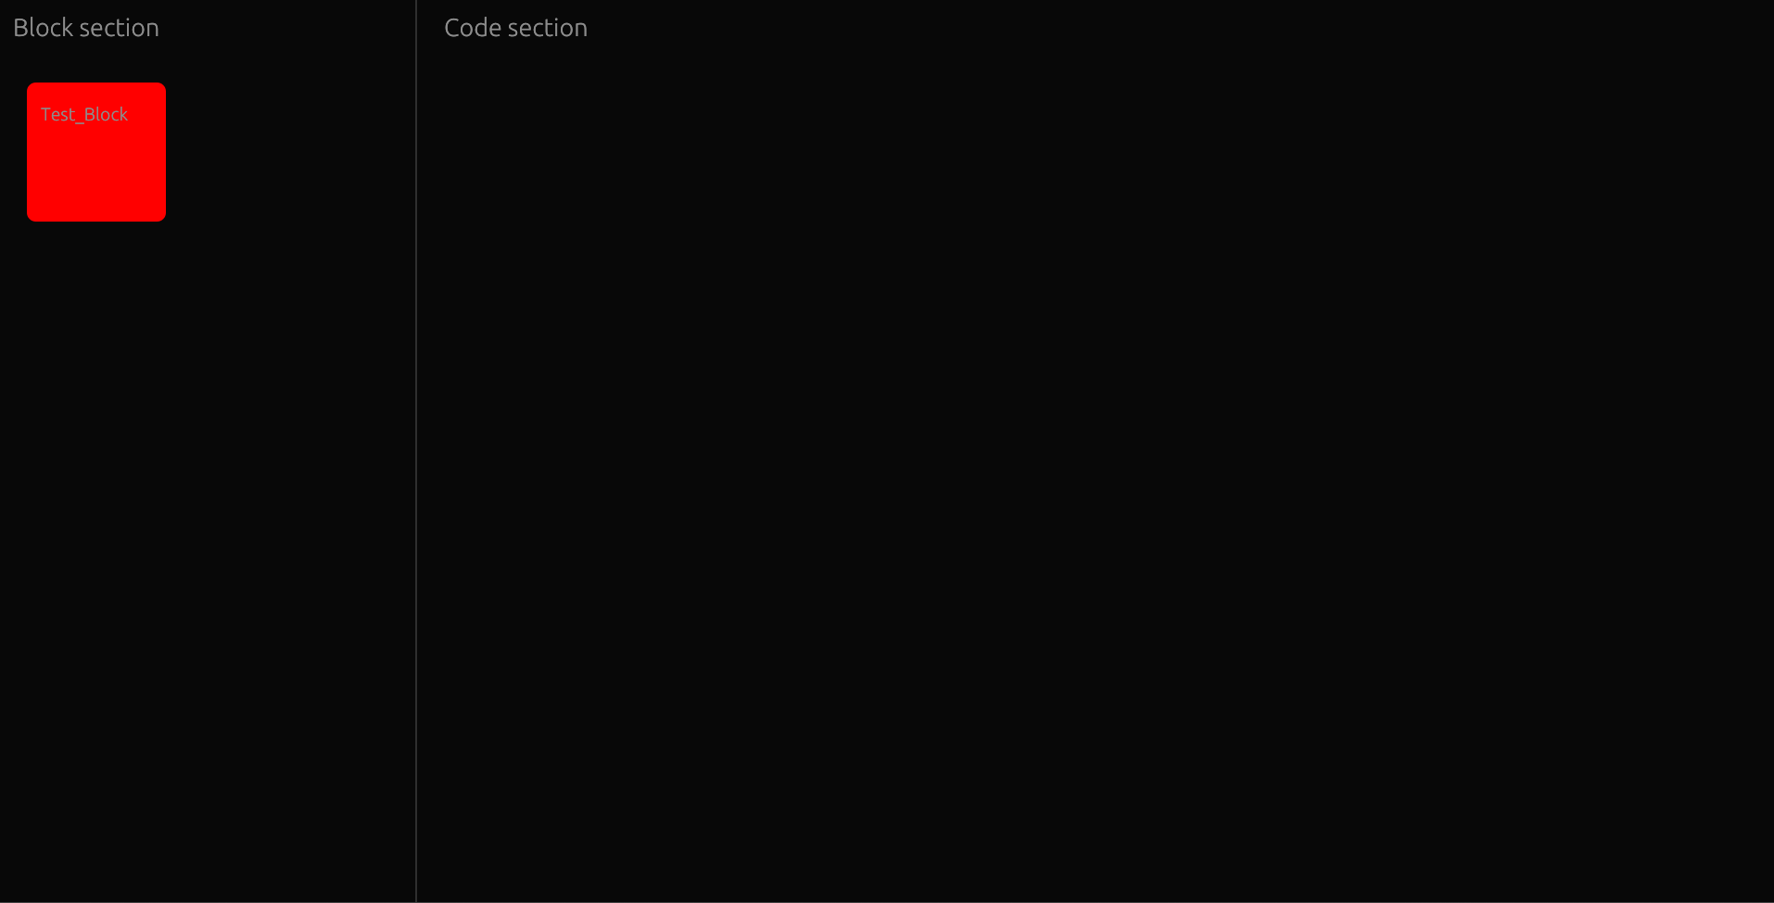
This screenshot shows the block rendering correctly with the correct text as shown in in the linked json file.

Post-Development Tests
Test ID | What is being tested? | Outcome | Pass/Fail
S3T1 | The box is red, 100x100 and has the title “Test_block” | The box was red and 100x100 with the title of Test_block | Pass
S3T2 | The block reads from the Json file that is associated with it | The block has read the correct information from the json | Pass
S3T3 | The block is in the correct position | The block was in the correct section | Pass

Evaluation
From this sprint I can say that it was successful, but I feel there is more to do in this area as the blocks are currently unable to be moved and there is only one, my next steps will be to make the blocks moveable and have more blocks for the ability to code.

Sprint 4 (S4)

Introduction
For this sprint I have chosen to work on being able to have the blocks move when selected by the mouse, this will allow for basic movement of the blocks into the code section allowing for the user to begin programming the code.

Analysis
For this sprint I am going to need to have input from the mouse within the window. Egui has native mouse support which allows me to use the mouse within the window. For this I used Rust foundation. (foundation, n.d.) The article contains the uses of the response struct to allow the program to have the blocks be interacted with. To help me understand how the mouse will work within the app.

Success Criteria
Unique ID | Success criteria | Explanation | Justification | Limitations
S4SC1 | The mouse will be able to interact with the window | To allow for the mouse to be used in the program | To allow for the future use of the mouse | The mouse has to be implemented using egui, as the mouse is not used by default
S4SC2 | The block will be able to be moved | So that the blocks will be able to be brought into the code section | To allow for code to be developed with the blocks | The blocks require more, complex code to be moved
S4SC3 | The mouse will be able to move the block | To allow for the block to be used in the code section | To allow for the movement of blocks into the code area to then be linked for coding | The block may be inaccurate in tracking the mouse.

Pre-Development Tests
Unique ID | Test ID | What is being tested? | Positive result
S4SC4 | S4T4 | The mouse will be able to interact with the window | The mouse interacts
S3SC2 | S3T2 | The block will be able to be moved | The block moves
S3SC3 | S3T3 | The mouse will be able to move the block | The mouse moves the block

Development
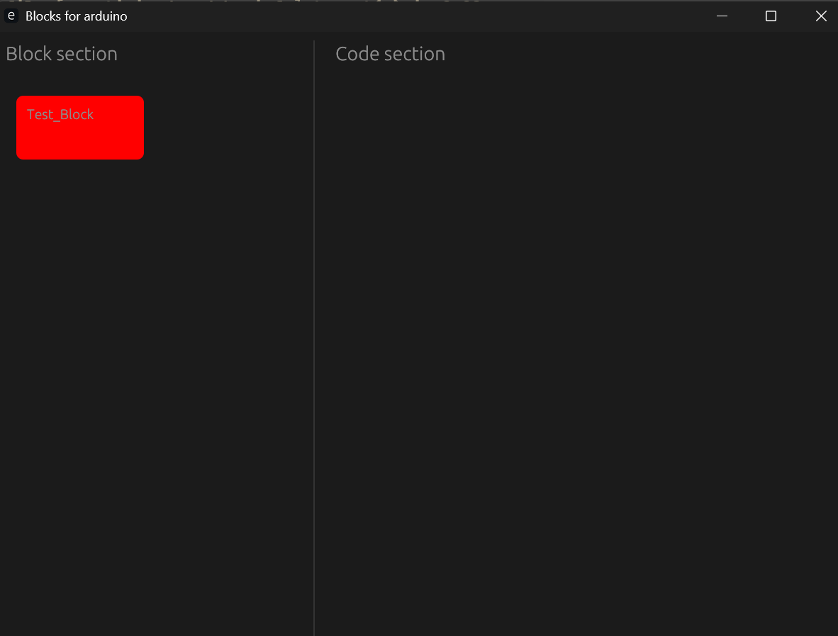
During the development process I found problems in my code, including the fact I had used an API that was out of date, so most of my development was spent rewriting my code so that it had an up to date API. Then I moved on to making the blocks be able to moved around the window. During development I found that part of the code I was using was using the incorrect and outdated part of a library, and during my development I changed it with the use of the suggestions of the documentation.

Post-Development Tests
Test ID | What is being tested? | Outcome | Pass/Fail
S4T1 | The mouse will be able to interact with the window | The mouse was able to interact | Pass
S4T2 | The block will be able to be moved | The block moved | Pass
S4T3 | The mouse will be able to move the block | The mouse was able to move the block | Pass

Evaluation
Overall, this sprint was successful, even with the API setback the sprint still was fully complete, this will then allow me to move toward into making the window into having the ability to join code blocks, this will be my next step.

Sprint 5 (S5)

Introduction
For this sprint I have chosen to work on implementing a two blocks that then can be able to be dragged into the code area to then be able to have the logic implemented to connect them in the future.

Analysis
This will require me to alter my code so that the program can read all of the json files within the “/Json” directory to then draw them to the screen, the json files can be altered to change the colours.

Success criteria
Unique ID | Success criteria | Explanation | Justification | Limitations
S5SC1 | There will be two blocks on the screen | This will allow me to begin to move toward having code that will be able to be compiled | This is so that the code can be run on an Arduino | The blocks do not full represent what the code is doing
S5SC2 | Each block will have a name and colour | This is to allow for the differentiation of the blocks on screen | To allow the user to easily distinguish the multiple blocks | As the number of blocks increases the colour will need to be divided into different groups based on what the blocks do
S5SC3 | There will be the ability for multiple new blocks to be added | This allows for the expansion of lots of blocks | This is to allow for programming to have lots of blocks to use | The code will need to have an array to store the loaded blocks which has to be a defined size at compile time

Pre-development test
Unique ID | Test ID | What is being tested? | Positive result
S5SC1 | S5T1 | Are there two blocks on screen | There are two blocks on screen
S5SC2 | S5T2 | Are the blocks different colours | They are both different colours
S5SC3 | S5T3 | There will be the ability for multiple new blocks to be added | There is the ability for multiple blocks

Design
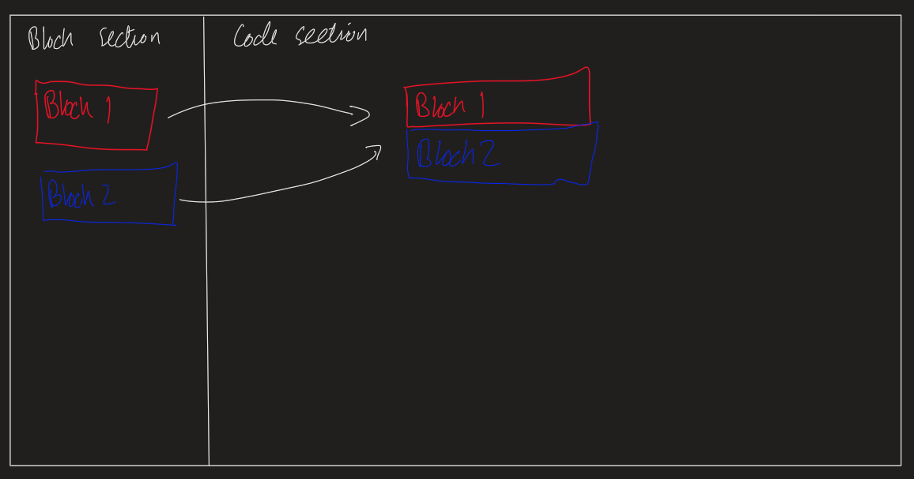
This is a rough sketch of how I want the blocks to be able to work together.

Development
During development I had to rework some of my previous code to allow for the reading and parsing of blocks to allow me to add an undefined number of blocks as json files that can be read, for this I had to alter.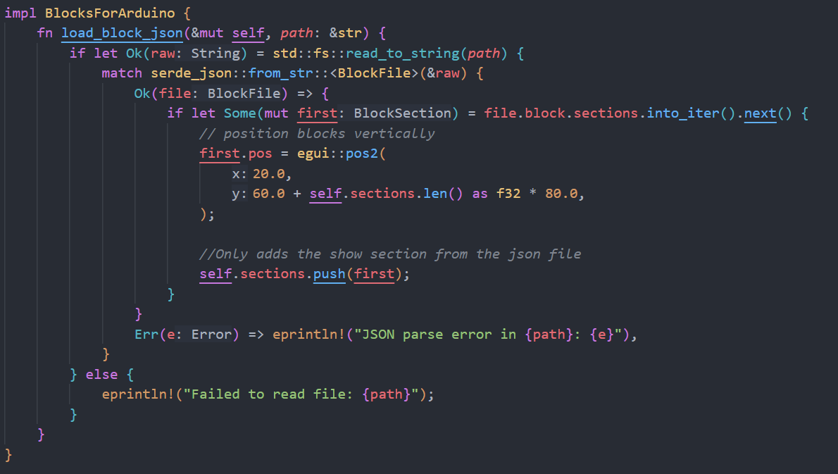
This code to allow for it to iterate through all the json files that were added to a vector in the main function to allow for it to write the name of the block and the colour. In rust a vector is continuously growing array, that is allocated to the heap.

Post-development test
Test ID | What is being tested? | Outcome | Pass/Fail
S5T1 | Are there two blocks on screen | There are two blocks on the screen | Pass
S5T2 | Are the blocks different colours | The blocks are blue and red respectively | Pass
S5T3 | There will be the ability for multiple new blocks to be added | There is now code to add multiple blocks | Pass

Evaluation
This sprint was successfully completed as there are now multiple blocks to be dragged around the screen, for my next sprint I am going to work on implementing logic for the blocks to allow them to organise themselves correctly.

Sprint 6 (S6)

Introduction
For this sprint I am going to work on implementing logic to allow the blocks to connect in the correct positions and having the ability to alter values within the block to add some user input into the code.

Analysis
For this sprint I need to begin by working on organising the blocks so that the blocks position themselves correctly based on the type of blocks, for example any blocks that connect to the bottom of the while loop block will connect at an offset to show that it is within the while block. I am then going to move onto working on having alterable values in the blocks to allow for the user to alter the code for the Arduino.

Success Criteria
Unique ID | Success criteria | Explanation | Justification | Limitations
S6SC1 | The blocks will interact | This will allow me to code using the blocks | This allows for the code to be expandable | The blocks have a highest number of interactions of 2 as that is how the program is sequenced
S6SC2 | They will be able to be rearranged | This allows for the code to be restructured | To allow for the code to be edited later on in use | There are only a small number of blocks so far so the code is very simple
S6SC3 | The while loop will have an offset underneath to show that the blocks are indented | This will allow for the code within the while loop to work correctly | This will allow me to align the code so it is more modular within the GUI | This will require more code to implement as the offset has to be easy for the user to see but the value used has to be determined once coded

Pre-Development test
Unique ID | Test ID | What is being tested? | Positive result
S6SC1 | S6T1 | Do the blocks interact and connect | The two blocks do connect
S6SC2 | S6T2 | The blocks can be detached and rearranged | They do detach and be rearranged
S6SC3 | S6T3 | The while loop has an indent underneath | There is an indent underneath the while loop

Design
For my design I am going to mock how to blocks work with the current program and show how the block will arrange:
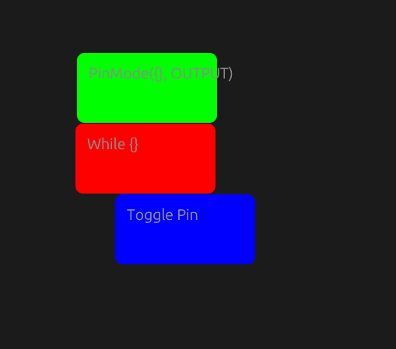
In this pre-development photo, we can see that the while loop should have an indent to show code within the loop, the blocks are also connected to allow them to then de detached and rearranged.

Development
During the development of this sprint, I had many ideas, these included:
- During the development I decided to choose that the blocks could be clicked to then have a new one appear in the code section to then be used
- I decided to add an offset to the connection of the while loop to allow for easier readability
- I decided that right click will delete the block.
During this process there were many errors that I had to overcome due to the way that I had written before. The main error was to do with the way the blocks interacted, it took lots of adjustment to get them to connect how I want them to.

Post-development test
Test ID | What is being tested? | Outcome | Pass/Fail
S6T1 | Do the blocks interact and connect | The blocks interact | Pass
S6T2 | The blocks can be detached and rearranged | The blocks can be attached, and rearranged | Pass
S6T3 | The while loop has an indent underneath | The while loop has an indent for its children blocks | Pass

Evaluation
This sprint was successfully completed as there is now a way to connect blocks and have them ordered with ease of reading features. My next steps will be to implement parameters into the blocks that then can be passed into the json files behind each block (and then Arduino code and have the blocks compile down into an Arduino code file Possibly). I also had the opportunity to speak to my stakeholder and they suggested the idea of adding the addition of user inputs to help the user then further tailor their blocks to their needs.

Sprint 7 (S7)

Introduction
For this sprint I have chosen to work on giving the user some more input into the program through the alterable parameters within the given blocks where they are applicable, for example within the pinMode set block, the pinMode set block is a blocks that allows the user to choose a pin on the Arduino and set it to either be an input or an output. This will also apply to the while loop block as the user will be able to define what the condition for the loop to execute is.

Analysis
For this sprint I am going to need to work on updating my current code to allow is to take a user input within the blocks, this requires me to change my program so that the blocks will contain a “widget” ( this is an egui term for a user interface) to allow for the input of values and then pass this value to the json file ready for the next steps, this will allow for the user to choose the pin that they use. Looking at what needs to be changed it may be beneficial to split my current code file up into smaller files for easier coding. This allows me to have an easier time working as I know what bits of code relate to what section of the program.

Success Criteria
Unique ID | Success criteria | Explanation | Justification | Limitations
S7SC1 | There will be an area to input into | This will allow the user to input into the program | This will allow for user input into the code | The code will have to have lots of changes to implement this feature
S7SC2 | The inputted value will enter the json file | This will be used in a later sprint for compilation to a file for an Arduino | This is so that later the json files are able to pass the inputted values into a code file that is able to run on an Arduino | The code will have to have extra section to allow the values to be passed into the json
S7SC3 | The single code file will be split into multiple files | This will make the code easier to read and debug as the split will mean that each file is shorter | This is to allow the code to be easier to update in future | This will mean that it is harder to debug due to the increased number of files

Pre-Development test
Unique ID | Test ID | What is being tested? | Positive result
S7SC1 | S7T1 | There is a box to allow for user input | There is a box and the user is able to input into it
S7SC2 | S7T2 | The inputted value from the user in passed into the json | There is an updated value within the json file
S7SC3 | S7T3 | Are there multiple code files | There are now multiple code files to use

Design
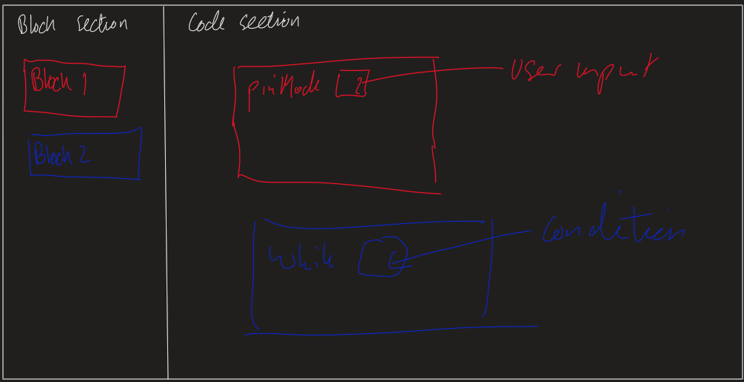
For the design of the user input I would like to work as I have shown above with there being a box within the block that the user can type into.
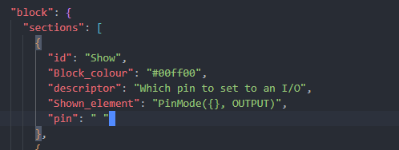
Within each json that has a user input I would also like there to be a variable like what I have shown above which is where the pin the user inputted is stored before being added to the A_C_E section ready for the future sprints.

Development
During development I found that splitting my code into discrete files was beneficial to me being able to continue this project as I now I have an easier time programming s each file has a discrete use and different use within the overall project. The split of the code into files allowed me to then add in the user input with ease as the files allowed me to add the code to the files fairly easily. This means that the user is now able to input into the boxes.

Post-development test
Test ID | What is being tested? | Outcome | Pass/Fail
S7T1 | There is a box to allow for user input | The boxes are able to be inputted into | Pass
S7T2 | The inputted value from the user in passed into the json | The input was was not stored in the json file | Fail
S7T3 | Are there multiple code files | There are now multiple code files for easier development | Pass

Evaluation
This sprint was mostly successful as the code is now in multiple code files that now make it easier to move on to later stages. The blocks having user input works well, but they do not pass that into the json file so I will have to work on this in a later sprint. In my next sprint I plan on working on converting the A_C_E section into a code file that would work on an Arduino.

Sprint 8 (S8)

Introduction
For this sprint I have chosen to work on syntax validation for the blocks within the program. This is to ensure that the blocks are in an order that will work when the blocks are compiled down into the code file that will work on an Arduino.

Analysis
This sprint will require me to alter my code to allow the program to check what blocks are on the screen and what order they are in, from this I will then have to check that the order makes sense, if the blocks are not in the correct order there should be a popup to suggest a change that needs to be made to the blocks for it to be in a logical order.

Success Criteria
Unique ID | Success criteria | Explanation | Justification | Limitations
S8SC1 | The code will check the order of the blocks | This is to help validate the order so that it can be compared to logical orders | This will allow the program to begin to convert the code to Arduino code | The blocks have to be added to a new array which will add complexity to the code
S8SC2 | The order is then compared to logical uses of each block | This can then be used to verify the order of the blocks on screen | The logical orders are the expected order for the blocks | The logical orders will have to add code to the program which increases complexity
S8SC3 | The program will have a popup if the blocks are in the wrong order | This will allow the users to see what there mistake is and alter the code to fix it | The popup add helpful notes to help the user fix the code | The popup will not always be 100% correct

Pre-Development test
Unique ID | Test ID | What is being tested? | Positive result
S8SC1 | S8T1 | The code checks the order of the blocks | There is an array in a previous_programs.txt with the order of the blocks
S8SC2 | S8T2 | The blocks are compared to previous programs | The program compares the current and previous sets of blocks and makes note of the differences
S8SC3 | S8T3 | There is a popup when the blocks are in the wrong order | There is now a popup that suggests what needs to be changed based on the above test

Design
For this sprint I am going to add a popup window to help the user with correctly sequencing there program with the blocks:
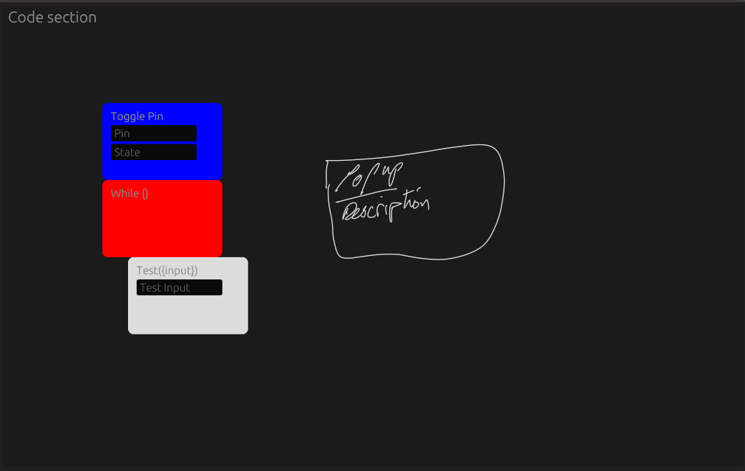

Aswell during this sprint I am going to sequence the blocks to help with the code validation.

Development
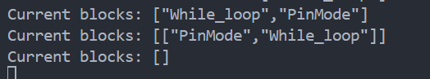
For this sprint I found there were many challenges, the first challenge I encountered was that to begin working on validating the sequence of the blocks I first has to work out what blocks were in the code section onscreen. This required me to first work out how to know what blocks where on screen based on which ones were clicked on by the mouse and then add this to an array.

The next step was then working out what blocks were connected and adding them to a sub array, this then allowed me to begin with validation of the sequence.
My next steps were then to go on to make a text file with all of the valid sequence of the blocks given to then allow me to iterate through and compare to the sequence of the blocks onscreen, then if there was no match the program created a popup that gave a suggestion to the user to allow them to fix there code to allow it to work.

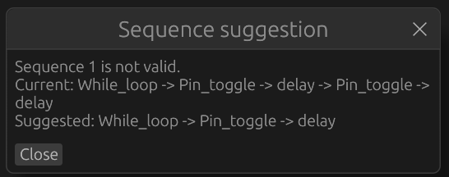

From this point I then went on to do data validation for the inputs within the blocks that has user inputs, this ensured that then when the code is then compiled down into a .ino (this is the file extension of Arduino code, it has a syntax built on cpp) file for the Arduino. To do this I began by adding a validation attribute to the input within the json, then this is passed to the main program to allow a comparison to occur.
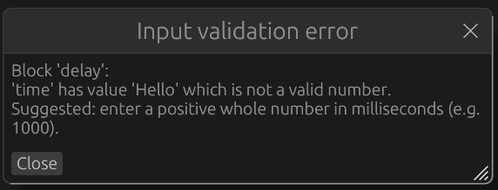
If the data inputted is the wrong type, then another popup will appear with a suggestion to the user of what needs to be changed and what it needs to be changed to.

Post-development test
Test ID | What is being tested? | Outcome | Pass/Fail
S8T1 | The code checks the order of the blocks | The code does check the order of the blocks | Pass
S8T2 | The blocks are compared to previous programs | The blocks order is compared to a file with all valid sequences | Pass
S8T3 | There is a popup when the blocks are in the wrong order | There are now multiple popups to assist the user in development | Pass

Evaluation
From the tests above I can say that this sprint was a success as based on the criteria above I can see that all of the objectives I had set out to do are now complete and working. The program is now able to detect the sequence of the blocks and suggest changes that need to be made. For my next sprint I am going to work on save/reload of previous workspaces within the program.

Sprint 9 (S9)

Introduction
For this sprint I have chosen to work on open and closing files, this will then allow the user to work on multiple different workspaces at a given time.

Analysis
For this sprint I have looked at how other programs handle open/close/save, such as how visual studio code has the ability to open, close, save and save as. For my project I have decided to implement a similar idea by having a open and close for workspaces.

Success Criteria
Unique ID | Success criteria | Explanation | Justification | Limitations
S9SC1 | The user is able to save code | This will allow them to then be able to revisit it at a later date | This will let the user create multiple programs | The code is only saved as the most recent edition and there is no rolling back to previous versions
S9SC2 | The user is able to reopen the code previously saved | This allows the user to then have multiple files that they can save | This is to allow the user to create multiple programs that they can swap between | The user is only able to have a single file open at a time
S9SC3 | The user can navigate through all code files they have saved | This will allow the users to open a specific file | The navigation helps to find a specific file within the “Workspaces” folder | Only a certain number of files that can be shown in the box at once

Pre-Development test
Unique ID | Test ID | What is being tested? | Positive result
S9SC1 | S9T1 | The user is able to save a file with a given name | There is a file with the name the user inputted
S9SC2 | S9T2 | The user can open a previous file | There is a list of previous files and the user can chose one to open
S9SC3 | S9T3 | The user has the ability to navigate through previous files | There are files for them to select

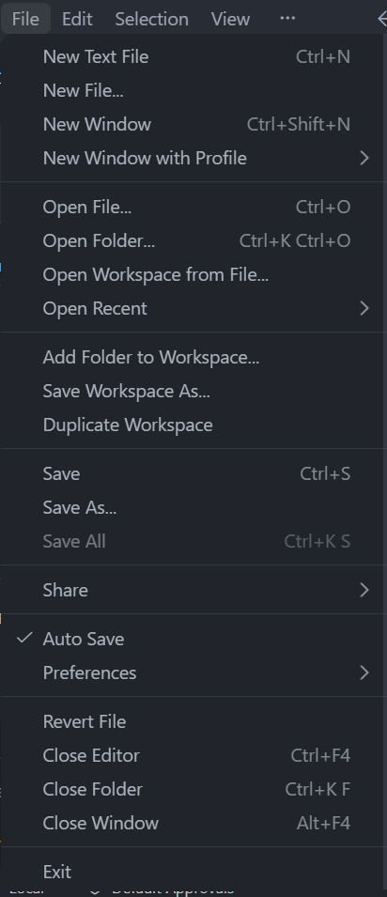
Design
For this sprint I have chosen to implement a similar system to how Visual studio code does it, with the options highlighted with red as I feel these are the key features that should be included.

Development
During this sprint I had decided that the saved files should be stored as json files as they are already in the program, and it adds no extra dependencies. From this I then added features to then save and open them from a menu bar at the top of the window.
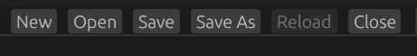
I ended up having these features on the same menu bar as the sequence checker as the formatting had already been done.
When the user presses the save button they now have the option to choose what they call the current set of blocks they are working on:
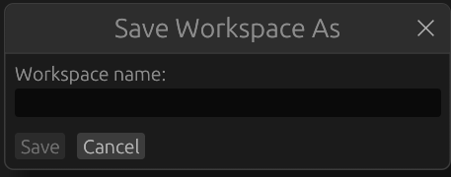
This then allows they to choose a file from the workspaces folder when they press the open button:
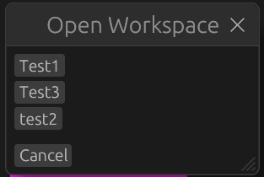
From pressing one of the workspaces they are then presented with any blocks that were saved to that workspace, and they blocks are configured how they were when it was saved.

Post-development test
Test ID | What is being tested? | Outcome | Pass/Fail
S9T1 | The user is able to save a file with a given name | The user can now save the current workspace with a name they choose | Pass
S9T2 | The user can open a previous file | The user can open any workspaces that they have previously saved | Pass
S9T3 | The user has the ability to navigate through previous files | The user has the ability to view all past workspaces that they have used | Pass

Evaluation
From the results shown above I can conclude that this sprint has been successful as the user now can save and reopen files. For my next steps I am going to work on the way to get the user input and start the process of taking the users inputs and using them in a way that I can then create a .ino file that will work on the Arduino.

Sprint 10 (S10)

Introduction
For this sprint I am going to work on taking the users inputs and begin to compilate it into a file that will be able to run on an Arduino. For this I am going to need to edit my code to read the users input and then add this into the Arduino code section of the json and then have it compilate into another file that has the extension of ino which is the file type that Arduinos use to run code.

Analysis
For this sprint I am going to have to add code to allow the program to read what the user has inputted and then have it add it to the A_C_E section for it to then be copied to a ino file that then will work on the Arduino.

Success Criteria
Unique ID | Success criteria | Explanation | Justification | Limitations
S10SC1 | The code now can read what the user has inputted | This will allow it to begin working on creating an .ino file | This allows for the beginning of Arduino code generation | The data types have to be correct to be read
S10SC2 | The code is now able to generate a .ino file | This will be so that the user could then upload it to an Arduino if they know how | This is so that the user can test there code by uploading it to an Arduino | The user may not know how to upload the file to the Arduino
S10SC3 | The user is able to view the .ino file | This is so the user can check the file before they possibly upload the file | This allows the user to check that the code they created is what they expect | The user may not be familiar with the Arduino coding language

Pre-Development test
Unique ID | Test ID | What is being tested? | Positive result
S10SC1 | S10T1 | The code now reads what the user has inputted | There is now a popup if the inputted value is the wrong type
S10SC2 | S10T2 | There is now an ino file outputted | There is an ino file with the same name as the workspace
S10SC3 | S10T3 | There are now ino files in the workspaces | The user opens the file and views the contents

Design
For this sprint I would like there to be a button that the user can press to compile the code to an Arduino ino file:
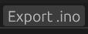
Like this, this will then allow me to then output an ino file that corresponds to what the user has created with the blocks.

Development
During development I decided that I should add some validation so that within the program the value for “Pin” is checked so that it is consistent within the whole program. This then allows me to check for continuity throughout the program:
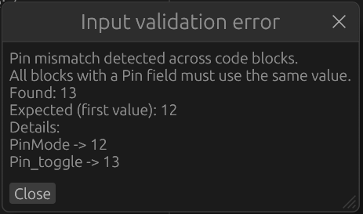
From this I then moved into adding a button that allows me to convert the blocks into an ino file:
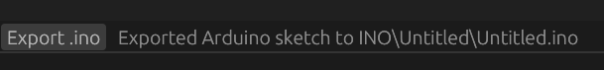
This button then creates folder within a INO folder, as this is how the Arduino files work, the Arduino file is then within that folder, the name of the folder and file are taken from the name of the workspace.

Post-development test
Test ID | What is being tested? | Outcome | Pass/Fail
S10T1 | The code now reads what the user has inputted | The program now knows what the user has inputted | Pass
S10T2 | There is now an ino file outputted | There is now an ino file that has been outputted by the program | Pass
S10T3 | There are now ino files in the workspaces | There are now ino files that have the same name as the workspace that it was created from | Pass

Evaluation
From the tests I can conclude that this sprint has been successful as I have now got it so that the blocks can now be exported to create a file that is then verified by the Arduino IDE which is the program that is mainly used to upload code to an Arduino. This ensures that my program has the correct syntax for the exporting the code.

Post Sprint Testing
Feature | Original success criteria | Post Sprint evaluation | Changes made | Appearance in development
Blocks for coding | To make the coding process easy and recognisable for student | The blocks can be used to create programs that are syntactically accurate | The only changes made were to how the blocks are stored, they have got a uniqueID that is a unique identifier for | Sprint 6 (S6), this is where I implemented the beginning of the blocks interacting
Window framework | To allow me to create the application for the user to use | The basis of the program is using a window framework; this works as I expected it to | There were no changes made to the window framework as it worked as I needed it to. | Sprint 1 (S1), this is where I first start using the window framework
Open/Close/Save files | Allows the users to open a file or close a file and save the files if they want to come back to the code later | This feature was added with little hassle as I decided to use another Json. | There was a slight change from what I had decided previously, I chose to use a json file to save the current blocks within the code section | Sprint 9 (S9), this is where I implemented the open/close/save of files
Compiling and uploading the code to the Arduino | To allow the user to compile the code and download it to the Arduino | This feature was not fully implemented due to time constraints, instead I chose to get the program to compile the blocks into a file that then could be uploaded to the Arduino | This was not fully implemented due to time constraints, and I chose to pivot and work on the program outputting a valid Arduino code file | Sprint 10 (S10), This is where I have added the compilation of code into a valid Arduino code file

Evaluation
Overall, this project has been a success. This is evident as most of the success criteria and key features that I had originally set out to include have been implemented fully.

Usability
Overall, I have found that the program I have made has an intuitive interface but may be confusing for newer users. This was also identified by my stakeholder, during our meeting my stakeholder identified that the interface was easy to use but was worried about the usability of the program for someone who is new to this area.

Incomplete sections
For this project I completed all the key features I had set out to in the key features section. In terms of additional features, I managed to include the compiling and uploading the code to the Arduino in partial as the program can output a code file that works on the Arduino, but cannot upload the code itself, for that it requires another piece of software that the user may not have. As well for incomplete features I chose not to add the access of USB ports due to the time constraints. The debugging feature was implemented to an extent as the program includes popups that inform the user of sequence problems or inconsistencies in which pin the user is using.

Maintenance
This project is stored in a GitHub repository (Jeal, n.d.), and there is a current pre-release version of the project available. This is where the project is mainly stored and will be stored in the future. The project is very portable as it is a compiled project and can be distributed very easily. Currently the project can be run on most systems. There is no current way to back up the project.

Future development
In the future I would like to continue developing this project. Using what was said in the incomplete sections above, I would strive to implement the USB port access as this increases the useability of the program. Along with the USB port integration I would also like to add a way to fully upload the code to an Arduino without the use of a third-party software.
The future development would also build upon features already included. First I would build upon the debugging to allow for more helpful comments and make the debugging more friendly to beginners to allow them to begin to understand the code.

Final evaluation
Overall, I feel pleased with how this project has turned out. I feel that I have designed and coded a project that I feel is to the standard I would like it to be. I feel that I have hit most of my targets that I set out at the beginning of the project.

Bibliography
Blockly. (2012, May 13). blockly. Retrieved from google blockly: https://google.github.io/blockly
Blocklyduino. (2012, Novemeber 12). github. Retrieved from github.io: blocklyduino.github.io
Co, M. (2017, February 19). mBlock. Retrieved from mBlock.cc: https://mBlock.cc
contributors, B. .. (2017, April 20). Docs.rs. Retrieved from docs.rs: https://crates.io/crates/serde_json
Docs, R. (2020, May 20). Docs.rs. Retrieved from docs.rs: https://docs.rs/egui/latet/egui/widgets/struct.Separator.html
Emilk. (2020, May 30). github. Retrieved from github.com: https://github.com/emilk/egui
foundation, R. (n.d.). Docs.rs. Retrieved from docs.rs: https://docs.rs/egui/latest/egui/response/struct.Response.html
gtk-rs. (2021, July 12). github. Retrieved from Github: https://github.com/gtk-rs/gtk4-rs
Jeal, D. (n.d.). Blocks_for_arduino Github. Retrieved from Github: https://github.com/Ex7740/NEA-Computer-science
Microsoft. (2022). Makecode. Retrieved from Microsoft makecode: makecode.microbit.org
Serde. (2016, May 14). Github.com. Retrieved from Github: https://github.com/serde-rs/serde
UI, S. (2021, June 30). github.com. Retrieved from Github: https://github.com/slint-ui/slint
w3resources. (2024, November 23). w3resources. Retrieved from w3resources.com: https://www.w3resources.com/rust-tutorial/learn-rust-egui-gui-development.php

Code

Main.rs
// Module declarations for the application
mod app;
mod model;
mod helper;

use std::fs;
use eframe::egui;
use app::BlocksForArduino;

/// Entry point for the Blocks for Arduino application.
///
/// Initializes the egui GUI framework with a 1000x650 window and loads all
/// block definitions from JSON files in the "Json_files" directory. Also
/// generates and syncs valid sequences based on loaded blocks.
fn main() -> eframe::Result<()> {
// Collect all JSON files from the "Json_files" directory
let mut files = Vec::new();

if let Ok(entries) = fs::read_dir("Json_files") {
for entry in entries.flatten() {
let path = entry.path();
if path.is_file() {
files.push(path);
}
}
}

// Configure the application window
let options = eframe::NativeOptions {
viewport: egui::ViewportBuilder::default()
.with_inner_size([1000.0, 650.0])
.with_title("Blocks for Arduino"),
..Default::default()
};

// Launch the application
eframe::run_native(
"Blocks for Arduino",
options,
Box::new(|_cc| {
let mut app = BlocksForArduino::default();

// Load all block JSON files to populate the palette
for path in files.iter().filter_map(|p| p.to_str()) {
app.load_block_json(path);
}

// Generate valid block sequences based on loaded blocks
app.sync_valid_sequences_with_loaded_blocks();

Ok(Box::new(app))
}),
)
}

App.rs
// Main application logic for Blocks for Arduino
// This file contains the core state management, block manipulation, validation,
// workspace persistence, and UI rendering for the visual block-based Arduino code editor.

use crate::helper::*;
use crate::model::*;
use eframe::egui;
use std::collections::{HashMap, HashSet};

// UI Layout Constants
const GLOBAL_X: f32 = 140.0; // Block width in pixels
const GLOBAL_Y: f32 = 90.0; // Block height in pixels
const VALID_SEQUENCES_PATH: &str = "Valid_sequences.txt";
const INO_OUTPUT_DIR: &str = "INO";
const BLOCKS_START_Y: f32 = 120.0; // Y-position where blocks start rendering
const PALETTE_BLOCK_GAP: f32 = 10.0; // Vertical gap between palette blocks
const MAX_SEQUENCE_BLOCKS_FOR_GENERATION: usize = 7; // Max blocks to use in sequence generation

/// Main application state for the Blocks for Arduino editor.
///
/// Manages all blocks (both palette templates and code instances), block connections,
/// user interactions, validation, and workspace management. The application uses a
/// tree structure where blocks can be attached as children to form executable sequences.
pub struct BlocksForArduino {
/// All blocks in the editor (both palette and code blocks)
pub sections: Vec<BlockSection>,

/// Tracks whether mouse was pressed in previous frame (for detecting releases)
pub was_mouse_down: bool,

/// Current top-level block connections (can be Single or Group)
pub current_blocks: Vec<BlockListEntry>,

/// Status message displayed in the toolbar
pub status_message: String,

/// Valid block sequences loaded from Valid_sequences.txt
pub valid_sequences: Vec<Vec<String>>,

/// Popup state for sequence validation suggestions
pub show_sequence_popup: bool,
pub sequence_popup_text: String,

/// Popup state for input validation errors
pub show_validation_popup: bool,
pub validation_popup_text: String,

// Workspace management
/// Name of the currently open workspace
pub workspace_name: String,

/// State for Open Workspace dialog
pub show_open_dialog: bool,
pub available_workspaces: Vec<String>,

/// State for Save As dialog
pub show_save_as_dialog: bool,
pub save_as_name_input: String,

/// Scroll position for palette blocks (left side)
pub palette_scroll_offset: f32,
}

impl Default for BlocksForArduino {
fn default() -> Self {
Self {
sections: Vec::new(),
was_mouse_down: false,
current_blocks: Vec::new(),
status_message: String::new(),
valid_sequences: Self::load_valid_sequences(VALID_SEQUENCES_PATH),
show_sequence_popup: false,
sequence_popup_text: String::new(),
show_validation_popup: false,
validation_popup_text: String::new(),
workspace_name: String::new(),
show_open_dialog: false,
available_workspaces: Vec::new(),
show_save_as_dialog: false,
save_as_name_input: String::new(),
palette_scroll_offset: 0.0,
}
}
}

/* ---------- APP LOGIC ---------- */
impl BlocksForArduino {
/// Generates a unique instance identifier using UUID v4
fn new_instance_id() -> String {
uuid::Uuid::new_v4().to_string()
}

/// Gets the unique_id for a block, falling back to id if unique_id is not set
fn block_unique_id(&self, idx: usize) -> String {
self.sections[idx]
.unique_id
.clone()
.unwrap_or_else(|| self.sections[idx].id.clone())
}

/// Counts the number of code blocks (excludes palette blocks)
fn code_block_count(&self) -> usize {
self.sections.iter().filter(|block| !block.is_palette).count()
}

/// Creates an empty HashMap of input values based on the block's input definitions
fn build_input_values(block: &BlockSection) -> HashMap<String, String> {
let mut values = HashMap::new();
for input in &block.inputs {
values.insert(input.name.clone(), String::new());
}
values
}

/// Initializes all runtime-only fields on a block (position, connections, input values, etc.)
/// This is called when creating new blocks or loading from snapshots.
fn initialise_runtime_fields(block: &mut BlockSection, pos: egui::Pos2, is_palette: bool) {
block.pos = pos;
block.attached_to = None;
block.children.clear();
block.input_values = Self::build_input_values(block);
block.instance_id = Self::new_instance_id();
block.is_palette = is_palette;
}

/// Loads a block definition from a JSON file and adds it to the palette.
///
/// The JSON file should contain a "block" key with "sections" containing block definitions.
/// Only the first "show" section or the section with shown_element is displayed in the palette.
/// Looks for an "A_C_E" section to extract the code template.
pub fn load_block_json(&mut self, path: &str) {
let raw = match std::fs::read_to_string(path) {
Ok(r) => r,
Err(e) => {
println!("Failed to read {}: {}", path, e);
return;
}
};

let file: BlockFile = match serde_json::from_str(&raw) {
Ok(f) => f,
Err(e) => {
println!("Invalid JSON in {}: {}", path, e);
return;
}
};

let mut sections = file.block.sections.into_iter();

let mut show_section = None;
let mut ace_template = None;

for section in sections.by_ref() {
let section_id = section.id.to_ascii_lowercase();
if section_id == "show" || section.shown_element.is_some() {
if show_section.is_none() {
show_section = Some(section.clone());
}
}

if section_id == "a_c_e" {
ace_template = section.code_equivelant.clone();
}
}

let mut block = match show_section {
Some(mut b) => {
b.code_equivelant = ace_template;
b
}
None => return,
};

// If no unique_id provided, use the block's id field
if block.unique_id.is_none() {
block.unique_id = Some(block.id.clone());
}

Self::initialise_runtime_fields(
&mut block,
egui::pos2(
20.0,
BLOCKS_START_Y
+ self.sections.iter().filter(|b| b.is_palette).count() as f32
* (GLOBAL_Y + PALETTE_BLOCK_GAP),
),
true,
);
self.sections.push(block);
}

fn loaded_palette_block_ids(&self) -> Vec<String> {
let mut seen = HashSet::new();
let mut ids = Vec::new();

for block in self.sections.iter().filter(|block| block.is_palette) {
let block_id = block
.unique_id
.as_ref()
.cloned()
.unwrap_or_else(|| block.id.clone());
if seen.insert(block_id.clone()) {
ids.push(block_id);
}
}

ids
}

/// Recursively generates all possible permutations of block sequences up to MAX_SEQUENCE_BLOCKS_FOR_GENERATION
/// Used for validating block connection orders
fn generate_sequences_recursive(
block_ids: &[String],
used: &mut [bool],
current: &mut Vec<String>,
out: &mut Vec<Vec<String>>,
) {
for idx in 0..block_ids.len() {
if used[idx] {
continue;
}

used[idx] = true;
current.push(block_ids[idx].clone());
out.push(current.clone());
Self::generate_sequences_recursive(block_ids, used, current, out);
current.pop();
used[idx] = false;
}
}

/// Generates all valid block sequence permutations from available palette blocks
/// Useful for initial setup and validation of block order constraints
fn generate_valid_sequences_from_blocks(block_ids: &[String]) -> Vec<Vec<String>> {
if block_ids.is_empty() {
return Vec::new();
}

let limited_ids: Vec<String> = block_ids
.iter()
.take(MAX_SEQUENCE_BLOCKS_FOR_GENERATION)
.cloned()
.collect();

let mut used = vec![false; limited_ids.len()];
let mut current = Vec::new();
let mut sequences = Vec::new();
Self::generate_sequences_recursive(&limited_ids, &mut used, &mut current, &mut sequences);
sequences
}

pub fn sync_valid_sequences_with_loaded_blocks(&mut self) {
let palette_ids = self.loaded_palette_block_ids();
let generated = Self::generate_valid_sequences_from_blocks(&palette_ids);
self.valid_sequences = generated.clone();

match serde_json::to_string_pretty(&generated) {
Ok(serialized) => {
if let Err(err) = std::fs::write(VALID_SEQUENCES_PATH, serialized) {
eprintln!("Failed to write {}: {}", VALID_SEQUENCES_PATH, err);
}
}
Err(err) => {
eprintln!("Failed to serialise generated sequences: {}", err);
}
}
}

/// Creates a new code block instance from a palette block.
/// The new block is positioned offset from existing code blocks.
pub fn spawn_code_block(&mut self, source: usize) {
let mut new_block = self.sections[source].clone();
let offset = self.code_block_count() as f32 * 15.0;
Self::initialise_runtime_fields(
&mut new_block,
egui::pos2(320.0 + offset, BLOCKS_START_Y + offset),
false,
);

self.sections.push(new_block);
self.refresh_current_blocks();
}

/// Detaches a block from its parent, removing it from the parent's children list.
/// Used when the user drags a block away or before deletion.
fn detach_block(&mut self, idx: usize) {
if let Some(parent) = self.sections[idx].attached_to.take() {
self.sections[parent].children.retain(|&child| child != idx);
self.refresh_current_blocks();
}
}

/// Attempts to snap a block to a parent if it's positioned within snap distance.
/// Searches for compatible parents and establishes parent-child connection if appropriate.
fn try_snap(&mut self, idx: usize) {
let size = egui::vec2(GLOBAL_X, GLOBAL_Y);
let snap = 12.0;
let my_pos = self.sections[idx].pos;

for j in 0..self.sections.len() {
if j == idx {
continue;
}
let parent = &self.sections[j];
let offset = parent
.child_offset
.map(|o| o.vec2())
.unwrap_or(egui::vec2(0.0, 0.0));

let target_x = parent.pos.x + offset.x;
let target_y = parent.pos.y + size.y + offset.y;

if (my_pos.y - target_y).abs() < snap && (my_pos.x - target_x).abs() < snap {
self.detach_block(idx);
self.sections[idx].pos = egui::pos2(target_x, target_y);
self.sections[idx].attached_to = Some(j);
if !self.sections[j].children.contains(&idx) {
self.sections[j].children.push(idx);
}
self.refresh_current_blocks();
break;
}
}
}

/// Repositions all child blocks in a vertical line below their parent.
/// Called after parent block is moved to maintain proper child alignment.
fn move_children(&mut self, parent: usize) {
let size = egui::vec2(GLOBAL_X, GLOBAL_Y);
let base = self.sections[parent].pos;
let offset = self.sections[parent]
.child_offset
.map(|o| o.vec2())
.unwrap_or(egui::vec2(0.0, 0.0));

let mut y = base.y + size.y + offset.y;
let children = self.sections[parent].children.clone();

for child in children {
self.sections[child].pos = egui::pos2(base.x + offset.x, y);
y += size.y;
self.move_children(child);
}
}

/// Recursively collects all descendants (children, grandchildren, etc.) of a block
/// as a flat list of indices. Used for deletion and serialization.
fn collect_descendants(&self, idx: usize, out: &mut Vec<usize>) {
out.push(idx);
for &child in &self.sections[idx].children {
self.collect_descendants(child, out);
}
}

/// Recursively collects the unique IDs of a block and all its connected descendants
/// Used to build the current block sequence representation.
fn collect_connected_unique_ids(&self, idx: usize, out: &mut Vec<String>) {
out.push(self.block_unique_id(idx));
for &child in &self.sections[idx].children {
self.collect_connected_unique_ids(child, out);
}
}

fn build_current_blocks(&self) -> Vec<BlockListEntry> {
let mut roots: Vec<usize> = self
.sections
.iter()
.enumerate()
.filter(|(_, block)| !block.is_palette && block.attached_to.is_none())
.map(|(idx, _)| idx)
.collect();
roots.sort_by(|a, b| self.sections[*a].pos.y.total_cmp(&self.sections[*b].pos.y));

roots
.into_iter()
.map(|root| {
let mut group = Vec::new();
self.collect_connected_unique_ids(root, &mut group);
if group.len() == 1 {
BlockListEntry::Single(group.remove(0))
} else {
BlockListEntry::Group(group)
}
})
.collect()
}

/// Converts the current blocks to a JSON string representation for display/debugging
fn current_blocks_json(&self) -> String {
serde_json::to_string(&self.current_blocks).unwrap_or_else(|_| "[]".to_string())
}

/// Loads valid block sequences from the specified JSON file.
/// Returns empty Vec if file is missing or contains invalid JSON.
fn load_valid_sequences(path: &str) -> Vec<Vec<String>> {
let raw = match std::fs::read_to_string(path) {
Ok(raw) => raw,
Err(err) => {
eprintln!("Failed to read {}: {}", path, err);
return Vec::new();
}
};

match serde_json::from_str::<Vec<Vec<String>>>(&raw) {
Ok(sequences) => sequences,
Err(err) => {
eprintln!("Invalid sequence JSON in {}: {}", path, err);
Vec::new()
}
}
}

/// Converts current block connections into a flat list of sequences.
/// Each sequence is either a single block or a group of connected blocks.
fn flatten_current_sequences(&self) -> Vec<Vec<String>> {
self.current_blocks
.iter()
.map(|entry| match entry {
BlockListEntry::Single(id) => vec![id.clone()],
BlockListEntry::Group(ids) => ids.clone(),
})
.collect()
}

/// Calculates the edit distance (Levenshtein-like) between two block sequences.
/// Used for suggesting corrections when validation fails.
fn sequence_distance(a: &[String], b: &[String]) -> usize {
let min_len = a.len().min(b.len());
let mut distance = a.len().abs_diff(b.len());
for i in 0..min_len {
if a[i] != b[i] {
distance += 1;
}
}
distance
}

/// Gathers all available block IDs (both palette and code blocks)
fn available_block_ids(&self) -> HashSet<String> {
self.sections
.iter()
.map(|block| {
block
.unique_id
.as_ref()
.cloned()
.unwrap_or_else(|| block.id.clone())
})
.collect()
}

/// Filters valid sequences to only include those where all blocks are available
fn valid_sequences_for_blocks<'a>(
&'a self,
available_blocks: &HashSet<String>,
) -> Vec<&'a Vec<String>> {
self.valid_sequences
.iter()
.filter(|sequence| {
sequence
.iter()
.all(|block_id| available_blocks.contains(block_id))
})
.collect()
}

/// Suggests the closest valid sequence to the current one using sequence distance
fn suggest_sequence(sequence: &[String], candidates: &[&Vec<String>]) -> Option<Vec<String>> {
candidates
.iter()
.min_by_key(|candidate| Self::sequence_distance(sequence, candidate))
.map(|candidate| (*candidate).clone())
}

/// Formats a sequence into a readable string like "Block1 -> Block2 -> Block3"
fn join_sequence(sequence: &[String]) -> String {
sequence.join(" -> ")
}

/// Validates that the current block sequence matches one of the valid sequences.
/// Returns detailed error messages with suggestions if validation fails.
fn validate_current_sequences(&self) -> Result<(), String> {
if self.valid_sequences.is_empty() {
return Err(format!(
"Could not validate because {} is missing or invalid JSON",
VALID_SEQUENCES_PATH
));
}

let available_blocks = self.available_block_ids();
let valid_sequences = self.valid_sequences_for_blocks(&available_blocks);
if valid_sequences.is_empty() {
return Err(format!(
"No valid sequences can be checked because every entry in {} references blocks that are not currently loaded.",
VALID_SEQUENCES_PATH
));
}

let sequences = self.flatten_current_sequences();

for (idx, sequence) in sequences.iter().enumerate() {
if let Some(missing_block) =
sequence.iter().find(|block_id| !available_blocks.contains(*block_id))
{
return Err(format!(
"Sequence {} contains unknown block '{}'.\nCurrent: {}\nSuggested: add '{}' to {} or remove it from the sequence.",
idx + 1,
missing_block,
Self::join_sequence(sequence),
missing_block,
VALID_SEQUENCES_PATH
));
}

if valid_sequences.iter().any(|valid| *valid == sequence) {
continue;
}

let current_text = Self::join_sequence(sequence);
let suggestion = Self::suggest_sequence(sequence, &valid_sequences)
.map(|s| Self::join_sequence(&s))
.unwrap_or_else(|| "No suggestion available".to_string());

return Err(format!(
"Sequence {} is not valid.\nCurrent: {}\nSuggested: {}",
idx + 1,
current_text,
suggestion
));
}

Ok(())
}

// ------------------------------------------------------------------
// Input value validation
// ------------------------------------------------------------------

/// Checks a single raw value against a validation rule and returns a
/// human-readable error with a concrete suggestion when invalid.
fn validate_input_value(value: &str, rule: &str, field_name: &str) -> Result<(), String> {
let trimmed = value.trim();
if trimmed.is_empty() {
return Err(format!(
"'{field_name}' must not be empty.\nSuggested: fill in a valid value."
));
}
match rule {
"arduino_pin" => {
let upper = trimmed.to_uppercase();
let valid = upper
.parse::<u8>()
.map_or(false, |n| n <= 13)
|| (upper.starts_with('A')
&& upper[1..].parse::<u8>().map_or(false, |n| n <= 5));
if !valid {
return Err(format!(
"'{field_name}' has value '{trimmed}' which is not a valid Arduino pin.\n\
Suggested: use a number 0–13 for digital pins (e.g. 13),\n\
or A0–A5 for analog pins (e.g. A0)."
));
}
}
"arduino_state" => {
let upper = trimmed.to_uppercase();
if !matches!(upper.as_str(), "HIGH" | "LOW" | "1" | "0") {
return Err(format!(
"'{field_name}' has value '{trimmed}' which is not a valid pin state.\n\
Suggested: use HIGH or LOW (or the numeric equivalents 1 / 0)."
));
}
}
"positive_integer" => match trimmed.parse::<u32>() {
Ok(0) => {
return Err(format!(
"'{field_name}' must be greater than 0.\n\
Suggested: enter a positive whole number in milliseconds (e.g. 1000)."
));
}
Err(_) => {
return Err(format!(
"'{field_name}' has value '{trimmed}' which is not a valid number.\n\
Suggested: enter a positive whole number in milliseconds (e.g. 1000)."
));
}
Ok(_) => {}
},
"arduino_condition" => {
if trimmed.eq_ignore_ascii_case("true") && trimmed != "true" {
return Err(format!(
"'{field_name}' uses '{trimmed}', but Arduino boolean literals are lowercase.\n\
Suggested: use true (lowercase)."
));
}

if trimmed.eq_ignore_ascii_case("false") && trimmed != "false" {
return Err(format!(
"'{field_name}' uses '{trimmed}', but Arduino boolean literals are lowercase.\n\
Suggested: use false (lowercase)."
));
}
}
_ => {}
}
Ok(())
}

/// Validates all required inputs across every non-palette block.
/// Returns the first error found, formatted ready for the popup.
fn validate_block_inputs(&self) -> Result<(), String> {
for block in &self.sections {
if block.is_palette {
continue;
}
let block_name = block
.unique_id
.as_deref()
.unwrap_or(&block.id)
.to_string();
for input in &block.inputs {
if let Some(ref rule) = input.validation {
let value = block
.input_values
.get(&input.name)
.map(|s| s.as_str())
.unwrap_or("");
if let Err(msg) =
Self::validate_input_value(value, rule, &input.name)
{
return Err(format!("Block '{block_name}':\n{msg}"));
}
}
}
}
Ok(())
}

/// Validates that all blocks use the same Pin value (if they have one)
/// Prevents mixing of pins across different code blocks
fn validate_pin_consistency(&self) -> Result<(), String> {
let mut expected_pin: Option<String> = None;
let mut pin_sources: Vec<String> = Vec::new();

for block in self.sections.iter().filter(|b| !b.is_palette) {
let pin_value = Self::resolve_input_value(&block.input_values, "Pin")
.map(|v| v.trim())
.filter(|v| !v.is_empty());

let Some(pin) = pin_value else {
continue;
};

let block_name = block.unique_id.as_deref().unwrap_or(&block.id);
pin_sources.push(format!("{} -> {}", block_name, pin));

if let Some(ref expected) = expected_pin {
if !expected.eq_ignore_ascii_case(pin) {
return Err(format!(
"Pin mismatch detected across code blocks.\nAll blocks with a Pin field must use the same value.\nFound: {}\nExpected (first value): {}\nDetails:\n{}",
pin,
expected,
pin_sources.join("\n")
));
}
} else {
expected_pin = Some(pin.to_string());
}
}

Ok(())
}

fn root_block_indices(&self) -> Vec<usize> {
let mut roots: Vec<usize> = self
.sections
.iter()
.enumerate()
.filter(|(_, block)| !block.is_palette && block.attached_to.is_none())
.map(|(idx, _)| idx)
.collect();

roots.sort_by(|a, b| {
self.sections[*a]
.pos
.y
.total_cmp(&self.sections[*b].pos.y)
.then_with(|| self.sections[*a].pos.x.total_cmp(&self.sections[*b].pos.x))
});

roots
}

/// Gets all child block indices sorted by position (top-to-bottom, left-to-right)
fn sorted_child_indices(&self, idx: usize) -> Vec<usize> {
let mut children = self.sections[idx].children.clone();
children.sort_by(|a, b| {
self.sections[*a]
.pos
.y
.total_cmp(&self.sections[*b].pos.y)
.then_with(|| self.sections[*a].pos.x.total_cmp(&self.sections[*b].pos.x))
});
children
}

/// Indents a line of code by the specified number of levels (2 spaces per level)
/// Empty lines are returned unchanged
fn indent_line(line: &str, level: usize) -> String {
if line.trim().is_empty() {
return String::new();
}

let mut out = String::new();
out.push_str(&" ".repeat(level));
out.push_str(line);
out
}

/// Recursively renders a block and its children to Arduino code.
/// Handles template substitution, indentation, and brace nesting for control structures.
fn render_block_recursive(
&self,
idx: usize,
indent_level: usize,
out: &mut Vec<String>,
) -> Result<(), String> {
let block = &self.sections[idx];
let block_name = block.unique_id.as_deref().unwrap_or(&block.id);
let template = block.code_equivelant.as_deref().ok_or_else(|| {
format!(
"Block '{}' does not define an A_C_E Code_Equivelant template.",
block_name
)
})?;

let (resolved, missing) = Self::fill_template_with_inputs(template, block);
if !missing.is_empty() {
return Err(format!(
"Block '{}' is missing values for placeholders: {}.",
block_name,
missing.join(", ")
));
}

let template_lines: Vec<String> = resolved.lines().map(|line| line.trim_end().to_string()).collect();
let children = self.sorted_child_indices(idx);
let close_idx = template_lines.iter().rposition(|line| line.trim() == "}");
let has_open_brace = template_lines.iter().any(|line| line.contains('{'));

// For blocks with braces (like if/loop), insert children inside the braces
if !children.is_empty() && has_open_brace {
if let Some(close_idx) = close_idx {
for line in template_lines.iter().take(close_idx) {
out.push(Self::indent_line(line, indent_level));
}

for child in children {
self.render_block_recursive(child, indent_level + 1, out)?;
}

for line in template_lines.iter().skip(close_idx) {
out.push(Self::indent_line(line, indent_level));
}

return Ok(());
}
}

for line in &template_lines {
out.push(Self::indent_line(line, indent_level));
}

for child in children {
self.render_block_recursive(child, indent_level, out)?;
}

Ok(())
}

/// Looks up an input value case-insensitively (first exact match, then case-insensitive match)
fn resolve_input_value<'a>(
input_values: &'a HashMap<String, String>,
key: &str,
) -> Option<&'a str> {
if let Some(value) = input_values.get(key) {
return Some(value.as_str());
}

let lower_key = key.to_ascii_lowercase();
input_values
.iter()
.find(|(candidate, _)| candidate.to_ascii_lowercase() == lower_key)
.map(|(_, value)| value.as_str())
}

/// Checks if a string is a valid placeholder token (alphanumeric + underscore + spaces)
fn is_placeholder_token(token: &str) -> bool {
!token.is_empty()
&& !token.contains('\n')
&& !token.contains('\r')
&& token
.chars()
.all(|c| c.is_ascii_alphanumeric() || c == '_' || c == ' ')
}

/// Normalizes input values according to validation rules
/// (e.g., converts HIGH/1 to 1 for arduino_state validation)
fn normalize_value_for_rule(value: &str, rule: Option<&str>) -> String {
match rule {
Some("arduino_state") => {
let upper = value.trim().to_ascii_uppercase();
match upper.as_str() {
"HIGH" | "1" => "1".to_string(),
"LOW" | "0" => "0".to_string(),
_ => value.trim().to_string(),
}
}
_ => value.trim().to_string(),
}
}

/// Finds the input definition for a key (case-insensitive)
fn resolve_input_definition<'a>(block: &'a BlockSection, key: &str) -> Option<&'a InputDefinition> {
let lower_key = key.to_ascii_lowercase();
block
.inputs
.iter()
.find(|candidate| candidate.name.to_ascii_lowercase() == lower_key)
}

/// Substitutes placeholder values in a code template.
/// Placeholders are marked with curly braces like {variable_name}.
/// Returns the filled template and a list of any missing placeholders.
fn fill_template_with_inputs(
template: &str,
block: &BlockSection,
) -> (String, Vec<String>) {
let mut out = String::with_capacity(template.len());
let mut missing = Vec::new();
let mut cursor = 0usize;

while cursor < template.len() {
let Some(rel_open) = template[cursor..].find('{') else {
out.push_str(&template[cursor..]);
break;
};

let open_idx = cursor + rel_open;
let after_open = open_idx + 1;

out.push_str(&template[cursor..open_idx]);

let Some(rel_close) = template[after_open..].find('}') else {
out.push('{');
cursor = after_open;
continue;
};

let close_idx = after_open + rel_close;
let raw_key = &template[after_open..close_idx];
let key = raw_key.trim();

if Self::is_placeholder_token(key) {
if let Some(value) = Self::resolve_input_value(&block.input_values, key) {
let rule = Self::resolve_input_definition(block, key)
.and_then(|input| input.validation.as_deref());
out.push_str(&Self::normalize_value_for_rule(value, rule));
} else {
missing.push(key.to_string());
out.push('{');
out.push_str(raw_key);
out.push('}');
}
cursor = close_idx + 1;
} else {
out.push('{');
cursor = after_open;
}
}

(out, missing)
}

/// Generates code lines from all root blocks to be placed in the loop() function
fn render_ino_loop_lines(&self) -> Result<Vec<String>, String> {
let roots = self.root_block_indices();
if roots.is_empty() {
return Err("No code blocks in workspace. Add blocks to generate an .ino file.".to_string());
}

let mut lines = Vec::new();

for root in roots {
self.render_block_recursive(root, 0, &mut lines)?;
}

Ok(lines)
}

/// Checks if a line is a pinMode() call, which should be in the setup() method
fn is_setup_line(line: &str) -> bool {
line.trim_start().to_ascii_lowercase().starts_with("pinmode(")
}

/// Generates the complete Arduino .ino source code from the current blocks.
/// Separates pinMode() calls into setup() and other code into loop().
fn build_ino_source(&self) -> Result<String, String> {
let generated_lines = self.render_ino_loop_lines()?;
let mut setup_lines = Vec::new();
let mut loop_lines = Vec::new();

for line in generated_lines {
if Self::is_setup_line(&line) {
setup_lines.push(line);
} else {
loop_lines.push(line);
}
}

let mut src = String::new();
src.push_str("void setup() {\n");
for line in setup_lines {
if line.trim().is_empty() {
src.push('\n');
} else {
src.push_str(" ");
src.push_str(&line);
src.push('\n');
}
}
src.push_str("}\n\n");
src.push_str("void loop() {\n");

for line in loop_lines {
if line.trim().is_empty() {
src.push('\n');
} else {
src.push_str(" ");
src.push_str(&line);
src.push('\n');
}
}

src.push_str("}\n");
Ok(src)
}

/// Exports the current workspace as an Arduino .ino file.
/// Creates a directory structure and saves the generated code.
/// Returns the path where the file was written.
fn export_ino(&self) -> Result<std::path::PathBuf, String> {
let file_stem = if self.workspace_name.trim().is_empty() {
"Untitled".to_string()
} else {
let safe = Self::safe_filename(&self.workspace_name);
if safe.is_empty() {
"Untitled".to_string()
} else {
safe
}
};

let workspace_dir = std::path::Path::new(INO_OUTPUT_DIR).join(&file_stem);
std::fs::create_dir_all(&workspace_dir)
.map_err(|e| format!("Could not create {}: {e}", workspace_dir.display()))?;

let path = workspace_dir.join(format!("{}.ino", file_stem));
let source = self.build_ino_source()?;

std::fs::write(&path, source)
.map_err(|e| format!("Could not write {}: {e}", path.display()))?;

Ok(path)
}

/// Rebuilds the current_blocks list from the block tree structure.
/// Called whenever the block tree changes (attach, detach, delete).
fn refresh_current_blocks(&mut self) {
self.current_blocks = self.build_current_blocks();
println!("Current blocks: {}", self.current_blocks_json());
}

/// Deletes a block and all its children from the workspace.
/// Automatically updates parent-child connections for remaining blocks.
fn delete_block(&mut self, idx: usize) {
self.detach_block(idx);

let mut to_delete = Vec::new();
self.collect_descendants(idx, &mut to_delete);

to_delete.sort_unstable_by(|a, b| b.cmp(a));

for &i in &to_delete {
self.sections.remove(i);
}

for block in &mut self.sections {
if let Some(parent) = block.attached_to {
block.attached_to = if to_delete.contains(&parent) {
None
} else {
Some(parent - to_delete.iter().filter(|&&deleted| deleted < parent).count())
};
}

let mut updated_children = Vec::new();
for child in &block.children {
if !to_delete.contains(child) {
let shift = to_delete.iter().filter(|&&deleted| deleted < *child).count();
updated_children.push(*child - shift);
}
}
block.children = updated_children;
}

self.refresh_current_blocks();
}
}

/* ---------- WORKSPACE I/O ---------- */

const WORKSPACES_DIR: &str = "workspaces";

impl BlocksForArduino {
/// Returns a safe filesystem filename from an arbitrary user-supplied name.
/// Only allows alphanumeric characters, spaces, hyphens, and underscores.
fn safe_filename(name: &str) -> String {
let stem: String = name
.chars()
.filter(|c| c.is_alphanumeric() || *c == ' ' || *c == '-' || *c == '_')
.collect();
stem.trim().to_string()
}

/// Constructs the filesystem path for a workspace file
fn workspace_path(name: &str) -> std::path::PathBuf {
std::path::Path::new(WORKSPACES_DIR).join(format!("{}.json", Self::safe_filename(name)))
}

/// Lists all available workspaces saved in the workspaces directory
pub fn list_workspaces() -> Vec<String> {
let mut names = Vec::new();
if let Ok(entries) = std::fs::read_dir(WORKSPACES_DIR) {
for entry in entries.flatten() {
let path = entry.path();
if path.extension().and_then(|e| e.to_str()) == Some("json") {
if let Some(stem) = path.file_stem().and_then(|s| s.to_str()) {
names.push(stem.to_string());
}
}
}
}
names.sort();
names
}

/// Saves the current workspace (including all code blocks but not palette blocks) to a JSON file.
/// Creates the workspaces directory if it doesn't exist.
pub fn save_workspace(&self, name: &str) -> Result<(), String> {
let safe = Self::safe_filename(name);
if safe.is_empty() {
return Err("Workspace name must contain at least one letter or digit.".to_string());
}
std::fs::create_dir_all(WORKSPACES_DIR)
.map_err(|e| format!("Could not create workspaces directory: {e}"))?;

// Snapshot only the code blocks (not palette blocks)
let blocks: Vec<BlockSnapshot> = self
.sections
.iter()
.filter(|b| !b.is_palette)
.map(|b| BlockSnapshot {
unique_id: b.unique_id.clone().unwrap_or_else(|| b.id.clone()),
pos_x: b.pos.x,
pos_y: b.pos.y,
input_values: b.input_values.clone(),
instance_id: b.instance_id.clone(),
attached_to_instance_id: b
.attached_to
.map(|idx| self.sections[idx].instance_id.clone()),
})
.collect();

let snapshot = WorkspaceSnapshot {
name: safe.clone(),
blocks,
};
let json = serde_json::to_string_pretty(&snapshot)
.map_err(|e| format!("Serialisation error: {e}"))?;

let path = Self::workspace_path(&safe);
std::fs::write(&path, json)
.map_err(|e| format!("Could not write {}: {e}", path.display()))?;

Ok(())
}

/// Loads a saved workspace by name, restor all code blocks and their connections.
/// Requires that all referenced block types are already loaded as palette blocks.
pub fn load_workspace_by_name(&mut self, name: &str) -> Result<(), String> {
let path = Self::workspace_path(name);
let json = std::fs::read_to_string(&path)
.map_err(|e| format!("Could not read {}: {e}", path.display()))?;
let snapshot: WorkspaceSnapshot = serde_json::from_str(&json)
.map_err(|e| format!("Invalid workspace JSON: {e}"))?;

// Remove all non-palette blocks and reset palette connection state
self.sections.retain(|b| b.is_palette);
for b in &mut self.sections {
b.children.clear();
b.attached_to = None;
}

let base_index = self.sections.len();

// First pass: create code blocks from snapshots
for snap in &snapshot.blocks {
let palette_idx = self
.sections
.iter()
.position(|b| b.is_palette && b.unique_id.as_deref().unwrap_or(&b.id) == snap.unique_id.as_str());

let palette_idx = match palette_idx {
Some(i) => i,
None => {
return Err(format!(
"Unknown block type '{}' in workspace — is the block definition loaded?",
snap.unique_id
))
}
};

let mut new_block = self.sections[palette_idx].clone();
new_block.pos = egui::pos2(snap.pos_x, snap.pos_y);
new_block.instance_id = snap.instance_id.clone();
new_block.input_values = snap.input_values.clone();
new_block.is_palette = false;
new_block.attached_to = None;
new_block.children.clear();
self.sections.push(new_block);
}

// Second pass: rebuild parent/child connections using instance IDs
let id_to_idx: std::collections::HashMap<String, usize> = self
.sections
.iter()
.enumerate()
.filter(|(_, b)| !b.is_palette)
.map(|(i, b)| (b.instance_id.clone(), i))
.collect();

for (offset, snap) in snapshot.blocks.iter().enumerate() {
if let Some(ref parent_iid) = snap.attached_to_instance_id {
let child_idx = base_index + offset;
if let Some(&parent_idx) = id_to_idx.get(parent_iid) {
self.sections[child_idx].attached_to = Some(parent_idx);
if !self.sections[parent_idx].children.contains(&child_idx) {
self.sections[parent_idx].children.push(child_idx);
}
}
}
}

self.workspace_name = snapshot.name;
self.refresh_current_blocks();
Ok(())
}

/// Closes the current workspace by removing all code blocks and clearing the workspace name.
/// Palette blocks remain intact for creating new workspaces.
pub fn close_workspace(&mut self) {
self.sections.retain(|b| b.is_palette);
for b in &mut self.sections {
b.children.clear();
b.attached_to = None;
}
self.workspace_name.clear();
self.status_message.clear();
self.refresh_current_blocks();
}
}

/* ---------- UI ---------- */

/// Implementation of the egui App trait for rendering and handling the UI
impl eframe::App for BlocksForArduino {
/// Main update loop called every frame - handles rendering and user input
fn update(&mut self, ctx: &egui::Context, _frame: &mut eframe::Frame) {
let mouse_down = ctx.input(|i| i.pointer.primary_down());
let mouse_released = self.was_mouse_down && !mouse_down;
self.was_mouse_down = mouse_down;

let mut delete_request: Option<usize> = None;

// --- TOP TOOLBAR PANEL ---
egui::TopBottomPanel::top("toolbar").show(ctx, |ui| {
ui.horizontal(|ui| {
// Workspace controls
if ui.button("New").clicked() {
self.close_workspace();
}
if ui.button("Open").clicked() {
self.available_workspaces = Self::list_workspaces();
self.show_open_dialog = true;
}
if ui.button("Save").clicked() {
if self.workspace_name.is_empty() {
self.save_as_name_input.clear();
self.show_save_as_dialog = true;
} else {
let name = self.workspace_name.clone();
match self.save_workspace(&name) {
Ok(()) => self.status_message = format!("Saved \"{}\"", name),
Err(e) => self.status_message = e,
}
}
}
if ui.button("Save As").clicked() {
self.save_as_name_input = self.workspace_name.clone();
self.show_save_as_dialog = true;
}
if ui.add_enabled(!self.workspace_name.is_empty(), egui::Button::new("Reload")).clicked() {
let name = self.workspace_name.clone();
match self.load_workspace_by_name(&name) {
Ok(()) => self.status_message = format!("Reloaded \"{}\"", name),
Err(e) => self.status_message = e,
}
}
if ui.button("Close").clicked() {
self.close_workspace();
}

ui.separator();

let name_label = if self.workspace_name.is_empty() {
"Untitled".to_string()
} else {
self.workspace_name.clone()
};
ui.label(format!("Workspace: {}", name_label));

ui.separator();

// --- Validation ---
if ui.button("Check connections").clicked() {
// Step 1 – validate field values before checking sequences
match self.validate_block_inputs() {
Err(message) => {
self.status_message =
"Invalid block inputs detected.".to_string();
self.validation_popup_text = message;
self.show_validation_popup = true;
}
Ok(()) => {
// Step 2 – validate cross-block pin consistency
match self.validate_pin_consistency() {
Err(message) => {
self.status_message =
"Pin mismatch detected.".to_string();
self.validation_popup_text = message;
self.show_validation_popup = true;
}
Ok(()) => {
// Step 3 – validate block-order sequences
if self.current_blocks.is_empty() {
self.status_message =
"No code-block connections found".to_string();
} else {
match self.validate_current_sequences() {
Ok(()) => {
let current_blocks = self.current_blocks_json();
self.status_message = format!(
"Connected blocks are valid: {}",
current_blocks
);
println!(
"Connected blocks are valid: {}",
current_blocks
);
self.show_sequence_popup = false;
self.sequence_popup_text.clear();
}
Err(message) => {
self.status_message =
"Invalid block order detected".to_string();
self.sequence_popup_text = message;
self.show_sequence_popup = true;
}
}
}
}
}
}
}
}

if ui.button("Export .ino").clicked() {
match self.validate_block_inputs() {
Err(message) => {
self.status_message =
"Invalid block inputs detected.".to_string();
self.validation_popup_text = message;
self.show_validation_popup = true;
}
Ok(()) => match self.validate_pin_consistency() {
Err(message) => {
self.status_message =
"Pin mismatch detected.".to_string();
self.validation_popup_text = message;
self.show_validation_popup = true;
}
Ok(()) => match self.export_ino() {
Ok(path) => {
self.status_message = format!(
"Exported Arduino sketch to {}",
path.display()
);
}
Err(err) => {
self.status_message = err;
}
},
},
}
}

if !self.status_message.is_empty() {
ui.label(&self.status_message);
}
});
});

egui::CentralPanel::default().show(ctx, |ui| {
// --- CENTRAL CANVAS ---
// Renders the main editor area with palette blocks on left and code canvas on right
let screen = ui.max_rect();
let divider_x = screen.left() + 300.0;

// ---- headings / divider / stats ---------------------------------
{
let painter = ui.painter();
let total_blocks = self.sections.len();
let palette_blocks = self.sections.iter().filter(|b| b.is_palette).count();
let code_blocks = total_blocks - palette_blocks;

let heading_y = screen.top() + 10.0;
let stats_y = screen.top() + 35.0;
let left_x = screen.left() + 10.0;
let right_heading_x = divider_x + 20.0;

painter.text(
egui::pos2(left_x, stats_y),
egui::Align2::LEFT_TOP,
format!(
"Total: {} | Palette: {} | Code: {}",
total_blocks, palette_blocks, code_blocks
),
egui::TextStyle::Body.resolve(ui.style()),
ui.style().visuals.text_color(),
);

painter.text(
egui::pos2(left_x, heading_y),
egui::Align2::LEFT_TOP,
"Block section",
egui::TextStyle::Heading.resolve(ui.style()),
ui.style().visuals.text_color(),
);

painter.text(
egui::pos2(right_heading_x, heading_y),
egui::Align2::LEFT_TOP,
"Code section",
egui::TextStyle::Heading.resolve(ui.style()),
ui.style().visuals.text_color(),
);

painter.line_segment(
[
egui::pos2(divider_x, screen.top()),
egui::pos2(divider_x, screen.bottom()),
],
egui::Stroke::new(
1.0,
ui.style().visuals.widgets.noninteractive.bg_stroke.color,
),
);
}

// ---- palette scroll handling ------------------------------------
let palette_count = self.sections.iter().filter(|b| b.is_palette).count();
let palette_slot_h = GLOBAL_Y + PALETTE_BLOCK_GAP;
let palette_content_h = BLOCKS_START_Y + palette_count as f32 * palette_slot_h;
let palette_visible_rect = egui::Rect::from_min_max(
egui::pos2(screen.left(), screen.top()),
egui::pos2(divider_x - 1.0, screen.bottom()),
);
let max_scroll = (palette_content_h - palette_visible_rect.height()).max(0.0);

let scroll_delta_y = ctx.input(|i| {
if i.pointer
.hover_pos()
.map_or(false, |p| palette_visible_rect.contains(p))
{
i.smooth_scroll_delta.y
} else {
0.0
}
});
self.palette_scroll_offset =
(self.palette_scroll_offset - scroll_delta_y).clamp(0.0, max_scroll);

// ---- blocks -----------------------------------------------------
let size = egui::vec2(GLOBAL_X, GLOBAL_Y);
for i in 0..self.sections.len() {
let is_palette = self.sections[i].is_palette;

// For palette blocks apply the scroll offset to the render position.
let render_pos = if is_palette {
let nat = self.sections[i].pos;
egui::pos2(nat.x, nat.y - self.palette_scroll_offset)
} else {
self.sections[i].pos
};

// Skip palette blocks that are fully scrolled out of view.
if is_palette
&& (render_pos.y + size.y < palette_visible_rect.top()
|| render_pos.y > palette_visible_rect.bottom())
{
continue;
}

let rect = egui::Rect::from_min_size(render_pos, size);
let response = ui.allocate_rect(rect, egui::Sense::click_and_drag());

if response.clicked() && is_palette {
self.spawn_code_block(i);
}

if response.drag_started() && !is_palette {
self.detach_block(i);
}

if response.dragged() && !is_palette {
let delta = response.drag_delta();
self.sections[i].pos += delta;
self.move_children(i);
}

if mouse_released && response.hovered() && !is_palette {
self.try_snap(i);
}

if response.secondary_clicked() && !is_palette {
delete_request = Some(i);
}

// Clip palette blocks so they don't overdraw outside their column.
let painter = if is_palette {
ui.painter().with_clip_rect(palette_visible_rect)
} else {
ui.painter().clone()
};

let color = self.sections[i]
.block_colour
.as_ref()
.map(|c| parse_hex_colour(c))
.unwrap_or(egui::Color32::from_rgb(80, 160, 240));

painter.rect_filled(rect, 6.0, color);

let label = self.sections[i]
.shown_element
.clone()
.unwrap_or_else(|| self.sections[i].id.clone());

painter.text(
render_pos + egui::vec2(10.0, 8.0),
egui::Align2::LEFT_TOP,
label,
egui::TextStyle::Body.resolve(ui.style()),
ui.style().visuals.text_color(),
);

let mut y_offset = 26.0;

if is_palette {
// Palette blocks: render input names as static clipped text so they
// scroll correctly with the block background via the palette painter.
for input in &self.sections[i].inputs {
painter.text(
render_pos + egui::vec2(10.0, y_offset),
egui::Align2::LEFT_TOP,
&input.name,
egui::TextStyle::Small.resolve(ui.style()),
ui.style().visuals.text_color(),
);
y_offset += 18.0;
}
} else {
let block = &mut self.sections[i];
for (key, value) in block.input_values.iter_mut() {
let input_rect = egui::Rect::from_min_size(
render_pos + egui::vec2(10.0, y_offset),
egui::vec2(100.0, 15.0),
);

ui.scope_builder(egui::UiBuilder::new().max_rect(input_rect), |ui| {
ui.add(egui::TextEdit::singleline(value).hint_text(key));
});

y_offset += 22.0;
}
}
}

// ---- palette scrollbar indicator --------------------------------
if max_scroll > 0.0 {
let track_top = palette_visible_rect.top() + BLOCKS_START_Y;
let track_bottom = palette_visible_rect.bottom() - 4.0;
let track_h = (track_bottom - track_top).max(1.0);
let thumb_h = ((palette_visible_rect.height() / palette_content_h) * track_h)
.clamp(20.0, track_h);
let thumb_top = track_top
+ (self.palette_scroll_offset / max_scroll) * (track_h - thumb_h);
let bar_x = divider_x - 7.0;
let thumb_rect = egui::Rect::from_min_size(
egui::pos2(bar_x, thumb_top),
egui::vec2(4.0, thumb_h),
);
ui.painter().rect_filled(
thumb_rect,
2.0,
egui::Color32::from_gray(140),
);
}
});

if let Some(idx) = delete_request {
self.delete_block(idx);
}

if self.show_sequence_popup {
let mut open = self.show_sequence_popup;
let mut close_requested = false;

egui::Window::new("Sequence suggestion")
.collapsible(false)
.resizable(false)
.open(&mut open)
.show(ctx, |ui| {
ui.label(&self.sequence_popup_text);
ui.add_space(8.0);
if ui.button("Close").clicked() {
close_requested = true;
}
});

self.show_sequence_popup = open && !close_requested;
}

if self.show_validation_popup {
let mut open = self.show_validation_popup;
let mut close_requested = false;

egui::Window::new("Input validation error")
.collapsible(false)
.resizable(true)
.open(&mut open)
.show(ctx, |ui| {
ui.label(&self.validation_popup_text);
ui.add_space(8.0);
if ui.button("Close").clicked() {
close_requested = true;
}
});

self.show_validation_popup = open && !close_requested;
}

// --- Open workspace dialog ---
if self.show_open_dialog {
let mut open = self.show_open_dialog;
let mut close_requested = false;
let mut selected: Option<String> = None;

egui::Window::new("Open Workspace")
.collapsible(false)
.resizable(true)
.open(&mut open)
.show(ctx, |ui| {
if self.available_workspaces.is_empty() {
ui.label("No saved workspaces found.");
} else {
egui::ScrollArea::vertical()
.max_height(300.0)
.show(ui, |ui| {
for name in &self.available_workspaces {
if ui.button(name).clicked() {
selected = Some(name.clone());
}
}
});
}
ui.add_space(8.0);
if ui.button("Cancel").clicked() {
close_requested = true;
}
});

if let Some(name) = selected {
match self.load_workspace_by_name(&name) {
Ok(()) => self.status_message = format!("Opened \"{}\"", name),
Err(e) => self.status_message = e,
}
close_requested = true;
}

self.show_open_dialog = open && !close_requested;
}

// --- Save As dialog ---
if self.show_save_as_dialog {
let mut open = self.show_save_as_dialog;
let mut close_requested = false;
let mut do_save: Option<String> = None;

egui::Window::new("Save Workspace As")
.collapsible(false)
.resizable(false)
.open(&mut open)
.show(ctx, |ui| {
ui.label("Workspace name:");
let resp = ui.text_edit_singleline(&mut self.save_as_name_input);
if resp.lost_focus() && ui.input(|i| i.key_pressed(egui::Key::Enter)) {
let trimmed = self.save_as_name_input.trim().to_string();
if !trimmed.is_empty() {
do_save = Some(trimmed);
}
}
ui.add_space(8.0);
ui.horizontal(|ui| {
let can_save = !Self::safe_filename(&self.save_as_name_input).is_empty();
if ui.add_enabled(can_save, egui::Button::new("Save")).clicked() {
do_save = Some(Self::safe_filename(&self.save_as_name_input));
}
if ui.button("Cancel").clicked() {
close_requested = true;
}
});
});

if let Some(name) = do_save {
match self.save_workspace(&name) {
Ok(()) => {
self.workspace_name = name.clone();
self.status_message = format!("Saved \"{}\"", name);
close_requested = true;
}
Err(e) => self.status_message = e,
}
}

self.show_save_as_dialog = open && !close_requested;
}
}
}

Model.rs
// Data structures for block definitions, workspace management, and serialization
use eframe::egui;
use serde::{Deserialize, Serialize};
use std::collections::HashMap;

/// Represents a list entry for block sequences - either a single block or a group
#[derive(Serialize, Clone, Debug, PartialEq, Eq)]
#[serde(untagged)]
pub enum BlockListEntry {
/// A single block ID
Single(String),
/// A group of connected blocks
Group(Vec<String>),
}

/// Wrapper structure for deserializing block definitions from JSON files
#[derive(Deserialize, Clone)]
pub struct BlockFile {
pub block: BlockContainer,
}

/// Container for block sections loaded from JSON
#[derive(Deserialize, Clone)]
pub struct BlockContainer {
pub sections: Vec<BlockSection>,
}

/// Represents a single block in the application. Contains both static properties
/// (loaded from JSON) and runtime properties (created during execution).
#[derive(Deserialize, Clone)]
pub struct BlockSection {
/// Unique identifier for the block type
pub id: String,

/// Optional unique ID used in valid sequences (falls back to id if not specified)
#[serde(default)]
pub unique_id: Option<String>,

/// Hex color code for the block appearance (e.g., "#FF5733")
#[serde(default)]
#[serde(rename = "Block_colour")]
pub block_colour: Option<String>,

/// Display label shown on the block in the UI
#[serde(default)]
#[serde(rename = "Shown_element")]
pub shown_element: Option<String>,

/// Arduino code template with {placeholder} tokens for input substitution
#[serde(default)]
#[serde(rename = "Code_Equivelant")]
pub code_equivelant: Option<String>,

/// Offset for positioning child blocks relative to this block
#[serde(default)]
pub child_offset: Option<Offset>,

/// Input definitions specifying which values the block requires
#[serde(default)]
pub inputs: Vec<InputDefinition>,

/* ---------- RUNTIME ONLY (not serialized) ---------- */

/// Current position of this block in the editor canvas
#[serde(skip)]
pub pos: egui::Pos2,

/// Index of the block this one is attached to (parent block)
#[serde(skip)]
pub attached_to: Option<usize>,

/// Indices of blocks attached below this one (child blocks)
#[serde(skip)]
pub children: Vec<usize>,

/// Input values entered by the user for this block instance
#[serde(skip)]
pub input_values: HashMap<String, String>,

/// Unique instance identifier for this block (persisted across save/load)
#[serde(skip)]
pub instance_id: String,

/// True if this is a palette block (template), false if code block (instance)
#[serde(skip)]
pub is_palette: bool,
}

/// Definition for an input field on a block, including validation rules
#[derive(Deserialize, Clone)]
pub struct InputDefinition {
/// Name of the input field
pub name: String,
/// Optional validation rule. Supported values:
/// "arduino_pin" – 0–13 or A0–A5
/// "arduino_state" – HIGH / LOW / 1 / 0
/// "positive_integer" – whole number > 0
#[serde(default)]
pub validation: Option<String>,
}

/// X and Y offset coordinates for positioning child blocks
#[derive(Deserialize, Clone, Copy)]
pub struct Offset {
/// X-axis offset in pixels
pub x: f32,
/// Y-axis offset in pixels
pub y: f32,
}

// ---------- WORKSPACE PERSISTENCE ----------

/// Snapshot of a single block's state for saving to disk
#[derive(Serialize, Deserialize)]
pub struct BlockSnapshot {
/// Block type unique identifier
pub unique_id: String,
/// X-coordinate on the canvas
pub pos_x: f32,
/// Y-coordinate on the canvas
pub pos_y: f32,
/// Input values entered by the user
pub input_values: HashMap<String, String>,
/// Unique instance ID for this block
pub instance_id: String,
/// Instance ID of the parent block (if attached)
pub attached_to_instance_id: Option<String>,
}

/// Complete workspace snapshot including all blocks and metadata
#[derive(Serialize, Deserialize)]
pub struct WorkspaceSnapshot {
/// Name of the workspace
pub name: String,
/// All non-palette blocks in the workspace
pub blocks: Vec<BlockSnapshot>,
}

impl Offset {
/// Converts this Offset to an egui::Vec2 for use in UI calculations
pub fn vec2(self) -> egui::Vec2 {
egui::vec2(self.x, self.y)
}
}

/*
#[derive(Serialize, Deserialize, Clone)]
pub struct WorkspaceSnapshot {
pub blocks: Vec<SavedBlock>,
}

#[derive(Serialize, Deserialize, Clone)]
pub struct SavedBlock {
pub instance_id: String,
pub definition_id: String,
pub unique_id: Option<String>,
pub pos: SavedPos,
pub attached_to: Option<String>,
pub input_values: HashMap<String, String>,
}

#[derive(Serialize, Deserialize, Clone, Copy)]
pub struct SavedPos {
pub x: f32,
pub y: f32,
}

impl SavedPos {
pub fn from_pos2(pos: egui::Pos2) -> Self {
Self { x: pos.x, y: pos.y }
}

pub fn to_pos2(self) -> egui::Pos2 {
egui::pos2(self.x, self.y)
}
}
*/

Helper.rs
// Helper functions for UI and color processing
use eframe::egui;

/// Parses a hexadecimal color string and converts it to an egui Color32.
///
/// Expects a 6-character hex string (with or without '#' prefix).
/// Returns the parsed color or LIGHT_GRAY if parsing fails.
///
/// # Arguments
/// * `hex` - A hex color string (e.g., "#FF5733" or "FF5733")
///
/// # Returns
/// An egui::Color32 representing the parsed colour
pub fn parse_hex_colour(hex: &str) -> egui::Color32 {
let hex = hex.trim_start_matches('#');

// Only process valid 6-character hex strings
if hex.len() == 6 {
if let Ok(v) = u32::from_str_radix(hex, 16) {
return egui::Color32::from_rgb(
((v >> 16) & 0xFF) as u8,
((v >> 8) & 0xFF) as u8,
(v & 0xFF) as u8,
);
}
}

// Return default colour if parsing fails
egui::Color32::LIGHT_GRAY
}

While_loop.json
{
"unique_id": "While_loop",
"block": {
"sections": [
{
"id": "Show",
"unique_id": "While_loop",
"Block_colour": "#ff0000",
"descriptor": "While loop",
"Shown_element": "While {}",
"inputs": [
{ "name": "condition", "validation": "arduino_condition" }
],
"size": {"x": "200", "y": "100"},
"child_offset": { "x": 30.0, "y": 0.0 }
},
{
"id": "A_C_E",
"descriptor": "Arduino while loop",
"Code_Equivelant": "while({condition}) {\n // code to be executed\n}"
}
]
}
}

PinMode.json
{
"unique_id": "PinMode",
"block": {
"sections": [
{
"id": "Show",
"unique_id": "PinMode",
"Block_colour": "#00ff00",
"descriptor": "Which pin to set to an I/O",
"Shown_element": "PinMode({}, OUTPUT)",
"inputs": [
{ "name": "Pin", "validation": "arduino_pin" }
]
},
{
"id": "A_C_E",
"descriptor": "Arduino equivalent",
"Code_Equivelant": "pinMode({pin}, OUTPUT);"
}
]
}
}

Pin_toggle.json
{
"unique_id": "Pin_toggle",
"block": {
"sections": [
{
"id": "Show",
"unique_id": "Pin_toggle",
"Block_colour": "#0000ff",
"descriptor": "A test block",
"Shown_element": "Toggle Pin",
"inputs": [
{ "name": "Pin", "validation": "arduino_pin" },
{ "name": "State", "validation": "arduino_state" }
]
},
{
"id": "A_C_E",
"descriptor": "Arduino equivalent",
"Code_Equivelant": "digitalWrite({pin}, {state});"
}
]
}
}

Delay.json
{
"unique_id": "delay",
"block": {
"sections": [
{
"id": "Show",
"unique_id": "delay",
"Block_colour": "#ff00ff",
"descriptor": "Delay for a set amount of time",
"Shown_element": "Delay({time}ms)",
"inputs": [
{ "name": "time", "validation": "positive_integer" }
]
},
{
"id": "A_C_E",
"descriptor": "Arduino equivalent",
"Code_Equivelant": "delay({time});"
}
]
}
}

Valid_sequences.txt
[
[
"delay"
],
[
"delay",
"PinMode"
],
[
"delay",
"PinMode",
"Pin_toggle"
],
[
"delay",
"PinMode",
"Pin_toggle",
"While_loop"
],
[
"delay",
"PinMode",
"While_loop"
],
[
"delay",
"PinMode",
"While_loop",
"Pin_toggle"
],
[
"delay",
"Pin_toggle"
],
[
"delay",
"Pin_toggle",
"PinMode"
],
[
"delay",
"Pin_toggle",
"PinMode",
"While_loop"
],
[
"delay",
"Pin_toggle",
"While_loop"
],
[
"delay",
"Pin_toggle",
"While_loop",
"PinMode"
],
[
"delay",
"While_loop"
],
[
"delay",
"While_loop",
"PinMode"
],
[
"delay",
"While_loop",
"PinMode",
"Pin_toggle"
],
[
"delay",
"While_loop",
"Pin_toggle"
],
[
"delay",
"While_loop",
"Pin_toggle",
"PinMode"
],
[
"PinMode"
],
[
"PinMode",
"delay"
],
[
"PinMode",
"delay",
"Pin_toggle"
],
[
"PinMode",
"delay",
"Pin_toggle",
"While_loop"
],
[
"PinMode",
"delay",
"While_loop"
],
[
"PinMode",
"delay",
"While_loop",
"Pin_toggle"
],
[
"PinMode",
"Pin_toggle"
],
[
"PinMode",
"Pin_toggle",
"delay"
],
[
"PinMode",
"Pin_toggle",
"delay",
"While_loop"
],
[
"PinMode",
"Pin_toggle",
"While_loop"
],
[
"PinMode",
"Pin_toggle",
"While_loop",
"delay"
],
[
"PinMode",
"While_loop"
],
[
"PinMode",
"While_loop",
"delay"
],
[
"PinMode",
"While_loop",
"delay",
"Pin_toggle"
],
[
"PinMode",
"While_loop",
"Pin_toggle"
],
[
"PinMode",
"While_loop",
"Pin_toggle",
"delay"
],
[
"Pin_toggle"
],
[
"Pin_toggle",
"delay"
],
[
"Pin_toggle",
"delay",
"PinMode"
],
[
"Pin_toggle",
"delay",
"PinMode",
"While_loop"
],
[
"Pin_toggle",
"delay",
"While_loop"
],
[
"Pin_toggle",
"delay",
"While_loop",
"PinMode"
],
[
"Pin_toggle",
"PinMode"
],
[
"Pin_toggle",
"PinMode",
"delay"
],
[
"Pin_toggle",
"PinMode",
"delay",
"While_loop"
],
[
"Pin_toggle",
"PinMode",
"While_loop"
],
[
"Pin_toggle",
"PinMode",
"While_loop",
"delay"
],
[
"Pin_toggle",
"While_loop"
],
[
"Pin_toggle",
"While_loop",
"delay"
],
[
"Pin_toggle",
"While_loop",
"delay",
"PinMode"
],
[
"Pin_toggle",
"While_loop",
"PinMode"
],
[
"Pin_toggle",
"While_loop",
"PinMode",
"delay"
],
[
"While_loop"
],
[
"While_loop",
"delay"
],
[
"While_loop",
"delay",
"PinMode"
],
[
"While_loop",
"delay",
"PinMode",
"Pin_toggle"
],
[
"While_loop",
"delay",
"Pin_toggle"
],
[
"While_loop",
"delay",
"Pin_toggle",
"PinMode"
],
[
"While_loop",
"PinMode"
],
[
"While_loop",
"PinMode",
"delay"
],
[
"While_loop",
"PinMode",
"delay",
"Pin_toggle"
],
[
"While_loop",
"PinMode",
"Pin_toggle"
],
[
"While_loop",
"PinMode",
"Pin_toggle",
"delay"
],
[
"While_loop",
"Pin_toggle"
],
[
"While_loop",
"Pin_toggle",
"delay"
],
[
"While_loop",
"Pin_toggle",
"delay",
"PinMode"
],
[
"While_loop",
"Pin_toggle",
"PinMode"
],
[
"While_loop",
"Pin_toggle",
"PinMode",
"delay"
]
]

