Parameter Documentation

"SimMain.m" is the central place from which you run the simulation but also choose the settings you wish to have.
To define a sequence which you would like to simulate, divide it up into blocks of constant magnetic fields. These blocks can be either “RF blocks” or “encoding blocks” with optional readout:
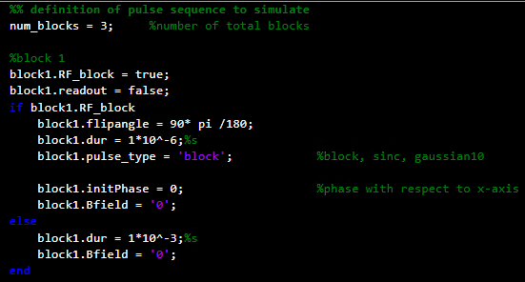
After sequence definition a bunch of important settings for the simulation can be chosen such as FOV, B0, simulated/reconstructed matrix size, gradient strength but also “factor_os”. This parameter handles oversampling in the time domain. In general, the sampling frequency is calculated by Nyquists theorem as for conventional MRI (keep in mind that this already assumes demodulated signals) such that “factor_os” has to be chosen such that also the original, not-modulated signal is sampled sufficiently.
There are the following Booleans which change the simulation procedure as follows:
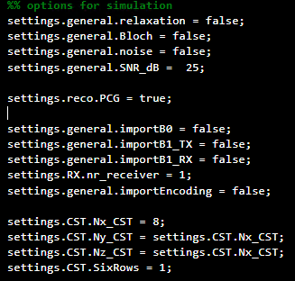

Relaxation: Boolean to switch on/off relaxation effects during Bloch/matrix-based simulation of the MRI signal.
Bloch: Boolean which enables Bloch simulation – solving Bloch equation numerically (for convergence, “factor_os” has to be chosen large enough (typically >1000000)).
noise & SNR_dB: Add gaussian white noise to simulated signal with the chosen SNR_dB.
PCG: Reconstruction can either be done by conjugate gradient or using the algebraic reconstruction technique (ART). The latter one converges only slowly but requires less RAM since per iteration only one row of the encoding matrix is required.
importB0/B1_TX/B1_RX: These variables enable the import of the B0, transmit or receive field from the folder “FieldData”.
Nr_receiver: Number of receiver coils – not yet used during simulation because Low-field MRI is often reyling on one RX channel but generalization to multiple coils can be done easily.
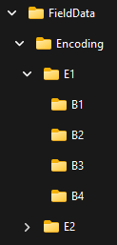
importEncoding: Enables the import of the encoding fields from the folder “FieldData\Encoding”:
The structure in this folder is as follows: Each encoding step (folder “E”) has its own subfolders in which the txt-files of the encoding fields are located for each block (folder “B”) of the simulated sequence. The following parameters “Nx_CST, Ny_CST, Nz_CST and SixRows” are the size of the imported txt-files as well as specifying the format of the imported files.

Sample
The sample used for the simulation can either be imported (folder “Sample”) or manually defined. Predefined options are the Shepp-Logan Phantom, a sphere, a cylinder, or a 1D/2D rectangle whose code is located in “samplePrep.m”.

Simulation:
First, for each block of a sequence, the magnetization vector is calculated. If this block is a “readout-block”, then the induced EMF is determined, demodulated and downsampled.

Reconstruction:
Reconstruction is currently optimized for one echo and receive coil and not written to be generically able to reconstruct all possible sequences/parameter inputs. However, the reconstruction can be easily adapted for multiple echos and receiver coils.

“ArrayShow” is a nice toolbox to visualize matrices. By default the first to dimensions are displayed, leaving the possibility to scroll in the last dimension starting from “1”. These buttons
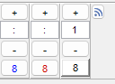
enable to scroll through the matrix by using “+” or “-“ or by scrolling with the mouse wheel. Sometimes errors pop up, then, I would recommend to close the window which makes problems and reopen the array you want to have a look at.

