CSE341 - Lab: 02

## AHMAD AL ASAD

ID: 19101196

Sec: 04

Task 2: Swap two numbers, using a maximum of 3 registers

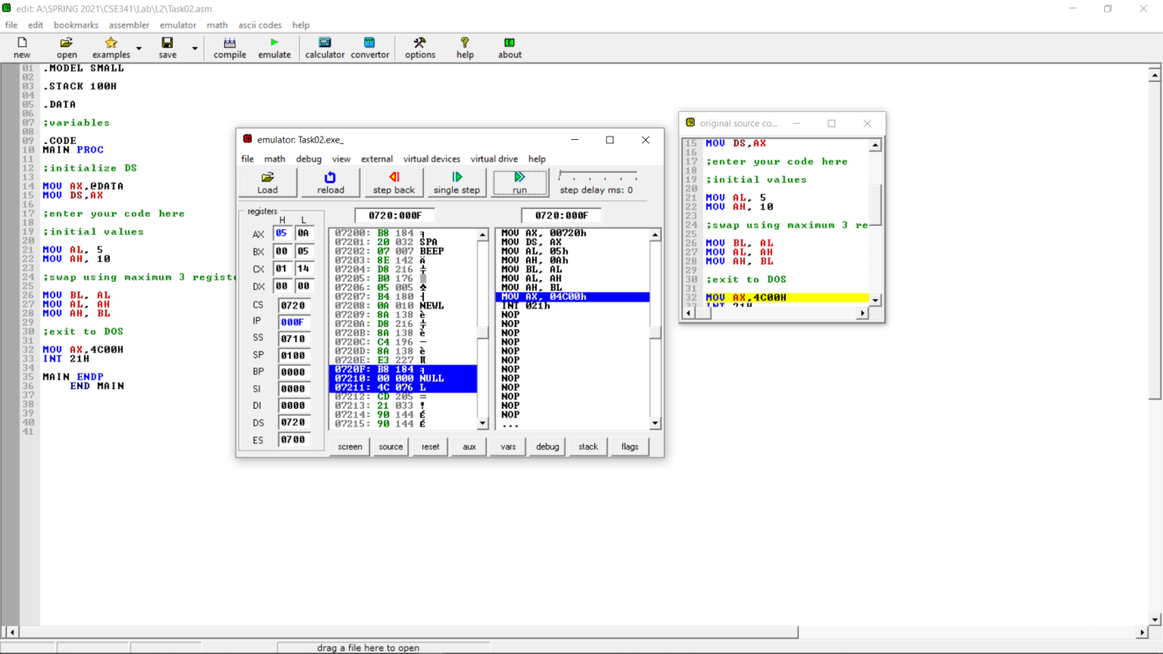

Task 5: Swap two numbers using ADD/SUB instructions only

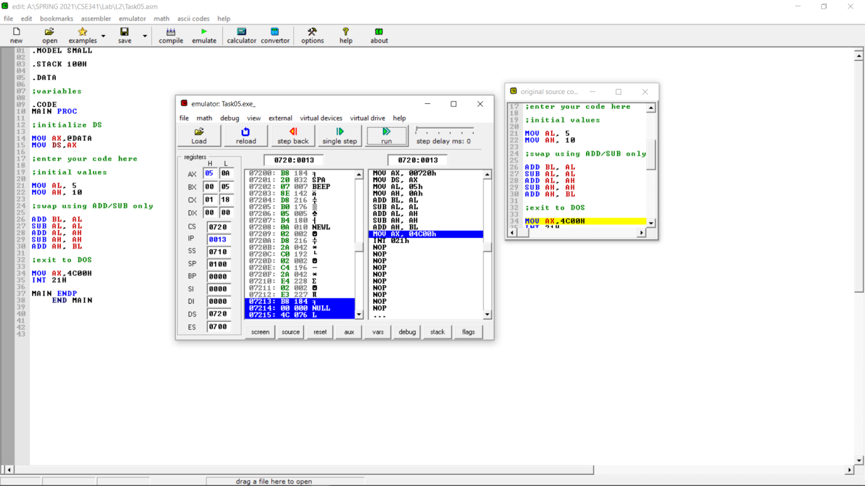

Task 6:

* Part 3: C = A + (B + 1)

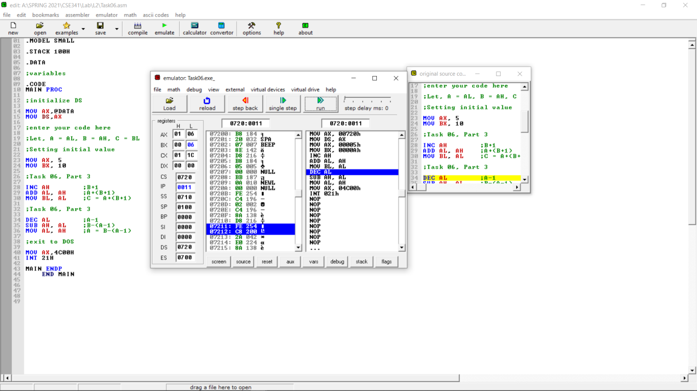

* Part 4: A = B - (A - 1)

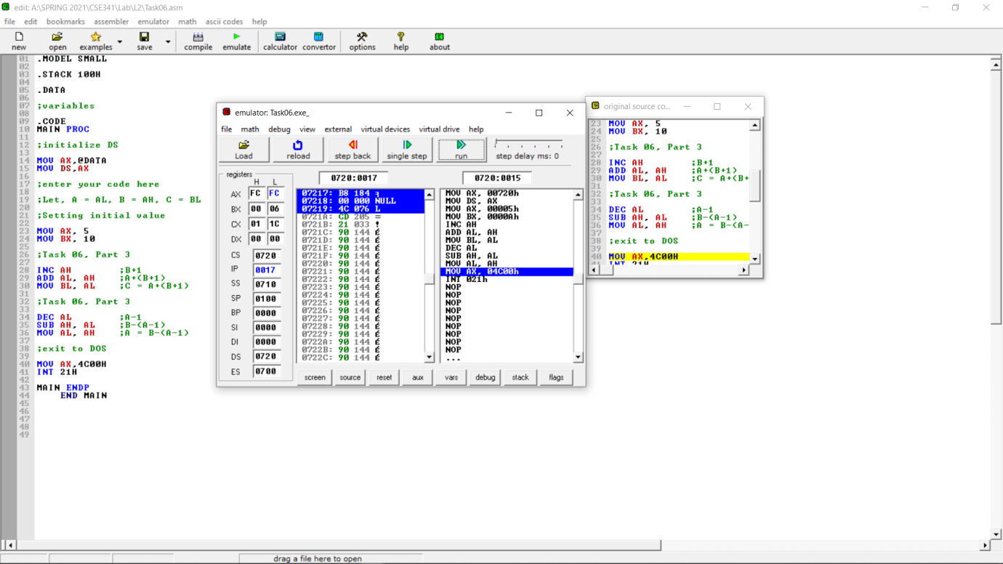

Task 7:

* Part 3: X * Y / Z

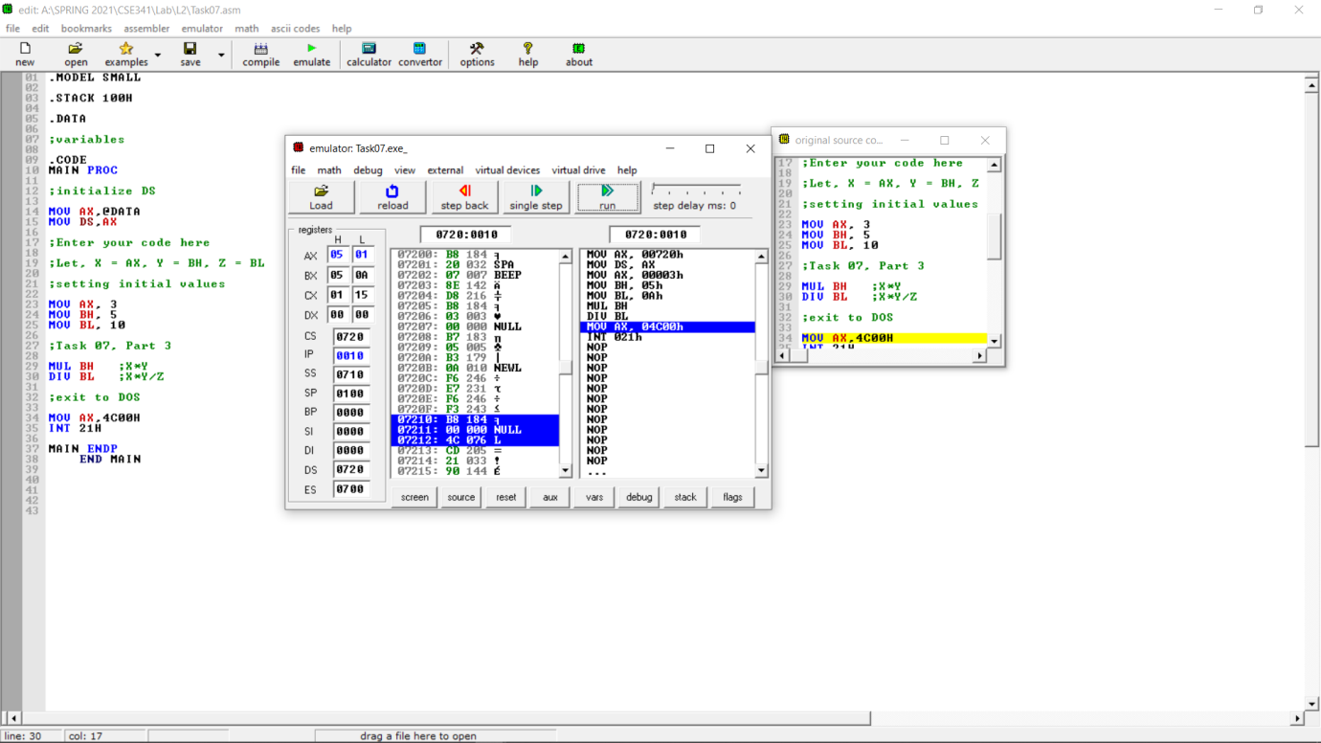

Task 8:

* Part 4: C2A2 * ABCD / BED

