CSE341 - Lab: 06

## AHMAD AL ASAD

ID: 19101196

Sec: 04

Task 01:

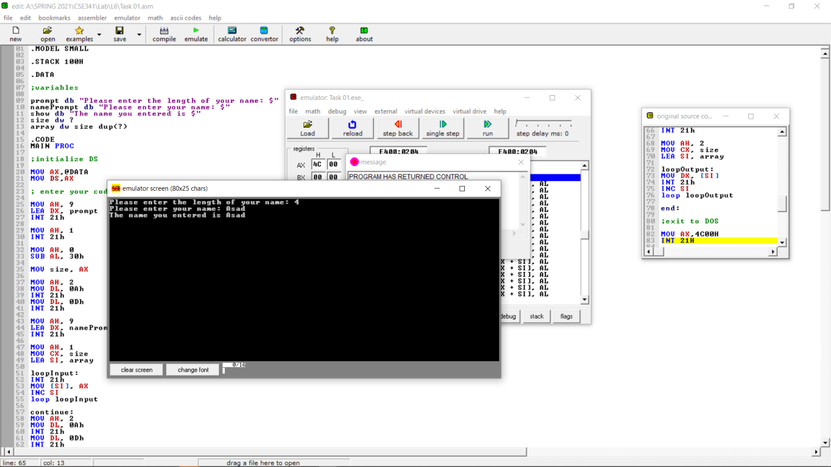

Task 02:

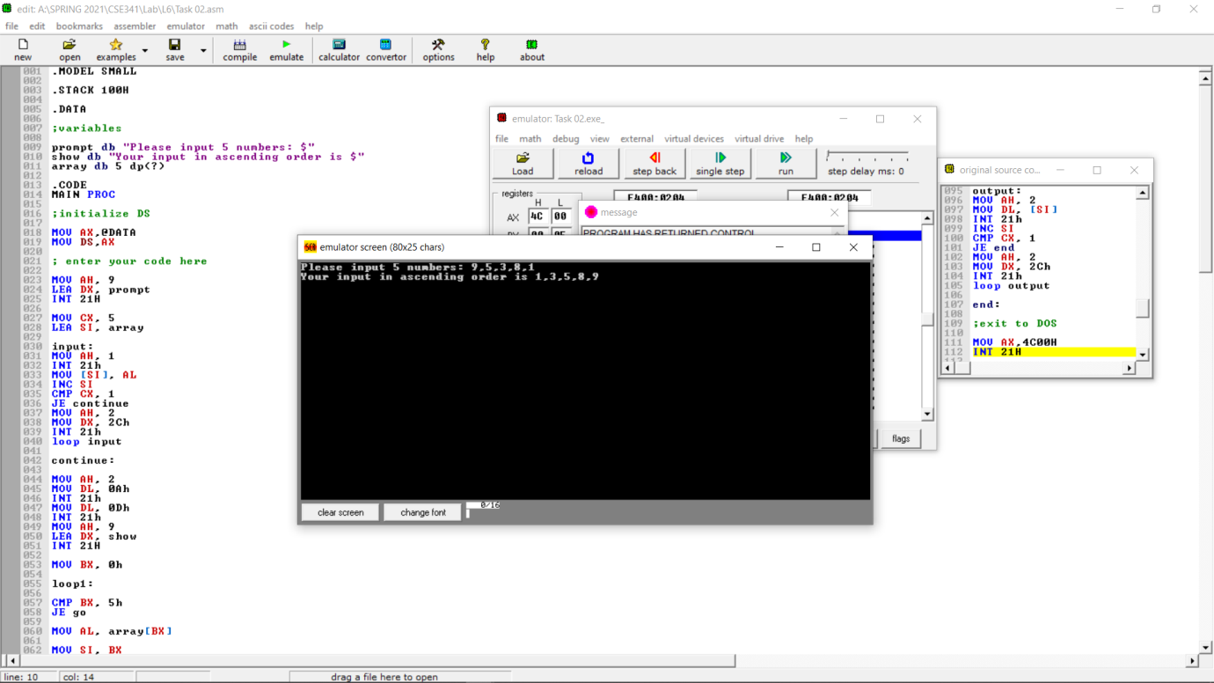

Task 03:

