**Install prerquisites**

Install Python and Jupyter using the Anaconda Distribution, which includes Python, the Jupyter Notebook, and other commonly used packages for scientific computing and data science.

<https://www.anaconda.com/download/>

First, download Anaconda. I recommend downloading Anaconda’s latest Python 3 version.

Second, install the version of Anaconda which you downloaded, following the instructions on the download page.

**Test your notebook**

Open a command prompt (on Windows) or terminal (MAC/Linux) and run the following command:

jupyter notebook

Your notebook should open in a browser, by showing your folders, and go to Documents.

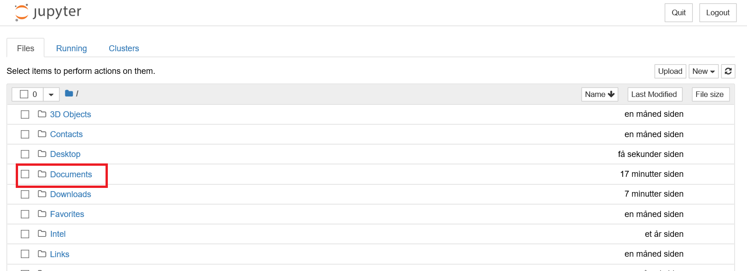

Create a new folder for your Python Notebooks. Click on New, which will generate an “Untitled Folder”.

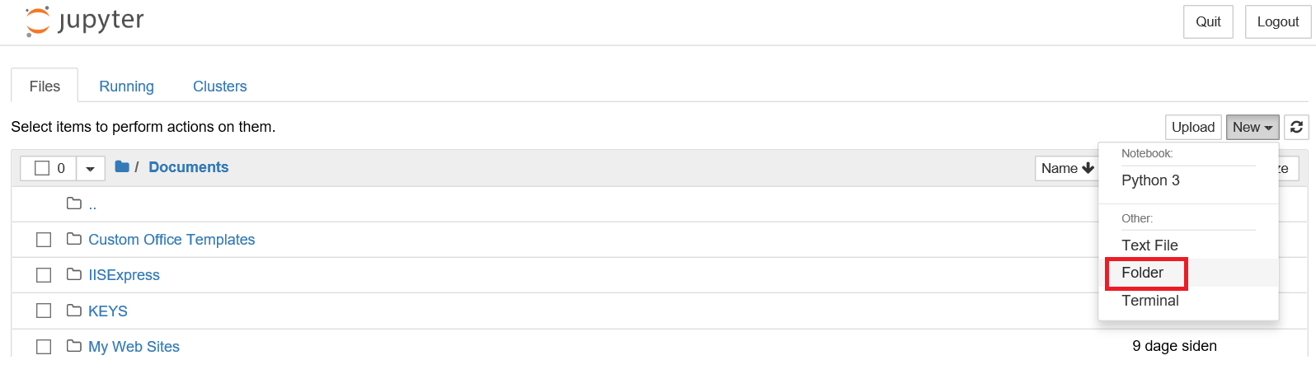

Choose the folder and then click Rename, and call it for example PythonNotebooks.

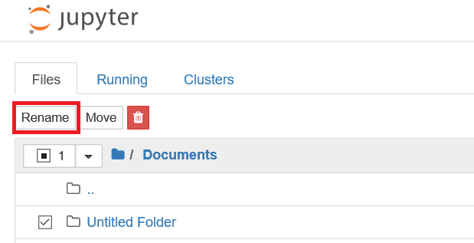

Go into your new and renamed folder, and click on new again, and choose Python 3.

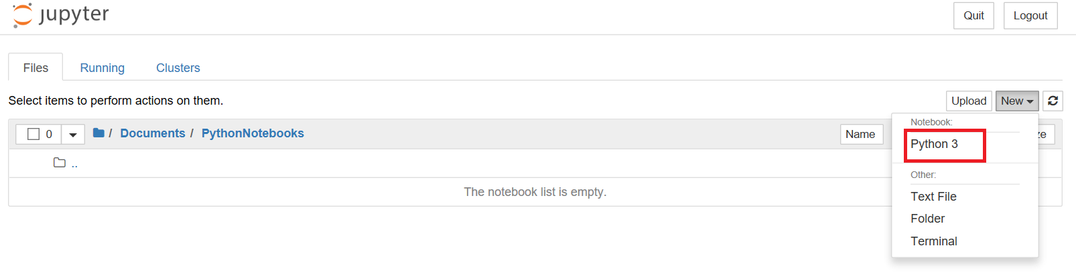

This will open your notebook where you will spend most of your time during today’s session. To test whether you did everything correctly, write into the first input: print(“Hello!!”), and click RUN!

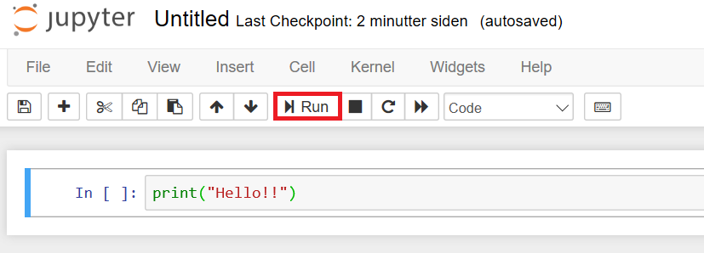

If you did everything good, the notebook will answer you Hello!! 😊